Supplementary information

Supplementary Figure 1. ISG65 peptide mapping. In total 239 ISG65-derived peptides were identified. This corresponds to a sequence coverage of 97%. The covered sequence is depicted in red.

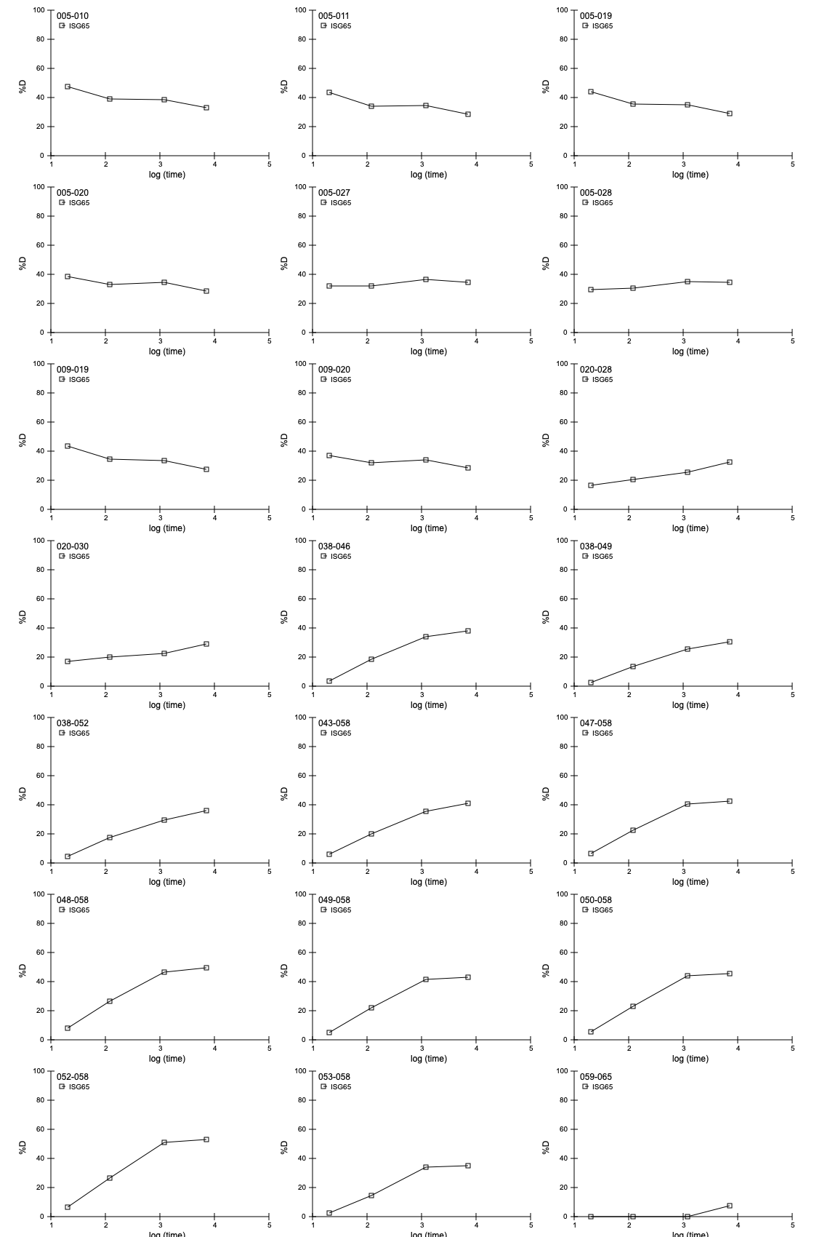
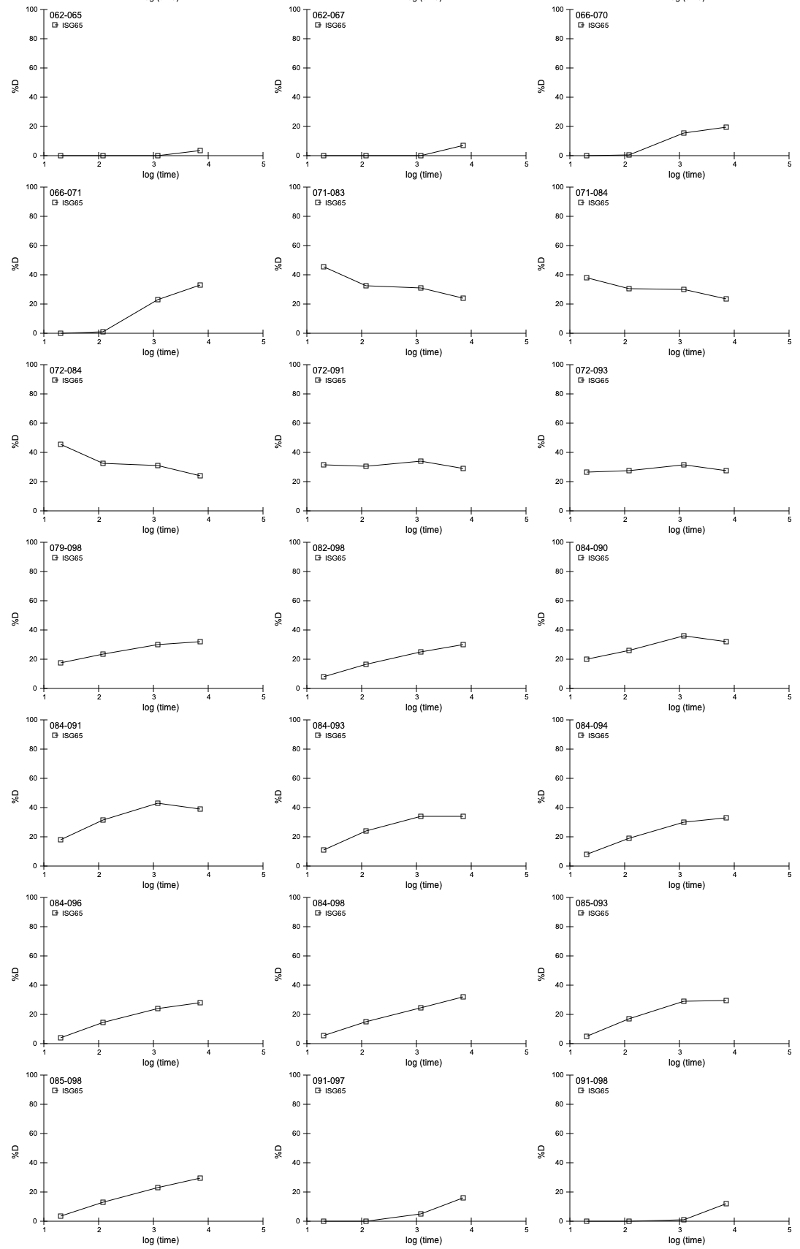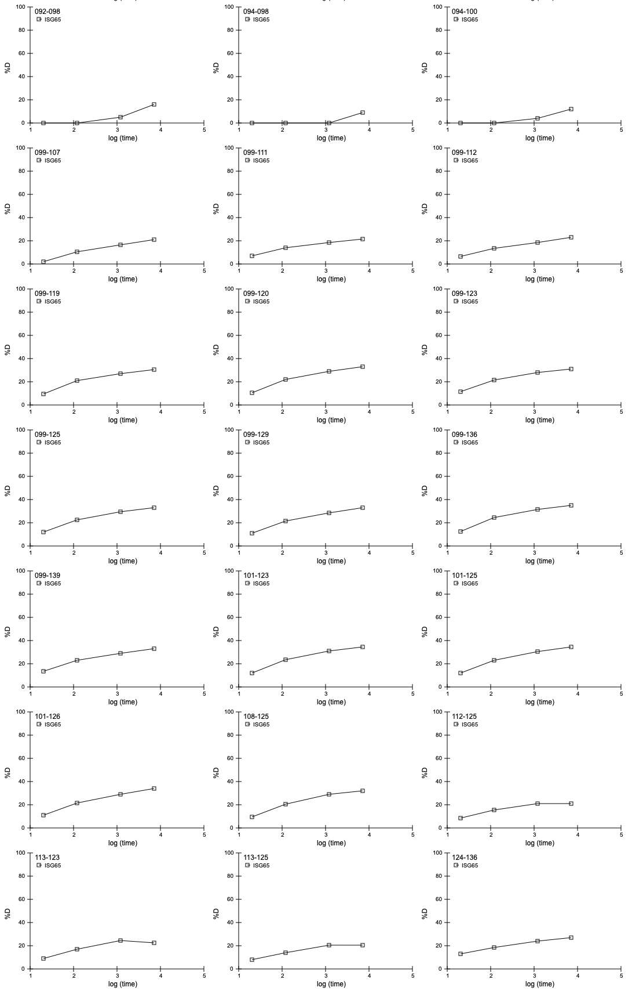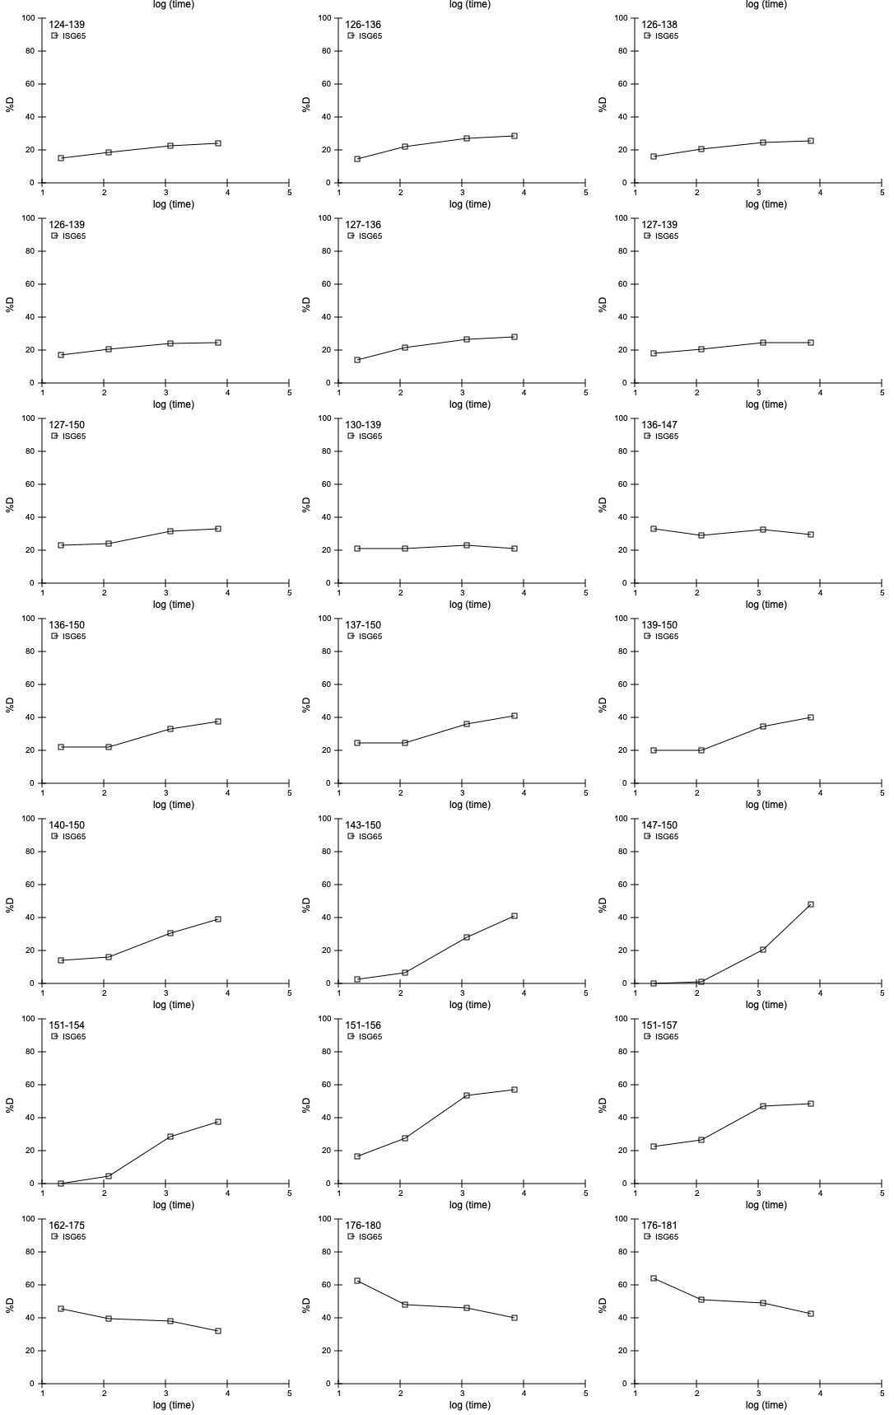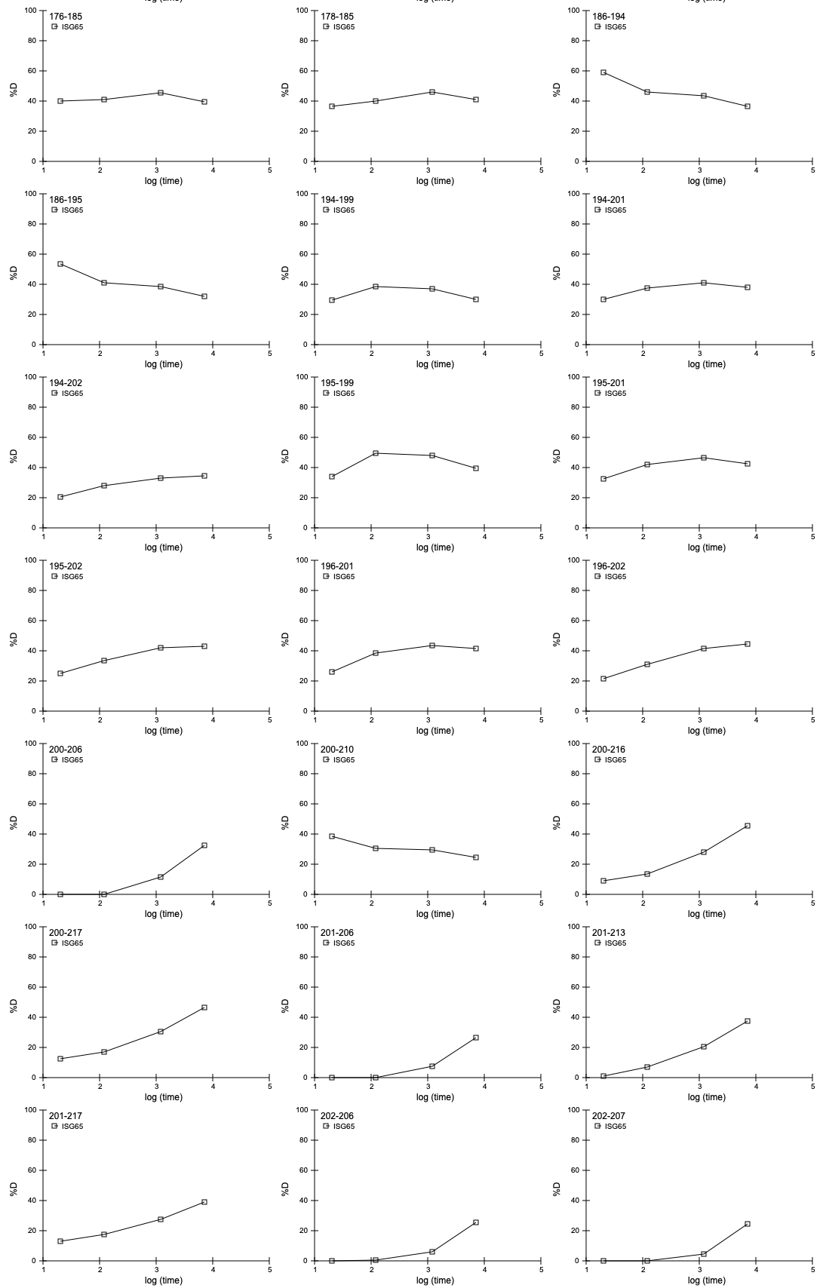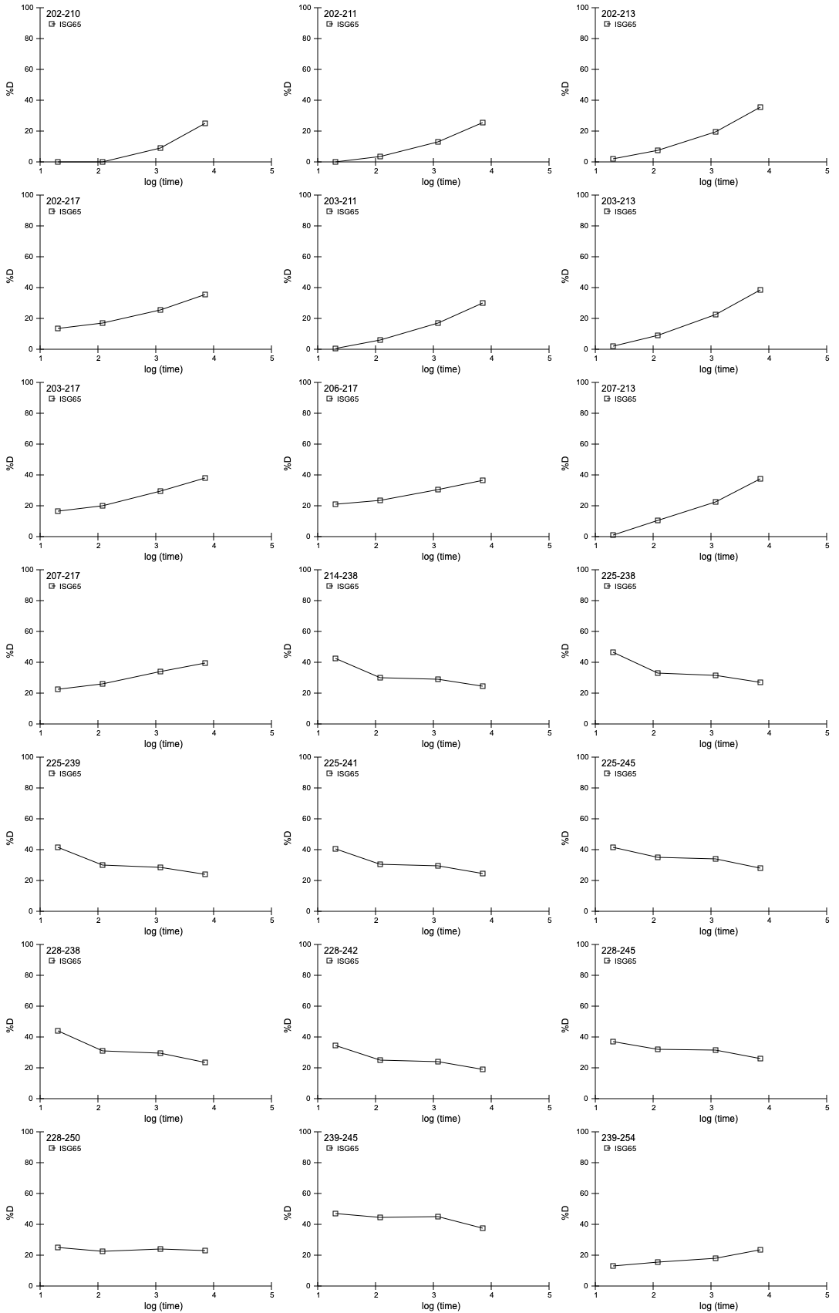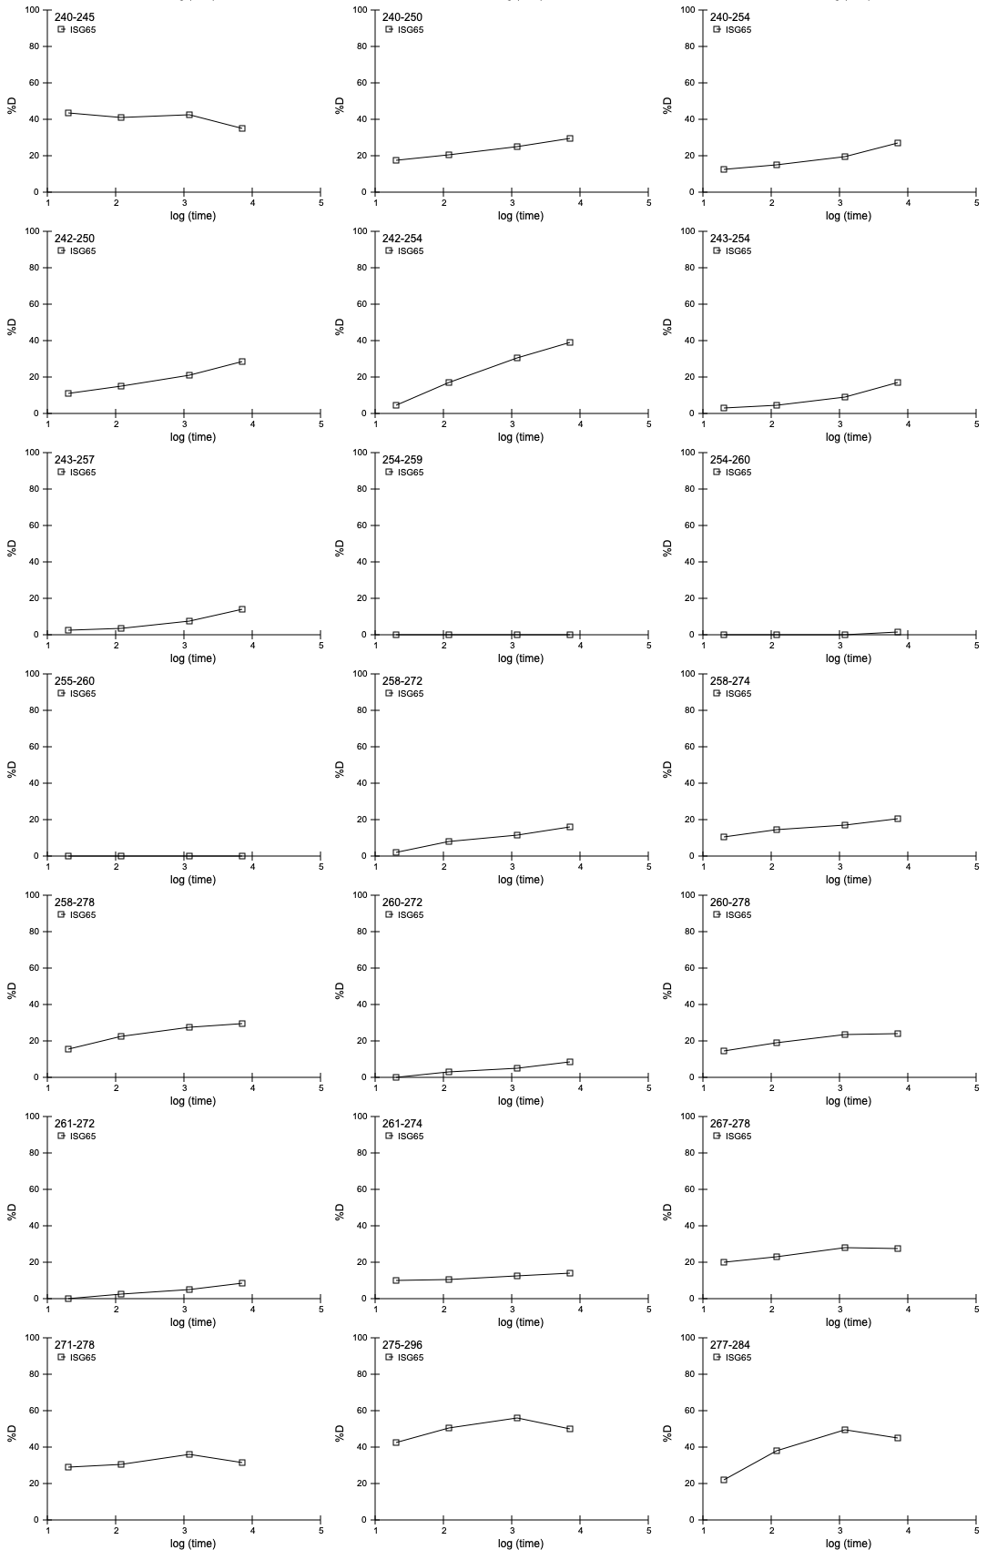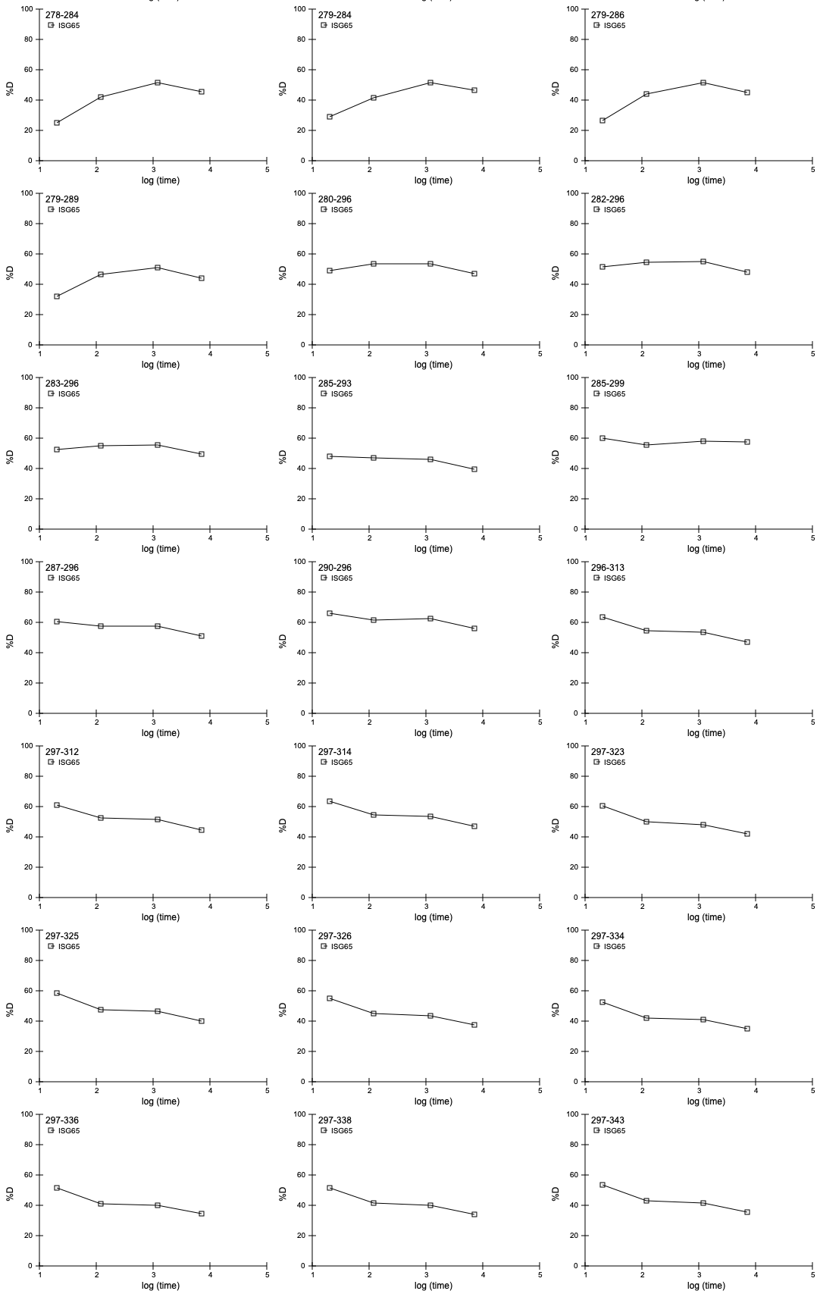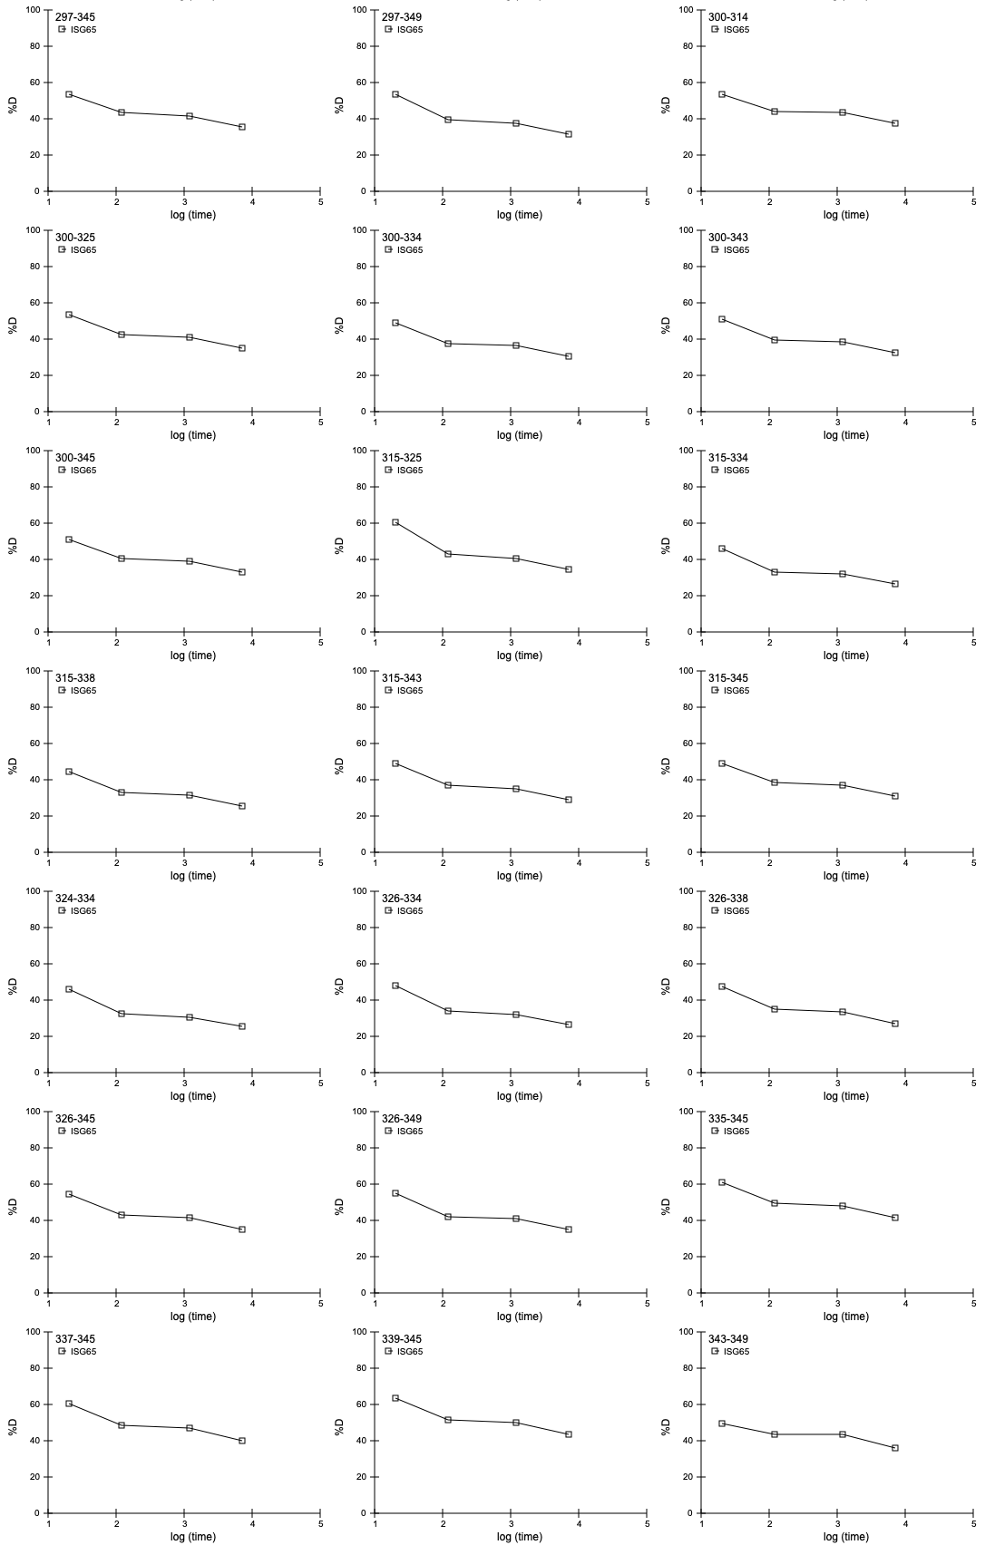
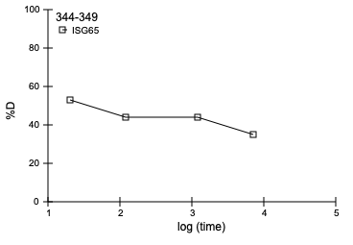

Supplementary Figure 2. Rates of deuterium uptake for ISG65-derived peptides. Peptide masses were determined after 20s, 120s and 1200s and 7200s and the percentage of deuterium uptake calculated. The position of each peptide in the sequence of ISG65 is indicated.

Supplementary Figure 3. Longest and shortest ISG65 construct have different α-helical content but similar melting temperatures. (A) CD spectra collected between 5°C and 80°C and melting curve of construct ISG65₁₈₋₃₆₃, expressed in E. coli (EC). (B) CD spectra collected between 5°C and 80°C and melting curve of construct ISG65₃₂₋₃₀₆, expressed in Drosophila melanogaster (DM) S2 cells. Melting temperatures (T_{m}) were calculated from mean residue ellipticity (θ) measured at 222nm. Filled circles represent the experimental data points and dashed lines the fit.

