The TLR-2/TonEBP signaling pathway regulates 29-kDa fibronectin fragment-dependent expression of matrix metalloproteinases

Hyun Sook Hwang^{a,b#}, Mi Hyun Lee^{a,b#}, Hyun Ah Kim^{a,b*}
ª Division of Rheumatology, Department of Internal Medicine, Hallym University Sacred Heart Hospital, Gyeonggi, 14068, Korea; ^{b} Institute for Skeletal Aging, Hallym University, Chunchon, 24251, Korea

Table S1. Primer sequences
Gene | Primer sequence
TonEBP | forward: 5’-CCA-CCA-CCT-GAG-GAC-TTG-CT-3’  reverse: 5’-TCC-AAT-CCA-CAC-CCC-TCA-TC-3’
MMP-1 | forward: 5’-AGT-GAC-TGG-GAA-ACC-AGA-TGC-TGA-3’  reverse: 5’-GCT-CTT-GGC-AAA-TCT-GGC-GTG-TAA-3
MMP-3 | forward: 5’-GCG-TGG-ATG-CCG-CAT-ATG-AAG-TTA-3’  reverse: 5’-AAA-CCT-AGG-GTG-TGG-ATG-CCT-CTT-3
MMP-13 | forward: 5’-AAG-GAC-CCT-GGA-GCA-CTC-ATG-TTT-3’  reverse: 5’- TGG-CAT-CAA-GGG-ATA-AGG-AAG-GGT-3
SMIT | forward: 5’-GCA-GAG-CTG-GTT-GCT-CCA-A-3’  reverse: 5’-CCA-CAG-GAA-CCA-GCT-TCA-TCA-3
TauT | forward: 5’-CAG-TGG-CAT-CCT-TAG-GTC-ATT-CA-3’  reverse: 5’-GCT-GCT-TGC-CCA-TTG-GAG-TA-3
AR | forward: 5’-CAC-TGG-CCG-ACT-GGC-TTT-AA-3’  reverse: 5’-GCC-CGA-CTC-ATC-CAA-TGG-3
VDCC L d type | forward: 5’-TTG-GCA-AGC-TGC-AAT-CGA-T-3’  reverse: 5’-GGG-TGC-AGA-GGT-GCT-CAT-AGT-T-3
VDCC L c type | forward: 5’-ACG-TCT-TTT-GGA-ATC-AGT-GTC-TTG-3’  reverse: 5’-CCG-TAG-GGA-AGC-CCA-ATA-CTT-3
AQP-1 | forward: 5’-GCC-TGG-GCA-TCG-AGA-TCA-3’  reverse: 5’-TAG-TAG-CCA-GCA-CGC-ATA-GCA-3
ASIC | forward: 5’-CCA-CCGCACCTGCTACCTT-3’  reverse: 5’-GGG-CTCCGAGGACACAGA-3
TRPV4 | forward: 5’-GGC-TGC-TCC-CAT-TCT-TGC-T-3’  reverse: 5’-GAT-GGC-TCT-CGA-AAC-TCC-TCA-T-3
P2RX7 | forward: 5’-CGG-TTG-TGT-CCC-GAG-TAT-CC-3’  reverse: 5’- ACA-ACC-TCG-GTC-AGA-GGA-ACA-3

Table S2. siRNA sequence
Gene | siRNA sequence
si-control | sense: 5’-CCU-ACG-CCA-CCA-AUU-UCG-U-3’  antisense: 5’-ACG-AAA-UUG-GUG-GCG-UAG-G-3’
si-TonEBP | sense: 5’-GAC-CAU-GGU-CCA-AAU-GCA-A-3’  antisense: 5’-UUG-CAU-UUG-GAC-CAU-GGU-C-3’
si-TLR-2 | sense: 5’-GAU-GUU-AGC-AAC-AAC-AAU-C-3’  antisense 5’-GAU-UGU-UGU-UGC-UAA-CAU-C-3’
si-CaM | sense: 5’- CAG-AAC-UUC-GCC-AUG-UGA-U-3’  antisense 5’- AUC-ACA-UGG-CGA-AGU-UCU-G-3’
Si-CaN | sense: 5’- CA G-AC A-AU G-GC U-AU A-AA C-U-3’  antisense 5’-AGU-UUA-UAG-CCA-UUG-UCU-G-3’

The TLR-2/TonEBP signaling pathway regulates 29-kDa fibronectin fragment-dependent expression of matrix metalloproteinases

Hyun Sook Hwang^{a,b#}, Mi Hyun Lee^{a,b#}, Hyun Ah Kim^{a,b*}
ª Division of Rheumatology, Department of Internal Medicine, Hallym University Sacred Heart Hospital, Gyeonggi, 14068, Korea; ^{b} Institute for Skeletal Aging, Hallym University, Chunchon, 24251, Korea

Original Blots

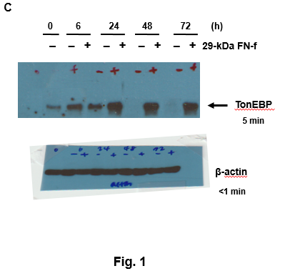

Supplementary Figure 1. Display of original blots and exposure time for TonEBP and β-actin Western blot analysis (Fig 1C). Membranes were cut to minimize antibody use. Membranes were separately probed for TonEBP and β-actin.

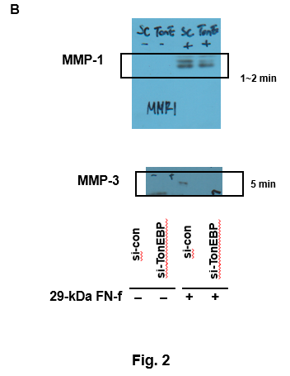

Supplementary Figure 2. Display of full length blots and exposure time for MMP-1 and -3 Western blot analysis (Fig 2B). Membranes were cut to minimize antibody use. Membranes were separately probed for MMP-1 and -3.

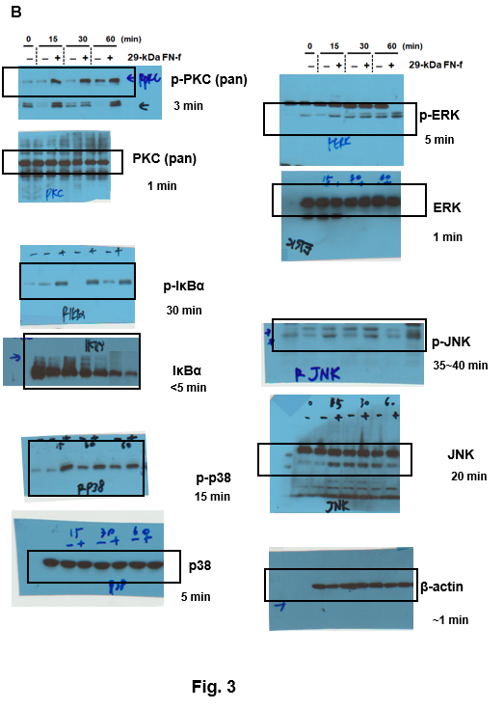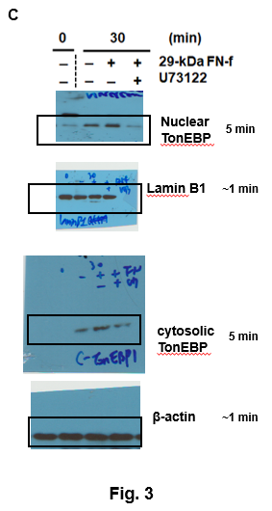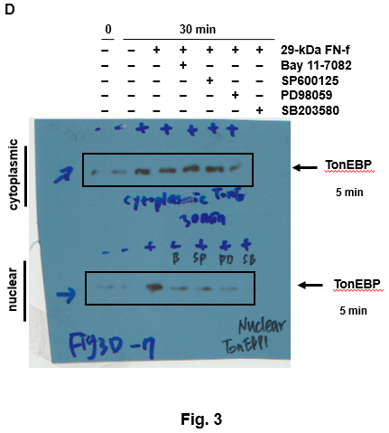

Supplementary Figure 3. Display of full length blots and exposure time for (B) p-PKC/PKC, p-Iκ-Bα/Iκ-Bα, p-p38/p38, pERK/ERK, and p-JNK/JNK, (C), (D) nuclear and cytosolic TonEBP Western blot analysis (Fig 3B, C, and D). Membranes were cut to minimize antibody use. Membranes were separately probed for p-PKC/PKC, p-Iκ-Bα/Iκ-Bα, p-p38/p38, pERK/ERK, p-JNK/JNK, and TonEBP .

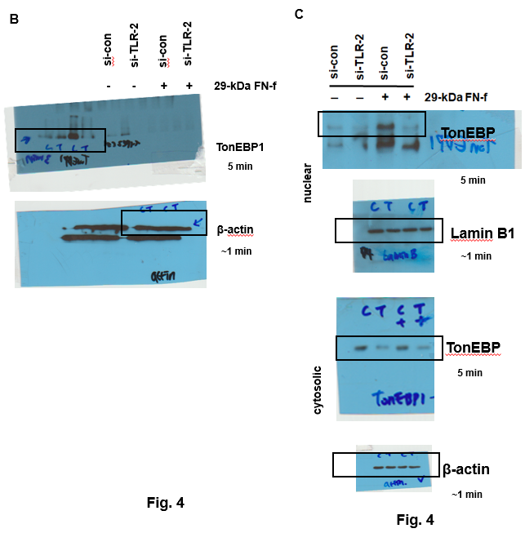

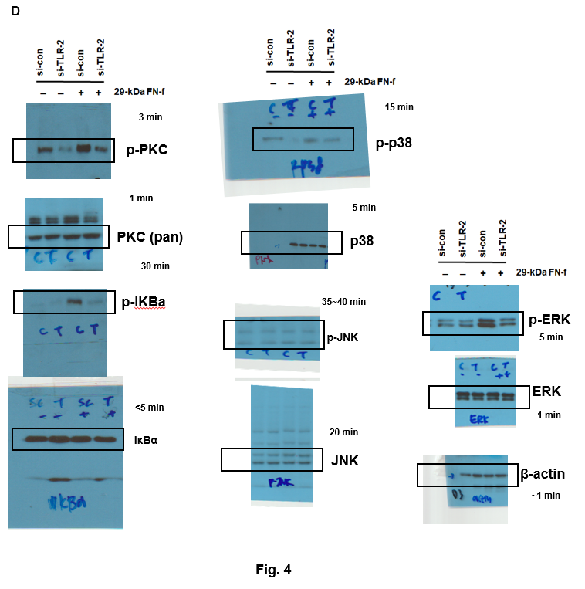
Supplementary Figure 4. Display of full length blots and exposure time for (B) TonEBP and β-actin, (C) nuclear and cytosolic TonEBP, and (D) p-PKC/PKC, p-Iκ-Bα/Iκ-Bα, p-p38/p38, pERK/ERK, and p-JNK/JNK Western blot analysis (Fig 4B, C, and D). Membranes were cut to minimize antibody use. Membranes were separately probed for p-PKC/PKC, p-Iκ-Bα/Iκ-Bα, p-p38/p38, pERK/ERK, p-JNK/JNK, and TonEBP.

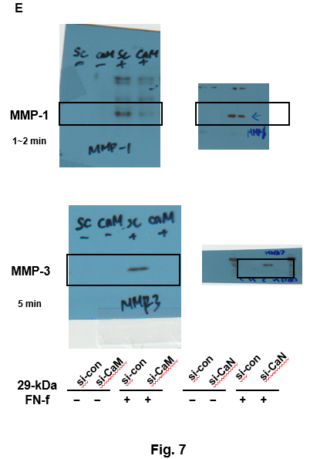

Supplementary Figure 5. Display of full length blots and exposure time for MMP-1 and -3 Western blot analysis (Fig 7E). Membranes were cut to minimize antibody use. Membranes were separately probed for MMP-1 and -3.

