ENGINEERING BRANCHING MORPHOGENESIS USING CELL COMMUNICATION

Chloé D. Devillard, Christophe A. Marquette*

3d.FAB, CNRS, INSA, Univ Lyon, CPE-Lyon, UMR5246, ICBMS, Université Lyon 1, 1 rue Victor Grignard, Villeurbanne Cedex, France

Supplementary information
Supplementary Table 1 List and function description of the 43 human angiogenic proteins targeted by the multiplex ELISA test in the culture medium supernatant of 3D bioprinted tissue.
Human angiogenic protein | Functions
Angiogenin | Binds to actin on the surface of endothelial cells; once bound, angiogenin is endocytosed and translocated to the nucleus. Stimulates ribosomal RNA synthesis including that containing the initiation site sequences of 45S rRNA. Cleaves tRNA within anticodon loops to produce tRNA-derived stress-induced fragments (tiRNAs) which inhibit protein synthesis and triggers the assembly of stress granules (SGs). Angiogenin induces vascularization of normal and malignant tissues. Angiogenic activity is regulated by interaction with RNH1 in vivo.
Angiopoietin-1 | Binds and activates TEK/TIE2 receptor by inducing its dimerization and tyrosine phosphorylation. Plays an important role in the regulation of angiogenesis, endothelial cell survival, proliferation, migration, adhesion and cell spreading, reorganization of the actin cytoskeleton, but also maintenance of vascular quiescence. Required for normal angiogenesis and heart development during embryogenesis. After birth, activates or inhibits angiogenesis, depending on the context. Inhibits angiogenesis and promotes vascular stability in quiescent vessels, where endothelial cells have tight contacts. In quiescent vessels, ANGPT1 oligomers recruit TEK to cell-cell contacts, forming complexes with TEK molecules from adjoining cells, and this leads to preferential activation of phosphatidylinositol 3-kinase and the AKT1 signaling cascades. In migrating endothelial cells that lack cell-cell adhesions, ANGT1 recruits TEK to contacts with the extracellular matrix, leading to the formation of focal adhesion complexes, activation of PTK2/FAK and of the downstream kinases MAPK1/ERK2 and MAPK3/ERK1, and ultimately to the stimulation of sprouting angiogenesis. Mediates blood vessel maturation/stability. Implicated in endothelial developmental processes later and distinct from that of VEGF. Appears to play a crucial role in mediating reciprocal interactions between the endothelium and surrounding matrix and mesenchyme.
Angiopoietin-2 | Binds to TEK/TIE2, competing for the ANGPT1 binding site, and modulating ANGPT1 signaling. Can induce tyrosine phosphorylation of TEK/TIE2 in the absence of ANGPT1. In the absence of angiogenic inducers, such as VEGF, ANGPT2-mediated loosening of cell-matrix contacts may induce endothelial cell apoptosis with consequent vascular regression. In concert with VEGF, it may facilitate endothelial cell migration and proliferation, thus serving as a permissive angiogenic signal.
Angiostatin | Angiostatin is an angiogenesis inhibitor that blocks neovascularization and growth of experimental primary and metastatic tumors in vivo.
bFGF | Acts as a ligand for FGFR1, FGFR2, FGFR3 and FGFR4.  Also acts as an integrin ligand which is required for FGF2 signaling.  Binds to integrin ITGAV:ITGB3.  Plays an important role in the regulation of cell survival, cell division, cell differentiation and cell migration.  Functions as a potent mitogen in vitro.  Can induce angiogenesis.  Mediates phosphorylation of ERK1/2 and thereby promotes retinal lens fiber differentiation.
EGF | EGF stimulates the growth of various epidermal and epithelial tissues in vivo and in vitro and of some fibroblasts in cell culture. Magnesiotropic hormone that stimulates magnesium reabsorption in the renal distal convoluted tubule via engagement of EGFR and activation of the magnesium channel TRPM6. Can induce neurite outgrowth in motoneurons of the pond snail Lymnaea stagnalis in vitro.  Branching morphogenesis of an epithelial tube.
ENA-78 (CXCL5) | Involved in neutrophil activation. In vitro, ENA-78(8-78) and ENA-78(9-78) show a threefold higher chemotactic activity for neutrophil granulocytes.
Endostatin | May regulate extracellular matrix-dependent motility and morphogenesis of endothelial and non-endothelial cells; the function requires homotrimerization and implicates MAPK signaling.  Potently inhibits endothelial cell proliferation and angiogenesis.  May inhibit angiogenesis by binding to the heparan sulfate proteoglycans involved in growth factor signaling (By similarity).  Inhibits VEGFA-induced endothelial cell proliferation and migration. Seems to inhibit VEGFA-mediated signaling by blocking the interaction of VEGFA to its receptor KDR/VEGFR2. Modulates endothelial cell migration in an integrin-dependent manner implicating integrin ITGA5:ITGB1 and to a lesser extent ITGAV:ITGB3 and ITGAV:ITGB5 (By similarity).
GCSF | Granulocyte/macrophage colony-stimulating factors are cytokines that act in hematopoiesis by controlling the production, differentiation, and function of 2 related white cell populations of the blood, the granulocytes and the monocytes-macrophages. This CSF induces granulocytes.
GM-CSF | Cytokine that stimulates the growth and differentiation of hematopoietic precursor cells from various lineages, including granulocytes, macrophages, eosinophils and erythrocytes.
Gro alpha/beta/gamma | -
I-309 (TCA-3/CCL1) | Cytokine that is chemotactic for monocytes but not for neutrophils. Binds to CCR8.
IFN-gamma | Type II interferon produced by immune cells such as T-cells and NK cells that plays crucial roles in antimicrobial, antiviral, and antitumor responses by activating effector immune cells and enhancing antigen presentation.  Primarily signals through the JAK-STAT pathway after interaction with its receptor IFNGR1 to affect gene regulation.  Upon IFNG binding, IFNGR1 intracellular domain opens out to allow association of downstream signaling components JAK2, JAK1 and STAT1, leading to STAT1 activation, nuclear translocation and transcription of IFNG-regulated genes. Many of the induced genes are transcription factors such as IRF1 that are able to further drive regulation of a next wave of transcription.  Plays a role in class I antigen presentation pathway by inducing a replacement of catalytic proteasome subunits with immunoproteasome subunits.  In turn, increases the quantity, quality, and repertoire of peptides for class I MHC loading.  Increases the efficiency of peptide generation also by inducing the expression of activator PA28 that associates with the proteasome and alters its proteolytic cleavage preference.  Up-regulates as well MHC II complexes on the cell surface by promoting expression of several key molecules such as cathepsins B/CTSB, H/CTSH, and L/CTSL.  Participates in the regulation of hematopoietic stem cells during development and under homeostatic conditions by affecting their development, quiescence, and differentiation (By similarity).
IGF-1 | The insulin-like growth factors, isolated from plasma, are structurally and functionally related to insulin but have a much higher growth-promoting activity. May be a physiological regulator of [1-14C]-2-deoxy-D-glucose (2DG) transport and glycogen synthesis in osteoblasts. Stimulates glucose transport in bone-derived osteoblastic (PyMS) cells and is effective at much lower concentrations than insulin, not only regarding glycogen and DNA synthesis but also with regard to enhancing glucose uptake. May play a role in synapse maturation.  Ca²⁺-dependent exocytosis of IGF1 is required for sensory perception of smell in the olfactory bulb (By similarity).  Acts as a ligand for IGF1R. Binds to the alpha subunit of IGF1R, leading to the activation of the intrinsic tyrosine kinase activity which autophosphorylates tyrosine residues in the beta subunit thus initiatiating a cascade of down-stream signaling events leading to activation of the PI3K-AKT/PKB and the Ras-MAPK pathways. Binds to integrins ITGAV:ITGB3 and ITGA6:ITGB4. Its binding to integrins and subsequent ternary complex formation with integrins and IGFR1 are essential for IGF1 signaling. Induces the phosphorylation and activation of IGFR1, MAPK3/ERK1, MAPK1/ERK2 and AKT1.
IL-10 | Major immune regulatory cytokine that acts on many cells of the immune system where it has profound anti-inflammatory functions, limiting excessive tissue disruption caused by inflammation. Mechanistically, IL10 binds to its heterotetrameric receptor comprising IL10RA and IL10RB leading to JAK1 and STAT2-mediated phosphorylation of STAT3.  In turn, STAT3 translocates to the nucleus where it drives expression of anti-inflammatory mediators.  Targets antigen-presenting cells (APCs) such as macrophages and monocytes and inhibits their release of pro-inflammatory cytokines including granulocyte-macrophage colony-stimulating factor /GM-CSF, granulocyte colony-stimulating factor/G-CSF, IL-1 alpha, IL-1 beta, IL-6, IL-8 and TNF-alpha.  Interferes also with antigen presentation by reducing the expression of MHC-class II and co-stimulatory molecules, thereby inhibiting their ability to induce T cell activation .  In addition, controls the inflammatory response of macrophages by reprogramming essential metabolic pathways including mTOR signaling (By similarity).  Branching involved in labyrinthine layer morphogenesis.
IL-1 alpha (IL-1 F1) | Produced by activated macrophages, IL-1 stimulates thymocyte proliferation by inducing IL-2 release, B-cell maturation and proliferation, and fibroblast growth factor activity. IL-1 proteins are involved in the inflammatory response, being identified as endogenous pyrogens, and are reported to stimulate the release of prostaglandin and collagenase from synovial cells.  Connective tissue replacement involved in inflammatory response wound healing.  Positive regulation of angiogenesis.
IL-1 beta (IL-1 F2) | Potent proinflammatory cytokine (PubMed:3920526, PubMed:10653850, PubMed:12794819).  Initially discovered as the major endogenous pyrogen, induces prostaglandin synthesis, neutrophil influx and activation, T-cell activation and cytokine production, B-cell activation and antibody production, and fibroblast proliferation and collagen production (PubMed:3920526).  Promotes Th17 differentiation of T-cells. Synergizes with IL12/interleukin-12 to induce IFNG synthesis from T-helper 1 (Th1) cells  Plays a role in angiogenesis by inducing VEGF production synergistically with TNF and IL6.  Involved in transduction of inflammation downstream of pyroptosis: its mature form is specifically released in the extracellular milieu by passing through the gasdermin-D (GSDMD) pore.
IL-2 | Produced by T-cells in response to antigenic or mitogenic stimulation, this protein is required for T-cell proliferation and other activities crucial to regulation of the immune response. Can stimulate B-cells, monocytes, lymphokine-activated killer cells, natural killer cells, and glioma cells.
IL-4 | Participates in at least several B-cell activation processes as well as of other cell types.  It is a costimulator of DNA-synthesis. It induces the expression of class II MHC molecules on resting B-cells. It enhances both secretion and cell surface expression of IgE and IgG1. It also regulates the expression of the low affinity Fc receptor for IgE (CD23) on both lymphocytes and monocytes. Positively regulates IL31RA expression in macrophages (By similarity).  Stimulates autophagy in dendritic cells by interfering with mTORC1 signaling and through the induction of RUFY4 (By similarity).  Negative regulation of endothelial cell apoptotic process.
IL-6 | Acts as an essential factor in bone homeostasis and on vessels directly or indirectly by induction of VEGF, resulting in increased angiogenesis activity and vascular permeability.  Induces, through 'trans-signaling' and synergistically with IL1B and TNF, the production of VEGF.  Involved in metabolic controls, is discharged into the bloodstream after muscle contraction increasing lipolysis and improving insulin resistance.  'Trans-signaling' in central nervous system also regulates energy and glucose homeostasis (By similarity).  Mediates, through GLP-1, crosstalk between insulin-sensitive tissues, intestinal L cells and pancreatic islets to adapt to changes in insulin demand (By similarity).  Also acts as a myokine (Probable). Plays a protective role during liver injury, being required for maintenance of tissue regeneration (By similarity).  Also has a pivotal role in iron metabolism by regulating HAMP/hepcidin expression upon inflammation or bacterial infection.
IL-8 (CXCL8) | IL-8 is a chemotactic factor that attracts neutrophils, basophils, and T-cells, but not monocytes. It is also involved in neutrophil activation. It is released from several cell types in response to an inflammatory stimulus. IL-8(6-77) has a 5-10-fold higher activity on neutrophil activation, IL-8(5-77) has increased activity on neutrophil activation and IL-8(7-77) has a higher affinity to receptors CXCR1 and CXCR2 as compared to IL-8(1-77), respectively.
I-TAC (CXCL11) | Chemotactic for interleukin-activated T-cells but not unstimulated T-cells, neutrophils or monocytes. Induces calcium release in activated T-cells. Binds to CXCR3. May play an important role in CNS diseases which involve T-cell recruitment. May play a role in skin immune responses.
Leptin | Key player in the regulation of energy balance and body weight control. Once released into the circulation, has central and peripheral effects by binding LEPR, found in many tissues, which results in the activation of several major signaling pathways.  In the hypothalamus, acts as an appetite-regulating factor that induces a decrease in food intake and an increase in energy consumption by inducing anorexinogenic factors and suppressing orexigenic neuropeptides, also regulates bone mass and secretion of hypothalamo-pituitary-adrenal hormones. In the periphery, increases basal metabolism, influences reproductive function, regulates pancreatic beta-cell function and insulin secretion, is pro-angiogenic for endothelial cell and affects innate and adaptive immunity.  In the arcuate nucleus of the hypothalamus, activates by depolarization POMC neurons inducing FOS and SOCS3 expression to release anorexigenic peptides and inhibits by hyperpolarization NPY neurons inducing SOCS3 with a consequent reduction on release of orexigenic peptides (By similarity).  In addition to its known satiety inducing effect, has a modulatory role in nutrient absorption. In the intestine, reduces glucose absorption by enterocytes by activating PKC and leading to a sequential activation of p38, PI3K and ERK signaling pathways which exerts an inhibitory effect on glucose absorption.  Acts as a growth factor on certain tissues, through the activation of different signaling pathways increases expression of genes involved in cell cycle regulation such as CCND1, via JAK2-STAT3 pathway, or VEGFA, via MAPK1/3 and PI3K-AKT1 pathways.  May also play an apoptotic role via JAK2-STAT3 pathway and up-regulation of BIRC5 expression.  Pro-angiogenic, has mitogenic activity on vascular endothelial cells and plays a role in matrix remodeling by regulating the expression of matrix metalloproteinases (MMPs) and tissue inhibitors of metalloproteinases (TIMPs).  In innate immunity, modulates the activity and function of neutrophils by increasing chemotaxis and the secretion of oxygen radicals. Increases phagocytosis by macrophages and enhances secretion of pro-inflammatory mediators. Increases cytotoxic ability of NK cells.  Plays a pro-inflammatory role, in synergy with IL1B, by inducing NOS2 wich promotes the production of IL6, IL8 and Prostaglandin E2, through a signaling pathway that involves JAK2, PI3K, MAP2K1/MEK1 and MAPK14/p38.  In adaptive immunity, promotes the switch of memory T-cells towards T helper-1 cell immune responses.  Increases CD4⁺CD25⁻ T-cell proliferation and reduces autophagy during TCR (T-cell receptor) stimulation, through MTOR signaling pathway activation and BCL2 up-regulation.
MCP-1 (CCL2) | Acts as a ligand for C-C chemokine receptor CCR2.  Signals through binding and activation of CCR2 and induces a strong chemotactic response and mobilization of intracellular calcium ions.  Exhibits a chemotactic activity for monocytes and basophils but not neutrophils or eosinophils.  May be involved in the recruitment of monocytes into the arterial wall during the disease process of atherosclerosis.
MCP-3 (MARC/CCL7) | Chemotactic factor that attracts monocytes and eosinophils, but not neutrophils. Augments monocyte anti-tumor activity. Also induces the release of gelatinase B. This protein can bind heparin. Binds to CCR1, CCR2 and CCR3.
MCP-4 (CCL13) | Chemotactic factor that attracts monocytes, lymphocytes, basophils and eosinophils, but not neutrophils. Signals through CCR2B and CCR3 receptors. Plays a role in the accumulation of leukocytes at both sides of allergic and non-allergic inflammation. May be involved in the recruitment of monocytes into the arterial wall during the disease process of atherosclerosis. May play a role in the monocyte attraction in tissues chronically exposed to exogenous pathogens.
MMP-1 | Cleaves collagens of types I, II, and III at one site in the helical domain. Also cleaves collagens of types VII and X.
MMP-9 | Matrix metalloproteinase that plays an essential role in local proteolysis of the extracellular matrix and in leukocyte migration.  Could play a role in bone osteoclastic resorption.  Cleaves KiSS1 at a Gly-|-Leu bond.  Cleaves NINJ1 to generate the Secreted ninjurin-1 form.  Cleaves type IV and type V collagen into large C-terminal three quarter fragments and shorter N-terminal one quarter fragments.  Degrades fibronectin but not laminin or Pz-peptide.
PDGF-BB | Growth factor that plays an essential role in the regulation of embryonic development, cell proliferation, cell migration, survival and chemotaxis. Potent mitogen for cells of mesenchymal origin.  Required for normal proliferation and recruitment of pericytes and vascular smooth muscle cells in the central nervous system, skin, lung, heart and placenta. Required for normal blood vessel development, and for normal development of kidney glomeruli. Plays an important role in wound healing. Signaling is modulated by the formation of heterodimers with PDGFA.
PECAM (CD31) | Cell adhesion molecule which is required for leukocyte transendothelial migration (TEM) under most inflammatory conditions.  Tyr-690 plays a critical role in TEM and is required for efficient trafficking of PECAM1 to and from the lateral border recycling compartment (LBRC) and is also essential for the LBRC membrane to be targeted around migrating leukocytes.  Trans-homophilic interaction may play a role in endothelial cell-cell adhesion via cell junctions.  Heterophilic interaction with CD177 plays a role in transendothelial migration of neutrophils.  Homophilic ligation of PECAM1 prevents macrophage-mediated phagocytosis of neighboring viable leukocytes by transmitting a detachment signal.  Promotes macrophage-mediated phagocytosis of apoptotic leukocytes by tethering them to the phagocytic cells; PECAM1-mediated detachment signal appears to be disabled in apoptotic leukocytes.  Modulates bradykinin receptor BDKRB2 activation.  Regulates bradykinin- and hyperosmotic shock-induced ERK1/2 activation in endothelial cells.
PLGF | Growth factor active in angiogenesis and endothelial cell growth, stimulating their proliferation and migration. It binds to the receptor FLT1/VEGFR-1. Isoform PlGF-2 binds NRP1/neuropilin-1 and NRP2/neuropilin-2 in a heparin-dependent manner. Also promotes cell tumor growth.  Vascular endothelial growth factor receptor binding.  Positive regulation of angiogenesis.
RANTES (CCL5) | Chemoattractant for blood monocytes, memory T-helper cells and eosinophils. Causes the release of histamine from basophils and activates eosinophils. May activate several chemokine receptors including CCR1, CCR3, CCR4 and CCR5. One of the major HIV-suppressive factors produced by CD8+ T-cells. Recombinant RANTES protein induces a dose-dependent inhibition of different strains of HIV-1, HIV-2, and simian immunodeficiency virus (SIV). The processed form RANTES(3-68) acts as a natural chemotaxis inhibitor and is a more potent inhibitor of HIV-1-infection. The second processed form RANTES(4-68) exhibits reduced chemotactic and HIV-suppressive activity compared with RANTES(1-68) and RANTES(3-68).  May also be an agonist of the G protein-coupled receptor GPR75, stimulating inositol trisphosphate production and calcium mobilization through its activation. Together with GPR75, may play a role in neuron survival through activation of a downstream signaling pathway involving the PI3, Akt and MAP kinases. By activating GPR75 may also play a role in insulin secretion by islet cells.
TGF beta 1 | Multifunctional protein that regulates the growth and differentiation of various cell types and is involved in various processes, such as normal development, immune function, microglia function and responses to neurodegeneration.
Thrombopoietin (TPO) | Lineage-specific cytokine affecting the proliferation and maturation of megakaryocytes from their committed progenitor cells. It acts at a late stage of megakaryocyte development. It may be the major physiological regulator of circulating platelets.
Tie-2 | Tyrosine-protein kinase that acts as cell-surface receptor for ANGPT1, ANGPT2 and ANGPT4 and regulates angiogenesis, endothelial cell survival, proliferation, migration, adhesion and cell spreading, reorganization of the actin cytoskeleton, but also maintenance of vascular quiescence. Has anti-inflammatory effects by preventing the leakage of proinflammatory plasma proteins and leukocytes from blood vessels. Required for normal angiogenesis and heart development during embryogenesis. Required for post-natal hematopoiesis. After birth, activates or inhibits angiogenesis, depending on the context. Inhibits angiogenesis and promotes vascular stability in quiescent vessels, where endothelial cells have tight contacts. In quiescent vessels, ANGPT1 oligomers recruit TEK to cell-cell contacts, forming complexes with TEK molecules from adjoining cells, and this leads to preferential activation of phosphatidylinositol 3-kinase and the AKT1 signaling cascades. In migrating endothelial cells that lack cell-cell adhesions, ANGT1 recruits TEK to contacts with the extracellular matrix, leading to the formation of focal adhesion complexes, activation of PTK2/FAK and of the downstream kinases MAPK1/ERK2 and MAPK3/ERK1, and ultimately to the stimulation of sprouting angiogenesis. ANGPT1 signaling triggers receptor dimerization and autophosphorylation at specific tyrosine residues that then serve as binding sites for scaffold proteins and effectors. Signaling is modulated by ANGPT2 that has lower affinity for TEK, can promote TEK autophosphorylation in the absence of ANGPT1, but inhibits ANGPT1-mediated signaling by competing for the same binding site. Signaling is also modulated by formation of heterodimers with TIE1, and by proteolytic processing that gives rise to a soluble TEK extracellular domain. The soluble extracellular domain modulates signaling by functioning as decoy receptor for angiopoietins. TEK phosphorylates DOK2, GRB7, GRB14, PIK3R1; SHC1 and TIE1.
TIMP-1 | Metalloproteinase inhibitor that functions by forming one to one complexes with target metalloproteinases, such as collagenases, and irreversibly inactivates them by binding to their catalytic zinc cofactor. Acts on MMP1, MMP2, MMP3, MMP7, MMP8, MMP9, MMP10, MMP11, MMP12, MMP13 and MMP16. Does not act on MMP14. Also functions as a growth factor that regulates cell differentiation, migration and cell death and activates cellular signaling cascades via CD63 and ITGB1. Plays a role in integrin signaling. Mediates erythropoiesis in vitro; but, unlike IL3, it is species-specific, stimulating the growth and differentiation of only human and murine erythroid progenitors.
TIMP-2 | Complexes with metalloproteinases (such as collagenases) and irreversibly inactivates them by binding to their catalytic zinc cofactor. Known to act on MMP-1, MMP-2, MMP-3, MMP-7, MMP-8, MMP-9, MMP-10, MMP-13, MMP-14, MMP-15, MMP-16 and MMP-19.
TNF alpha | Cytokine that binds to TNFRSF1A/TNFR1 and TNFRSF1B/TNFBR. It is mainly secreted by macrophages and can induce cell death of certain tumor cell lines. It is potent pyrogen causing fever by direct action or by stimulation of interleukin-1 secretion and is implicated in the induction of cachexia, Under certain conditions it can stimulate cell proliferation and induce cell differentiation. Impairs regulatory T-cells (Treg) function in individuals with rheumatoid arthritis via FOXP3 dephosphorylation. Up-regulates the expression of protein phosphatase 1 (PP1), which dephosphorylates the key 'Ser-418' residue of FOXP3, thereby inactivating FOXP3 and rendering Treg cells functionally defective.  Key mediator of cell death in the anticancer action of BCG-stimulated neutrophils in combination with DIABLO/SMAC mimetic in the RT4v6 bladder cancer cell line.  Induces insulin resistance in adipocytes via inhibition of insulin-induced IRS1 tyrosine phosphorylation and insulin-induced glucose uptake. Induces GKAP42 protein degradation in adipocytes which is partially responsible for TNF-induced insulin resistance (By similarity).  Plays a role in angiogenesis by inducing VEGF production synergistically with IL1B and IL6.
uPAR | Acts as a receptor for urokinase plasminogen activator. Plays a role in localizing and promoting plasmin formation. Mediates the proteolysis-independent signal transduction activation effects of U-PA. It is subject to negative-feedback regulation by U-PA which cleaves it into an inactive form.
VEGF-A | Growth factor active in angiogenesis, vasculogenesis and endothelial cell growth. Induces endothelial cell proliferation, promotes cell migration, inhibits apoptosis and induces permeabilization of blood vessels. Binds to the FLT1/VEGFR1 and KDR/VEGFR2 receptors, heparan sulfate and heparin. NRP1/Neuropilin-1 binds isoforms VEGF-165 and VEGF-145. Isoform VEGF165B binds to KDR but does not activate downstream signaling pathways, does not activate angiogenesis and inhibits tumor growth. Binding to NRP1 receptor initiates a signaling pathway needed for motor neuron axon guidance and cell body migration, including for the caudal migration of facial motor neurons from rhombomere 4 to rhombomere 6 during embryonic development.  Also binds the DEAR/FBXW7-AS1 receptor.
VEGFR2 | Tyrosine-protein kinase that acts as a cell-surface receptor for VEGFA, VEGFC and VEGFD. Plays an essential role in the regulation of angiogenesis, vascular development, vascular permeability, and embryonic hematopoiesis. Promotes proliferation, survival, migration and differentiation of endothelial cells. Promotes reorganization of the actin cytoskeleton. Isoforms lacking a transmembrane domain, such as isoform 2 and isoform 3, may function as decoy receptors for VEGFA, VEGFC and/or VEGFD. Isoform 2 plays an important role as negative regulator of VEGFA- and VEGFC-mediated lymphangiogenesis by limiting the amount of free VEGFA and/or VEGFC and preventing their binding to FLT4. Modulates FLT1 and FLT4 signaling by forming heterodimers. Binding of vascular growth factors to isoform 1 leads to the activation of several signaling cascades. Activation of PLCG1 leads to the production of the cellular signaling molecules diacylglycerol and inositol 1,4,5-trisphosphate and the activation of protein kinase C. Mediates activation of MAPK1/ERK2, MAPK3/ERK1 and the MAP kinase signaling pathway, as well as of the AKT1 signaling pathway. Mediates phosphorylation of PIK3R1, the regulatory subunit of phosphatidylinositol 3-kinase, reorganization of the actin cytoskeleton and activation of PTK2/FAK1. Required for VEGFA-mediated induction of NOS2 and NOS3, leading to the production of the signaling molecule nitric oxide (NO) by endothelial cells. Phosphorylates PLCG1. Promotes phosphorylation of FYN, NCK1, NOS3, PIK3R1, PTK2/FAK1 and SRC.
VEGFR3 | Tyrosine-protein kinase that acts as a cell-surface receptor for VEGFC and VEGFD, and plays an essential role in adult lymphangiogenesis and in the development of the vascular network and the cardiovascular system during embryonic development. Promotes proliferation, survival and migration of endothelial cells, and regulates angiogenic sprouting. Signaling by activated FLT4 leads to enhanced production of VEGFC, and to a lesser degree VEGFA, thereby creating a positive feedback loop that enhances FLT4 signaling. Modulates KDR signaling by forming heterodimers. The secreted isoform 3 may function as a decoy receptor for VEGFC and/or VEGFD and play an important role as a negative regulator of VEGFC-mediated lymphangiogenesis and angiogenesis. Binding of vascular growth factors to isoform 1 or isoform 2 leads to the activation of several signaling cascades; isoform 2 seems to be less efficient in signal transduction, because it has a truncated C-terminus and therefore lacks several phosphorylation sites. Mediates activation of the MAPK1/ERK2, MAPK3/ERK1 signaling pathway, of MAPK8 and the JUN signaling pathway, and of the AKT1 signaling pathway. Phosphorylates SHC1. Mediates phosphorylation of PIK3R1, the regulatory subunit of phosphatidylinositol 3-kinase. Promotes phosphorylation of MAPK8 at 'Thr-183' and 'Tyr-185', and of AKT1 at 'Ser-473'.
VEGF-D | Growth factor active in angiogenesis, lymphangiogenesis and endothelial cell growth, stimulating their proliferation and migration and also has effects on the permeability of blood vessels. May function in the formation of the venous and lymphatic vascular systems during embryogenesis, and also in the maintenance of differentiated lymphatic endothelium in adults. Binds and activates VEGFR-2 (KDR/FLK1) and VEGFR-3 (FLT4) receptors.

For this study we analyzed the culture supernatant of a bioprinted hydrogel composed of fibroblasts and HUVECs. A control test composed of fresh cell culture medium (DMEM/EGM2) was carried out in parallel. The samples are deposited on two array membrane bringing together a total of 43 antibodies associated with the 43 human proteins of interest involved in the phenomenon of angiogenesis (ST1).

Supplementary Table 2 Antibody array membrane pattern of the 43 antibodies associated with the 43 human proteins of interest involved in the process of angiogenesis, used during the study of the soluble factors secreted in the culture supernatant.
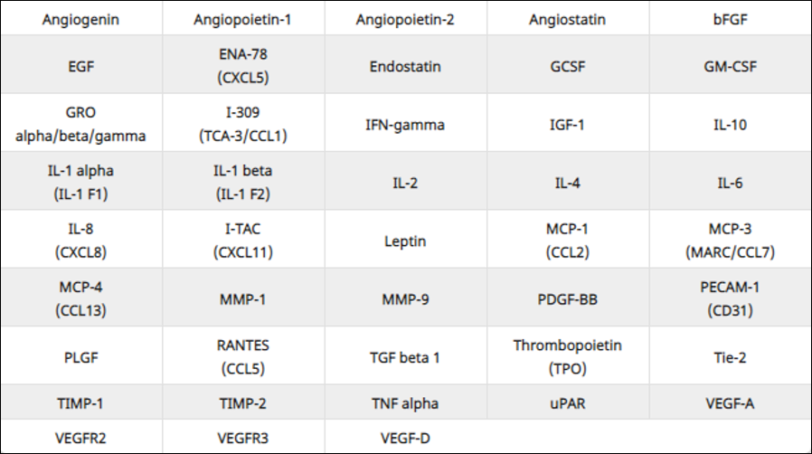

The presence of these proteins is then detected by means of a chemiluminescence reaction observable via a CCD camera. The operation of this method is schematized in S1.
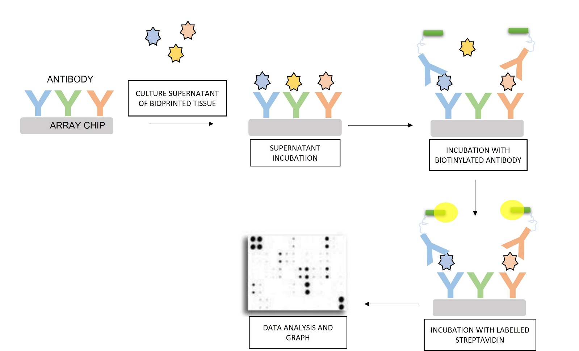
Supplementary Figure 1 Schematic diagram of the detection of human proteins involved in angiogenesis present in the culture supernatant of bioprinted tissues.

In S2 are shown the results of protein detection by chemiluminescence. Matrix n°1 at the top and matrix n°2 at the bottom with their control matrix are present.
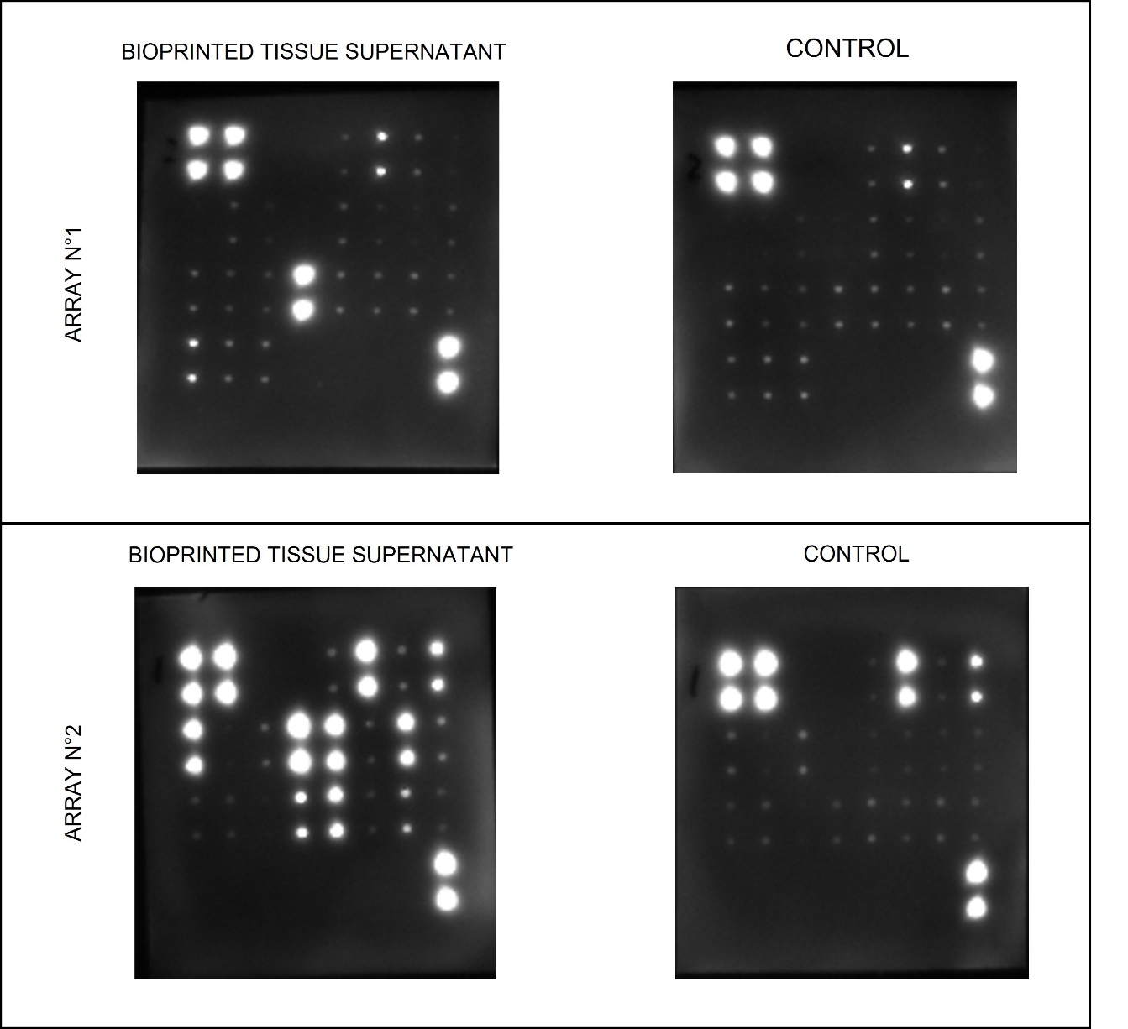
Supplementary Figure 2 Detection by chemiluminescence of the two antibody matrices directed against 43 proteins involved in the process of angiogenesis. Detection carried out in the culture supernatant of a tissue after 48 h of culture and detection carried out in a control of fresh culture medium in the absence of cells. Signal integration time of 20 sec.

