Supplementary
Supplementary 1 (S1). Dual culture test for representative isolates
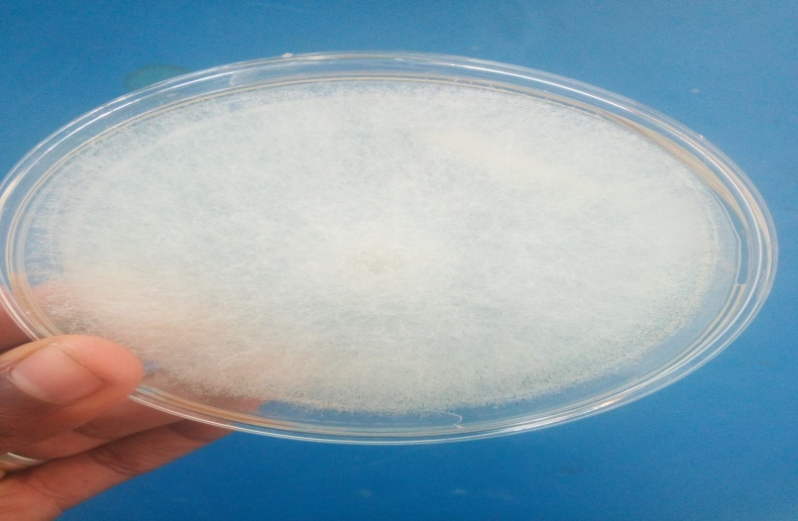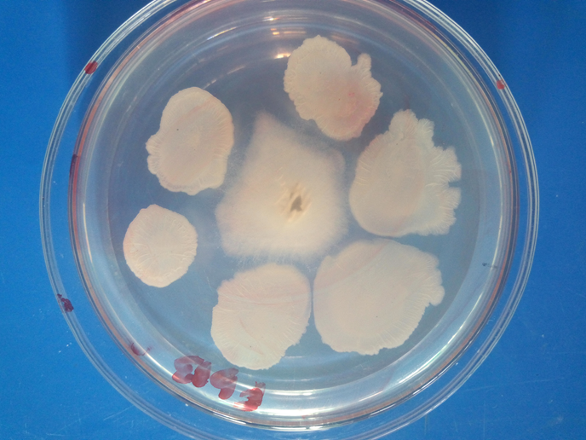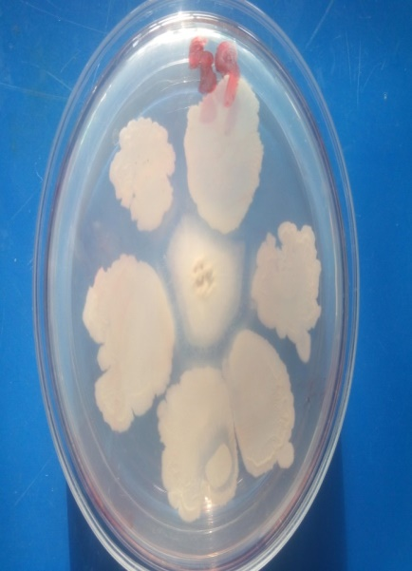
Control WUGRB- 8 WUGRB- 9
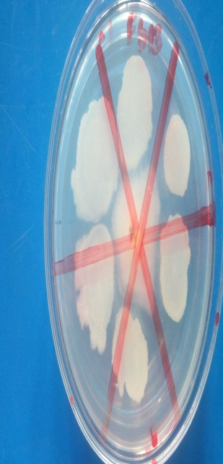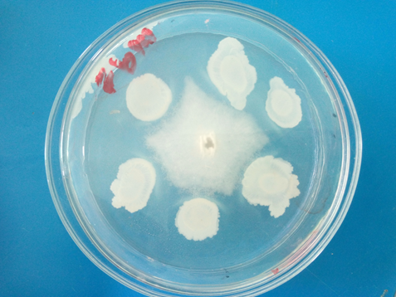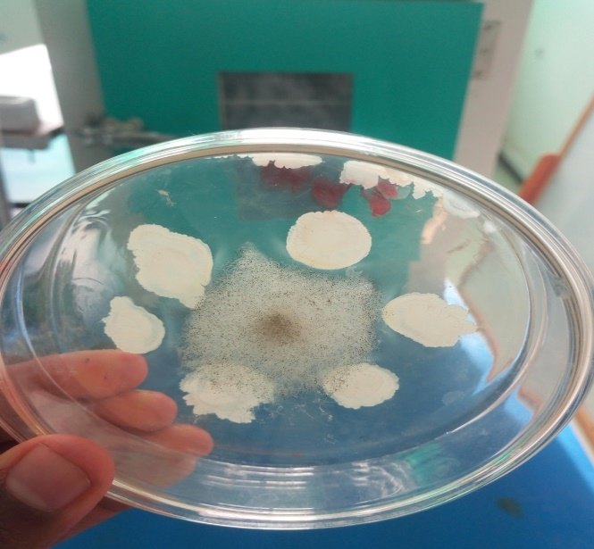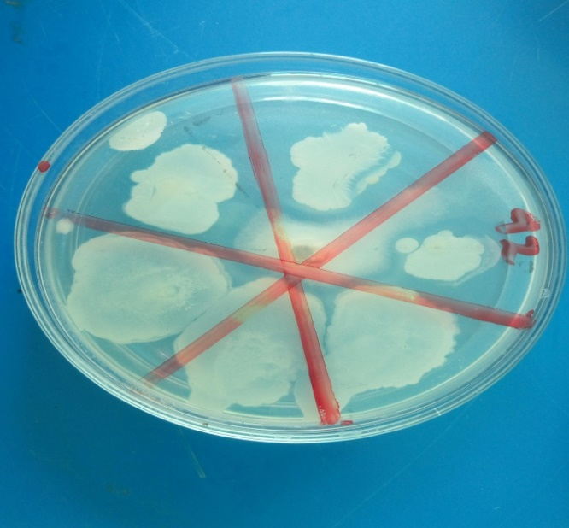
WUGRB-13 WUGRB-14 WUGRB- 91 WUGRB-92

Supplementary 2 (S2). The effect of selected isolates on the vegetative growth of garlic under greenhouse conditions
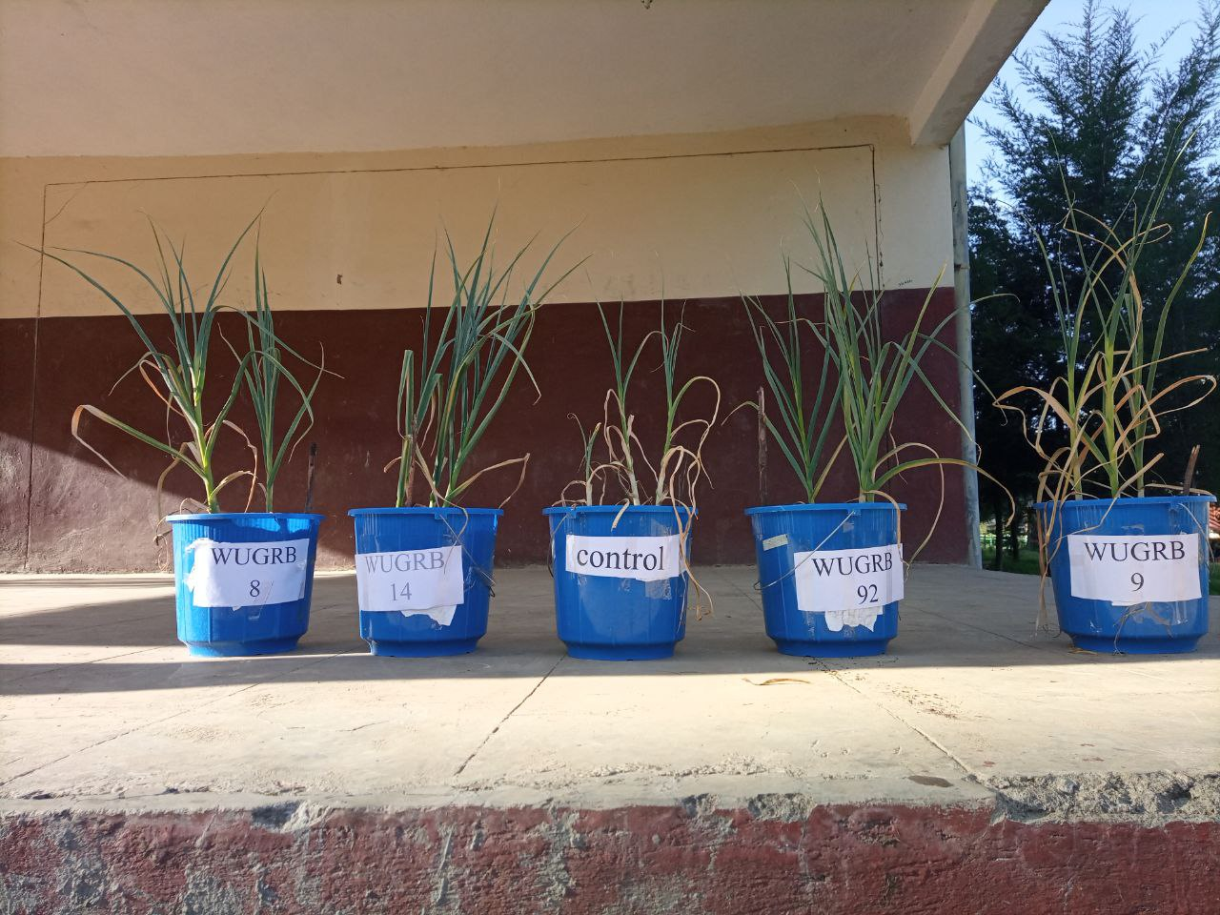
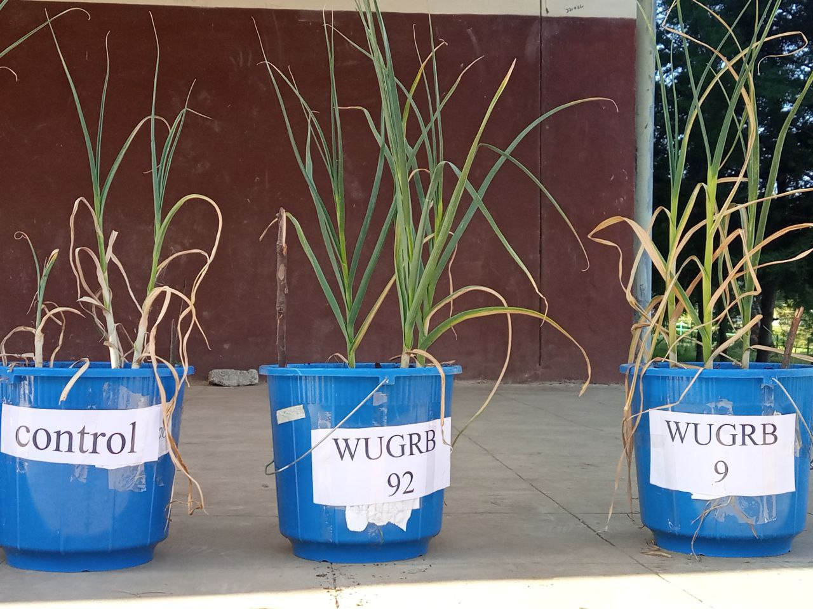
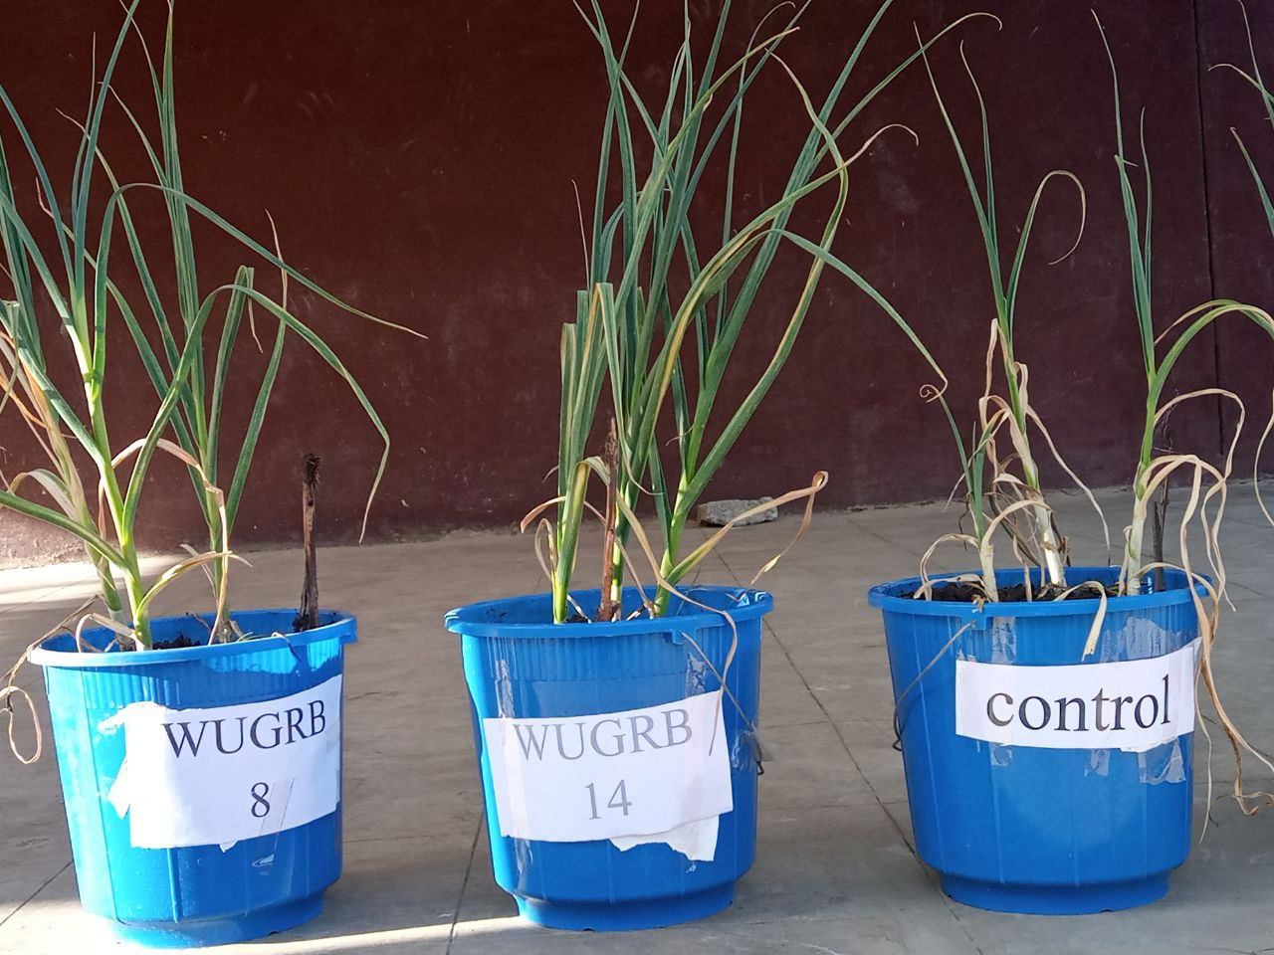
Supplementary 3(S3): The effect of Rhizobacteria on bulb size of garlic
Supplementary 4(S4): The effect of Rhizobacteria on cloves of garlic

