Supplementary Material
Supplementary Table 1. Average nucleotide identity (ANI) and digital DNA–DNA hybridization (dDDH) between strain YPG26^{T} and other species of Paenibacillus.
The whole genome sequences of other Paenibacillus species were derived from NCBI GenBank database (https://www.ncbi.nlm.nih.gov/genome/?term=paenibacillus).
Strain | RefSeq assembly Accession no. | YPG26
Strain | RefSeq assembly Accession no. | ANI（%） | dDDH（%）
Paenibacillus yonginensis strain DCY84 | NZ_CP014167.1 | 71.07 | 14
Paenibacillus physcomitrellae strain XB | NZ_CP022584.1 | 71.02 | 13.8
Paenibacillus lentus strain DSM 25539 | NZ_CP034248.1 | 70.58 | 13.9
Paenibacillus lutimineralis strain MBLB1234 | NZ_CP034346.1 | 70.52 | 13.5
Paenibacillus sabinae T27 | NZ_CP004078.1 | 70.41 | 13.5
Paenibacillus cellulositrophicus strain KACC 16577 | NZ_CP045295.1 | 70.29 | 13.6
Paenibacillus ihbetae strain IHBB 9852 | NZ_CP016809.1 | 70.21 | 13.5
Paenibacillus xylanilyticus strain W4 | NZ_CP018620.1 | 70.02 | 13.3
Paenibacillus lautus strain E7593-69 | NZ_CP032412.1 | 70 | 13.4
Paenibacillus donghaensis strain KCTC 13049 | NZ_CP021780.1 | 69.95 | 13.4
Paenibacillus jilunlii strain KACC 16679 | NZ_CP048429.1 | 69.94 | 13.4
Paenibacillus stellifer strain DSM 14472 | NZ_CP009286.1 | 69.9 | 13.4
Paenibacillus durus strain DSM 1735 | NZ_CP009288.1 | 69.89 | 13.4
Paenibacillus graminis strain DSM 15220 | NZ_CP009287.1 | 69.89 | 13.4
Paenibacillus borealis strain DSM 13188 | NZ_CP009285.1 | 69.88 | 13.3
Paenibacillus riograndensis SBR5 isolate SBR5(T) | NZ_LN831776.1 | 69.87 | 13.4
Paenibacillus glucanolyticus strain DSM 5162 | NZ_CP015286.1 | 69.86 | 13.6
Paenibacillus kribbensis strain AM49 | NZ_CP020028.1 | 69.73 | 13.4
Paenibacillus brasilensis strain KACC 13842 | NZ_CP045298.1 | 69.7 | 13.5
Paenibacillus xylanexedens strain PAMC 22703 | NZ_CP018620.1 | 69.7 | 13.3
Paenibacillus terrae HPL-003 | NC_016641.1 | 69.6 | 13.4
Paenibacillus bovis strain BD3526 | NZ_CP013023.1 | 69.55 | 13.4
Paenibacillus polymyxa E681 | NC_014483.2 | 69.54 | 13.5
Paenibacillus peoriae strain HS311 | NZ_CP011512.1 | 69.51 | 13.4
Paenibacillus uliginis N3/975 | LT840184.1 | 69.47 | 13.4
Paenibacillus swuensis strain DY6 | NZ_CP011388.1 | 69.41 | 13.4
Paenibacillus odorifer strain DSM 15391 | NZ_CP009428.1 | 69.18 | 13.3
Paenibacillus beijingensis strain DSM 24997 | NZ_CP011058.1 | 68.74 | 13.2
Paenibacillus guangzhouensis strain KCTC 33171 | NZ_CP045293.1 | 68.66 | 13.3
Paenibacillus thiaminolyticus strain NRRL B-4156 | NZ_CP041405.1 | 68.66 | 13.2
Paenibacillus protaetiae strain FW100M-2 | NZ_CP035492.1 | 68.56 | 13.3
Paenibacillus albus strain 18JY67-1 | NZ_CP034437.1 | 68.55 | 13.2
Paenibacillus crassostreae strain LPB0068 | NZ_CP017770.1 | 68.53 | 13.4
Paenibacillus antarcticus strain KACC 11469 | NZ_CP043611.1 | 68.48 | 13.4
Paenibacillus mucilaginosus KNP414 | NC_015690.1 | 68.46 | 13.2
Paenibacillus chitinolyticus strain KCCM 41400 | NZ_CP026520.1 | 68.34 | 13.2
Paenibacillus naphthalenovorans strain 32O-Y | NZ_CP013652.1 | 68.18 | 13.2
Paenibacillus baekrokdamisoli strain KCTC 33723 | NZ_AP019308.1 | 68 | 13.1
Paenibacillus psychroresistens strain ML311-T8 | NZ_CP034235.1 | 67.84 | 13.2
Paenibacillus larvae subsp. larvae strain ATCC 9545 | NZ_CP019687.1 | 67.56 | 13.2

Supplementary Table 2. The deduced amylase from the genome of the strain YPG26^{T}.
Sequence alignment of the deduced amylase sequence of the strain YPG26^{T} were performed with sequences available in the GenBank database.
 | YPG26_  Gene_id | Identity (%) | GenBank_  Accession | CAZymes_  family
α-Amylase | GM000512 | 56.6 | APO47284.1 | GH13_14
α-Amylase | GM000514 | 74.9 | AWB43174.1 | GH13_20
α-Amylase | GM000649 | 75.7 | AIQ34118.1 | GH13_31
α-Amylase | GM000819 | 41.9 | AWK41767.1 | GH13_3
α-Amylase | GM000825 | 69.5 | AIQ34761.1 | GH13_12
α-Amylase | GM000893 | 59.6 | AIQ36212.1 | GH13_36
α-Amylase | GM001245 | 65 | AIQ65105.1 | GH13_20
α-Amylase | GM002325 | 65.5 | ANY75663.1 | GH13_14
α-Amylase | GM002347 | 79.6 | AWB44458.1 | GH13_31
α-Amylase | GM002354 | 80.3 | AWV36638.1 | GH13_31
α-Amylase | GM002792 | 60.6 | AFH61936.1 | GH13
α-Amylase | GM003448 | 57.1 | AHO16406.1 | GH13_11
α-Amylase | GM003615 | 79.1 | AIQ61435.1 | GH13_5
β-Amylase | GM003086 | 69.3 | AFH60845.1 | GH14
β-Amylase | GM003767 | 41.4 | AAA23204.1 | GH14

Supplementary Table 3. The putative BGCs genes of antimicrobial substances of the strain YPG26^{T}.
The putative BGCs gene’s function were identified by comparing gene sequences available in the GenBank database.
Gene | YPG26_  Gene_ Location: | Gene function | GenBank_  Accession | Identity
A1 | 463,481 - 463,591 | / | / | /
A2 | 463,709 - 463,915 | plantaricin C family lantibiotic | WP_199794786.1 | 83.82%
A3 | 469,340 - 469,519 | class II lanthipeptide (LchA2/BrtA2 family) | WP_146113448.1 | 75.00%
B1 | 463,983 - 467,006 | type 2 lantipeptide synthetase LanM | WP_158702647.1 | 75.50%
C1 | 467,097 - 469,247 | ATP-binding cassette domain-containing protein | WP_158702646.1 | 77.06%
B2 | 469,633 - 472,479 | type 2 lantipeptide synthetase LanM | WP_106765798.1 | 67.41%
C2 | 472,523 - 474,652 | ABC transporter | WP_106765797.1 | 80.93%
D | 474,854 - 475,870 | LacI family DNA-binding transcriptional regulator | WP_127199122.1 | 83.09%
E | 476,097 - 478,667 | glycoside hydrolase family 2 protein | WP_127199121.1 | 86.44%

Supplementary Table 4. The predicted antibiotic resistance genes in the genome of the strain YPG26^{T}.
Antibiotic-resistant genes were identified by comparing whole-genome sequences against the comprehensive antibiotic research database (CARD).
YPG26_  Gene_id | Gene name | ARO | Identity
GM000931 | salA | 3003749 | 0.30
GM002278 | lrfA | 3003730 | 0.33
GM003525 | efrA | 3003948 | 0.46
GM003758 | mepA | 3000026 | 0.47
GM003216 | tmrB | 3003059 | 0.52
GM002058 | blt | 3003551 | 0.53
GM002429 | sav1866 | 3000489 | 0.55
GM002080 | lsaC | 3003112 | 0.60
GM002716 | TaeA | 3003986 | 0.72
GM001870 | LlmA 23S ribosomal RNA methyltransferase | 3003982 | 0.84

Supplementary Figure 1 Maximum likelihood phylogenetic tree of the strain YPG26^{T}.
Maximum likelihood phylogenetic tree based on the 16S rRNA gene sequences of the strain YPG26^{T} (1384 bp) showed the taxonomic position of the strain YPG26^{T} and closely related taxa. Bootstrap values (percentages of 1000 replications) are shown at branch points. Bacillus subtilis DSM 10^{T} (GenBank accession no. AJ276351) was used as outgroup. The bar, 0.01 nucleotide substitutions per site.
Supplementary Figure 2 Phenotypic characteristics of the strain YPG26^{T}.
(A) Colony morphology of the strain YPG26^{T} aerobic culture on TSB agar plate; (B) Colony morphology of the strain YPG26^{T} anaerobic culture on TSB agar plate; (C) Transmission electron microscopy (TEM) image of the strain YPG26^{T}; (D) Gram staining of the strain YPG26^{T}; (E-G) Growth curves of the strain YPG26^{T} at different temperature, pH, and NaCl concentration.

Supplementary Figure 3 Functional annotation of the strain YPG26^{T} genome.
(A) COG functional annotation; (B) KEGG functional annotation; (C) GO functional annotation.
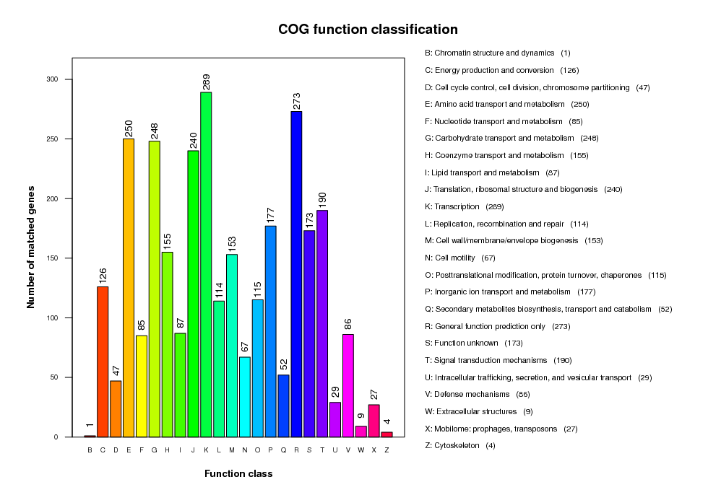
(A) COG functional annotation
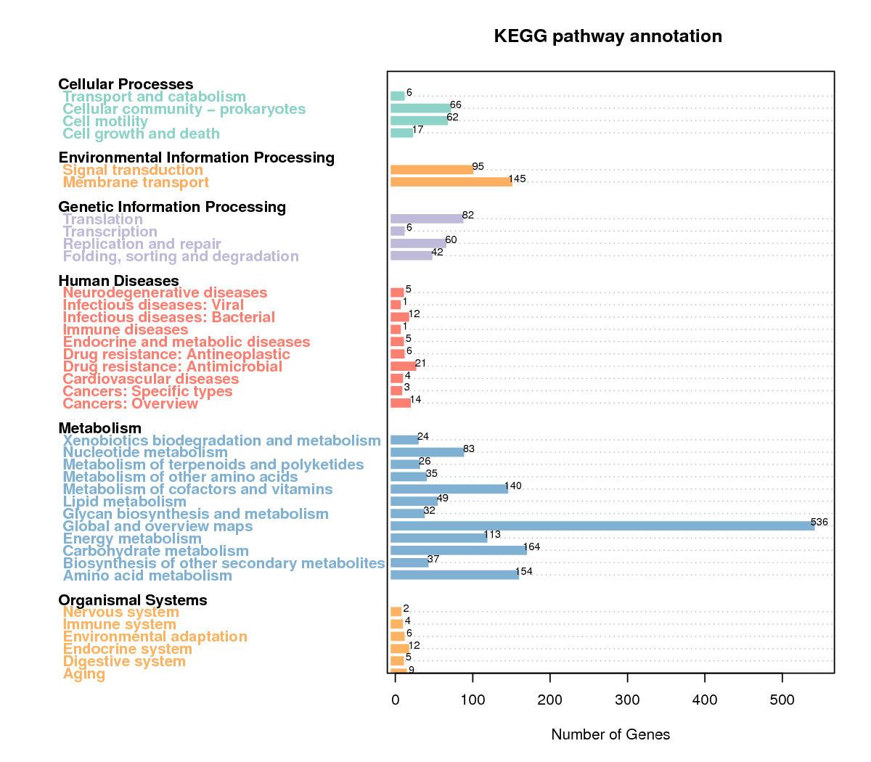
(B) KEGG functional annotation
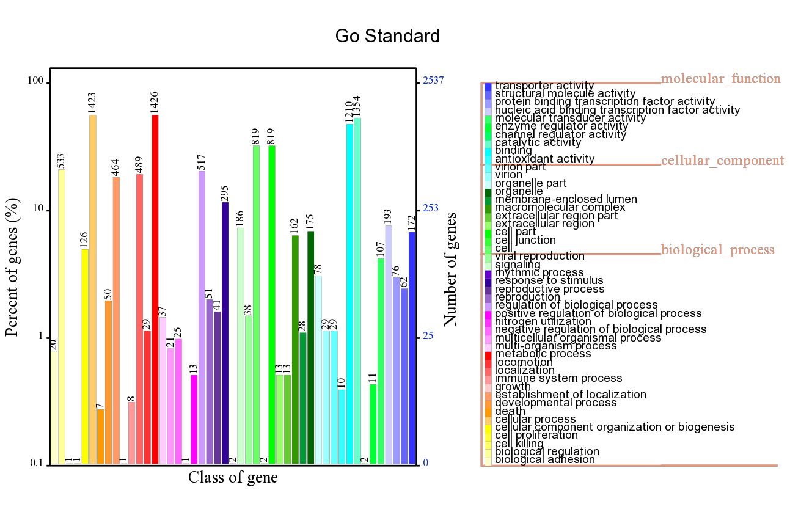
(C) GO functional annotation

