Supporting Information

Stability was essential for insecticidal activity of Vip3Aa toxin against Spodoptera exigua
Bai-Wen Fu ², Lian Xu ¹, Mei-Xia Zheng ¹, Qing-Xi Chen ², Yan Shi ²*, and Yu-Jing Zhu ¹*

¹ Agricultural Bio-Resources Research Institute, Fujian Academy of Agricultural Sciences, Fuzhou 350003, China.
² School of Life Sciences, Xiamen University, Xiamen 361005, China.
* Corresponding authors:
Tel/Fax: 0591-83723032. E-mail: zyjingfz@163.com (Yu-Jing Zhu)
Tel/Fax: 0592-2184648. E-mail: yshi@xmu.edu.cn (Yan Shi)

Table S1. Primer sequences used for the generation of Vip3Aa mutants.
primer | primer sequence (5’-3’)
P591A F | GTTAAAAgcaAAAACTGAGTATGTAATCCAA
P591A R | CAGTTTTtgcTTTTAACTTATCTCCAATAAA
P605A F | AGGAAAAgcaTCTATTCATTTAAAAGATGAA
P605A R | GAATAGAtgcTTTTCCTTTAACAGTATATTG
P779A F | TGGTGGTgcaATTGTACATTTTTACGATGTC
P779A R | GTACAATtgcACCACCATATAAATTATTCCC
The mutant and replacement nucleotide sequences were shown in lower case text.

Fig S1
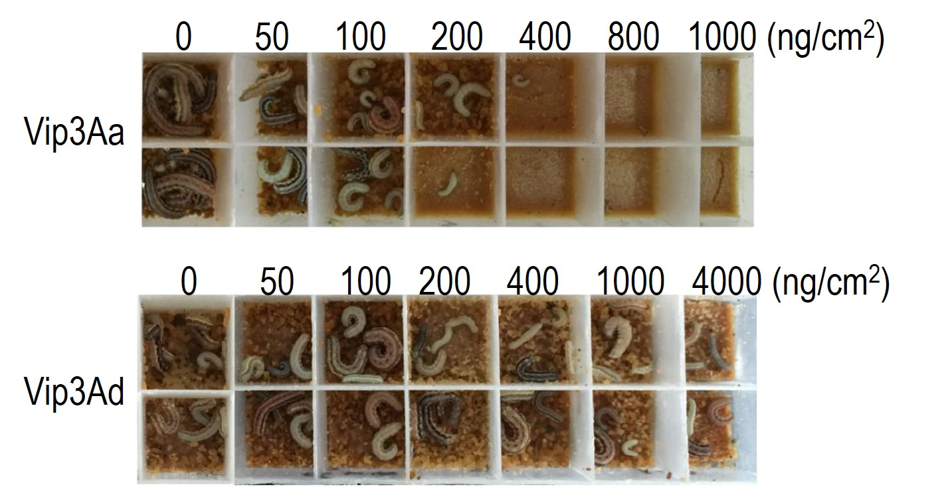

Fig S1. The insecticidal activities of Vip3Aa and Vip3Ad against first-instar larvae of S. exigua.

Fig S2
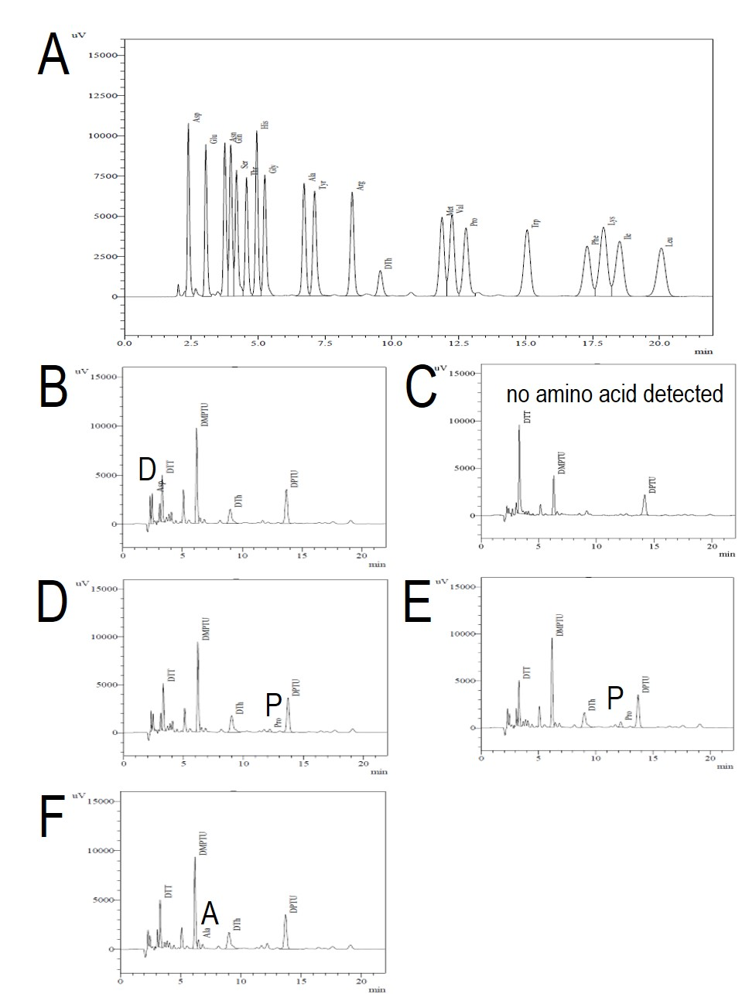
Fig S2. N-terminal sequencing identified cleavage-sites of Vip3Aa processed by Spodoptera exigua midgut juice. (A) Spectrum of 19 PTH-amino acids standards; (B)-(F) N-terminal amino acid identification of Vip3Aa activated-toxin.

Fig S3
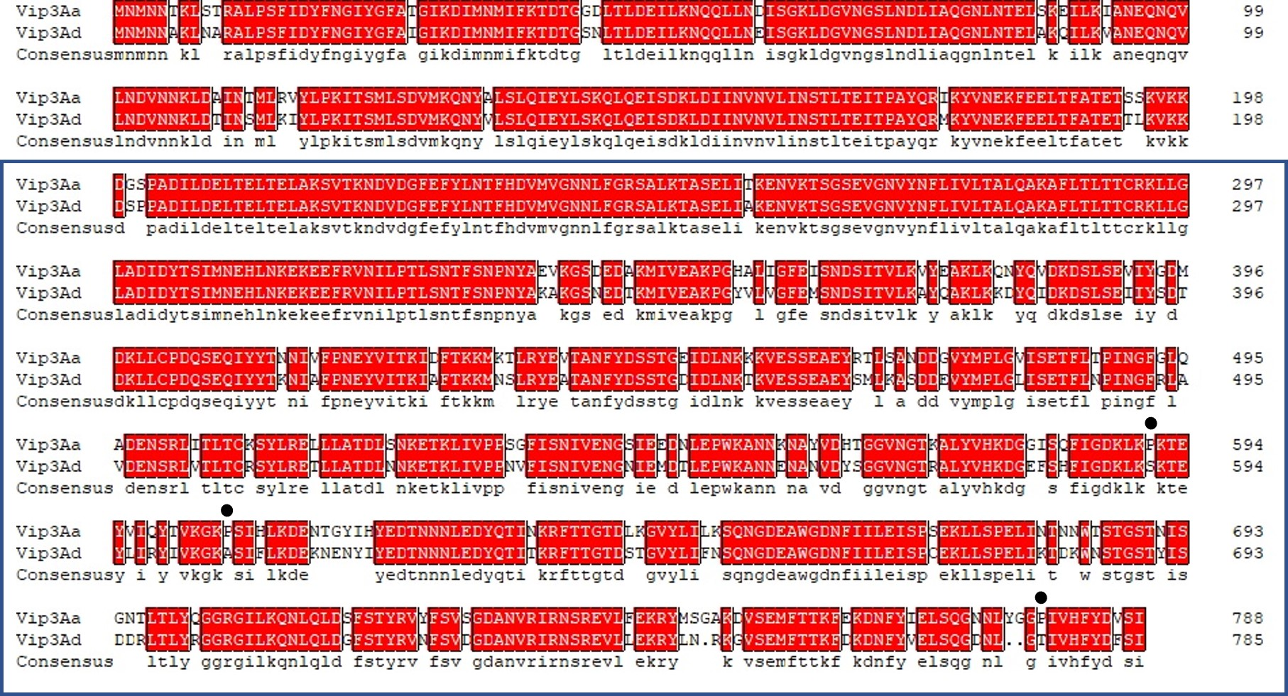
Fig S3. Amino acid sequence alignment of Vip3Aa and Vip3Ad. The sequences in blue box were Vip3Aa and Vip3Ad activated-toxins. The positions of three extra prolines (P591, P605 and P779) was indicated as (●).

