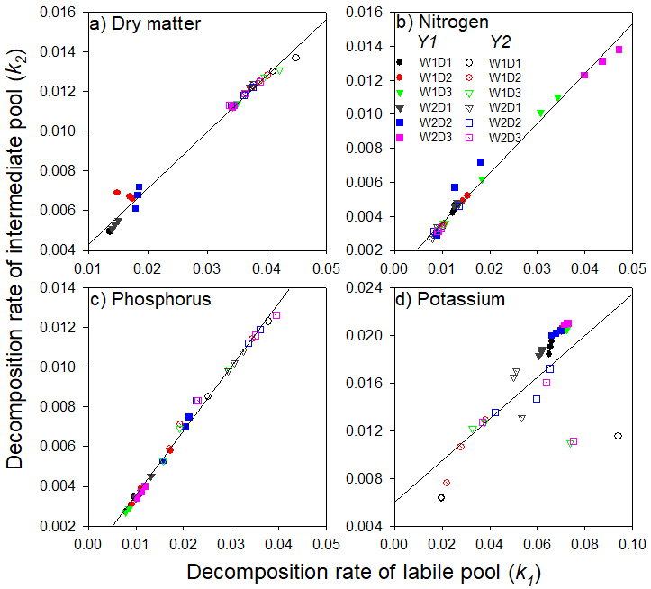
Fig. S1. The relationships between decomposition rate of intermediate pool (k₂) and labile pool (k₁) of dry matter (a), nitrogen (b), phosphorus (c), and potassium (d).

Table S1. Parameters of dry matter (DM) decomposition, nitrogen, phosphorus, and potassium release under three factors: (ⅰ) irrigation regimes (W1 and W2), (ⅱ) straw incorporation rates (S1, S2, and S3), and (ⅲ) experimental years (Y1 and Y2) using simulated equation.
Year | W | S | DM |  |  |  |  |  | N
Year | W | S | Y0 (%) | a (%) | k₁ | c (%) | k₂ | R² | Y0 (%) | a (%) | k₁ | c (%) | k₂ | R²
Y1 | W1 | S1 | 20.40 | 40.24 | 0.014 | 39.36 | 0.005 | 0.91 | 27.39 | 36.48 | 0.013 | 36.14 | 0.004 | 0.90
 |  | S2 | 25.07 | 37.57 | 0.016 | 37.36 | 0.007 | 0.96 | 39.87 | 29.84 | 0.013 | 30.29 | 0.005 | 0.76
 |  | S3 | 26.93 | 36.31 | 0.035 | 36.76 | 0.011 | 0.89 | 36.39 | 31.55 | 0.028 | 32.05 | 0.009 | 0.67
 | W2 | S1 | 22.66 | 39.54 | 0.015 | 37.80 | 0.005 | 0.91 | 28.84 | 35.98 | 0.013 | 35.17 | 0.005 | 0.89
 |  | S2 | 25.96 | 37.55 | 0.018 | 36.49 | 0.007 | 0.95 | 38.78 | 30.84 | 0.013 | 30.38 | 0.005 | 0.84
 |  | S3 | 27.08 | 36.24 | 0.034 | 36.68 | 0.011 | 0.93 | 36.85 | 31.38 | 0.044 | 31.77 | 0.013 | 0.63
Y2 | W1 | S1 | 34.80 | 32.38 | 0.041 | 32.82 | 0.013 | 0.92 | 51.86 | 24.26 | 0.010 | 23.89 | 0.003 | 0.75
 |  | S2 | 36.83 | 31.36 | 0.039 | 31.81 | 0.013 | 0.91 | 54.24 | 23.09 | 0.010 | 22.68 | 0.004 | 0.71
 |  | S3 | 38.88 | 30.34 | 0.040 | 30.77 | 0.013 | 0.95 | 55.10 | 22.70 | 0.010 | 22.20 | 0.003 | 0.81
 | W2 | S1 | 36.69 | 31.43 | 0.037 | 31.88 | 0.012 | 0.93 | 29.27 | 35.54 | 0.008 | 35.19 | 0.003 | 0.73
 |  | S2 | 36.21 | 31.68 | 0.036 | 32.11 | 0.012 | 0.89 | 50.14 | 25.14 | 0.010 | 24.72 | 0.004 | 0.76
 |  | S3 | 37.96 | 30.80 | 0.036 | 31.24 | 0.012 | 0.93 | 50.68 | 24.85 | 0.009 | 24.47 | 0.003 | 0.76
Continued of Table S1.
Year | W | S | P |  |  |  |  |  | K
Year | W | S | Y0 (%) | a (%) | k₁ | c (%) | k₂ | R² | Y0 (%) | a (%) | k₁ | c (%) | k₂ | R²
Y1 | W1 | S1 | 16.61 | 42.05 | 0.009 | 41.34 | 0.003 | 0.77 | 1.98 | 49.27 | 0.065 | 48.75 | 0.019 | 0.98
 |  | S2 | 25.62 | 37.11 | 0.013 | 37.26 | 0.004 | 0.61 | 2.51 | 48.99 | 0.071 | 48.50 | 0.021 | 0.97
 |  | S3 | 24.55 | 37.85 | 0.008 | 37.61 | 0.003 | 0.53 | 2.19 | 49.16 | 0.072 | 48.65 | 0.021 | 0.97
 | W2 | S1 | 19.12 | 40.71 | 0.011 | 40.17 | 0.004 | 0.79 | 2.38 | 49.04 | 0.061 | 48.58 | 0.019 | 0.99
 |  | S2 | 25.89 | 36.77 | 0.019 | 37.34 | 0.007 | 0.77 | 2.59 | 48.94 | 0.068 | 48.47 | 0.020 | 0.97
 |  | S3 | 25.57 | 37.39 | 0.011 | 37.05 | 0.004 | 0.72 | 2.86 | 48.82 | 0.072 | 48.32 | 0.021 | 0.97
Y2 | W1 | S1 | 19.36 | 40.09 | 0.033 | 40.55 | 0.011 | 0.89 | 9.44 | 45.08 | 0.044 | 45.48 | 0.008 | 0.93
 |  | S2 | 20.58 | 39.79 | 0.024 | 39.63 | 0.008 | 0.91 | 9.52 | 45.26 | 0.029 | 45.22 | 0.010 | 0.98
 |  | S3 | 23.03 | 38.53 | 0.021 | 38.45 | 0.007 | 0.93 | 9.81 | 44.21 | 0.048 | 45.98 | 0.012 | 0.99
 | W2 | S1 | 18.85 | 40.34 | 0.031 | 40.81 | 0.010 | 0.87 | 16.44 | 41.79 | 0.052 | 41.77 | 0.016 | 0.95
 |  | S2 | 19.05 | 40.18 | 0.031 | 40.77 | 0.010 | 0.90 | 9.80 | 45.11 | 0.056 | 45.09 | 0.015 | 0.98
 |  | S3 | 24.26 | 37.62 | 0.033 | 38.12 | 0.011 | 0.90 | 9.81 | 44.45 | 0.059 | 45.74 | 0.013 | 0.98
Data were derived from fitted equation: Y = Y0 + ae^{-k1t} + ce^{-k2t}, where Y0 + a + c = 100, Y is the residual wight after straw returned time t (d), Y0, a and c are the resistant, labile and intermediate fraction of dry matter or nutrient, respectively. k₁ is the decomposition rate of a and k₂ is decomposition rate of c.

