Supplementary Information
Microbacterium caeni sp. nov., a novel species isolated from sludge in Yeosu, Korea
Antonie van Leeuwenhoek

You-Jung Jung¹, Sang-Hoon Lee², Na-Kyung Kim³, Hyeokjun Yoon¹, Garam Jeong¹, Byoung-Hee Lee¹, Hee-Deung Park², Moonsuk Hur^{1*}

* Corresponding author: heomsk@korea.kr

¹Biological Resources Research Department, National Institute of Biological Resources, Incheon 22689, Republic of Korea; ²Research Institute of Engineering and Technology, Korea University, Seoul 02841, Republic of Korea; ³School of Civil, Environmental and Architectural Engineering, Korea University, Seoul 02841, Republic of Korea
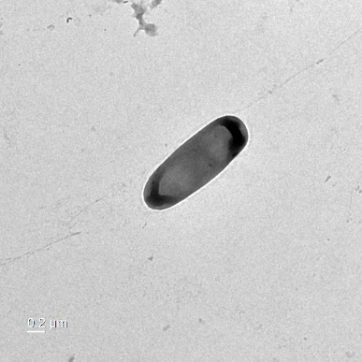

Fig. S1 Transmission electron micrograph of Microbacterium sp. strain NIBRBAC000506063^{T}. Bar, 0.2 µm.

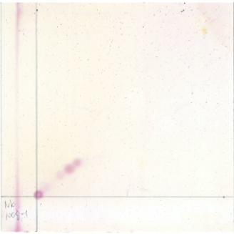
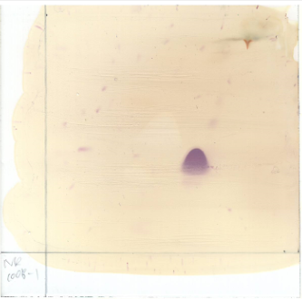
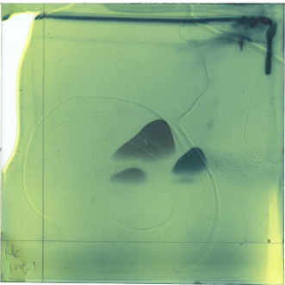
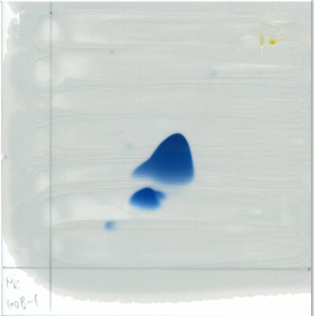
DPG
GL1
PG
L1
APL1
APL1
APL1
GL1
DPG
PG
2
1
Total lipids
Phospholipids
Aminolipids
Glycolipids
Fig. S2 Two-dimensional thin-layer chromatogram (TLC) of total polar lipids of strain NIBRBAC000506063^{T}. 1, first dimension of TLC; 2, second dimension of TLC. DPG, diphosphatidylglycerol; PG, phosphatidylglycerol; GL, glycolipid; APL, aminophospholipid; L, unidentified lipid.

Table S1 Comparison of the contig of Microbacterium sp. strain NIBRBAC000506063^{T} with the NCBI genome database.
Original/User's Label | Status | Project Accession | No. of contigs | Genome size (bp) | DNA G+C content (%) | No. of CDSs | No. of rRNA | No. of tRNA | Mean of CDS lengths (bp) | Median of CDS lengths (bp)
Microbacterium mitrae  strain M4-8 | SCAFFOLD | GCA_008017445.1 | 10 | 2,821,547 | 63.7 | 2485 | 5 | 49 | 987.6 | 686.5

Table S2 Clusters of orthologous group (COG) annotations of the Microbacterium sp. strain NIBRBAC000506063^{T} genome
COG | Description | Count (Gene) | Ratio (%)
C | Energy production and conversion | 211 | 5.56
D | Cell cycle control, cell division, chromosome partitioning | 60 | 1.58
E | Amino acid transport and metabolism | 365 | 9.62
F | Nucleotide transport and metabolism | 87 | 2.29
G | Carbohydrate transport and metabolism | 318 | 8.38
H | Coenzyme transport and metabolism | 172 | 4.53
I | Lipid transport and metabolism | 233 | 6.14
J | Translation, ribosomal structure and biogenesis | 230 | 6.06
K | Transcription | 269 | 7.09
L | Replication, recombination and repair | 164 | 4.32
M | Cell wall/membrane/envelope biogenesis | 169 | 4.45
O | Posttranslational modification, protein turnover, chaperones | 139 | 3.66
P | Inorganic ion transport and metabolism | 234 | 6.17
Q | Secondary metabolites biosynthesis, transport and catabolism | 113 | 2.98
R | General function prediction only | 414 | 10.91
S | Function unknown | 213 | 5.61
T | Signal transduction mechanisms | 165 | 4.35
U | Intracellular trafficking, secretion, and vesicular transport | 50 | 1.32
V | Defense mechanisms | 123 | 3.24
X | Mobilome: prophages, transposons | 66 | 1.74
Total |  | 3795 | 100

