Supplementary materials

1. Genotyping for identifying PPT1 KI and WT
The male and female PPT1 knock-in offspring with WT/c.451C>T mutation were used to make as breeders to generate enough reservoir of PPT1 KI mice in current study. These breeders carried out yielding WT, WT/c.451C>T, and c.451C>T/c.451C>T (PPT1 KI) mice. The genotypes of PPT1 KI and its wild-type littermate were identified by PCR. Figure S1 demonstrates the representative genotyping data of PPT1 KI and WT mice.
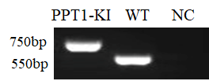
Figure S1 Representative blot of PPT1 KI mice genotyping. PPT1-KI, PPT1 c.451C>T/c.451C>T mouse; WT, wild type littermate; NC, negative control.

2. Behavioral study
(1) Clasping behavior in PPT1 KI mice
Hind-limb clasping during tail suspension has been used as an indicator of neurological dysfunction in various animal models of neurological disease (Lalonde and Strazielle, 2011). In the test, mouse was suspended by the base of the tail and videotaped for 10–15 seconds. Three separate trials were performed for consecutive 3 days and the a representative picture was shown in the SF2. The clasping behavior was not manifested in WT mice, but can be easily seen in their Ppt1-KI littermates over 6 month-old.
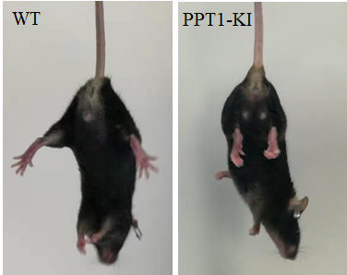
Figure S2 Representative pictures of clasping behavior in PPT1 KI mouse comparing to the wild type mouse. WT, wild type litter-mate; PPT1 KI, PPT1 knock-in c.451C>T/c.451C>T mouse.

(2) Video-recording in seizure activity in PPT1 KI and WT litter-mate
PPT1 KI mice aged from 5–7 months old and 7 months old WT mice were put into the observation cage with water and food at room temperature (25 ± 2 °C). Mice were video-taped by the Plexon CinePLex Studio Application Version 3.7 (Plexon, USA) for 24 h in 12 h/12 h day/night cycle (lights on at 8 a.m.). The video was edited by Adobe illustrator CS6.
Video clips for seizure-recordings of PPT1 KI mice were uploaded in my google drive which can be shared you at the link: https://drive.google.com/drive/my-drive.

3. Age-related changes in the expression of GFAP and GluN2B in PPT1 KI mice
Figure S3 Representative western blots (top) and the bar graph (bottom) show that expressions of GFAP and GluN2B in hippocampus in PPT1 KI mice from 1 to 7 months old. A: GFAP, (1 month old vs. 4 months old, p=0.01, n=21); B: GluN2B, (1month old vs. 7 months old, p<0.01, n=35)

