Supporting Information

Filterless narrowband near-infrared Si photodetector
Zhuhua Xu^{1,2#}, Chuying Sun^{3#}, Miao He^{1,2}, Siyi Min³, Cong Zhao^{1,2}, Zhenghao Liu⁵, Jingzhou Li⁴, Wen-Di Li^{3,*} Man-Chung Tang², H.Y. Fu^{1,*}, Feiyu Kang^{1,2}, Jiangyu Li⁵, Yang Shen⁶, and Guodan Wei^{1,2,*}
¹Tsinghua-Berkeley Shenzhen Institute (TBSI), Tsinghua University Shenzhen 518055, China
²Tsinghua Shenzhen International Graduate School (SIGS), Tsinghua University Shenzhen 518055, China
³Department of Mechanical Engineering, University of Hong Kong, Hong Kong 999077, China
⁴Hangzhou Institute for Advanced Study, University of Chinese Academy of Sciences Hangzhou 310024, China
⁵Department of Materials Science and Engineering, Southern University of Science and Technology, Shenzhen 518055, China
⁶State Key Lab of New Ceramics and Fine Processing, Schoolof Materials Science and Engineering, Tsinghua University,Beijing 100084, Chin

# These two authors have contributed equally to this work.
Corresponding authors: Guodan Wei: weiguodan@sz.tsinghua.edu.cn
Wen-Di Li: liwd@hku.hk
H.Y. Fu: hyfu@sz.tsinghua.edu.cn
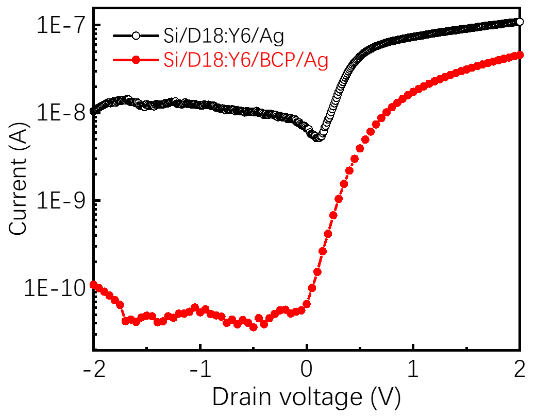
Fig. S1 The dark I-V curves of Ag/Si/D18:Y6/Ag and Ag/Si/D18:Y6/BCP/Ag devices.
The etching process of Si nanograting: The silicon templates with uniform nano-gratings were fabricated through home-made interference lithography followed by inductively coupled plasma (ICP) etching, chrome (Cr) evaporation and lift-off process. Firstly, the silicon substrate was spin-coated with a 200 nm thick antireflection coating (ARC, AZ Barli II, Micro Chemicals) and baked at 200 °C for 1 min. A layer of 200nm thick positive photoresist (AZ MiR 701, Micro Chemicals) film were then spin-coated for interference lithography. After patterning the photoresist, the oxygen reactive ion etching (RIE) was used to etch the ARC layer and the photoresist pattern was then converted into Cr mask by depositing 30 nm-thick chrome using electron-beam evaporation. Then lift-off was performed with ultrasonic agitation in RCA-1 solution (NH₃·H₂O:H₂O₂:H₂O = 1:1:5) at 75 °C for 3 min. The Cr mask pattern was transferred into silicon with a 430 nm structure depth by CHF3/SF6 plasma in the ICP system with 68/10 sccm flow rates, a 5 mTorr pressure, a 150 W source power, and a 50 W bias power. Finally, after the removal of Cr mask, the fabrication of nano-structured silicon molds was completed. The illustration is shown in Fig. S2. The silicon (p-type; electrical resistivity 7-9 Ω·cm; crystal orientation <100>) is purchased from Suzhou Jingsi Electronic Research Co., LTD. The size of nanograting is designed as period of 600 nm, width of intracavity and cavity wall of 330 nm and 270 nm and depth of 370 nm.
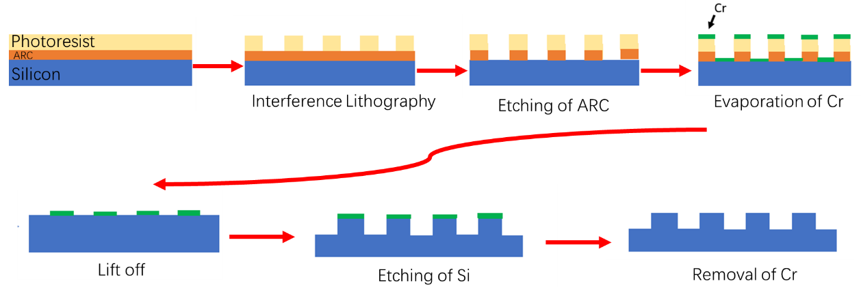
Fig. S2 The process of Si nanograting fabrication by etching.
Device fabrication: The D18 and Y6 as the mass ratio of 1:1.6 are dissolved in chloroform as 11 mg/ml. The mixed solution needs to be stirred and dissolved for 8 hours. The D18:Y6 film was spin-coated on the Si substrate with nanograting as 3000 rmp for 30 s. To get the different thickness of D18:Y6 film, the different concentration is used, and 5.5, 11, 22 mg/ml for 53, 123, 265 nm, respectively. the BCP is dissolved in isopropanol as 0.5 mg/ml and spin-coated on D18:Y6 film as 2000 rmp for 30 s. Finally, Ag electrodes were deposited by thermal evaporation of 300-nm-thick under 5×10⁻⁴ Pa with deposition rate of 2 Å s ⁻¹.
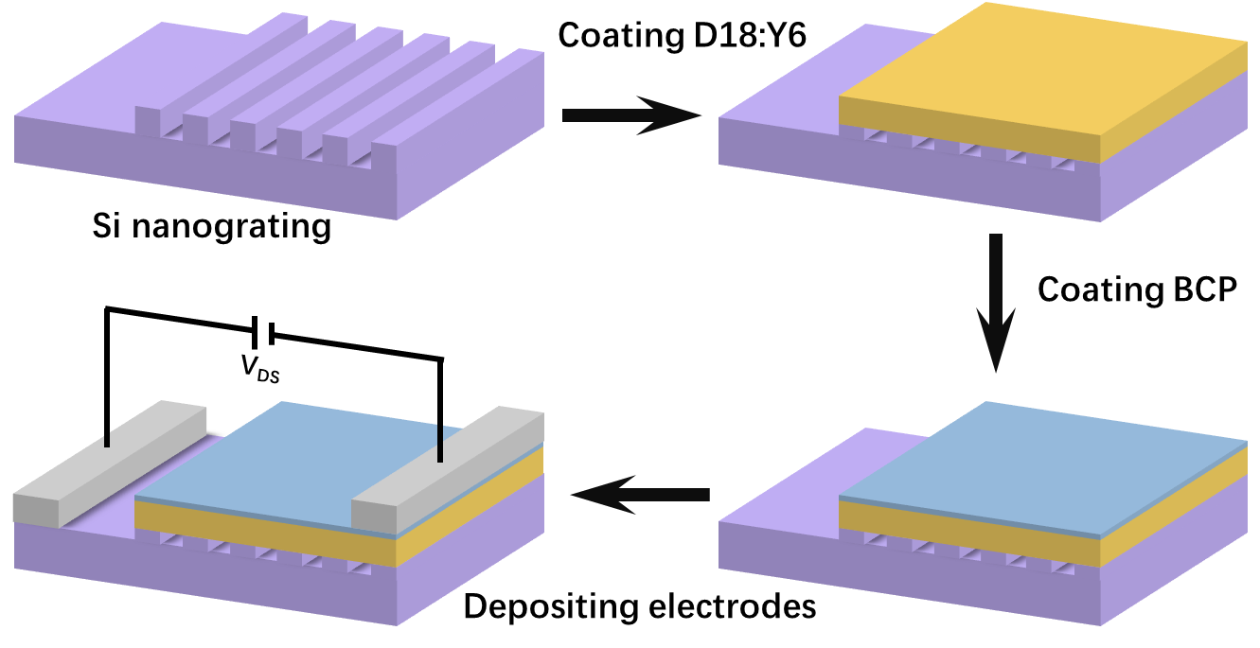
Fig. S3 The process of device fabrication.
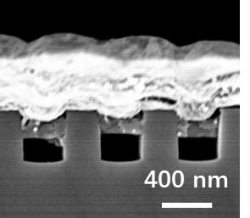
Fig. S4 The cross-section SEM image of Si nanograting with D18:Y6 film.
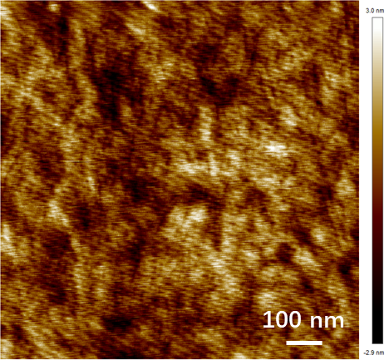
Fig. S5 The AFM mapping of D18:Y6 film spin-coated on Si substrate
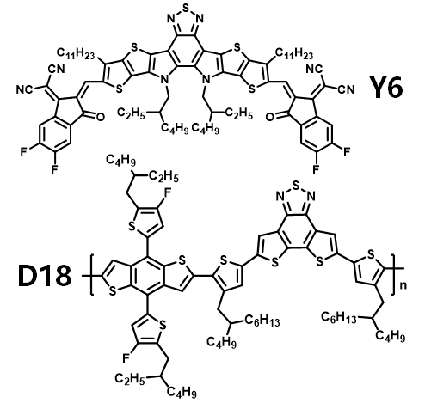
Fig. S6 The molecular structures of D18 and Y6.
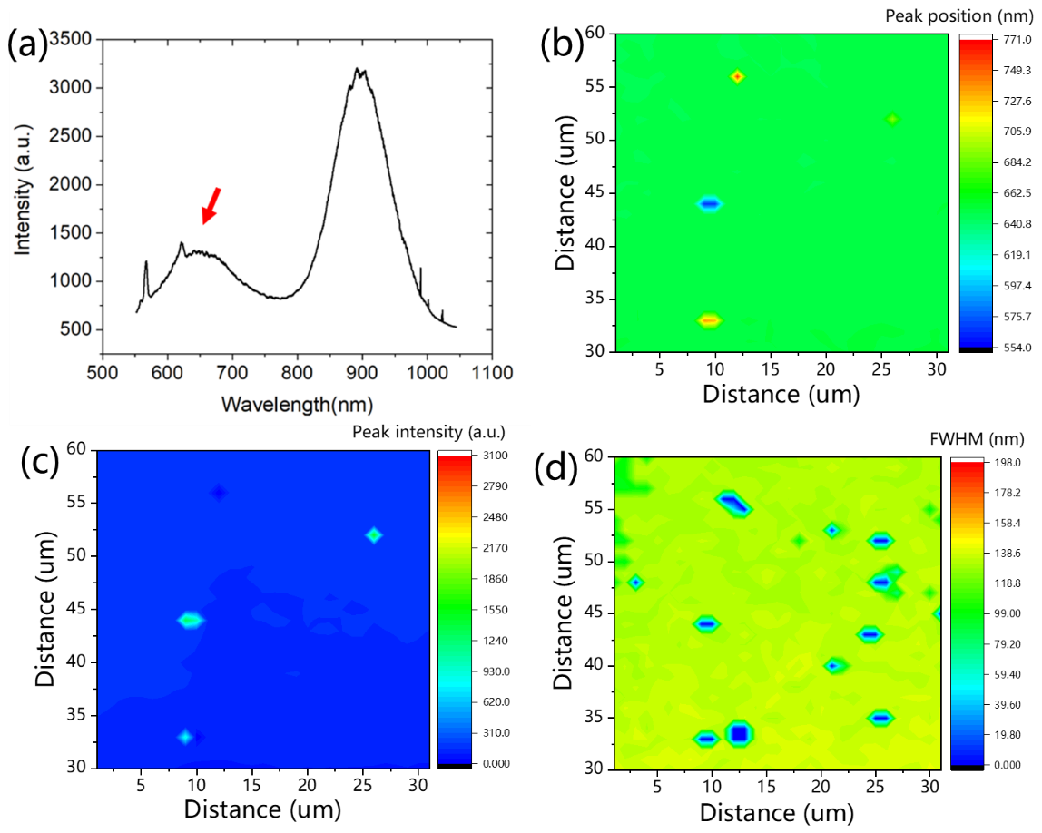
Fig. S7 The PL of D18, Y6 and D18:Y6 mixture with the quenching peak of 648 nm marked with red arrow. (b), (c) and (d) The corresponding peak position, intensity and FWHM mapping, respectively.
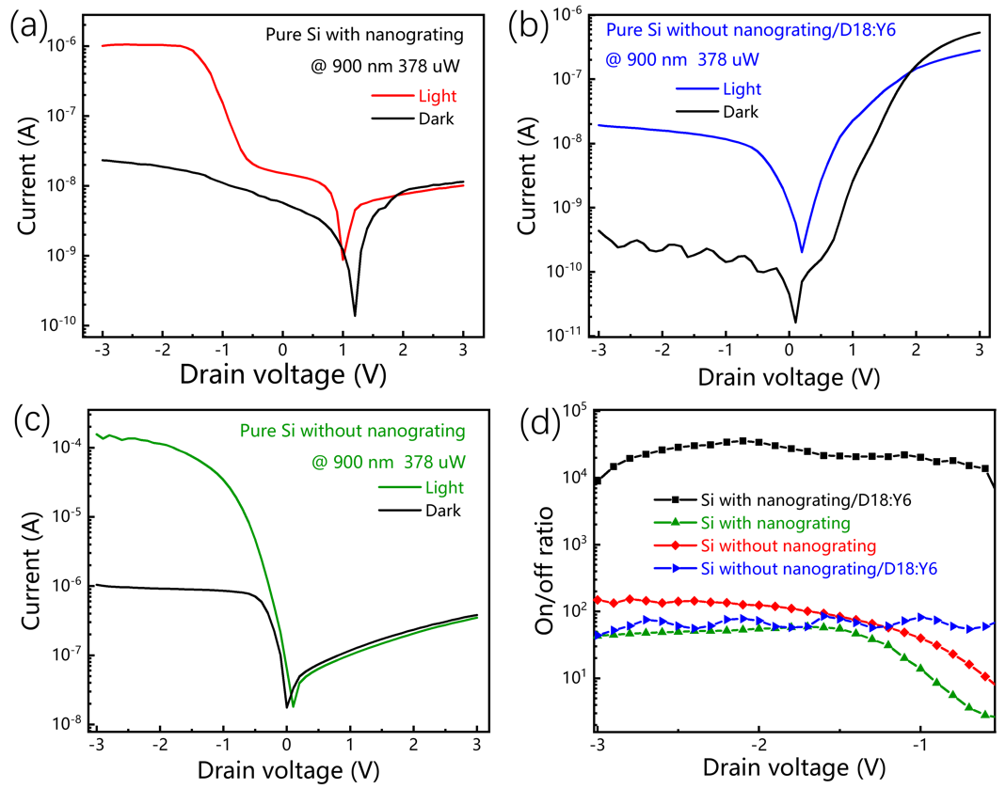
Fig. S8 (a), (b) and (c) The I-V curves corresponding to device of Ag/Si-nanograting/Ag, Ag/Si/D18:Y6/BCP/Ag and Ag/Si/Ag under the same condition, respectively. (d) The corresponding on/off ratio.
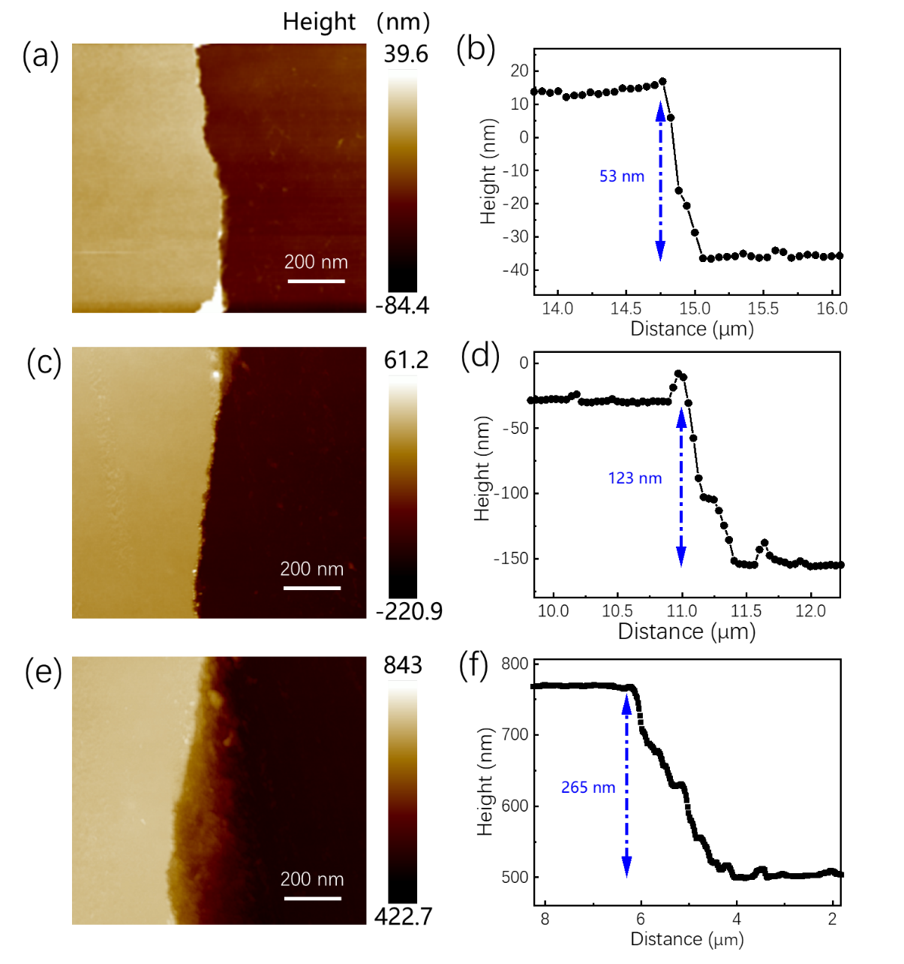
Fig. S9 The AFM and thickness dependence on distance corresponding to different D18:Y6 film. The curve of (b) was taken from (a), the curve of (d) was taken from (c) and the curve of (f) was taken from (e).
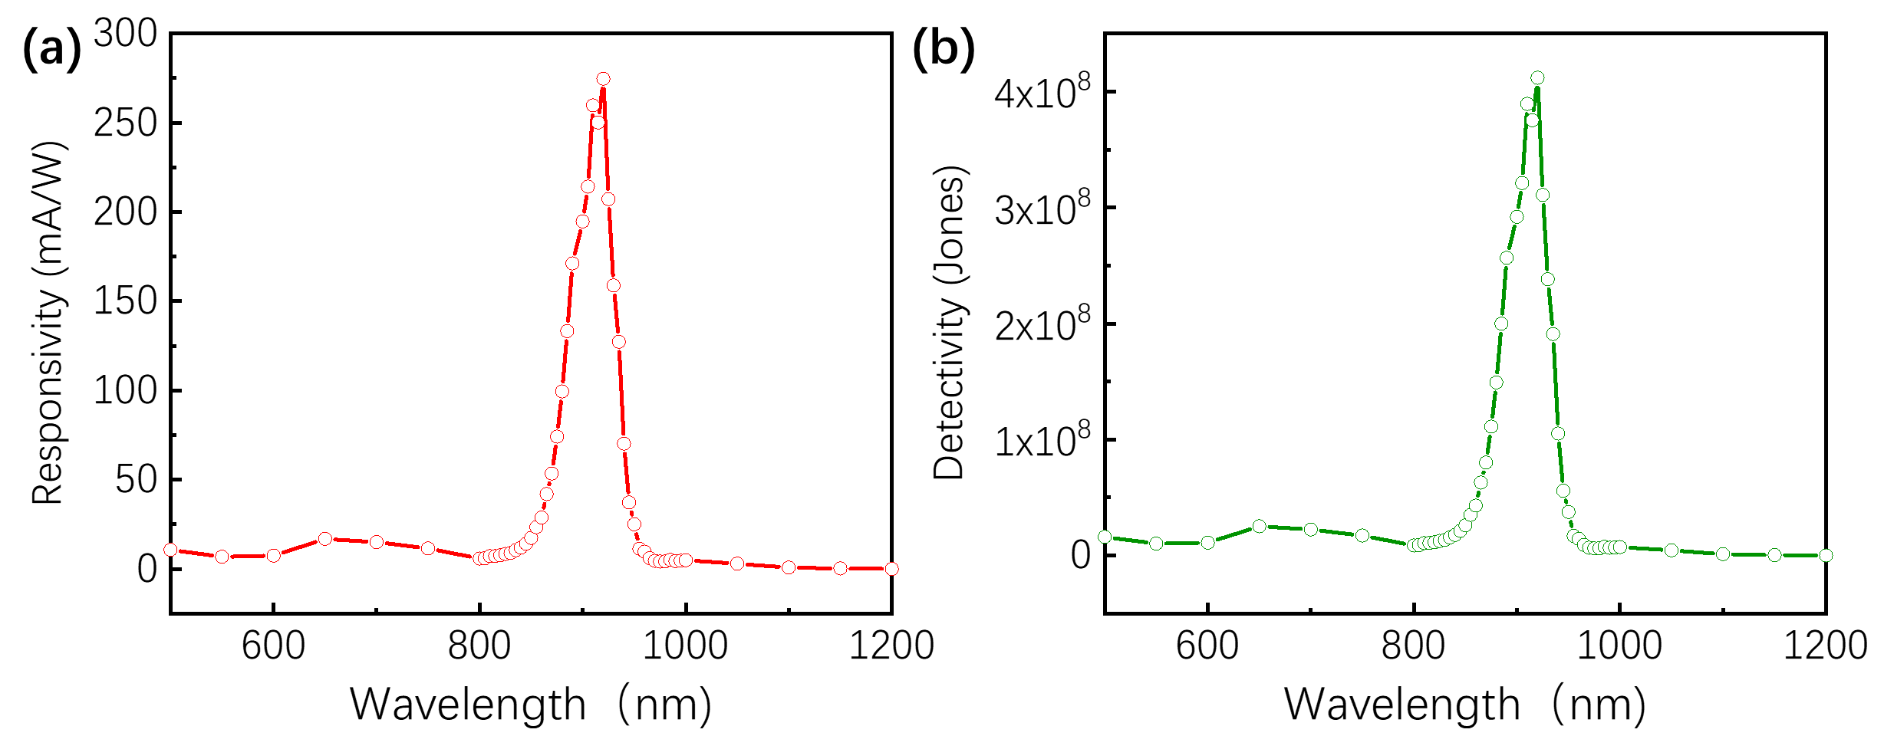
Fig. S10 (a) and (b) The responsivity and detectivity dependence on wavelength corresponding to Ag/Si-nanograting/D18:Y6/BCP/Ag device for the thickness of 123 nm, respectively.
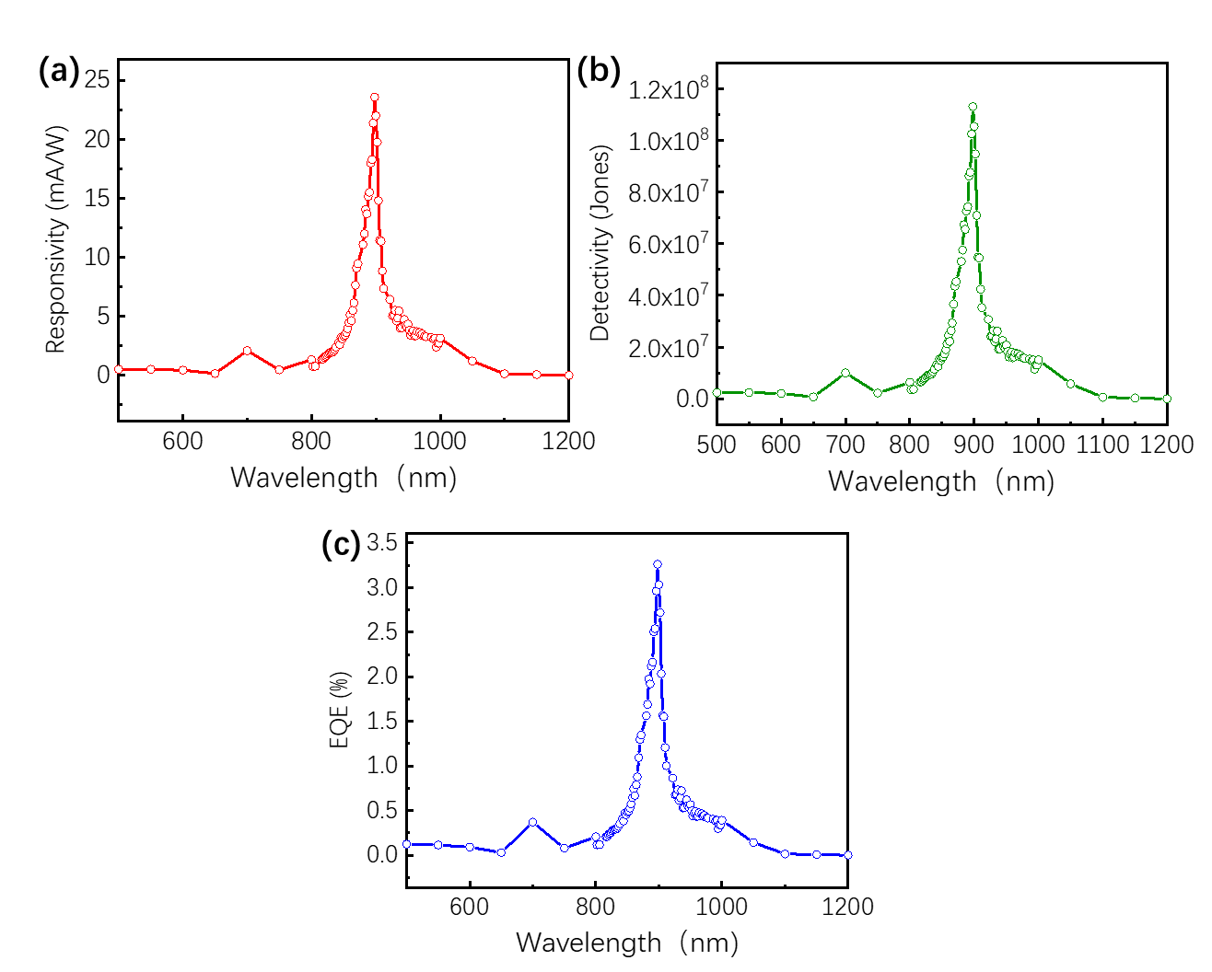
Fig. S11 (a), (b) and (c) The responsivity, detectivity and EQE dependence on wavelength corresponding to Ag/Si-nanograting/D18:Y6/BCP/Ag device for the thickness of 265 nm, respectively.

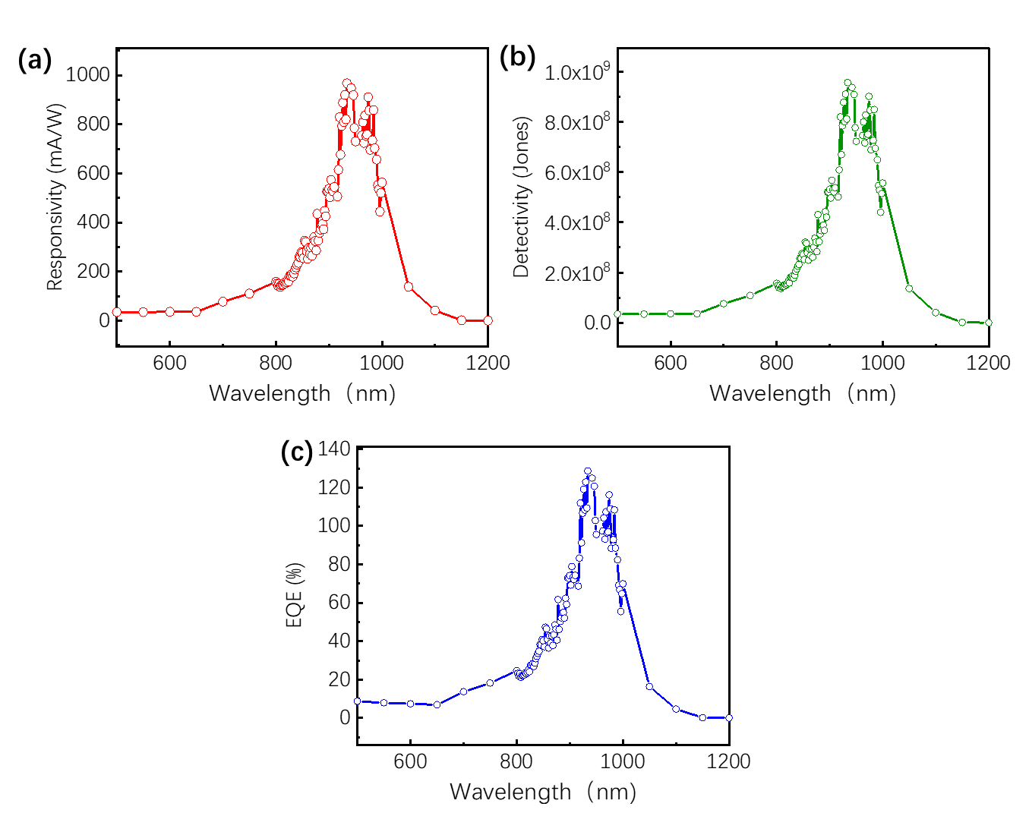
Fig. S12 (a), (b) and (c) The responsivity, detectivity and EQE dependence on wavelength corresponding to Ag/Si-nanograting/D18:Y6/BCP/Ag device for the thickness of 53 nm, respectively.

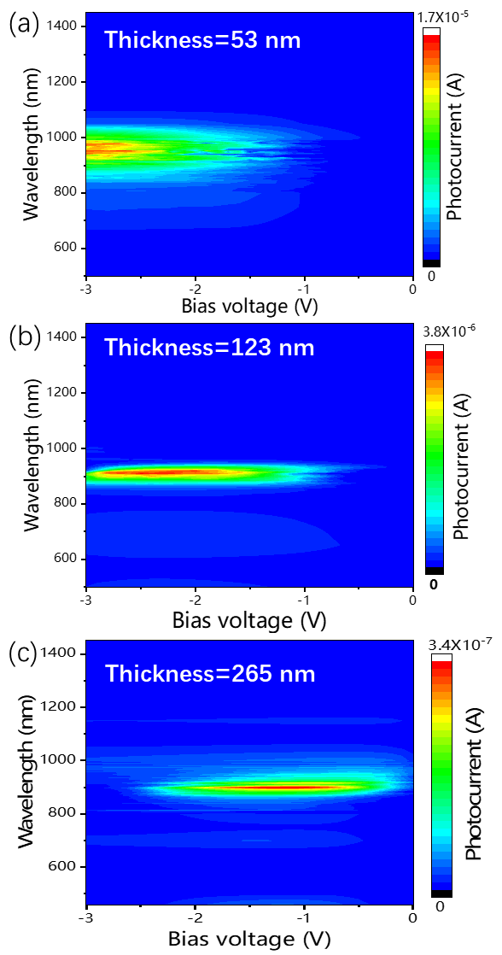
Fig. 13 (a), (b) and (c) The photocurrent mapping under different wavelength and bias voltage corresponding to the different thickness of 53 nm, 123 nm and 265 nm for D18:Y6 film.
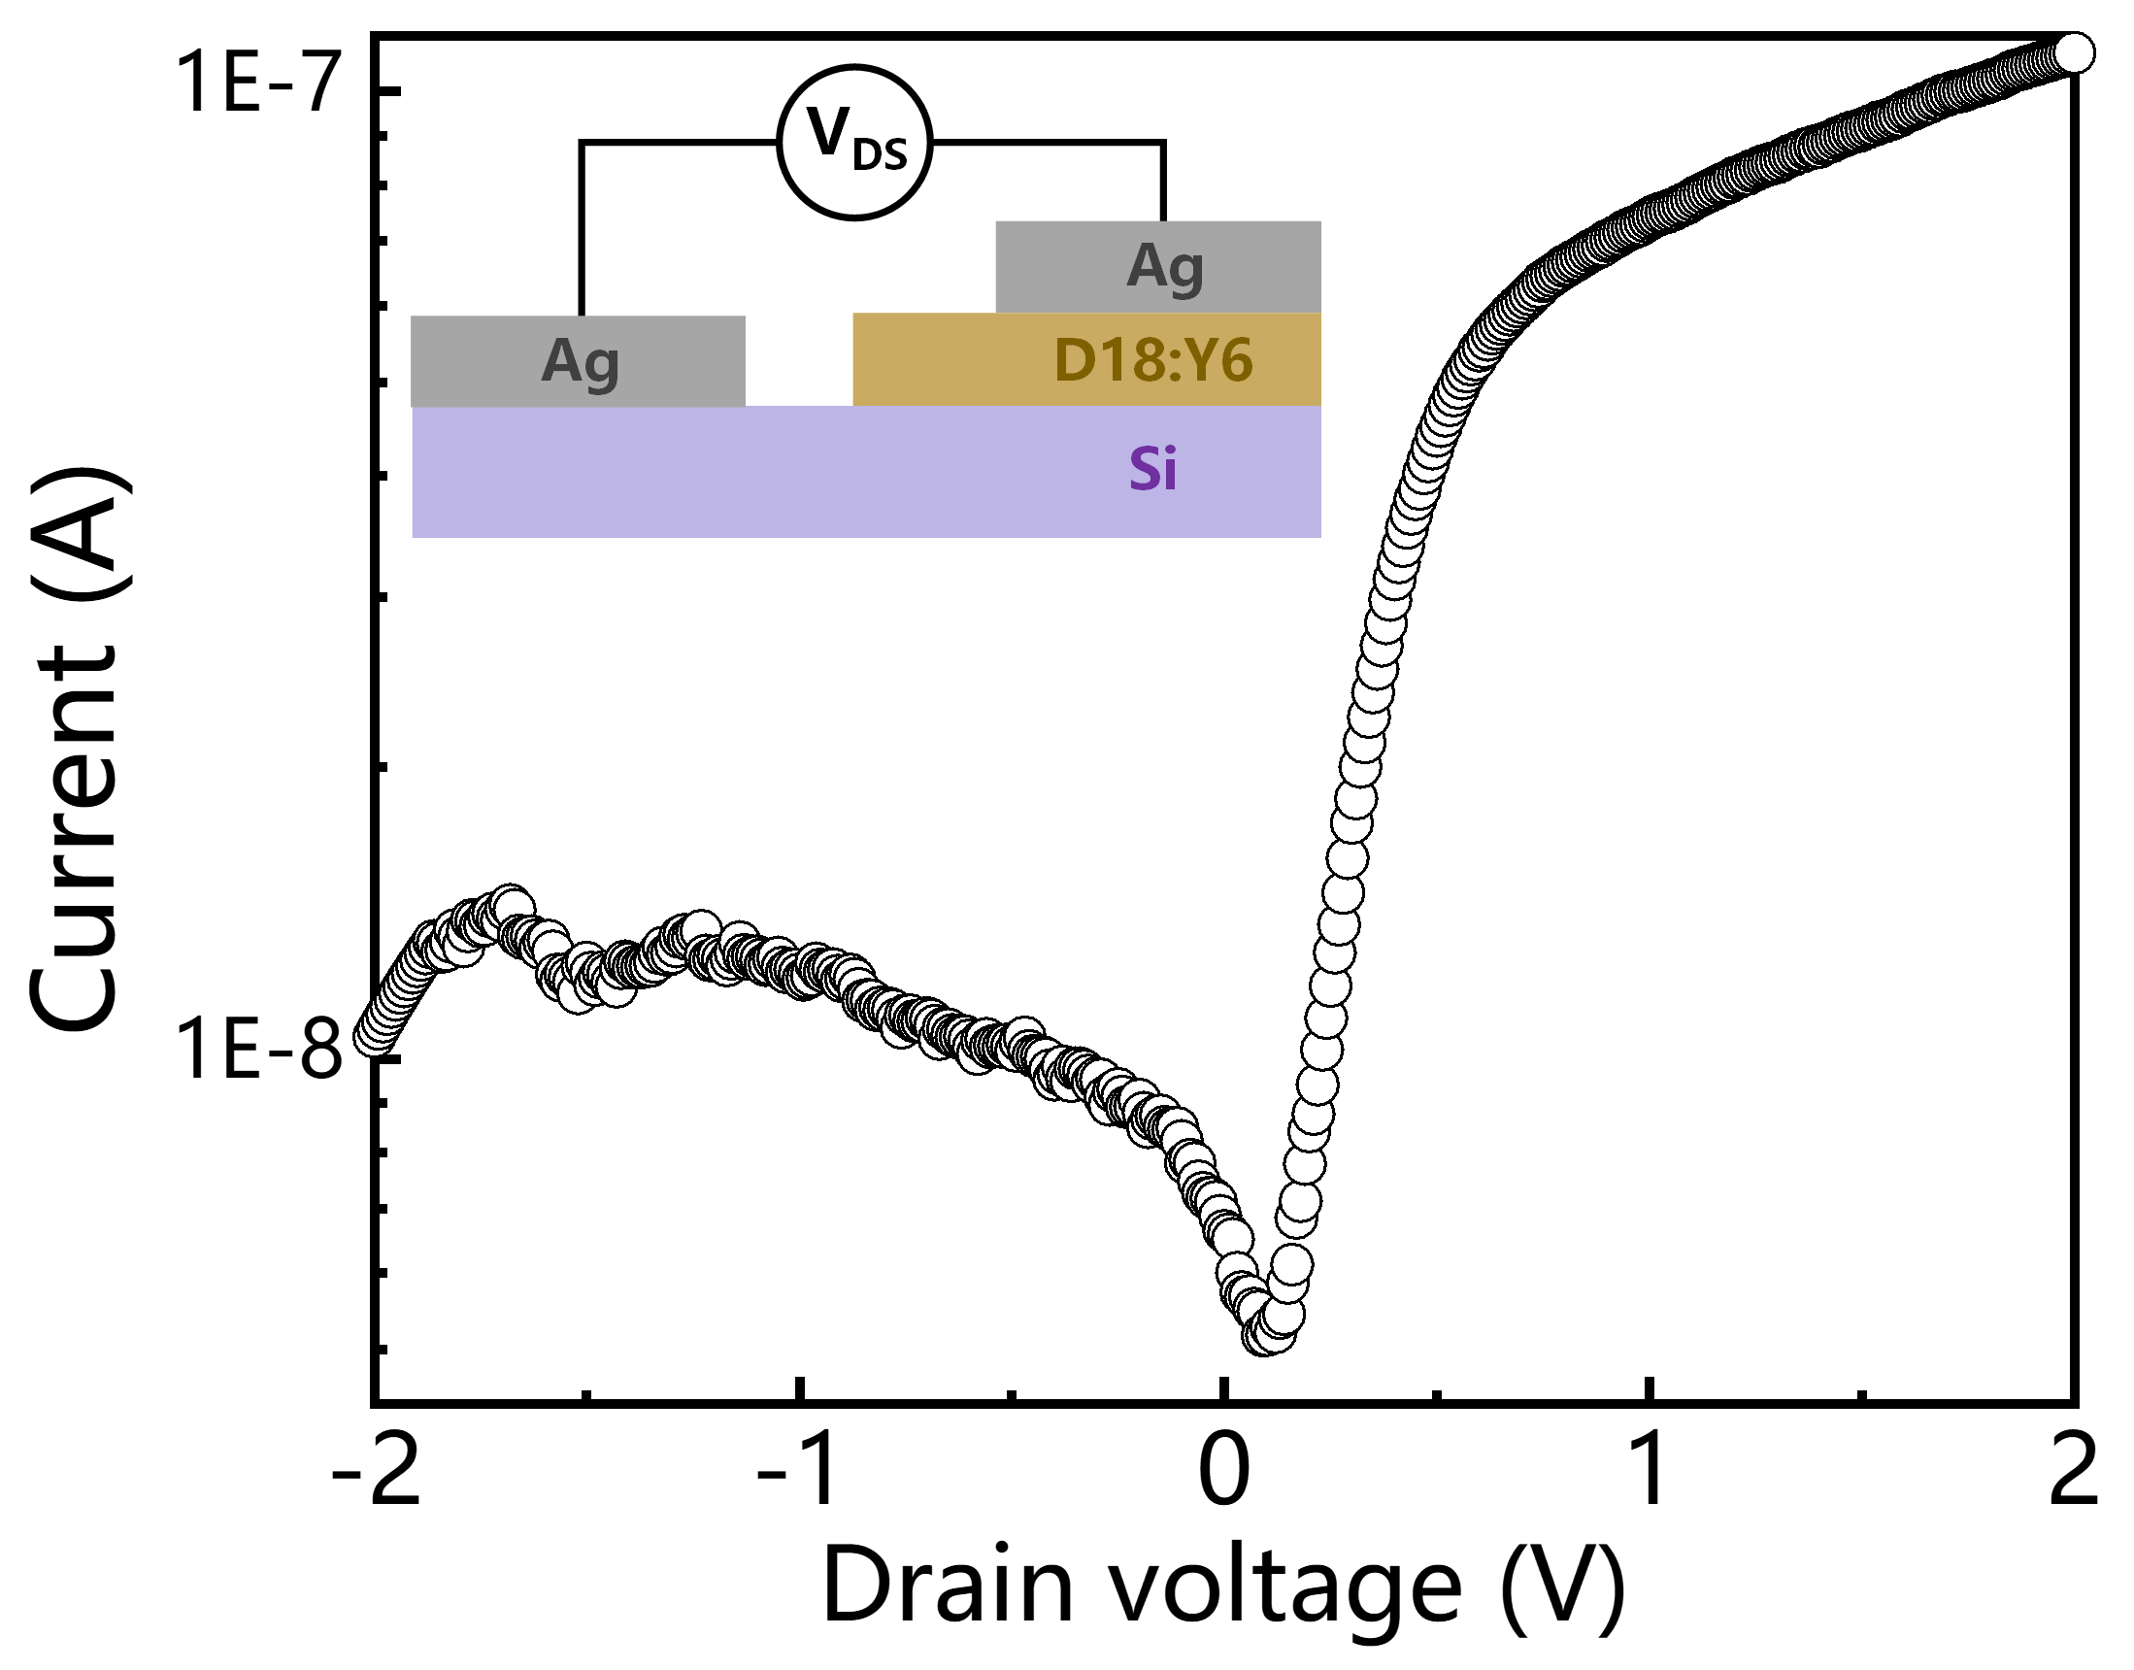
Fig. S14 The I-V curve pure Si/D18:Y6 junction. Insert: Corresponding device structure.
The calculation of responsivity, detectivity and EQE:
The responsivity (R), detectivity (D*) and the external quantum efficiency (EQE) are performance key indicators of PD and calculated according to
$R=\frac{I_{light}-I_{dark}}{PA}$ (1)
$D^{*}=\frac{R}{\sqrt{\frac{2eI_{dark}}{A}}}$ (2)
$EQE=\frac{Rhc}{eλ}$ (3)
where I_{light} and I_{dark} were light and dark currents, respectively. P and A represented the power density of excitation light and channel effective area of PD, respectively. The e is the electronic charge. h represents Planck constant; c represents the speed of light and 𝜆 represents the excitation light wavelength.
Conversion process of surface potential difference (SPD) and Fermi energy level:
The potential difference between the AFM tip and sample surface can be calculated as follows:
eV_{spd-intracavity}= W_{tip} – W_{intracavity}
eV_{spd-cavity wall}= W_{tip}-W_{cavity wall}
where e, W_{cavity wall}, W_{intracavity} and W_{tip} represent electron charge, work functions of cavity wall region (contact with D18:Y6 film), cavity region (not contact D18:Y6 film), and AFM tip, respectively. So, the Fermi level difference (ΔE_{f}) between cavity wall and cavity region can be calculated by
ΔE_{f} = W_{intracavity}-W_{cavity wall}= eV_{spd-intracavity} – eV_{spd-cavity wall}.
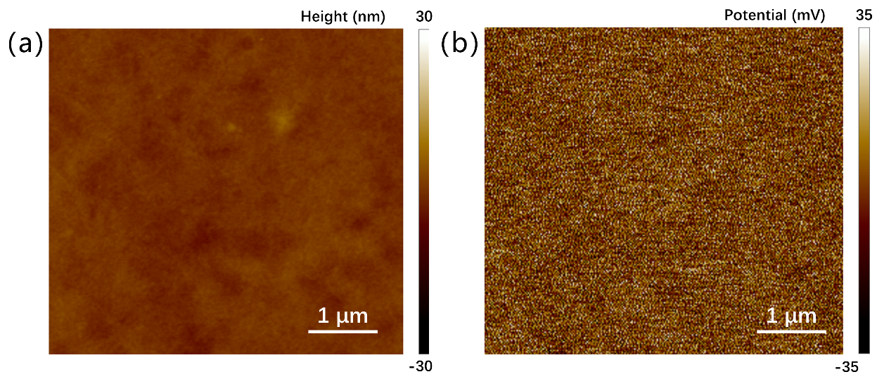
Fig. S15 The AFM and corresponding KPFM mapping for the Si/D18:Y6 film

