Fully automatic landmarking of 2D photographs identifies novel genetic loci influencing facial features
Table of contents
Supplementary note 1: Regional association plots for genomic regions replicated in this study. 2
Supplementary note 2: Regional association plots for novel regions detected in this study which reached genome-wide significance and replicated in either Chinese or European cohort, besides the 5 highlighted ones in the main text. 7
Supplementary note 3: Regional association plots for novel regions detected in this study whose replication P-values are insignificant in both Chinese and European cohorts. 19
Supplementary figures 22
Supplementary figure S1: Full Face++ landmarking protocol. 22
Supplementary figure S2: Correspondence of the landmarking protocols of manual (left) and Face++ (right). 23
Supplementary figure S3: Histograms for 5 inter-landmark distances that are most significantly associated with 5 the novel genomic regions in Table 2. 24
Supplementary figure S4: Covariates correlations and heritability. 25
Supplementary figure S5: Comparison of gene expression in the cranial neural crest cells (CNCCs). 26
Supplementary figure S6: Screenshot of UCSC Genome Browser for Human showing the craniofacial enhancers on certain genomic regions. 27
Supplementary Tables 29
Supplementary Table S1. Interclass correlation coefficient and median distance for each corresponding landmark pair from manual and Face++ protocols. 29
Supplementary Table S2. Description of the 34 landmarks selected for the GWAS analyses. 29
Supplementary Table S3. Covariate correlations. 29
Supplementary Table S4. Overall GWAS results. 29
Supplementary Table S5. Interaction between EDAR and other associated regions. 29
Supplementary Movie: Mouse craniofacial morphology impacted by 22q12.1 (index SNP: rs32069343). 29

Supplementary note 1: Regional association plots for genomic regions replicated in this study.
Some of those regions are associated with multiple ILDs (see Table S4). Below we only show plots for the trait with the strongest association to each region.
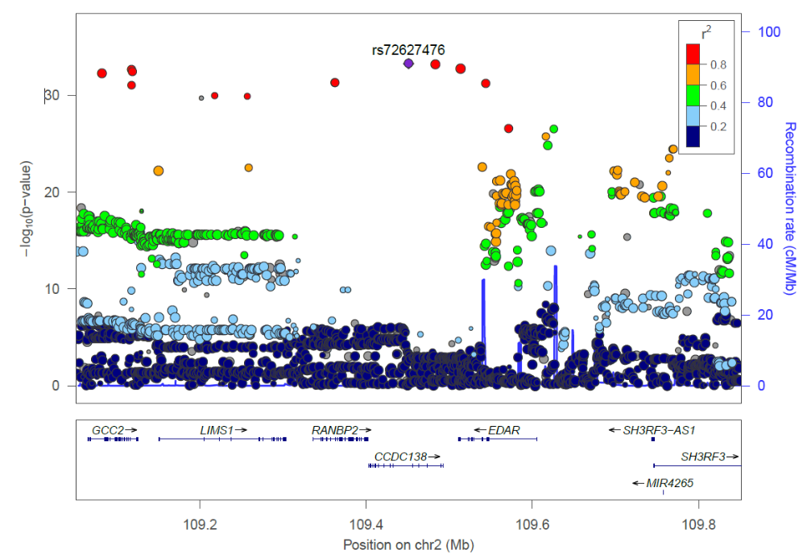
2q12.3: EDAR. We associated SNPs from EDAR (ectodysplasin A receptor) region with 75 inter-landmark distances (Figure 2 in manuscript). EDAR region has previously been associated with facial flatness, jaw protrusion, and distance between ectocanthion and otobasion inferius¹⁻³. The trait with the strongest association here is D198 (landmarks 43-71).

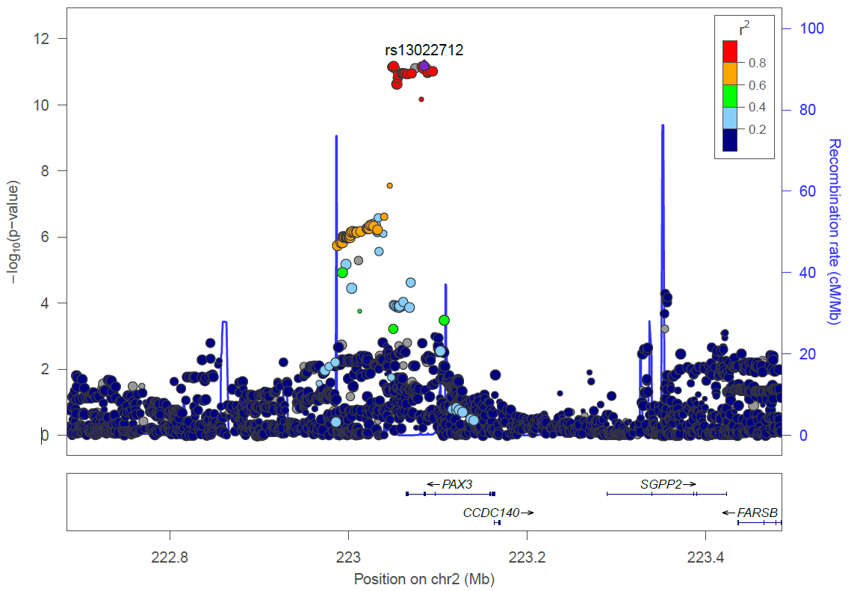
2q36.1: PAX3. We associated SNPs within PAX3 (paired box 3) gene with 18 inter-landmark distances (Figure 2 in manuscript). SNPs in PAX3 have been associated with the distance between eyes, and brow ridge protrusion^{2, 4}. The trait with the strongest association is the distance between landmarks 43 and 58.

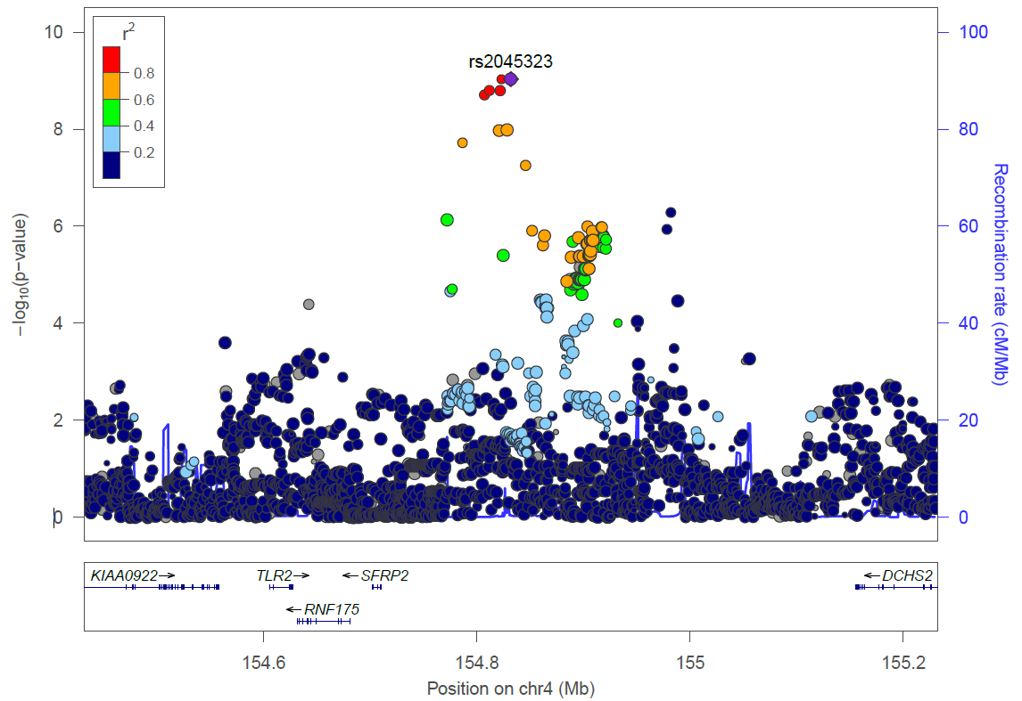
4q31.3: Intergenic (DCHS2, SFRP2). We associated SNPs in the vicinity of the SFRP2 (secreted frizzled related protein 2) and DCHS2 (dachsous cadherin-related 2) genes with 8 traits (Figure 2 in manuscript). This region has been associated with the distance endocanthion-alare distance, columella inclination and nose morphology^{1, 5, 6}. The trait with the most significant association is the distance between landmarks 35 and 58.

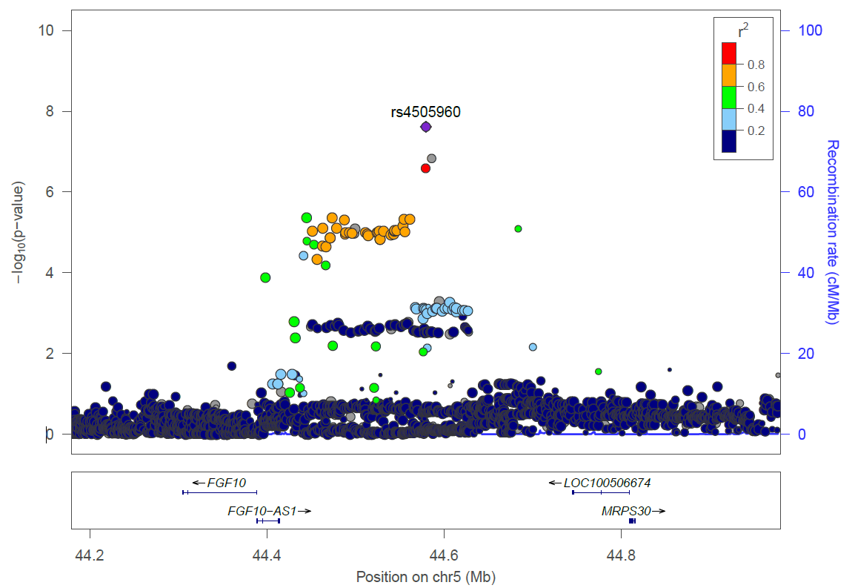
5p12: Intergenic (FGF10, LOC100506674). We associated one SNP from 5p12 region with three inter-landmark distances. It has been associated with variation in a facial segment previously⁷. The trait with the most significant association is the distance between landmarks 48 and 58.

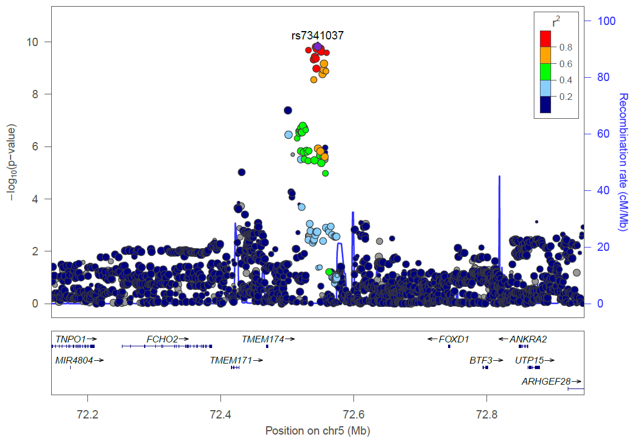
5q13.2: FOXD1. We associated SNPs in the vicinity of the FOXD1 (forkhead box D1) with 10 inter-landmark distances (Figure 2 in manuscript). It has been associated with eye-brow thickness in a Chinese sample⁸. The trait with the most significant association is the distance between landmarks 42 and 67.

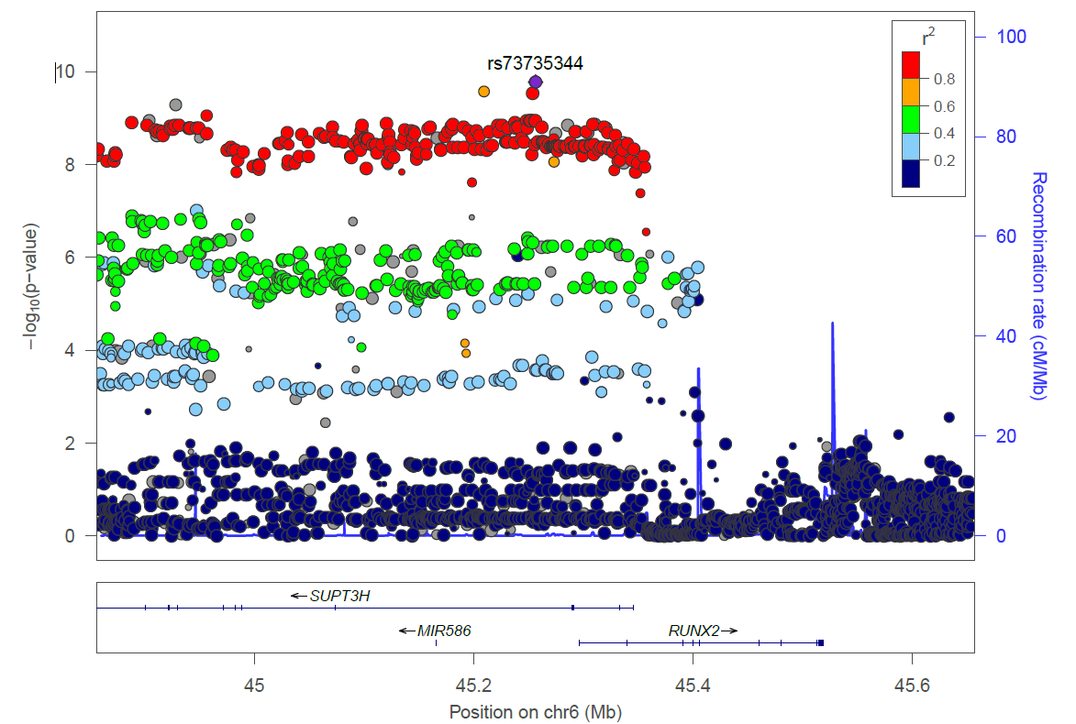
6p21.1: SUPT3H, RUNX2. Since the information of linkage disequilibrium (LD) with the most significant SNP (rs141680515) is not available, the second most significant SNP (rs73735344) is used to make this plot. We associated SNPs within SUPT3H (SPT3 homolog, SAGA and STAGA complex component) and RUNX2 (RUNX family transcription factor 2) genes with 15 inter-landmark distances. It has been associated with nose bridge breadth previously¹. The trait with the strongest association here is the distance between landmarks 43 and 58.

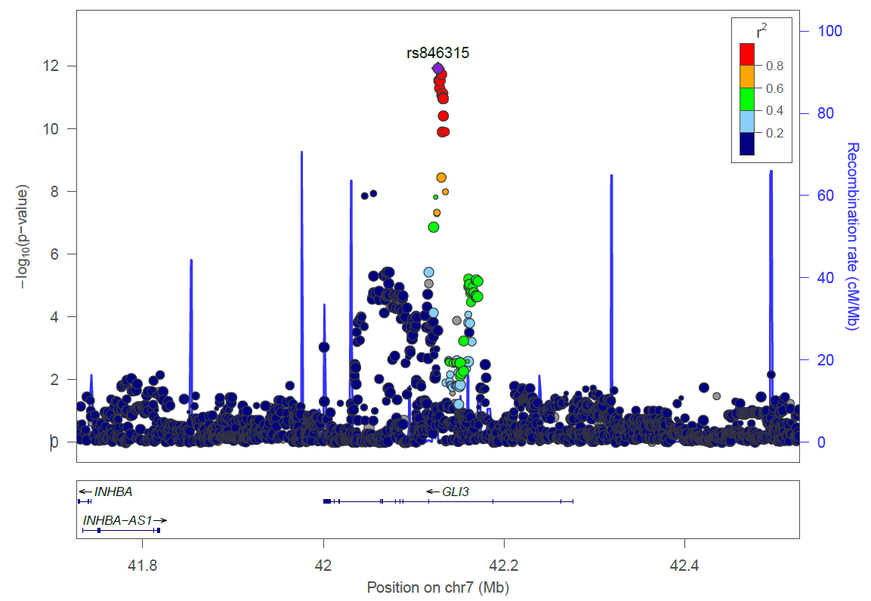
7p14.1: GLI3. We associated SNPs within GLI3 (GLI Family Zinc Finger 3) gene with 5 inter-landmark distances (Figure 2 in the manuscript). It has been shown to be associated with nose wing breadth previously¹. The one with the strongest association in this study is the distance between the left and right nasal root contour.

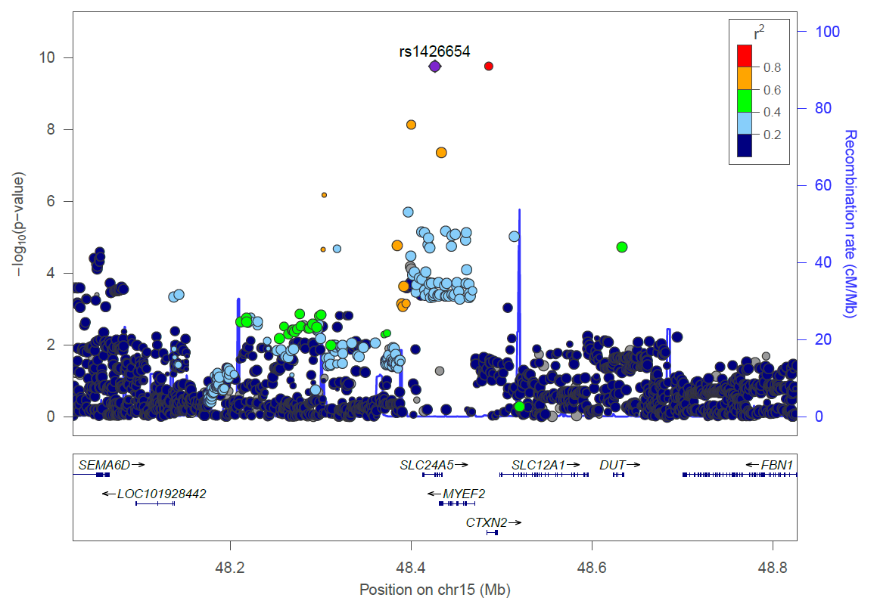
15q21.1: SLC24A5. We associated SNPs from SLC24A5 (solute carrier family 24 member 5) gene with two inter-landmark distances. Previously this signal has been associated with nose tip roundness². The one shown here represents upper lip thickness (landmarks 97-105).

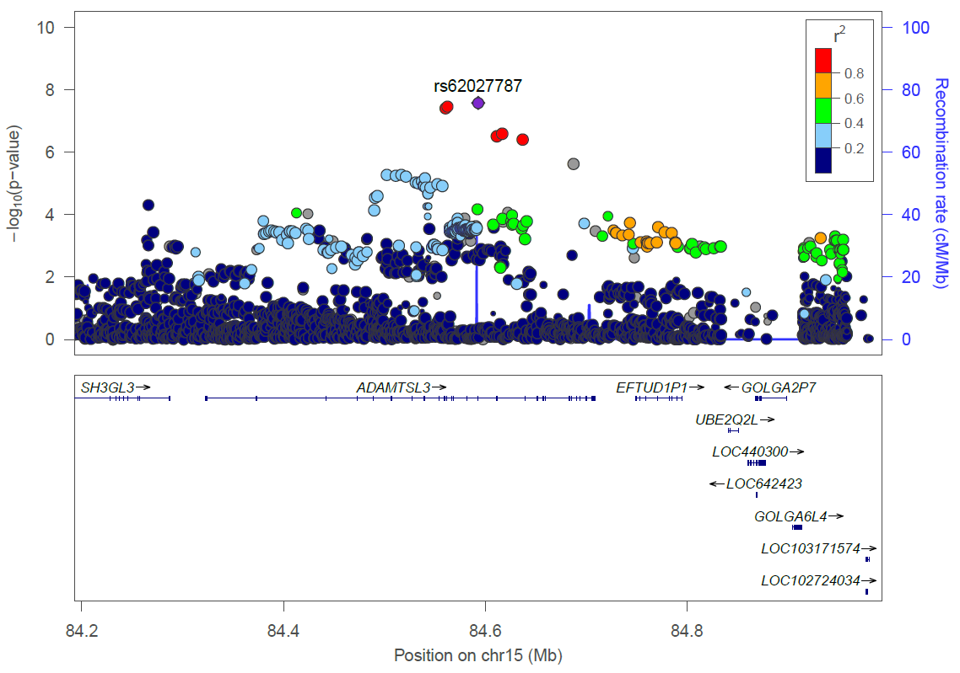
15q25.2: ADAMTSL3. We associated SNPs within ADAMTSL3 (ADAMTS like 3) gene with one inter-landmark distance (Landmarks 38-71). It has been associated with variation in a facial segment previously⁷.

Supplementary note 2: Regional association plots for novel regions detected in this study which reached genome-wide significance and replicated in either Chinese or European cohort, besides the 5 highlighted ones in the main text.
Some of those regions are associated with multiple ILDs (see Table S4). Below we only show plots for the trait with the strongest association to each region.

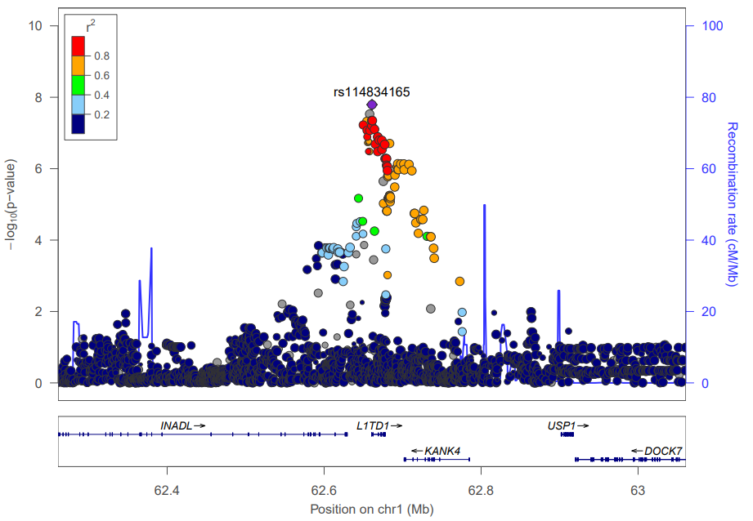
1p31.3: KANK4. We associated SNPs from L1TD1 (LINE1 type transposase domain containing 1) and KANK4 (KN motif and ankyrin repeat domains 4) region with three ILDs and the most significant one is the distance between left frontotemporale and right exocanthion. Homozygous mutations of KANK4 gene were identified in two patients with nephrotic syndrome, and they also presented facial dysmorphism and short stature (OMIM #614612).

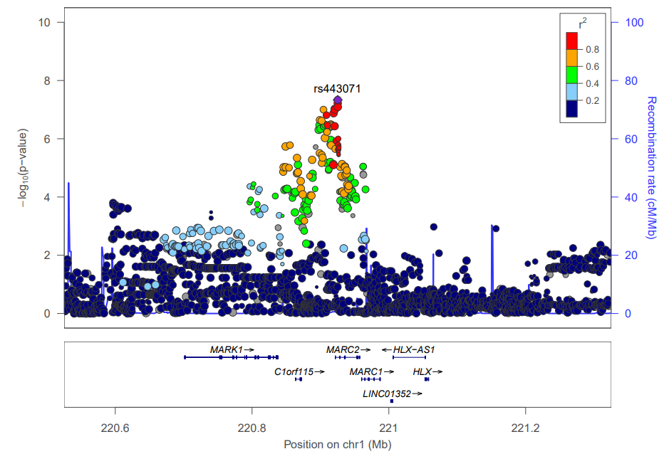
1q41: MARK1, MARC2. We associated an SNP from MARK1 (microtubule affinity regulating kinase 1) and MARC2 (Mitochondrial amidoxime reducing component) region with the distance between subnasal and stomion. MARK1 has been reported to be associated with a facial segment previously⁷. However, according to the conditioning analysis, our signal is independent of the signal reported before.

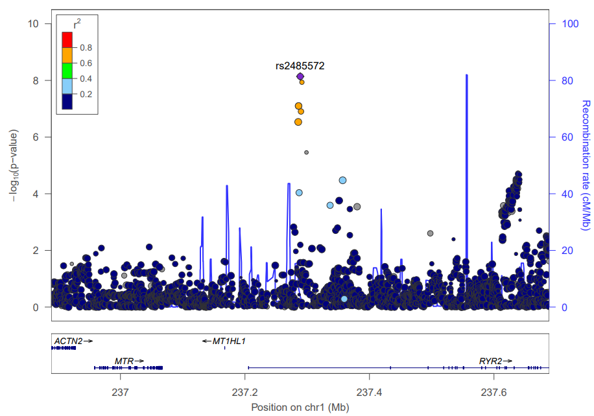
1q43: RYR2. We associated SNPs within RYR2 (ryanodine receptor 2) gene with three ILDs and the most significant one is the distance between right exocanthion and stomion. Mutations in RYR2 gene were reported to be associated with stress-induced polymorphic ventricular tachycardia⁹.

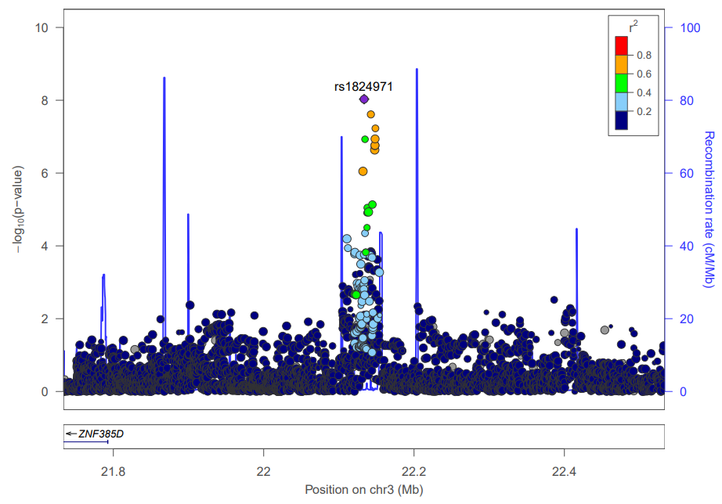
3p24.3: Intergenic (ZNF385D). We associated SNPs in 3p24.3 region with eyebrow thickness.

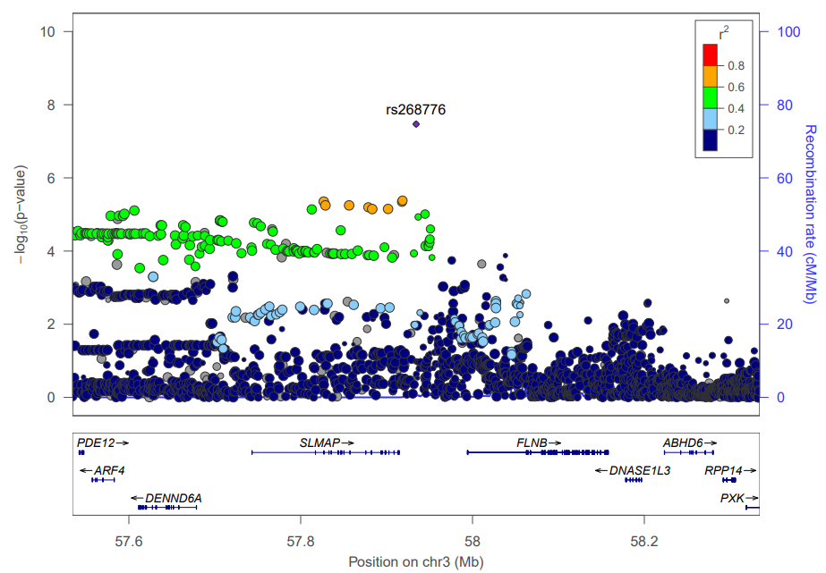
3p14.3: Intergenic (SLMAP, FLNB). We associated SNPs from SLMAP (sarcolemma associated protein) and FLNB (filamin B) region with eyebrow thickness. It was reported that a patient with FLNB gene exclusion presented postnatal growth retardation, facial dysmorphism, and other abnormal traits¹⁰.

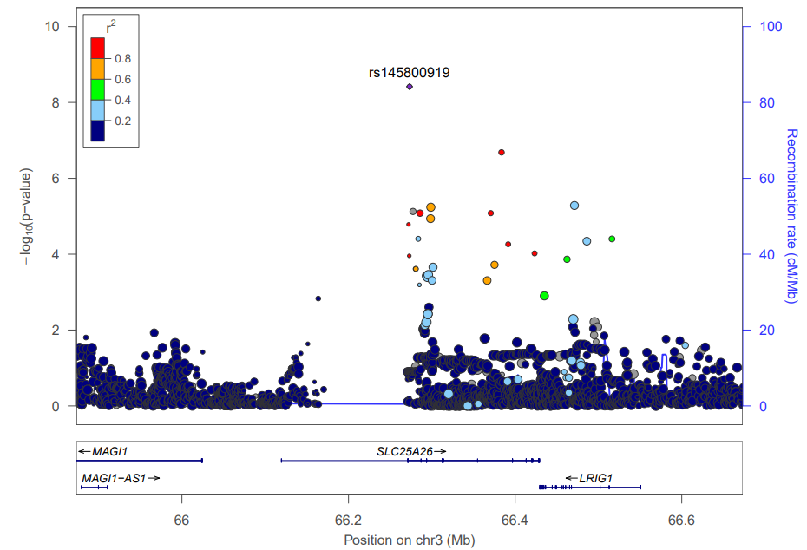
3p14.1: SLC25A26. We associated one SNP within SLC25A26 (solute carrier family 25 member 26) with two ILDs and the most significant one is the distance between right cheilion and left palpebrale inferious.

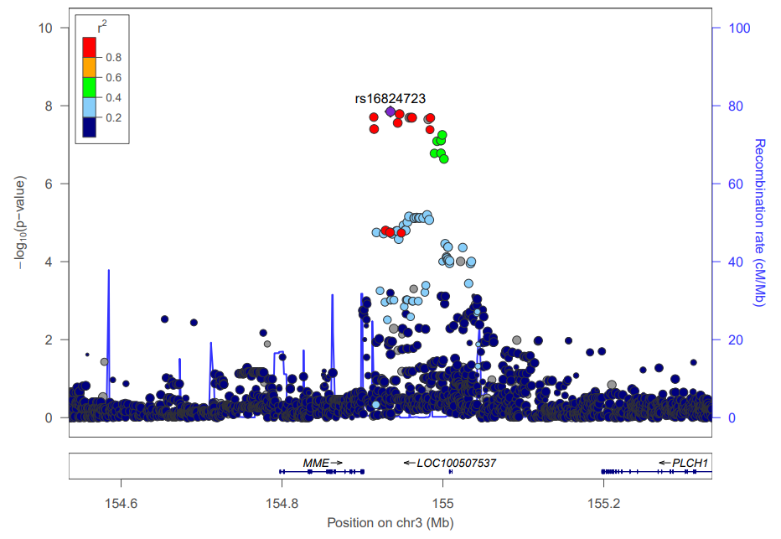
3q25.2: MME, LOC100507537. We associated SNPs from MME (membrane metalloendopeptidase) and LOC100507537 with four ILDs that are all related to eyebrow size. It is reported that mutations in MME would cause Charcot-Marie-Tooth disease, and they showed muscle weakness, atrophy, and sensory disturbance in the lower extremities¹¹.

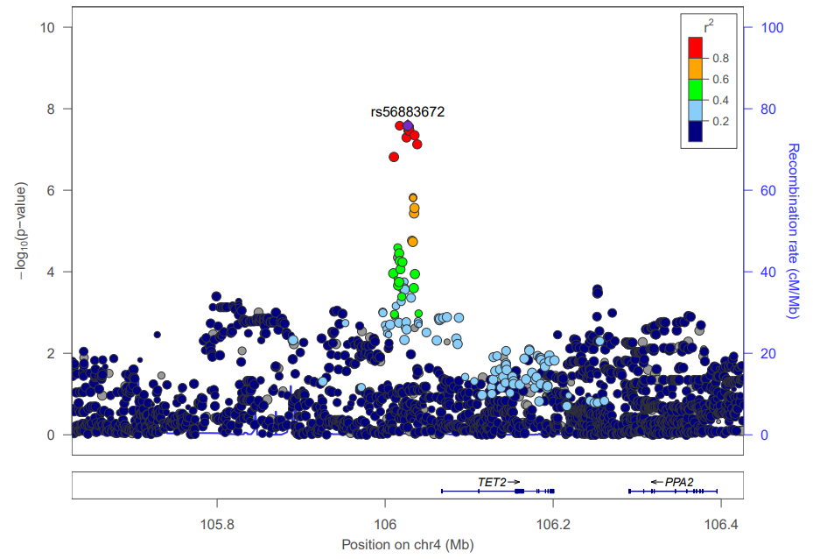
4q24: Intergenic (TET2). We associated one SNP in 4q24 region with the distance between the frontozygomatic suture and the uppermost landmark of the face contour.

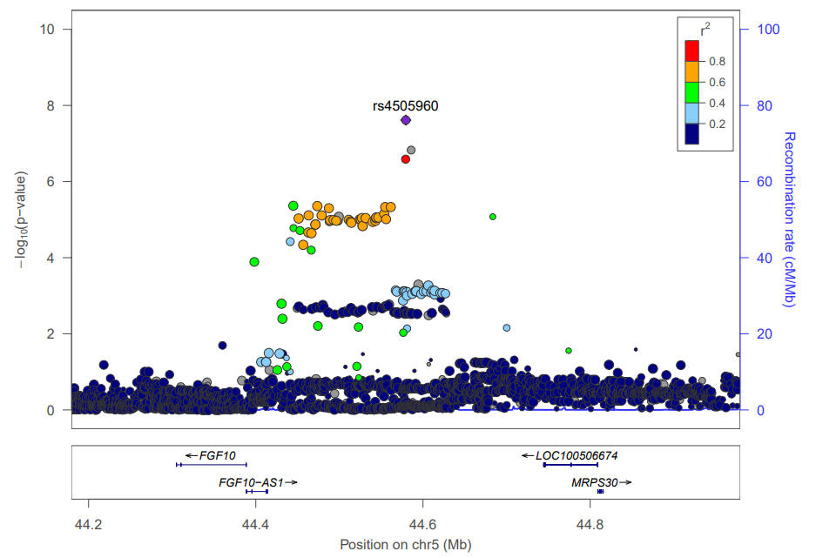
5p12: Intergenic (FGF10, LOC100506674). We associated an SNP in the intergenic region between FGF10 (fibroblast growth factor 10) and LOC100506674 with three ILDs and the most significant one is the distance between the right alare and left eyebrow lower right corner. In mice, this gene is required for embryonic epidermal morphogenesis including brain development.

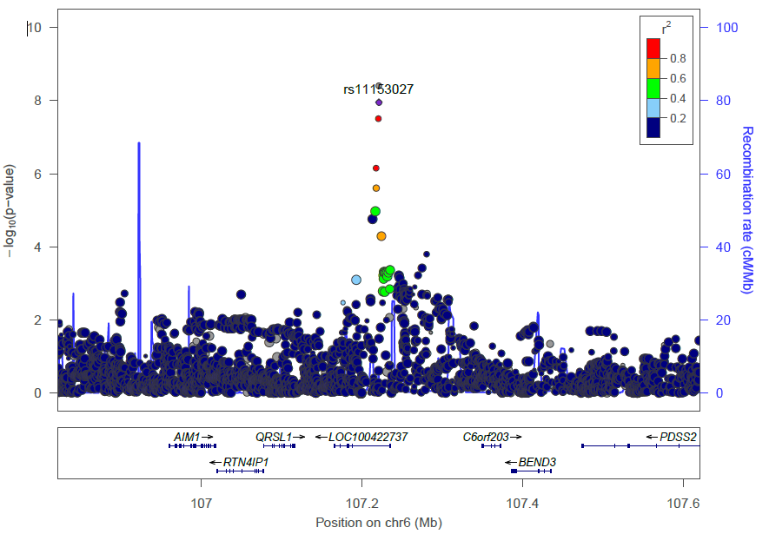
6q21: LOC100422737. We associated SNPs within LOC100422737 with three ILDs and the most significant one is the distance between alare and subnasal.

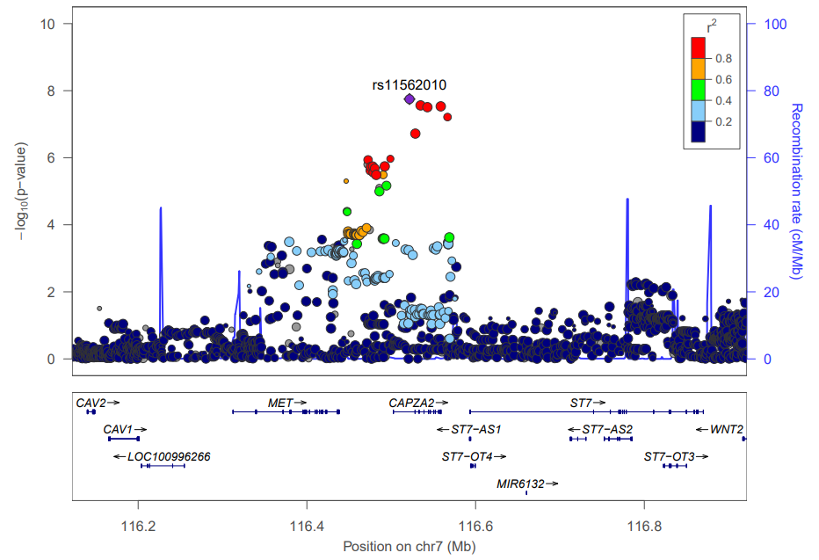
7q31.2: CAPZA2. We associated SNPs within CAPZA2 (capping actin protein of muscle Z-line subunit alpha 2) with 2 ILDs and the most significant one is the distance between right endocanthion and uppermost landmark of left face contour.

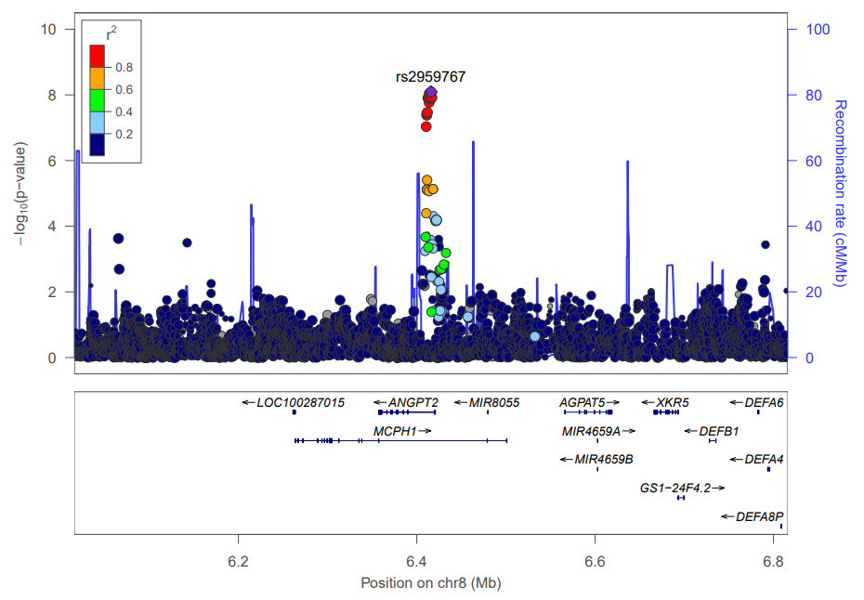
8p23.1: MCPH1. We associated SNPs within MCPH1 (microcephalin 1) with four ILDs, and the most significant is the distance between the right alare and the upmost landmark of the left face contour. Mutations in MCPH1 have been associated with primary autosomal recessive microcephaly in humans characterized by a significantly small head and brain size and intellectual disability. Mcph1-deficient mice were also demonstrated to have normal skull structure but smaller skull size than wild type ¹². A study identified a homozygous mutation in MCPH1 in a microcephaly patient who also has characteristics of bird-like facies with micrognathia, craniosynostosis and ptosis ¹³. One associated trait in this study is the distance between subnasal and gnathion, which slightly corresponds to the symptom of micrognathia of the above-mentioned microcephaly patient.

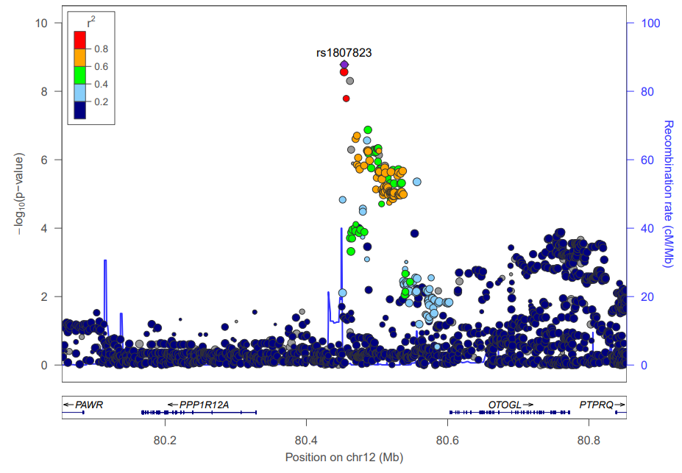
12q21.31: Intergenic (PPP1R12A, OTOGL). We associated SNPs from 12q21.31 region with 8 ILDs, and the most significant one is the distance between palpebrale superious and alare. Heterozygosity mutation in PPP1R12A (protein phosphatase 1 regulatory subunit 12A) was identified in a genitourinary and brain malformation patient ¹⁴, who also had characteristics of minor facial dysmorphisms, such as low-set ears and micrognathia (OMIM #602021). The associated traits identified in this study were all around eye and nose areas.

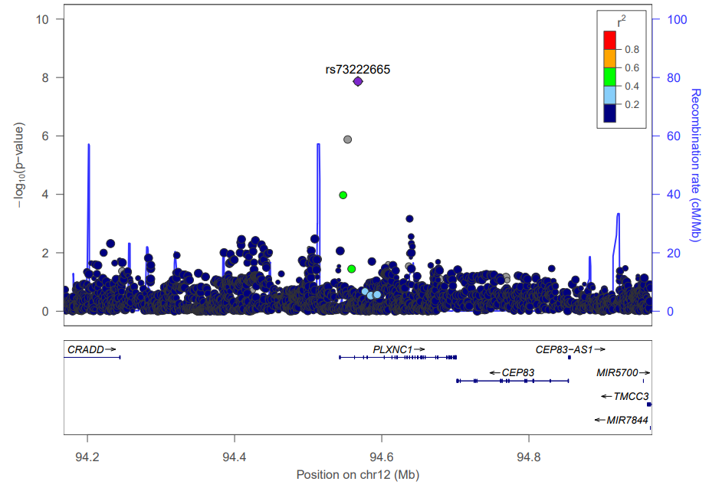
12q22: PLXNC1. We associated one SNP within PLXNC1 (plexin C1) with the lower lip thickness.

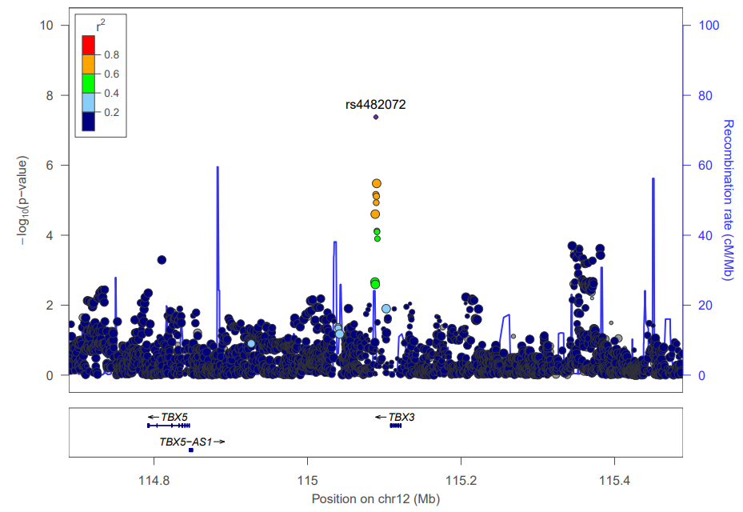
12q24.21: Intergenic (TBX5, TBX3). We associated an SNP in the intergenic region between TBX5 (T-box transcription factor 5) and TBX3 (T-box transcription factor 3) with the distance between right palpebrale superious and right eyebrow lower-left corner. TBX3 has been reported to be associated with the distance between pronasale and right alare previously⁶. However, according to a conditioning analysis, our signal is independent of the ones reported before.

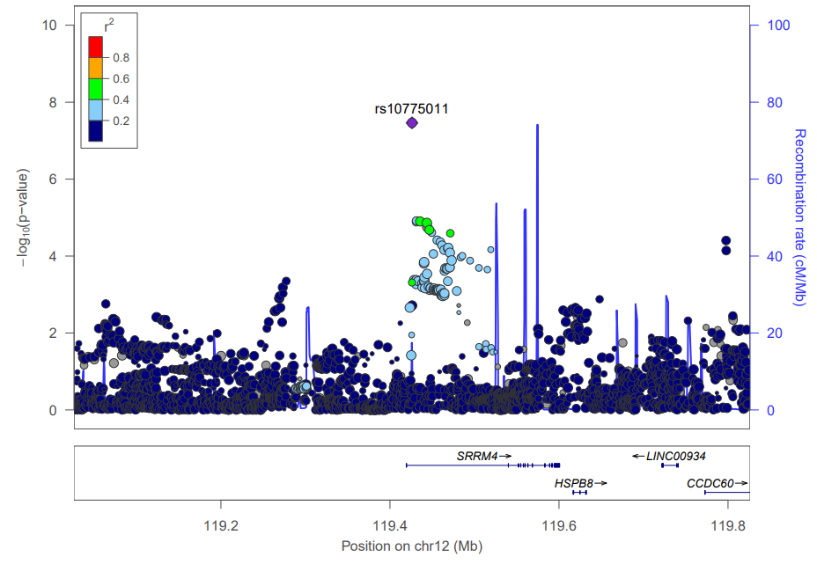
12q24.23: SRRM4. We associated an SNP within SRRM4 (serine/arginine repetitive matrix 4) with the distance between the right endocanthion and the right cheilion. Srrm4 knockdown partially restores the ability of zebrafish facial branchiomotor neurons to migrate in rest (RE1-silencing transcription factor) mutants. In addition, SRRM4 has been reported to be associated with lip morphology¹⁵.

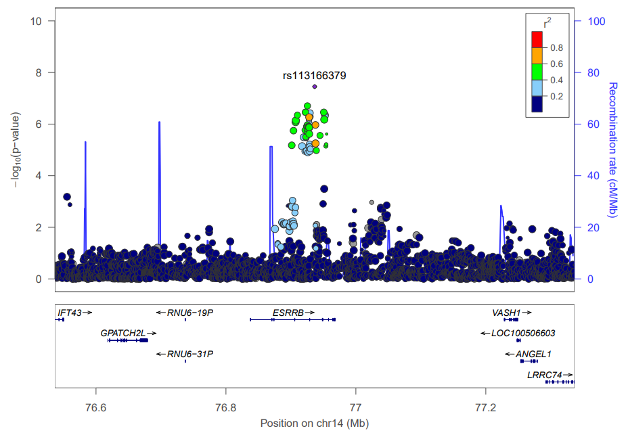
14q24.3: ESRRB. We associated SNPs within ESRRB (estrogen related receptor beta) gene with two ILDs, and the most significant one is the distance between right cheilion and the right eyebrow lower-left corner. In mice, Esrrb plays an essential role in placental development and is expressed during inner ear development, which indicates its essential role in inner ear development and function (OMIM #602167).

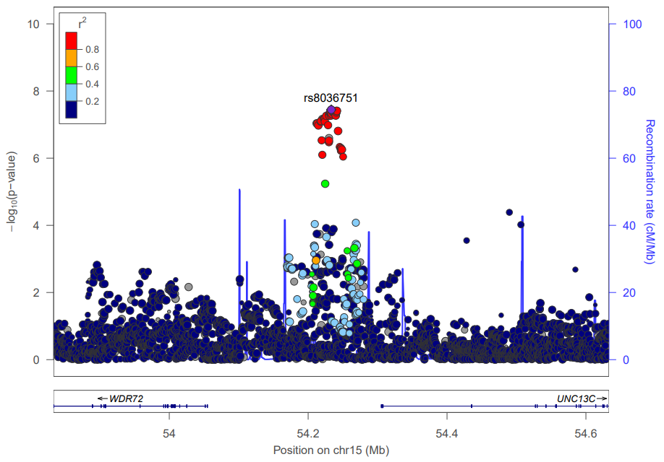
15q21.3: Intergenic (WDR72, UNC13C). We associated SNPs in the intergenic region between WDR72 (WD repeat domain 72) and UNC13C (unc-13 homolog C) with the distance between crista philtre and stomion.

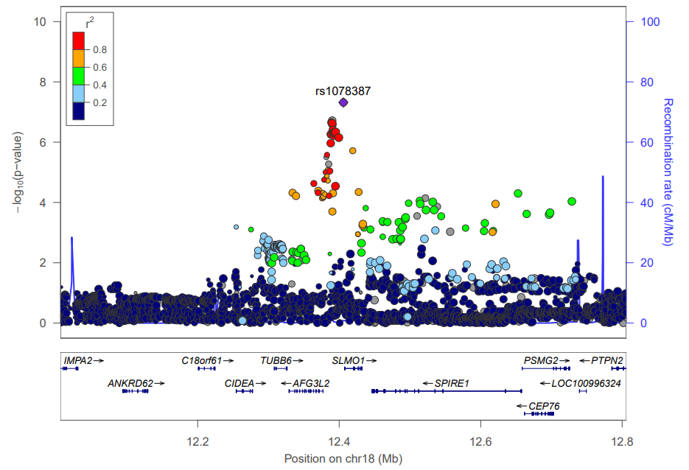
18p11.21: TUBB6, SLMO1. We associated an SNP within SLMO1 (PRELI domain containing 3A) associated with the distance between stomion and gnathion. A previous study showed that mutations in its nearby gene TUBB6 (tubulin beta 6 class V) would cause congenital non-progressive facial palsy¹⁶.

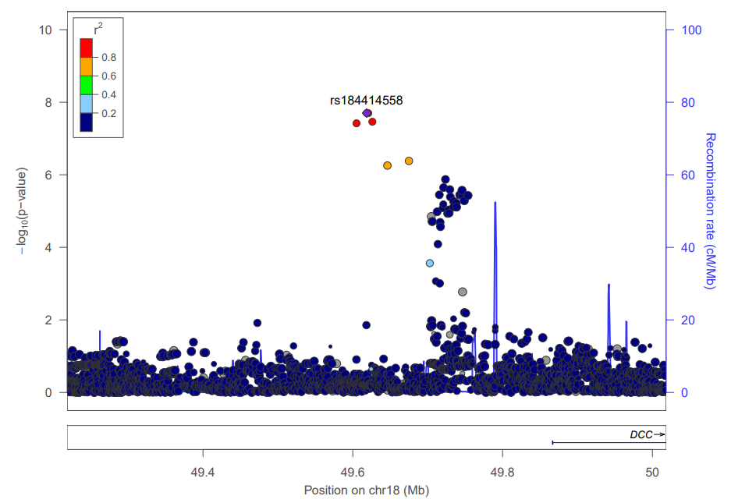
18q21.2: Intergenic (DCC). We associated SNPs in 18q21.2 region with two ILDs, and the most significant one is the distance between right frontotemporale and labiale inferious. DCC was reported to be associated with BMI¹⁷.

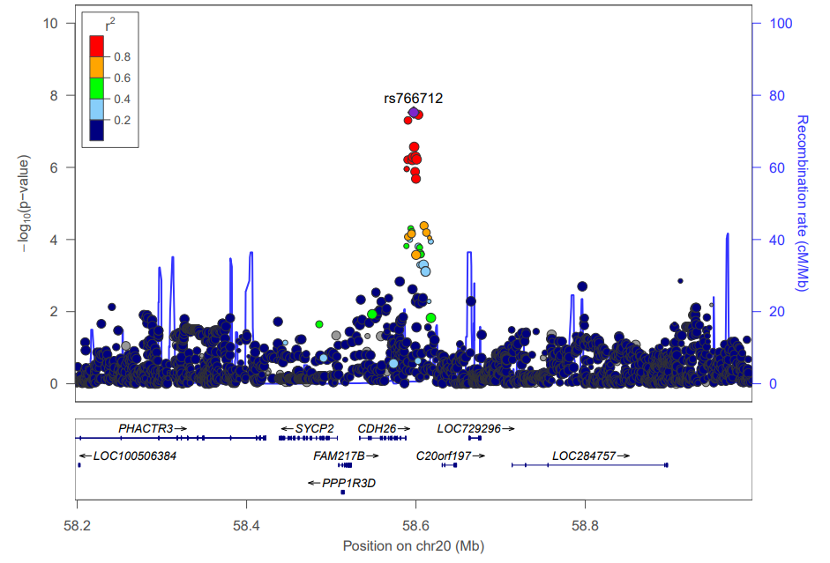
20q13.33: Intergenic (SYCP2, CDH26, LOC729296). We associated SNPs from 20q13.33 region with the distance between gnathion and nasion. A previous study has reported that SYCP2 (synaptonemal complex protein 2) gene was overexpressed in Immunodeficiency, centromeric instability and facial anomalies syndrome (ICF) compared to healthy control¹⁸.

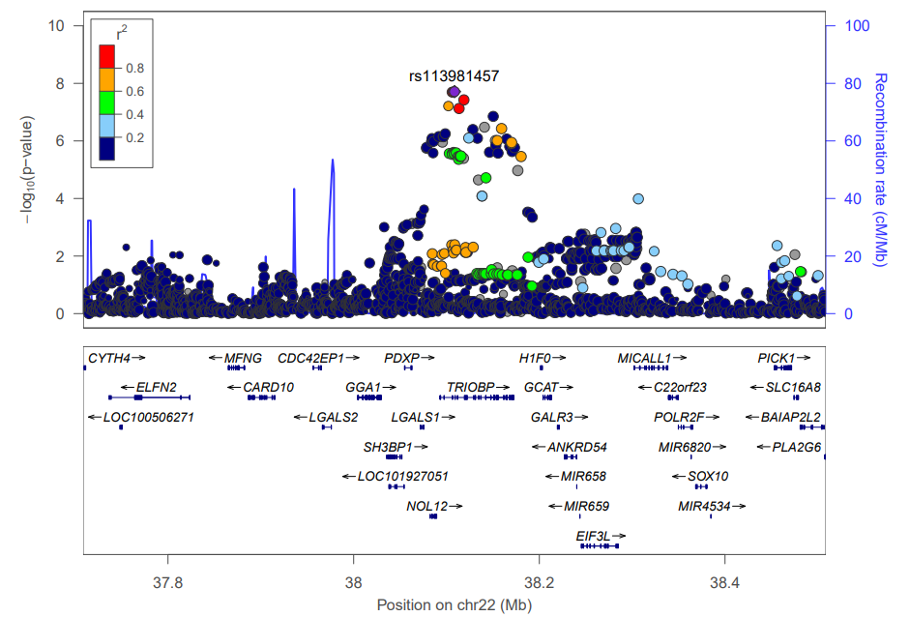
22q13.1: NOL12, TRIOBP. We associated SNPs within TRIOBP (TRIO and F-actin binding protein) genes with the distance between subnasal and right nose contour. Mutations in TRIOBP have been associated with a form of autosomal recessive nonsyndromic deafness¹⁹.

Supplementary note 3: Regional association plots for novel regions detected in this study whose replication P-values are insignificant in both Chinese and European cohorts.
It is due to either the unavailability of the SNPs in these two cohorts (first five) or weak P-value (the last one).
One genomic region on the sex chromosome (Xp22.13) could not be shown here, because locuszoom plots for X chromosome is not available.

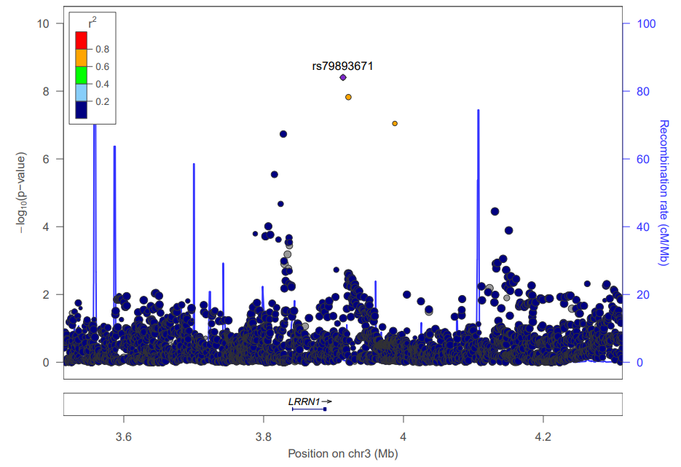
3p26.2: Intergenic (LRRN1). We associated SNPs in 3p26.2 region with the distance between the right alare and the upmost landmark of face contour. Mutations of several candidate genes for autism including LRRN1 (leucine rich repeat neuronal 1) were identified in a child who also had facial dysmorphology²⁰.

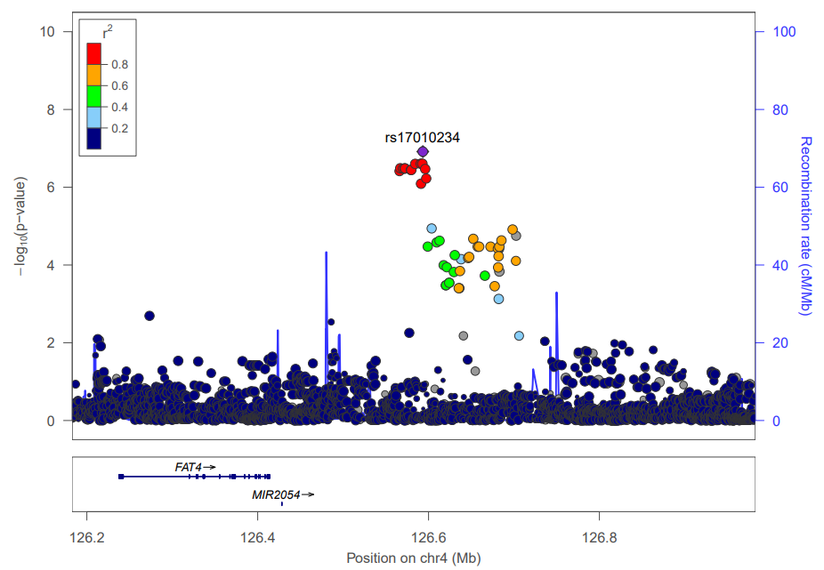
4q28.1: Intergenic (MIR2054). We associated an SNP in 4q28.1 region with the distance between palpebrale superious and nasal root contour.

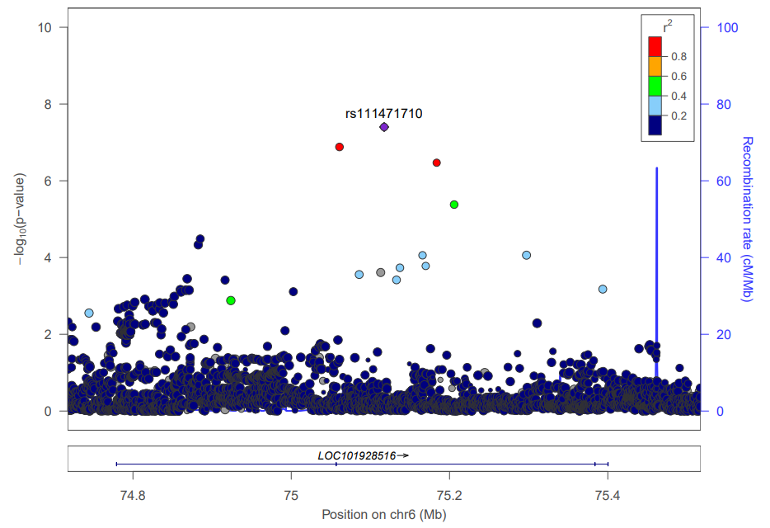
6q13: LOC101928516. We associated an SNP within LOC101928561 with a distance representing eyebrow thickness.

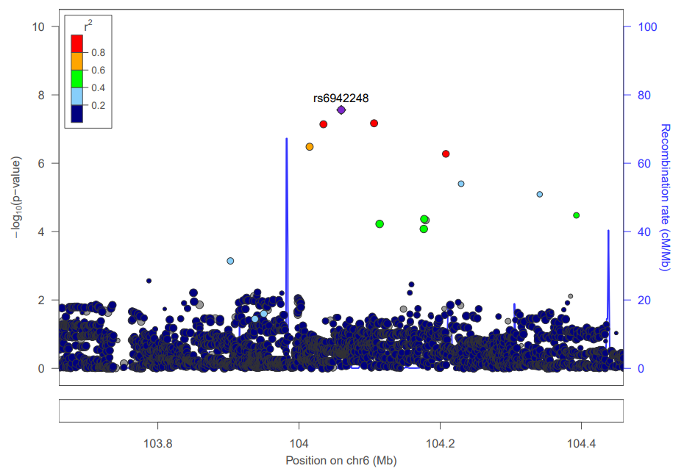
6q16.3: Intergenic. We associated an SNP in 6q16.3 region with the distance between stomion and the uppermost landmark of the right face contour.

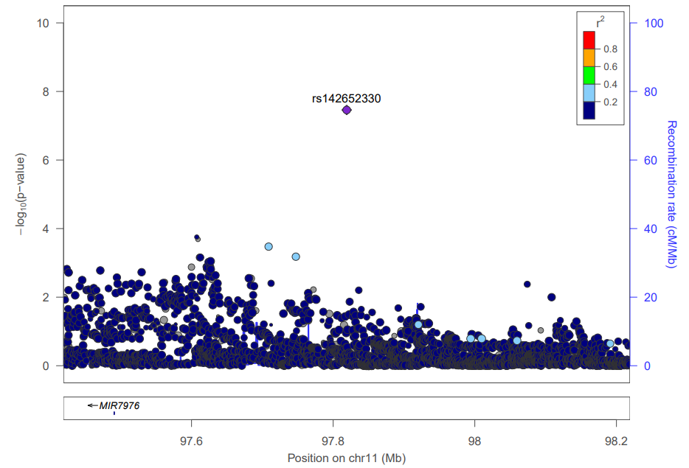
11q22.1: Intergenic (MIR7976). We associated one SNP in 11q22.1 region with upper lip thickness.

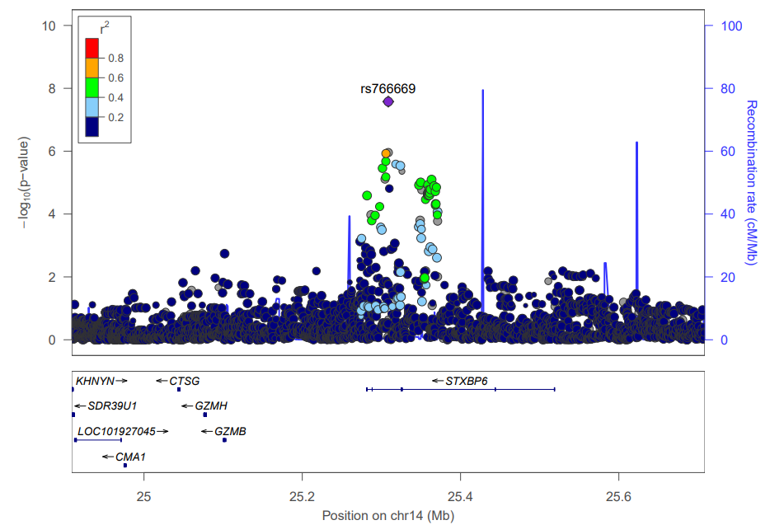
14q12: STXBP6. We associated an SNP within STXBP6 (syntaxin binding protein 6) with the distance between right nose contour and right eyebrow upper left corner. Some potential regulatory pathways of Stxbp6 in the central nervous system were suggested in the previous study²¹.

Supplementary figures

Supplementary figure S1: Full Face++ landmarking protocol.
All the 106 landmarks are shown, and the 34 landmarks that are used to derive the 301 facial inter-landmark distances are marked in red color.

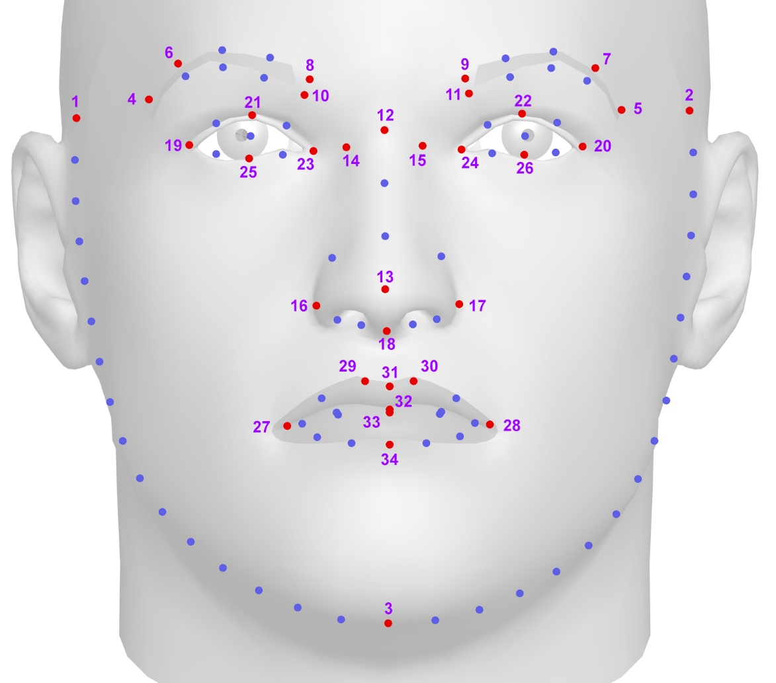

Supplementary figure S2: Correspondence of the landmarking protocols of manual (left) and Face++ (right).
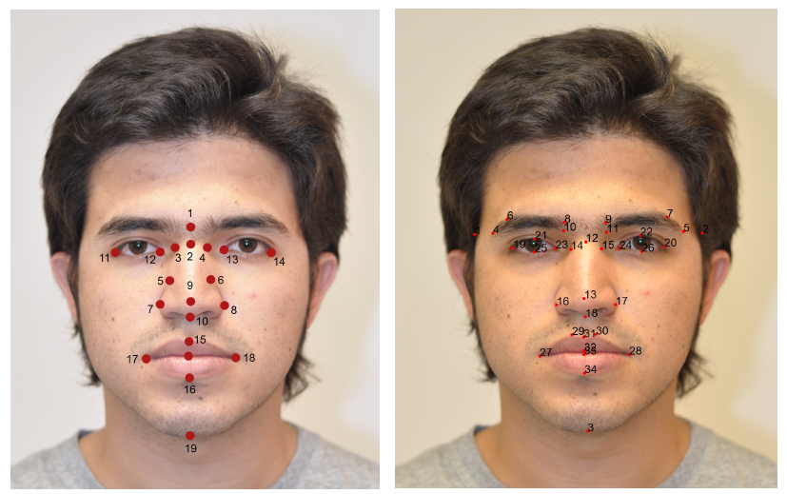
Manual | Face++ | Manual | Face++
2 | 12 | 12 | 23
3 | 14 | 13 | 24
4 | 15 | 14 | 20
7 | 16 | 15 | 31
8 | 17 | 16 | 34
9 | 13 | 17 | 27
10 | 18 | 18 | 28
11 | 19 | 19 | 3

Supplementary figure S3: Histograms for 5 inter-landmark distances that are most significantly associated with 5 the novel genomic regions in Table 2.
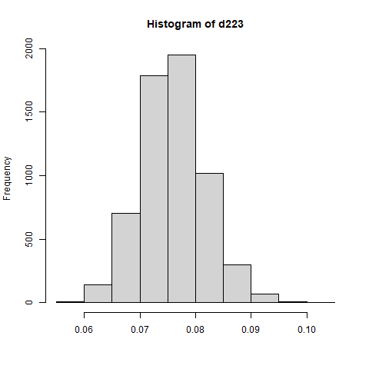
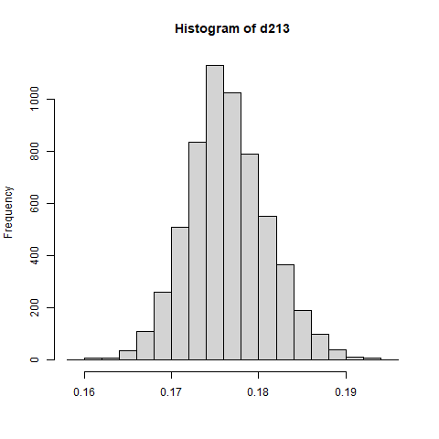
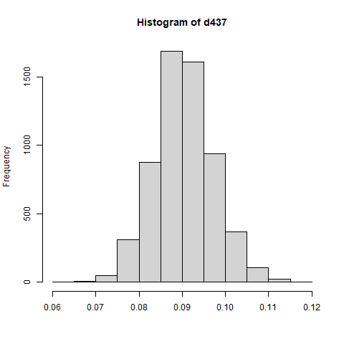
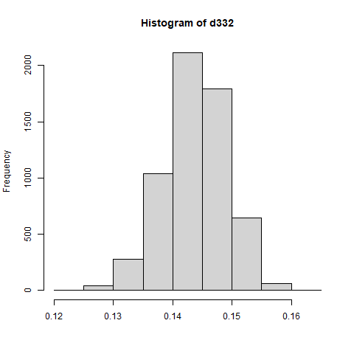
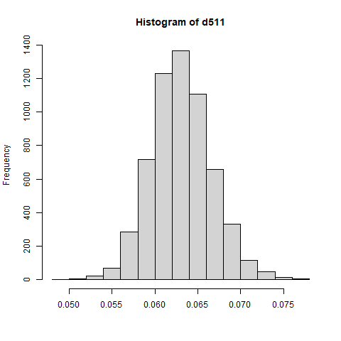
Histograms for D223, D213, D332, D511 and D437. They all show considerable variation and are approximately normally distributed.
D223: landmarks 13-25, associated with 1q32.3
D213: landmarks 2-25, associated with 3q21.1
D437: landmarks 3-31, associated with 22q12.1
D511: landmarks 16-33, associated with 10p11.1
D332: landmarks 10-27, associated with 8p11.21

Supplementary figure S4: Covariates correlations and heritability.
The correlation between each ILD with nine covariates (age, BMI, sex, three ancestries, and three head angles), and heritability. Red color represents a positive correlation, while blue represents a negative correlation. The darker the color, the stronger the correlation.
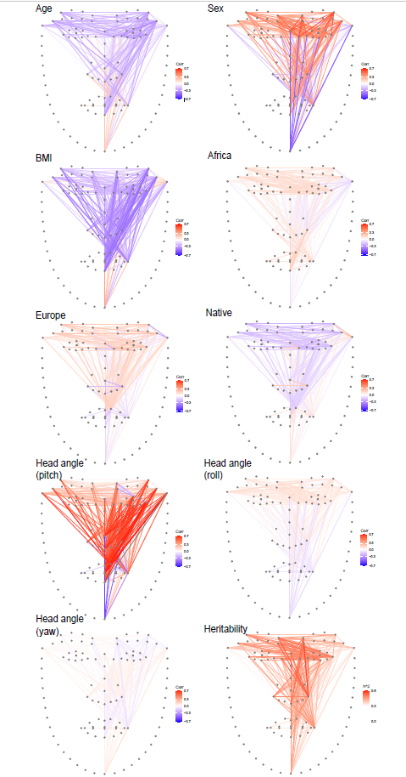

Supplementary figure S5: Comparison of gene expression in the cranial neural crest cells (CNCCs).
Green box: 30 genes annotated to five reported genomic regions in Tabl e1. Blue box: 73 genes annotated to the rest of 37 novel genomic regions. Red box: the other 55,779 genes expressed in CNCCs as background genes. Candidate genes in reported and novel regions expressed significantly higher than background genes in every sample (one-tailed t-test for mean data, P_{backgroud-reported} = 0.00475, P_{backgroud-novel} = 1.618×10⁻¹⁰).
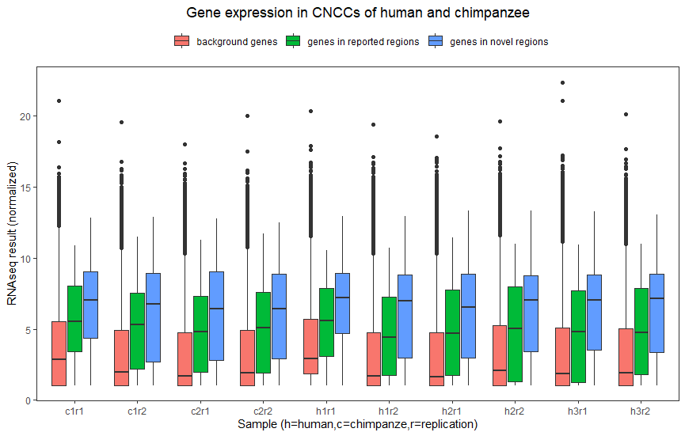

Supplementary figure S6: Screenshot of UCSC Genome Browser for Human showing the craniofacial enhancers on certain genomic regions.
Top graph displays the region of 1q32.3 (chr1: 212,774,757-212,791,621). This detected region from our result is within the craniofacial super-enhancer region. Bottom graph displays the region of 12q21.31 (chr12: 78,336,774-81,993,461). The genomic region we detected is near the craniofacial super-enhancer. Graphs were obtained from UCSC Genome Browser for Human²².
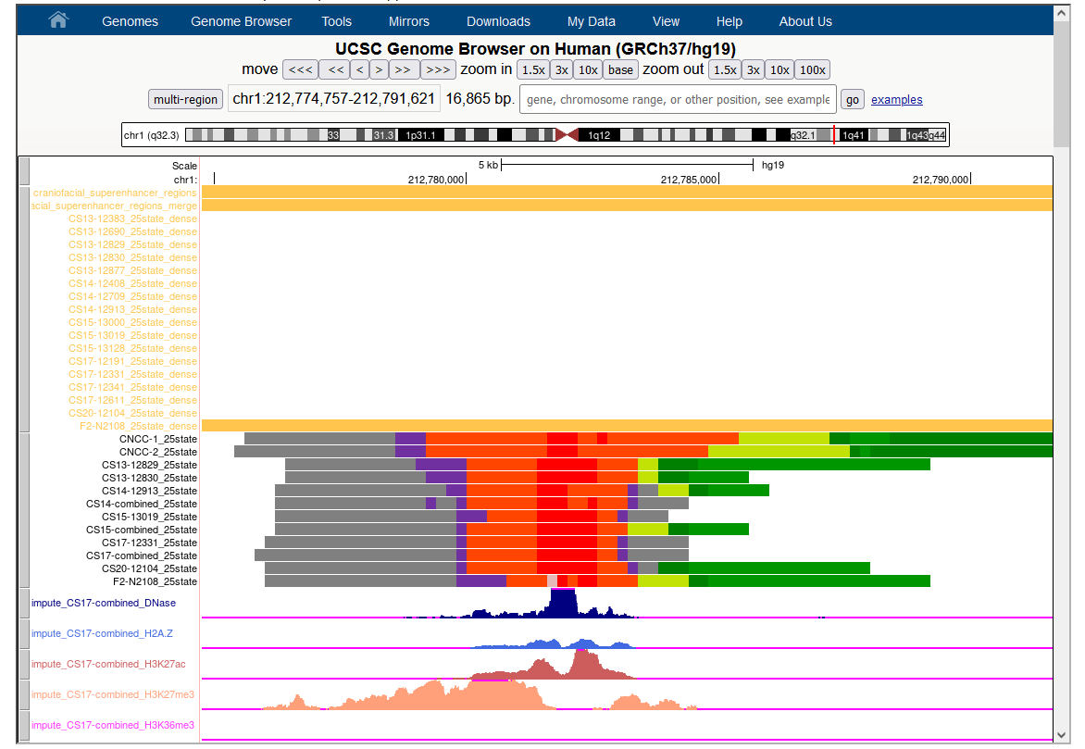
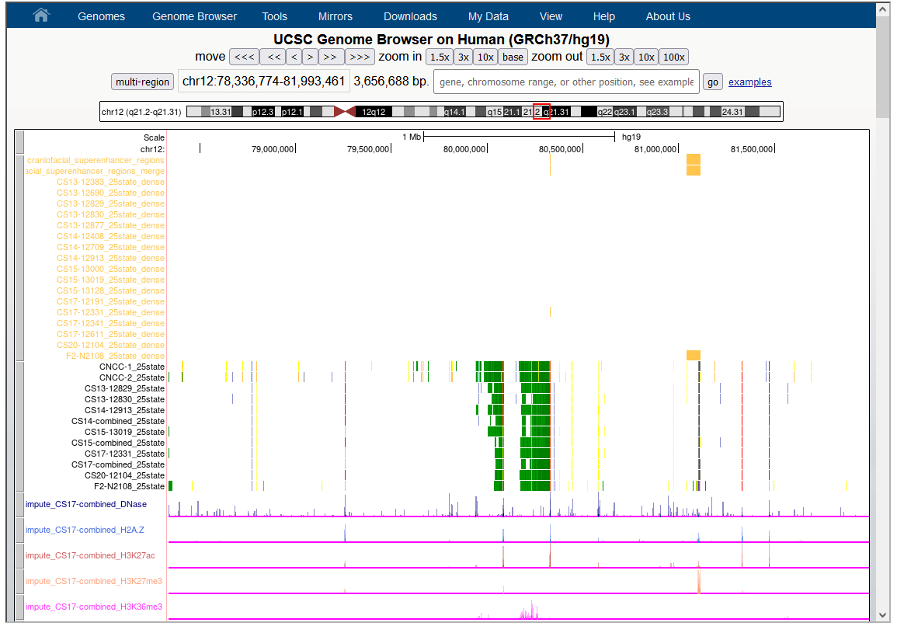

Supplementary Tables

Supplementary Table S1. Interclass correlation coefficient and median distance for each corresponding landmark pair from manual and Face++ protocols.

Landmark-pair index | x  coordinate ICC | y coordinate ICC | Median distance (pixel)
1 | 0.98 | 0.98 | 18.60
2 | 0.93 | 0.99 | 20.00
3 | 0.97 | 0.99 | 15.30
4 | 0.92 | 0.99 | 14.87
5 | 0.98 | 1.00 | 11.66
6 | 0.96 | 1.00 | 14.37
7 | 0.95 | 1.00 | 12.65
8 | 0.94 | 0.98 | 18.03
9 | 0.93 | 0.99 | 15.41
10 | 0.97 | 1.00 | 15.13
11 | 0.99 | 1.00 | 16.03
12 | 0.92 | 1.00 | 10.30
13 | 0.90 | 1.00 | 13.04
14 | 0.86 | 1.00 | 14.49
15 | 0.94 | 1.00 | 19.42
16 | 0.83 | 0.99 | 23.29

Supplementary Table S2. Description of the 34 landmarks selected for the GWAS analyses.
See supplementary_tables_S2.xlsx

Supplementary Table S3. Covariate correlations.
See supplementary_tables_S3.xlsx

Supplementary Table S4. Overall GWAS results.
See supplementary_tables_S4.xlsx

Supplementary Table S5. Interaction between EDAR and other associated regions.
See supplementary_tables_S5.xlsx

Supplementary Movie: Mouse craniofacial morphology impacted by 22q12.1 (index SNP: rs32069343).
See supplementray_movie.mp4
Reference
1. Adhikari, K., et al., A genome-wide association scan implicates DCHS2, RUNX2, GLI3, PAX1 and EDAR in human facial variation. Nature Communications, 2016. 7.
2. Bonfante, B., et al., A GWAS in Latin Americans identifies novel face shape loci, implicating VPS13B and a Denisovan introgressed region in facial variation. Science Advances, 2021. 7(6).
3. Li, Y., et al., EDAR, LYPLAL1, PRDM16, PAX3, DKK1, TNFSF12, CACNA2D3, and SUPT3H gene variants influence facial morphology in a Eurasian population. Human Genetics, 2019. 138(6): p. 681-689.
4. Liu, F., et al., A genome-wide association study identifies five loci influencing facial morphology in Europeans. PLoS Genet, 2012. 8(9): p. e1002932.
5. Claes, P., et al., Genome-wide mapping of global-to-local genetic effects on human facial shape. Nature Genetics, 2018. 50(3): p. 414-+.
6. Xiong, Z.Y., et al., Novel genetic loci affecting facial shape variation in humans. Elife, 2019. 8.
7. White, J.D., et al., Insights into the genetic architecture of the human face. Nature Genetics, 2021. 53(1).
8. Wu, S.J., et al., Genome-wide association studies and CRISPR/Cas9-mediated gene editing identify regulatory variants influencing eyebrow thickness in humans. Plos Genetics, 2018. 14(9).
9. Jung, C.B., et al., Dantrolene rescues arrhythmogenic RYR2 defect in a patient-specific stem cell model of catecholaminergic polymorphic ventricular tachycardia. EMBO Mol Med, 2012. 4(3): p. 180-91.
10. Sousa, S.B., et al., Postnatal growth retardation, facial dysmorphism, spondylocarpal synostosis, cardiac defect, and inner ear malformation (cardiospondylocarpofacial syndrome?)--a distinct syndrome? Am J Med Genet A, 2010. 152A(3): p. 539-46.
11. Higuchi, Y., et al., Mutations in MME cause an autosomal-recessive Charcot-Marie-Tooth disease type 2. Ann Neurol, 2016. 79(4): p. 659-72.
12. Chen, J., et al., Mcph1-Deficient Mice Reveal a Role for MCPH1 in Otitis Media. Plos One, 2013. 8(3).
13. Farooq, M., et al., Craniosynostosis-microcephaly with chromosomal breakage and other abnormalities is caused by a truncating MCPH1 mutation and is allelic to premature chromosomal condensation syndrome and primary autosomal recessive microcephaly type 1. Am J Med Genet A, 2010. 152A(2): p. 495-7.
14. Hughes, J.J., et al., Loss-of-Function Variants in PPP1R12A: From Isolated Sex Reversal to Holoprosencephaly Spectrum and Urogenital Malformations. Am J Hum Genet, 2020. 106(1): p. 121-128.
15. Lee, M.K., et al., Genome-wide association study of facial morphology reveals novel associations with FREM1 and PARK2. PLoS One, 2017. 12(4): p. e0176566.
16. Fazeli, W., et al., A TUBB6 mutation is associated with autosomal dominant non-progressive congenital facial palsy, bilateral ptosis and velopharyngeal dysfunction. Hum Mol Genet, 2017. 26(20): p. 4055-4066.
17. Velez Edwards, D.R., et al., Gene-environment interactions and obesity traits among postmenopausal African-American and Hispanic women in the Women's Health Initiative SHARe Study. Hum Genet, 2013. 132(3): p. 323-36.
18. Simo-Riudalbas, L., et al., Genome-Wide DNA Methylation Analysis Identifies Novel Hypomethylated Non-Pericentromeric Genes with Potential Clinical Implications in ICF Syndrome. PLoS One, 2015. 10(7): p. e0132517.
19. Zaharija, B., B. Samardzija, and N.J. Bradshaw, The TRIOBP Isoforms and Their Distinct Roles in Actin Stabilization, Deafness, Mental Illness, and Cancer. Molecules, 2020. 25(21).
20. Davis, L.K., et al., Novel copy number variants in children with autism and additional developmental anomalies. J Neurodev Disord, 2009. 1(4): p. 292-301.
21. Liu, C., et al., Behavioral and Gene Expression Analysis of Stxbp6-Knockout Mice. Brain Sci, 2021. 11(4).
22. Kent, W.J., et al., The human genome browser at UCSC. Genome Research, 2002. 12(6): p. 996-1006.

