Supplementary figures
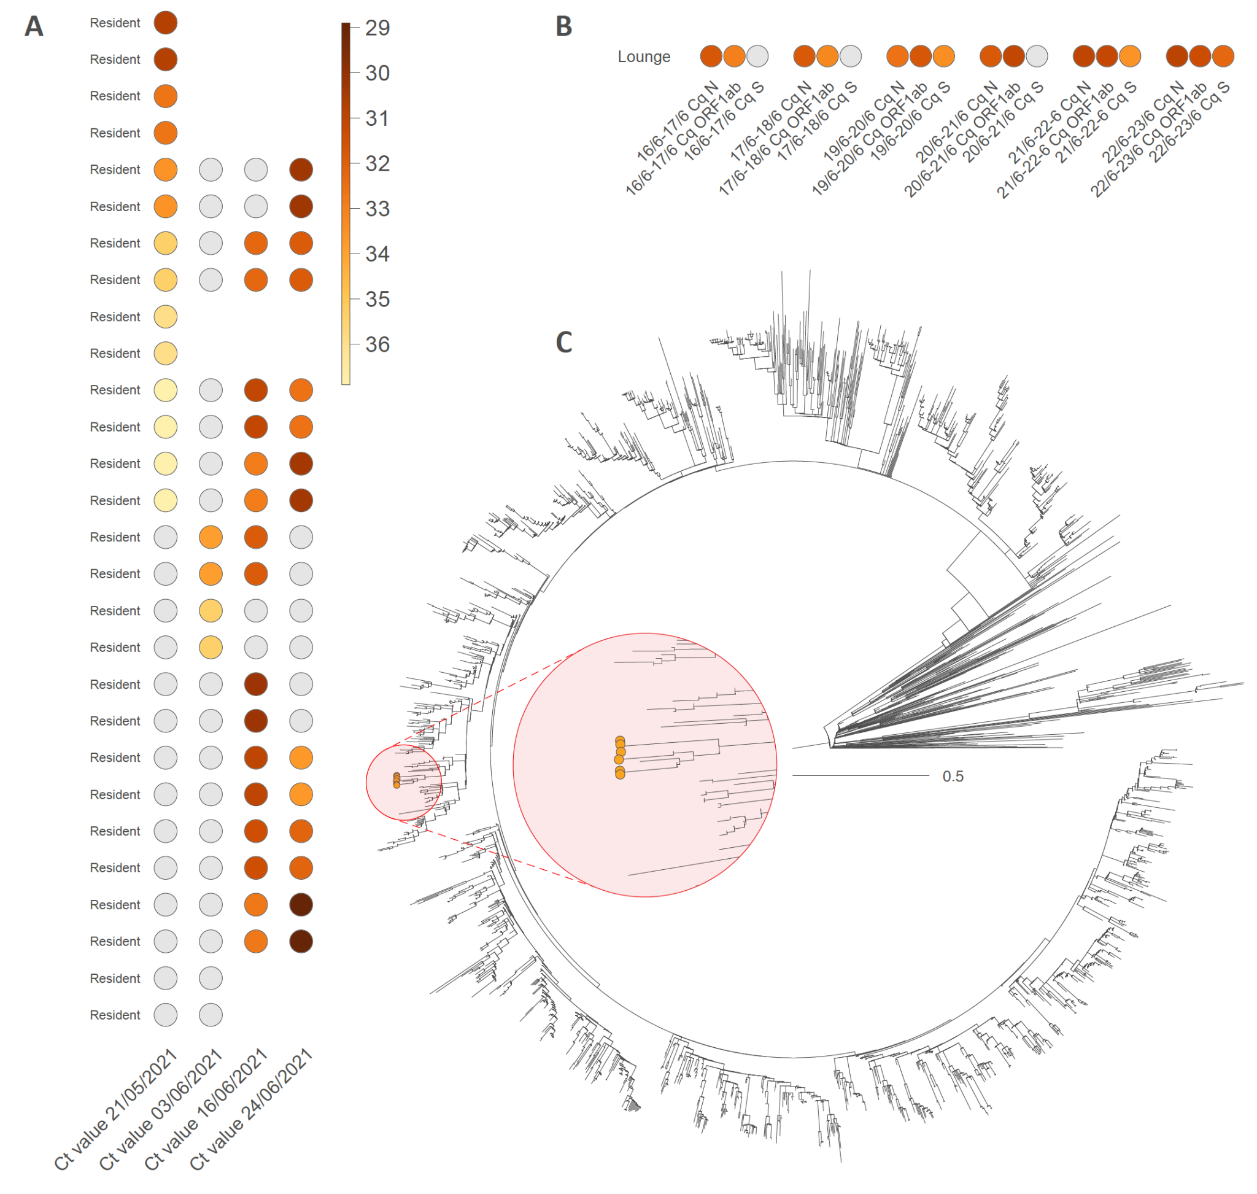
Supplementary Figure 1: Overview of the outbreak in nursing home B (Gamma/P.1). We report the evolution through time of Ct values measured in both infected resident members (A) and aerosols analyzed in the lounge of the nursing home (B). Grey dots refer to negative PCR results. In addition, we also report the time-scaled phylogenetic analysis involving Gamma (P.1) genomes sampled and sequenced from this outbreak (C), showing one phylogenetic cluster of 6 infections (orange dots) likely corresponding to a single introduction event into nursing home B.

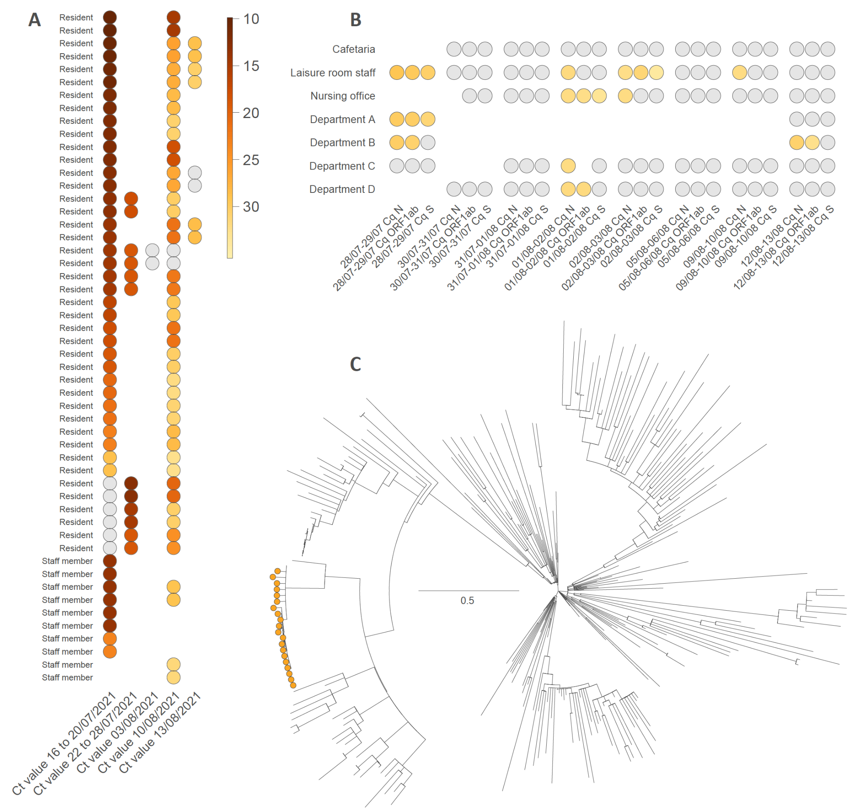
Supplementary Figure 2: Overview of the outbreak in nursing home C (Mu/B.1.621). We report the evolution through time of Ct values measured in both infected resident/staff members (genes) (A) and aerosols analyzed in various sections within the nursing home (B). Grey dots refer to negative PCR results. In addition, we also report the time-scaled phylogenetic analysis involving Mu (B.1.621) genomes sampled and sequenced from this outbreak (C), showing one phylogenetic cluster (with short branch lengths) of 20 infections (orange dots) likely corresponding to a single introduction event.

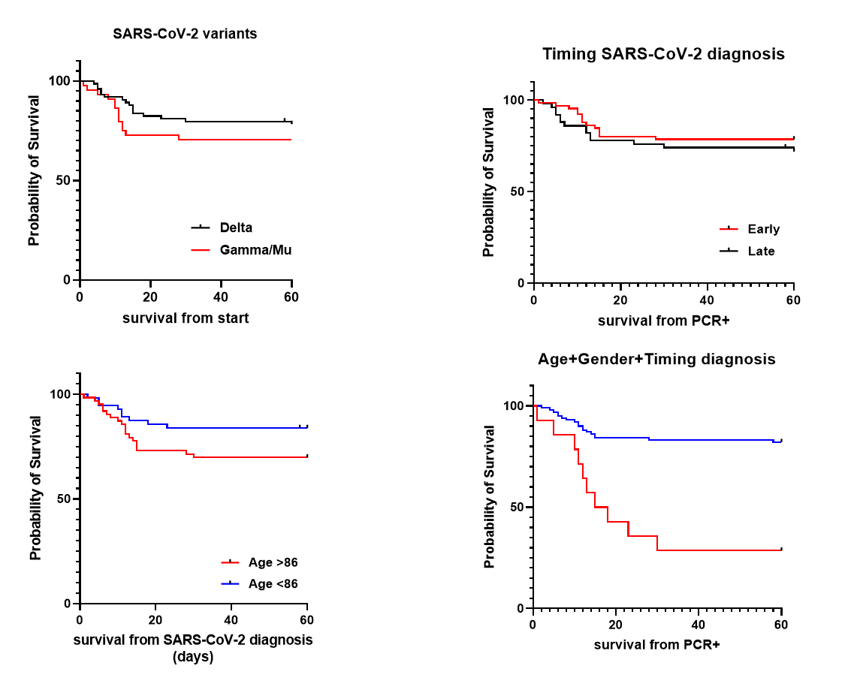

Supplementary Figure 3: Kaplan-Meier survival curves comparing (A) SARS-CoV-2 variants Delta vs. non-Delta (Gamma/Mu, Log-rank test, p=0.28), (B) Age above or below the median (86 years, Log-rank test, p=0.0078); (C) Timing of SARS-CoV-2 diagnosis (PCR+): early (0-7 days) vs. late (>7 days), with regard to the start of the respective outbreaks, Log-rank test, p=0.40; (D) Combined probability of age, sex, variant, and timing of diagnosis (Log-rank test, p<0.0001).

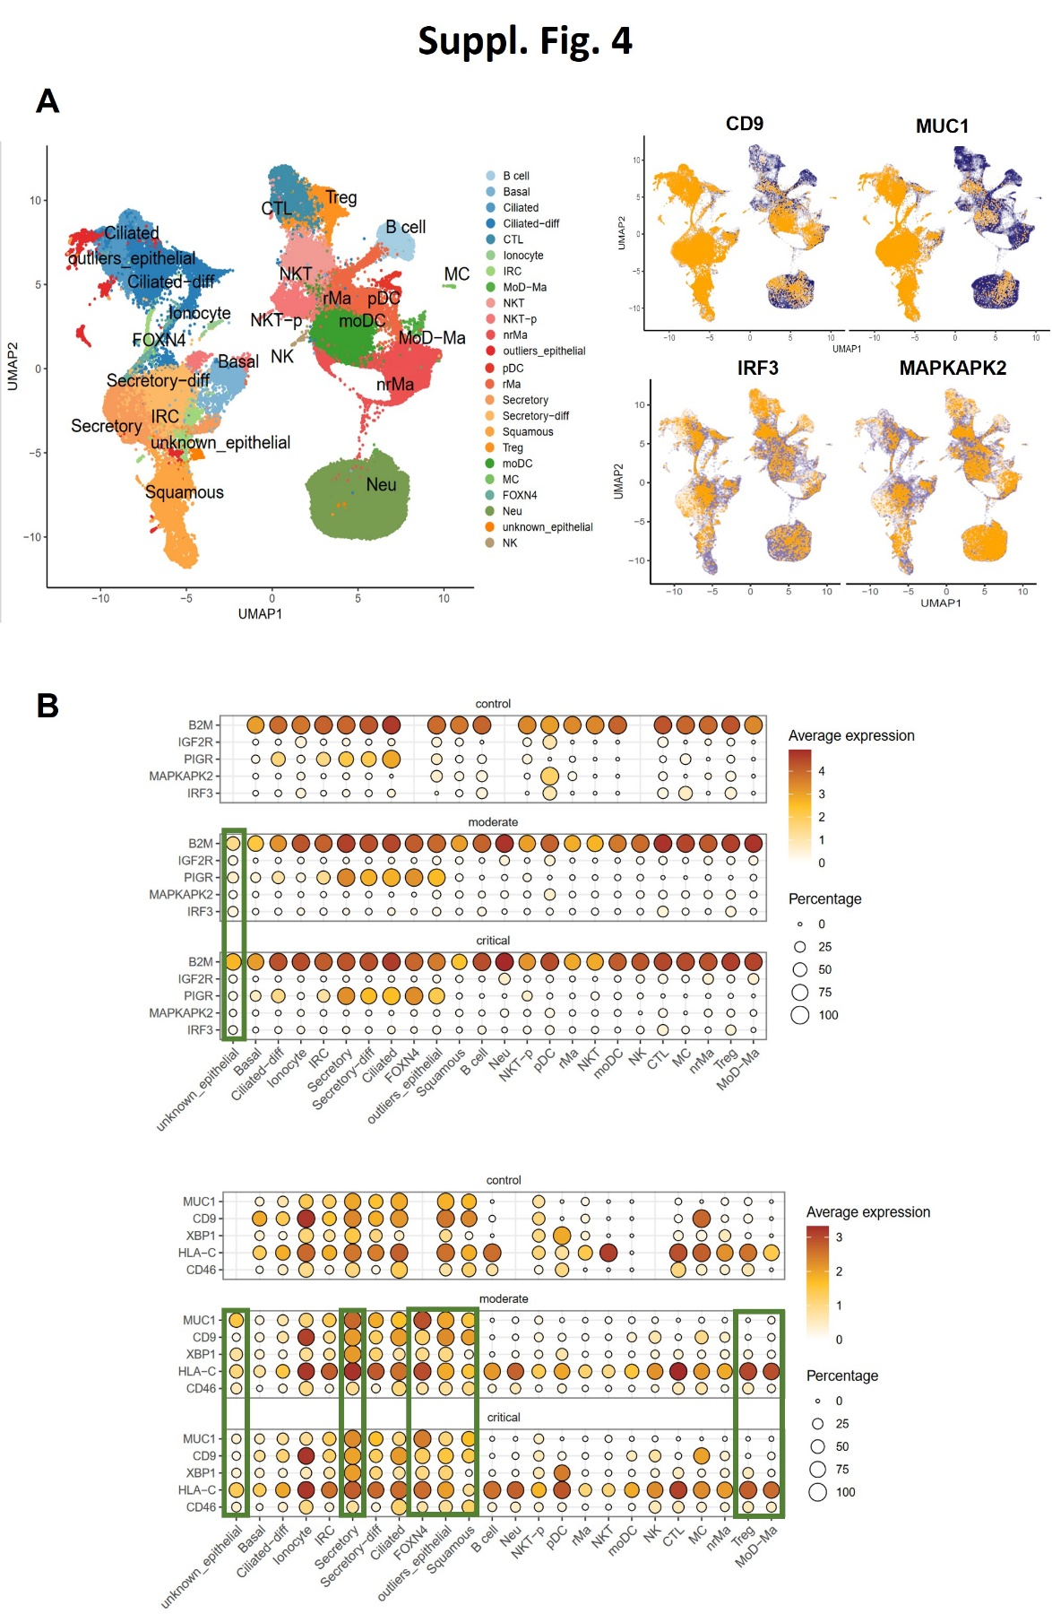

Supplementary Figure 4: Reanalysis of single-cell RNAseq data
Reanalysis of publicly available single-cell RNAseq data²⁶ shows cell-specific expression of strongest down-regulated genes in fatal cases. (A) UMAP plot of single-cells from all controls and patients (blue) with overlaid normalized expression of selected genes (yellow). (B). Green boxes show replicated findings of gene- and/or cell-specific up-regulation between post-vaccine (fatal COVID-19, this study) and pre-vaccine data sets (moderate vs critical COVID-19).
Supplementary tables
Supplementary table 1: Detailed demographic and clinical characteristics of nursing home residents and staff involved in the three post-vaccination outbreaks
Characteristics |  | Nursing home A  Delta | Nursing home B  Gamma | Nursing home C  Mu
Median age (range)
Residents |  | 87 (63 – 102) | 82 (59 – 98) | 87 (64 – 103)
Staff |  | 37 (17 – 82) | 42 (28 – 62) | 34 (15 – 74)
Sex – number (%)
Male |  | 71 (26.5%) | 11 (23.9%) | 77 (25.2%)
Female |  | 197 (73.5%) | 35 (76.1%) | 229 (74.8%)
Start vaccination residents |  | 08/01/2021 | 12/01/2021 | 26/01/2021
Vaccination rate (PCR+)
Fully | Overall  Resident  Staff | 81.9% (86.8%)  96% (94.6%)  66% (50.0%) | 73.9% (89.5%)  86.2% (89.5%)  52.9% (-) | 98.2% (100%)  98.0% (100%)  98.7% (100%)
Partially | Overall  Resident  Staff | 2.6% (2.2%)  1% (1.4%)  5.3% (11.1%) | 13.0% (10.5%)  13.8% (10.5%)  11.8% (-) | 0.4% (-)  0.7% (-)  -
Not | Overall  Resident  Staff | 15.5% (11.0%)  3% (4.1%)  28.7% (38.9%) | 13.0% (-)  -  35.3% (-) | 1.3% (-)  1.3% (-)  1.3% (-)
First documented case |  | 17/05/2021 | 20/05/2021 | 20/07/2021
PCR positivity
Overall |  | 38.1% (102/268) | 41.3% (19/46) | 7.8% (24/306)
Residents |  | 62.5% (75/120) | 65.5% (19/29) | 12.0% (20/166) 69.0% (20/29)⁴
Staff |  | 17.1% (25/146)¹ | - | 2.9% (4/140)
Fatality rate
Overall |  | 14.7% (15/102) | 36.8% (7/19) | 29.1% (7/24)
Residents |  | 20.0% (15/75)² | 36.8% (7/19)³ | 35.0% (7/20)⁵
Symptoms (for PCR+)
Presence |  | 48.0% (49/102) | 57.9% (11/19) | 58.3% (14/24)
Absence |  | 25.5% (26/102) | 42.1% (8/19) | 41.7% (10/24)
Unknown |  | 26.5% (27/102) | - | -
* Only persons for whom status (resident or staff member or other) was known and for whom information was available with respect to SARS-CoV-2 infection status, were considered to calculate the different rates. For nursing home C, the three isolated Delta cases were not considered to be part of the Mu outbreak. For all three nursing home outbreaks, both students and volunteers are included in the group of staff members, partially explaining a lower vaccination coverage in this group compared to the older residents. All residents as well as most staff members received the Comirnaty (Pfizer) vaccine.

¹ Two additional family members of the staff were SARS-CoV-2 PCR-positive.
² An additional resident died, although not SARS-CoV-2 PCR-positive.
³ Although one fatal case was not SARS-CoV-2 PCR positive, this death was classified as COVID-19-related due to severe respiratory symptoms and recent close contact with positive residents.
⁴ Considering only the 29 residents of the two affected departments, positivity rates increase up to 69.0%.
⁵ An additional resident died, not SARS-CoV-2 PCR positive, with death considered not-COVID-19 related.
Supplementary Table 2: Multivariable Logistic Regression of Demographic and Clinical Characteristics of Residents with COVID-19 (sensitivity analysis¹)
 | Model 1 |  | Model 2 |  | Model 3* |  | Model 4
Variable | Odds ratio | 95% CI | Odds ratio | 95% CI | Odds ratio | 95% CI | Odds ratio | 95% CI
Gender[M] | 3.56 | 1.17-11.33 | 3.55 | 1.29-10.1 | 5.96 | 1.75-22.63 | 6.19 | 1.77-24.38
Age | 1.12 | 1.04-1.21 | 1.08 | 1.02-1.16 | 1.15 | 1.06-1.25 | 1.16 | 1.07-1.28
SARS-CoV-2 Gamma/Mu | - | - | 1.74 | 0.71-4.32 | 4.54 | 1.38-17.10 | 4.83 | 1.42-18.93
Late PCR+ | - | - | - | - | 3.28 | 1.04-11.58 | 3.80 | 1.12-14.75
Dementia | - | - | - | - | - | - | 1.05 | 0.37-3.07
Diabetes | - | - | - | - | - | - | 0.98 | 0.26-4.01
Nadir Cq value | - | - | - | - | - | - | 1.02 | 0.96-1.08
¹Excluding unvaccinated, partly vaccinated residents and infected residents without a PCR-positive test (diagnosed by a rapid antigen test)
*Model 3 was the best model, according to corrected Akaike's Information Criterion (AICc), significant variables in bold

Supplementary Table 3: Multivariable Logistic Regression of Demographic and Clinical Characteristics of Residents with COVID-19 (each nursing home separately)
 | Nursing home A  ‘Delta’ |  | Nursing home B ‘Gamma’ |  | Nursing home C  ‘Mu’
Variable | Odds ratio | 95% CI | Odds ratio | 95% CI | Odds ratio | 95% CI
Gender[M] | 43.72 | 3.51-1195 | 52.38 | 1.21-20117 | 0.75 | 0.02-19.22
Age | 1.32 | 1.13-1.66 | 1.20 | 0.97-1.64 | 1.01 | 0.76-1.30
Late PCR+ | 14.68 | 1.79-230.7 | 15.19 | 0.21-3571 | - | -
Other drugs¹ | 0.015 | 0.001-0.16 | - | - | - | -
Dementia | - | - | - | - | 0.02 | 0.001-0.30
Nadir Cq value | - | - | 1.78 | 1.04-4.51 | - | -

Best models, according to corrected Akaike's Information Criterion (AICc),
Significant variables in bold
¹Any prescription drugs not belonging to the following categories: ACE inhibitors, anti-hypertensives, Proton Pump Inhibitors, statins, corticosteroids (or other immunosuppressants), psychotropics/antidepressants, metformin.

Supplementary Methods
Quantification of viral loads
Aerosol samples were collected using the AerosolSense instrument (Thermo Fisher Scientifics), sampling 200 liters of room air per minute, for a total of 18-26h. Viruses are trapped on the collection substrate of a removable sample cartridge (Thermo Fisher Scientifics), followed by lysis in transport buffer (DNA/RNA Shield, Zymo Research).

RNA extraction was performed using the DEXR-15-LM96 kit for automated extraction (Diagenode, Seraing, Belgium) with 350 μl sample input. Samples were spiked with a purified MS2 bacteriophage as internal control according to the manufacturer's instructions (Thermo Fisher Scientific, A47817). Extracted RNA was eluted from magnetic beads in 50 μl of UltraPure DNase/RNase free distilled water. RT-PCR testing was performed with the TaqPath COVID-19 CE-IVD RT-PCR kit (Thermo Fisher Scientific). Results were analyzed using the FastFinder analysis software (Ugentec, Belgium) and expressed as a quantification cycle (Cq) for the ORF1ab, N, and S gene targets. Samples were reported negative when all viral gene targets were above a Cq value of 37 and when the MS2 internal control Cq value was lower than 27.5.

Whole-genome sequencing and phylogenetic analyses
Samples with a sufficiently high viral load (>1000 RNA copies/ml) were analyzed using whole-genome sequencing. An automatic RNA extraction was performed using the MagMAx Viral / Pathogen kit II (MVPII) (Thermo Fisher Scientific, A48383) with 200 μl sample input. The genomes were amplified following the ARTIC network protocol V3 or V4 ¹ or as described by Freed et al.². After clean-up of the amplicons, libraries were prepared using the SQK-LSK109+EXP-NBD196 ligation sequencing kit from Oxford Nanopore Technologies. Subsequently, the libraries were quantified, and sequencing was performed on a GridION platform using MinKNOW’s built-in basecalling, demultiplexing and adapter trimming. Sequencing runs were processed using the ARTIC analysis pipeline and custom scripts. Full-length genome sequences accompanied with metadata were submitted to GISAID (see list of accession IDs). SARS-CoV-2 lineage assignments were derived using the Pangolin tool and Nextclade (https://clades.nextstrain.org/). The following GISAID IDs corresponding to SARS-CoV-2 genomes were generated as part of this study:
EPI_ISL_2289002, EPI_ISL_2301430, EPI_ISL_2304141, EPI_ISL_2304143, EPI_ISL_2348574-78, EPI_ISL_2348580-86, EPI_ISL_2348587-92, EPI_ISL_2626083-96, EPI_ISL_2864473-74, EPI_ISL_2864478, EPI_ISL_2864483, EPI_ISL_2864485, EPI_ISL_2864489, EPI_ISL_2864573-76, EPI_ISL_2864707-10, EPI_ISL_2864714-15, EPI_ISL_2864717-21, EPI_ISL_2886237, EPI_ISL_3118412-26, EPI_ISL_4007338, EPI_ISL_4008034, EPI_ISL_4008052, EPI_ISL_4348705, EPI_ISL_4348711, EPI_ISL_4348959, EPI_ISL_4354278, EPI_ISL_4358318, EPI_ISL_4571448-51, EPI_ISL_5349110

To analyze the evolutionary relationships among infectious cases, we performed a distinct phylogenetic analysis, each time focused on one of three variants involved in a specific nursing home outbreak. For each nursing home, the phylogenetic analysis was based on an alignment made of (i) the viral genomes collected in the considered nursing home and sequenced in the context of the present study, as well as (ii) the genomic sequences of the same variant available for Belgium at the time of the outbreak, and (iii) a subtree of the European Nextstrain build containing all the genomic sequences of that variant at the time of the outbreak. Other sequences ancestrally related in the Nextstrain build to the variants under study were included to ensure sufficient temporal signal for a molecular clock calibration. To construct the multiple sequence alignments, we mapped each data set against the reference sequence EPI_ISL_406801 using minimap2 v2.20-r1061 ⁶ and trimmed the data to positions 265-29,674 to mask out 3' and 5' untranslated regions. To obtain a maximum-likelihood phylogeny, we ran IQ-TREE 2.0.3 ³ using a general time-reversible (GTR) model ⁴ of nucleotide substitution with empirical base frequencies and four free site rate categories,⁷ which was selected as the optimal model using IQ-TREE’s ModelFinder tool. We then time-calibrated the phylogeny using TreeTime 0.8.4 ⁵ and set to filter samples that deviated more than four interquartile ranges from a root-to-tip regression.⁸ The final alignments were made of 1728 genomic sequences for nursing home A (Delta; 1128 from Belgium, 58 from the nursing home), 2341 for nursing home B (Gamma; 2036 from Belgium, 6 from the nursing home), and 289 for nursing home C (Mu; 28 from Belgium, 20 from the nursing home).

Supplementary References:
1. Quick J. nCoV-2019 sequencing protocol. Available on https://artic.network/ncov-2019.
2. Freed NE, Vlkova M, Faisal MB, Silander OK. Rapid and inexpensive whole-genome sequencing of SARS-CoV-2 using 1200 bp tiled amplicons and Oxford Nanopore Rapid Barcoding. Biology Methods and Protocols 2020;5.
3. Minh BQ, Schmidt HA, Chernomor O, Schrempf D, Woodhams MD, von Haeseler A, Lanfear R. IQ-TREE 2: new models and efficient methods for phylogenetic inference in the genomic era. Mol. Biol. Evol 2020;37(5):1530–1534.
4. Tavaré S. Some probabilistic and statistical problems in the analysis of DNA sequences. Lectures Math. Life Sci 1986;17:57–86.
5. Sagulenko P, Puller V, Neher RA. TreeTime: Maximum-likelihood phylodynamic analysis. Virus Evol 2018;4:vex042.
6. Heng L. Minimap2: pairwise alignment for nucleotide sequences. Bioinformatics 2018;34(18):3094-3100.
7. Yang Z. A space-time process model for the evolution of DNA sequences. Genetics 1995;139:993–1005.
8. Dellicour S, Durkin K, Hong SL, et al. A phylodynamic workflow to rapidly gain insights into the dispersal history and dynamics of SARS-CoV-2 lineages. Mol. Biol. Evol 2021;38(4):1608-1613.

