Supplementary materials
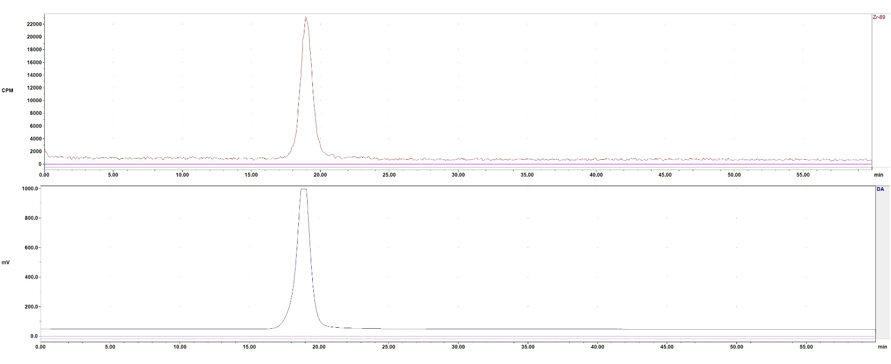
(A)

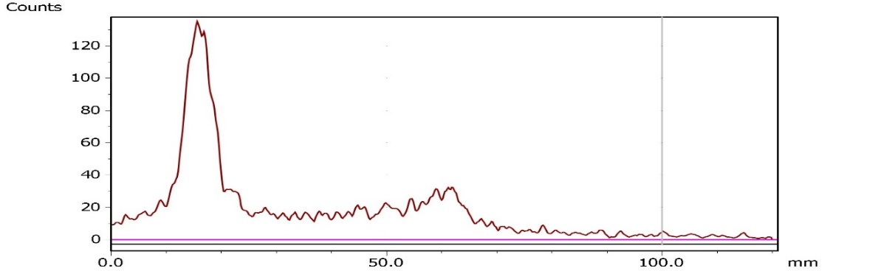
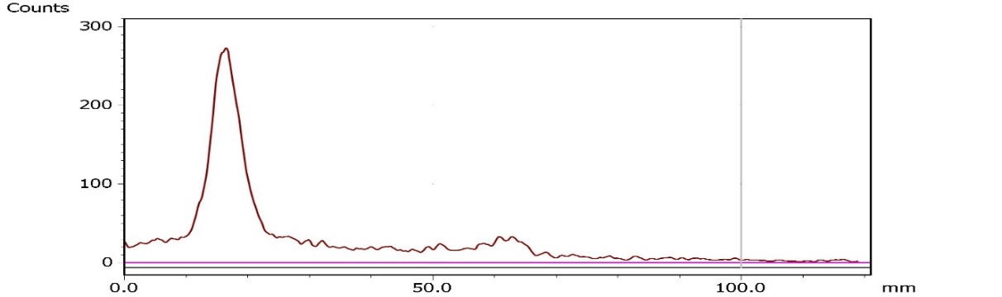
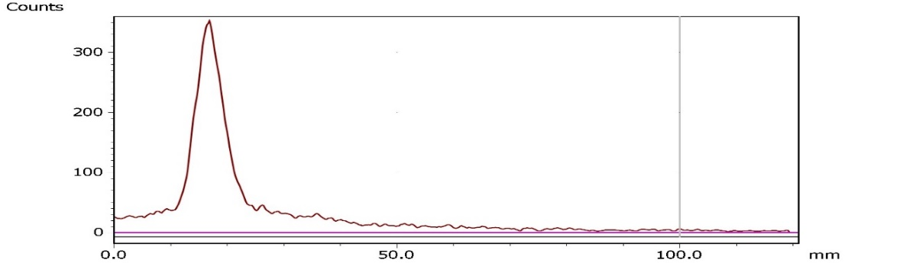
(B)

Figure S1: (A)The SEC-HPLC profile of ⁸⁹Zr-Lipo680 with radio (upper) /UV (bottom) signals. The purity of ⁸⁹Zr labelled lipo680 was >90% (92% recovery) in both radio and UV detection. (B) Radio-TLC stability test of ⁸⁹Zr-Lipo680 in buffer for 1, 24, 72 hours post labeling (top to the bottom).

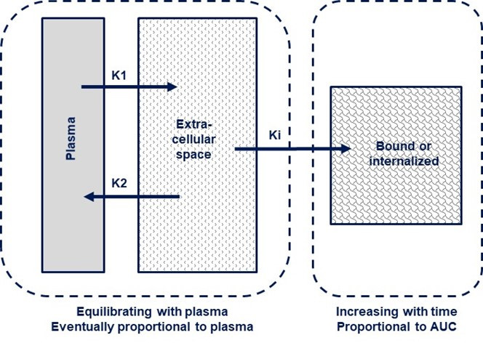

Figure S2. A simplified compartment model for ⁸⁹Zr-labelled liposomes
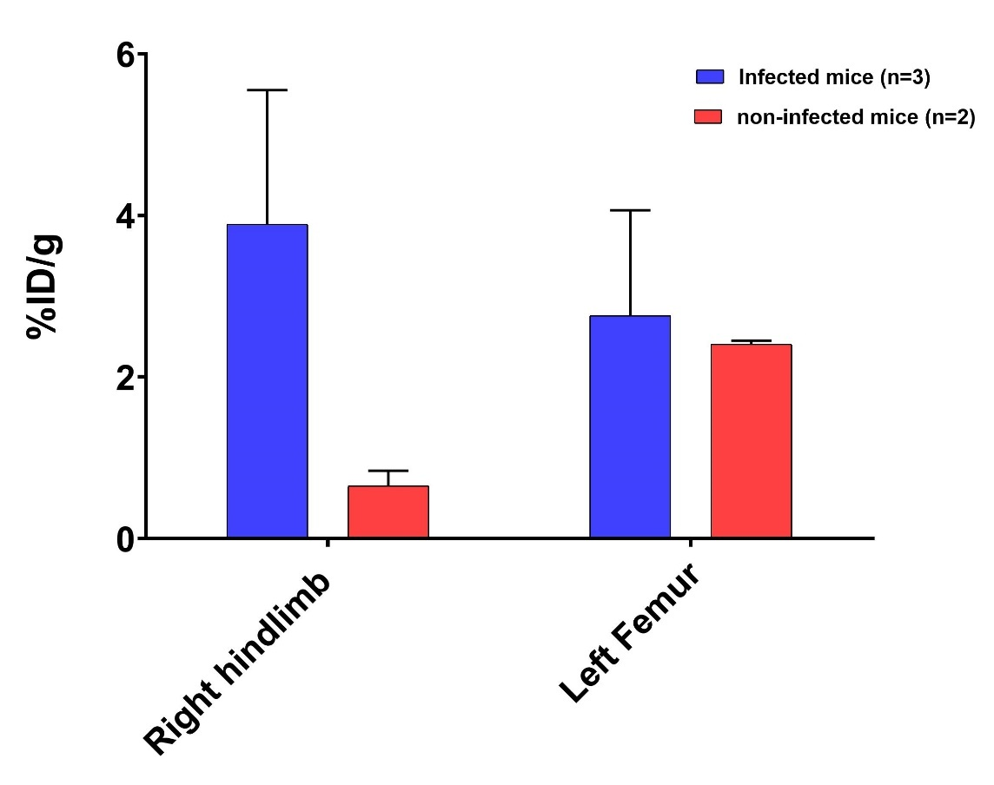

Figure S3. ⁸⁹Zr-GSK2485680 (Lipo680) distribution in ex vivo tissues collected at 168 hours post dose from naïve mice and mice with E. coli hindlimb infection. %ID/g = % of injection dosage (radioactivity)/ gram of tissue.

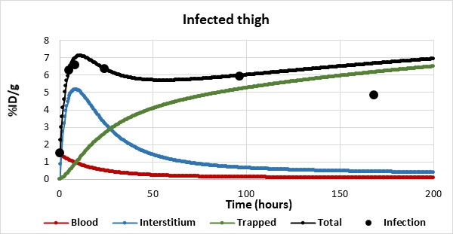
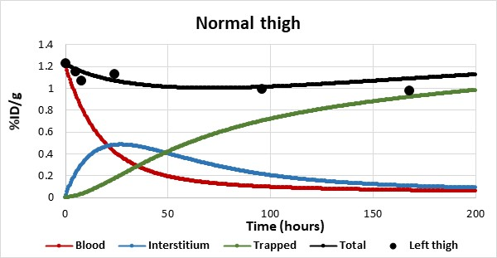
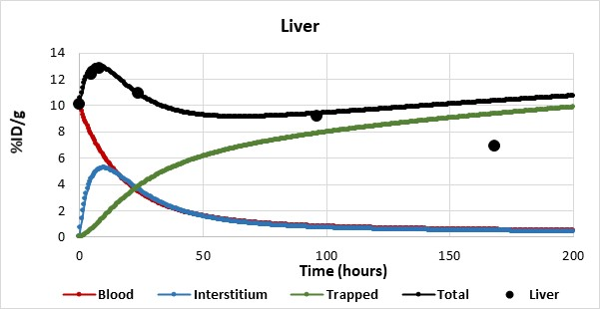
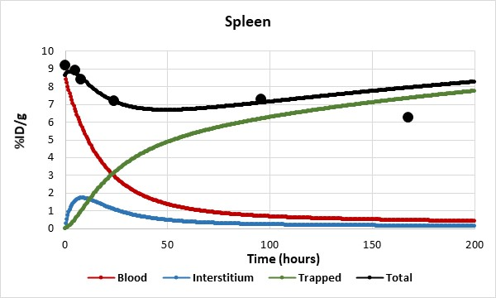
Figure S4. Kinetic uptake curves in different tissues, including fitted graphs for blood and interstitial space contributions plus estimates of time course of contribution to an irreversible binding. The initial blood data fitted to a mono-exponential function. Of note, we have omitted the very late time point of 7 days (168 hours) in this analysis. We reason that at such late time point other factors may influence the readings, including that phagocytic cells like macrophages may have engulphed cells and cell debris and trafficked out of the tissue, carrying with them part of the radioactivity.

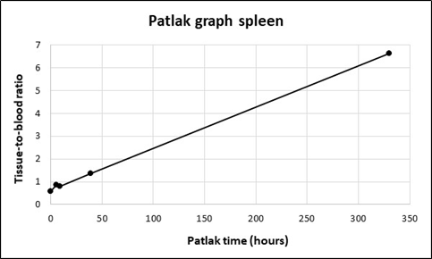

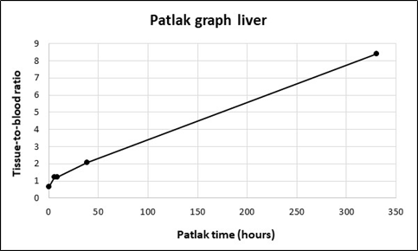
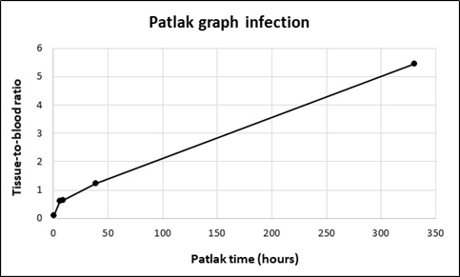
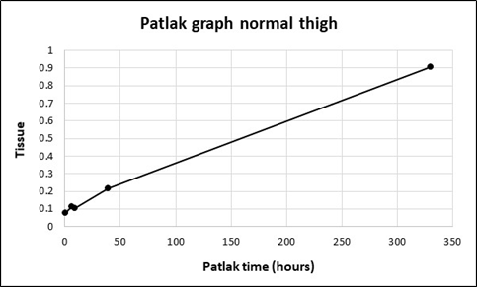

Figure S5. Patlak graphs from the 168 hours group.

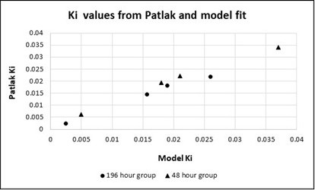
Figure S6. Ki values obtained by linear regression from Patlak plots (last two values) for different structures compared to Ki values obtained through model fit.

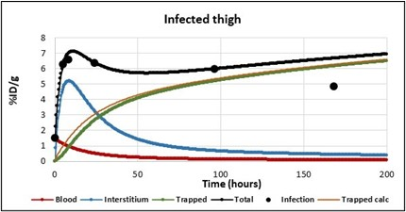
Figure S7. Components making up the tissue uptake in infected hindlimb. The thin black line represents the predicted trapped portion obtained by multiplying blood AUC with the Patlak slope obtained from linear regression of the time points at 24 and 98 hours.

