Supplementary Information
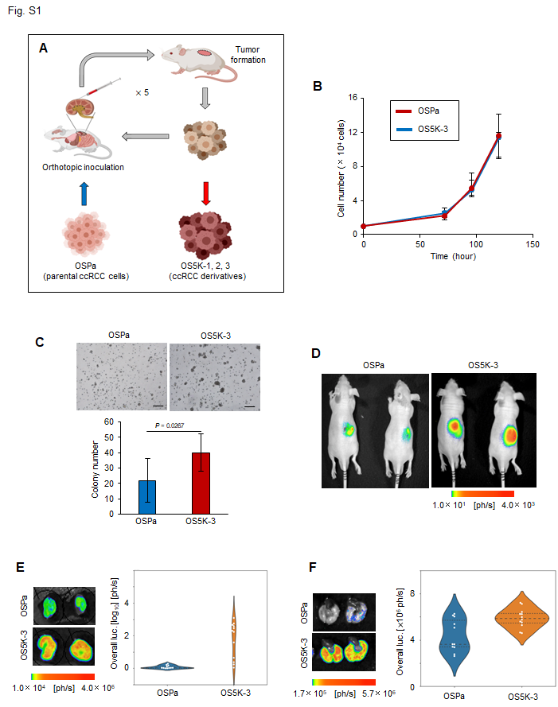

Fig. S1. Establishment of ccRCC derivatives using serial orthotopic transplantation model. A. Schematic of the experimental procedure. B. Cell proliferation assay. Cells were seeded for 3-5 days and counted. The bars represent the mean ± SD (two-sided Student’s t-test) C. Colony formation assay. Cells were seeded into soft agar and cultured for 15 days. Representative photographs (top). Scale bar, 200 µm. Colony number was quantified (bottom). The bars represent the mean ± SD (two-sided Welch’s t-test, n = 15) D. In vivo bioluminescence imaging of the primary tumor. OS-RC-2 derivatives were inoculated into mice and analyzed after 17 days. E, F. Ex vivo bioluminescence imaging of the primary (E) and metastatic lung (F) tumors in mice in D. The mice were sacrificed 17 days after the inoculation. Representative images (left) and their quantification (right). The bars represent the mean and 1st and 3rd quartiles (E: two-sided Welch’s t-test; F: two-sided Student’s t-test; n = 11, OSPa; n = 12 OS5K-3).
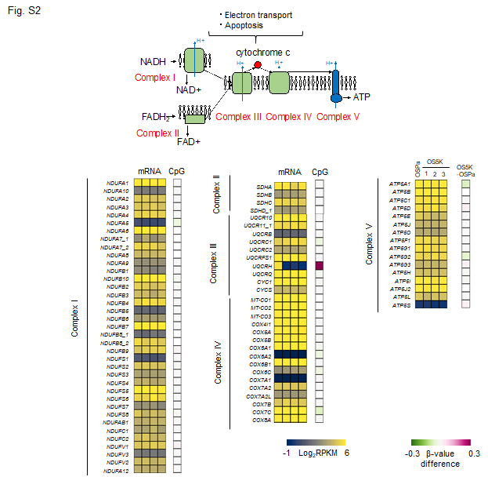
Fig. S2. Expression and methylation status of genes encoding electron transport chain components in OS-RC-2 derivatives. Diagram of electron transport chain in mitochondrial inner membrane (top). Expression and methylation status of genes encoding electron transport chain components in OSPa, OS5K-1, OS5K-2, and OS5K-3 cells (bottom). Heatmap shows the gene expression in each cell in Fig. 3B (mRNA) or the β-value difference between the OS5K and OSPa cells in each promoter CpG locus in Fig. 3A (methylation status in CpG).

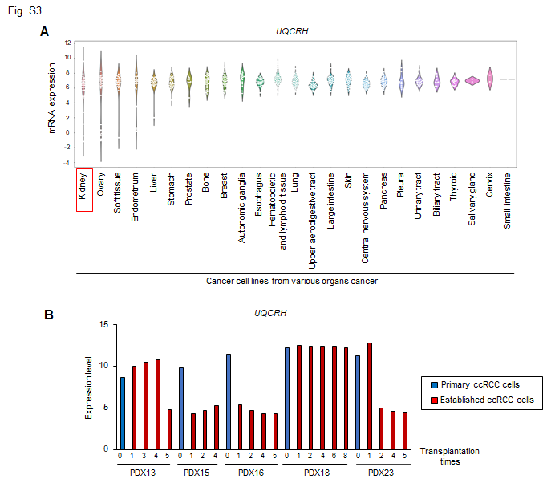
Fig. S3. Clinical significance of UQCRH downregulation in human cancers. A. UQCRH mRNA expression in cancer cell lines derived from the indicated organs using the data set from the Broad Institute Cancer Cell Line Encyclopedia. B. Decreased UQCRH expression in ccRCC cells in patient-derived xenograft (PDX) models. Data set from the NCBI Gene Expression Omnibus (GEO) database (GSE83820) was analyzed. Blue bars indicate the UQCRH mRNA levels in parental ccRCC cells derived from patients. Red bars indicate the UQCRH mRNA levels in cells after orthotopic inoculation into mice (n = 5).
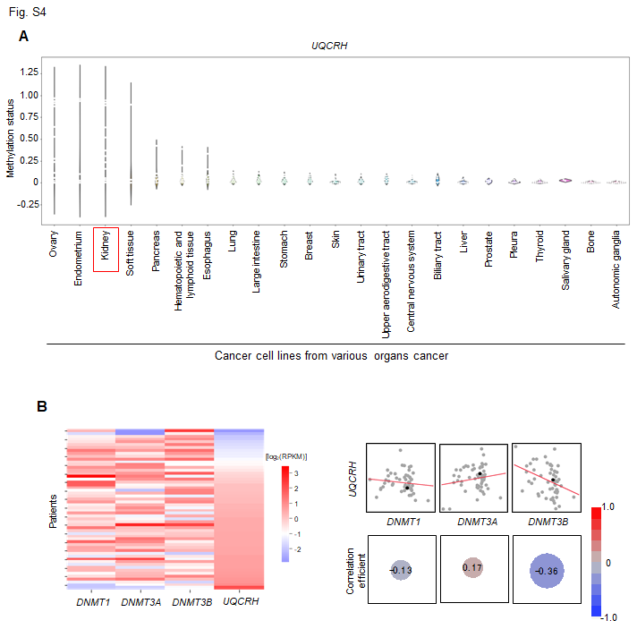
Fig. S4. Correlation between DNA methylation and UQCRH expression in human cancers. A. Methylation status of the UQCRH promoter locus in cancer cell lines derived from the indicated organs. Data set from Broad Institute Cancer Cell Line Encyclopedia were analyzed. B. Correlation between UQCRH expression and DNMT expression in ccRCC patients. Data set from TCGA was analyzed. Heatmap shows the expression of UQCRH, DNMT1, DNMT3A, and DNMT3B (left). Correlation analysis of expression of UQCRH and DNMTs (right). The circle size and the number indicate the correlation efficient.
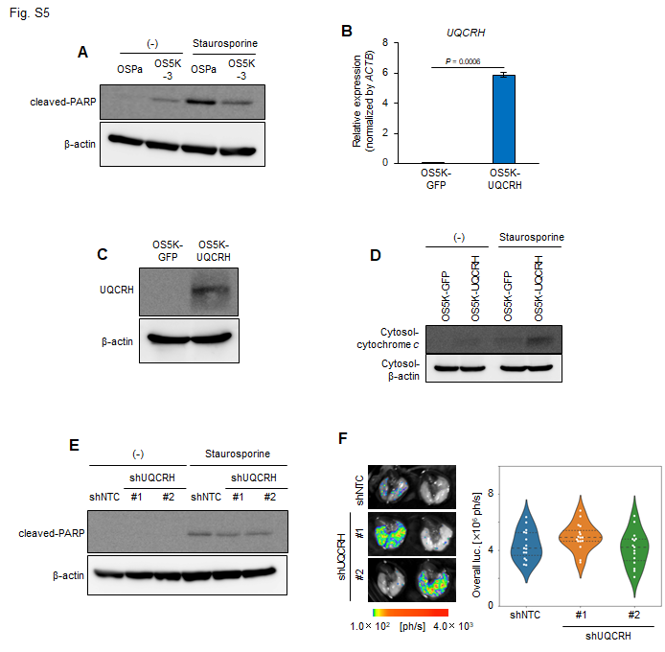
Fig. S5. UQCRH regulates the induction of apoptosis in ccRCC cells. A. Immunoblotting of cleaved-PARP and β-actin in OS-RC-2 derivatives. Cells were treated with staurosporine (50 nM) for 48 h. B, C. Overexpression of UQCRH in OS5K-3 cells. OS5K-3 cells were infected with lentiviral vectors encoding GFP (OS5K-GFP) or UQCRH (OS5K-UQCRH). UQCRH mRNA was measured using qRT-PCR analysis (B). The bars represent the mean ± SD (two-sided Welch’s t-test, n = 2). UQCRH protein was detected using immunoblotting (C). D. Immunoblotting of cytochrome c and β-actin in OS5K-3-GFP and OS5K-3-UQCRH cells. Cells were treated with staurosporine (1 µM) for 6 h. Cytosolic fraction was collected. E. Immunoblotting of cleaved-PARP and β-actin in OSPa-shNTC, OSPa-shUQCRH#1, and OSPa-shUQCRH#2 cells. Cells were treated with staurosporine (50 nM) for 48 h. F. Representative images (left) of the ex vivo bioluminescence imaging of the metastatic lung tumors in mice in Fig. 6G and their quantification (right). The bars represent the mean and 1st and 3rd quartiles (one-way ANOVA and Tukey’s test).
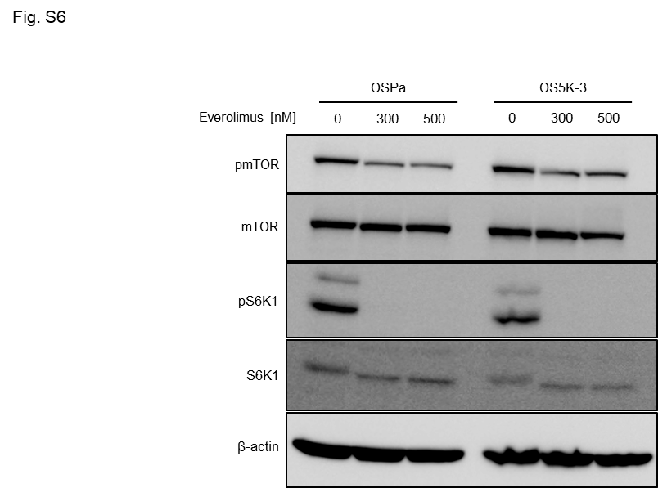

Fig. S6. Inhibition of mTOR signaling in OS-RC-2 derivatives by everolimus. Cells were treated with everolimus (0.3 or 0.5 μM) for 2 h. The indicated proteins were detected using immunoblotting.

