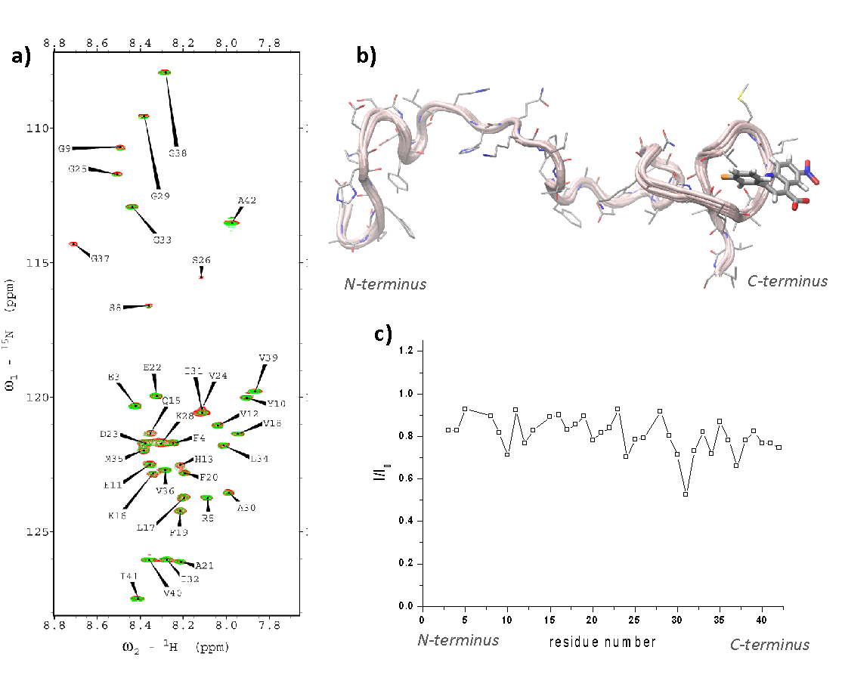
Extended Data Figure 1: NMR analysis and modelling reveal the binding site of MJ040 in the C-terminal of monomeric Aβ₄₂. a) ¹H-¹⁵N-HSQC spectrum of Aβ₄₂ (100 µM) measured (50 mM phosphate buffer, pH 7.5, 2% DMSO) in the presence (green) or absence (red) of MJ040X (500 µM). Both experimental conditions included 2% DMSO. The spectra were measured at 278K using an NMR spectrometer operating at the ¹H frequency of 700 MHz. No significant chemical shift changes were observed upon addition of MJ040X to Aβ₄₂. However, the interaction with the molecule induced broadening of the resonances, with strongest effects in I/I_{o} found in the C-terminal region (specifically in residues E31 and G37). Assignments of the resonances in ¹H -¹⁵N -HSQC spectra of Aβ₄₂ were derived from a previous study.⁶⁹ b) Modelling of the interaction between MJ040X and Aβ₄₂ conformations using an approach to identify the binding modes of small molecules with this protein⁶⁵. The programme FRED⁶⁸ was used to perform the docking of the molecule in these hot spots. c) Variation of signal intensity over the sequence of Aβ₄₂ in the presence of MJ040X (intensity of the green resonances (with MJ040X)/intensity of the background Aβ₄₂ resonance in a).

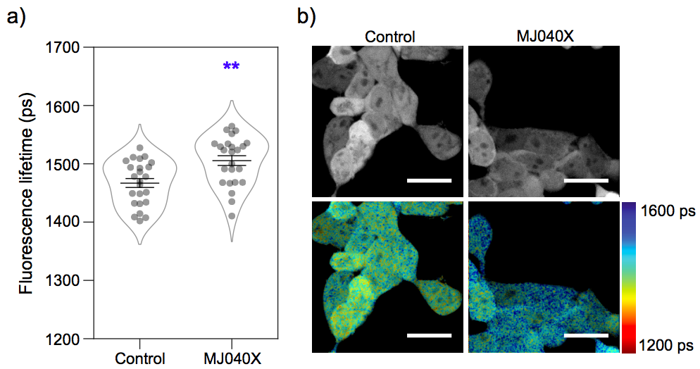

Extended Data Figure 2: MJ040X treatment increases fluorescence lifetime of mCherry-Aβ₄₂ HEK cells. Intensity-averaged fluorescence lifetimes of mCherry-Aβ₄₂ cells treated with DMSO (control) or MJ040X (2.5 μM) for 48 h. The intensity-averaged fluorescence lifetimes are 1467 ± 8 ps and 1505 ± 8 ps, for the control and MJ040X-treated cells, respectively, confirming that MJ040X does inhibit the aggregation of Aβ₄₂ inside the cell. The diagram displays mean fluorescence lifetime ± SEM. Statistical analysis was performed using an unpaired t-test, 3 biological repeats ** = p<0.01. Scale bar = 20 μm.

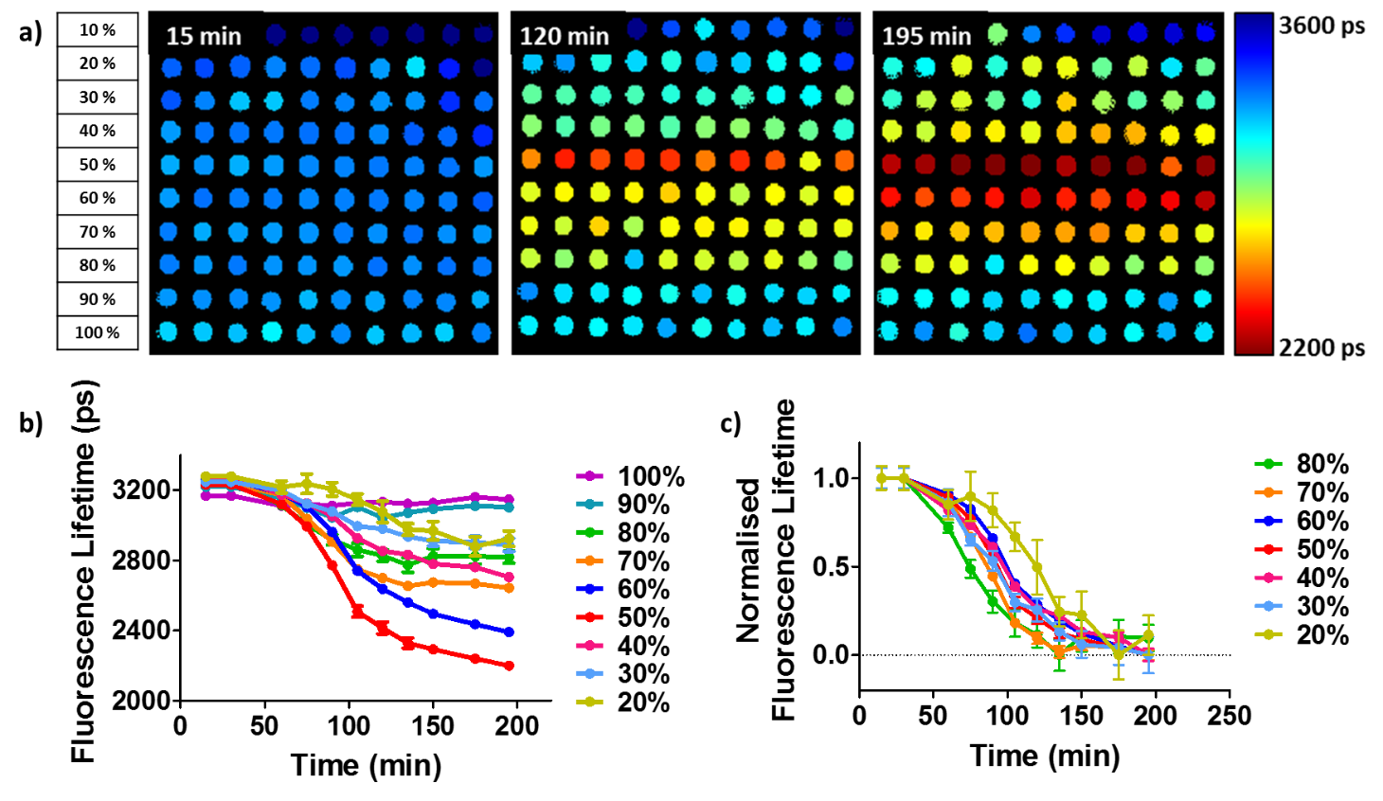
Extended Data Figure 3: Effect of labelling density on rate of peptide aggregation and change in fluorescence lifetime. a) Labelling density gradient in microfluidic chip. Each row contains 10 droplets of increasing labelled Aβ₄₂ (10 μM). b) Aggregation profiles of Aβ₄₂ at different labelling densities. 50% labelled shows the largest dynamic range. c) Normalised aggregation profiles at different labelling densities. Aggregation curves from 90% and 100% labelled Aβ₄₂ are omitted due to negligible aggregation. Plots show mean ± SEM, n = 10.

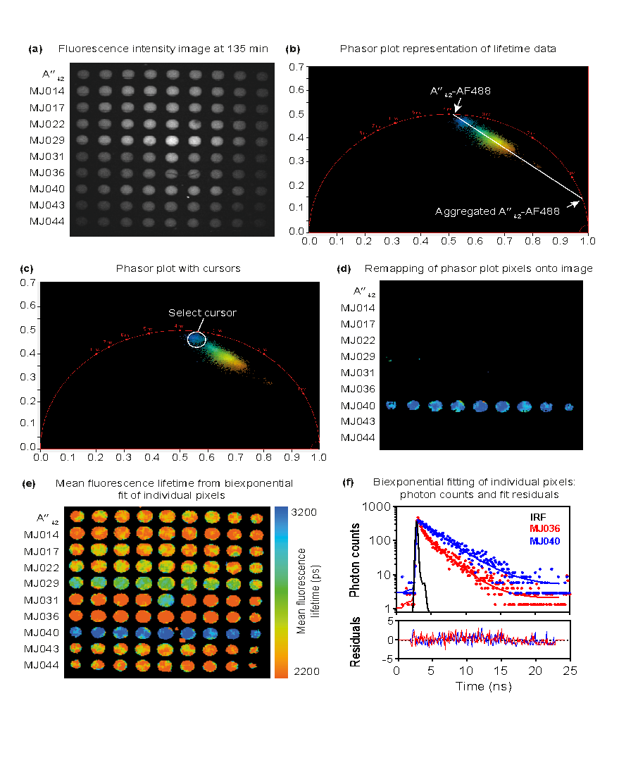
Extended Data Figure 4: Detailed analysis of compound collection screening with a phasor plot and biexponential fit. (a) Raw fluorescence intensity image of nine droplet replicates containing peptide and test compounds at the 135-minute time point. (b) Phasor plot analysis of the lifetime data from the entire nanoFLIM image. This is an unbiased analysis approach, which does not rely on a fitting model of exponential decay data. Native unaggregated Aβ₄₂ tagged with AF488 lies in the universal circle near 4 ns and fully aggregated Aβ₄₂-AF488 has a very short (quenched) fluorescence lifetime close to 1 ns. All droplets contain a mixture of these two species in different proportions. (c) The phasor plot shows a bimodal distribution in which a small subgroup of points (selected with the cursor) are closer to the native, unaggregated Aβ₄₂ species than the rest of the points. (d) Points selected by the cursor in (c) with the least amount of aggregated Aβ₄₂ correspond to the droplets containing MJ040, showing the effectiveness of the compound in inhibiting aggregation. (e) The phasor plot reveals that decay curves in image (a) are biexponential as they lie within the universal circle between two pure single exponential species. Standard biexponential fitting to decay curves are performed to extract quantitative lifetime parameters. The mean fluorescence lifetime is high for droplets containing MJ040, which shows that Aβ₄₂ aggregation is inhibited in these droplets. (f) Typical fluorescence decay curves (with a comparison between MJ036 and MJ040), biexponential fits to the raw data, and the fit residuals for individual pixels of the FLIM image. The instrument response function (IRF) for the setup is also plotted.

