Additional files

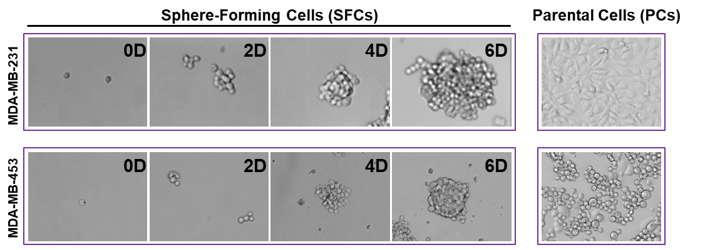
Additional file 1:

Figure S1 Culture of breast cancer stem-like cells. MDA-MB-231 and MDA-MB-453 sphere-forming cells (SFCs) were enriched from parental cells (PCs) and maintained in stem cell culture medium. These cells were further sorted by magnetic separation for the phenotype of CD44⁺/CD24⁻. The microscopic images were acquired using inverted phase contrast microscope. Original magnification: 200×.

Additional file 2
Table S1 Subcutaneous tumor formation in nude mice
Cell Types | No. of cells inoculated | Tumor incidence | Latency period (d)
MDA-MB-231-PCs | 1 x 10⁴ | 0/6 | -
MDA-MB-231-PCs | 1 x 10⁵ | 6/6 | 15
MDA-MB-231-PCs | 1 x 10⁶ | 6/6 | 8
MDA-MB-231-SFCs | 1 x 10² | 0/6 | -
MDA-MB-231-SFCs | 1 x 10³ | 1/6 | 15
MDA-MB-231-SFCs | 1 x 10⁴ | 6/6 | 7
PC, Parental Cells; SFC, Sphere-Forming Cells

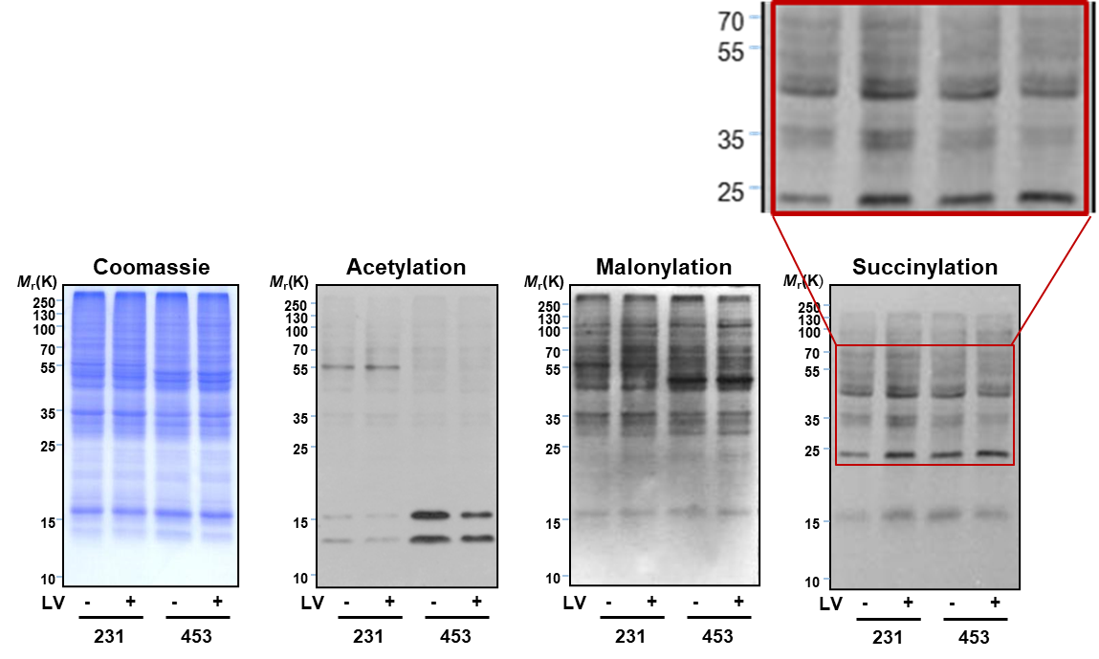
Additional file 3

Figure S2 Western blot analysis of common lysine acylations. Effect of lovastatin on the four common lysine acylation types in MDA-MB-231 vs. MDA-MB-453 CSCs. Equal amounts of proteins extracted from vehicle- or lovastatin-treated cells were separated on SDS-PAGE gels and probed each with an antibody against pan-acetyllysine (Kac), malonyllysine (Kmal), or succinyllysine (Ksucc) followed by HRP-conjugated secondary antibody incubation and ECL development. Coomassie brilliant blue staining was used as an equal-loading control.
LV, lovastatin.

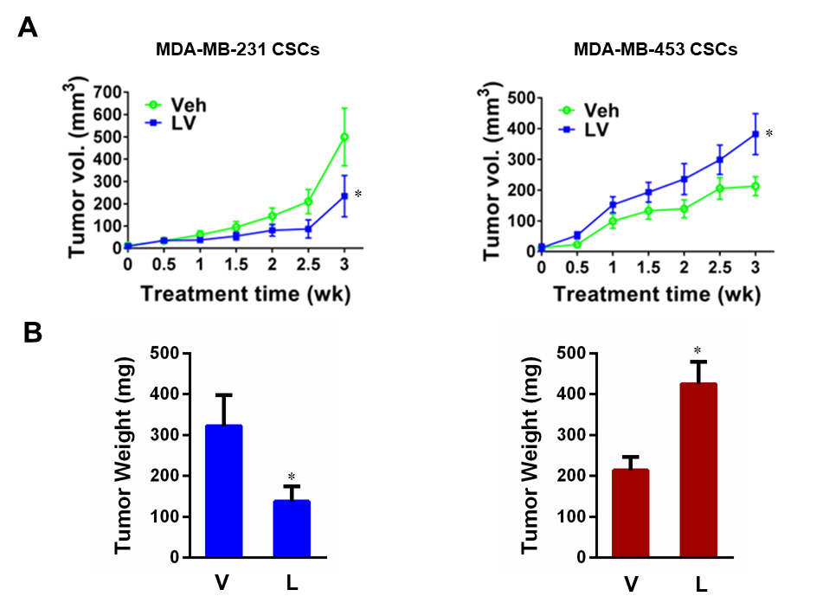
Additional file 4
Figure S3 Lovastatin suppresses growth of orthotopic tumors in nude mice derived from MDA-MB-231 CSCs but not MDA-MB-453 CSCs. a Change of tumor volume over time in different groups. b The tumor weight of the mice in different groups. Data are shown as mean ± SEM.
* P < 0.05, compared with control; V or Veh, vehicle; L or LV, lovastatin.

