Supplementary Material
Contents
Study Oversight 2
Figure S1: Global Covid-19 Cases during the Study Period 3
Figure S2: SARS-cov2 Variants in Israel during the Study Period 4
Figure S3: Transition from first-booster to second-booster status 5
Data Sources 6
Explanation on the Socio-Economic Status (SES) Measure 7
Table2: Association of Mortality Rates with Vaccination Status adjusted for Confounding Variables, Ages 60 -69 8
Table 3: Association of Mortality Rates with Vaccination Status adjusted for Confounding Variables, Ages 70 -79 9
Table 4: Association of Mortality Rates with Vaccination Status adjusted for Confounding Variables, Ages 80+ 9
Figure S4: Comparison of SARS-cov2 Infections per million in selected countries 10
References 11

Study Oversight

All the authors participated in the study design. Tanya Beckenstein extracted the data. Dr. Yaron and Dr. Peretz oversaw the data extraction; Ruslan Sergienko analyzed the data with the guidance of Prof. Friger. All authors vouch for the data and analysis. Dr. Arbel wrote the initial manuscript. All authors contributed to the writing and critical review of the manuscript and decided to submit it for publication. The study was approved by the CHS Community Helsinki committee and the CHS data utilization committee.

Figure S1: Global Covid-19 Cases during the Study Period

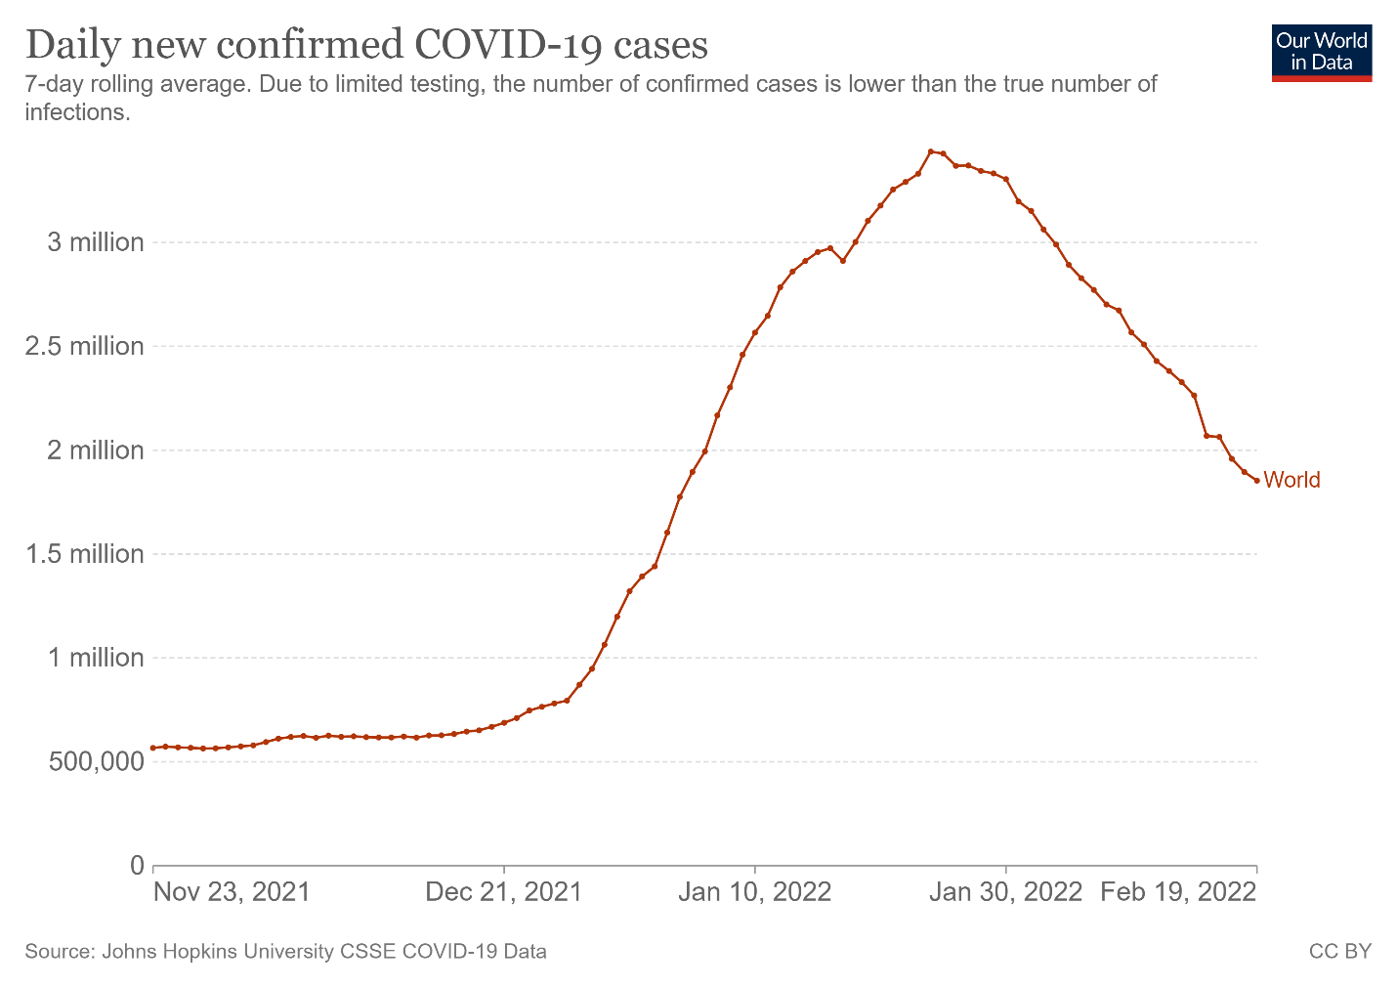

Figure S2: SARS-cov2 Variants in Israel during the Study Period

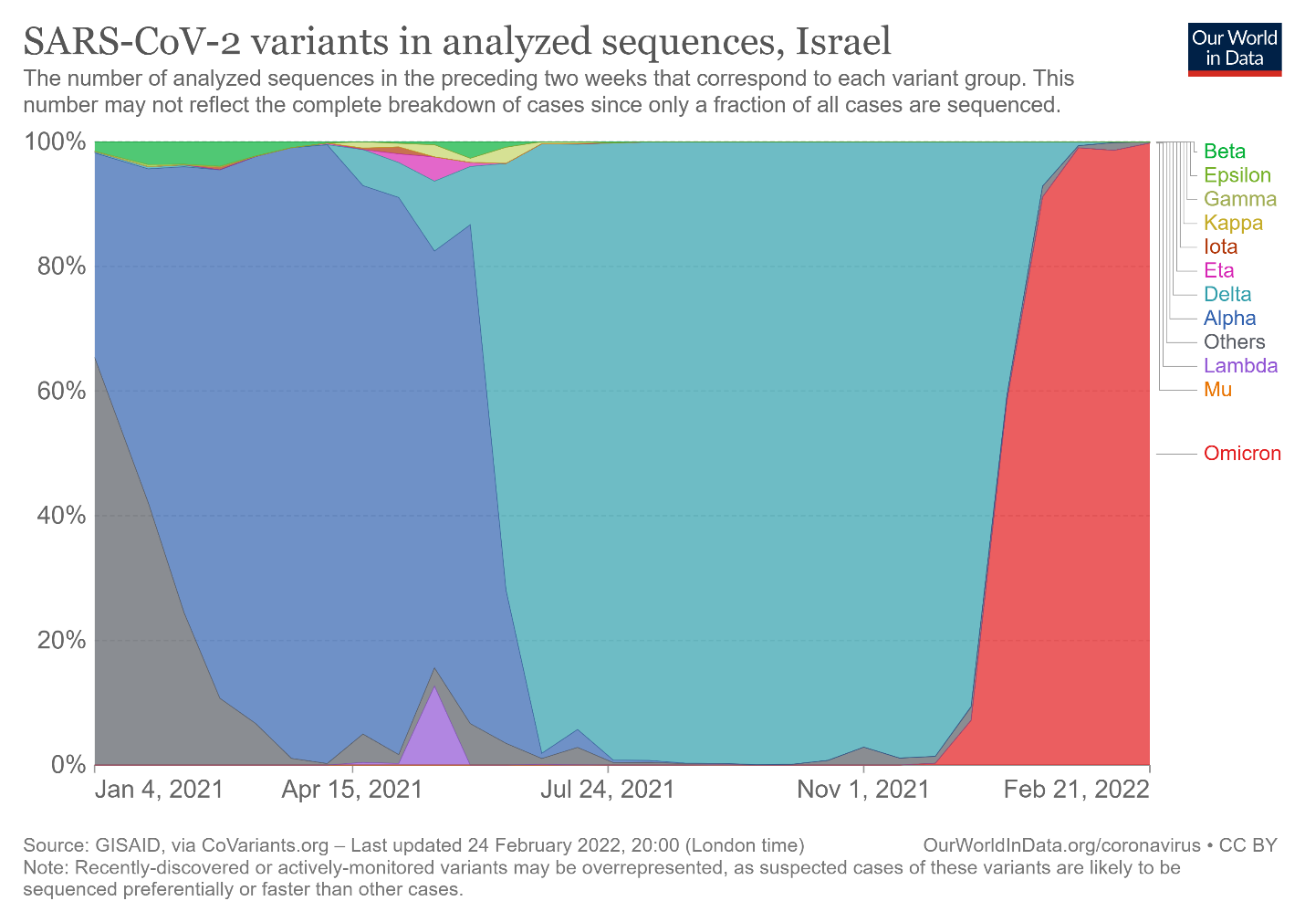

Figure S3: Transition from first-booster to second-booster status

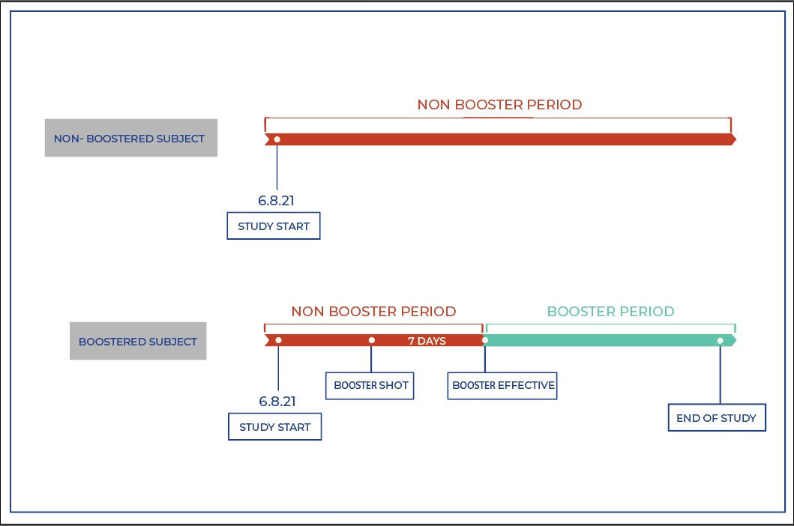
First Booster Subject

Second Booster Period
First Booster Period
First Booster Period
Second Booster Subject

Data Sources

Data in this study comes from the electronic medical records of Clalit Health
Services (CHS). CHS is the largest of four integrated payer-provider health care
organizations that provide mandatory health care coverage in Israel. CHS covers
approximately 52% of the population of Israel (4.7 million persons). The dropout
rate from CHS is 1- 2% yearly (1).
CHS pools the data from its many operational systems into a unified central data warehouse used for policy and research. This data repository includes detailed primary and secondary care information on hospitalizations, medications, laboratory results, and imaging tests. Due to the early adoption of electronic medical records and the low yearly dropout rate, CHS has good long-term follow-up of patients, ranging from the year 2000 (2).
Since the COVID-19 pandemic, the Israeli Ministry of Health (MOH) has centrally collected all COVID-19 related data. These include complete data on PCR testing, vaccination status, hospitalizations, and COVID-19 associated deaths, as reported daily to the MOH by all Israeli hospitals. The MOH transfers this data daily to the Israeli health funds (3). This allows integration of background medical information with vaccination status and COVID-19 related outcomes for the entire CHS patient population. The integrated data was used to generate the dataset for this study.

Explanation on the Socio-Economic Status (SES) Measure

SES was based on the small statistical areas (SSA) used in the 2008 Israeli census. The SSAs contain 3000–4000 people and are created to maintain homogeneity in terms of the sociodemographic composition of the population (4). The Israeli Central Bureau of Statistics (CBS) utilized demography, education, employment, housing conditions, and income to define the SSAs, and these were grouped into 20 categories. This data was updated by the POINTS Location Intelligence Company (5) to improve the accuracy of the SES measure, using up-to-date sociodemographic, commercial, and housing data (6). The entire CHS population was grouped into ten categories, ranging from 1 (lowest) to 10 (highest).

Table1: Results of the Schonfeld Global Test
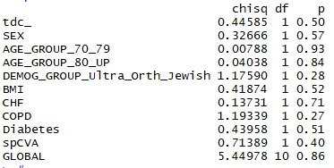

Table2: Association of Mortality Rates with Vaccination Status adjusted for Confounding Variables, Ages 60 -69

 | Sig. | Exp(B) | 95.0% CI for Exp(B)
 | Sig. | Exp(B) | Lower | Upper
Second Booster (Effective) | 0.000 | 0.16 | 0.06 | 0.41
SEX | 0.559 | 1.23 | 0.61 | 2.48
DEMOG_GROUP_Ultra_Orth_Jewish | 0.829 | 0.80 | 0.11 | 5.86
BMI | 0.043 | 0.93 | 0.87 | 1.00
CHF | 0.000 | 11.16 | 5.27 | 23.65
COPD | 0.425 | 1.49 | 0.56 | 3.94
Diabetes | 0.001 | 3.56 | 1.72 | 7.36
s/p CVA | 0.009 | 2.89 | 1.31 | 6.39

Table 3: Association of Mortality Rates with Vaccination Status adjusted for Confounding Variables, Ages 70 -79

 | Sig. | Exp(B) | 95.0% CI for Exp(B)
 | Sig. | Exp(B) | Lower | Upper
Second Booster (Effective) | 0.000 | 0.28 | 0.17 | 0.46
SEX | 0.517 | 1.17 | 0.72 | 1.90
DEMOG_GROUP_Ultra_Orth_Jewish | 0.027 | 2.58 | 1.12 | 5.96
BMI | 0.147 | 0.97 | 0.92 | 1.01
CHF | 0.000 | 3.91 | 2.27 | 6.73
COPD | 0.002 | 2.46 | 1.38 | 4.38
Diabetes | 0.000 | 3.13 | 1.85 | 5.31
s/p CVA | 0.000 | 3.70 | 2.26 | 6.07

Table 4: Association of Mortality Rates with Vaccination Status adjusted for Confounding Variables, Ages 80+

 | Sig. | Exp(B) | 95.0% CI for Exp(B)
 | Sig. | Exp(B) | Lower | Upper
Second Booster (Effective) | 0.000 | 0.20 | 0.15 | 0.27
SEX | 0.000 | 1.76 | 1.33 | 2.32
DEMOG_GROUP_Ultra_Orth_Jewish | 0.221 | 1.46 | 0.80 | 2.68
BMI | 0.004 | 0.96 | 0.93 | 0.99
CHF | 0.000 | 3.61 | 2.70 | 4.81
COPD | 0.010 | 1.61 | 1.12 | 2.32
Diabetes | 0.001 | 1.60 | 1.21 | 2.10
s/p CVA | 0.064 | 1.34 | 0.98 | 1.83

Figure S4: Comparison of SARS-cov2 Infections per million in selected countries

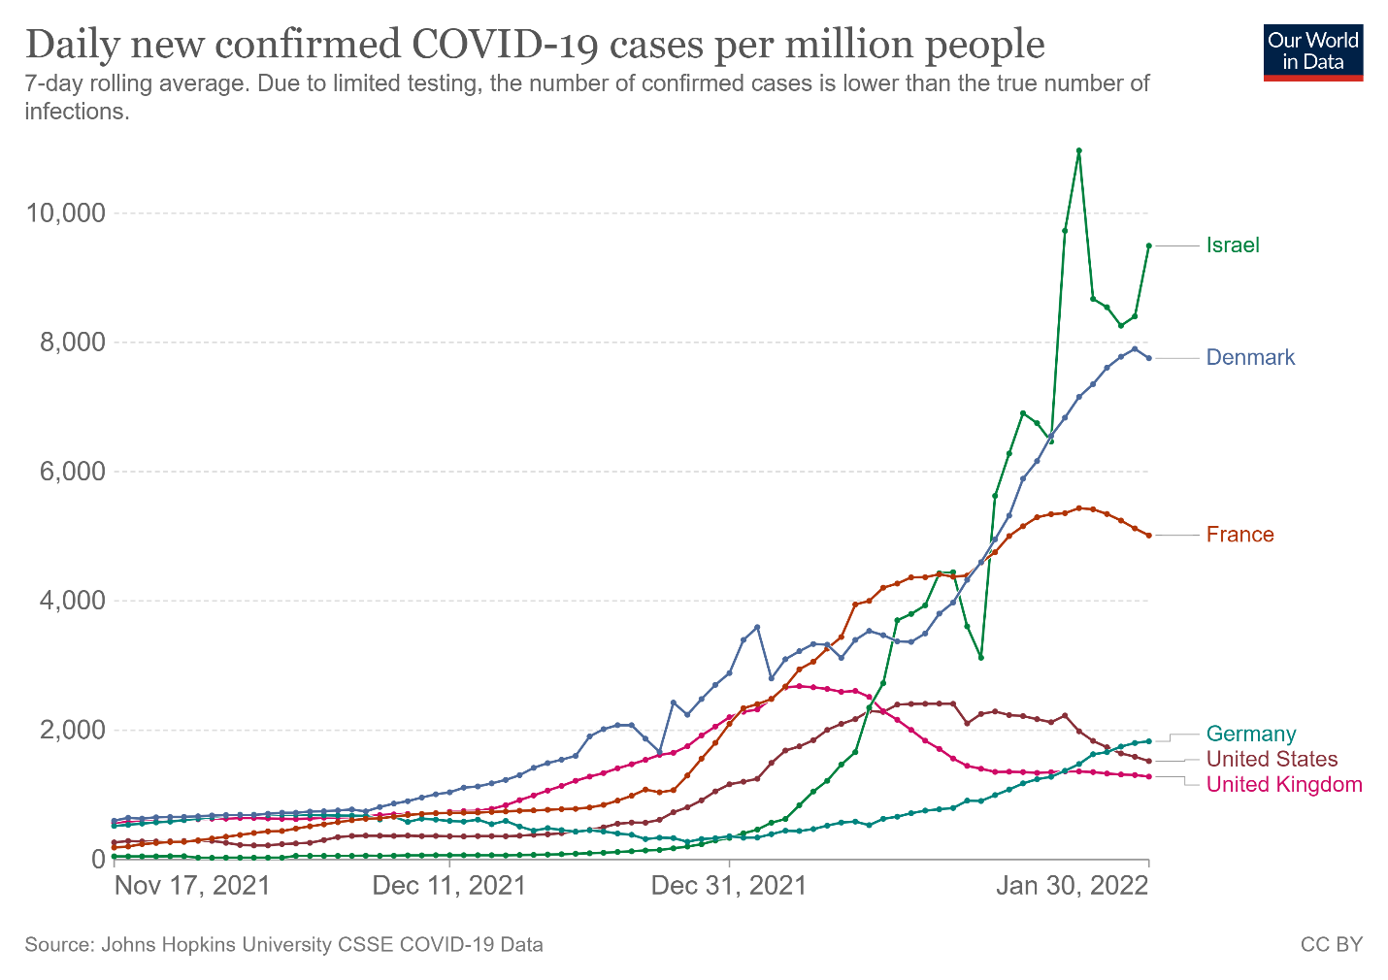

References

- Dagan N, Barda N, Kepten E, et al. BNT162b2 mRNA Covid-19 Vaccine in a Nationwide Mass Vaccination Setting. N Engl J Med. 2021;384(15):1412-1423. doi:10.1056/NEJMoa2101765.
- Barda, N., Dagan, N., Ben-Shlomo, Y., Kepten, E., Waxman, J., Ohana, R., Hernán, M.A., Lipsitch, M., Kohane, I., Netzer, D. and Reis, B.Y., 2021. Safety of the BNT162b2 mRNA Covid-19 vaccine in a nationwide setting. New England Journal of Medicine, 385(12), pp.1078-1090.
- Bar-On YM, Goldberg Y, Mandel M, et al. Protection of BNT162b2 Vaccine Booster against Covid-19 in Israel [published online ahead of print, 2021 Sep 15. N Engl J Med. 2021; NEJMoa2114255. doi:10.1056/NEJMoa2114255
- Central Bureau of Statistics Israel. Characterization and classification of geographical units by the socio-economic level of the population 2008. Jerusalem, 2013.
- Points location intelligence, 2021. https://points.co.il/en/points-location-intelligence/[Accessed Oct 3, 2021].
- Weisband, Y.L., Kaufman-Shriqui, V., Sagy, Y.W., Krieger, M., Ahmad, W.A. and Manor, O., 2020. Area-level socio-economic disparity trends in nutritional status among 5–6-year-old children in Israel. Archives of disease in childhood, 105(11), pp.1049-1054.

