Table 1 Summary of study characteristics

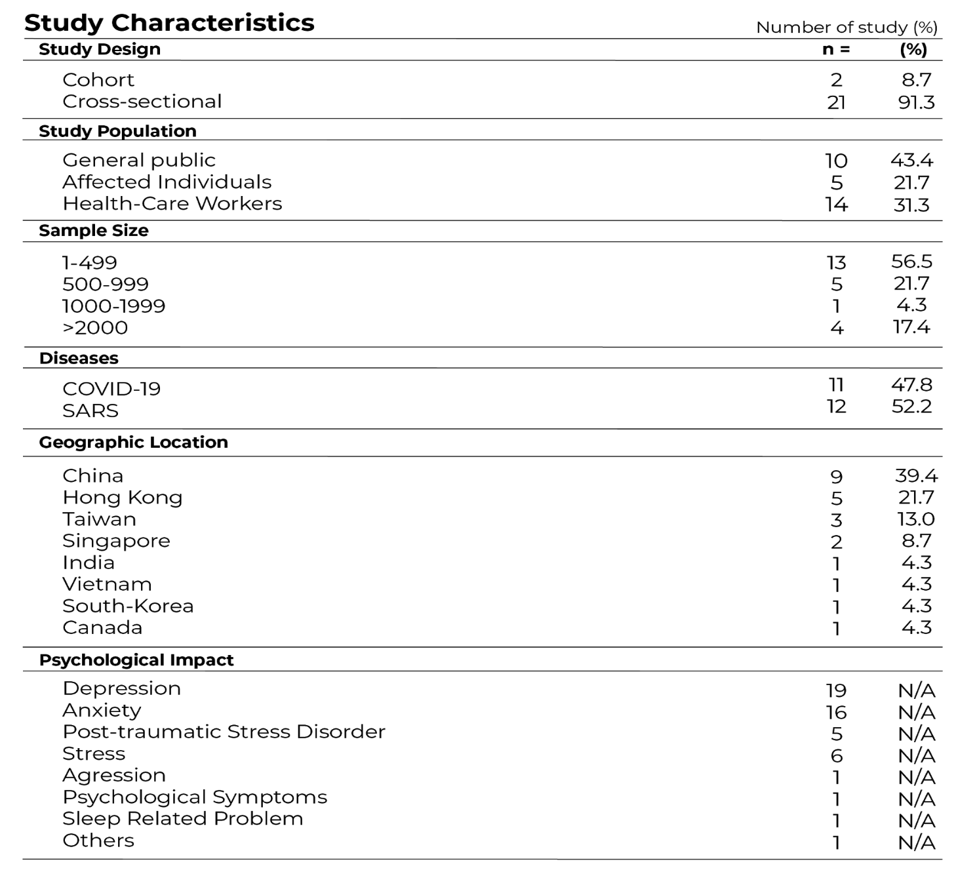

Table 2 Summary of study findings
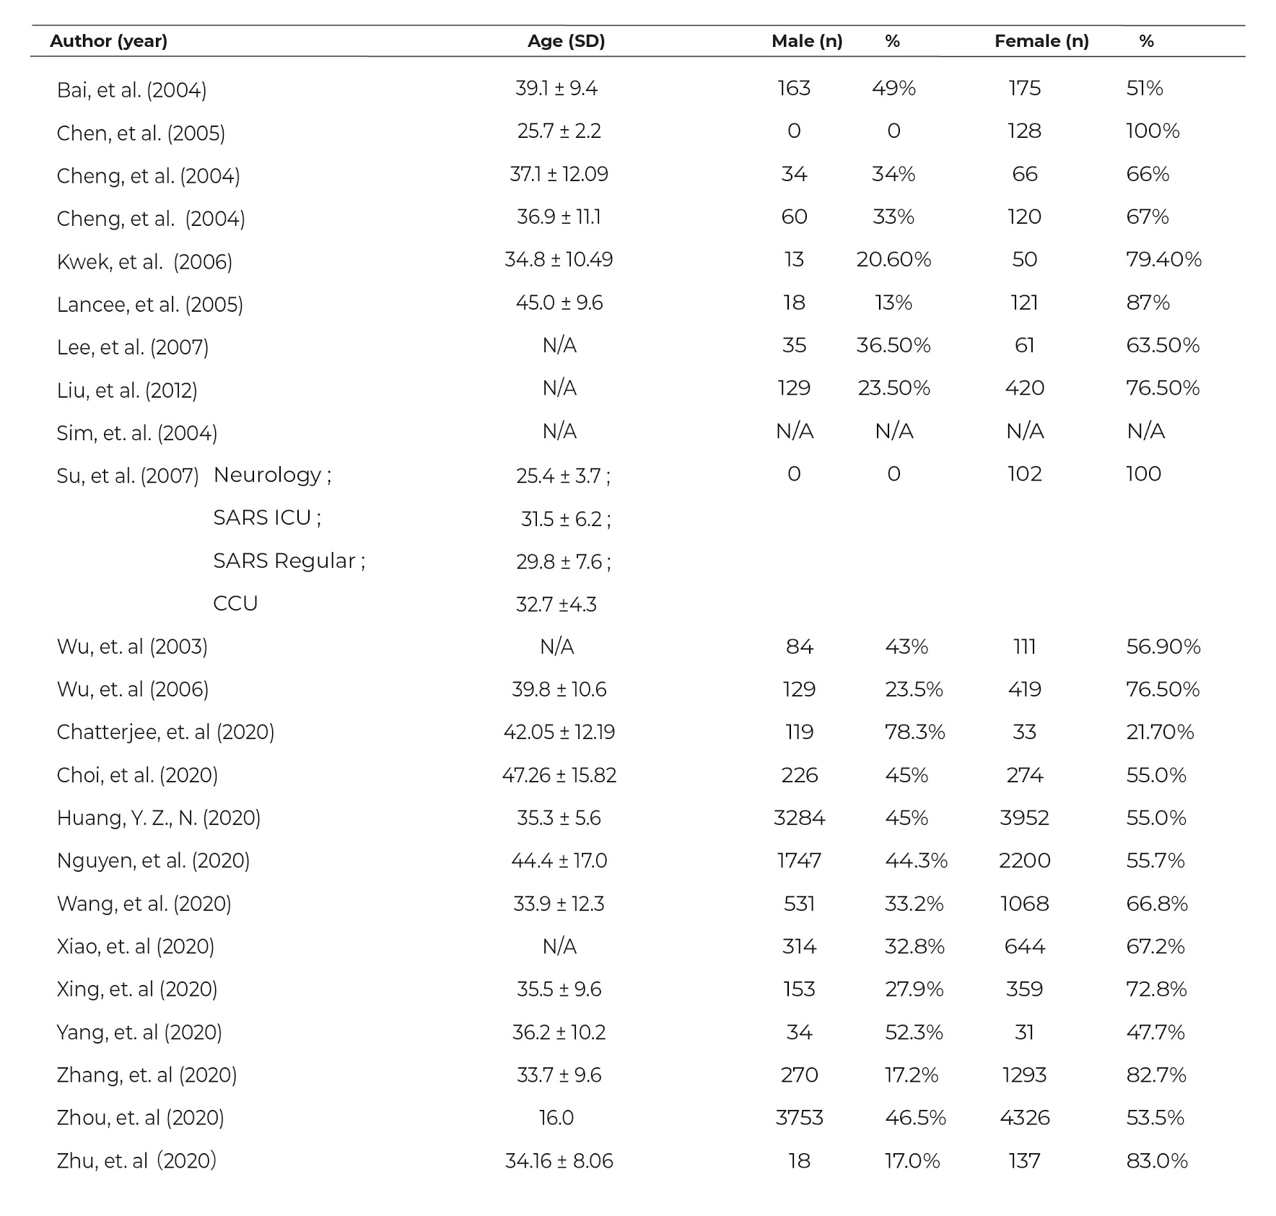

Table 3 Assessment tools used for measurement of depression, anxiety, stress, PTSD, and Psychological symptoms

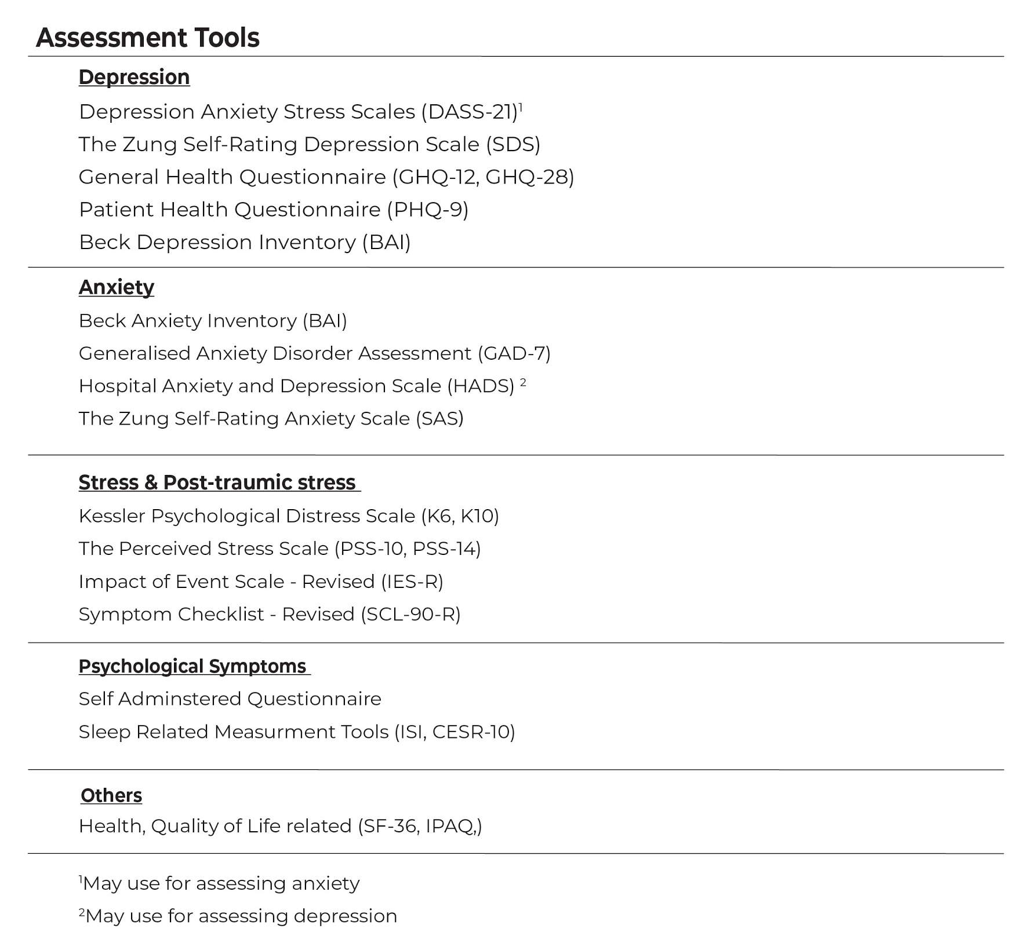

Table 4 JBI Critical Appraisal Checklist for Analytical Cross Sectional Studies

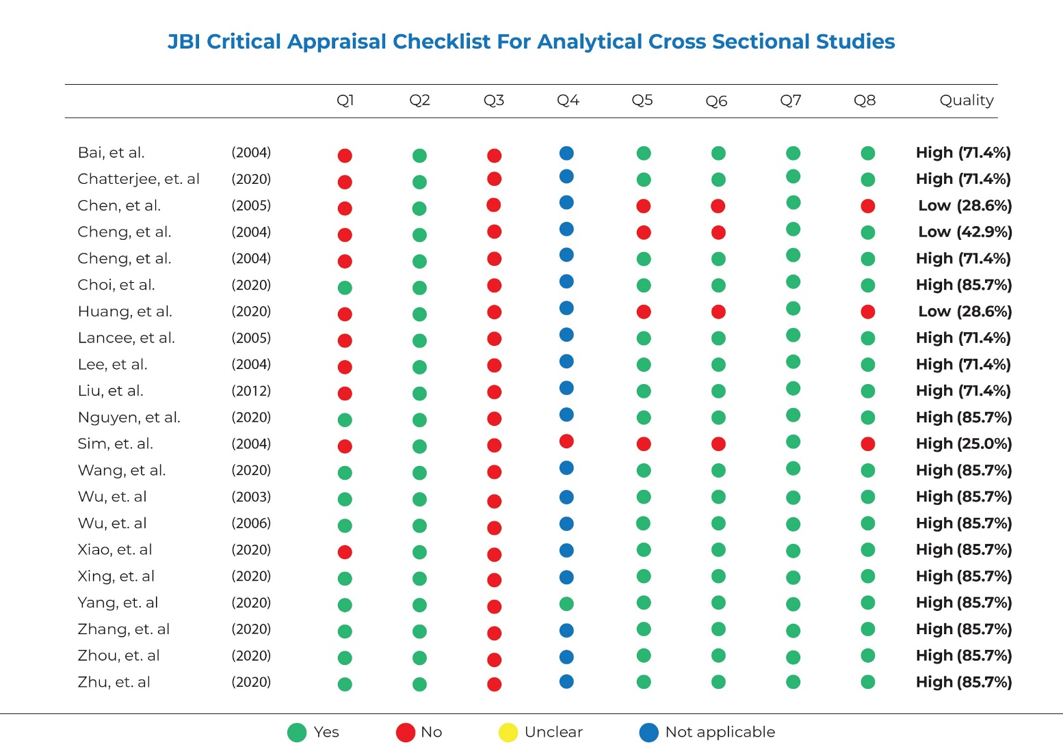

Table 5 JBI Critical Appraisal Checklist For Cohort Studies

