Morbidity after elective surgery in patients on chronic dialysis: a systematic review and meta-analysis

Dharmenaan Palamuthusingam^{1,2,3*}, Arun Nadarajah⁴, MBBS, David Wayne Johnson^{5,6,7}, Elaine Marie Pascoe⁸, Carmel Marie Hawley^{5,6,8}, Magid Fahim^{5,8}

Supplementary material (online):

Supplementary Table 1: Search strategy to be used in EMBASE

- 'dialysis':de,ti,ab
- 'end-stage renal disease':de,ti,ab
- 'renal replacement therapy':de,ti,ab
- 'hemodialysis':de,ti,ab
- 'peritoneal dialysis':de,ti,ab
- 1 OR 2 OR 3 OR 4 OR 5
- 'continuous renal replacement therapy'/exp
- 'continuous renal replacement therapy'
- 'acute kidney failure'/exp
- 'acute kidney failure'
- 'kidney transplantation'/exp
- 'kidney transplantation'
- 7 OR 8 OR 9 OR 10 OR 11 OR 12 OR 13
- 6 NOT 13
- surgery:de,ti,ab
- 'postoperative complication'/mj
- 'cardiovascular mortality'/exp
- 'hospital mortality'/exp
- 'surgical mortality'/exp
- 'anastomosis dehiscence'/exp
- 'anastomosis leakage'/exp
- 'failed back surgery syndrome'/exp
- 'gastric band erosion'/exp
- 'vein graft disease'/exp
- 'paravalvular leak'/exp
- 'postoperative edema'/exp
- 'postoperative hemorrhage'/exp
- 'postoperative ileus'/exp
- 'postoperative infection'/exp
- 'postoperative inflammation'/exp
- 'postoperative thrombosis'/exp
- 'periprosthetic fracture'/exp
- 'prosthetic valve dysfunction'/exp
- 'surgical infection'/exp
- 'surgical injury'/exp
- 'heart infarction'/exp
- 'cerebrovascular accident'/exp
- 'hospital readmission'/exp
- 'reoperation'/exp
- 'blood transfusion'
- 16 OR 17 OR 18 OR 19 OR 20 OR 21 OR 22 OR 23 OR 24 OR 25 OR 26 OR 27 OR 28 OR 29 OR 30 OR 31 OR 32 OR 33 OR 34 OR 35 OR 36 OR 37 OR 38 OR 39 OR 40
- 14 AND 15 AND 41

Supplementary Table 2: Search Strategy for MEDLINE
- AB dialysis
- TI dialysis
- AB 'renal dialysis'
- TI 'renal dialysis'
- AB hemodialysis
- TI hemodialysis
- AB 'end stage renal disease'
- AB 'end stage renal failure'
- AB 'end stage kidney failure'
- AB 'end stage kidney disease'
- TI 'end stage renal disease'
- TI 'end stage renal failure'
- TI 'end stage kidney failure'
- TI 'end stage kidney disease'
- 1 OR 2 OR 3 OR 4 OR 5 OR 6 OR 7 OR 8 OR 9 OR 10 OR 11 OR 12 OR 13 OR 14
- AB transplantation
- TI transplantation
- AB acute kidney injury
- TI acute kidney injury
- AB continous renal replacement therapy
- TI continous renal replacement therapy
- 16 OR 17 OR 18 OR 19 OR 20 OR 21 OR 22
- 15 NOT 22
- AB surgery
- TI surgery
- MM "Specialties, Surgical+"
- 24 OR 25 OR 26
- MM “Postoperative Complications”
- MH "Cause of Death"
- MH "Survival"
- MH "Arrhythmias, Cardiac+"
- MH "Death+"
- MH "Hemorrhage+"
- MH "Hypovolemia"
- MH "Seroma"
- MH "Serositis"
- MH "Abscess"
- MH "Cellulitis"
- MH "Empyema"
- MH "Systemic Inflammatory Response Syndrome+"
- MH "Intraoperative Complications"
- MH "Infarction"
- MH "Fat Necrosis"
- MH "Gangrene"
- MH "Femur Head Necrosis"
- MH "Anastomotic Leak"
- MH "Graft Occlusion, Vascular"
- MH "Incisional Hernia"
- MH "Malignant Hyperthermia"
- MH "Postcholecystectomy Syndrome"
- MH "Postgastrectomy Syndromes"
- MH "Postoperative Hemorrhage"
- MH "Postpericardiotomy Syndrome"
- MH "Prosthesis-Related Infections"
- MH "Prosthesis Failure"
- MH "Surgical Wound Dehiscence"
- MH "Surgical Wound Infection"
- MH "Respiratory Aspiration+"
- MH "Multiple Organ Failure"
- MH "Shock, Cardiogenic"
- MH "Shock, Hemorrhagic"
- MH "Ulcer"
- MH "Arrhythmias, Cardiac"
- MH "Death, Sudden, Cardiac"
- MH "Out-of-Hospital Cardiac Arrest"
- MH "Edema, Cardiac"
- MH "Heart Failure, Diastolic"
- MH "Heart Failure, Systolic"
- MH "Acute Coronary Syndrome"
- MH "Angina, Unstable+"
- MH "Coronary Artery Disease"
- MH "Coronary Occlusion"
- MH "Anterior Wall Myocardial Infarction"
- MH "Inferior Wall Myocardial Infarction"
- MH "Non-ST Elevated Myocardial Infarction"
- MH "Shock, Cardiogenic"
- MH "ST Elevation Myocardial Infarction"
- MH "Coronary Thrombosis"
- MH "Postpericardiotomy Syndrome"
- MH "Cerebral Infarction"
- MH "Stroke, Lacunar"
- MH "Brain Infarction"
- MH "Pneumonia, Aspiration"
- MH "Pneumonia, Bacterial"
- MH "Pulmonary Atelectasis"
- MH "Pulmonary Edema"
- MH "Pulmonary Embolism"
- MH "Length of Stay"
- MH "Patient Readmission"
- MH "Erythrocyte Transfusion"
- MH "Blood Transfusion"
- MH "Reoperation"
- MH "Second-Look Surgery"
- 28 OR 29 OR 30 OR 30 OR 31 OR 32 OR 33 OR 34 OR 35 OR 36 OR 37 OR 38 OR 39 40 OR 41 OR 42 OR 43 OR 44 OR 45 OR 46 OR 47 OR 48 OR 49 OR 50 OR 51 OR 52 OR 53 OR 54 OR 55 OR 56 OR 57 OR 58 OR 59 OR 60 OR 61 OR 62 OR 63 OR 64 OR 65 OR 66 OR 67 OR 68 OR 69 OR 70 OR 71 OR 72 OR 73 OR 74 OR 75 OR 76 OR 77 OR 78 OR 79 OR 80 OR 81 OR 82 OR 83 OR 84 OR 85 OR 86 OR 87 OR 88 OR 89 OR 90 OR 91 OR 92 OR 93
- 23 AND 27 AND 94

Supplementary Table 3: Search strategy for CENTRAL

- #1 dialysis
- #2 end stage kidney disease
- #3 end stage renal disease
- #4 hemodialysis
- #5 peritoneal dialysis
- #6 (dialysis):ti,ab,kw OR (end stage renal disease):ti,ab,kw OR (end stage kidney disease):ti,ab,kw OR (haemodialysis):ti,ab,kw OR (peritoneal dialysis):ti,ab,kw (Word variations have been searched)
- #7 surgery
- #8 perioperative outcomes
- #9 perioperative mortality
- #10 perioperative complications
- #11 postoperative complications
- #12 postoperative mortality
- #13 #8 OR #9 OR #10 OR #11 OR #12
- #14 #6 AND #7 AND #13

Supplementary Table 4: Methodological quality of included studies (based on Newcastle-Ottawa scale)
First Author | Cohort Study Design | Dialysis Modality | Selection / | Comparability / | Outcomes /
Al Sarraf, 2011 | Retrospective | Unspecified |  |  | 
Ambur 2019 | Retrospective | Both |  |  | 
Andalib, 2016 | Retrospective | Unspecified |  | - | 
Balceniuk 2019 | Retrospective | Both |  |  | 
Barbas, 2014 | Retrospective | Unspecified |  |  | 
Cancienne 2019 | Retrospective | Both |  | - | 
Charytan, 2007 | Retrospective | Both |  |  | 
Cheng, 2013 | Retrospective | Both |  |  | 
Chikuda, 2012 | Retrospective | Haemodialysis |  | - | 
Chikwe,2010 | Retrospective | Unspecified |  |  | 
Chung, 2017 | Retrospective | Unspecified |  |  | 
Cloyd, 2014 | Retrospective | Haemodialysis |  |  | 
Cooper, 2006 | Retrospective | Unspecified |  |  | 
Ekici, 2009 | Retrospective | Peritoneal Dialysis |  | - | 
Fornara, 1998 | Retrospective | Haemodialysis |  | - | 
Fukushima, 2005 | Prospective | Haemodialysis |  | - | 
Gajdos, 2013 | Retrospective | Both |  |  | 
Gajdos, 2013 | Retrospective | Both |  |  | 
Griffin 2019 | Retrospective | Haemodialysis |  | - | 
Hibino, 2016 | Retrospective | Haemodialysis |  | - | 
Hickson, 2018 | Retrospective | Haemodialysis |  | - | 
Hickson 2018 | Retrospective | Both |  | - | 
Hu, 2015 | Retrospective | Unspecified |  |  | 
Inoue 2018 | Retrospective | Both |  | - | 
Kan, 2004 | Retrospective | Both |  | - | 
Lantis 2001 | Retrospective | Unspecified |  | - | 
Lin 2019 | Retrospective | Unspecified |  |  | 
Lizaur-Utrilla, 2016 | Retrospective | Unspecified |  | - | 
Marique, 2017 | Retrospective | Unspecified |  |  | 
May 2018 | Retrospective | Both |  | - | 
Montgomery 2019 | Retrospective | Unspecified |  | - | 
Murai, 2007 | Retrospective | Haemodialysis |  | - | 
O Hare | Retrospective | Unspecified |  |  | 
Ottesen, 2018 | Retrospective | Unspecified |  |  | 
Ottesen, 2018 | Retrospective | Unspecified |  |  | 
Ponumsamy, 2015 | Retrospective | Unspecified |  |  | 
Rahmanian, 2008 | Retrospective | Unspecified |  |  | 
Rao, 2017 | Retrospective | Unspecified |  |  | 
Rao 2014 | Retrospective | Unspecified |  | - | 
Raza, 2017 | Retrospective | Haemodialysis |  | - | 
Schmitges, 2012 | Retrospective | Unspecified |  |  | 
Schneider, 2009 | Retrospective | Unspecified |  | - | 
Tam 2015 | Retrospective | Unspecified |  |  | 
Thourani, 2012 | Retrospective | Haemodialysis |  |  | 
Vasileva 2014 | Retrospective | Unspecified |  |  | 
Wong 2003 | Retrospective | Unspecified |  | - | 
Yamashita 2012 | Retrospective | Both |  | - | 
Yamauchi, 2012 | Retrospective | Haemodialysis |  | - | 
Yu 2011 | Prospective | Haemodialysis |  | - | 

Selection criteria (out of 4 stars): Representation of exposed cohort, selection of non-exposed group, ascertainment of exposure, demonstration that outcome of interest was not present at start of study
Comparability (out of 2 stars): Comparability of cohorts by the design or analysis
Outcomes (out of 3 stars): Assessment of outcomes, Follow-up duration and adequacy of follow-up of cohorts

Supplementary Table 5: Meta-analysis of non-fatal post-operative complications
 | Unadjusted outcomes |  |  |  |  |  |  |  |  | Adjusted ratios
Outcome | Type of Surgery | Number of studies | Dialysis patients | Median rate (%) | Normal kidney function | Median rate (%) | Overall effect OR (95% CI) | I²(%) | P | Number of studies | Overall effect OR (95% CI) ^{c} | I² | P
Return to theatre | Cardiac | 10 | 10 744 | 6.0 | 226 300 | 3.2 | 1.61 (1.12-2.30) | 85 | <0.001 | 1 | 2.10 (1.95-2.25) | - | -
Return to theatre | General | 7 | 4 562 | 5.4 | 936 063 | 2.0 | 2.75 (1.98-3.81) | 83 | <0.001 | 3 | 1.83 (1.58-2.09) | 32 | 0.229
Return to theatre | Orthopaedic | 4 | 2 071 | 3.9 | 356 859 | 3.2 | 1.96 (0.63-6.06) | 95 | <0.001 | 3 | 1.97 (1.51-2.44) | 65 | 0.059
Return to theatre | Vascular | 4 | 3 603 | 16.6 | 74 911 | 8.8 | 2.13 (1.33-3.41) | 94 | <0.001 | 2 | 2.17 (1.87-2.48) | 90 | <0.001
Return to theatre | Urology/gynaecology | 0 | - | - | - | - | - | - | - | - | - | - | -
Transfusion requirement | Cardiac | 6 | 3 144 | 79.1 | 113 325 | 34.6 | 4.23 (2.80-6.37) | 87 | 0.000 | 2 | 0.70 (-.05-1.44) | 76 | 0.043
Transfusion requirement | General | 6 | 2 966 | 1.7 | 744 727 | 0.5 | 3.21 (2.14-4.81) | 56 | 0.046 | 1 | 1.78 (1.26-2.29) | - | -
Transfusion requirement | Orthopaedic | 6 | 6 237 | 29.0 | 8 729 950 | 11.3 | 2.47 (1.84-3.32) | 92 | 0.000 | - | - | - | -
Transfusion requirement | Vascular | 2 | 1 131 | 1.4-100 ª | 11 730 | 0.4-89.4 ª | 3.49 (1.96-6.21) | 0 | 0.768 | - | - | - | -
Transfusion requirement | Urology/gynaecology | 3 | 1 505 | 12.1 | 12 517 | 5.8 | 2.16 (1.83-2.55) | 0 | 0.923 | 1 | 2.05 (1.54-2.56) | - | -
Thromboembolic events (DVT/PE) | Cardiac | 1 | 1 300 | 0.2 ^{b} | 18 387 | 0.2 | 1.15 (0.35-3.73) | - | - | -
Thromboembolic events (DVT/PE) | General | 9 | 4 796 | 1.2 | 961 014 | 0.5 | 1.75 (1.25-2.45) | 21 | 0.260 | 1 | 0.80 (0.60-1.20) | - | -
Thromboembolic events (DVT/PE) | Orthopaedic | 6 | 3 812 | 1.2 | 2 911 782 | 1.2 | 1.56 (0.84-2.89) | 69 | 0.012 | - | - | - | -
Thromboembolic events (DVT/PE) | Vascular | 4 | 5 308 | 1.8 | 84 484 | 0.9 | 2.12 (0.56-8.07) | 97 | 0.000 | 1 | 1.46 (0.92-2.32) | - | -
Thromboembolic events (DVT/PE) | Urology/gynaecology | 1 | 445 | 0.7 | 7870 | 0.8 | 0.87 (0.27-2.78) | - | - | - | - | - | -

ªOnly 2 studies and therefore the complication rate from both studies are provided. If only a single study, then the incidence from that study is shown.
^{b} Single study
^{c}In instances where only a single study is available, then no meta-analysis was performed.
Supplementary Figure 1: Odds of postoperative pneumonia for chronic dialysis patients

Author
Year
Chronic dialysis
Normal kidney function
Unadjusted OR
Adjusted OR

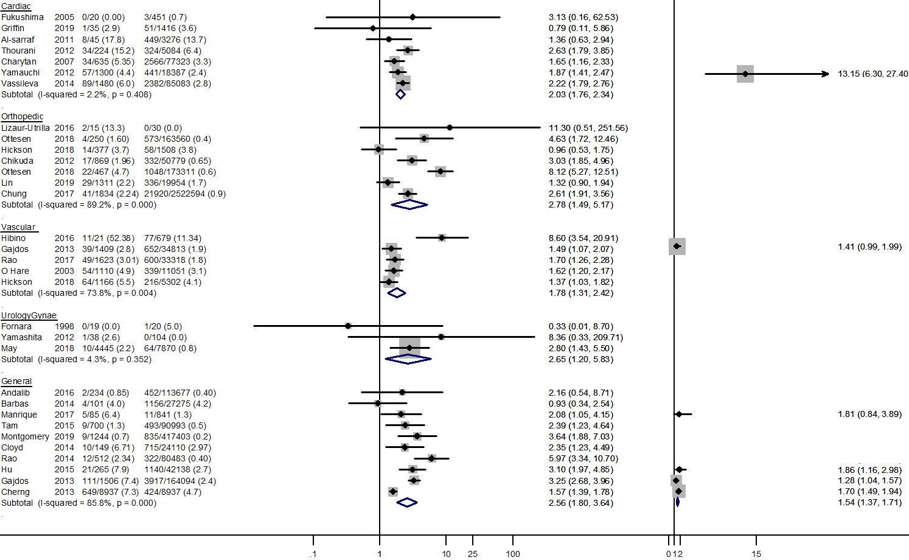
Higher odds on chronic dialysis
Lower odds on chronic dialysis
Higher odds on chronic dialysis
Lower odds on chronic dialysis

Supplementary Figure 2A-G: Meta-regression

Figure A: Meta-regression for postoperative myocardial infarction odds by weighted mean age
Each circle represents a study; the circle size is representative of the weight of that study in the analysis. The relation between logarithmic myocardial infarction odds ratio and the weighted mean age of dialysis and non-dialysis patients is significant (slope -0.05, 95% CI -0.09 – -0.02, I² 59.2%, adjusted R² 49.6%, p=0.002).
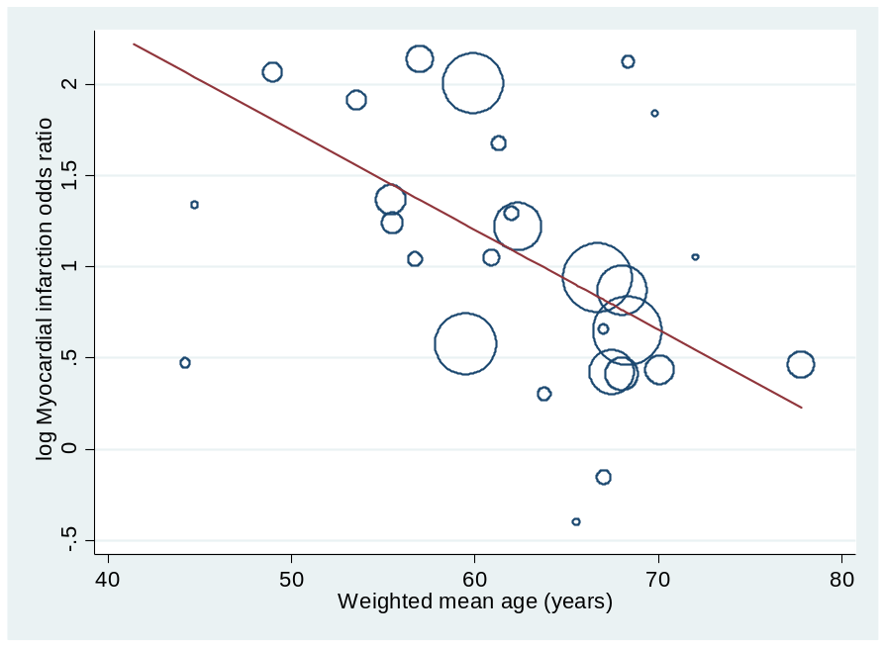

Figure B: Meta-regression for postoperative myocardial infarction odds by prevalence of diabetes mellitus
Each circle represents a study; the circle size is representative of the weight of that study in the analysis. The relation between logarithmic myocardial infarction odds ratio and the prevalence of diabetes mellitus of dialysis and non-dialysis patients is significant (slope -0.02, 95% CI -0.03 – -0.01, I² 47.3%, adjusted R² 60.3%, p=0.004).

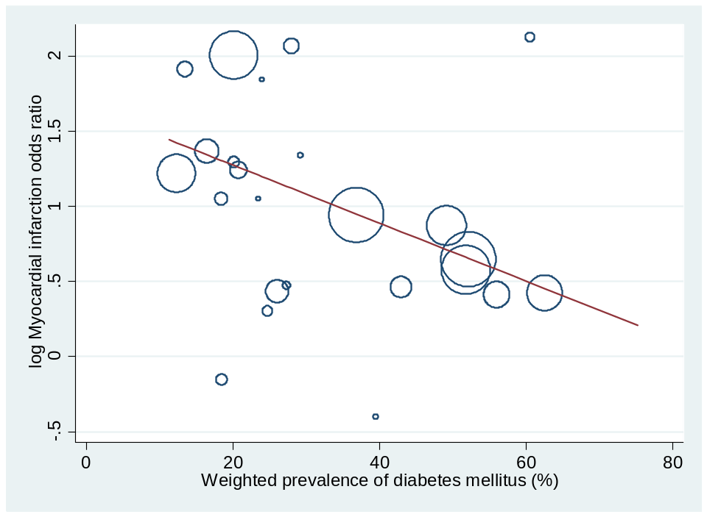

Figure C: Meta-regression for postoperative stroke odds ratio by weighted mean age
Each circle represents a study; the circle size is representative of the weight of that study in the analysis. The relation between logarithmic stroke odds ratio and the weighted mean age of dialysis and non-dialysis patients is significant (slope -0.04, 95% CI -0.08 – -0.01, I² 91.4%, adjusted R² 24.3%, p=0.031).

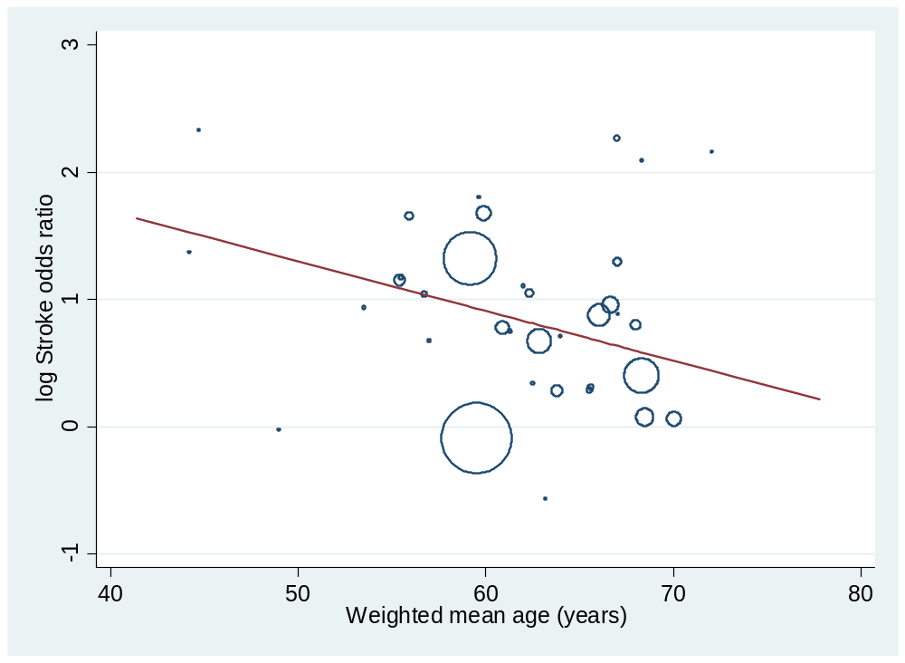

Figure D: Meta-regression for postoperative stroke odds ratio by prevalence of ischemic heart disease
Each circle represents a study; the circle size is representative of the weight of that study in the analysis. The relation between logarithmic stroke odds ratio and the prevalence of ischemic heart disease of dialysis and non-dialysis patients is significant (slope -0.02, 95% CI -0.04 – -0.01, I² 75.0%, adjusted R² 42.8%, p=0.008).

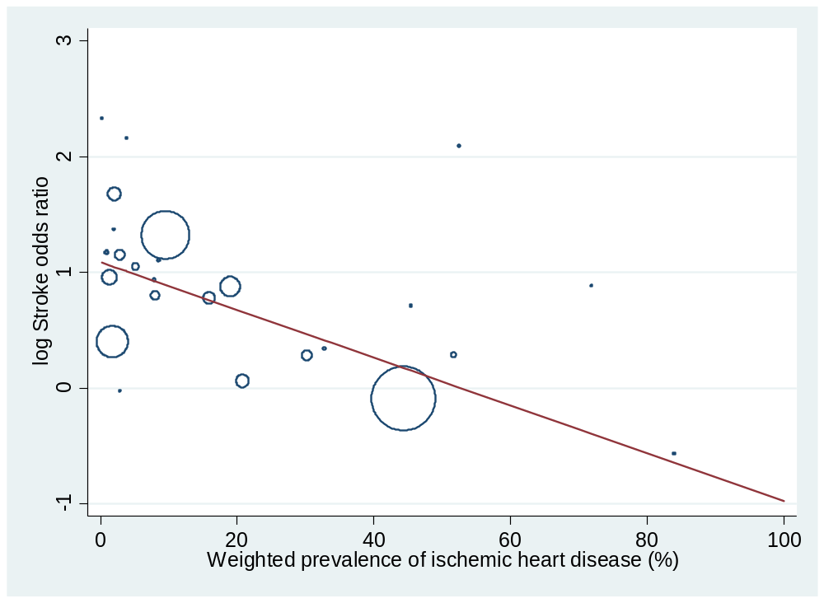

Figure E: Meta-regression for surgical site infection risk by prevalence of ischemic heart disease
Each circle represents a study; the circle size is representative of the weight of that study in the analysis. The relation between logarithmic surgical site infection odds ratio and the prevalence of ischemic heart disease of dialysis and non-dialysis patients is significant (slope 0.03, 95% CI 0.01 – 0.05, I² 84.0%, adjusted R² 54.1%, p=0.006).

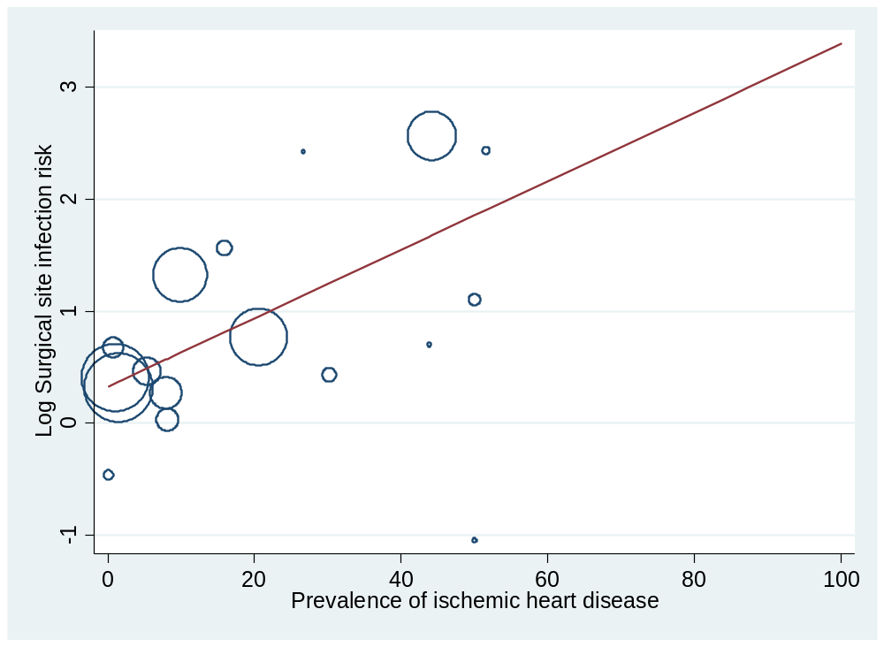

Figure F: Meta-regression for postoperative pneumonia odds ratio by weighted mean age.
Each circle represents a study; the circle size is representative of the weight of that study in the analysis. The relation between logarithmic pneumonia odds ratio and the weighted mean of dialysis and non-dialysis patients is significant (slope -0.04, 95% CI -0.06 – 0.01, I² 73.0%, adjusted R² 51.7%, p=0.003).

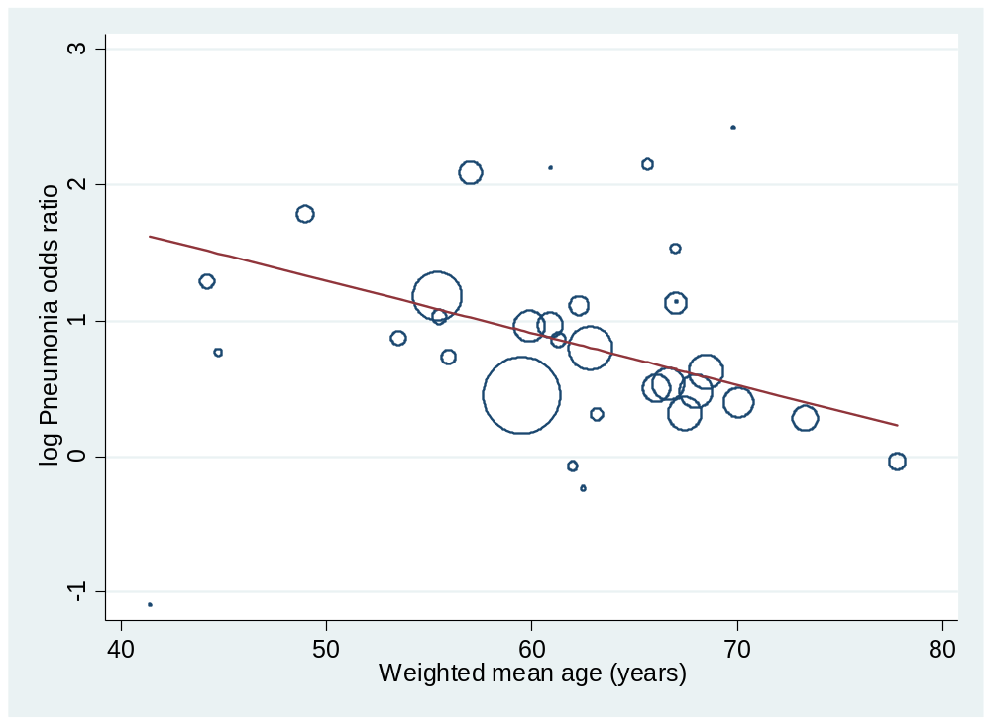

Figure G: Meta-regression for postoperative pneumonia odds ratio by prevalence of diabetes mellitus.
Each circle represents a study; the circle size is representative of the weight of that study in the analysis. The relation between logarithmic pneumonia odds ratio and the prevalence of diabetes in dialysis and non-dialysis patients is significant (slope -0.02, 95% CI -0.02 – 0.00, I² 66.8%, adjusted R² 52.7%, p=0.003).

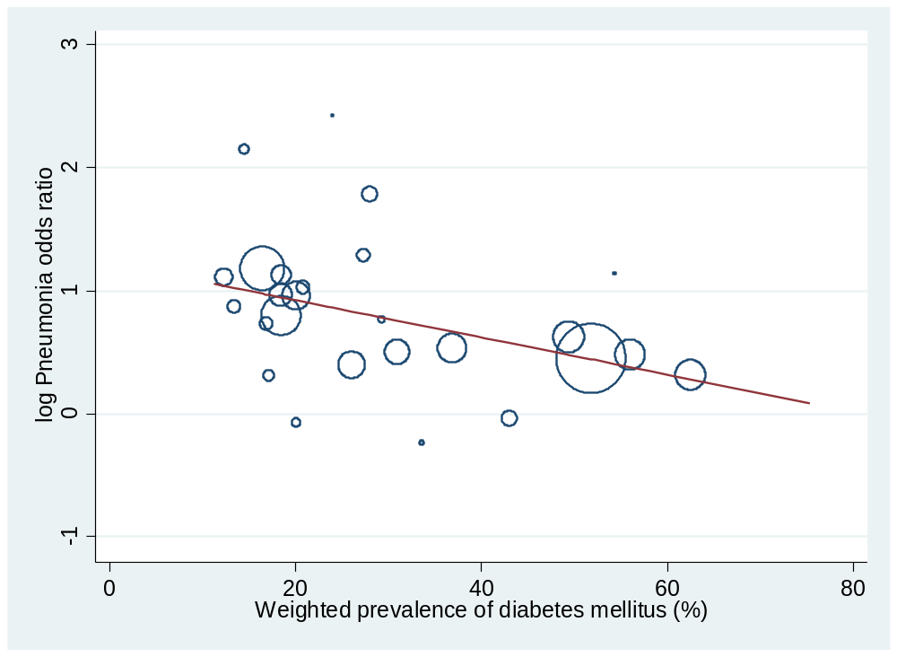

Supplementary Figure 3A-E: Funnel plots

Supplementary Figure 3A: Myocardial infarction
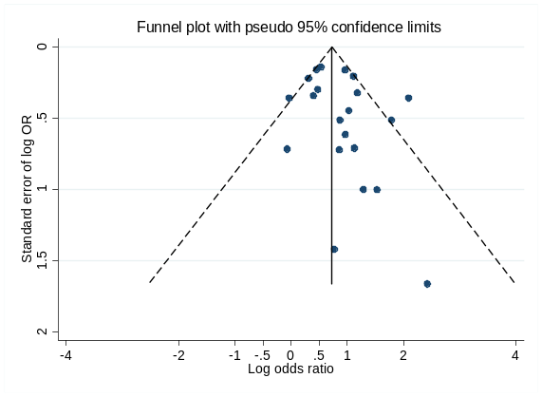

Supplementary Figure 3B: Stroke

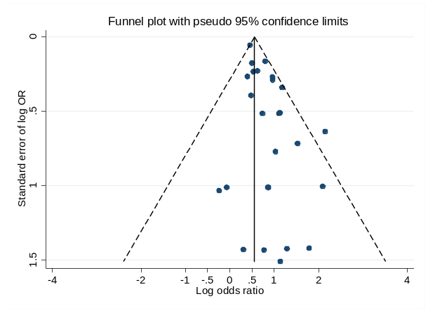

Supplementary Figure 3C: Sepsis
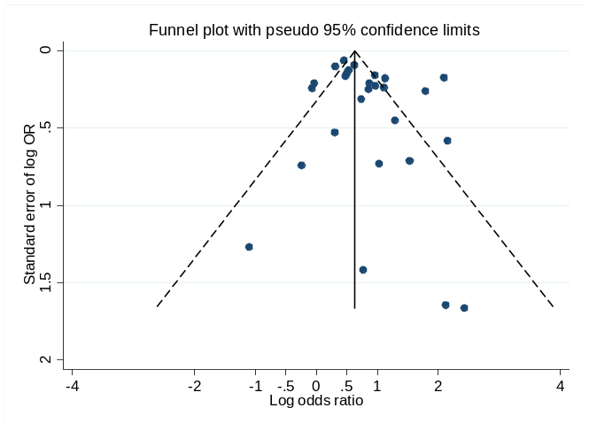

Supplementary Figure 3D: Surgical Site Infection
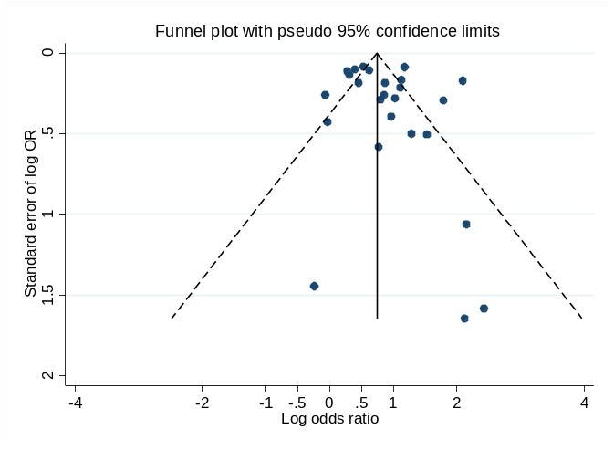

Supplementary Figure 3E

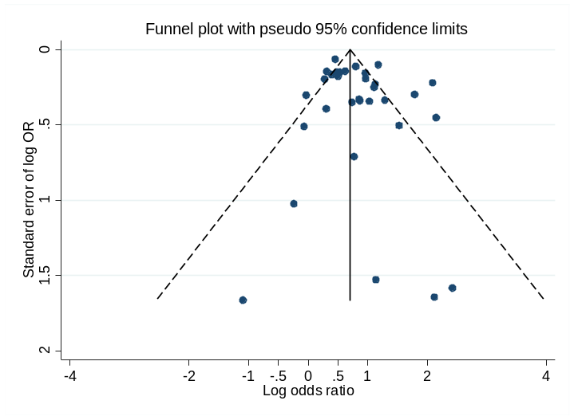

Supplementary Table 6: Post-operative morbidity outcomes and grading of the certainty of evidence using GRADE.

Outcomes (Studies) | Certainty of evidence (GRADE) | Rationale
Outcomes (Studies) | Certainty of evidence (GRADE) | Risk of bias | Inconsistency | Indirectness | Imprecision | Publication bias | Strong association | Other Comments
Myocardial infarction (31) | Low ^{a, c, d, f} | ↓ | – | – | ↓ | – | ↑ | Certainty of evidence not down-graded for inconsistency due to heterogeneity being explained by increasing patient age and prevalence of diabetes.
Stroke (35) | Low ^{a, c, e, f} | ↓ | – | – | – | – | ↑ | Certainty of evidence not down-graded for inconsistency due to heterogeneity being explained by increasing patient age and prevalence of ischemic heart disease.
Sepsis (35) | Low ^{a, b, c, e, f} | ↓ | ↓ | – | – | – | ↑ | –
Surgical site infection (37) | Low ^{a, c, e, f} | ↓ | ↓ | – | – | – | ↑ | Certainty of evidence not down-graded for inconsistency due to heterogeneity being explained by increasing prevalence of ischemic heart disease.
Pneumonia (32) | Low ^{a, b, c, d, f} | ↓ | ↓↓ | – | – | – | ↑ | –

ª Certainty of evidence down-graded due to concerns of poor comparability between study cohorts
^{b} Certainty of evidence down-graded for inconsistency due to residual heterogeneity that remained unexplained despite investigators efforts to identify plausible explanation
^{c} Certainty of evidence not down-graded for indirectness
^{d} Certainty of evidence down-graded for imprecision, due to few events and wide confidence intervals.
^{e} Certainty of evidence not down-graded for imprecision due to significant number of events in both groups.
^{f} Certainty of evidence upgraded by one level due to large (>2 fold) risk estimate

