Appendix 1. Study Population and generation of the cohort for analysis

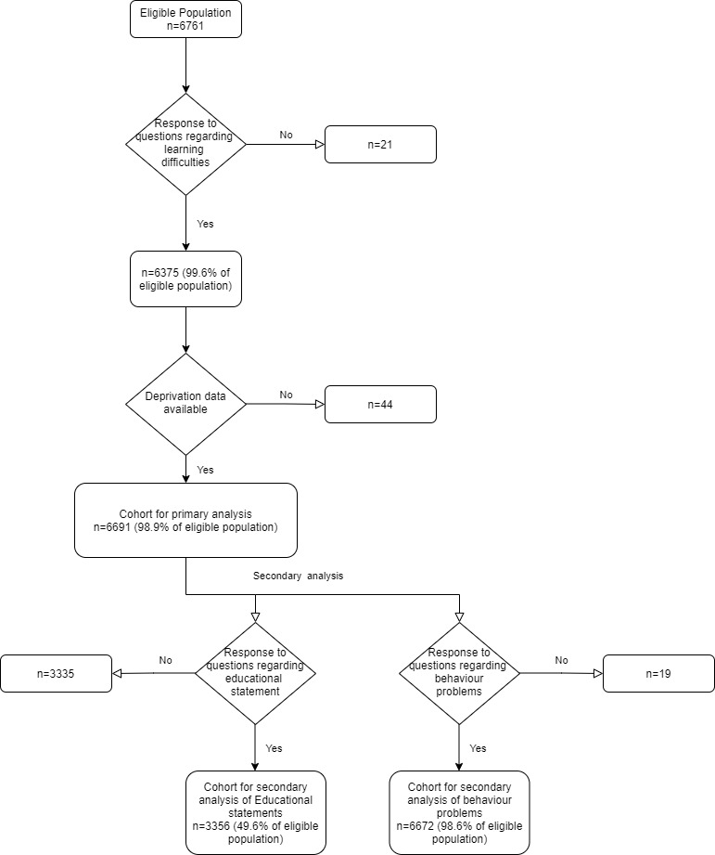
Appendix 2- Data regarding Age at time of survey in combined tabular and graphical format
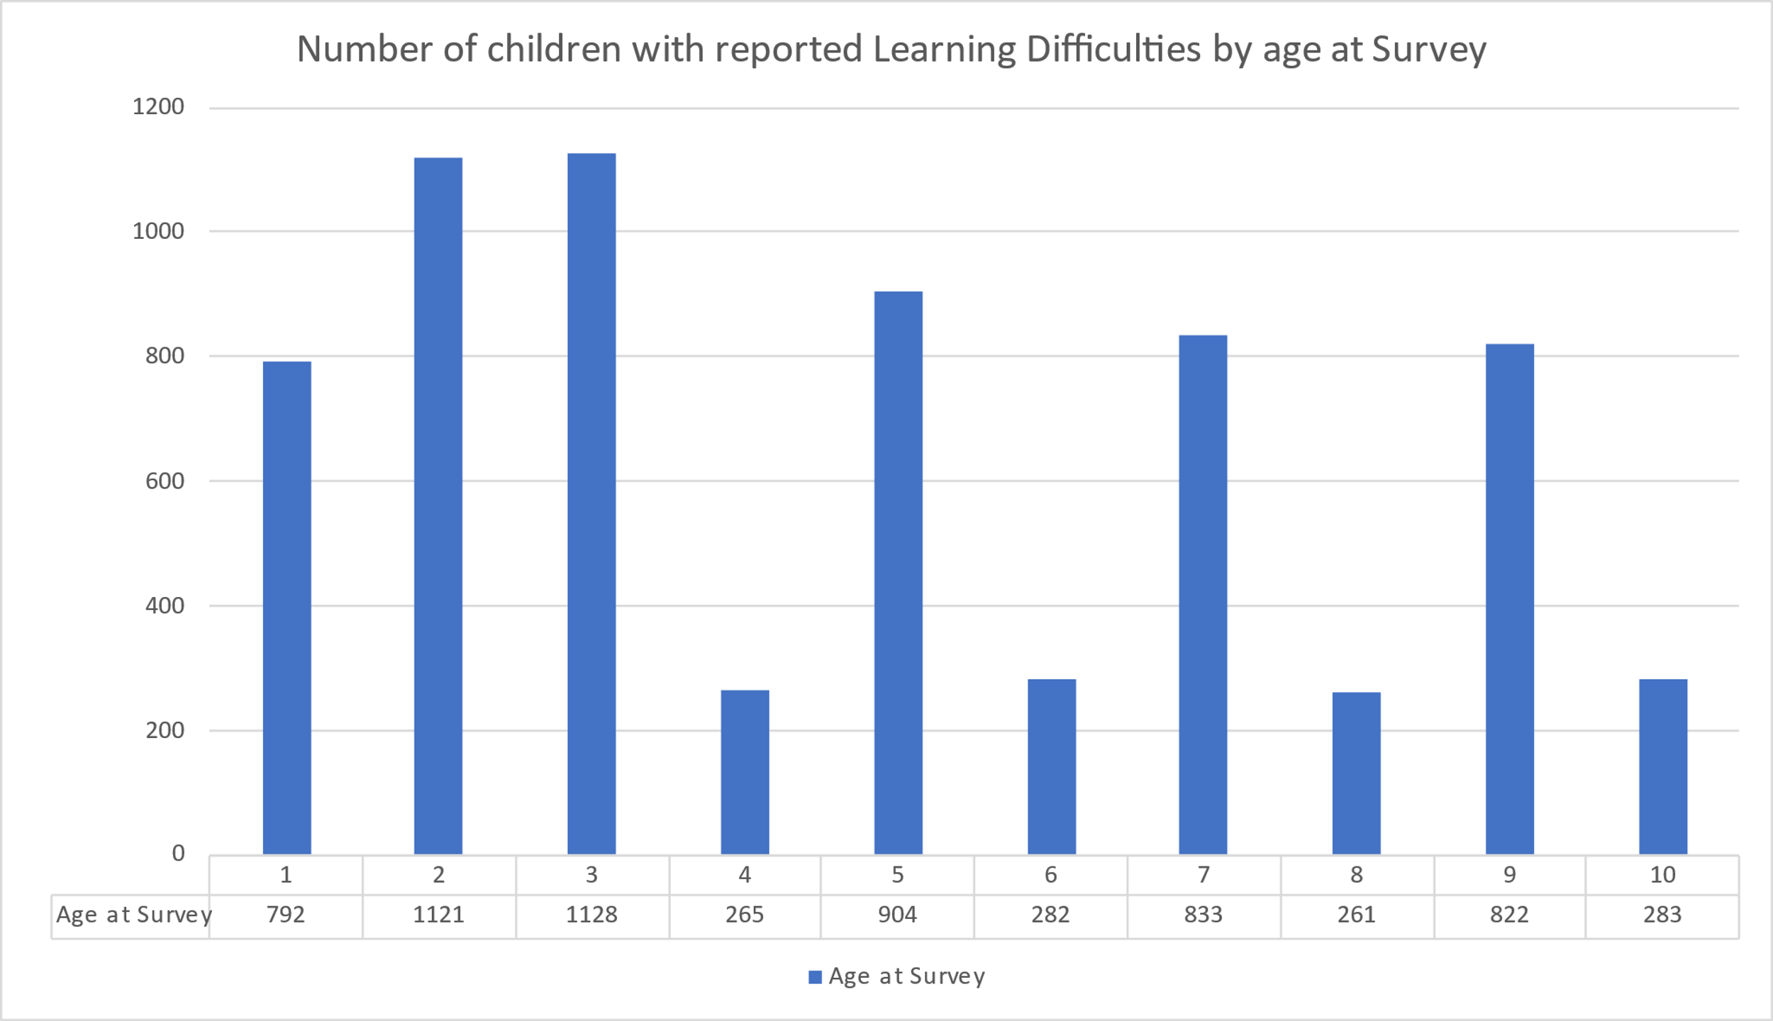

Appendix 3- Comparison of Responders and Non Responders in the original study
Measure | Responders  n=7149 | Non-Responders  n=19593 | p
Preterm | 4284 (59.9%) | 9090 (46.4%) | <0.001
Living in most deprived 50% | 3357 (47.0%) | 12068 (61.6%) | <0.001
Age at time of survey | 4.7 (2.8) | 5.3 (2.8) | <0.001
Male Sex | 3862 (54.0%) | 10666 (54.4%) | 0.6
Birthweight in kg | 2.74 (0.86) | 2.91 (0.81) | <0.001
Numbers are number (%) or mean (SD) as appropriate.

Appendix 4. Comparison of Eligible cohort to those excluded
Measure | Analysed cohort  (n=6761) | Participants with missing data (n=70) | p
Preterm | 4023 (60.1%) | 38 (54.3%) | 0.3
Maternal age in years | 30.256 (5.8) | 30.375 (6.3) | 0.9
Minority ethnicity | 362 (6.1%) | 1 (1.6%) | 0.1
Male sex | 3631 (54.3%) | 28 (40.0%) | 0.02
Smoking during pregnancy | 840 (13.1%) | 11 (16.2%) | 0.5
Breastfeeding initiated at birth | 3680 (55.0%) | 32 (45.7%) | 0.1
Delivery by NVD | 2940 (49.4%) | 30 (46.9%) | 0.4
Numbers are number (%) or mean (SD) as appropriate.
Appendix 5. Number of children with Learning disability split by gestational group and deciles of deprivation measure (WIMD), combined deciles and groups to reduce identifiability
Deprivation Decile | Term (>37 weeks) | Late preterm (36 weeks) | Moderate preterm (32 to 35 weeks) | Very preterm (28 to 31 weeks) | Extreme preterm (less than 28 weeks)
9th/10th (Least Deprived) | 22 (3.51%) | 22 (7.33%) | 32 (9.58%) | 13 (9.35%) | 11 (16.92%)
7th/8th | 23 (4.11%) | 19 (7.04%) | 22 (6.73%) | 12 (8.11%) | 15 (34.88%)
5th/6th | 20 (3.53%) | 24 (8.82%) | 41 (11.29%) | 17 (11.11%) | 8 (19.04%)
3rd/4th | 23 (4.67%) | 25 (8.47%) | 36 (10.43%) | 17 (12.59%) | 11 (20.37%)
1st/2nd (Most Deprived) | 32 (7.60%) | 21 (8.30%) | 38 (12.62%) | 21 (15.91%) | 16 (31.37%)
Values are number (%)

