Supplementary materials：
S1：
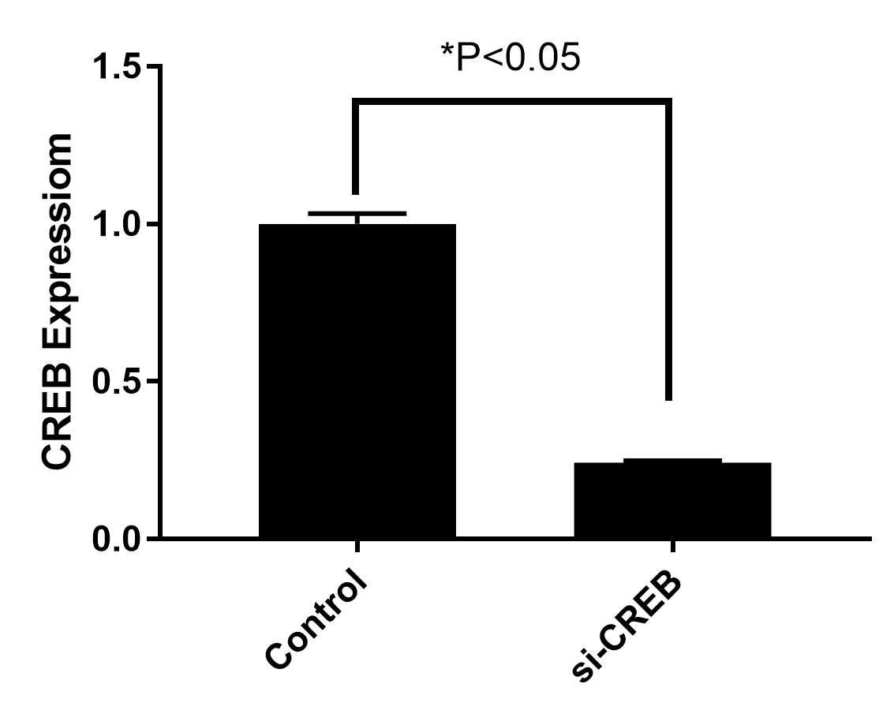
S1:When CREB is under-expressed by adenovirus, its PCR results decrease.
Graphic abstract

