Supplementary materials

Methodology

De novo design of PfGST inhibitors by Isosteric fragments replacements (IFR) approach
The Cartesian coordinates of all atoms except F atom were optimized (i.e. F atom coordinate was fixed during optimization). The scoring function used during optimization was MMFF94 which includes van der Waals (VdW) and electrostatic interactions for estimating fragment-protein interactions (inter molecular interaction energy or Inter MIE) as well as molecular mechanics for internal fragment strain (intra molecular interaction energy or Intra MIE). While the searching function used was theThe parameters used for SZYBKI during optimization step were “-opt_cart”, “-fix_smart “F”” and protein-ligand interaction energy parameter “-protein_elec” of “ExactCoulomb” which considers only electrostatic and VdW interactions. Following optimization, a single point energy calculation was performed with “-no_opt” but further considers desolvation effect by setting the protein-ligand interaction energy parameter to “PB”.
The two optimized databases of fragments replacements were uploaded into Matlab as two cell arrays using (read_docked_database) function. Subsequently, the two cell arrays were screened for a list of fragments joining possibilities using (screen_for_connection_3) function. The function can be represented as “comb_list= screen_for_connection_3(n1,n2, RO_range,angle_range,clash_thresh,mw_range,HBD_range,HBA_range, LogP_range, E_range,E_db_filter_max,linker)” where n1 and n2 are isosteric fragments databases which have been optimized with fixed R atom, “RO_limit“ is the allowed R atom overlap range in Å, “angle_range” is range of allowed degrees of angle between the two R atoms parents, “clash_thresh“ is the distance threshold in Å between docked fragments atoms, and the distance below the threshold means the fragments clash. The “mw_range”, “HBD_range”, “HBA_range”, “LogP_range”, and “E_range”, are the allowed ranges of final molecular weight in dalton, number of hydrogen bond donors, number of hydrogen bond acceptors, calculated LogP, and energy score, respectively. The (screen_for_connection_3) function uses upper and lower limits range to screen for R atoms overlap (i.e. R1 and R2 for fragment 1 and fragment 2, respectively) in case a linker atom is being used to join the two fragments. While screen for R and P atoms overlap (P1 and P2 are parent atoms of R1 and R2, respectively) if no linker is used (i.e. “linker” is false). The angle range of R1-P2-R2 atoms is only applied if linker atom is used. The parameters used in (screen_for_connection_3) function to screen for possible IFR ligands were RO_range from 0 to 0.5 Å, angle_range from 100-140 °, clash threshold of 2 Å, linker Boolean was true and other parameters were blank (i.e. [ ]).
The generated connectivity list produced by (screen_for_connection) as well as the two databases of fragments replacements were then used to guide IFR ligand construction using (combination_maker_manager) function. The function can accept a parameter for the type of linker atom to be used for fragments joining which was set to carbon atom.
Since the designed ligands were intended for synthesis, computational synthetic accessibility score was recommended for filtration purpose. The score was calculated on fly in (combination_maker_manager3). The score is based on structural complexity, similarity to available starting materials as well as assessment of strategic bonds where a structure can be decomposed to obtain simpler fragments [34]. OpenEye has included synthetic accessibility score within the framework of BROOD, however did not provide the ability to use the score function as separate function. In order to circumvent this hindrance, a fake library of several fragments have been made, then BROOD was asked to replace one of the two joined fragments in the ligand using the fake database. When BROOD succeeds in finding replacement fragments or even if it fails, the output file contains synthetic accessibility score for generated molecule(s) –if any- as well as score for the parent molecule (which is exactly what we seek for). The synthetic accessibility score for the parent molecule was then extracted from the molecular tag of the BROOD output sdf file.
The designed ligands were docked to the G-site of pfGST inorder to look for global minimum conformations. Since FRED only explores transitional and rotational degrees of freedom for ligands center of geometry, conformational sampling was generated using OMEGA for every ligand before docking. Some of default parameters for OMEGA were adjusted for generating conformational database. Since most of intramolecular interactions were disappeared upon ligand binding to protein, both of VdW and electrostatic terms were omitted during the generation of ligand conformation by setting “-searchff” to modified force field of mmff94s_Trunc [54]. The “-ewindow” or energy window flag was set to 10 kcal/mol, which has been reported to be sufficient for sampling flexible bioactive conformers [54]. The energy window was used as an acceptance or rejection criterion for output conformers, whereby any conformer that has a calculated strain energy less than the sum of the energy window and the energy of the global minimum conformer was accepted. Conformers with strain energies above this threshold were rejected. The stereo centers were fixed and did not allow to flip during conformational sampling by setting “-strictstereo” as false In order to improve conformational sampling while maintaining reasonable docking time, the “–maxconfs” parameter was set to 1000 [55, 56]. Because FRED can only accept maximum of 10000 molecules in single file, the database was divided into smaller databases of compressed multi-conformer OEBinary (oeb.gz) format. The latter format is preferred with FRED since it reduces I/O penalty encountered with other formats like sdf. The MS-DOS commands used for performing previous steps are listed in supplementary materials. Similar commands are used with DFR approach.
The IFR ligands were also docked by AUTODOCK VINA using default parameters except exhaustiveness was set to 20, as well as by AUTODOCK4.2 using default parameters except maximum number of energy evaluations was set to 500,000. The same grid box was used with each of FRED, VINA and AUTODOCK4.2

De novo design of PfGST inhibitors by Docked fragments replacements (DFR) approach
The docked fragments were then screened for joining possibilities using (screening_for_connection) function followed by ligands construction using (combination_maker_manager3). Initially, the fragments database (which is in SDF format) was filtered by FILTER program (OpenEye) to remove fragments not composed of H, C, N, O, S, Cl, and R atom types. The OMEGA (OpenEye) was then used to generate molecular conformations for each fragment (i.e. conformational fragments database) using default settings. Since, OMEGA cannot recognize atoms type (R) in the fragments, the atom type was changed to fluorine (F) before conformational generation. The fragment database contains many molecules with chiral centers, therefore, stereo centers were fixed as provided in the fragment database and did not allowed to flip by using “-strictstereo false” parameter. To avoid production of collapsed conformations especially for large polar fragments, Merck Molecular Force Field [37, 57-63] variant without Columbic term (mmff_NoEstat) was used.
The two filtered docked fragments databases (.sdf format) were converted into two arrays of cell type in Matlab using (read_docked_database) function.
A connectivity list was generated using (screen_for_connection_3) by setting parameters of “RO_range” from 0 to 0.5 Å, “angle_range” from 100 to 140 °, “clash_thresh” of 2 Å, and “E_db_filter” (the highest allowed Chemgauss4 score) to be -2. No linker atom or properties restriction were applied, thus the rest parameters were set as blank (i.e. [ ]). The list generated with the previous parameters can be used to prepare less flexible ligands (i.e. maximally contain 9 rotatable bonds). A database of DFR ligands was generated from the list via (combination_maker_manager3) function without linker atom for fragments join.

The interaction of GSH, GSX and GLN-CYS moiety to G-site of PfGST
In order to investigate the differences in predicted binding modes and energies among GSH, GSX and GLN-CYS moiety, the docking programs of FRED, AUTODOCK4.2 and VINA were used. The ligands conformations used for FRED docking were generated by OMEGA using “-maxconfs” of 1000, “-ewindow” of 10, “-strictstereo” of false, and “-searchff” of mmff94s_Trunc. The parameters used with AUTODOCK4.2 and VINA as well as the parameters for grid box and SZYBKI were similar to that used for docking IFR and DFR ligands.

Results and discussion

Interaction of GSX to G-site of PfGST
H-bonds are classified according to donor-acceptor distances of 2.2-2.5 Å as "strong, mostly covalent", 2.5-3.2 Å as "moderate, mostly electrostatic", 3.2-4.0 Å as "weak, electrostatic", and the energies are 40-14, 15-4, and <4 kcal/mol, respectively [64].

Selection of docking software for the designed ligands
The performance of molecular docking software is related to its searching and scoring functions. FRED uses prepared conformational database of narrow intramolecular energy window (10 kcal/mol) and Chemgaussian4 scoring function (which only recognizes shape and H-bonding) was enough to represent the important interactions between the ligands and PfGST. The speed and success of FRED in this experiment can be attributed to search space restriction by the use of pre-prepared conformational database for the ligand. The conformational database includes only ligands conformations of Intra MIE within a narrow window (ewindow=10 kcal/mol). Comparing VINA and AUTODOCK4.2, the searching function in VINA combines Monte Carlo stochastic global search method with Broyden-Fletcher-Goldfarb-Shanno (BFGS) quasi-Newton a deterministic local optimization method [65], while in AUTODOCK the stochastic Lamarckian genetic algorithm (LGA) combines GA with local search by pseudo-Solis and Wets method [66]. The deterministic optimization behavior is more prominent in VINA which frequently provides same solution over repeated runs while AUTODOCK4.2 is not (i.e. stochastic behavior is prominent). Other difference which affects the results is the scoring function which is consensus empirical-knowledge based scoring functions in VINA [40] while single semi-empirical free energy force field function in AUTODOCK4.2 [67]. Since both of FRED and VINA were able to reproduce crystal conformations of GSH and GLN-CYS moiety at G-site of dimeric PfGST (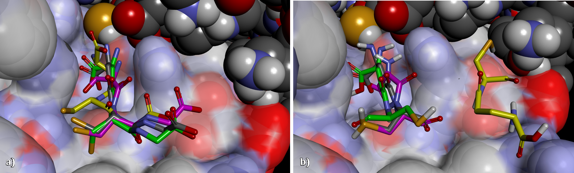
Figure 7), both programs were nominated for docking procedures during ligands design.

Query fragments and generation of isosteric fragments replacements
Table S1: An energy for top five ranked isosteric fragment replacements for GLN-R (first row), showing the energy values as determined by SZYBKI as well as electrostatic shape-Tanimoto (ET) combo. The F atom has been used instead of R atom in order to perform optimization and energy calculation by SZYBKI.
Index | Structure | VdW | Coulomb | Inter MIE | Intra MIE | ET combo
GLN-F |  | -6.83 | -30.16 | -36.99 | 41.50 | -
1 |  | 4.36 | -154.27 | -149.91 | 36.47 | 0.68
2 |  | 8.79 | -150.73 | -141.94 | 48.29 | 0.75
3 |  | 11.53 | -148.31 | -136.79 | -22.37 | 0.72
4 |  | 10.35 | -83.49 | -73.14 | 15.19 | 0.66
5 |  | -0.01 | -50.79 | -50.80 | -0.05 | 0.83
6 |  | -0.44 | -47.46 | -47.90 | -10.67 | 0.73
7 |  | -0.32 | -47.32 | -47.64 | -8.20 | 0.72
8 |  | 4.48 | -47.65 | -43.17 | 16.45 | 0.62
9 |  | 0.09 | -40.15 | -40.07 | -28.92 | 0.72
10 |  | 0.80 | -39.17 | -38.37 | -22.74 | 0.69
11 |  | -2.83 | -35.47 | -38.30 | 80.21 | 0.74
12 |  | -0.78 | -36.24 | -37.02 | 12.85 | 0.64
13 |  | -0.70 | -35.76 | -36.47 | -0.86 | 0.67
14 |  | -4.64 | -30.56 | -35.20 | -28.42 | 0.64
15 |  | -7.59 | -27.42 | -35.00 | -49.45 | 0.87

Table S2: An energy top ranked list of isosteric fragment replacements for CYS-R (first row), showing the energy values as determined by SZYBKI as well as electrostatic shape-Tanimoto (ET) combo. The F atom has been used instead of R atom in order to perform optimization and energy calculation by SZYBKI.
Index | Structure | VdW | Coulomb | Inter MIE | Intra MIE | ET combo
CYS-F |  | -4.18 | -21.52 | -25.70 | -16.72 | -
1 |  | 1.57 | -180.31 | -178.74 | -12.59 | 1.00
2 |  | 4.50 | -180.85 | -176.35 | -34.16 | 1.06
3 |  | 2.06 | -178.06 | -176.00 | -14.09 | 1.10
4 |  | 2.98 | -177.31 | -174.33 | -24.26 | 1.06
5 |  | 6.23 | -165.83 | -159.60 | -25.55 | 0.99
6 |  | 7.97 | -66.11 | -58.13 | -11.91 | 1.04
7 |  | -5.92 | -37.99 | -43.92 | -40.66 | 1.10
8 |  | -8.09 | -33.58 | -41.66 | -60.09 | 1.10
9 |  | -3.20 | -36.34 | -39.54 | -68.20 | 1.19
10 |  | -4.37 | -32.67 | -37.03 | -33.15 | 1.15
11 |  | -2.60 | -33.49 | -36.09 | -6.37 | 1.05
12 |  | -3.30 | -32.53 | -35.83 | -47.62 | 1.18
13 |  | -1.48 | -33.11 | -34.60 | -6.69 | 1.13
14 |  | -2.07 | -32.45 | -34.52 | -59.38 | 1.01
15 |  | -6.60 | -27.78 | -34.39 | -35.36 | 1.03

Figure S: Scatter plots for electrostatic shape-Tanimoto (ET) combo score versus Inter MIE

Construction and optimization of IFR ligands
a)
b)

c)
Figure S12 Scatter plots for values of a) Intra MIE, b) Inter MIE

Figure : Histogram showing the distribution of synthetic accessibility score among IFR ligands.

Figure Error! No text of specified style in document..17: Histogram showing the frequencies of Intra MIE and Inter MIE in the IFR ligands.
The average value for increment in internal strain of IFR ligands upon binding (ΔIntra MIE) was 6.54±28.74 kcal/mol (Figure 11). However, more than 25% of IFR ligands showed no internal strain upon binding (i.e. ΔIntra MIE < 0). Interestingly, lower ΔIntra MIE (5.05±32.90 kcal/mol) was obtained if protein was kept fixed during Cartesian optimization. It seems that promoting receptor flexibility during optimization exerts unfavorable impact on relieving ligands internal strain due to expansion of conformational space that lead to immature convergence.

The synthetic accessibility score is implemented in BROOD and is based on structural complexity, similarity to available starting materials as well as assessment of strategic bonds where a structure can be decomposed to obtain simpler fragments (Boda et al., 2007).
Optimization of designed ligands Cartesian coordinates was performed by using MMFF94 and Quasi-Newton BFGS search method. The method was used to find local minimum on the Inter+Intra MIE surface. However, the method does not fully explore molecular mechanical as well as translational and quaternion rotational spaces and, thus, prone to entrapment within local minima. Therefore, docking was recommended for designed ligands to find whether the optimized binding mode can represent the global minimum binding mode predicted by docking.
Following optimization, both of FRED and VINA docked modes can avidly bound G-site of PfGST. Although FRED showed better results with respect to mean of Inter MIE, VINA showed less deviation from initial constructed optimized binding mode. Higher confidence can be provided for VINA results due to preferences in searching and scoring functions compared to FRED . Therefore, VINA has been previously used by AutoGrow-3 for fragments docking before using docked fragments in de novo ligand assembly. Although, FRED has been successfully used in virtual screening, its usage is frequently limited to initial filtration of databases before using other docking software of more precise scoring function to judge binding affinities (Osolodkin et al., 2011; Hsieh et al., 2012). Furthermore, due to the nature of its scoring function, FRED is more recommended for docking against hydrophobic than mixed or polar pockets (McGaughey et al., 2007; Pencheva et al., 2010).

Docking of IFR ligands
The observed variation between SZYBKI optimized compared to FRED and VINA docked binding modes can be related to the difference in scoring and searching functions incorporated in each software. The scoring function used by SZYBKI to optimized ligands Cartesian coordinates is MMFF94 that simulates electrostatic and VdW interactions as well as the molecular mechanics terms of bond stretching, angle bending, out of plane bending, and torsion interactions [37]. Chemgaussian scoring function of FRED, on the other hand, has a simpler hypersurface than traditional scoring functions because it accounts for shape alone and uses smooth analytical functions. The newer version of Chemgaussian4 simulates Gaussian smoothed shape (that mimics VdW), hydrogen bonding interactions with implicit solvent, metal-chelator interactions, as well as considers the directionality for H-bonding and metal-chelator interactions [35, 38, 39]. Therefore, general electrostatic interaction is only implicitly considered within H-bonding term in Chemgaussian4, which also uses Gaussian smoothed atomic sphere instead of VdW sphere which tolerates trespass of actual VdW radii. Therefore, high VdW potential was observed for FRED docked modes. In order to prevent getting docked modes of high internal strain, the conformer database to be provided for FRED is usually generated within restricted ewindow. VINA, on the other hand, uses consensus scoring function of semi-empirical and knowledge based. The semi empirical part has been inspired from X-score which accounts for VdW interaction, H-bonding, deformation penalty, and hydrophobic effect [68]. Similar to FRED, the electrostatic interactions are only implicitly considered in VINA. The final score used in VINA to direct optimization stage includes summation of Inter MIE and Intra MIE, which consequently, prevents getting internally strained docked modes [40].
The other cause for the variation is related to the mode of searching function and the way of structure handling during optimization. Optimization of Cartesian coordinates using SZBYKI involves Quasi-Newton BFGS local search method. Therefore, the optimization performance depends on initial conformation [69], and has lower efficiency in crossing energy barriers related to translational and rotational motions. Furthermore, optimization of molecular mechanical part of the molecule is less efficient using Cartesian compared to internal coordinates [70]. FRED, on the other hand, uses exhaustive systematic search to do solid body optimization of a fixed database of ligand conformers. Therefore, FRED performs global optimization with respect to translational and rotational degrees of freedom; however, no optimization is performed for molecular mechanical part. VINA has been supplied with two sequential searching methods: global search via stochastic Markov chain Monte Carlo algorithm, followed by local search via Quasi-Newton BFGS method, yet, both methods used to optimize translation and rotation vectors between the receptor and the ligand as well as all the rotatable bonds [65]. From all molecular mechanical terms, only torsional bond is optimized by VINA. Other terms like bond stretches and angles are fixed as provided by input conformation, thus no computational cost is paid for their optimization.

Flexible-flexible optimization of Cartesian coordinates and calculation of free energy for protein-ligand interaction by simplified Molecular Mechanics Poisson-Boltzmann Surface Area (MMPBSA) method
The MMPBSA method has been developed to calculate free energy of binding from molecular mechanics, desolvation and entropy terms. The Free energy of solvation is introduced by using a numerical Poisson-Boltzmann (PB) calculation for the electrostatic portion, and a surface-area (SA) dependent term for non-electrostatic contributions to solvation [71]. The trajectories for receptor-ligand interactions can be obtained from Monte Carlo, molecular dynamics simulations [72, 73] or even from a single relaxed structure [17, 74, 75]. The entropy contribution can be separately calculated using normal-mode harmonic analysis [71, 73], quasi-harmonic analysis [76], or quasi-Gaussian approaches [77]. The MMPBSA method is superior to other methods in term of computational cost and satisfaction in comparing binding energies for non-homologous ligands structures [78-80], although with some errors in final energy that is mainly attributed to entropy calculation [81, 82].

303-IFR
According to calculated free energy, the top ranked IFR ligand was 303_IFR_31_260 (303-IFR). The synthetic accessibility score for 303-IFR (Figure Error! No text of specified style in document..18) was better than GSH, GSX and the other top ranked IFR ligands. Compared to GSH and GSX, the 303-IFR has improved VdW (-19 kcal/mol) but not electrostatic (-17 kcal/mol) interactions with G-site. The calculated free energy was better (-14 kcal/mol) than both of GSH and GSX which can be attributed to lower protein and ligand desolvation penalties (10 and 5 kcal/mol, respectively). Due to the presence of two ring systems, lower loss was observed in configurational entropy (-9 kcal/mol) upon binding, which favorably contribute to the final ΔS (3 kcal/mol). Although not been used in free energy calculation, the ΔIntra MIE was lower in 303-IFR (-54 kcal/mol) compared to both of GSH and GSX (6 and 19 kcal/mol, respectively).
Frag_1 ID= 31 |  | Frag_2 ID= 260
 |  | 
303_IFR_31_260, MW=264.28
Figure Error! No text of specified style in document..18: The structure of 303-IFR ligand and the constituent fragments.
During free energy calculation, the Cartesian coordinates of 303-IFR were optimized within G-site of PfGST dimer with flexibility promoted to the ligand and residues of Tyr9, Phe10, Lys15, Phe45, Gln58, Val59, Pro60, Gln71, Ser72, and Tyr211. The optimized binding mode of 303-IFR forms three H-bonds with Ser72 and Gln71 as well as VdW and hydrophobic interactions with each of Tyr9, Lys15, Gln58, Val59, and Pro60. From the residues previously shown to interact with GSH, only Gln71 and Ser72 establish H-bonds while Tyr9, Lys15, Gln58 and Pro60 establish VdW and hydrophobic interactions with 303-IFR (Figure Error! No text of specified style in document..19).
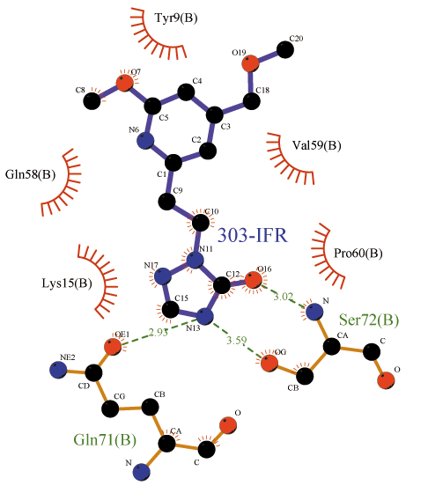
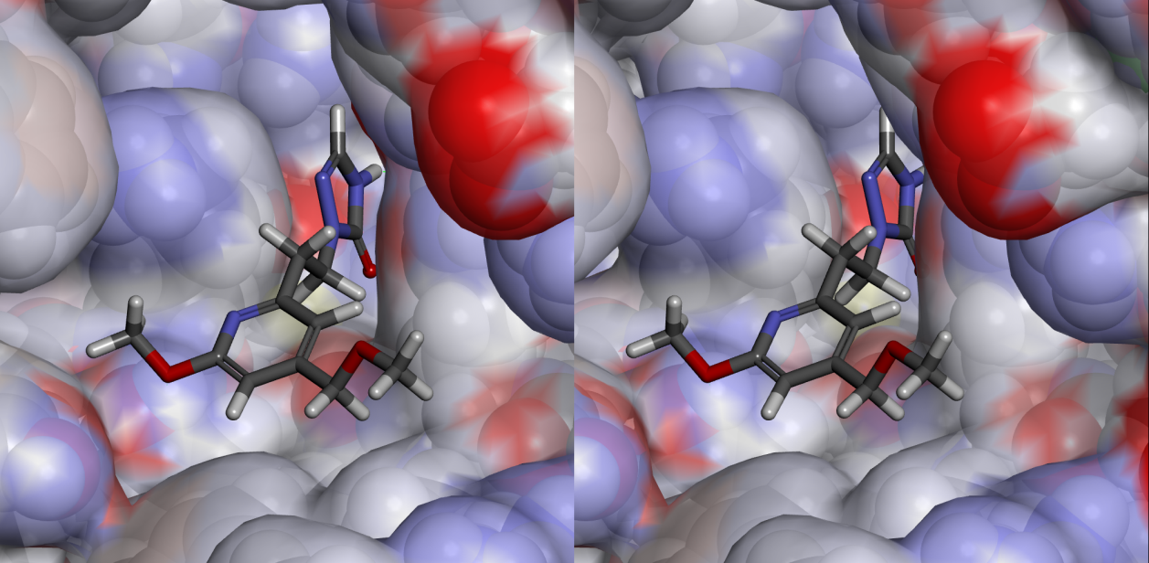
Figure Error! No text of specified style in document..19: The interaction of 303_IFR_31_260 (or 303-IFR) with G-site of PfGST. The top diagram shows 2D representation of inter-molecular interactions using dashed green lines for hydrogen bonds and radiated lines for VdW and hydrophobic interactions. The bottom Figure shows 3D stereo view including inter-molecular H-bonds (green dashed lines) and Pi stacking (orange lines).

1208-IFR
The second best ranked ligand was 1208_IFR_122_176 (1208-IFR) which has lower synthetic accessibility score of 0.55 which can be attributed to the presence of chiral centers (Figure Error! No text of specified style in document..20) [34]. The VdW potential (-16.39 kcal/mol) and entropy change (3.5 kcal/mol) of 1208-IFR was almost equivalent to that of 303-IFR. Even though, the electrostatic potential of 1208-IFR (-38.64 kcal/mol) was much lower than that of 303-IFR, the desolvation energies unfavorably affect the free energy of binding (-11.62 kcal/mol).
Frag_1 ID= 122 | Frag_2 ID= 176
1208_IFR_122_176, MW=267.39
Figure Error! No text of specified style in document..20: The structure of 1208-IFR ligand and the constituent fragments

During the optimization of 1208-IFR Cartesian coordinates within G-site of PfGST dimer, flexibility were provided for residues of Cys101, Asp105, Tyr9, Lys15, Gln58, Val59, Pro60, Gln71, Ser72, Gln73, Phe116, and Tyr211. Different mode of interaction was observed for 1208-IFR than 303-IFR (Figure Error! No text of specified style in document..21), the amino acids of G-site that were involved in hydrogen bonding with 1208-IFR were Ser72, Gln58, Val59 as well as Asp105 (from the other subunit). The Gln58 forms only weak hydrogen bonds with GSH, however, stronger interaction was observed with 1208-IFR due to suitable directionality of the carbonyl oxygen. Similarly, the interaction with Asp105 (from the other subunit) was stronger than in GSH.
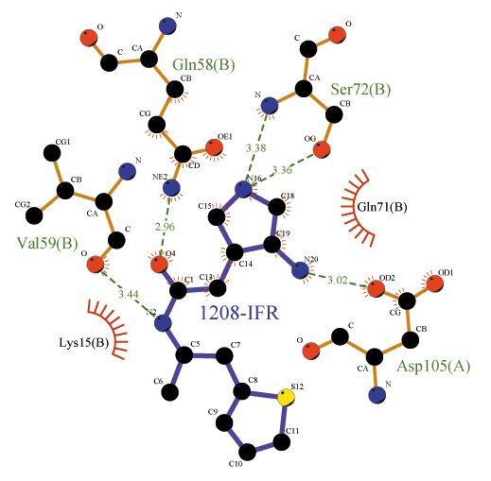
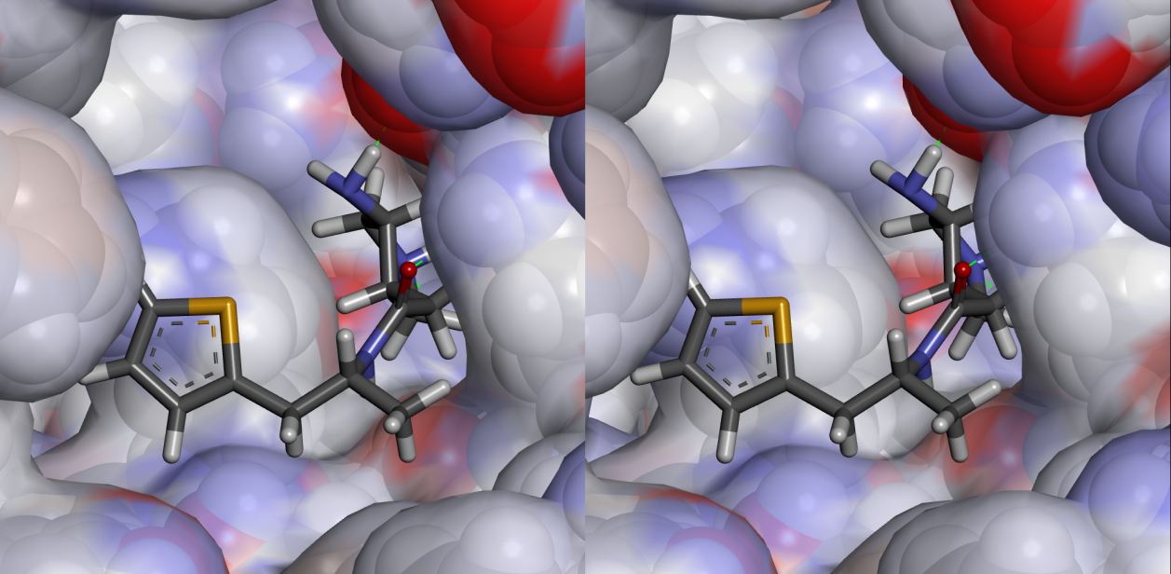

Figure Error! No text of specified style in document..21: The interaction of 1208_IFR_122_176 (or 1208-IFR) with G-site of PfGST. The top diagram shows 2D representation of inter-molecular interactions using dashed green lines for hydrogen bonds and radiated lines for VdW and hydrophobic interactions. The bottom Figure shows 3D stereo view including inter-molecular H-bonds (green dashed lines) and Pi stacking (orange lines).

De novo fragment-based design of PfGST inhibitor using docked fragments replacements (DFR) approach

Fragments preparations.
The score mean= -3.07(±1.45)

Figure Error! No text of specified style in document..22: The fluctuation in physicochemical properties of fragments docked to site-1 with respect to improvement in Chemgauss4 score. The horizontal axis represents fragment number while the vertical axis represents the value of the measured property.

Figure Error! No text of specified style in document..23: Scatter plots of Chemgauss4 score vs. molecular weight (MW) for fragments docked to site-1 and site-2.

The score mean= -2.90(±0.84)

Figure Error! No text of specified style in document..24: The fluctuation in physicochemical properties of fragments docked to site-2 with respect to improvement in Chemgauss4 score. The horizontal axis represents fragment number while the vertical axis represents the value of the measured property.

DFR ligands
The mean ΔIntra MIE of DFR ligands was higher than of IFR ligands (10.70±29.86 kcal/mol) and can be related to larger molecular size (Mean molecular weights are 279.04±49.83 and 252.43±23.11, respectively). Moreover, favorable ΔIntra MIE (i.e. value of less than zero) was not observed in any of DFR ligands compared to more than 20% of IFR ligands. The absence of favorable ΔIntra MIE in DFR ligands was mainly attributed to improper bond bends and torsions of larger molecular size (Table.7). In both of DFR and IFR ligands, the lower ΔIntra MIE value is related to electrostatic interaction between ligand’s polar atoms in solvent evacuated G-site (Mean ΔMMFF Coulomb values equal to -3.88±5.79 and -2.00±5.45 kcal/mol, respectively), however, other terms of bond bend, stretch, and torsion were almost unfavorable.

b)
c)
Figure 25: The energy terms calculated by SZYBKI during Cartesian coordinates optimization of DFR ligands within G-site of PfGST shown as a) fluctuation in relation to the Inter MIE, b) histograms for inter MIE and internal molecular strain developed due to binding, and c) the deviation in binding mode measured by RMSD (Å) following optimization and docking.

Commands used in IFR
Fragments Cartesian optimization
szybki -p optim_aligned_dimer1.pdbqt -protein_elec ExactCoulomb -opt_cart -in CYS-F_brood.hitlist.sdf -out szybki_opt_exact_fix-F_dimer_CYS-F_brood.hitlist.sdf -fix_smarts "F"
szybki -p optim_aligned_dimer1.pdbqt -protein_elec ExactCoulomb -opt_cart -in GLN-F_brood.hitlist.sdf -out szybki_opt_exact_fix-F_dimer_GLN-F_brood.hitlist.sdf -fix_smarts "F"
Fragments Cartesian 2nd optimization
szybki -p optim_aligned_dimer1.pdbqt -protein_elec PB -no_opt -in szybki_opt_exact_fix-F_dimer_CYS-F_brood.hitlist.sdf -out szybki_opt_exact_noopt_PB_fix-F_dimer_CYS-F_brood.hitlist.sdf

szybki -p optim_aligned_dimer1.pdbqt -protein_elec PB -no_opt -in szybki_opt_exact_fix-F_dimer_GLN-F_brood.hitlist.sdf -out szybki_opt_exact_noopt_PB_fix-F_dimer_GLN-F_brood.hitlist.sdf
Ligands Cartesian optimization
szybki –p optim_aligned_dimer1.pdbqt –protein_elec ExactCoulomb –opt_cart –in noH_comb_brood_24Jan_1.sdf –out szybki_opt_exact_noH_comb_brood_24Jan_1.sdf

szybki –p optim_aligned_dimer1.pdbqt –protein_elec PB –opt_cart –in szybki_opt_exact_noH_comb_brood_24Jan_1.sdf –out szybki_opt_exact_noopt_PB_noH_comb_brood_24Jan_1.sdf
Ligands conformational generation
omega2 -in noH_comb_brood_24Jan_1.sdf -out omega_noH_comb_brood_24Jan_1.oeb.gz -strictstereo false -maxconfs 1000 -ewindow 10 -sdEnergy true -searchff mmff94s_Trunc
Receptor preparation and Ligands docking
receptor_setup -protein optim_reduced_aligned_dimer1.mol2 -box box_GSH_docking_aligned_dimer.xyz -receptor customized_site_1_optim_reduced_receptor.pdb_aligned_20Dec.oeb.gz & receptor_toolbox -receptor customized_site_1_optim_reduced_receptor.pdb_aligned_20Dec.oeb.gz -prepare_score_cache fred -set_custom_constraints custom_aligned_20Dec.txt
fred -receptor customized_site_1_optim_reduced_receptor.pdb_aligned_20Dec.oeb.gz -dbase omega_noH_comb_brood_24Jan_1.oeb.gz -docked_molecule_file omega_noH_comb_brood_24Jan_1_docked.sdf -undocked_molecule_file omega_noH_comb_brood_24Jan_1_undocked.sdf -score_tag chemgauss4 -num_poses 1 -save_component_scores true -score_file omega_noH_comb_brood_24Jan_1_score.txt -hitlist_size 1000 -dock_resolution Standard
custom_aligned_20Dec.txt
SPHERE 1 1 -0.542 13.614 -3.515
SMARTS 1 F
box_GSH_docking_aligned_dimer.xyz
8
moh_dock_box_centre_-1.134_12.815_-2.800_elements_42_28_58
C -9.0090 7.5650 -13.6750
C 6.7410 7.5650 -13.6750
C -9.0090 18.0650 -13.6750
C 6.7410 18.0650 -13.6750
C -9.0090 7.5650 8.0750
C 6.7410 7.5650 8.0750
C -9.0090 18.0650 8.0750
C 6.7410 18.0650 8.0750

IFR-ligands top
