Supplementary Information
Ridged twin boundaries as prolific dislocation sources in high-entropy alloys and other low stacking-fault energy metals
Xiaoqian Fu¹, Jun Ding^{2,*},Cigdem Ozsoy-Keskinbora^{3,4}, Guang Yang⁵, Yujie Chen¹, Yan Fang¹, Eun Soo Park⁶, Ze Zhang¹, Robert O. Ritchie^{7,8,*}, En Ma^{2,*} and Qian Yu^{1,*}
¹ Center of Electron Microscopy and State Key Laboratory of Silicon Materials, School of Materials Science & Engineering, Zhejiang University, Hangzhou, 310027, China.
² Center for Alloy Innovation and Design (CAID), State Key Laboratory for Mechanical Behavior of Materials, Xi'an Jiaotong University, Xi'an 710049, China.
³ Materials Science Division, Thermo Fisher Scientific, Achtseweg Noord 5, 5651 GG Eindhoven, The Netherlands.
⁴ John A. Paulson School of Engineering and Applied Sciences, Harvard University, Cambridge, MA 02138, USA.
⁵ Thermo Fisher Scientific Inc., 2517 Jinke Road, Shanghai, 201210, China.
⁶ Research Institute of Advanced Materials, Department of Materials Science and Engineering, Seoul National University, Seoul 08826, Republic of Korea.
⁷ Materials Sciences Division, Lawrence Berkeley National Laboratory, Berkeley, CA, 94720, USA.
⁸ Department of Materials Science & Engineering, University of California, Berkeley, CA, 94720, USA.
* Corresponding authors: Jun Ding (dingsn@xjtu.edu.cn), Robert O. Ritchie (roritchie@lbl.gov), En Ma (maen@xjtu.edu.cn), and Qian Yu (yu_qian@zju.edu.cn)

Movie 1. Dislocation activity at twin-twin junction during in situ TEM tensile test. The dislocations were generated from twin-twin junction and then sluggishly moved on coherent twin boundaries with frequent pinning and de-pinning.

Figure S1 | Typical images of ridge-twin structures in different low-SFE materials. (a) Equiatomic CrCoNi medium-entropy alloy; (b) TWIP steel; (c) Pure Cu; (d) Pure Ag.

Figure S2 | Line profiles of intensity along a Σ3{112}-like ITB. The dark dashed lines marked out the Mn-enriched column, and the pink dashed lines marked out Co- and Ni-enriched columns. The enriched columns repeat every three atomic planes.

Figure S3 | Cross slip of dislocations on a CTB to grain interior. The cross-slipped dislocations are indicated by red arrows.

Figure S4 | Dislocation activities within grains during the deformation process. Strong interactions between dislocations and stacking faults were observed.

Figure S5 | Twin lamellas formed at the node of the ridge-twin boundary.

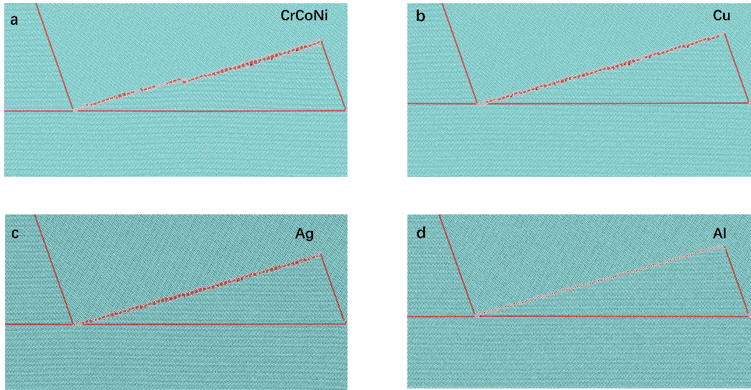
Figure S6 | Atomic configuration of ridge twins constructed in materials with different SFE. (a) CrCoNi medium-entropy alloy; (b) Cu; (c) Ag; (d) Al. The atoms are colored according to common neighbor analysis: blue, red and white atoms represent fcc, hcp and other structures, respectively.

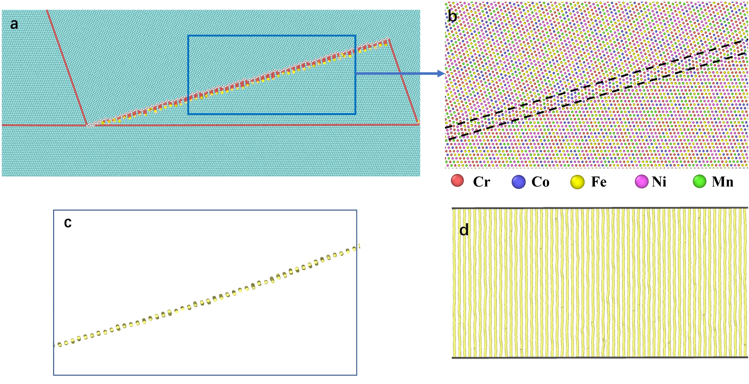
Figure S7 | Atomic configuration and dislocation array on the Σ3{112}-like ITBs in Cr₂₀Mn₁₄Fe₂₆Co₂₆Ni₂₄. (a) Atomic configuration of the ridge-twin structure; (b) Enlarged view of atomic configuration of Σ3{112}-like ITBs (denoted by blue lines) of Cr₂₀Mn₁₄Fe₂₆Co₂₆Ni₁₄ alloy. (b) and (c) are the side view and top view, respectively, of the array of Shockley partials in Σ3{112}-like ITBs.

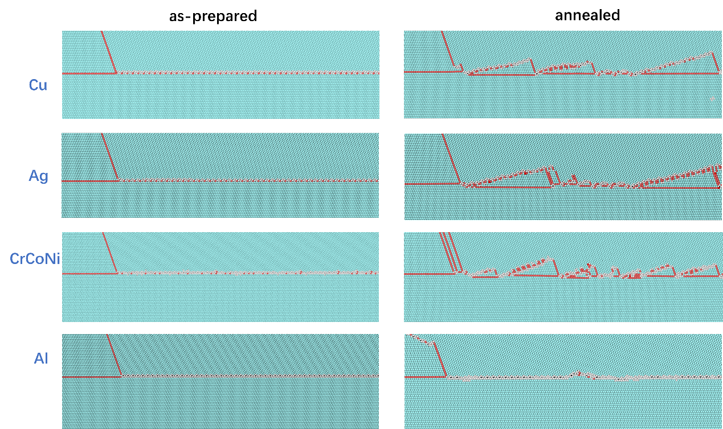
Figure S8 | Observation of the formation of the ridge twins in different SFE materials during annealing by MD simulation. The as-prepared and annealed configurations with Σ9{115}{111} GBs are shown for CrCoNi alloy, Cu, Ag and Al.

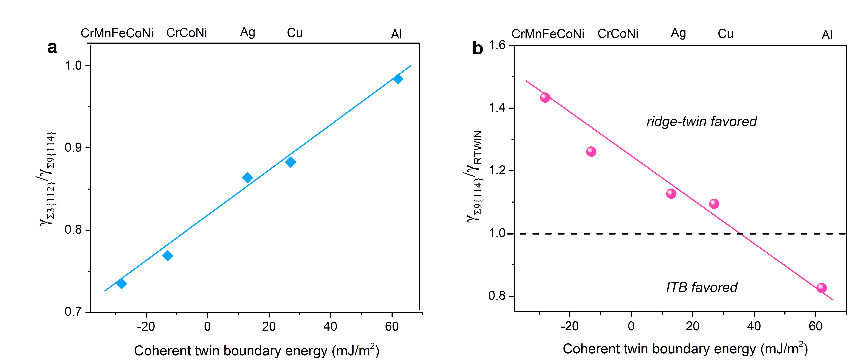
Figure S9 | Interfacial energies related with the coherent twin boundary energies. (a) The ratio of interfacial energy of Σ3{112}-like ITBs and Σ9{114} GB for all the studied materials; (b) The ratio of interfacial energy of Σ9{114} GB and ridge-twin structure for all the studied materials; the dashed line indicates the ratio of 1.0, which divides the ridge-twin favored and ITB favored regions.

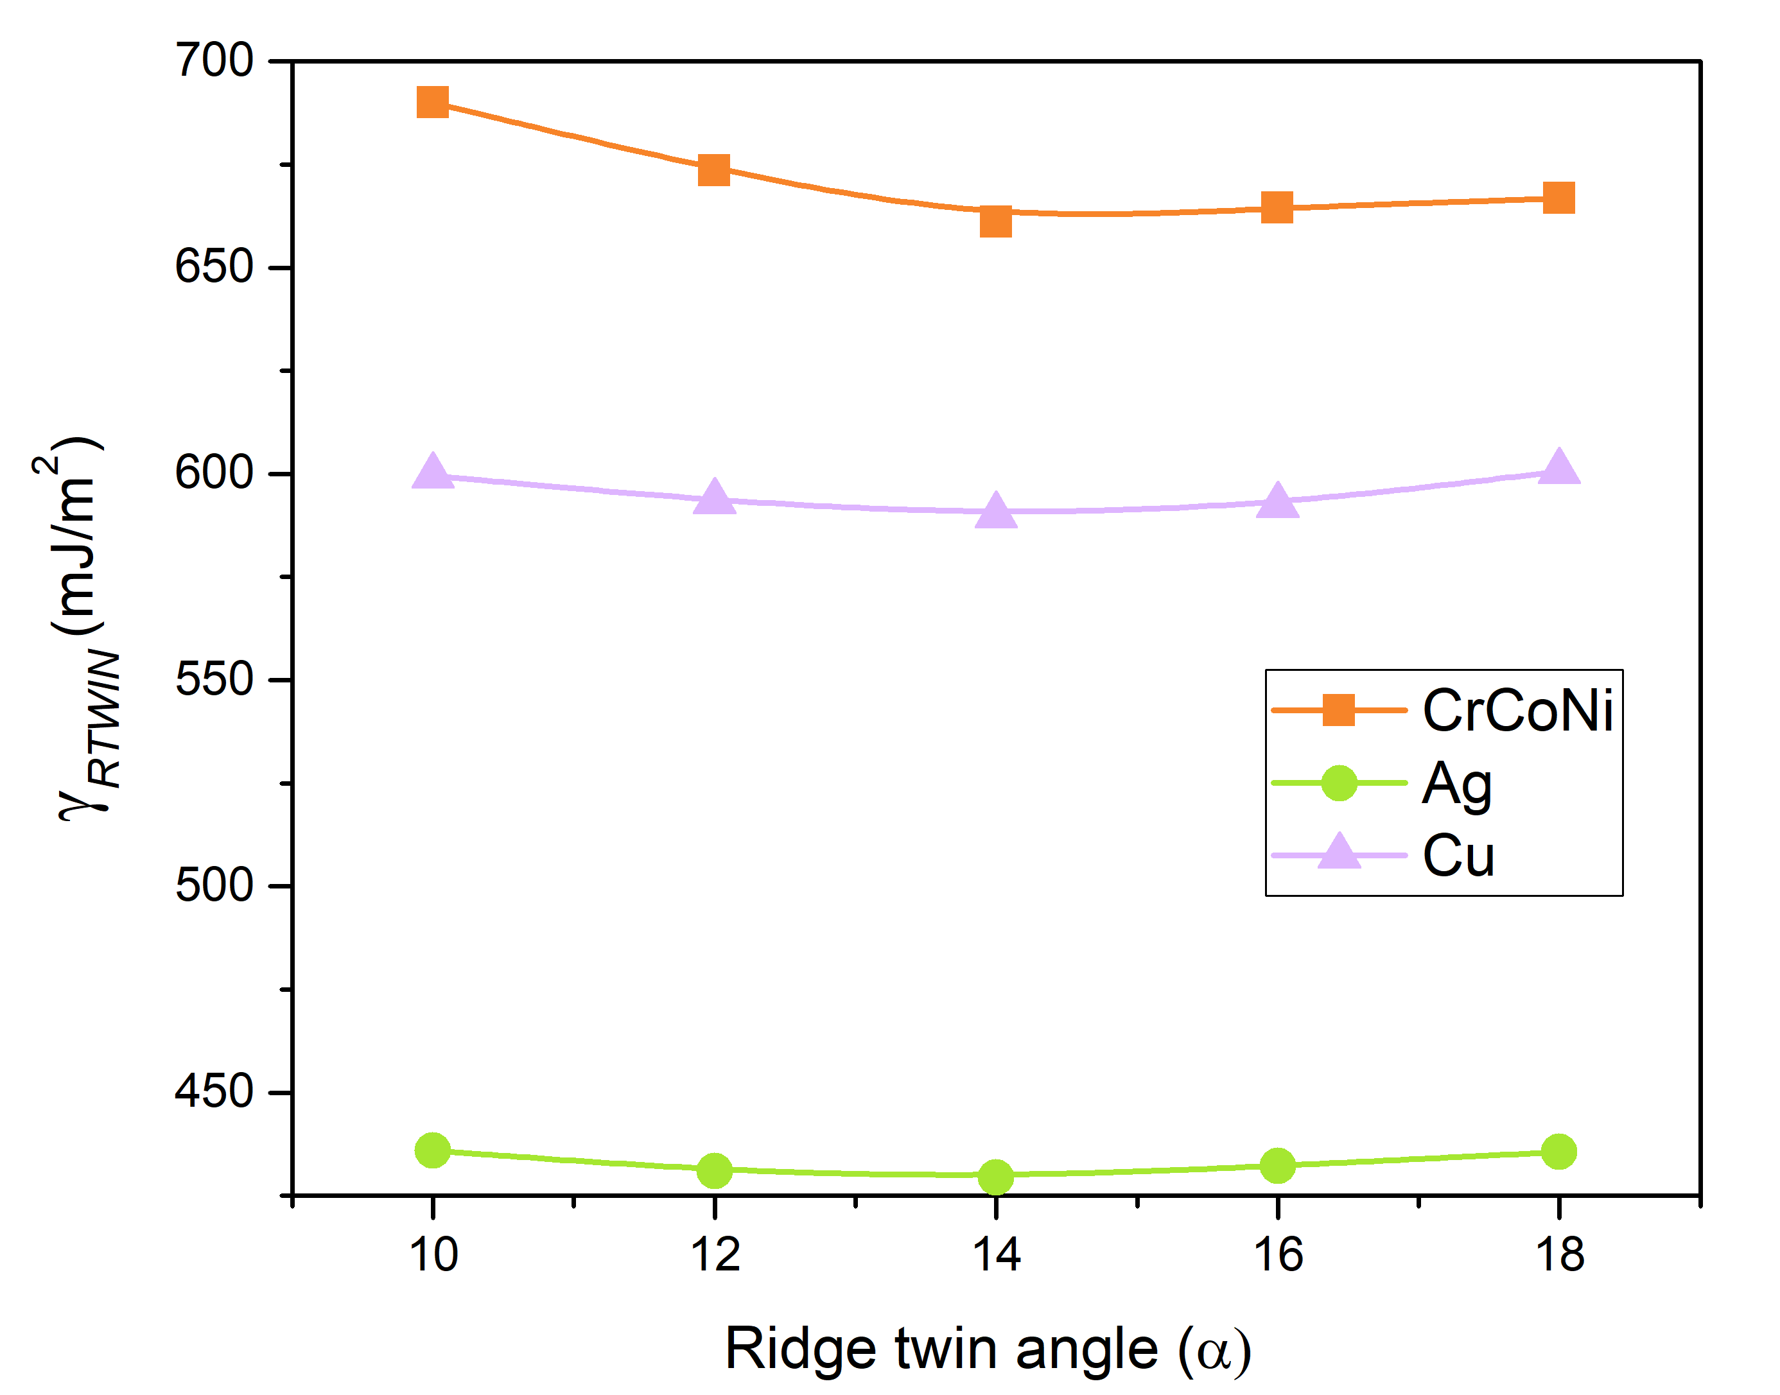

Figure S10 |The interfacial energy of ridge twins at various angles for CrCoNi, Ag and Cu.

Figure S11 | Stress field of hydrostatic stress and shear stress of ridge twin in pure Ag. A ridge twin with the length of ~60 nm was introduced in the middle (y-direction) of the configuration, which was applied with periodic boundary condition in x and z direction and free surface in y direction; (a) Atomic configuration; (b) Hydrostatic stress and corresponding profile; (c-d) Shear stress and corresponding profile.

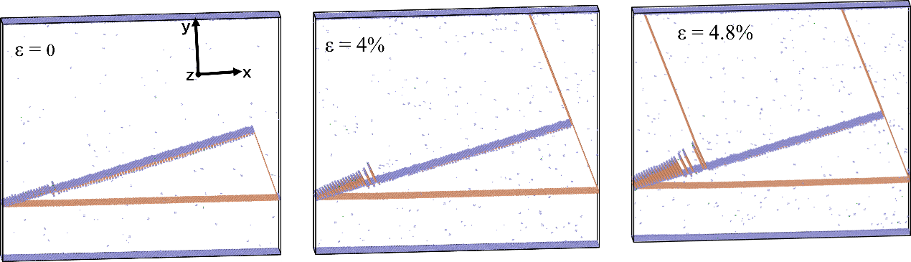
Figure S12 | Tensile deformation of Cr₂₀Mn₁₄Fe₂₆Co₂₆Ni₁₄ alloy by MD simulation. Only non-fcc atoms are colored (orange for hcp atoms and purple for other atoms). A sample of ridge-twin structure with the dimension of ~60 nm in x, ~54 nm in y and 10 nm in z direction, was applied with periodic boundary condition in x and z direction and free surface in y direction. A uniaxial tensile deformation in x axis was applied with the strain rate of 10⁻⁵ /ps at 300 K.

