Supplemental Material
A predictive in vitro risk assessment platform for pro-arrhythmic toxicity using human 3D cardiac microtissues

Celinda M. Kofron*¹, Tae Yun Kim*², Fabiola Munarin¹, Arvin H. Soepriatna¹, Rajeev J. Kant¹, Ulrike Mende², Bum-Rak Choi^{§2}, Kareen L.K. Coulombe^{§1}

¹Center for Biomedical Engineering, School of Engineering, Brown University, Providence, RI
²Cardiovascular Research Center, Cardiovascular Institute, Rhode Island Hospital and Alpert Medical School of Brown University, Providence, RI
* Contributed equally to this study.
§ Contributed equally to this study, co-corresponding authors.

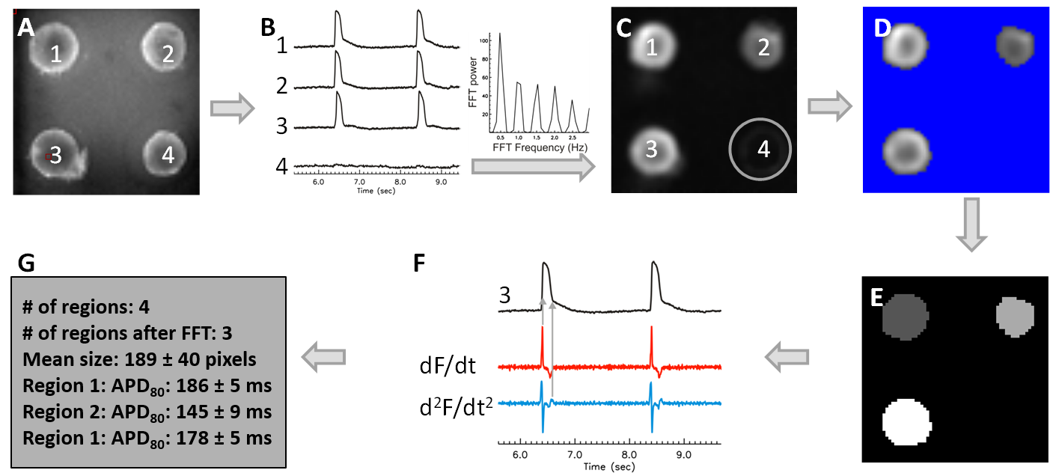

Supplemental Figure 1. Automated analysis pipeline from fluorescence signals obtained during optical mapping. (A) A greyscale snap shot of fluorescence from microtissues at 3.2x magnification (also shown in Fig 1E) during optical mapping. Individual microtissues are numbered 1 - 4. (B) Sample membrane voltage (V_{m}) traces recorded from the corresponding microtissues in panel A. Note that electrical stimulation did not evoke APs in microtissue #4 (where the fluorescence trace shows a flat line). Fast Fourier transform (FFT) was used to distinguish responsive microtissues from non-responsive microtissues lacking APs. (C) FFT_{max} image. The microtissue (#4) without APs is automatically removed in FFT_{max} (circle). (D) Automated thresholding using Otsu’s thresholding. (E) Blob coloring algorithm to detect individual microtissues. Signals within the same microtissue are averaged to acquire high signal-to-noise ratio and fidelity of data analysis. (F) Automated analysis (of sample trace #3, black) uses the first derivative (dF/dt, red trace) for detecting AP upstroke to calculate duration to 80% recovery (APD₈₀, see Figure 1G) or uses the maximum peak of the second derivative (d²F/dt², blue trace) for assessing the end of maximum repolarization rate to calculate AP duration APD_{MxR}.¹ APD_{MxR} is useful when motion artifacts or other interference on fluorescence recordings such as fluctuation in water level is suspected to elevate fluorescence level during repolarization and reproducible APD₈₀ measurement with low variation is not as reliable. (G) Sample output shows APD₈₀ statistics from the 3 excitable individual microtissues.

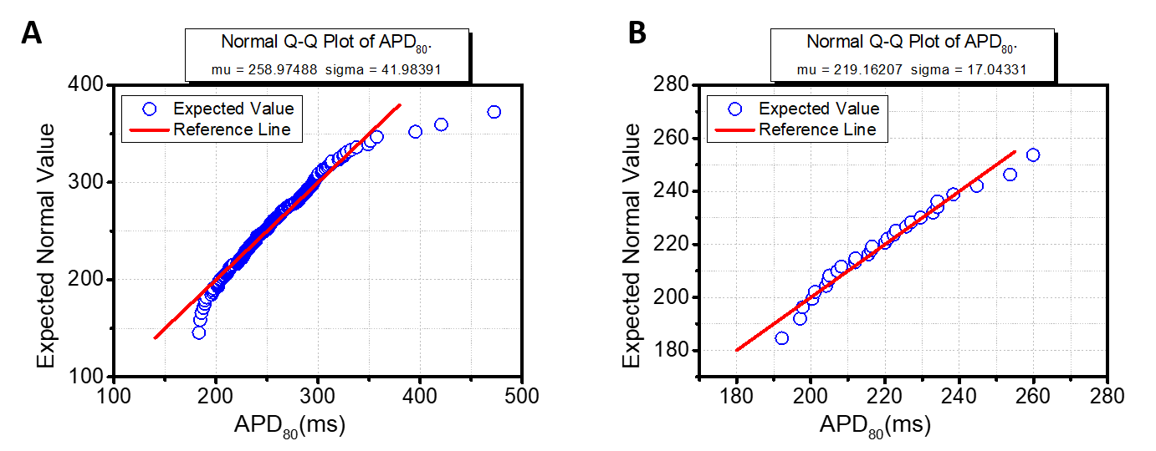
Supplemental Figure 2. Quantile-Quantile plot of APD data to normal distribution. APD₈₀ metric shows a nearly normal distribution for all data points except at the extremities when compared to the reference line (red) calculated from a normal distribution function for (A) all microtissues from 7 molds from 3 batches and (B) a single batch of 35 microtissues.

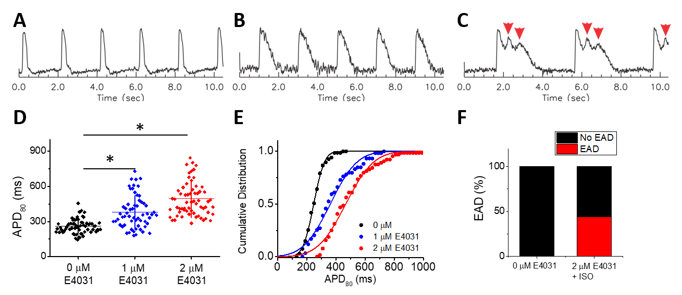
Supplemental Figure 3. Early after depolarizations in response to hERG channel blocker E4031 and isoproterenol in hiPSC-CM_{LP} with 5% hCF microtissues. (A-C) Representative V_{m} traces from control (DMSO vehicle, A), 2 µM E4031 exposure (B), and 2 µM E4031 plus 100 nM isoproterenol (ISO, C). APD₈₀ are prolonged under 2 µM E4031 and additional beta-adrenergic stimulation triggers early afterdepolarizations (EADs, red arrows). ISO alone does not evoke EADs (see Supplemental Figure S4A). (D, E) Scatter plot (D) and cumulative distribution of APD₈₀ (E) show dose-dependent increase of APD₈₀ and increased variation with E4031 (n=59-69 microtissues from 2 molds per group). Values shown by lines in (D) are means ± SD. *P < 0.05 vs. 0 μM. (F) Quantification of EAD incidence before (0 mM) and after (2 µM) E4031 in the presence of 100 nM ISO.

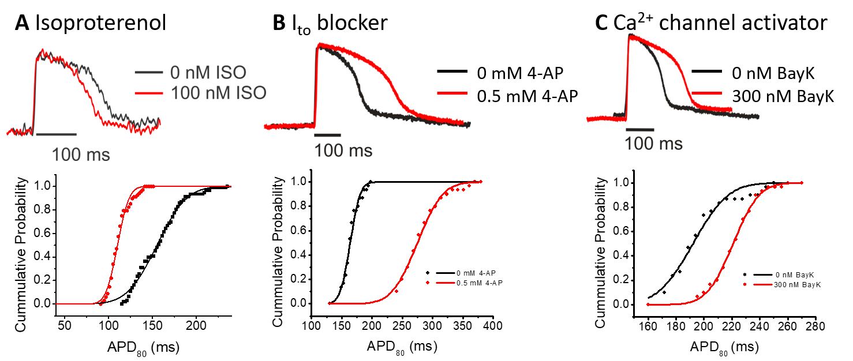
Supplemental Figure 4. Physiological responses to isoproterenol (ISO), 4-AP, and BayK8644 in hiPSC-CM_{LP} with 5% hCF microtissues. Representative traces of (top) and cumulative probability plots for APD₈₀ (bottom) show relative changes in response to indicated drugs before and after acute exposure. (A) Beta-adrenergic stimulation with 100 nM ISO shortened APD₈₀ (red) (166.6 ± 17.7 vs. 120.1 ± 10.5 after ISO, P = 8.91×10⁻¹⁹, n=29 microtissues). No early afterdepolarization (EAD) was observed. (B) Blockade of the transient outward potassium current (I_{to}) with 4-Aminopyridine (4-AP) prolonged APD₈₀ (red) (169.3 ± 14.7 vs. 288.7 ± 33.9 ms, P = 2.62×10⁻²⁶, n=35 microtissues). (C) L-type Ca²⁺ channel stimulation with 300 nM BayK8644 prolonged APD₈₀ (red) (199.5 ± 20.3 vs. 225.8 ± 14.6 ms, 1.15×10⁻⁹, n=35 microtissues).

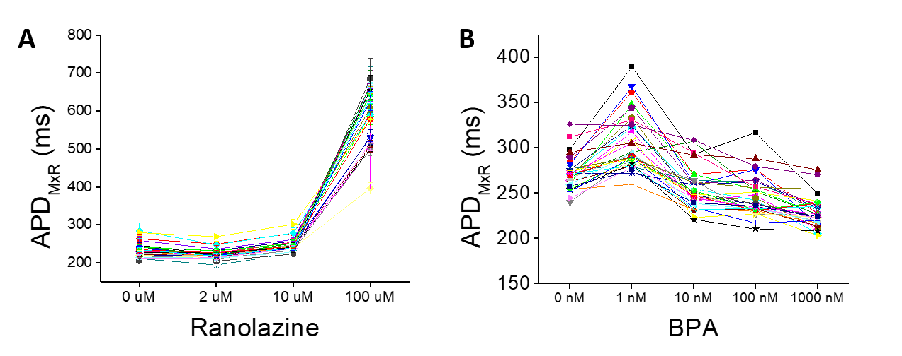
Supplemental Figure 5. Tracking individual microtissue dose responses of Ranolazine and BPA. Dose response curves for APD_{MxR} with increasing concentrations of (A) ranolazine (n=34 microtissues; shown in heatmap of Figure 5B) and (B) BPA (n=34 microtissues; heatmap shown in Figure 6B). The lines depict dose-dependent APD_{MxR} changes of individual microtissues. The analysis of individual microtissues before and after drug exposure at different concentrations using paired t-tests increases statistical power.

Supplemental Table 1. P-values from paired t-tests of data depicted in Figure 5C for ranolazine (top); Figure 6B for one experiment with BPA (up to 1 μM, bottom). Red font indicates P<0.05.

Supplemental Figure 6. APD_{tri} metric as an indicator of hERG channel blockade. The relationship between APD prolongation and APD triangulation (APD_{tri}) can be used to infer hERG channel blockade. We tested 3 major ion channel modulators that can prolong APD during the early phase (I_{to}, phase 1; with 4-AP), plateau phase (I_{Ca}, phase 2; with BayK8644), and repolarization (I_{Kr}, phase 3; with E4031) of the AP. Since I_{Kr} impacts the later phase of AP repolarization (phase 3), I_{Kr} blockade delays phase 3 repolarization to increase APD_{tri}. (A) Computer modeling to study the impact of I_{Kr} blockade on APD_{tri} using the O’Hara human myocyte model.² The conductances of I_{Na}, I_{to}, I_{Ca,} I_{Kr}, I_{Ks} were varied to have a Gaussian distribution of APDs in 10,000 cells (original parameters in O’Hara and Rudy² ± 20%). APD_{tri} changes under I_{Kr} block were investigated. Increase of I_{Kr} blockade (from black to blue, green, orange and red) increases APD_{tri} as APD_{MxR} increases (plot, left) and steepens the slope of APD_{tri} versus APD_{MxR} (bar graph, right). (B-D) Experimental results show that the increase of APD_{tri} is unique to I_{Kr} blockade. (B) The slope of APD_{tri} versus APD_{MxR} steepened in response to 1µM E4031, in agreement with the results from the computer modeling in panel A. The slope significantly increases between 0 and 1 µM E4031 (right, p = 0.011). (C) 0.5 mM 4-AP (I_{to} blockade) did not steepen the slope of APD_{tri} versus APD_{MxR} despite APD prolongation (p = 0.199). (D) 300 nM BayK8644 (I_{Ca} agonist) did not steepen APD_{tri} versus APD_{MxR} despite APD prolongation (p = 0.539).

Dose-dependent mean differences of AP metrics (Ranolazine)
Ranolazine | 2 μM | 10 μM | 100 μM
Rise Time | -0.35093 | 0.03604 | 7.77581
APD₃₀ | 4.39627 | 16.6689 | 53.5831
APD₅₀ | -3.46581 | 14.7128 | 101.51
APD₈₀ | 3.43512 | 64.7965 | 219.988
APD_{MxR} | -10.5228 | 6.64536 | 307.389
APD_{tri} | -3.5293 | 2.56326 | 198.626

Dose-dependent mean differences of AP metrics (BPA)
BPA | 1 nM | 10 nM | 100 nM
Rise Time | -0.12072 | -1.53018 | -2.27589
APD₃₀ | 19.687 | -10.3786 | -16.5818
APD₅₀ | 16.8487 | -15.1815 | -21.6624
APD₈₀ | 22.9907 | 1.23495 | 0.76422
APD_{MxR} | 10.2523 | -19.7025 | -31.285
APD_{tri} | -6.57858 | -4.48536 | -9.56911

Supplemental Table 2. Mean dose-response difference of AP metrics. Red and blue fonts indicate that AP metrics increased and decreased, respectively, by the paired t-test in Figure 7.

Movie S1. Beating human cardiac microtissue comprised of hiPSC-CMs and 5% hCFs imaged after 1 day in 3D culture while paced at 1 Hz.

Movie S2. Optical mapping of a human cardiac microtissue (left) and the corresponding voltage trace (right) under control conditions (DMSO as vehicle) while paced at 0.5 Hz.

Movie S3. Optical mapping of 2 human cardiac microtissues (left) and the corresponding voltage traces (right) under 2 μM E4031 showing APD prolongation and distinct EADs while paced at 0.5 Hz.

Supplemental Material References:
1. Efimov IR, Huang DT, Rendt JM, Salama G. Optical mapping of repolarization and refractoriness from intact hearts. Circulation 1994;90:1469-1480.
2. O'Hara T, Virag L, Varro A, Rudy Y. Simulation of the undiseased human cardiac ventricular action potential: model formulation and experimental validation. PLoS Comput Biol 2011;7:e1002061.

