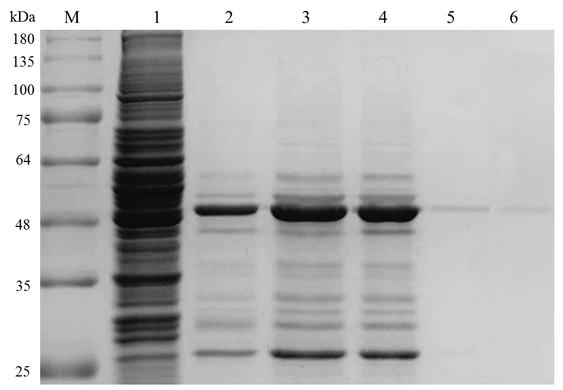
Supplementary Figure 1: Protein analysis of CK-BB at different purification stages: M: marker, 1. crude enzyme, 2: ethanol precipitation, 3: ammonium sulfate precipitation, 4. dialysis, 5: DEAE-Sepharose CL-6B anion chromatography, 6: sephacryl S-300 gel filtration chromatography.

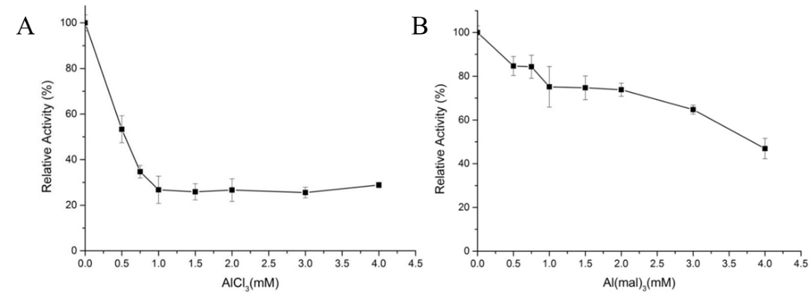
Supplementary Figure 2 (A) Inhibitory effect of different concentrations of AlCl₃ on brain-type creatine kinase; (B) Inhibitory effect of different concentrations of Al(mal)₃ on brain-type creatine kinase

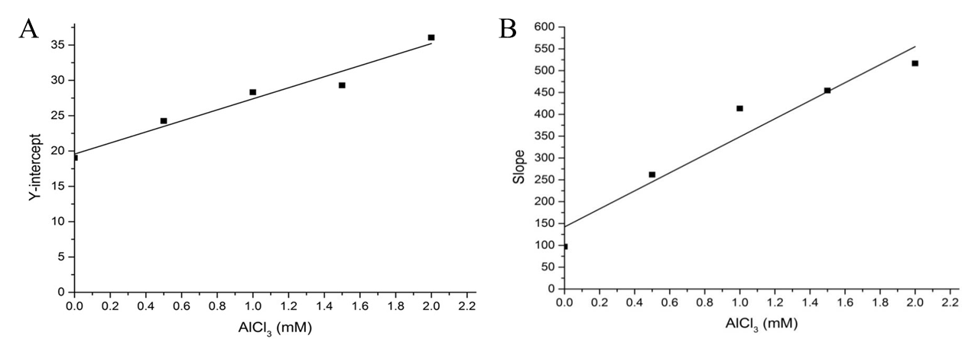
Supplementary Figure 3 (A) Relationship between AlCl₃ concentration and longitudinal intercept of Lineweaver-Burk curve; (B) Relationship between AlCl₃ concentration and slope of Lineweaver-Burk curve

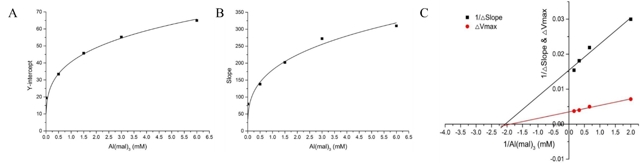
Supplementary Figure 4 (A) Relationship between Al(mal)₃ concentration and longitudinal intercept of Lineweaver-Burk curve; (B) Relationship between Al(mal)₃ concentration and slope of Lineweaver-Burk curve; (C) Relationship between Al(mal)₃ concentration and 1/△Slope and 1/△Y-intercept
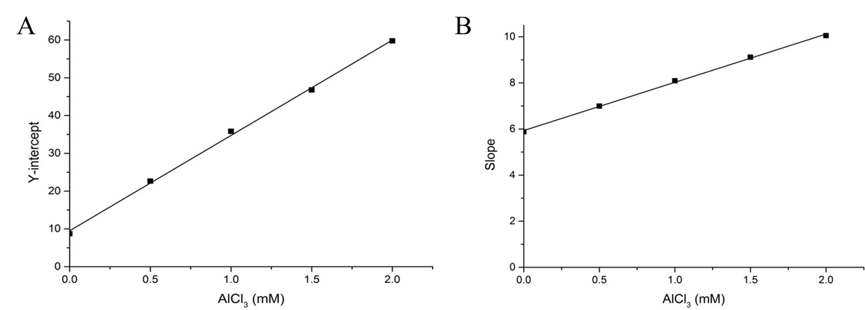
Supplementary Figure 5 (A) Relationship between AlCl₃ concentration and longitudinal intercept of Lineweaver-Burk curve; (B) Relationship between AlCl₃ concentration and slope of Lineweaver-Burk curve

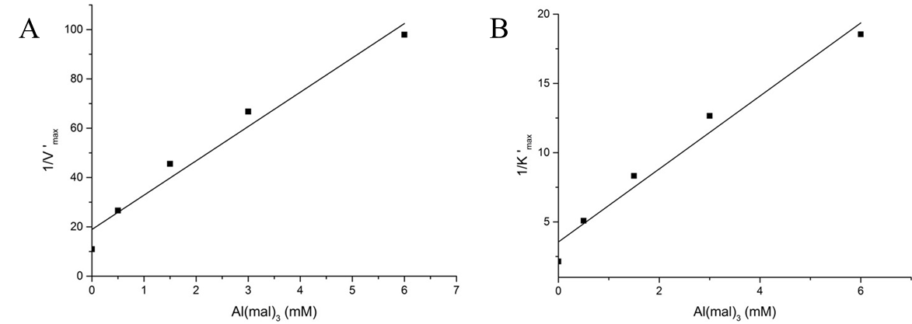
Supplementary Figure 6 (A) Relationship between Al(mal)₃ concentration and longitudinal intercept of Lineweaver-Burk curve; (B) Relationship between Al(mal)₃ concentration and slope of Lineweaver-Burk curve

