A Colorimetric Distinct Color Change Cu(II) 4-{[1-(2,5-dihydroxyphenyl)ethylidene]amino}-1,5-dimethyl-2-phenyl-1,2-dihydro-3H-pyrazol-3-one Chemosensor and its Application as a paper test kit
Nilima Patil^{ab}, Rajesh Dhakeª*, Raju Phalakª, Umesh Fegade^{b}*, Chennan Ramalingan^{c}, Vadivel Saravanan^{c}, Inamuddin^{d}, Tariq Altalhi^{e},
ªDepartment of Chemistry, D. D. N. Bhole College, Bhusawal, Jalgaon, 425201 (MH), India.
^{b}Department of Chemistry, Bhusawal Arts, Science and P. O. Nahata Commerce College, Bhusawal, Jalgaon, 425201 (MH), India.
^{c}Department of Chemistry, Kalasalingam Academy of Research and Education (Deemed to be University), Krishnankoil - 626 126, Tamilnadu, India.
^{d}Advanced Functional Materials Laboratory, Department of Applied Chemistry, Zakir Husain College of Engineering and Technology, Faculty of Engineering and Technology, Aligarh Muslim University, Aligarh-202002, India
^{e}Department of Chemistry, College of Science, Taif University, P.O. Box 11099, Taif 21944, Saudi Arabia
Corresponding author Email id:- drrbdhake@gmail.com, umeshfegade@gmail.com
UmeshFegade Orchid ID- 0000-0002-2599-668X

Sample preparation
The stock solution of C1 with a concentration of 1 × 10⁻³ M was made in the 60:40, v/v of CH₃OH/H₂O. The C1 was freely soluble in CH₃OH/CH₃CN ratio of 60:40, v/v at 25 °C. The working solution with a concentration of 1 × 10⁻⁵ M was prepared by diluting with CH₃OH/H₂O (60:40, v/v) solution. The stock solutions of all interferents (cations) with a concentration of 1 × 10⁻³ M were prepared in CH₃OH/H₂O (60:40, v/v) solution followed by the working solutions (c = 1 × 10⁻⁴ M).
Binding Constant
On the basis of the Benesi-Hildebrand (Eq.1) and Scatchard plot (Eq.2) methodology, K_{b} was calculated employing the following equation. The high value of the binding constant shows the stability of the complex and which is previously confirmed by the DFT calculation.
1/(F-F₀) = 1/(F∞ - F₀)K_{a}[G] + 1/(F∞-F₀) (Eq.1)
F-F₀/[G] = (F∞-F₀)K- (F-F₀)K (Eq.2)
F₀= absorbance in absence of guest ion,F = absorbance in presence of guest ion, F∞= absorbance after titration,[G] = concentration of guest.
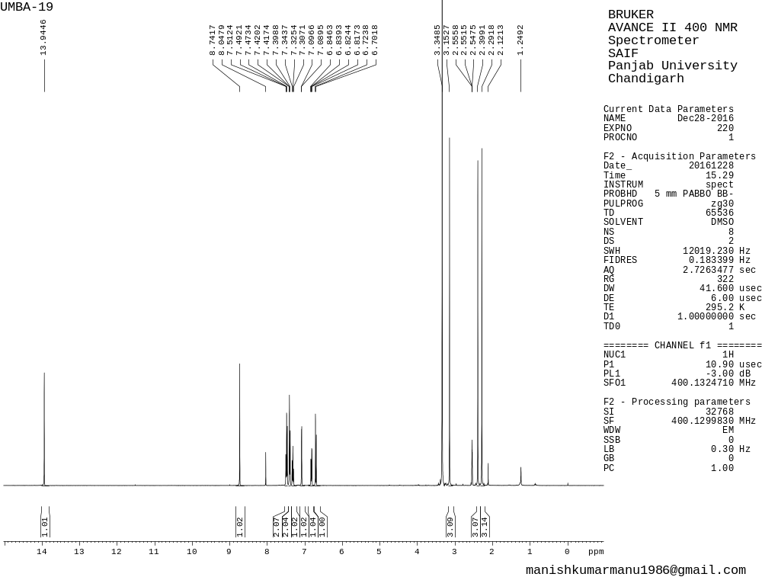
Figure S1¹H-NMR spectra of C1
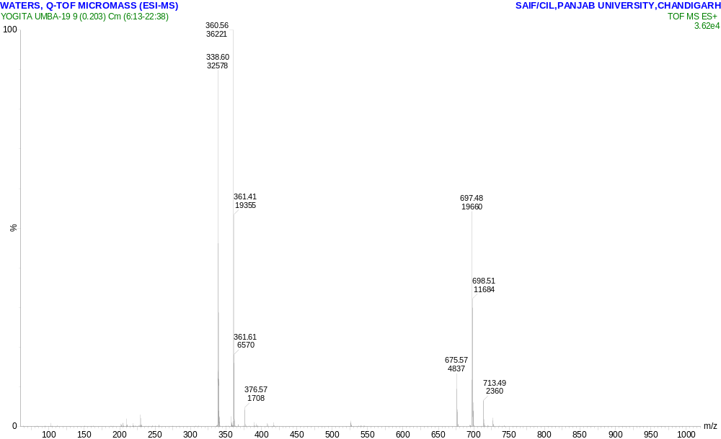
Figure S2 MASS spectra of C1

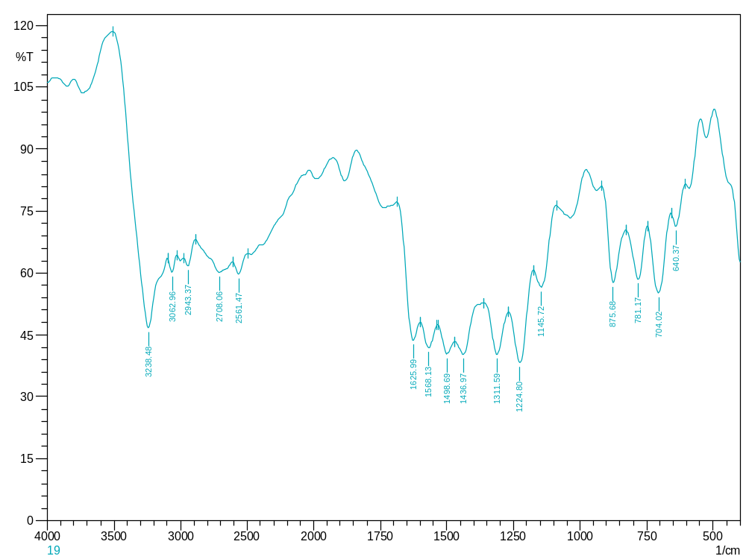
Figure S3 IR spectra of C1

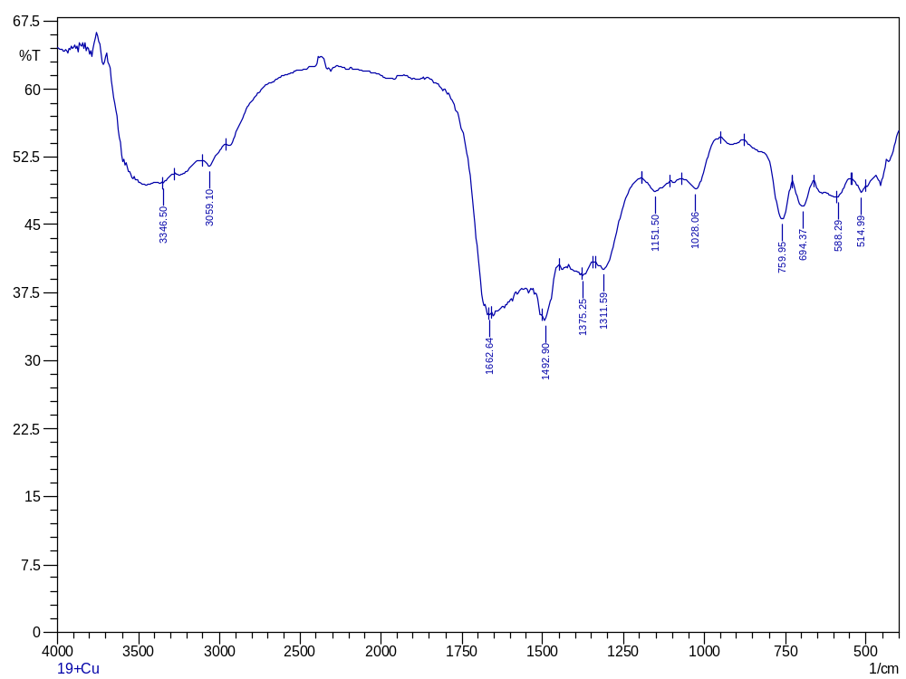
Figure S4 IR spectra of S1+Cu complex

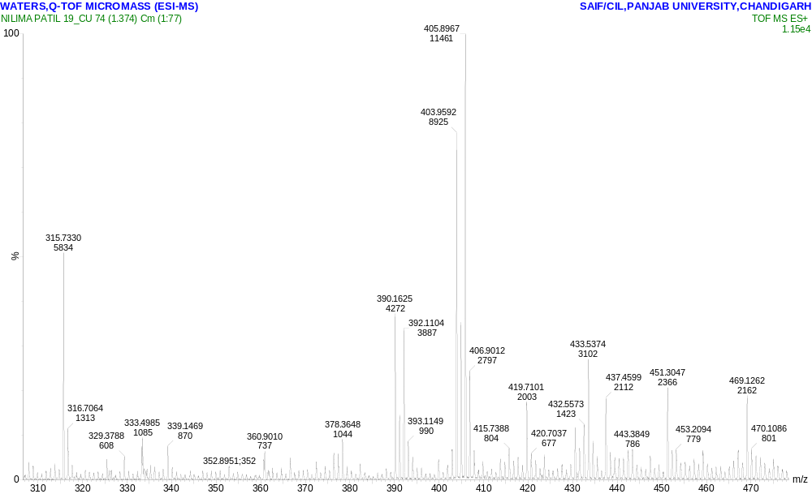Figure S5 MASS spectra of S1+Cu complex

Reference
- MinC Y, HuoC Z, XiaH G, FanX Q, 2015 Synthesis, Crystal structure and fluorescence properties of hydrozone Schiff base and its Zinc coordination polymer, Chinese Journal of Inorganic Chemistry, 31 317-322.
- Qin J,YangZ, 2015Bis-Schiff base as a donor-acceptor fluorescent probe: Recognition of Al³⁺ ions in near 100% aqueous solution, Journal of Photochemistry and Photobiology 303–304.
- GuoS, LiuG, FanC, PuS, 2018A new diarylethene-derived probe for colorimetric sensing of Cu(II) and fluorometric sensing of Cu(II) and Zn(II): Photochromism and High Selectivity, Sensors and Actuators B.266 603-613.
- DeshpandeS S, KhopkarS, ShankarlingG, 2017A thiazoloquinoxaline based “turn-on” chemodosimeter for detection of copper ions, Dyes and Pigments.147 393-399.
- RahmanM M, HussainM M, ArshadM N, AsiriaA M, 2020The synthesis and application of (E)-N0-(benzo[d] dioxol-5-ylmethylene)-4-methylbenzenesulfonohydrazide for the detection of carcinogenic lead, RSC Adv.10 5316–5327.
- KarC, SamantaS, GoswamiS, RameshA, DasG, 2015A single probe to sense Al(III) colorimetrically and Cd(II) by turn-on fluorescence in physiological conditions and live cells, corroborated by X-ray crystallographic and theoretical studies, Dalton Trans. 44, 4123–4132.
- KhanRI, RamuA, PitchumaniK, 2018Design and one-pot synthesis of a novel pyrene based fluorescent sensor for selective “turn on”, naked eye detection of Ni²⁺ ions, and live cell imaging, Sensors and Actuators B, 266 429-437.
- ZhangJ, ZhaoX, Liu X and DongC, 2020Enhanced chemical sensing for Cu²⁺ based on composites of ZIF-8 with small molecules, RSC Adv. 10 13998–14006.
- BenesiHA, Hildebrand JH 1949J. Am. Chem. Soc.712703-2707.
- Scatchard G 1949The attractions of proteins for small molecules and Ions, Annals of the New York Academy of Sciences51660–672.

