Supporting Information

SI. 1. FT-IR and ¹HNMR of protected 4-amino butyric acid.

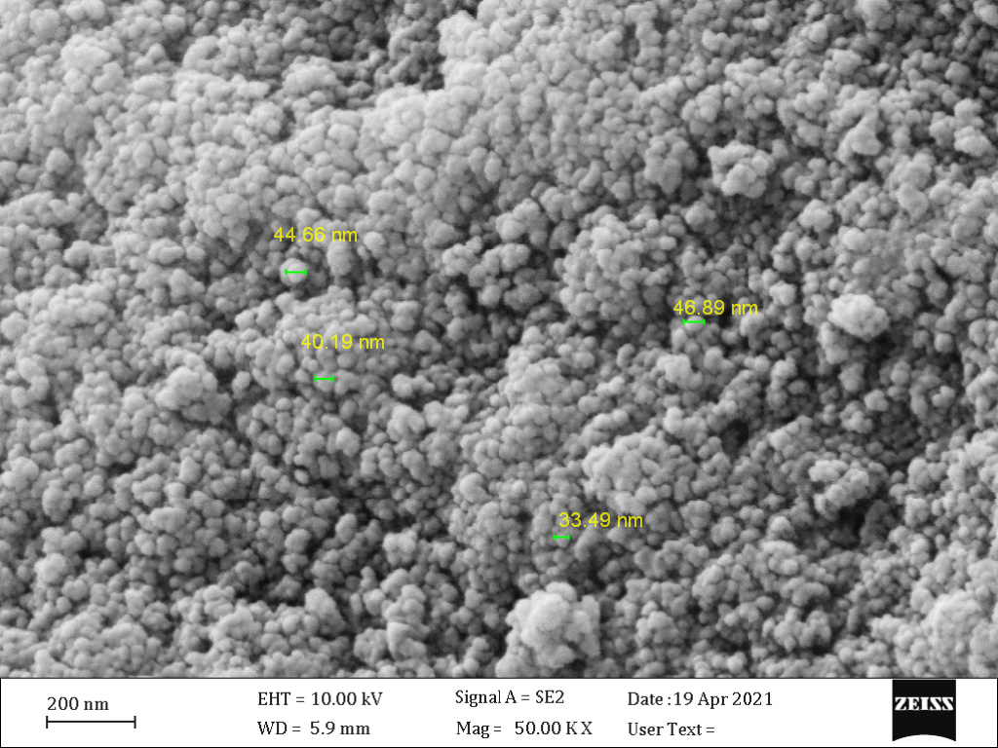
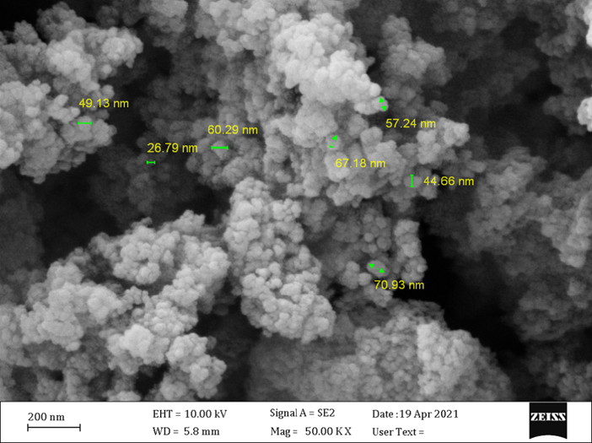
a
b

SI. 1. The FE-SEM of Fe₃O₄@SiO₂-NHCO-NH₂-MnTCPP (b)

SI. 2. The FE-SEM of Fe₃O₄@SiO₂-NHCO-NH₂ (a) and Fe₃O₄@SiO₂-NHCO-NH₂-MnTCPP (b).

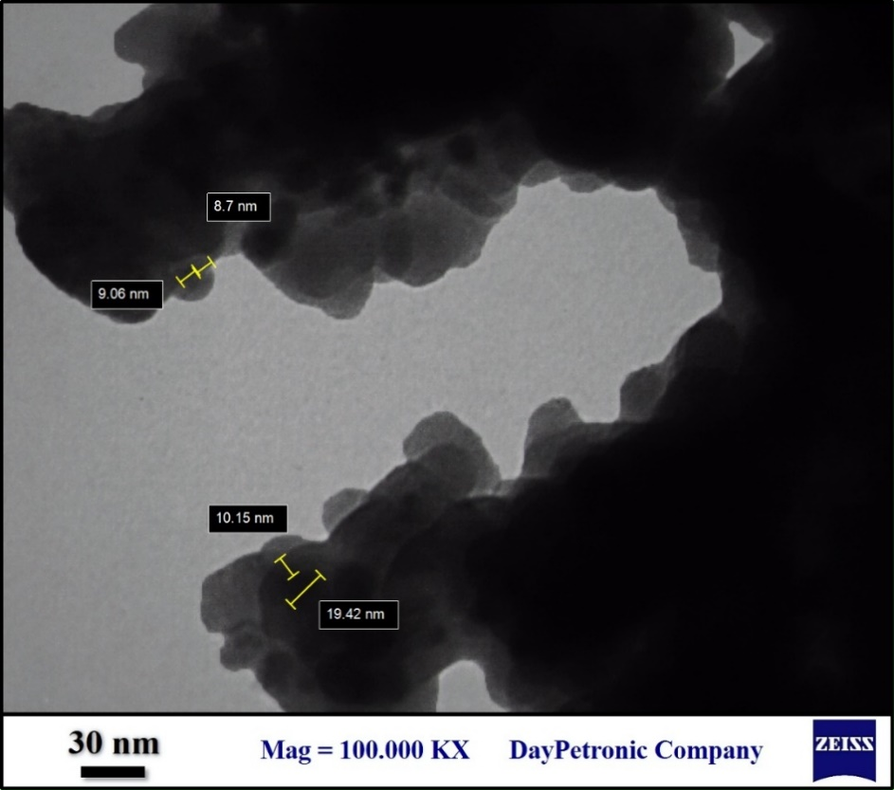
SI. 3. The TEM of Fe₃O₄@SiO₂-NHCO-NH₂-MnTCPP.

