Supplementary tables

Supplementary table 1. The complete list of indicator species OTUs detected for the different months in the auxiliary rooms of a daycare center in Oslo, Norway.
Excel table “Supplementary table 1”.

Supplementary table 2. The complete list of indicator species OTUs detected for the different months in the main rooms of two daycare centers in Oslo.
Excel table “Supplementary table 2”.

Supplementary figures

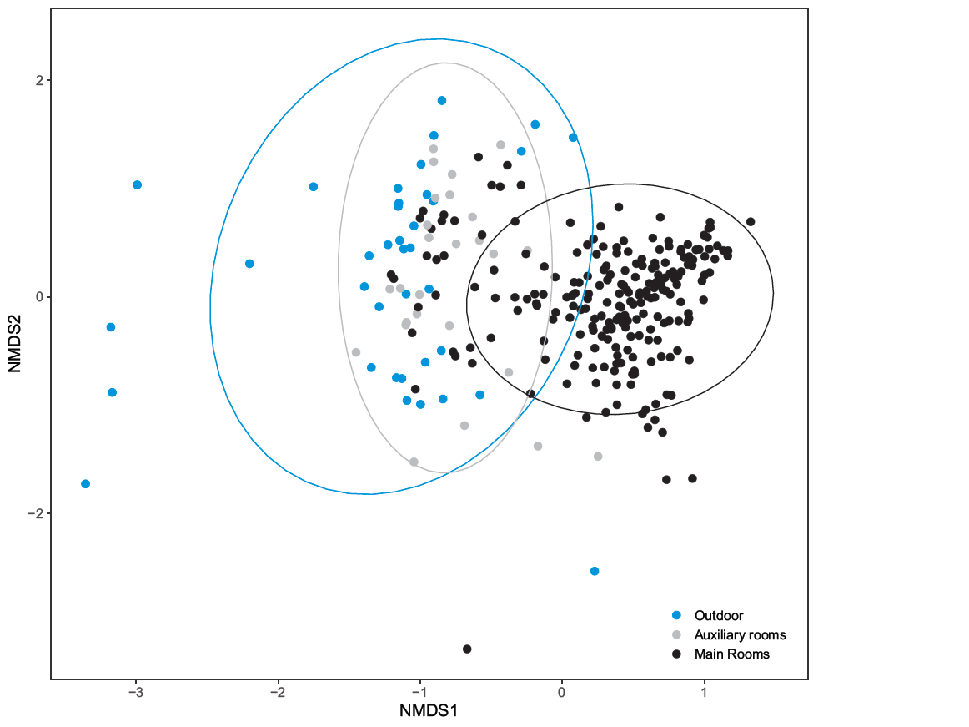
Fig. S1. Nonmetric multidimensional scaling (NMDS) ordination plot of fungal composition from outdoors air samples and indoor dust samples from different room types (main and auxiliary) of two daycare centers in Oslo, Norway sampled throughout a year. Each point represents one sample, and the color separates the samples from the outdoor and the auxiliary and main rooms.

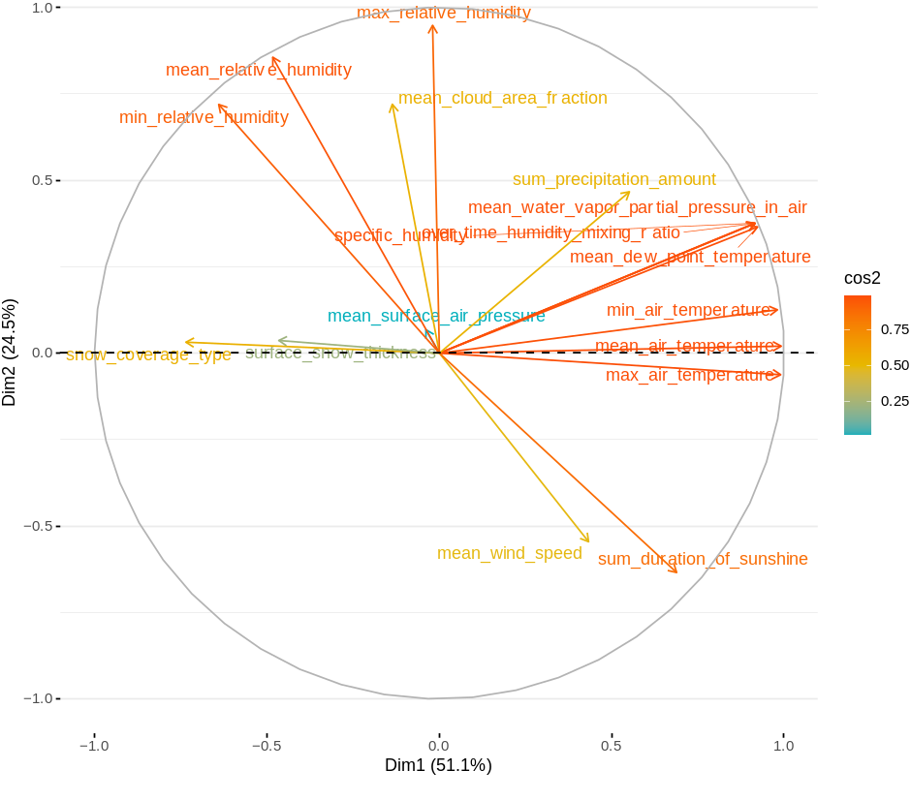
Fig. S2. Principal Component Analysis (PCA; Axes 1 and 2) for data from the meteorological numerical variables explored in this study. Data were recorded by the meteorological station at Blinder, located within 1 km² of both daycare centers in Oslo, Norway.

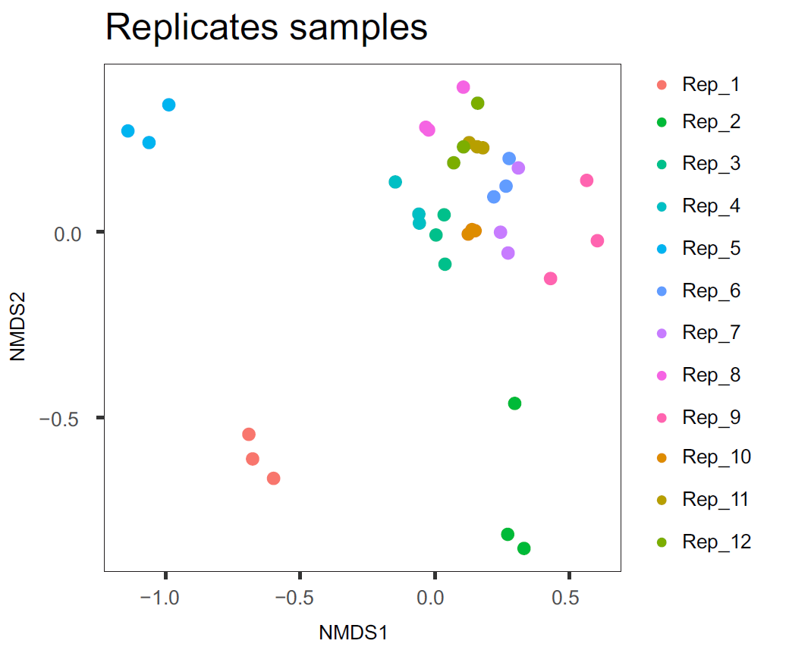
Fig. S3. Nonmetric multidimensional scaling (NMDS) ordination plot of technical PCR replicates included in the library preparation and sequencing. Each point represents one sample, and the color indicates the different replicates.

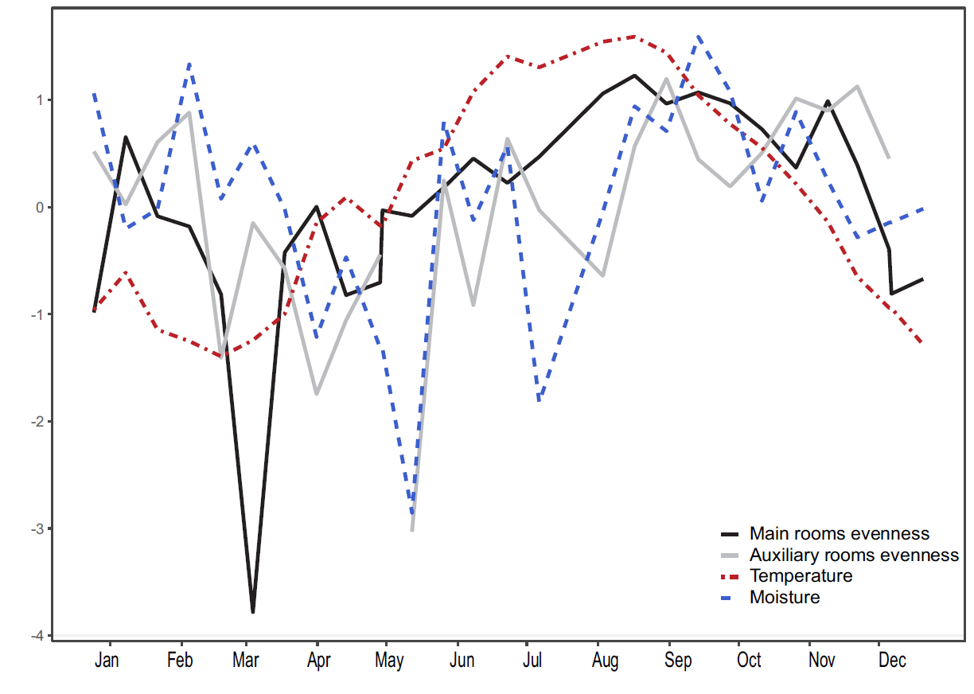
Fig. S4. Monthly evenness time-series of the dust samples in the main rooms (black line) and the auxiliary rooms (grey line) sampled in two daycare centers in Oslo, Norway. The dotted lines represent the monthly fluctuation of temperature (red) and moisture (blue). The gap in auxiliary rooms evenness in May is due to samples excluded from the analysis because of low number of reads.

