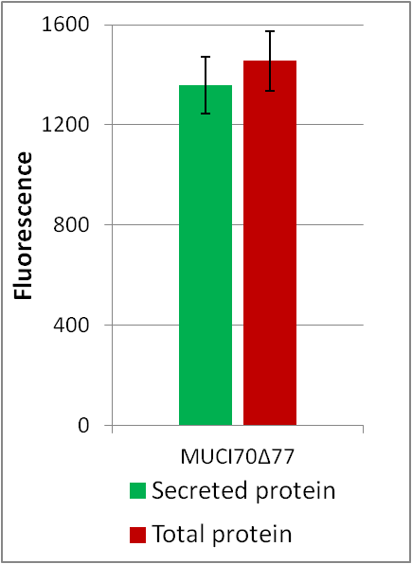
Supplemental Figure S1. Expression of MUCI70Δ77 in HEK293 cells
MUCI70Δ77 was expressed in a total of two small-scale (20 mL) and one large-scale (250 mL) cultures. Total protein is the measure of fluorescence of total GFP fluorescence from cells + culture medium. Secreted protein is the measure of fluorescence of cell-free medium. All samples are taken from a 100 µL aliquot from the cell culture after 6 days. MUCI70Δ77 was expressed with 93% secretion efficiency, defined as the proportion of secreted protein to the total protein fluorescence. Error bars represent the standard deviation from three biological replicates.

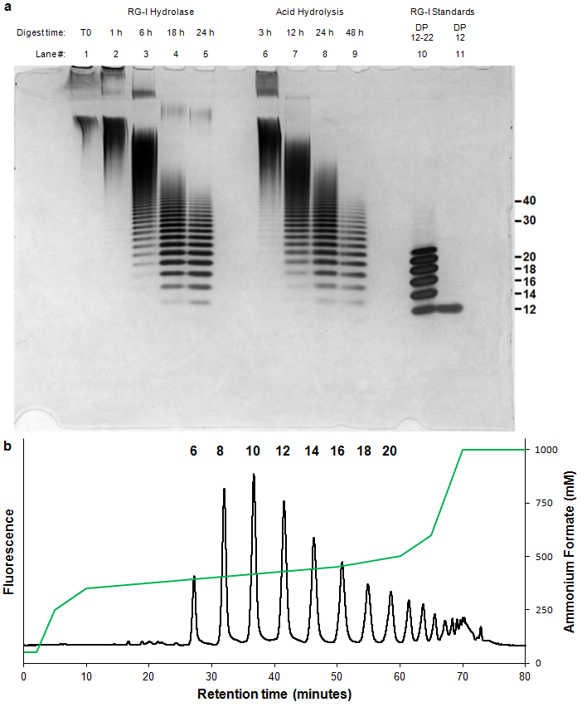
Supplemental Figure S2. Digest of RG-I mucilage and purification of RG-I acceptor oligosaccharides
a, Arabidopsis mucilage was digested for the indicated times with RG-I hydrolase and by acid hydrolysis. Digests were carried out using 10 mg of mucilage and 0.1 µg RG-I hydrolase from Aspergillus aculeatus at 40°C or 1M HCl at 80°C for the indicated time points.
b, RG-I oligosaccharides from digested mucilage were injected into a CarboPac PA-1 semi-preparative (22x250 mm) column following labeling with 2AB. Fractions were collected as individual peaks containing RG-I oligosaccharides of the indicated degree of polymerization (indicated above peak). Peaks were eluted in a gradient ranging from 50-1000 mM ammonium formate indicated by the green line.
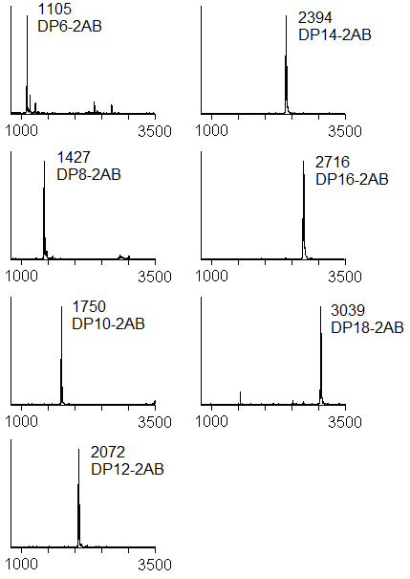
Supplemental Figure S3. MALDI of RG-I acceptors purified by anion exchange chromatography.
The purity of RG-I oligosaccharide fractions collected as in Supplemental Fig. 2B was assessed by MALDI-TOF mass spectrometry. DP, degree of polymerization.

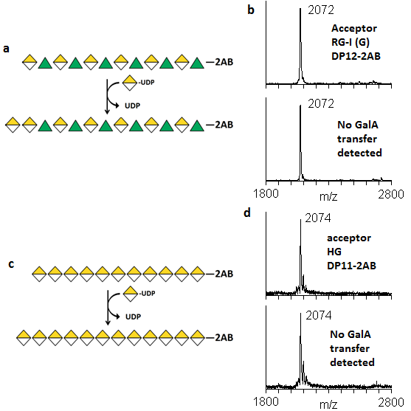
Supplemental Fig. S4. RGGAT1 does not transfer GalA to RG-I acceptors containing GalA on the non-reducing end or to HG acceptors.
a. Hypothetical transfer of GalA to the non-reducing end of an RG-I acceptor, resulting in RG-I oligosaccharides containing at least two contiguous GalA residues on the non-reducing end.
b. RGGAT1 does not catalyze the transfer of GalA to the RG-I (G) acceptor. RGGAT1 (1 mM) was incubated with UDP-GalA and an RG-I (G) acceptor for 1 hour. Longer incubation times did not result in any detectable activity.
c. Hypothetical transfer of GalA to the non-reducing end of an HG acceptor, resulting in elongation of the HG backbone by at least one GalA monosaccharide.
d. RGGAT1 does not catalyze the transfer of GalA to the HG acceptor. RGGAT1 (1 mM) was incubated with UDP-GalA and an HG acceptor for 1 hour. Longer incubation times did not result in any detectable activity.
Supplemental Figure S5. Biochemical characterization of RGGAT1 activity.
a, Comparison of RGGAT1 activity using two independent methods. For anion exchange, percentage of acceptor converted was calculated based on the relative proportion of the peaks for the DP12 (R) acceptor and DP13 (G) as the peak area in the fluorescence chromatogram. For UDP-Glo, activity was measured as a function of UDP released in a 10 min assay containing 1 mM UDP-GalA and 100 µM acceptor. This activity value was presented as “percentage of acceptor converted” based on the conversion that 1 µM UDP released is equal to conversion of 1% of the starting DP12 (R) acceptor to a DP13 (G) product.
b, Progress curve of activity using UDP-Glo. In all assays, each point represents the average of duplicate luminescence readings. The blue (assay with 1 mM UDP-GalA) and red (assay with 100 µM UDP-GalA) lines represent the average activity from three independent assays. The results from independent assays are shown as individual points.
c, Percentage of acceptor conversion was enhanced by addition of a phosphatase (potato apyrase, Sigma A6132) to the reaction. Percentage of acceptor converted was measured as the relative proportion of the peak area of the product to the remaining acceptor at 60 minutes in a reaction containing 50 nM enzyme, 1 mM UDP-GalA, and 100 µM DP12-2AB (R) acceptor.

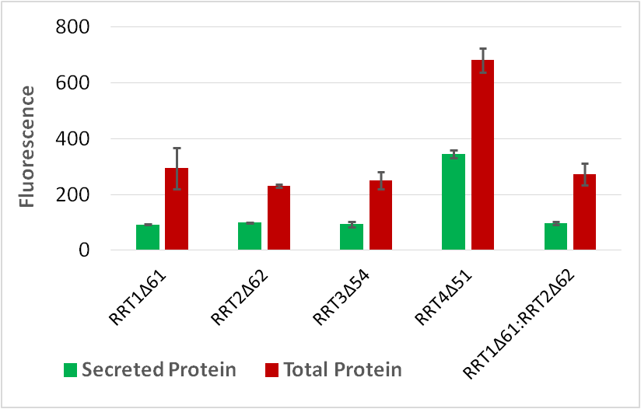
Supplemental Figure S6. Expression of RRT1, RRT2, RRT3, RRT4, and co-expression of RRT1:RRT2.
Four proteins from the RRT family were expressed in HEK293 cells. A co-expression experiment in which RRT1 and RRT2 were co-transfected into the cells was also performed. Total protein is the measure of fluorescence in the cells + culture medium. Secreted protein is the measure of fluorescence in cell-free medium. Of the four RRT-family proteins expressed in this system, RRT4Δ51 yielded the highest total protein. RRT4 protein expressed with 50% secretion efficiency. Error bars represent the standard deviation of two biological replicates. Co-expression of RRT1Δ61 with RRT2Δ62 did not result in increased expression, suggesting that these two proteins do not form a heterocomplex in vitro.

Supplemental Figure S7. The purified RRT4 protein has RG-I:RhaT activity.
The purified RRT4 enzyme was incubated with 1 mM UDP-Rha and an RG-I (G) acceptor, DP12. Activity was tested at pH 6.5 and 7.0 with either 1 µM or 5 µM enzyme. The reaction progress was detected by MALDI-MS at the indicated time points. Activity at pH 6.5 was higher based on the relative conversion of the acceptor (2072 Da) to the RhaT product (2218 Da).

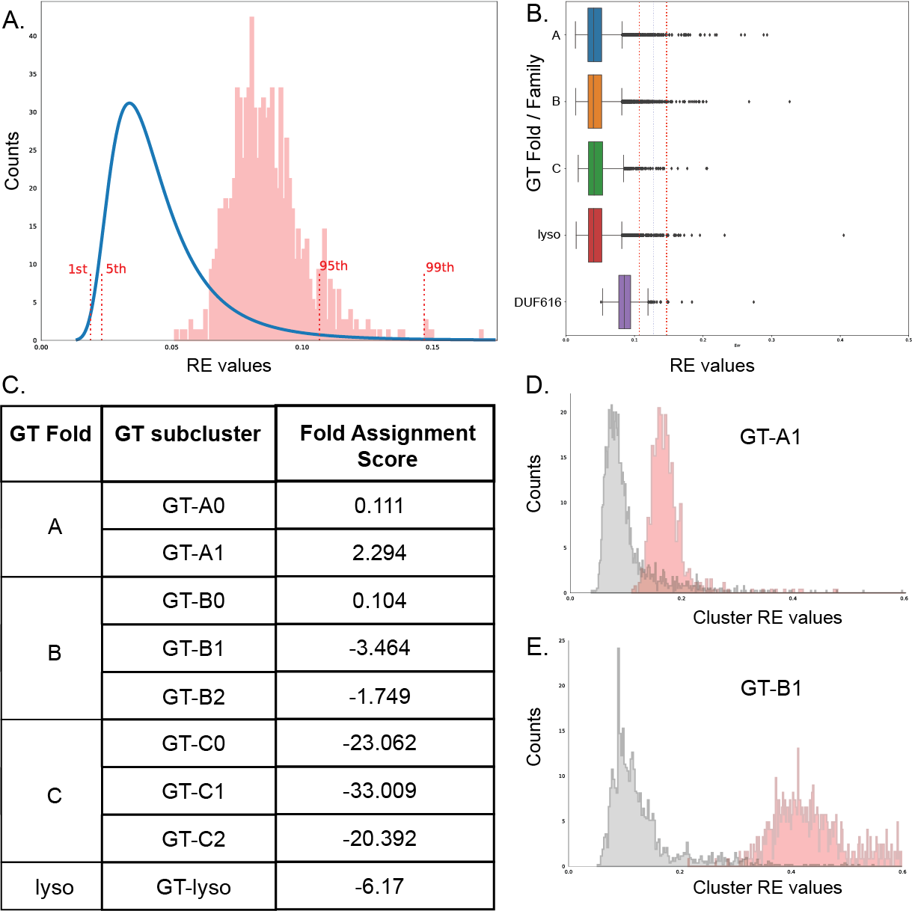
Supplemental Fig S8. DUF616 family sequences are predicted to be a GT-A fold type.
a, Reconstruction error (RE) values are calculated for DUF616 sequences and fall within 95% CI of the RE values for GT-A, B, C and lyso type folds suggesting that DUF616 belongs to one of the known folds.
b, RE values for the GT-A, B, C, lyso and DUF616 are shown as boxplots. Dotted lines mark the 95th and the 99th percentile.
c, Highest Fold Assignment Scores are found to be for the GT-A1 subcluster for the DUF616 sequences suggesting that the sequences from this novel family adopt a GT-A type fold.
d and e, The RE values against sub cluster GT-A1 and GT-B1 are plotted for DUF616 sequences. As seen, the RE values for GT-A1 are much closer to the true RE values suggesting overall similarity in core structural fold.
Supplemental Fig. S9. Top ranked RGGAT1 model generated from AlphaFold2, colored by confidence intervals ranging from 60-100 (blue to red).

