Supplementary Figures

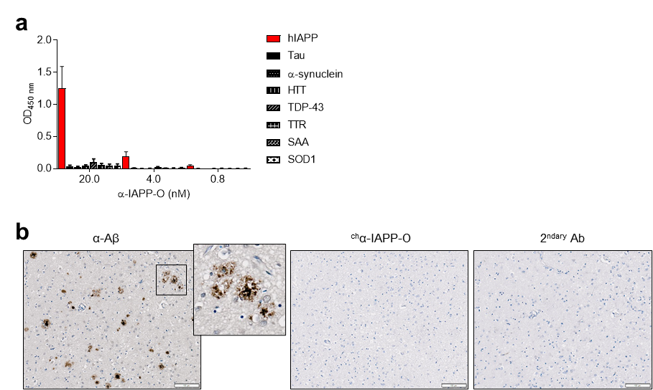
Supplementary Figure 1 Absence of α-IAPP-O cross-reactivity to unrelated amyloidogenic and misfolded proteins. (a) Binding of α-IAPP-O to human IAPP (hIAPP) aggregates, Tau, α-synuclein, huntingtin (HTT), TAR DNA-binding protein 43 (TDP-43), transthyretin (TTR), serum amyloid A (SAA) and superoxide dismutase 1 (SOD1) assessed by direct ELISA. OD_{450nm}, optical density at 450 nm. Data are means ± s.e.m. (b) Representative bright-field images of brain tissue sections from a patient with Alzheimer’s disease showing Aβ plaques detected using an anti-Aβ antibody (in brown) and stained with mouse ^{ch}α-IAPP-O. Anti-mouse secondary antibody was used as control (2^{ndary} Ab). Scale bar: 100 µm.

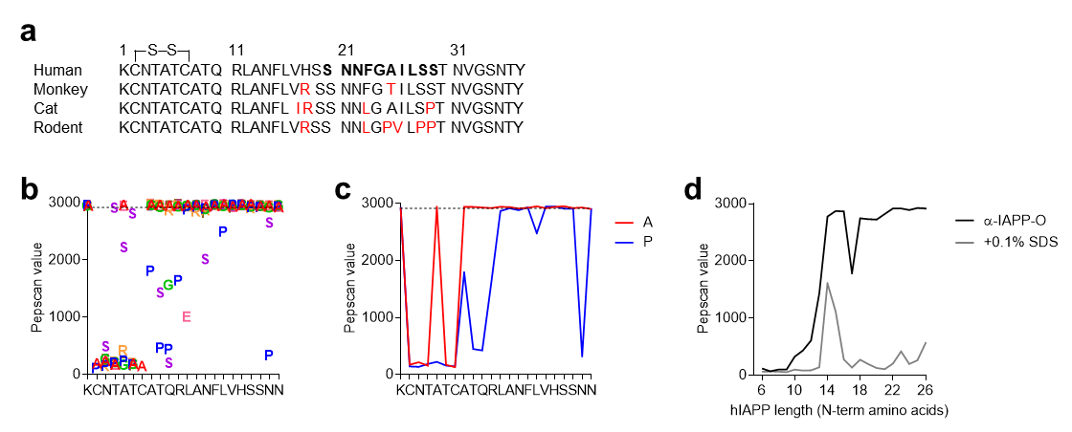
Supplementary Figure 2 α-IAPP-O binding to a conserved N-terminal epitope is strongly influenced by IAPP structure. (a) Comparison of human, rhesus monkey, cat, and rodent IAPP peptide sequences. Amino acid residues that differ from the human IAPP sequence are indicated in red and the human amyloidogenic region (20-29) essential for amyloid formation is represented in bold. A disulfide bond is formed between cysteine residues 2 and 7. (b-d) Epitope mapping of α-IAPP-O on 3D-structured hIAPP peptides showing critical roles for amino acids 2 to 7 at the N-terminus. Representation of α-IAPP-O binding to 22-mer peptides carrying single mutations indicated by the letter code of the amino acid at the position where the substitution is made (b), and contribution of alanine (A, red line) and proline (P, blue line) substitution that disrupt the peptide structure (c). The dashed line represents the mean signal obtained for the base peptide. Epitope recognition is enhanced for longer peptides (black line) and is impaired by C-terminal truncation and denaturation using 0.1% sodium dodecyl sulfate (SDS, grey line) (d).

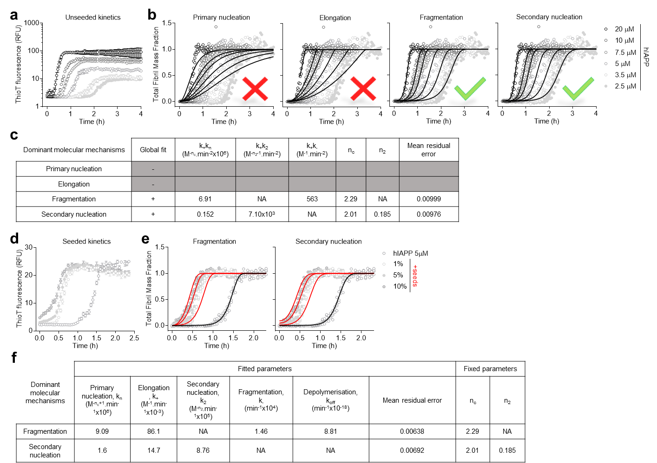
Supplementary Figure 3 Identification of the microscopic mechanisms underlying hIAPP aggregation. (a) Aggregation profile of hIAPP as a function of the initial peptide concentration monitored by thioflavin-T (ThioT) fluorescence intensity over time. Data are means ± s.e.m. from four replicates. (b) Kinetic analysis with global fit compatible with both fragmentation-dominated and secondary nucleation-dominated mechanisms. (c) Resulting product of elongation and primary nucleation rate constants (k₊k_{n}), elongation and secondary nucleation rate constants (k₊k₂), and elongation and fragmentation rate constants (k₊k₋). Shading in grey indicates poor global fit. n_{c}, primary nucleus size; n₂, secondary nucleus size; NA, not applicable. (d) Aggregation kinetics of hIAPP (5 µM) in the presence of 1, 5 and 10% seeds (pre-formed hIAPP fibrils). Experimental thioflavin-T (ThioT) fluorescence data are means ± s.e.m. from four replicates. (e,f) Kinetic analysis of data shown in d assuming fragmentation and secondary nucleation-dominated fibril formation (e) with corresponding kinetic rates upon fitting (f).

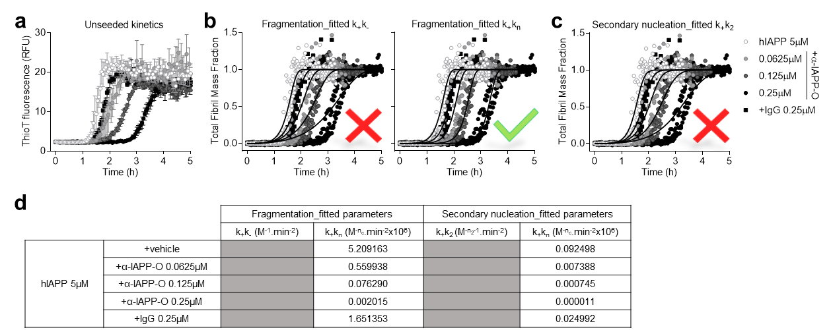
Supplementary Figure 4 α-IAPP-O concentration-dependently inhibits hIAPP assembly into amyloid fibrils. (a) Unseeded aggregation kinetics of hIAPP (5 µM) in the presence of α-IAPP-O (0.0625, 0.125 and 0.25 µM) and IgG control antibody (0.25 µM). Experimental ThioT fluorescence data are means ± s.e.m. from four replicates. (b-d) Kinetic analysis assuming fragmentation-dominated (b) or secondary nucleation-dominated (c) mechanisms at varying k₊k₋, k₊k_{n}, and k₊k₂ product rates. Fitting represented by solid lines is consistent with an effect of α-IAPP-O on the product of fibril elongation and primary nucleation rate (k₊k_{n}) under both fragmentation- and secondary nucleation-dominated regimes (see also Figure 2d), but not on k₊k₋ and k₊k₂. Simulated product of fibril elongation and primary nucleation rate for each condition tested (d). Shading in grey indicates poor global fit.

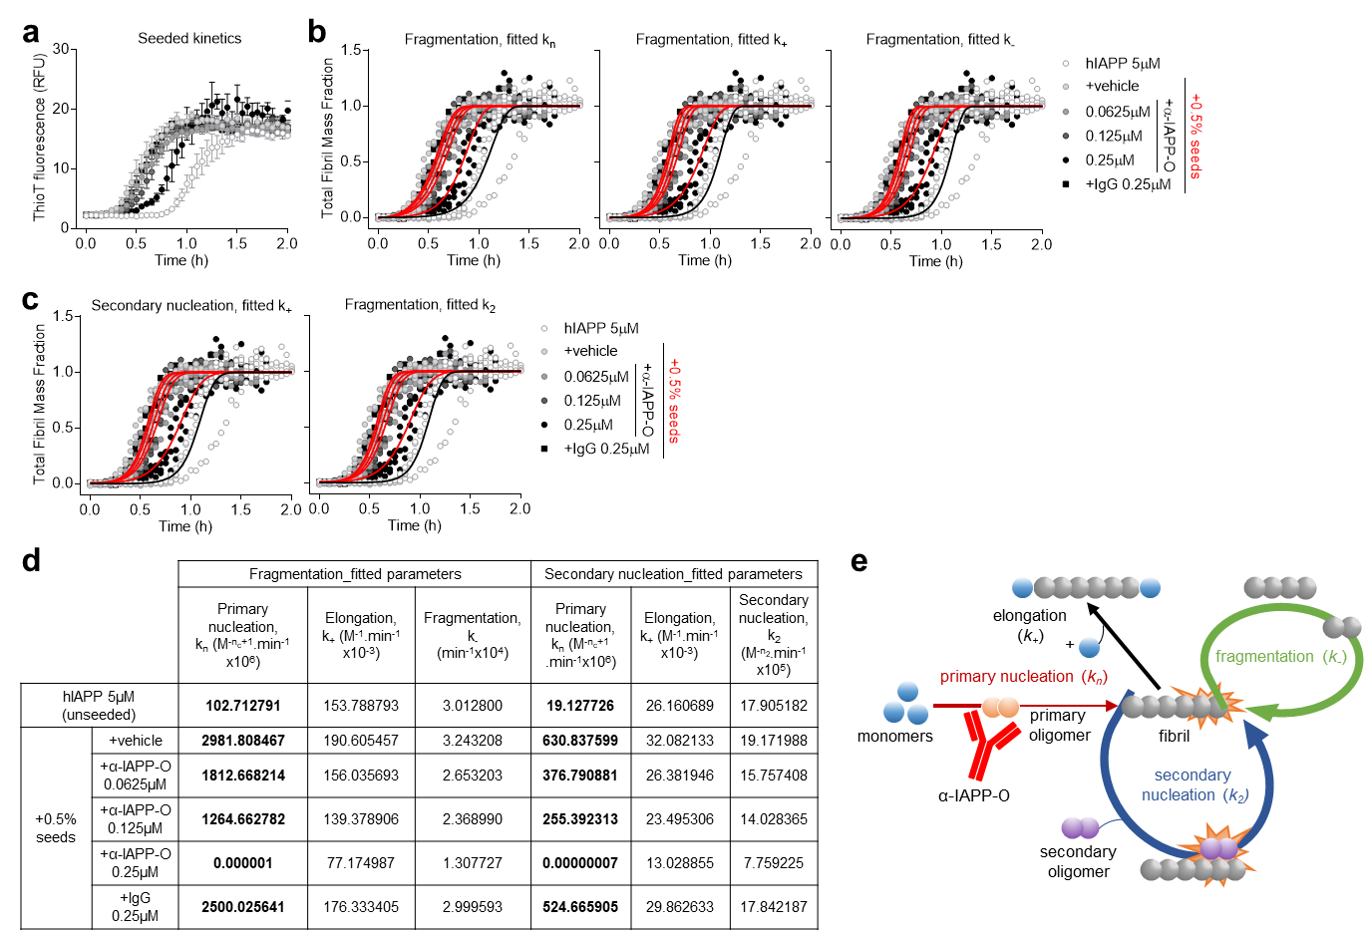
Supplementary Figure 5 α-IAPP-O inhibits primary nucleation. (a-d) Seeded hIAPP aggregation kinetics (0.5% fibrillar seeds) in the presence of α-IAPP-O and IgG control antibodies. ThioT fluorescence experimental data (means ± s.e.m. from four replicates) (a). Kinetic analysis at varying rates of primary nucleation (k_{n}), elongation (k₊) and fragmentation (k₋) under fragmentation-dominated (b) and secondary nucleation-dominated (c) regimes. Fitting to experimental data is represented by solid lines (unseeded and seeded hIAPP aggregation in back and red, respectively). Primary nucleation fitting under secondary nucleation-dominated regime is shown in Figure 2e. Simulated kinetic rates for each condition tested (d). (e) Schematic illustration of molecular mechanisms involved in hIAPP fibril formation, and inhibition of primary nucleation resulting from the interaction between α-IAPP-O and primary oligomers.

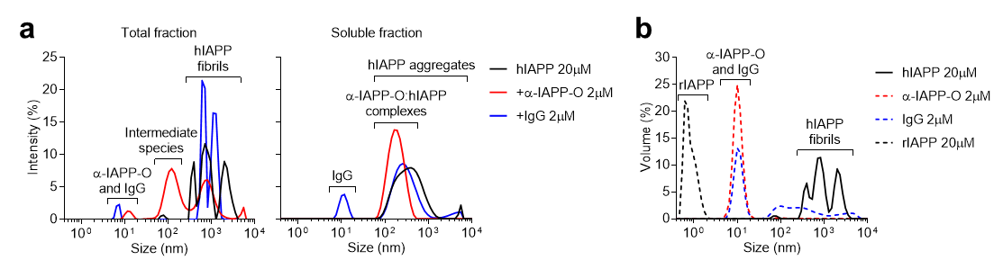
Supplementary Figure 6 α-IAPP-O forms complexes with soluble pre-fibrillar hIAPP species. (a) Intensity distribution of particle sizes in total (left panel) and soluble fractions (right panel) using dynamic light scattering (DLS). (b) Volume distribution of particle sizes in fractions containing hIAPP fibrils, α-IAPP-O, IgG, and monomeric rodent IAPP (rIAPP) measured by DLS. Data represent the average of three measurements on the two experimental replicates shown in Figure 2h.

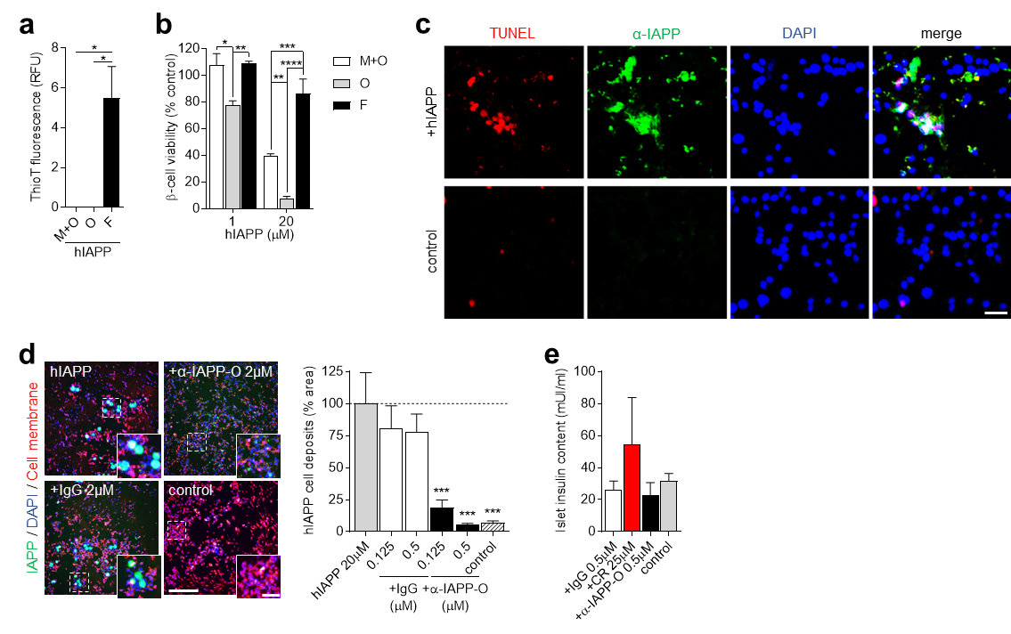
Supplementary Figure 7 α-IAPP-O prevents the deposition of toxic hIAPP oligomers on INS-1 beta cells. (a) Amyloid content in samples initially containing 20 µM hIAPP monomers and some oligomers (M+O), oligomers (O), and fibril end products (F) using thioflavin-T fluorescence assay (one-way ANOVA: F_{(2,6)}=12.51, P=0.0072; post hoc Tukey’s multiple comparisons test M+O and O versus F: *P=0.0117). (b) Viability of INS-1 beta cells exposed to pre-formed hIAPP species as a function of concentration and assessed by MTT assay (two-way ANOVA: F_{(2,12)}=41.62, P<0.0001; post hoc Tukey’s multiple comparisons test M+O and F 1 μM versus O 1 μM: *P=0.0114 and **P=0.0084, M+O and F 20 μM versus O 20 μM: **P=0.0078 and ****P<0.0001, M+O versus F 20 μM: ***P=0.0004). Data in a,b are means ± s.e.m. from three replicates. (c) Representative fluorescence microscopy images of membrane-bound hIAPP deposits detected by a non-selective α-IAPP antibody (in green) and TUNEL-positive apoptotic INS-1 beta cells (in red) upon incubation with hIAPP oligomers (+hIAPP, 20 µM). Cell nuclei are visualized by DAPI (in blue) and cells not exposed to hIAPP oligomers are used as control. Scale bar: 25 µm. (d) Representative fluorescence microscopy images (left panel) and quantification (right panel) of hIAPP cell deposits stained with α-IAPP (in green) on INS-1 cells exposed to hIAPP oligomers (20 µM) supplemented with α-IAPP-O and IgG control at indicated concentrations. DAPI-positive cell nuclei are shown in blue and plasma membrane in red. Scale bars: 300 and 100 µm. Data are means ± s.e.m from two independent experiments performed with three biological replicates (one-way ANOVA: F_{(5,30)}=9.717, P<0.0001; post hoc Dunnett’s multiple comparisons test α-IAPP-O 0.125 μM and 0.5 μM versus hIAPP 20 μM: ***P=0.0010 and ***P=0.0002, control versus hIAPP 20 μM: ***P=0.0002). (e) Human pancreatic islet insulin content upon culture in high glucose (11 mM) for seven days in the presence of α-IAPP-O (+α-IAPP-O 0.5 μM), IgG control (+IgG 0.5 μM) and Congo red (+CR 25 μM). Islets cultured in 5.5 mM glucose for seven days are used as control. Data are from three independent experiments (shown in Figure 3i), each of them using islets from a different donor (detailed in Supplementary Table 2). Data are expressed as means ± s.e.m (one-way ANOVA: F_{(3,8)}=0.8337, P=0.5120; post hoc Tukey’s multiple comparisons test).

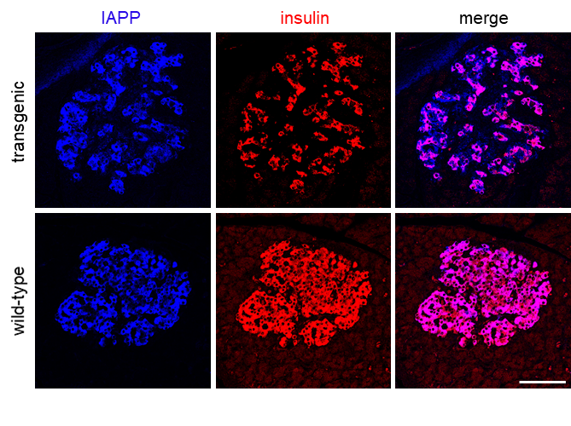
Supplementary Figure 8 IAPP is constitutively expressed in transgenic and wild-type rat beta cells. IAPP and insulin co-staining in transgenic and wild-type rat islets using an anti-IAPP antibody binding to physiological monomeric IAPP. Scale bar: 100 µm.

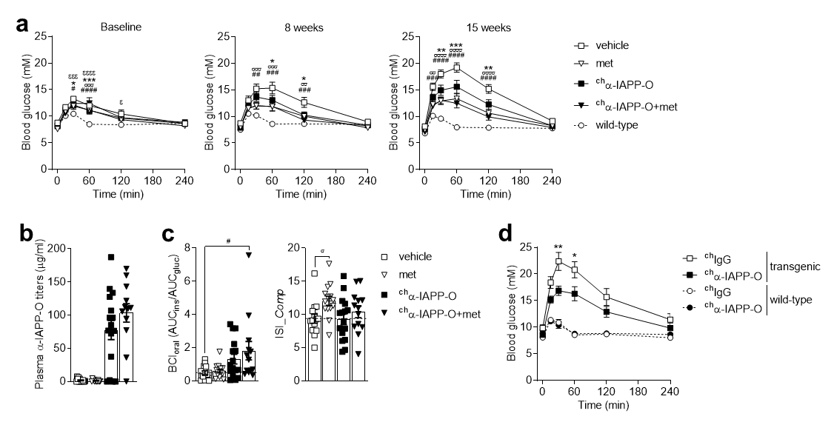
Supplementary Figure 9 Efficacy of α-IAPP-O compared to metformin in transgenic rats. (a) Oral glucose tolerance test (oGTT) in naïve transgenic and wild-type rats at baseline (12 weeks of age), and upon weekly intraperitoneal (i.p.) injection of rat chimeric α-IAPP-O (^{ch}α-IAPP-O, 3 mg/kg) and vehicle for 8 and 15 weeks (supplemental to Figure 4b). Metformin (met; 200 mg/kg/day) served as an active comparator and was combined with ^{ch}α-IAPP-O (^{ch}α-IAPP-O+met). Transgenic rats allocated in the different treatment groups showed glucose intolerance when compared to wild-type rats at baseline (repeated measures two-way ANOVA (time x treatment): F_{(20,325)}=2.643, P=0.0002; post hoc Dunnett’s multiple comparisons test ^{ch}α-IAPP-O versus wild-type at 30 and 60 min: *P=0.0495 and ***P=0.0006, met versus wild-type at 60 min: ^{σσσ}P=0.0007, ^{ch}α-IAPP-O+met versus wild-type at 30 and 60 min: #P=0.0266 and ####P<0.0001, and vehicle versus wild-type at 30, 60 and 120 min: ^{εεε}P=0.0003, ^{εεεε}P<0.0001 and ^{ε}P=0.0146). Glucose tolerance improved in transgenic rats receiving ^{ch}α-IAPP-O, met and ^{ch}α-IAPP-O+met for 8 weeks (repeated measures two-way ANOVA (time x treatment): F_{(15,265)}=1.982, P=0.0168; post hoc Dunnett’s multiple comparisons test ^{ch}α-IAPP-O versus vehicle at 60 and 120 min: *P=0.0215 and *P=0.0151, met versus vehicle at 30, 60 and 120 min: ^{σσσ}P=0.0009, ^{σσσ}P=0.0003 and ^{σσ}P=0.0096, and ^{ch}α-IAPP-O+met versus vehicle at 30, 60 and 120 min: ##P=0.0012, ###P=0.0004 and ###P=0.0008), 15 weeks (repeated measures two-way ANOVA (time x treatment): F_{(15,265)}=5.184, P<0.0001; post hoc Dunnett’s multiple comparisons test ^{ch}α-IAPP-O versus vehicle at 30, 60 and 120 min: **P=0.0034, ***P=0.0004 and **P=0.0052, met versus vehicle at 15, 30, 60 and 120 min: ^{σσ}P=0.0018, ^{σσσσ}P<0.0001, ^{σσσσ}P<0.0001 and ^{σσσσ}P<0.0001, and ^{ch}α-IAPP-O+met versus vehicle at 15, 30, 60 and 120 min: ###P=0.0010, ####P<0.0001, ####P<0.0001 and ####P<0.0001) and 24 weeks (repeated measures two-way ANOVA (time x treatment): F_{(15,265)}=2.466, P=0.0021; post hoc Dunnett’s multiple comparisons test ^{ch}α-IAPP-O versus vehicle at 60 and 120 min: *P=0.0319 and *P=0.0486, met versus vehicle at 15, 30, 60, 120 and 240 min: ^{σ}P=0.0232, ^{σσ}P=0.0011, ^{σσ}P=0.0012, ^{σσ}P=0.0018 and ^{σ}P=0.0393, and ^{ch}α-IAPP-O+met versus vehicle at 15, 30, 60, 120 and 240 min: ##P=0.0070, ##P=0.0054, ##P=0.0032, ###P=0.0006 and ##P=0.0052). (b) Plasma ^{ch}α-IAPP-O drug levels in 36-week-old hIAPP transgenic rats weekly injected (i.p.) with vehicle and rat chimeric α-IAPP-O (^{ch}α-IAPP-O, 3 mg/kg), and administered with metformin (met; 200 mg/kg/day) and metformin combined with ^{ch}α-IAPP-O (^{ch}α-IAPP-O+met) for 24 weeks. (c) Beta cell function and insulin sensitivity estimates using BCI_{oral} and ISI_Comp methods (one-way ANOVA: F_{(3,53)}=3.874 and 2.867, P=0.0141 and 0.0451; post hoc Dunnett’s multiple comparisons test ^{ch}α-IAPP-O+met versus vehicle: #P=0.0137, and met versus vehicle: ^{σ}P=0.0462). BCI_{oral} = AUC_{insulin}/AUC_{glucose}, where AUC corresponds to the area under the concentration curves during oGTT. ISI_Comp = 10’000 / (√ [G₀ x I₀ x G_{mean} x I_{mean}]), where G₀ and I₀ correspond to fasting blood glucose and plasma insulin levels, and the suffix “mean” to average levels of glucose and insulin during oGTT. Final group numbers in a-c were n=14 vehicle, n=14 met, n=16 ^{ch}α-IAPP-O, n=13 ^{ch}α-IAPP-O+met, n=13 wild-type. (d) oGTT in transgenic and wild-type rats weekly injected with ^{ch}IgG control antibody (n=12 and n=9, respectively) and ^{ch}α-IAPP-O (n=11 and n=8, respectively) at 3 mg/kg i.p. for 18 weeks. Treatment with ^{ch}α-IAPP-O improved glucose tolerance in transgenic rats (repeated measures two-way ANOVA (time x treatment): F_{(5,105)}=2.362, P=0.0449; post hoc Sidak’s multiple comparisons test ^{ch}α-IAPP-O versus ^{ch}IgG at 30 and 60 min: **P=0.0061 and *P=0.0411). All data are means ± s.e.m.

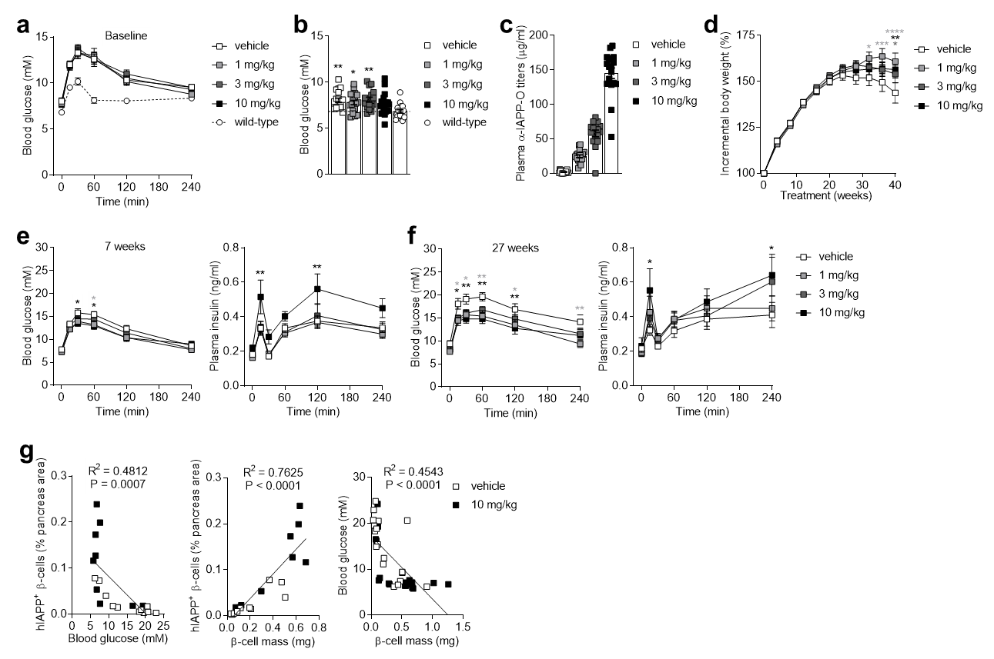
Supplementary Figure 10 Weekly α-IAPP-O dosing in diabetic rats slowed disease progression. (a,b) Oral glucose tolerance test (oGTT) (a) and fasting blood glucose levels (b) in naïve transgenic and wild-type rats prior treatment (baseline). Transgenic rats showed glucose intolerance (repeated measures two-way ANOVA (time x treatment): F_{(20,415)}=3.300, P<0.0001; post hoc Dunnett’s multiple comparisons test ^{ch}α-IAPP-O 1, 3, 10 mg/kg and vehicle versus wild-type at 15 min: ***P=0.0007, ***P=0.0005, ***P=0.0009 and ***P=0.0004, ^{ch}α-IAPP-O 1, 3, 10 mg/kg and vehicle versus wild-type at 30 and 60 min: ****P<0.0001, ^{ch}α-IAPP-O 1, 3, 10 mg/kg and vehicle versus wild-type at 120 min: **P=0.0035, ****P<0.0001, ***P=0.0005 and **P=0.0016) and hyperglycemia when compared to wild-type rats at baseline (one-way ANOVA: F_{(4,83)}=4.219, P=0.0037; post hoc Dunnett’s multiple comparisons test ^{ch}α-IAPP-O 1, 3, 10 mg/kg and vehicle versus wild-type: *P=0.0221, **P=0.0022, P=0.0621 and **P=0.0029). (c,d) Averaged ^{ch}α-IAPP-O plasma levels (c) and incremental body weight curves (d) in hIAPP transgenic rats upon weekly intraperitoneal (i.p.) injection of rat chimeric α-IAPP-O (^{ch}α-IAPP-O) at 1 mg/kg, 3 mg/kg and 10 mg/kg, and vehicle for 40 weeks. Incremental body weight (%) was expressed in relation to initial body weight measured at 12 weeks of age before the start of the treatment (repeated measures two-way ANOVA (time x treatment): F_{(30,670)}=2.322, P<0.0001; post hoc Dunnett’s multiple comparisons test ^{ch}α-IAPP-O 1 mg/kg versus vehicle at 32, 36 and 40 weeks: *P=0.0109, ***P=0.0003 and ****P<0.0001, ^{ch}α-IAPP-O 3 mg/kg versus vehicle at 40 weeks: *P=0.0183, ^{ch}α-IAPP-O 10 mg/kg versus vehicle at 40 weeks: **P=0.0017). (e,f) Blood glucose (left panel) and plasma insulin (right panel) levels during oGTT after 7 weeks (e) and 27 weeks (f) of treatment (supplemental to Figure 4d,e). Transgenic rats receiving ^{ch}α-IAPP-O had improved glucose tolerance after 7 weeks (repeated measures two-way ANOVA (time x treatment): F_{(15,335)}=1.265, P=0.2221; post hoc Dunnett’s multiple comparisons test ^{ch}α-IAPP-O 1 mg/kg versus vehicle at 60 min: *P=0.0288, ^{ch}α-IAPP-O 10 mg/kg versus vehicle at 30 and 60 min: *P=0.0243 and *P=0.0129) and 27 weeks (repeated measures two-way ANOVA (time x treatment): F_{(15,335)}=1.606, P=0.0703; post hoc Dunnett’s multiple comparisons test ^{ch}α-IAPP-O 1 mg/kg versus vehicle at 15, 30, 60, 120 and 240 min: *P=0.0247, *P=0.0365, **P=0.0070, *P=0.0393 and **P=0.0016, ^{ch}α-IAPP-O 10 mg/kg versus vehicle at 15, 30, 60 and 120 min: *P=0.0266, **P=0.0059, **P=0.0017 and **P=0.0093), together with increased insulin response during oGTT after 7 weeks (repeated measures two-way ANOVA (time x treatment): F_{(15,335)}=0.7976, P=0.6804; post hoc Dunnett’s multiple comparisons test ^{ch}α-IAPP-O 10 mg/kg versus vehicle at 15 and 120 min: **P=0.0046 and **P=0.0038) and 27 weeks (repeated measures two-way ANOVA (time x treatment): F_{(15,330)}=1.005, P=0.4490; post hoc Dunnett’s multiple comparisons test ^{ch}α-IAPP-O 10 mg/kg versus vehicle at 15 and 240 min: *P=0.0377 and *P=0.0390). Final group numbers in a-f were n=18 vehicle (n=17 for plasma insulin in f), n=19 1 mg/kg, n=16 3 mg/kg, n=18 10 mg/kg, n=17 wild-type. All data are means ± s.e.m. (g) Correlation analyses between pancreatic hIAPP-immunoreactive beta cell content, fasting blood glucose levels, and pancreatic beta cell mass in transgenic rats weekly injected with vehicle and ^{ch}α-IAPP-O (10 mg/kg i.p.) for 41 weeks.

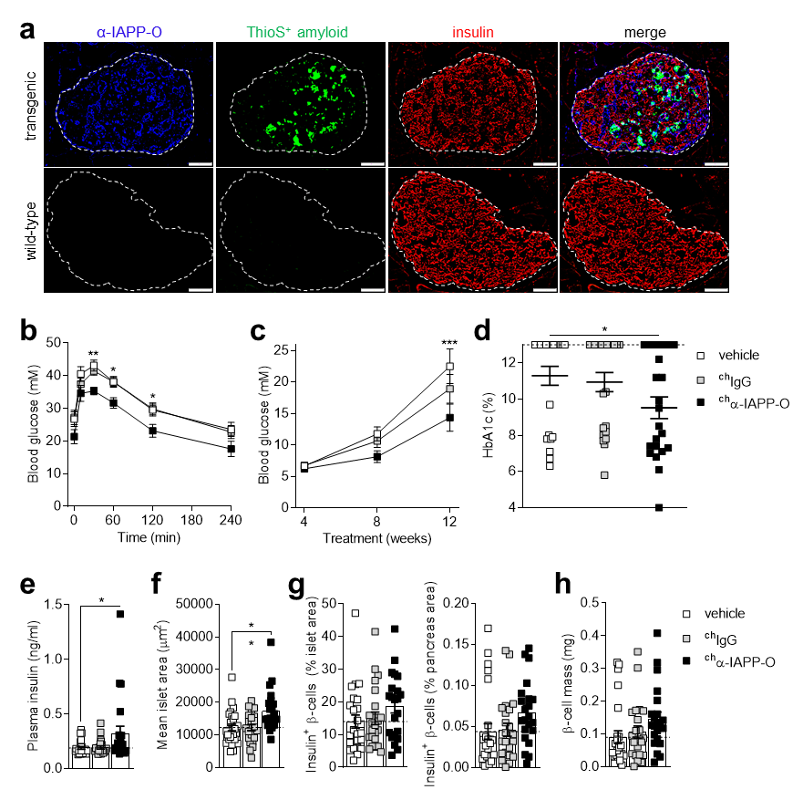
Supplementary Figure 11 α-IAPP-O improves glycemia and protects pancreatic beta cells in hIAPP transgenic mice. (a) Representative images of individual pancreatic islets from a transgenic and a wild-type mouse stained for α-IAPP-O target engagement (in blue) three day after a single intraperitoneal administration (30 mg/kg). ThioS-positive islet amyloid fibrils (in green) and insulin-positive beta cells (in red) are shown. Scale bar: 50 µm. (b) Blood glucose concentration over time after oral glucose challenge (oGTT) in hIAPP transgenic mice weekly injected (i.p.) with vehicle (n=25), mouse chimeric α-IAPP-O (^{ch}α-IAPP-O, 10 mg/kg, n=22) or an isotype-matched ^{ch}IgG antibody (10 mg/kg, n=23) for 10 weeks (repeated measures two-way ANOVA (time x treatment): F_{(10,335)}=0.8285, P=0.6013; post hoc Dunnett’s multiple comparisons test ^{ch}α-IAPP-O 10 mg/kg versus vehicle at 30, 60 and 120 min: **P=0.0084, *P=0.0341 and *P=0.0368). (c) Fasting blood glucose levels over the 12-week treatment period in transgenic mice described in b (repeated measures two-way ANOVA (time x treatment): F_{(4,134)}=2.255, P=0.0665; post hoc Dunnett’s multiple comparisons test ^{ch}α-IAPP-O 10 mg/kg versus vehicle at 12 weeks: ***P=0.0005). (d,e) HbA1c (d) and fasting plasma insulin levels (e) after 12 weeks of chronic treatment in transgenic mice described in b,c. Transgenic mice receiving ^{ch}α-IAPP-O showed reduced HbA1c (one-way ANOVA: F_{(2,67)}=2.843, P=0.0653; post hoc Dunnett’s multiple comparisons test ^{ch}α-IAPP-O versus vehicle: *P=0.0479) and increased plasma insulin levels (one-way ANOVA: F_{(2,67)}=3.978, P=0.0233; post hoc Dunnett’s multiple comparisons test ^{ch}α-IAPP-O versus vehicle: *P=0.0265). Dashed line in d represents the upper detection limit of the HbA1c assay. (f-h) Histological analysis of islet size (f), insulin-immunoreactive beta cell area (g) and beta cell mass (h) in the pancreas of transgenic mice described in b-e. Transgenic mice receiving ^{ch}α-IAPP-O had larger islets (one-way ANOVA: F_{(2,67)}=6.806, P=0.0020; post hoc Dunnett’s multiple comparisons test ^{ch}α-IAPP-O versus vehicle: **P=0.0037), and increased insulin-immunoreactive beta cell area (one-way ANOVA (% islet area and % pancreas area): F_{(2,67)}=1.511 and 2.154, P=0.2282 and 0.1240) and beta cell mass (one-way ANOVA: F_{(2,67)}=2.170, P=0.1221; post hoc Dunnett’s multiple comparisons test ^{ch}α-IAPP-O versus vehicle: P=0.0835) without reaching statistical significance. All data are means ± s.e.m.

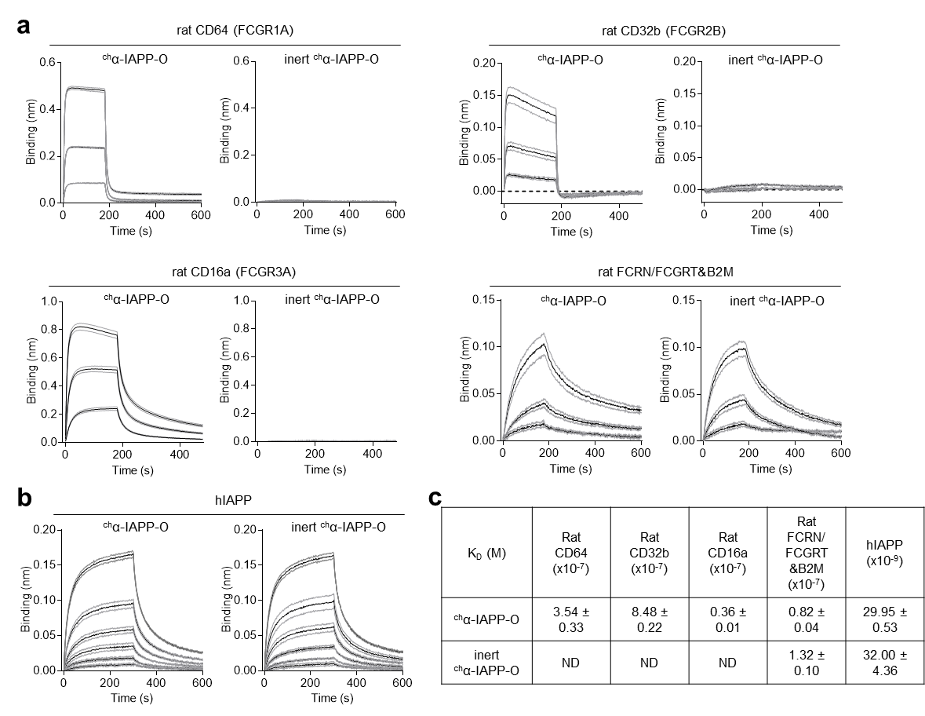
Supplementary Figure 12 Effector and inert α-IAPP-O interaction to IgG-Fc binding receptors. (a) Biolayer interferometry sensorgrams showing interactions between the Fc region of rat ^{ch}α-IAPP-O and its inert variant with rat IgG-Fc-binding receptors responsible for effector function such as CD64 (FcγRI), CD32b (FcγRIIB) and CD16a (FcγRIIIA) receptors, and the neonatal FcRN involved in antibody recycling. His-tagged recombinant Fc receptors were immobilized on the surface of anti-His biosensors and exposed to rat ^{ch}α-IAPP-O and inert ^{ch}α-IAPP-O (666, 222 and 74 nM). (b) Binding of rat ^{ch}α-IAPP-O and inert ^{ch}α-IAPP-O (100, 50, 25, 12.5, 6.25 and 3.125 nM) to hIAPP immobilized on AR2G biosensors. (c) Antibody K_{D} values for Fc receptors and hIAPP. Data are means ± s.e.m. of quadruplicates. ND, not determined due to low binding signal.

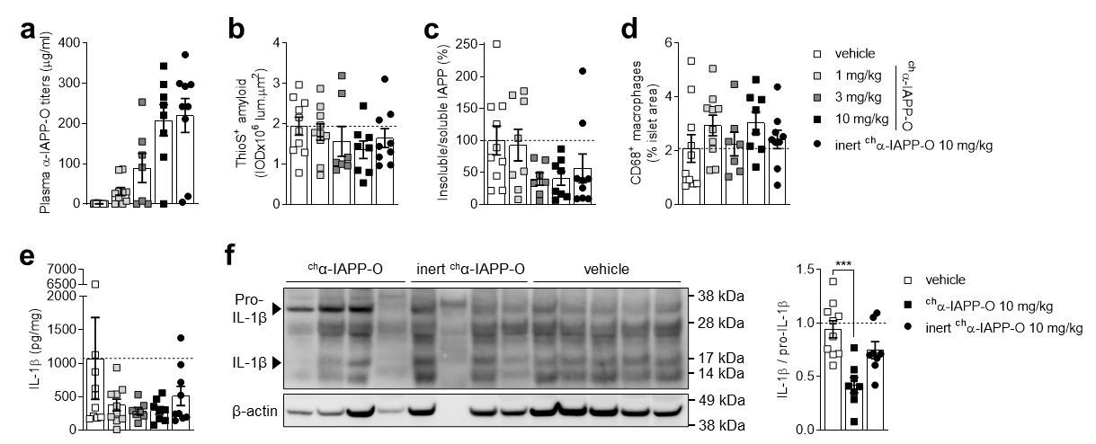
Supplementary Figure 13 Mechanism of action of α-IAPP-O in transgenic rats. (a) ^{ch}α-IAPP-O levels in plasma of transgenic rats weekly injected (i.p.) with ^{ch}α-IAPP-O (1 mg/kg, n=10; 3 mg/kg, n=7; 10 mg/kg, n=8), inert ^{ch}α-IAPP-O (10 mg/kg, n=9) and vehicle (n=10) for 38 weeks (supplemental to Figure 5a-d). (b) Quantification of ThioS-positive amyloid fibril density (IOD, integrated optical density) within pancreatic islets (one-way ANOVA: F_{(4,39)}=0.8318, P=0.5132). (c) Insoluble over soluble IAPP content in rat pancreas homogenates measured by ELISA (one-way ANOVA: F_{(4,37)}=2.029, P=0.1103). (d) Histological analysis of CD68-immunoreactive islet macrophages (one-way ANOVA: F_{(4,39)}=1.003, P=0.4177). (e,f) IL-1β cytokine levels in pancreas homogenates of transgenic rats described in a-d and determined by ELISA (e) and Western blot (f) (one-way ANOVA: F_{(4,39)}=1.094, P=0.3730 and F_{(2,23)}=11.69, P=0.0003; post hoc Dunnett’s multiple comparisons test ^{ch}α-IAPP-O 10 mg/kg versus vehicle: ***P=0.0001). All data are means ± s.e.m.

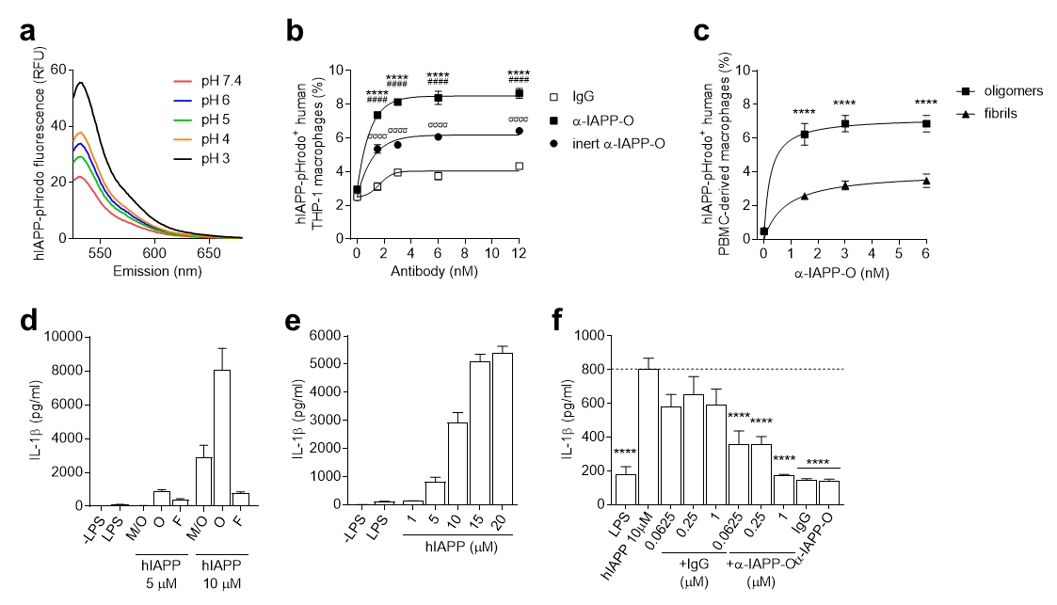
Supplementary Figure 14 α-IAPP-O triggers the uptake of hIAPP oligomers rather than fibrils by human macrophages and reduces . (a) pH-dependent fluorescence of prefibrillar hIAPP aggregates labeled with pHrodo dye (hIAPP-pHrodo, 1 µM). Fluorescence emission is increased at low pH allowing for selective measurement of hIAPP phagocytized into acidic phagosomes. Data are means of two replicates. (b) Phagocytosis of hIAPP-pHrodo by human THP-1 macrophages as a function of α-IAPP-O, inert α-IAPP-O and IgG control antibody concentrations using flow cytometry (repeated measures two-way ANOVA (concentration x treatment): F_{(8,24)}=29.56, P<0.0001; post hoc Tukey’s multiple comparisons test α-IAPP-O versus IgG, inert α-IAPP-O versus IgG and α-IAPP-O versus inert α-IAPP-O at 1.5, 3, 6 and 12 nM: ****P<0.0001, ^{σσσσ}P<0.0001 and ####P<0.0001). (c) Human PBMC-derived macrophage phagocytic activity on pHrodo-labeled prefibrillar oligomers and amyloid fibrils at increasing α-IAPP-O concentrations (repeated measures two-way ANOVA (concentration x treatment): F_{(3,12)}=16.26, P=0.0002; post hoc Sidak’s multiple comparisons test oligomers versus fibrils at 1.5, 3 and 6 nM of α-IAPP-O: ****P<0.0001). Data in b,c are means ± s.e.m. of three biological replicates. (d-f) Human THP-1 macrophage release of pro-inflammatory IL-1β cytokine when exposed to hIAPP. (d) IL-1β release in response to 5 and 10 µM pre-formed hIAPP species. Monomers and oligomers, M/O; oligomers (O); amyloid fibrils (F). Data are means ± s.e.m. from two independent experiments performed with three biological replicates. (e) IL-1β response as a function of exposure to hIAPP oligomers. Data are means ± s.e.m. of four biological replicates. (f) Release of IL-1β from THP-1 macrophages exposed to hIAPP oligomers (hIAPP 10 µM) supplemented with α-IAPP-O and IgG control at indicated concentrations (one-way ANOVA: F_{(9,110)}=15.18, P<0.0001; post hoc Dunnett’s multiple comparisons test versus hIAPP 10 µM: ****P<0.0001). Macrophages were primed with LPS unless stated differently (-LPS). α-IAPP-O and IgG were used at 1 µM in absence of hIAPP. Data are means ± s.e.m from two independent experiments performed with six biological replicates.

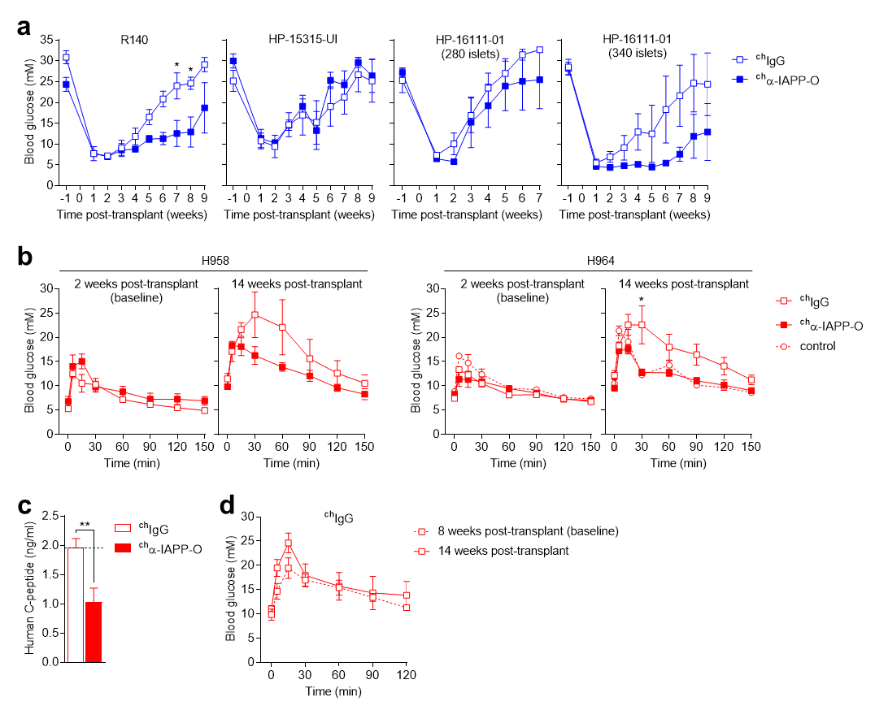
Supplementary Figure 15 α-IAPP-O treatment in human islet-engrafted mice. (a) Recurrence of hyperglycaemia in NSG recipient mice weekly injected (10 mg/kg i.p.) with mouse chimeric ^{ch}α-IAPP-O and ^{ch}IgG control (supplemental to Figure 6b). Data are from three independent experiments using human islets preparations from three non-diabetic donors (see Supplementary Table 2): R140 (n=2 ^{ch}IgG and n=3 ^{ch}α-IAPP-O; repeated measures two-way ANOVA (time x treatment): F_{(9,27)}=2.537, P=0.0296; post hoc Sidak’s multiple comparisons test ^{ch}α-IAPP-O versus ^{ch}IgG 7 and 8 weeks post-transplant: *P=0.0371 and *P=0.0310), HP-15315-UI (n=4 ^{ch}IgG and n=3 ^{ch}α-IAPP-O; repeated measures two-way ANOVA (time x treatment): F_{(9,45)}=0.4914, P=0.8726), HP-16111-01 (280 and 340 islets, n=4 and 3 ^{ch}IgG, n=4 and 4 ^{ch}α-IAPP-O; repeated measures two-way ANOVA (time x treatment): F_{(7,42)}=0.4590 and 1.296, P=0.8583 and 0.2658). Blood glucose values represent the average of biweekly measurements. (b) Blood glucose concentration during oral glucose tolerance tests 2 weeks (baseline) and 14 weeks post-transplant in HFD-fed Rag2^{-/-} recipient mice weekly injected (10 mg/kg i.p.) with ^{ch}α-IAPP-O and ^{ch}IgG control for 12 weeks (2 to 14 weeks post-transplant; supplemental to Figure 6d). Naïve Rag2^{-/-} recipient mice kept on regular diet for 12 weeks served as controls. Data are from two independent experiments using human islets preparations from two pre-diabetic donors (see Supplementary Table 2): H958 (n=3 ^{ch}IgG and n=3 ^{ch}α-IAPP-O; repeated measures two-way ANOVA (time x treatment) at baseline and 14 weeks post-transplant: F_{(7,28)}=1.805 and 2.500, P=0.1258 and 0.0396) and H964 (n=6 ^{ch}IgG, n=3 ^{ch}α-IAPP-O and n=2 control; repeated measures two-way ANOVA (time x treatment) at baseline and 14 weeks post-transplant: F_{(7,49)}=1.526 and 1.990, P=0.1807 and 0.0755; post hoc Sidak’s multiple comparisons test ^{ch}α-IAPP-O versus ^{ch}IgG 14 weeks post-transplant at 30 min: *P=0.0261). (c) Human C-peptide plasma levels in HFD-fed Rag2^{-/-} recipient mice weekly injected with ^{ch}α-IAPP-O (10 mg/kg i.p., n=6) and ^{ch}IgG control (10 mg/kg i.p., n=9) for 12 weeks (two-tailed unpaired t test, t=3.428, df=13, **P=0.0045). (d) oGTT blood glucose levels in HFD-induced diabetic Rag2^{-/-} recipient mice weekly injected with ^{ch}IgG (10 mg/kg i.p., n=4) for 6 weeks (8 to 14 weeks post-transplant; supplemental to Figure 6h; repeated measures two-way ANOVA (time x treatment): F_{(6,36)}=2.076, P=0.0805). All data are means ± s.e.m.

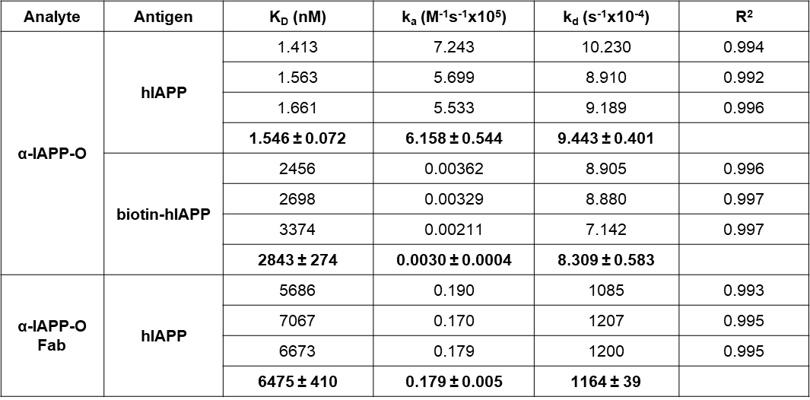
Supplementary Table 1 Biolayer interferometry binding constants of α-IAPP-O antibody and α-IAPP-O-derived Fab fragment to surface-immobilized hIAPP aggregates and monomeric biotin-hIAPP. K_{D}, affinity constant; k_{a}, association constant; k_{d}, dissociation constant; R², goodness of fitting using 1:1 interaction model. Data are expressed as means ± s.e.m. from three independent runs.

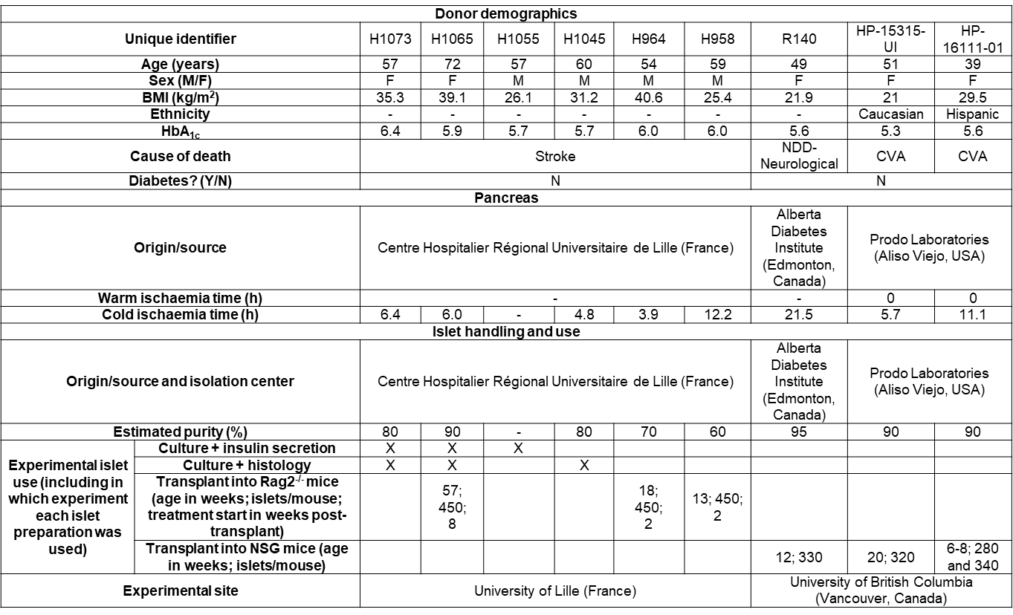
Supplementary Table 2 Human islet donor characteristics. -, data not collected. BMI≥30 kg/m² indicate obesity and HbA1c levels between 5.7 and 6.4 % a higher risk of developing type 2 diabetes. This table was prepared following recommendations by Hart and Powers³.

Supplementary Methods
Determination of α-IAPP-O cross-reactivity by ELISA
96-well microplates (Corning) were coated with freshly reconstituted synthetic hIAPP and amyloidogenic peptides resuspended at 1-10 µg/ml in carbonate buffer (15 mM Na₂CO₃, 35 mM NaHCO₃, pH 9.4) or PBS overnight at 4°C. Unspecific binding sites were blocked with PBS + 0.1% Tween-20 + 2% BSA and recombinant human α-IAPP-O antibody (20, 4 and 0.8 nM) was applied for 1h at room temperature. Binding was determined using a donkey anti-human HRP-conjugated secondary antibody (1:2000; Jackson ImmunoResearch) followed by measurement of HRP activity at 450 nm (optical density, OD).

Immunohistochemistry on human brain
Paraffin-embedded human brain sections from donors with Alzheimer’s disease (AD) were deparaffinized, rehydrated, blocked in PBS + 5% serum (horse/goat) + 4% BSA for 1h, incubated with mouse chimeric ^{ch}α-IAPP-O (100 nM) and mouse anti-Aβ-amyloid 6E10 antibody (30 nM; BioLegend) overnight at 4°C, and stained with biotinylated donkey anti-mouse secondary antibody (1:500; Jackson ImmunoResearch) combined with signal amplification using Vectastain ABC kit (Vector Laboratories). Slides were mounted using Hydromount media (National Diagnostics) and imaged on a Dotslide VS120 slide scanner (Olympus).

Epitope mapping
Precision epitope mapping was conducted at Pepscan Presto BV (Zuidersluisweg 2, 8243RC Lelystad, The Netherlands) using Pepscan’s proprietary CLIPS technology for conformational epitopes^{1,2}. The individual contribution of hIAPP amino acid residues 1-22 to α-IAPP-O binding was assessed by full substitution mutagenesis. Sensitivity of α-IAPP-O binding to peptide length and structure was assessed using C-terminus truncated hIAPP peptides (6 to 26 residues) and by addition of 0.1% SDS.

IAPP immunostaining on INS-1 cells
Rat insulinoma INS-1 beta cells (CRL-2058, Thermo Fisher Scientific) were exposed to hIAPP aggregates, α-IAPP-O, IgG control or vehicle for 12h and fixed in 4% paraformaldehyde for 10 min at room temperature, washed in PBS, blocked with a solution containing 5% serum (horse/goat) + 4% BSA in PBS for 1h, stained with rabbit anti-IAPP antibody (1:1000; T4157, Peninsula Laboratories) for 2h at room temperature and with Cy3-conjugated donkey anti-rabbit secondary antibody (1:1000; Jackson Immunoresearch) for 1h at room temperature. Cells were also stained with CellBriteTM Red cytoplasmic membrane dye (5 µl/ml in PBS; #30023, Biotium) for 20 minutes at room temperature and with DAPI (1:1000 in PBS). Cell apoptosis was visualized by TUNEL staining (In Situ Cell Death Detection Kit, TMR red; Roche). Cells were kept in PBS and fluorescence images were captured using a confocal laser scanning microscope (Leica SP8) and a widefield fluorescence imaging system (IN Cell Analyzer 2500 HS, GE Healthcare). Image analysis was performed on at least 3 different fields of view per well and 3 wells per condition using Image J software. IAPP deposition was computed as the image area occupied by IAPP staining expressed as percentage, with 100% corresponding to cells exposed to 20 µM hIAPP in absence of antibody.

Plasma α-IAPP-O levels
Plasma was isolated from rat blood samples by centrifugation and rat chimeric ^{ch}α-IAPP-O levels were determined by direct ELISA. 96-well microplates (Corning) were coated overnight at room temperature with an anti-idiotypic Fab antibody fragment (1 µg/ml in PBS; AbD23344.1, AbD Serotec) generated by HuCAL technology for high affinity binding to α-IAPP-O. Non-specific binding sites were blocked with PBS + 0.1% Tween-20 + 2% BSA for 1h at room temperature. Plasma samples were diluted 1:5’000 to 1:30’000 in PBS, incubated on plate for 1h at room temperature, and ^{ch}α-IAPP-O was detected with HRP-conjugated anti-rat IgG2b (gamma chain specific) and anti-rat kappa (kappa chain specific) secondary antibodies (1:5000; SouthernBiotech), followed by measurement of HRP activity using standard procedure. Plasma α-IAPP-O levels were calculated based on a standard curve (^{ch}α-IAPP-O concentration ranging from 1.37 pM to 1 nM in PBS).

Transgenic mice
Hemizygous hIAPP transgenic male mice (FVB/N-Tg(Ins2-IAPP)RHFSoel/J, #008232, The Jackson Laboratory, USA) were bred with DBA/2J wild-type female mice (#000671, The Jackson Laboratory, USA) to generate hIAPP transgenic and wild-type F1 male mice on a mixed FVB/N and DBA/2J background that were kept in standard housing conditions with free access to regular food and water. Mice received a once-weekly intraperitoneal (i.p.) injection of recombinant mouse chimeric ^{ch}α-IAPP-O and IgG control antibody (10 mg/kg). Treatment was initiated at 4 weeks of age for a duration of 12 weeks.
Mouse oral glucose tolerance test (oGTT) was performed upon a 5 hour-fast (with free access to water) with oral gavage of 2 g/kg glucose (50% solution, B. Braun Medical AG) and repeated blood sampling (0, 10, 30, 60, 120 and 240 min) from the tail vein. Fasting blood glucose was measured after overnight (12h) fasting. Blood glucose and glycated hemoglobin (HbA1c) were measured using a Contour XT glucometer (Bayer) and A1CNow+ test kit (Bayer), respectively. Plasma was isolated by centrifugation and insulin levels were determined by ELISA (mouse insulin ELISA, Mercodia). Mice were euthanized by ketamine/xylazine injection (100/20 mg/kg i.p.; Graeub AG, Switzerland) and pancreas tissue was removed, weighted, fixed in 4% paraformaldehyde (w/v) and embedded in paraffin, or frozen in OCT medium (following soaking in 30% sucrose) for histological analyses. Pancreas sections (3 µm) were blocked in PBS + 2.5% horse serum + 2.5% goat serum + 4% BSA for 1h at room temperature, incubated with guinea pig polyclonal anti-insulin antibody (1:3; FLEX, Dako) overnight at 4°C and with TRITC-conjugated goat anti-guinea pig secondary antibody (1:200; Jackson ImmunoResearch) for 1h at room temperature. α-IAPP-O-bound hIAPP aggregates (three days after a single i.p. administration of 30 mg/kg human α-IAPP-O) were revealed on fresh frozen tissue sections using Cy5-conjugated donkey anti-human secondary antibody (1:200). Slides were mounted using Hydromount media (National Diagnostics) and imaged on a Leica SP8 confocal laser scanning microscope. Islet area and insulin-immunoreactive beta cell content were quantified from all islets identified on five sections per mouse. Data were computed as the fluorescence area above a predetermined threshold using Image-Pro Premier software (Media Cybernetics) and expressed as percentage of corresponding islet and pancreas area. Beta cell mass (mg) was calculated as follows: (Σ insulin-positive area / pancreas area) x pancreas weight (mg). Mouse experiments were approved by Zürich cantonal authorities and performed as recommended by the Federal Veterinary Office (FVO).

Fc gamma receptor binding analysis
Antibody binding to rat and human Fc gamma receptors (FcγRs; Sino Biological, China) composed of His-tagged FCGR1A/CD64 (#80016-R08H and 10256-H08H), His-tagged FCGR2A/CD32a (#10374-H08H), His-tagged FCGR2B/CD32b (#80018-R08H and 10259-H08H), His-tagged FCGR3A/CD16a (#80017-R08H and 10389-H08H), His-tagged FCGR3B/CD16b (#11046-H08H) and untagged FCGRT&B2M (#CT030-R08H and #CT009-H08H) was measured with an Octet RED96 instrument (Pall ForteBio). FcγRs were reconstituted at 50 µg/mL in PBS (pH 7.4) and loaded on anti-His (HIS2) biosensors (Pall ForteBio) according to manufacturer’s recommendations. Untagged FCGRT&B2M were reconstituted at 50 µg/mL in PBS (pH 6) and loaded on amine-reactive (AR2G) biosensors (Pall ForteBio). Rat chimeric ^{ch}α-IAPP-O and inert ^{ch}α-IAPP-O, and human α-IAPP-O and inert α-IAPP-O were tested at indicated concentrations in PBS (pH 7.4 or 6.0) and binding response was analyzed with simultaneous Ka/Kd global fitting (1:1 interaction model) using the Octet system software. BLI sensorgrams were drawn using Prism 7software from GraphPad (San Diego, USA).

Measurement of IL-1β in rat pancreas
ELISA. Flash frozen rat pancreas samples were homogenized (10%, w/v) in 0.9% NaCl + protease inhibitor cocktail (cOmpleteTM, Roche) and centrifuged (12’000 g, 4°C, 15 min). Rat IL-1β was quantified in the supernatant by ELISA (#BMS630TEN, ThermoFisher Scientific).
Western blotting. Flash frozen rat pancreas tissues were homogenized (10%, w/v) in modified RIPA buffer (50 mM Tris-HCl pH 7.4, 150 mM NaCl, 1 mM EDTA, 5% NP-40, 0.5% Sodium deoxycholate, 0.1% SDS) and centrifuged (12’000 g, 4°C, 15 min). Proteins in the supernatant (60 µg) were resolved by gradient SDS-PAGE (NuPAGE 4-12% Bis-Tris gels, ThermoFisher Scientific) using NuPAGE LDS sample buffer (ThermoFisher Scientific) + 2.5% β-mercaptoethanol (95°C, 5 min) and NuPAGE MES SDS running buffer (ThermoFisher Scientific), and electroblotted (iBlot 2 Dry Blotting System, ThermoFisher Scientific) onto PVDF membrane. Non-specific binding sites were blocked with PBS + 0.05% Tween® 20 (P7949, Sigma) + 2% BSA (A8022, Sigma) for 1h. Membrane was immunoblotted with a rabbit anti-IL-1β antibody (1:2’500; ab9722, Abcam) and a mouse anti-β-actin antibody (1:100’000; A1978, Sigma) in blocking buffer at 4°C overnight and for 1h at room temperature, washed in PBS + 0.05% Tween® 20, and incubated for 1h with goat anti-rabbit and anti-mouse IgG (H+L) secondary antibodies coupled to HRP (1:10’000; 111-035-144 and 115-035-146, Jackson ImmunoResearch Laboratories). Antibody binding was revealed with HRP substrate (PierceTM ECL, ThermoFisher Scientific) and imaged using an ImageQuant LAS 4000 system (GE Healthcare, Switzerland). Images were quantified using Image J software.

THP-1 macrophages
Phagocytosis assay. Human THP-1 cells (ATCC) were seeded at a density of 5 x 10⁵ cells/ml and differentiated in RPMI-1640 medium (30-2001, ATCC) supplemented with 100 µg/ml penicillin/streptomycin, 10% FBS and 25 ng/mL PMA (Sigma) for 72h at 37°C and 5% CO₂. IFN-γ (20 ng/mL) was added to the culture medium for the last 24 hours. Lyophilized pHrodo-labeled hIAPP was prepared as described in online methods and pH-dependent fluorescence was measured on a Varioskan LUX plate reader (ThermoFisher Scientific) with fluorescence excitation at 505 nm and emission recorded at 525 to 680 nm (12 nm bandwidth). pHrodo-labeled hIAPP and antibodies were added to THP-1 macrophages plated in fresh RPMI-1640 medium supplemented with 100 µg/ml penicillin/streptomycin and 50 µg/mL of the scavenger receptor inhibitor Fucoidan (F5631, Sigma) for 1h at 37°C. THP-1 macrophages were detached and phagocytosis was analyzed using a FACS Aria II flow cytometer equipped with BD FACS Diva software (BD Biosciences) as described for PBMC-derived macrophages in online methods.
IL-1β release. Human THP-1 cells were seeded at a density of 1.25 x 10⁶ cells/ml in 48-well culture-treated plates (TPP), differentiated in culture medium (RPMI-1640 + 100 µg/ml penicillin/streptomycin + 10% FBS) supplemented with 150 ng/mL PMA (Sigma) for 2h, and placed back in culture medium at 37°C and 5% CO₂ overnight. Lyophilized hIAPP was reconstituted at indicated concentrations in serum-free RPMI 1640 medium (11879-RPMI, ThermoFisher Scientific) supplemented with 100 µg/ml penicillin and 100 µg/ml streptomycin, and incubated for 0h (M/O), 2h (O) and 4h (F) at room temperature under quiescent conditions before being applied to THP-1 cells primed with 500 ng/mL LPS (Sigma) for 3h. Human α-IAPP-O or IgG control antibody were added at indicated concentrations to the peptide solution. Control cells (with and without priming) were incubated in peptide-free culture medium. After 16h, IL-1β release and cytotoxicity were assessed in the cell supernatant using ELISA (ab108865, Abcam) and LDH assay (CyQUANTTM LDH Cytotoxicity assay kit, ThermoFisher Scientific) according to manufacturer’s instructions.

Supplementary References
1. de Weers, M. et al. Daratumumab, a novel therapeutic human CD38 monoclonal antibody, induces killing of multiple myeloma and other hematological tumors. J. Immunol. 186, 1840–1848 (2011).
2. Niederfellner, G. et al. Epitope characterization and crystal structure of GA101 provide insights into the molecular basis for type I/II distinction of CD20 antibodies. Blood 118, 358–367 (2011).
3. Hart, N. J. & Powers, A. C. Use of human islets to understand islet biology and diabetes: progress, challenges and suggestions. Diabetologia 62, 212–222 (2019).

