Table 1 Plastic material depolymerizations via monofunctional-, bifunctional-hydrocracking, tandem catalysis and hydrogenolysis pathways.
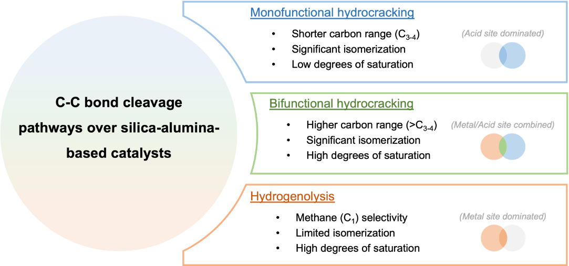
Entry | Sub. | Catalyst | S/C  ratio* | Type | Temp.  (ºC) | Time  (hr.) | Press.  (bar) | Conv.  (%) | Yield†  (Gas, %) | Yield‡  (Liq., %)
1 | LDPEª | ZSM-5 | 100 | Monofunctional  cracking | 400 | 2 | N/A | 90 | 46 | 44
2 | Mixed^{b} | Beta | 20 | Monofunctional  hydrocracking | 400 | 1 | 20 | 95 | 36 | 59
3 | LDPE^{c} | Pt_1wt%/Beta | 10 | Bifunctional  hydrocracking | 330 | 1 | 20 | 99 | 44 | 52
4 | LDPE^{d} | Pt/WO₃/ZrO₂  + Zeo-Y | 10 | Tandem  catalysis | 250 | 2 | 30 | 99 | 9 | 83
5 | LDPE^{e} | Ru/C | 28 | Hydrogenolysis | 225 | 16 | 20 | 99 | 55 | 45
6 | HDPE^{f} | Ru/C | 2 | Hydrogenolysis | 220 | 1 | 60 | 99 | 12 | 68
* S/C ratio = substrate/catalyst weight ratio; Note that the selected carbon range for the reported liquid hydrocarbon yields (wt%) may have slight differences among literature: † Gaseous products are typically defined as C₁₋₄; ‡ Liquid products are typically defined as C₅₋₂₀; ª Plastic properties/source not provided; ^{b} HDPE (ρ = 0.952 g/cm³, Sigma-Aldrich) + LDPE (ρ = 0.918 g/cm³, Sigma-Aldrich) + PP (Mw = 250,000 g/mol, ρ = 0.9 g/cm³) + PS (Mw = 192,000 g/mol) = (40 + 10 + 30 + 20)wt%; ^{c} LDPE (Mw ~150,000 g/mol); ^{d} LDPE (Mw ~250,000 g/mol, Sigma-Aldrich); ^{e} LDPE (Mw ~4,000 g/mol, Sigma-Aldrich); ^{f} HDPE water jug from local source, properties not specified.

Table 2 n-Hexadecane deconstructions with all 12 catalysts at 275, 325, and 375 ºC.
Entry | Catalyst | Temp. (ºC) | Conv. (%) | C₁₋₄ Yield (%) | C₅₋₁₆ Yield (%)
1 | SiO₂-Al₂O₃ | 275 ºC | 2.1±0.2 | 0.0 | 2.1
2 | SiO₂-Al₂O₃ | 325 ºC | 3.8±1.0 | 0.1 | 3.7
3 | SiO₂-Al₂O₃ | 375 ºC | 2.1±0.2 | 0.1 | 2.0
4 | Zeo-Y_H | 275 ºC | 4.5±0.3 | 0.3 | 4.2
5 | Zeo-Y_H | 325 ºC | 8.5±0.5 | 0.7 | 7.7
6 | Zeo-Y_H | 375 ºC | 26.7±1.4 | 3.3 | 23.3
7 | ZSM-5_H | 275 ºC | 13.7±2.4 | 3.8 | 10.0
8 | ZSM-5_H | 325 ºC | 91.6±4.4 | 35.5 | 56.2
9 | ZSM-5_H | 375 ºC | 98.0±2.0 | 77.3 | 20.8
10 | Co/SiO₂-Al₂O₃ | 275 ºC | 2.3±0.2 | 0.1 | 2.2
11 | Co/SiO₂-Al₂O₃ | 325 ºC | 2.3±0.3 | 0.0 | 2.2
12 | Co/SiO₂-Al₂O₃ | 375 ºC | 2.4±0.1 | 0.1 | 2.2
13 | Co/Zeo-Y_H | 275 ºC | 1.9±0.4 | 0.0 | 1.9
14 | Co/Zeo-Y_H | 325 ºC | 5.5±1.2 | 0.2 | 5.2
15 | Co/Zeo-Y_H | 375 ºC | 6.1±1.2 | 1.2 | 4.9
16 | Co/ZSM-5_H | 275 ºC | 1.9±0.1 | 0.1 | 1.8
17 | Co/ZSM-5_H | 325 ºC | 5.9±0.1 | 1.2 | 4.7
18 | Co/ZSM-5_H | 375 ºC | 49.0±3.7 | 12.7 | 36.3
19 | Ni/SiO₂-Al₂O₃ | 275 ºC | 2.6±0.6 | 0.1 | 2.6
20 | Ni/SiO₂-Al₂O₃ | 325 ºC | 3.3±1.4 | 0.1 | 3.2
21 | Ni/SiO₂-Al₂O₃ | 375 ºC | 3.8±1.2 | 0.2 | 3.7
22 | Ni/Zeo-Y_H | 275 ºC | 2.1±0.6 | 0.6 | 1.5
23 | Ni/Zeo-Y_H | 325 ºC | 4.4±0.4 | 0.4 | 4.0
24 | Ni/Zeo-Y_H | 375 ºC | 20.9±1.3 | 0.4 | 20.5
25 | Ni/ZSM-5_H | 275 ºC | 2.2±0.2 | 0.3 | 1.9
26 | Ni/ZSM-5_H | 325 ºC | 8.2±1.8 | 0.5 | 7.7
27 | Ni/ZSM-5_H | 375 ºC | 85.6±4.1 | 28.2 | 57.3
28 | Ru/SiO₂-Al₂O₃ | 275 ºC | 95.6±4.0 | 41.5 | 54.2
29 | Ru/SiO₂-Al₂O₃ | 325 ºC | 98.5±0.3 | 75.8 | 22.6
30 | Ru/SiO₂-Al₂O₃ | 375 ºC | 99.8±0.2 | 96.6 | 3.3
31 | Ru/Zeo-Y_H | 275 ºC | 96.0±0.9 | 56.6 | 39.3
32 | Ru/Zeo-Y_H | 325 ºC | 99.6±0.3 | 91.5 | 8.3
33 | Ru/Zeo-Y_H | 375 ºC | 99.0±1.0 | 92.4 | 6.9
34 | Ru/ZSM-5_H | 275 ºC | 99.4±0.6 | 92.8 | 6.6
35 | Ru/ZSM-5_H | 325 ºC | 98.0±2.0 | 99.7 | 0.3
36 | Ru/ZSM-5_H | 375 ºC | 99.8±0.2 | 98.8 | 1.1
Reaction conditions: n-hexadecane (1.59 g, 7.0 mmol), catalyst (0.1 g, metal loading = 2.5 wt%), S/C ratio (substrate/catalyst weight ratio) ~16, 45 bar H₂, 2 hrs. * All yields were calculated as the carbon yield and isomerized C₁₆ (isoC₁₆) are considered as products.

Table 3 Degrees of saturation of the liquid products obtained from the deconstruction of n-hexadecane.
Entry | Catalyst | Conversion (%) | Saturated  (%, δ = 0.25-2.0) | Unsaturated  (%, δ = 2.0-6.0) | Aromatic  (%, δ = 6.0-8.0)
1 | ZSM-5_H | 98.0±2.0 | 87.4±4.3 | 7.9±2.6 | 4.8±1.9
2 | Co/ZSM-5_H | 49.0±3.7 | 99.4±0.5 | 0.5±0.4 | 0.1±0.1
3 | Ni/ZSM-5_H | 85.6±4.1 | 97.6±0.8 | 2.3±0.7 | 0.1±0.1
4* | Co/ZSM-5_H | 93.1±4.3 | 96.2±1.8 | 3.1±1.6 | 0.6±0.2
5* | Ni/ZSM-5_H | 99.8±0.2 | 99.9±0.1 | 0.1±0.1 | 0.1±0.1
Reaction conditions: n-hexadecane (1.59 g, 7.0 mmol), catalyst (0.1 g, metal loading = 2.5 wt%), 45 bar H₂, 375 ºC, 2 hrs. * 45 bar H₂, 375 ºC, Reaction time = 6 hrs. Note that degrees of saturation are defined by the ratios of proton integrations via ¹H NMR to indicate the adjacent carbon-carbon bonding situation (saturated: δ = 0.25-2.0, unsaturated: δ = 2.0-6.0 and aromatics: δ = 2.0-6.0) given the C-H and C-C bond exclusivity of hydrocarbon molecules.

