Supplementary Information

Polyolefin depolymerization over silica-alumina-based catalysts: mechanistic classifications and benchmarking

Wei-Tse Lee¹, Antoine van Muyden¹, Felix D. Bobbink¹, Mounir D. Mensi¹, Jed R. Carullo¹, Paul J. Dyson^{1,*}

¹Institute of Chemical Sciences and Engineering, École Polytechnique Fédérale de Lausanne (EPFL), Lausanne, Switzerland.

Supplementary Figure 1 Powder X-ray of SiO₂-Al₂O₃, Co/SiO₂-Al₂O₃, Ni/SiO₂-Al₂O₃ and Ru/SiO₂-Al₂O₃ with 2𝜃 = 4-50 degree.

Supplementary Figure 2 Powder X-ray of Zeo-Y_H, Co/Zeo-Y_H, Ni/Zeo-Y_H and Ru/Zeo-Y_H with 2𝜃 = 4-50 degree.

Supplementary Figure 3 Powder X-ray of ZSM-5_H, Co/ZSM-5_H, Ni/ZSM-5_H and Ru/ZSM-5_H with 2𝜃 = 4-50 degree.

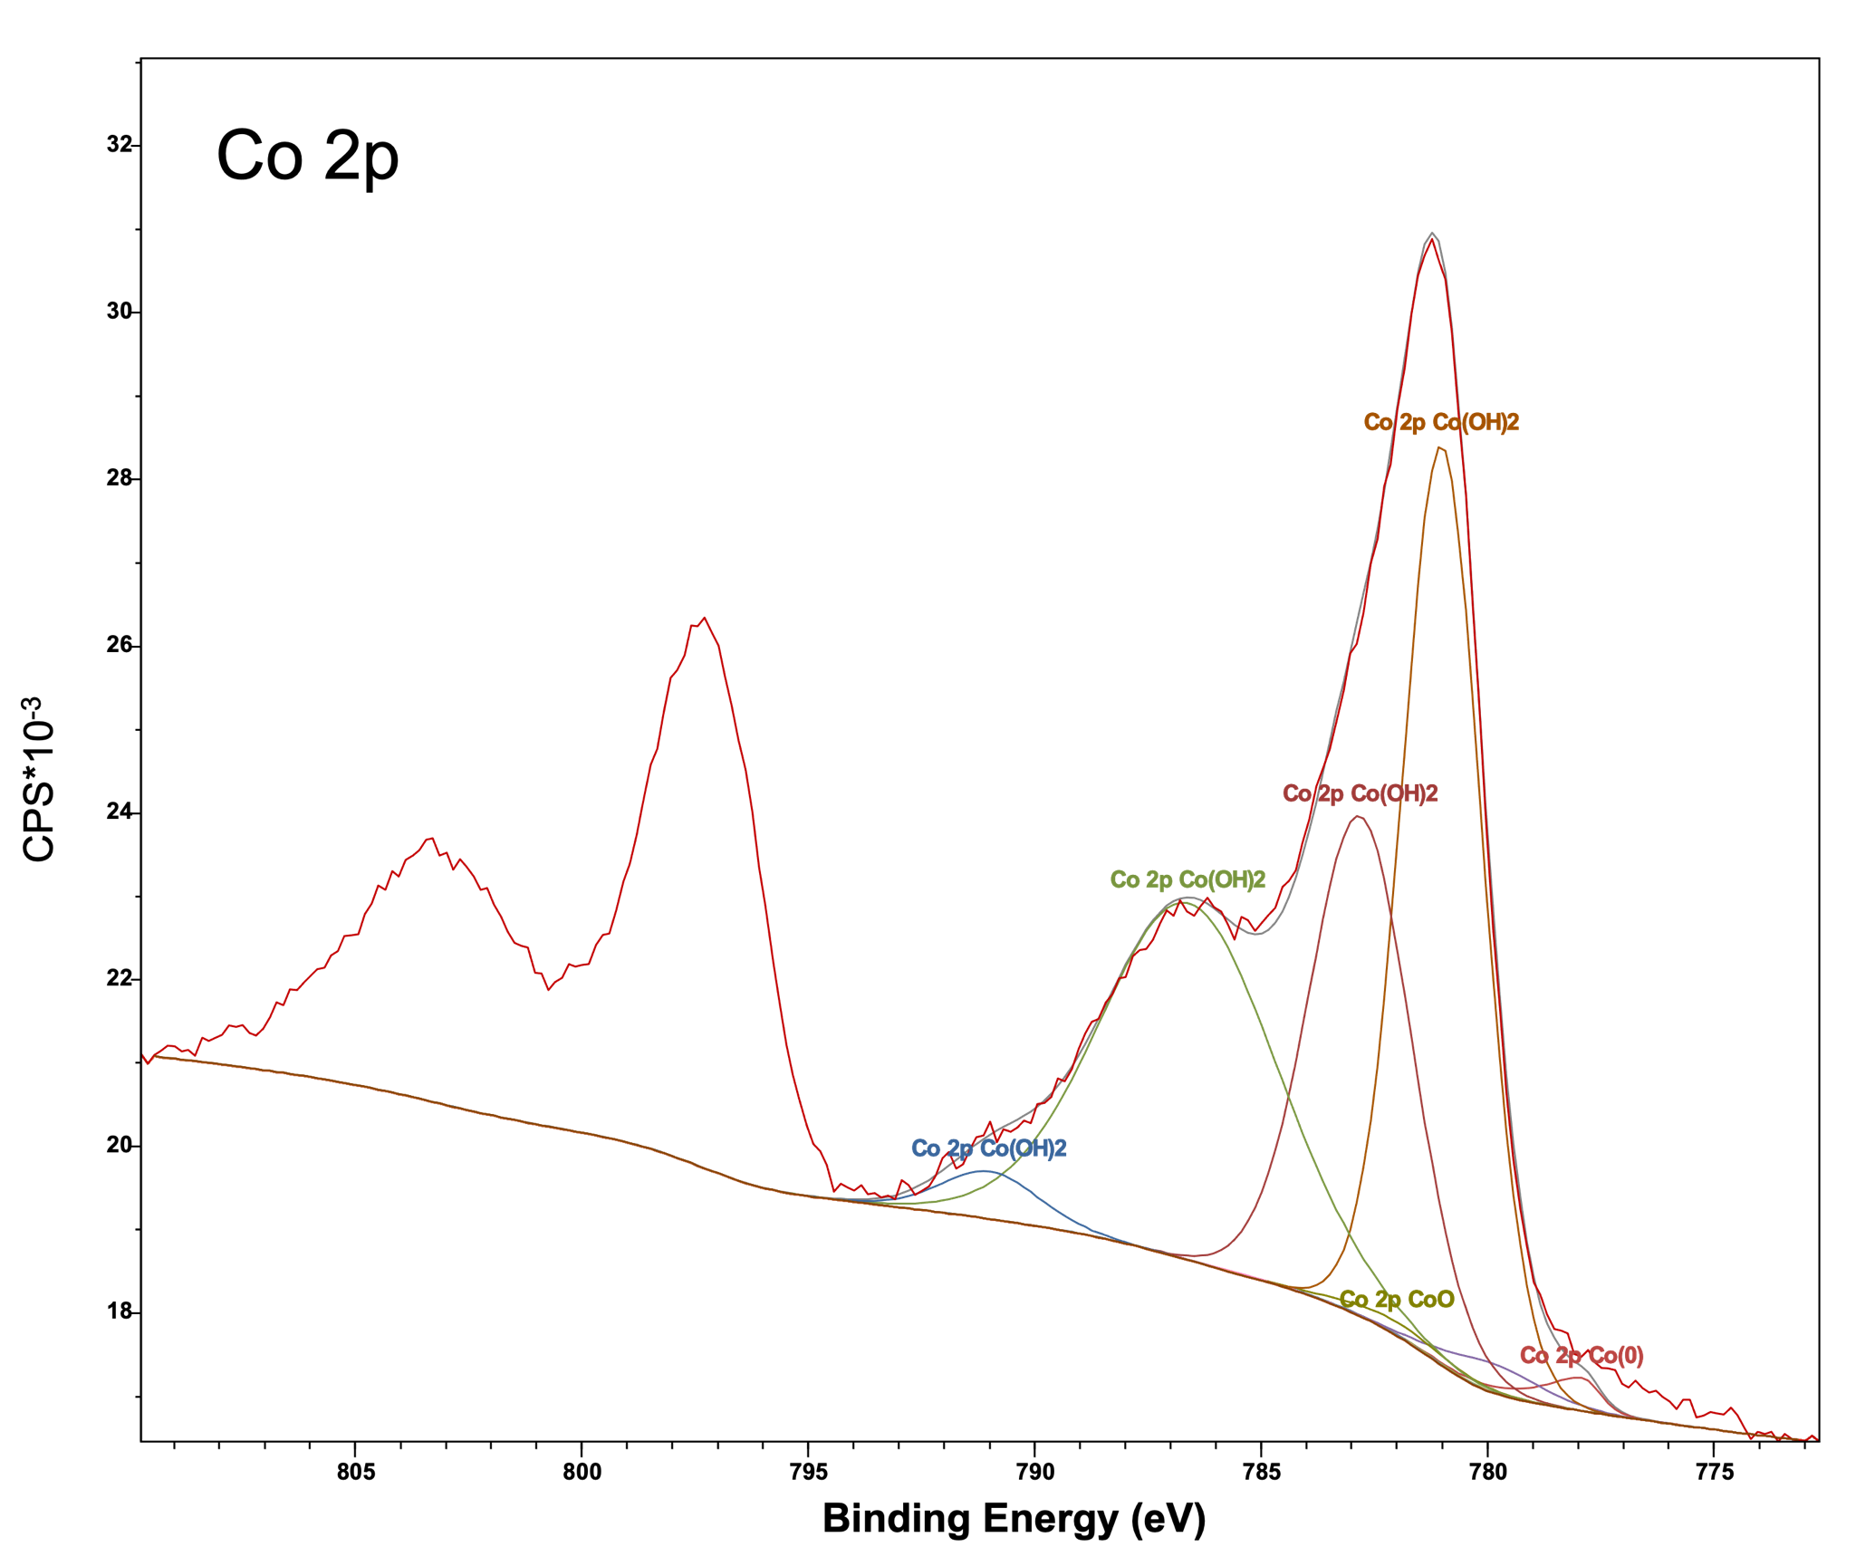
Supplementary Figure 4 Curve fitted XPS analysis of Co 2p region of Co/ZSM-5_H catalyst (fitting according to Mark Biesinger et al.).¹ The detailed fitting table can be revealed through the raw data upon reasonable request.

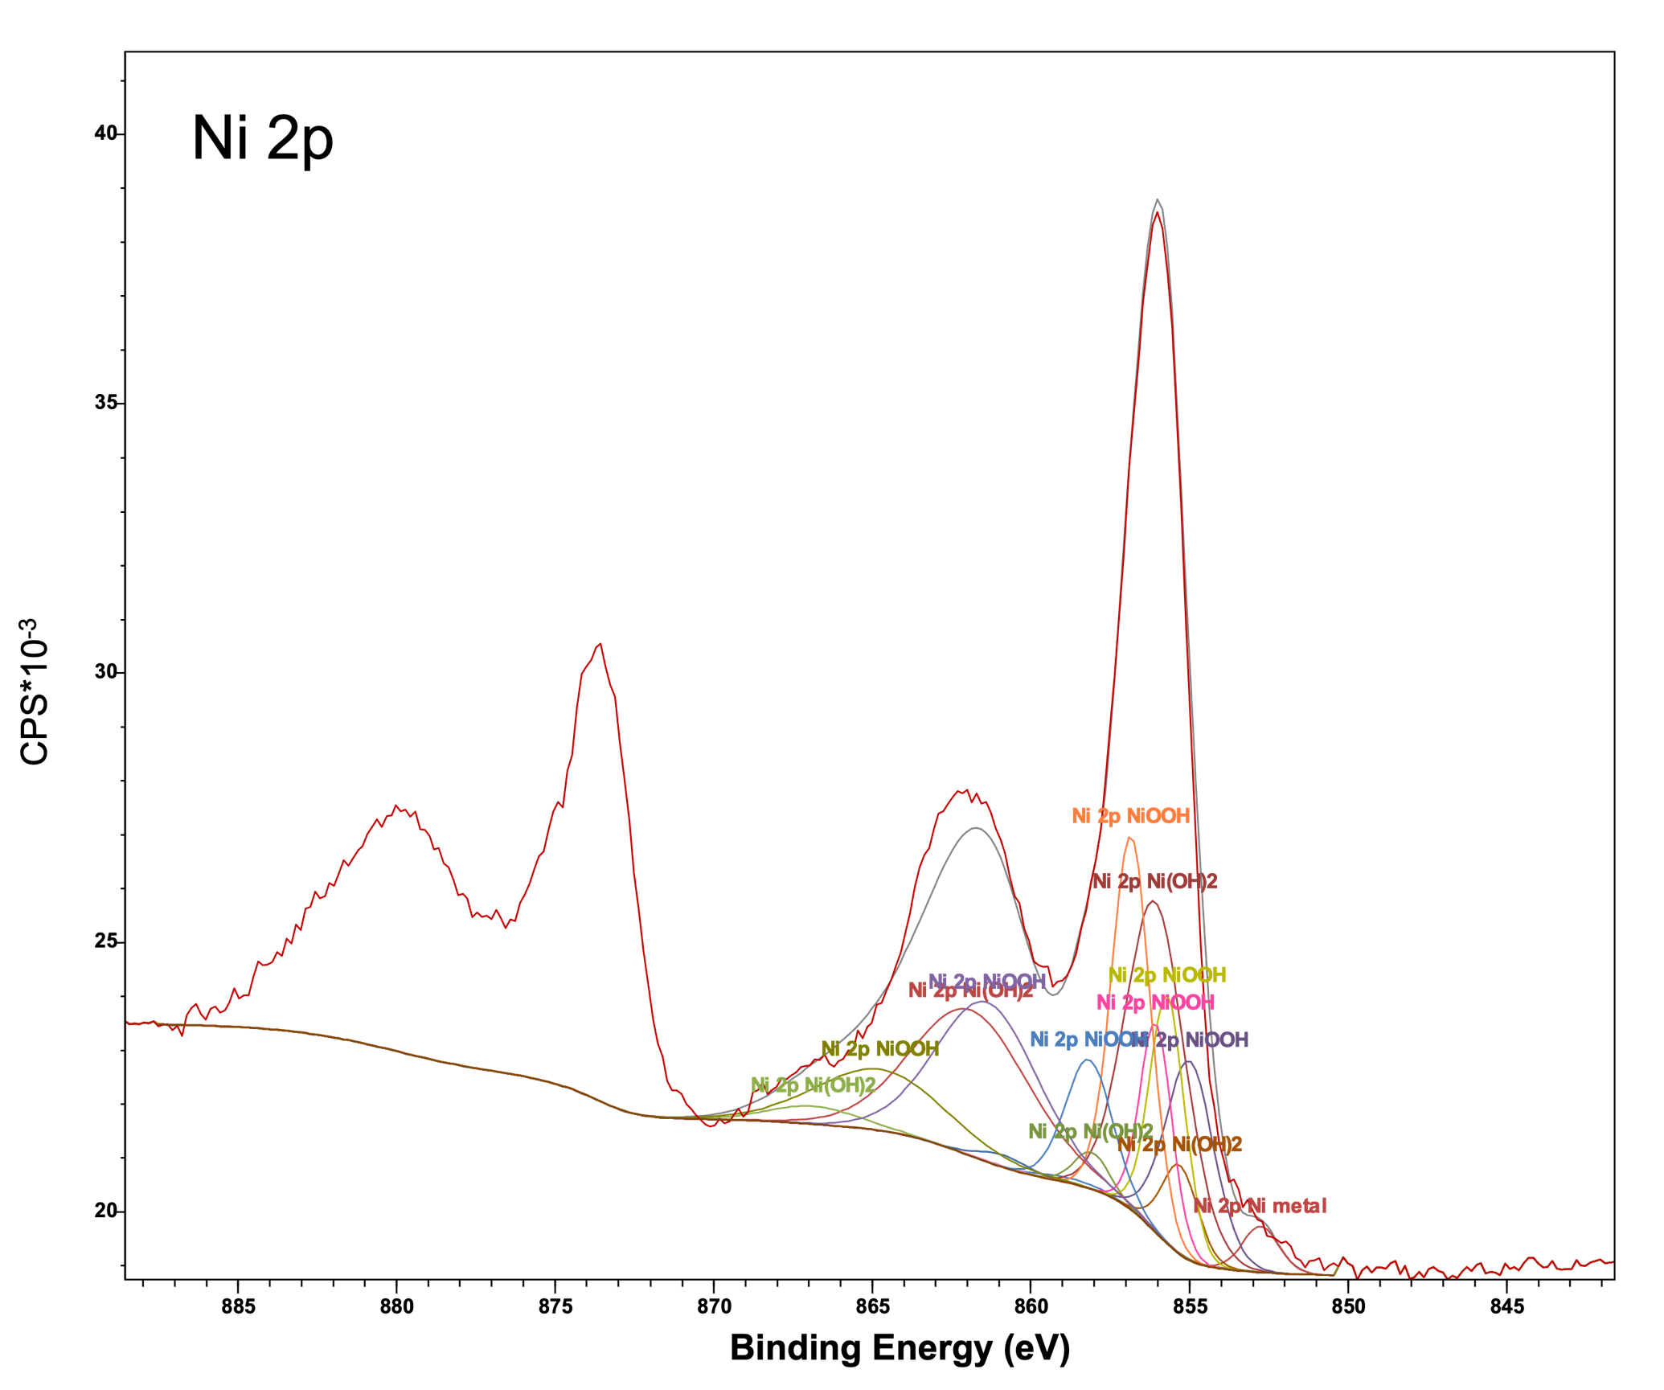
Supplementary Figure 5 Curve fitted XPS analysis of Ni 2p region of Ni/ZSM-5_H catalyst (fitting according to Mark Biesinger et al.).¹ The detailed fitting table can be revealed through the raw data upon reasonable request.

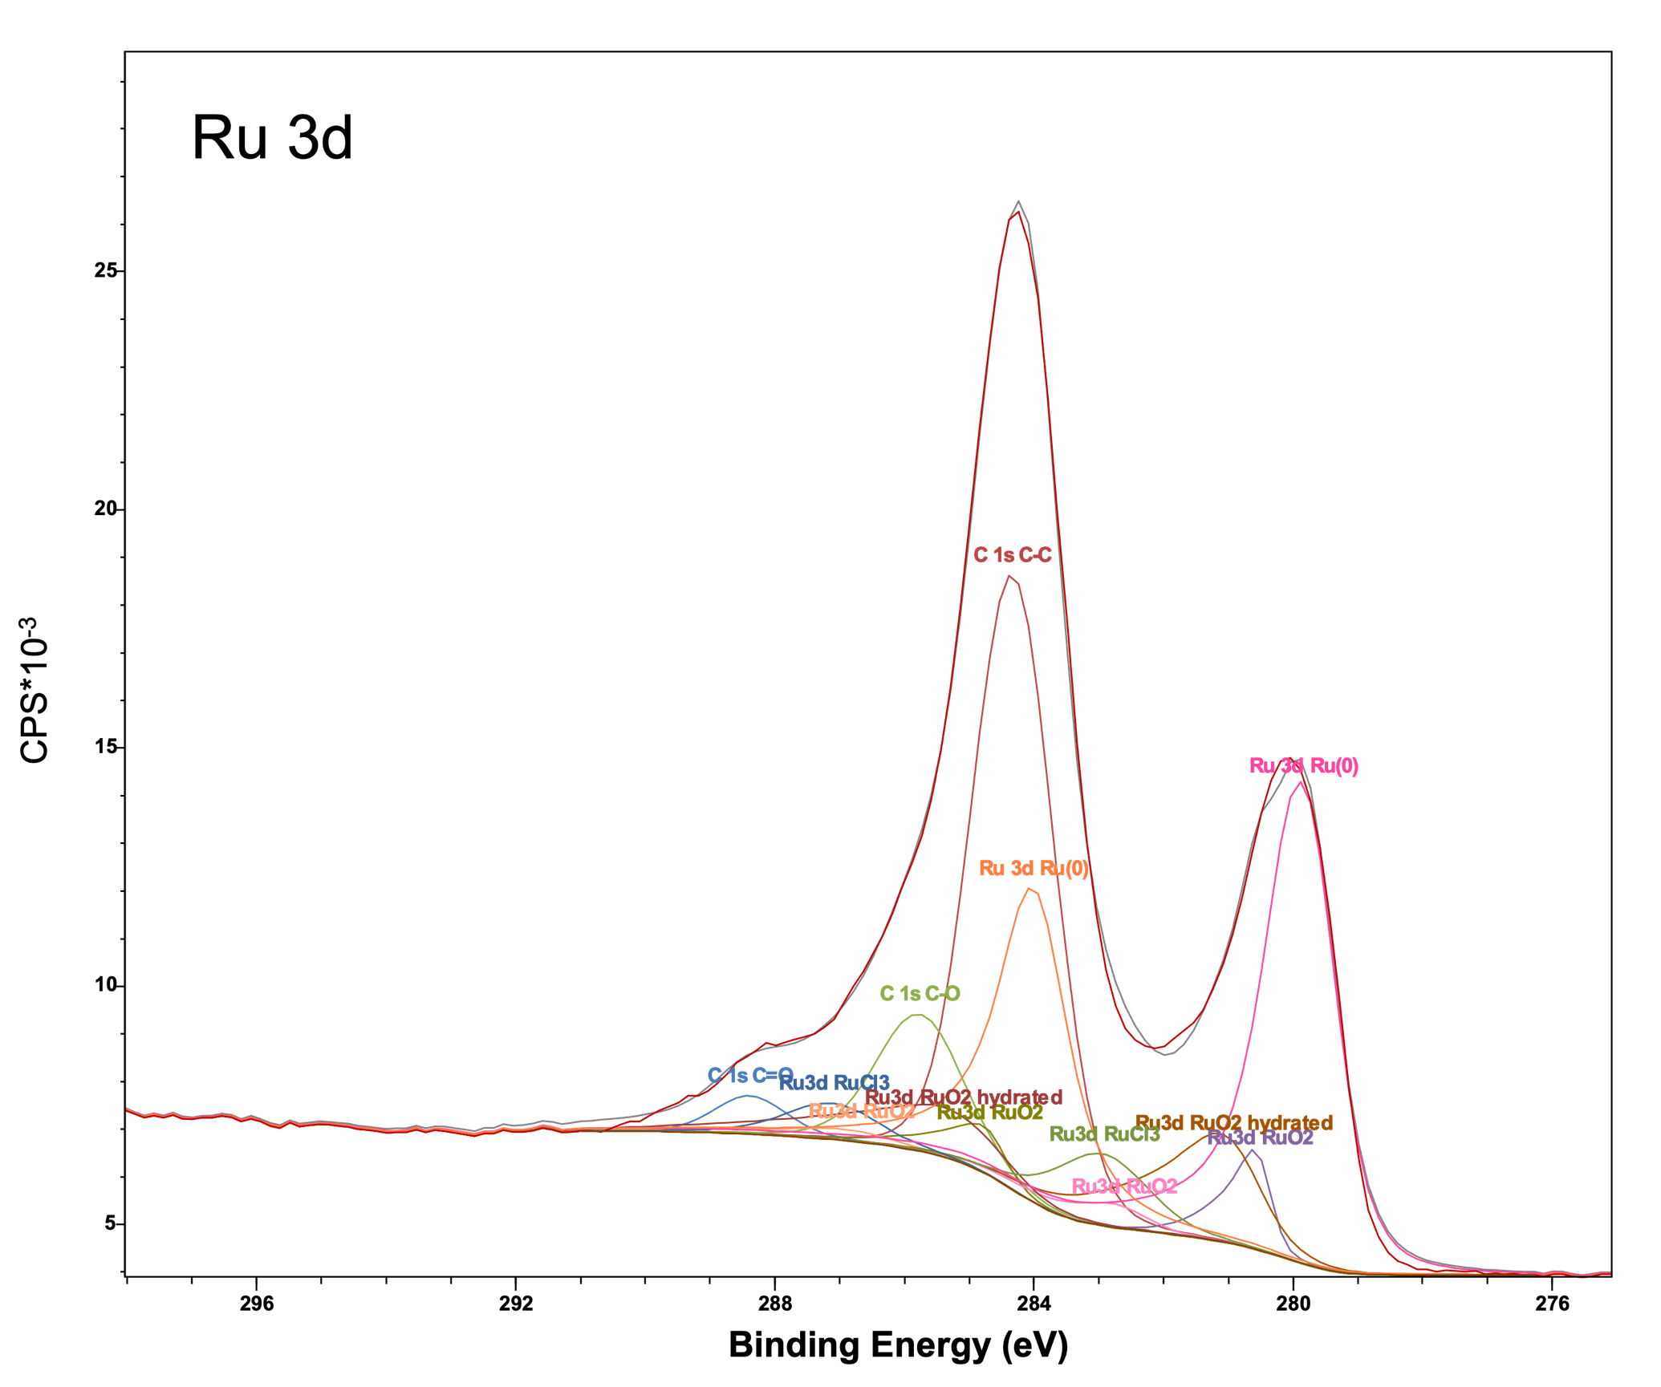
Supplementary Figure 6 Curve fitted XPS analysis of Ru 3d and C 1s region of Ru/ZSM-5_H catalyst (fitting according to David J. Morgan).² The detailed fitting table can be revealed through the raw data upon reasonable request.

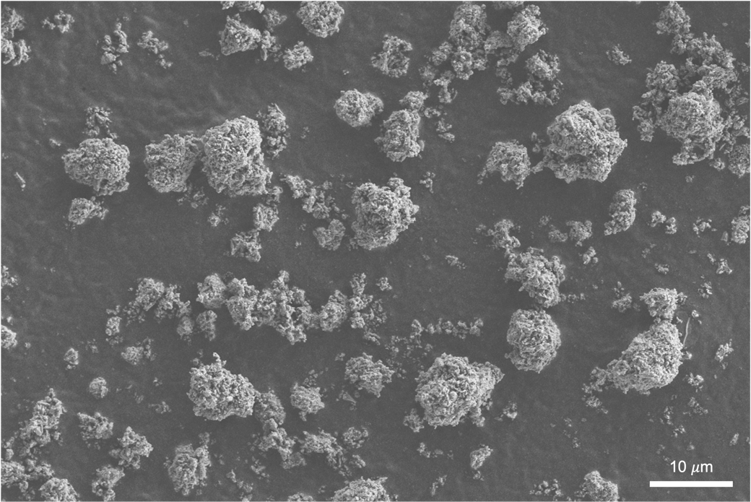  a | 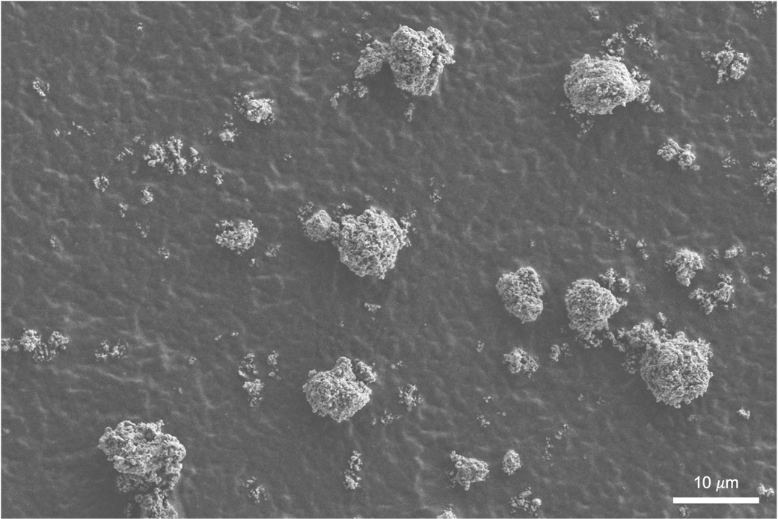  c
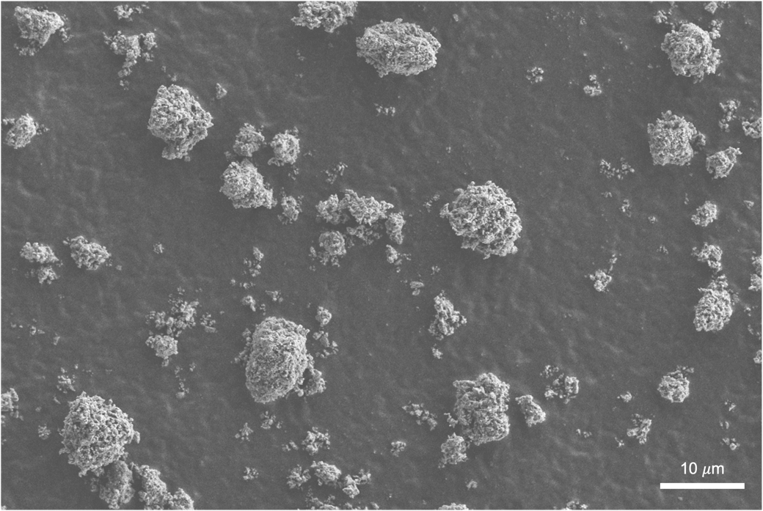  b | 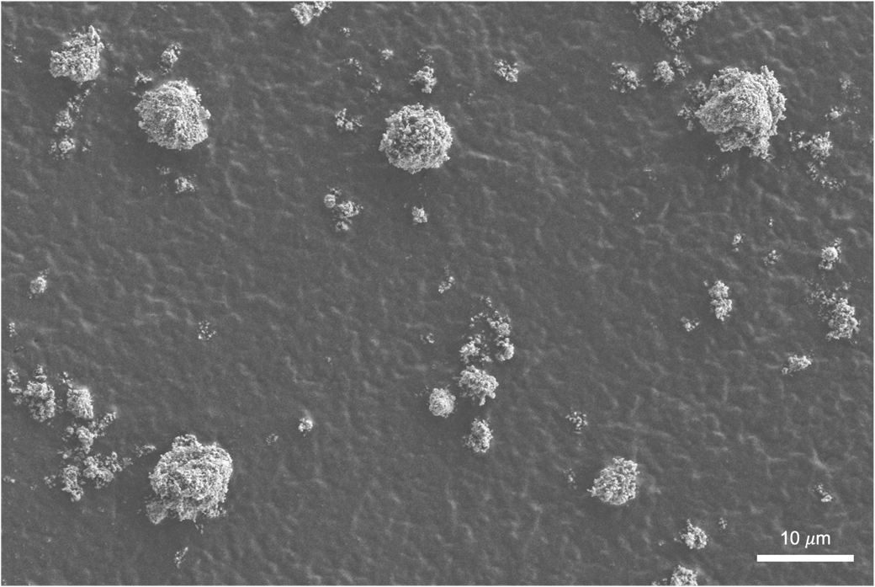  d
Supplementary Figure 7 a SEM images showing the particle distributions of ZSM-5_H (6.4-9.4 𝜇m), b Co/ZSM-5_H (6.3-9.7 𝜇m), c Ni/ZSM-5_H (6.3-8.6 𝜇m) and d Ru/ZSM-5_H (6.0-10.4 𝜇m).

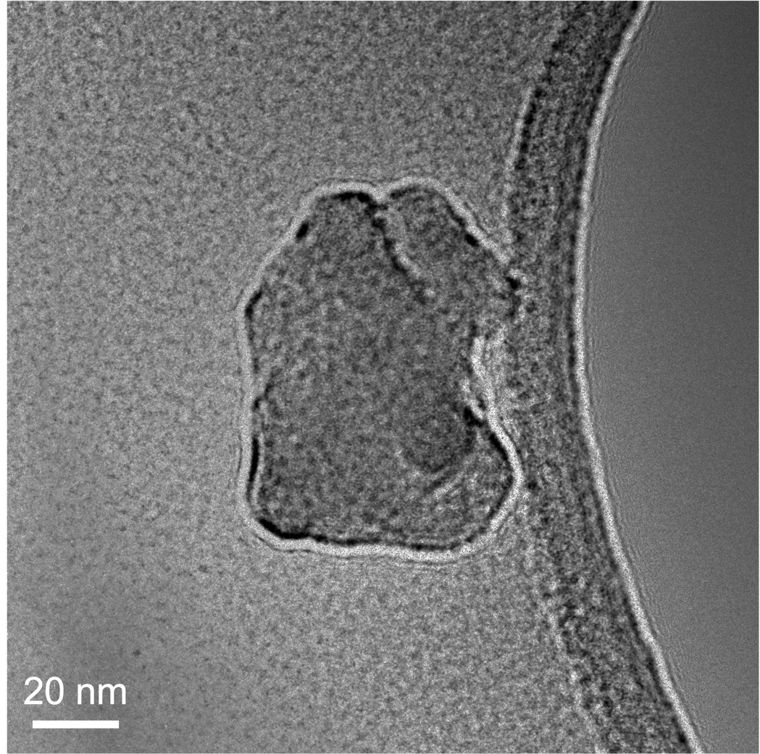  a |  | 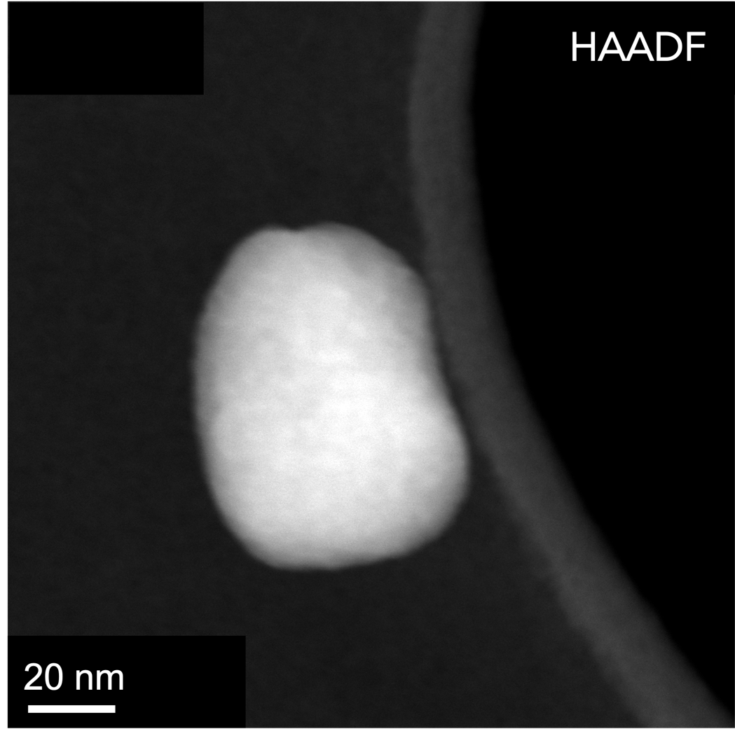  b
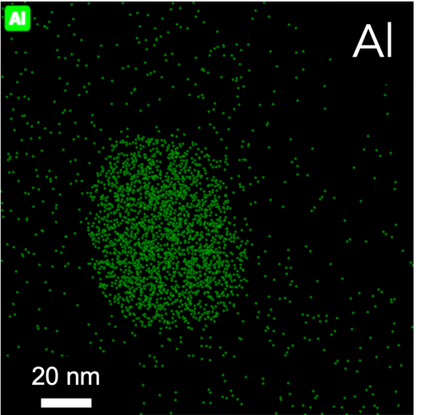  d  c | 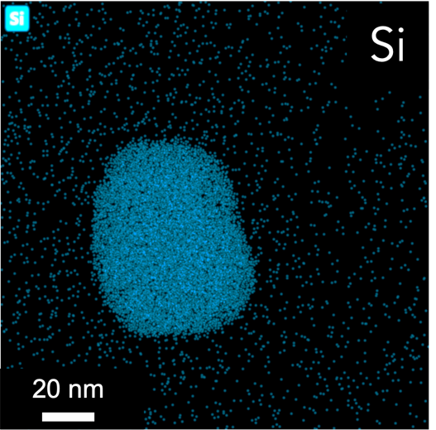 | 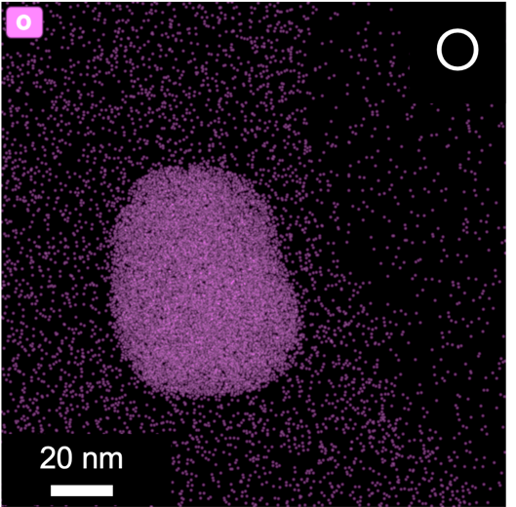  e | 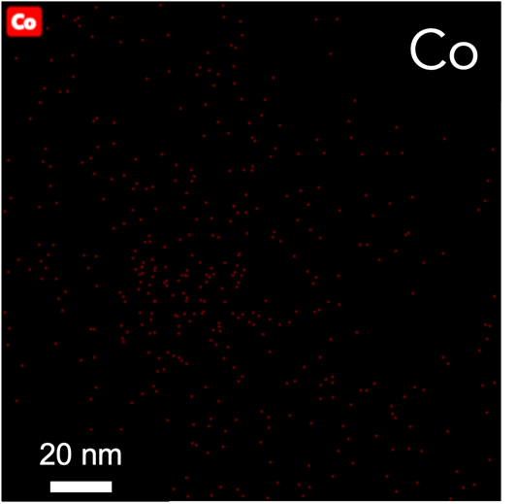  f
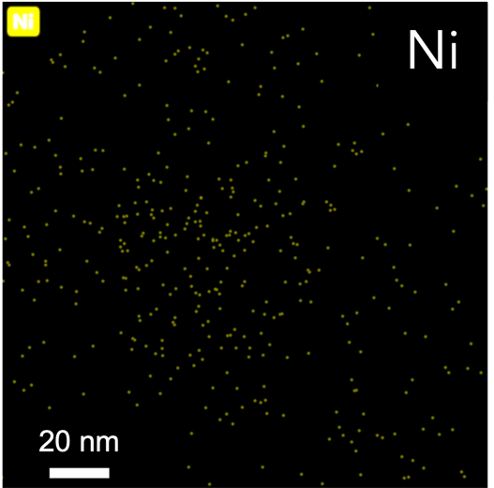  g | 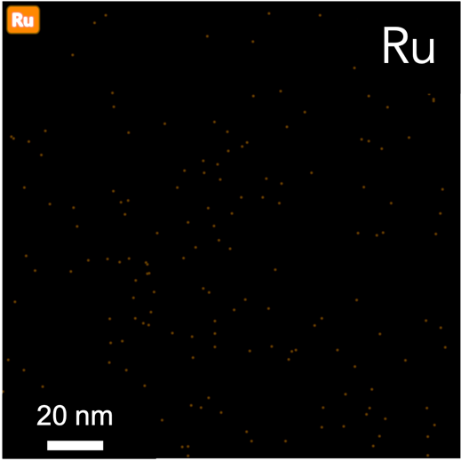  h
Supplementary Figure 8 a TEM bright-field image of ZSM-5_H. b HAADF image of ZSM-5_H. c STEM-EDS elemental mapping of Al, d Si, e O, f Co, g Ni and h Ru.

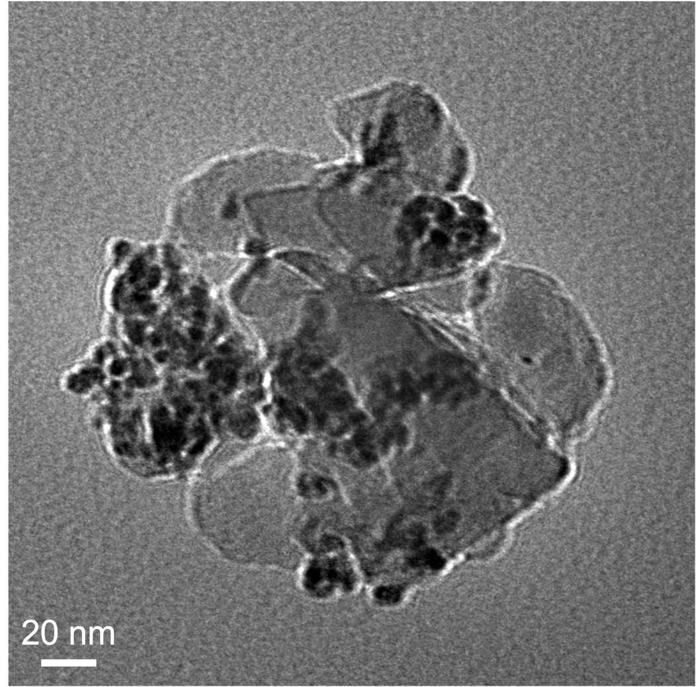  a |  | 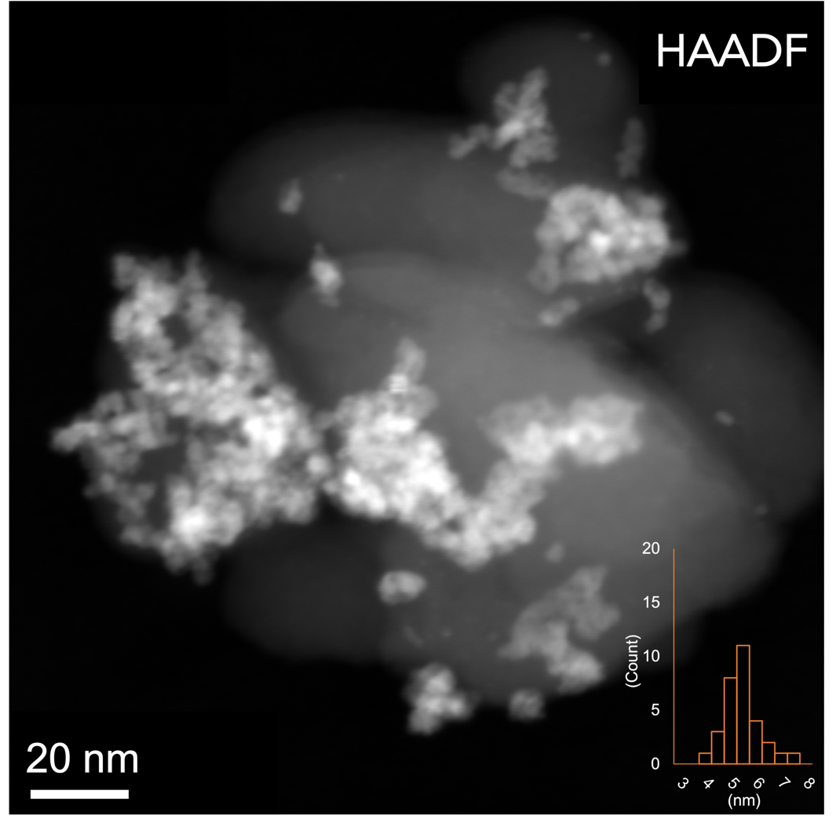  e  b
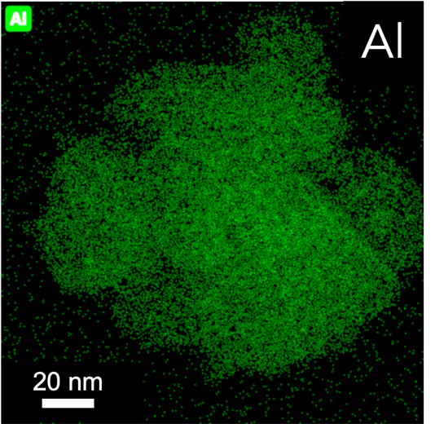  c  d | 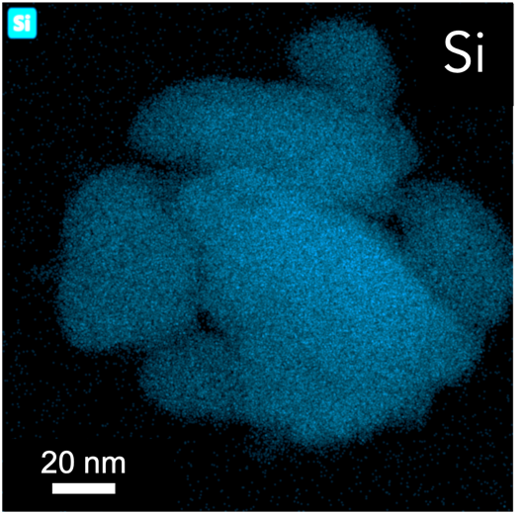 | 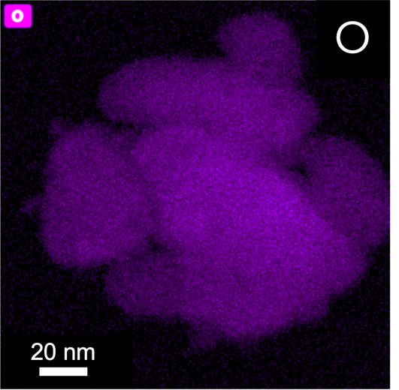 | 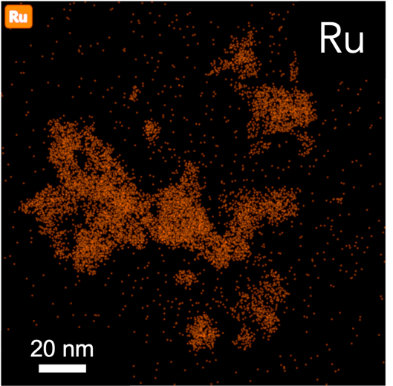  f
Supplementary Figure 9 a TEM bright-field image of Ru/ZSM-5_H. b HAADF image of Ru/ZSM-5_H with Ru NP distributions = 5.4±0.8 nm. c STEM-EDS elemental mapping of Al, d Si, e O and f Ru.

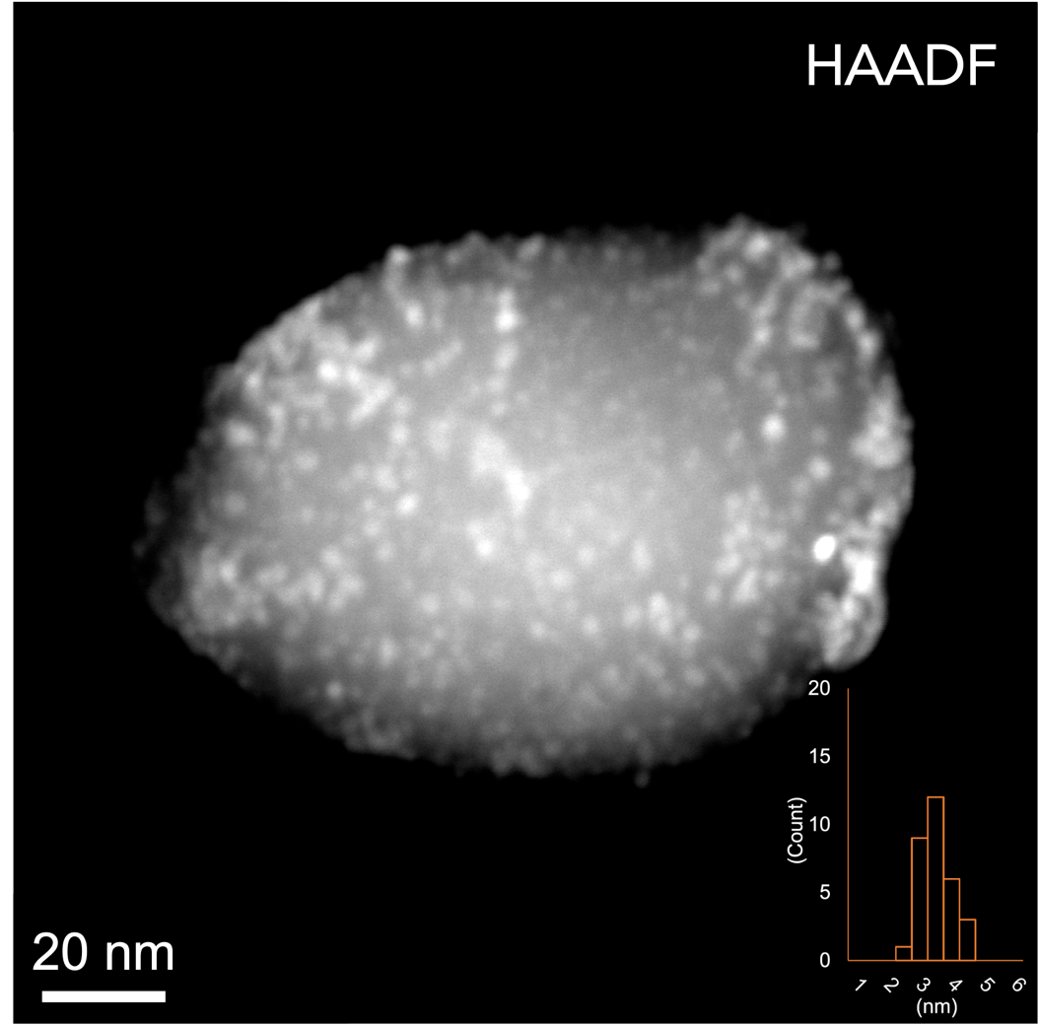  a | 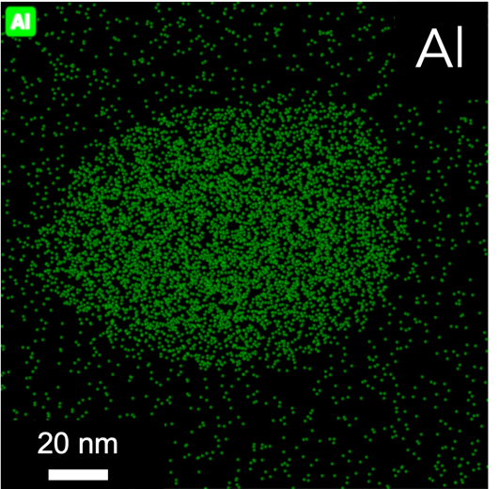  b | 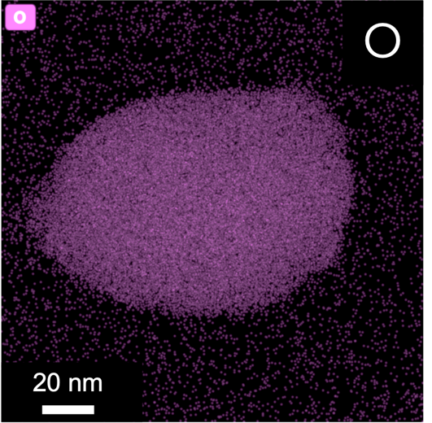  d
 | 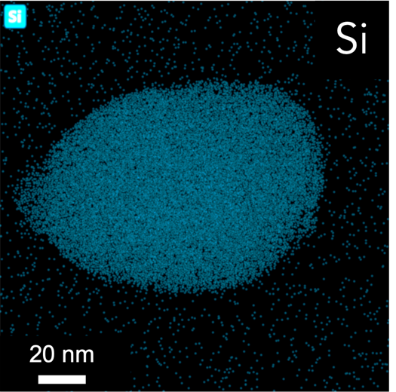  c  C | 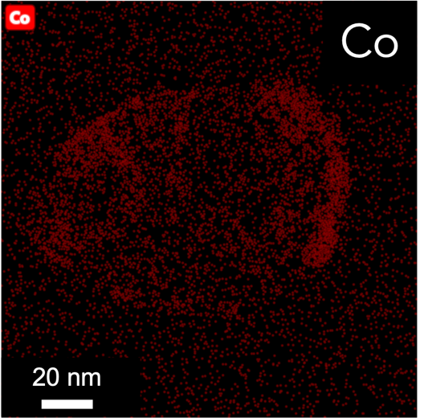  e
Supplementary Figure 10 a HAADF image of Co/ZSM-5_H with Co NP distributions = 3.6±0.5 nm. b STEM-EDS elemental mapping of Al, c Si, d O and e Co.

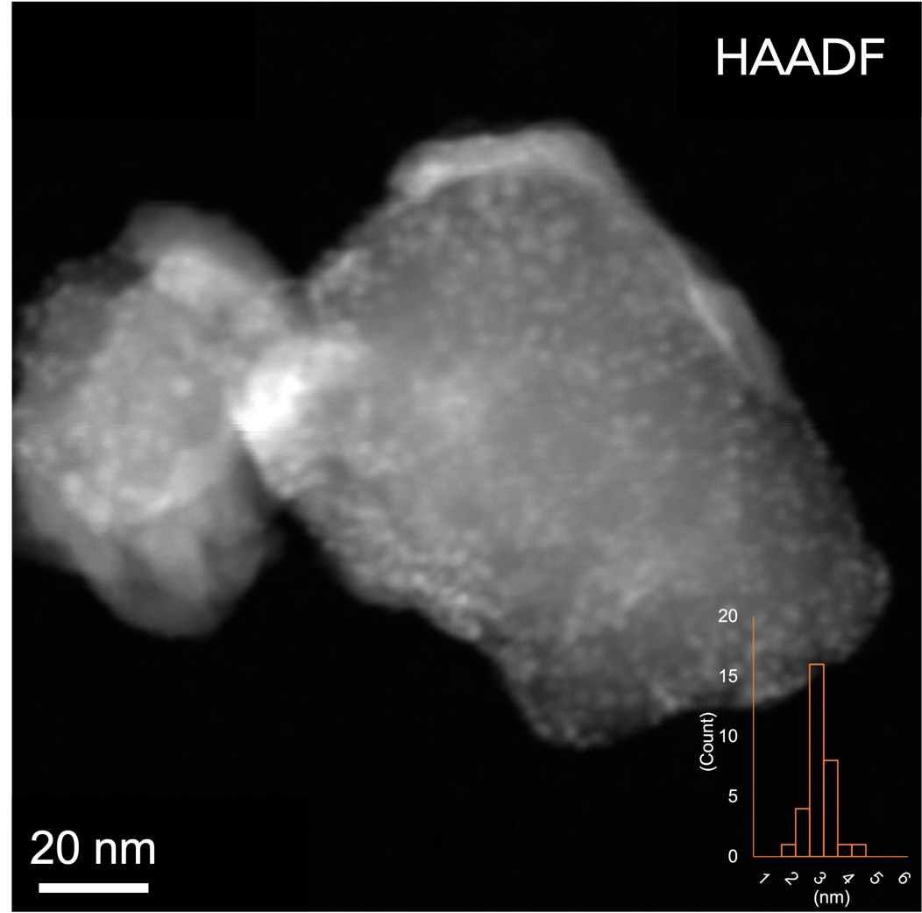  b  a | 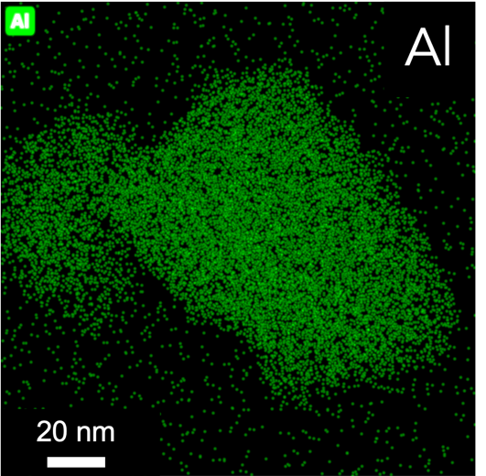 | 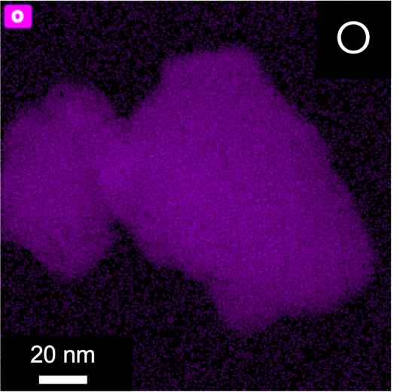  d
 | 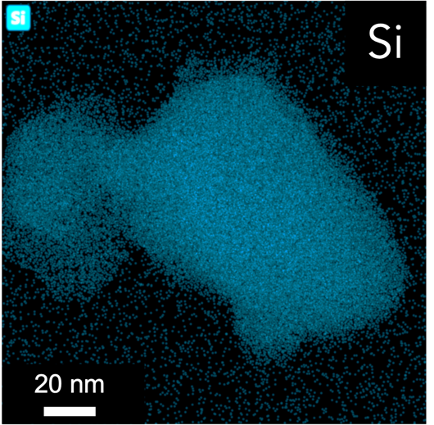  c  e | 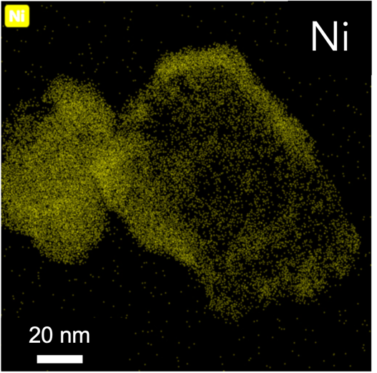
Supplementary Figure 11 a HAADF image of Ni/ZSM-5_H with Ni NP distributions = 3.1±0.4 nm. b STEM-EDS elemental mapping of Al, c Si, d O and e Ni.

Supplementary Figure 12 Product distributions after nC₁₆ (1.59 g) deconstructions in the presence of unmodified silica-alumina catalysts (0.1 g): SiO₂-Al₂O₃, Zeo-Y_H and ZSM-5_H, 45 bar H₂, 2 hrs. Note that nC₁₂ signal originated from the addition as an internal standard has been suppressed, and the yield of C₁₂ products herein was resulted from the nC₁₆ deconstruction.

Supplementary Figure 13 Product distributions after nC₁₆ (1.59 g) deconstructions in the presence of Co-modified catalysts (0.1 g, metal loading = 2.5 wt%): Co/SiO₂-Al₂O₃, Co/Zeo-Y_H and Co/ZSM-5_H, 45 bar H₂, 2 hrs. Note that nC₁₂ signal originated from the addition as an internal standard has been suppressed, and the yield of C₁₂ products herein was resulted from the nC₁₆ deconstruction.

Supplementary Figure 14 Product distributions after nC₁₆ (1.59 g) deconstructions in the presence of Ni-modified catalysts (0.1 g, metal loading = 2.5 wt%): Ni/SiO₂-Al₂O₃, Ni/Zeo-Y_H and Ni/ZSM-5_H, 45 bar H₂, 2 hrs. Note that nC₁₂ signal originated from the addition as an internal standard has been suppressed, and the yield of C₁₂ products herein was resulted from the nC₁₆ deconstruction.

Supplementary Figure 15 Product distributions after nC₁₆ (1.59 g) deconstructions in the presence of Ru-modified catalysts (0.1 g, metal loading = 2.5 wt%): Ru/SiO₂-Al₂O₃, Ru/Zeo-Y_H and Ru/ZSM-5_H, 45 bar H₂, 2 hrs. Note that nC₁₂ signal originated from the addition as an internal standard has been suppressed, and the yield of C₁₂ products herein was resulted from the nC₁₆ deconstruction.

a
b
Supplementary Figure 16 a Product distributions after nC₁₆ (1.59 g) deconstructions with 45 bar H₂ at 375 ºC, 2 hrs, under a hydrogen and a nitrogen atmosphere in the presence of SiO₂-Al₂O₃ (0.1 g) and b Zeo-Y_H (0.1 g). Note that nC₁₂ signal originated from the addition as an internal standard has been suppressed, and the yield of C₁₂ products herein was resulted from the nC₁₆ deconstruction.

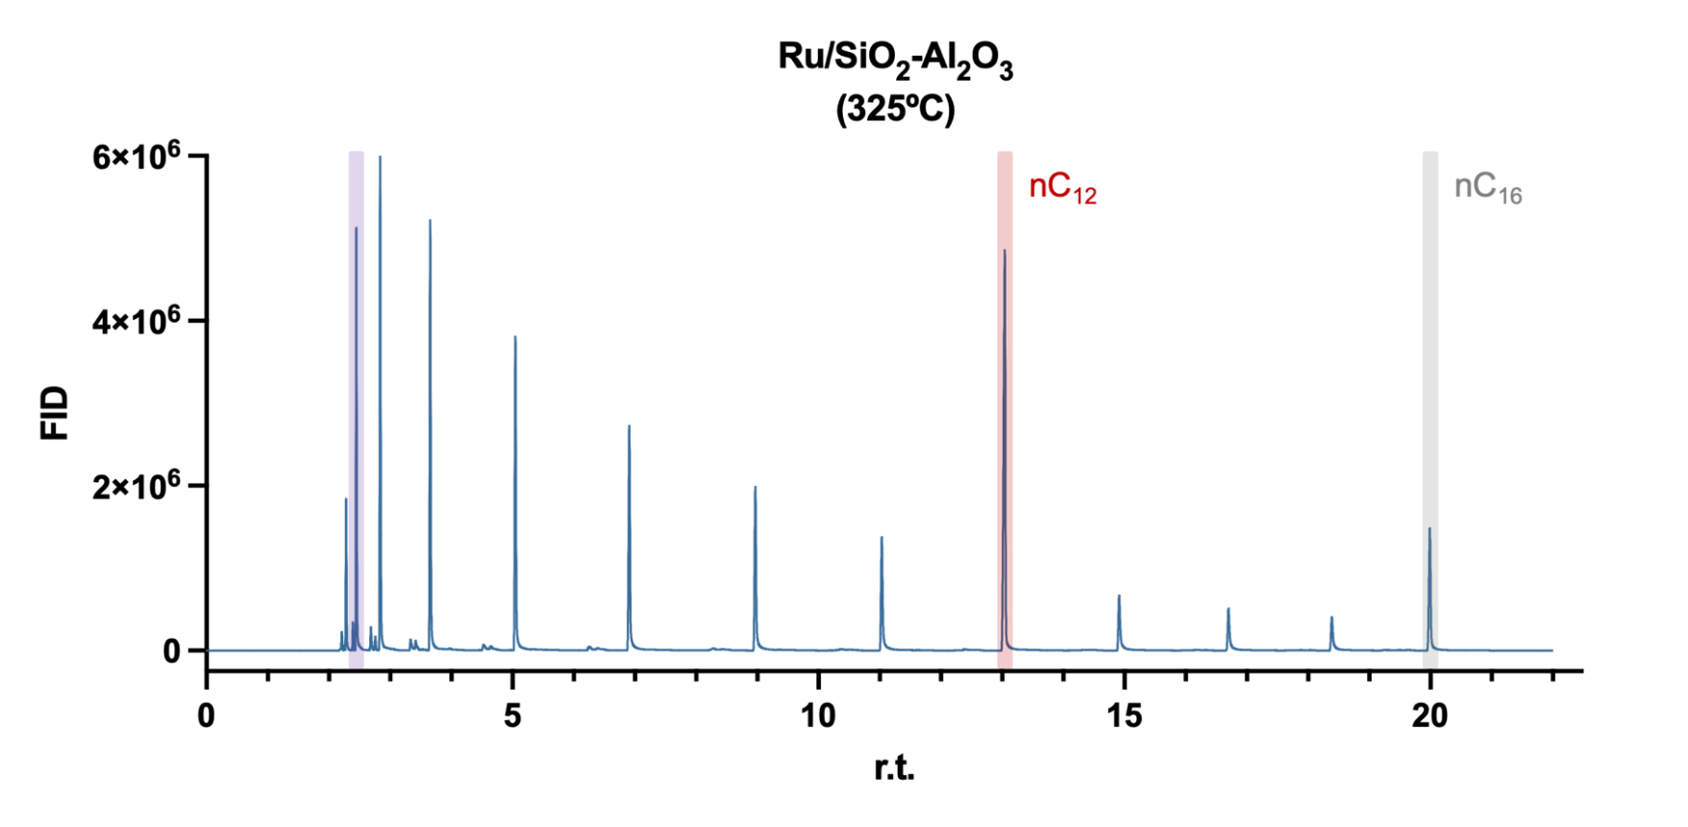
b
a
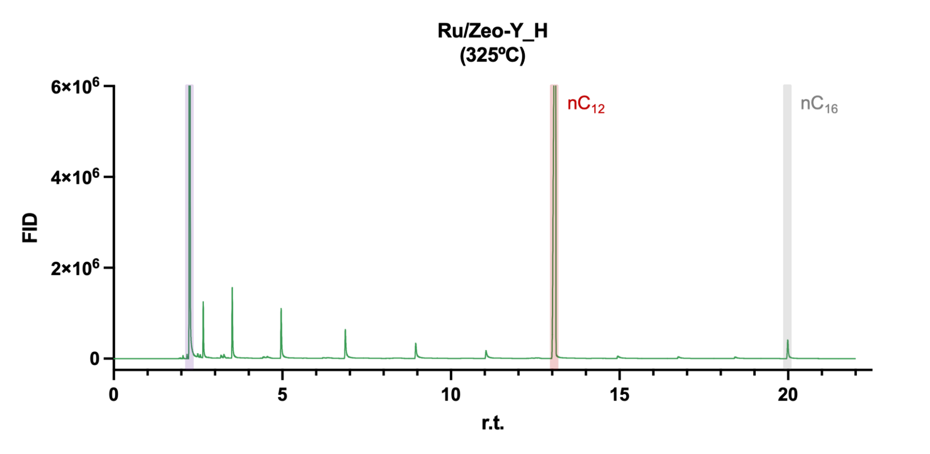
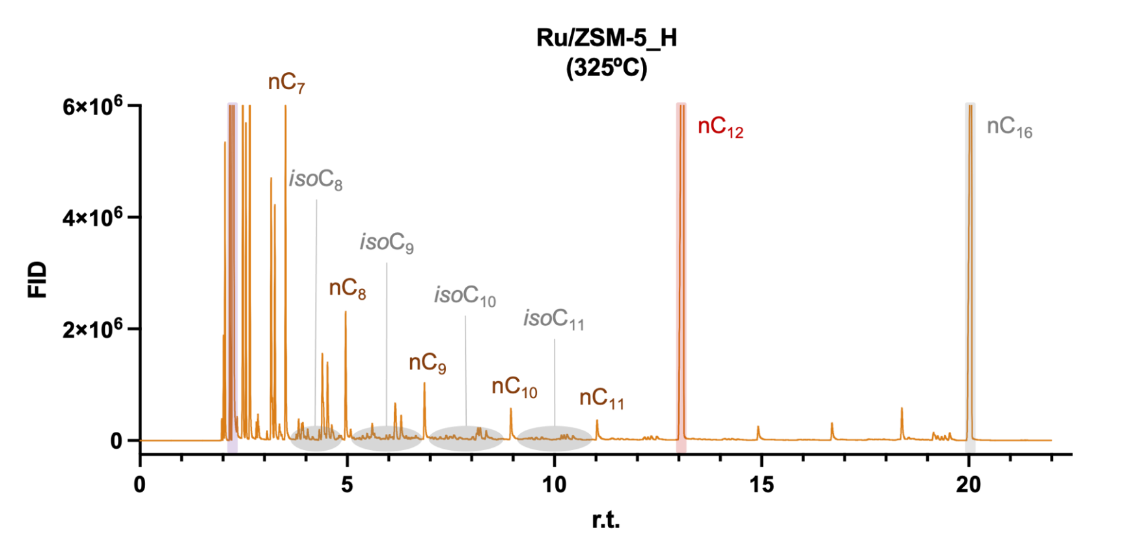
c
Supplementary Figure 17 a GC-FID traces of liquid products after the nC₁₆ (1.59 g) deconstruction with 45 bar H₂ at 325 ºC, 2 hrs, in the presence of (A) Ru/SiO₂-Al₂O₃ (0.1 g, metal loading = 2.5 wt%), b Ru/Zeo-Y_H (0.1 g, metal loading = 2.5 wt%) and c Ru/ZSM-5_H (0.1 g, metal loading = 2.5 wt%). Note that the peaks with retention time ~2.7 and ~14.1 min were diethyl ether (solvent for the GC sample) and nC₁₂ (internal standard), respectively.

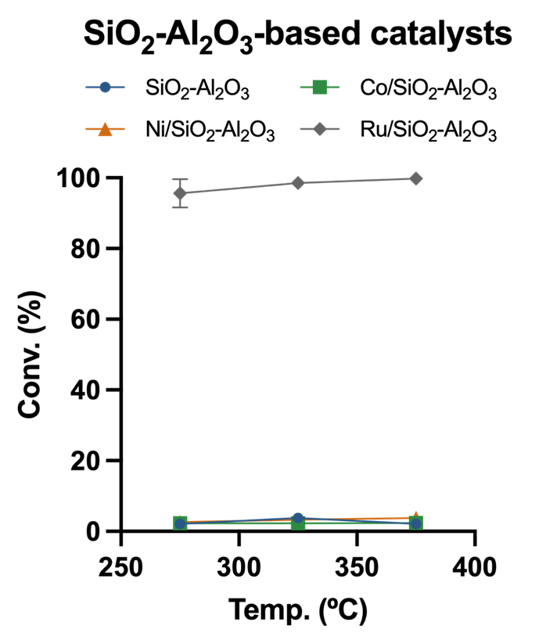  a | 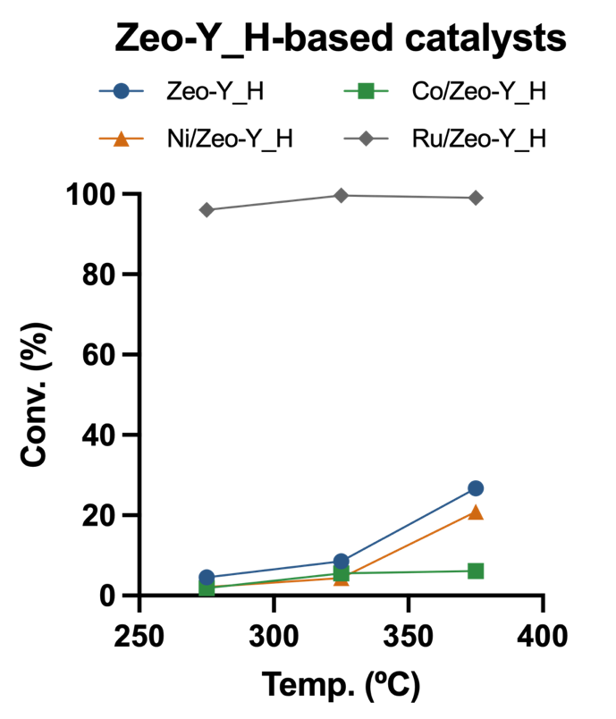  b | 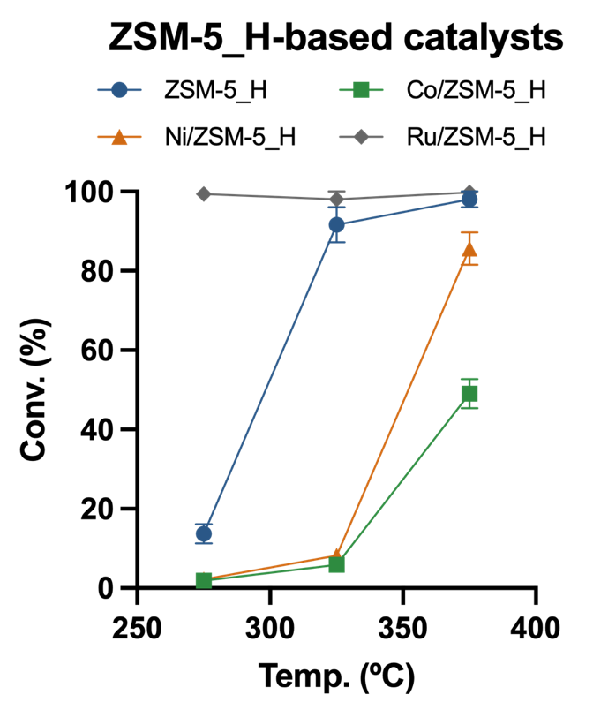  c
Supplementary Figure 18 a nC₁₆ (1.59 g) deconstructions with 45 bar H₂ at 275, 325 and 375 ºC, 2 hrs, in the presence of SiO₂-Al₂O₃-based catalysts (0.1 g, metal leading = 2.5 wt%): SiO₂-Al₂O₃, Co/SiO₂-Al₂O₃, Ni/SiO₂-Al₂O₃, Ru/SiO₂-Al₂O₃, b Zeo-Y_H-based catalysts (0.1 g, metal leading = 2.5 wt%): Zeo-Y_H, Co/Zeo-Y_H, Ni/Zeo-Y_H, Ru/Zeo-Y_H, c ZSM-5_H-based catalysts (0.1 g, metal leading = 2.5 wt%): ZSM-5_H, Co/ZSM-5_H, Ni/ZSM-5_H, Ru/ZSM-5_H.

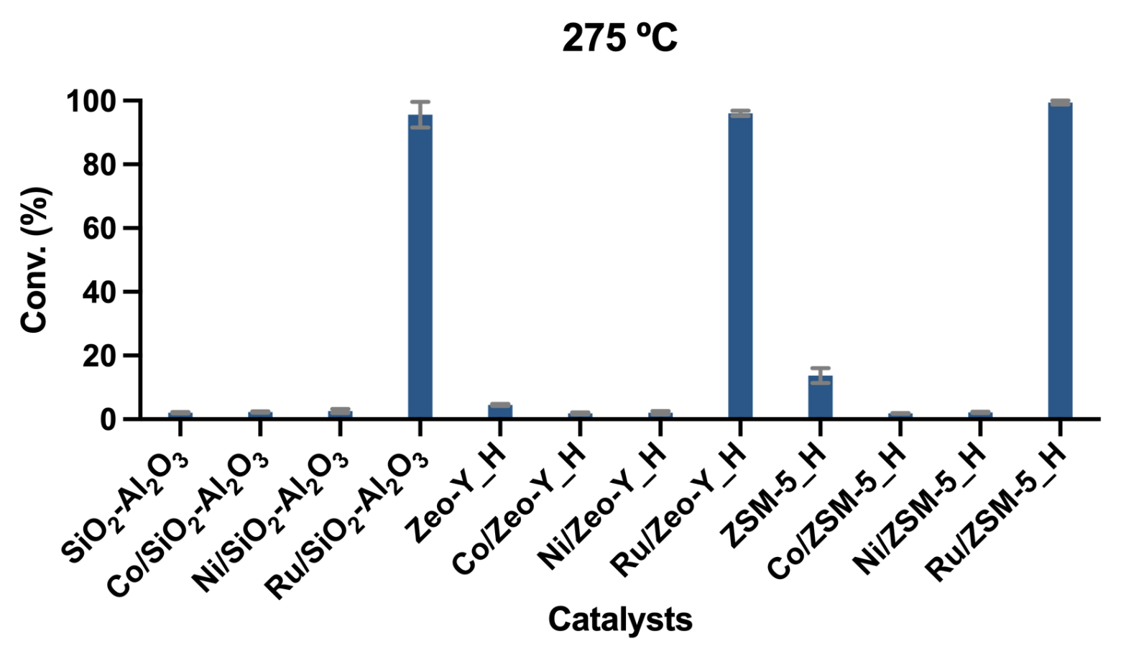
a
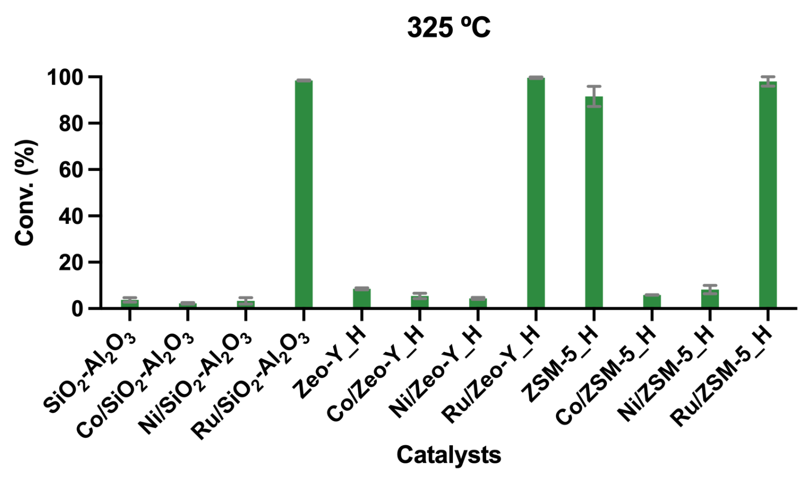
b
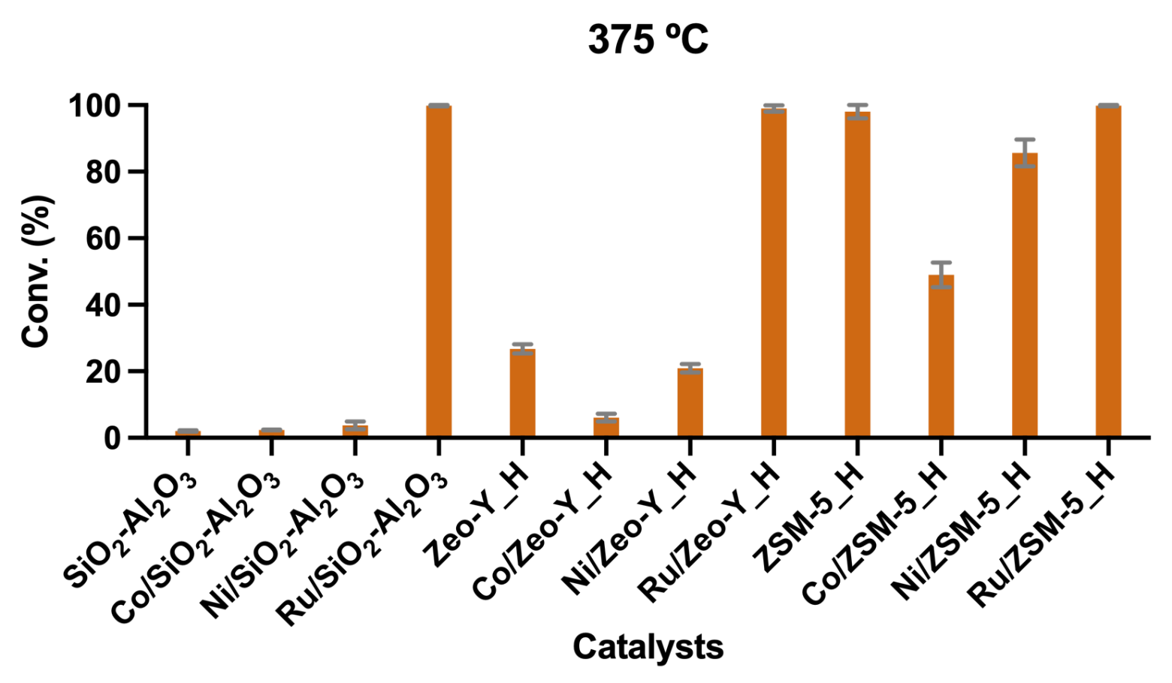
c
Supplementary Figure 19 a nC₁₆ (1.59 g) deconstructions with 45 bar H₂, 2 hrs, in the presence of SiO₂-Al₂O₃, Co/SiO₂-Al₂O₃, Ni/SiO₂-Al₂O₃, Ru/SiO₂-Al₂O₃, Zeo-Y_H, Co/Zeo-Y_H, Ni/Zeo-Y_H, Ru/Zeo-Y_H, ZSM-5_H, Co/ZSM-5_H, Ni/ZSM-5_H and Ru/ZSM-5_H (cat. = 0.1 g, metal loading = 2.5 wt%) at 275 ºC, b 325 ºC and c 375 ºC.
Supplementary Table 1 XPS surface relative atomic concentration of the ZSM-5_H-based catalysts.
Catalyst | Si% (2p) | Al% (2p) | O% (1s) | Co% (2p) | Ni% (2p) | Ru% (3d)
ZSM-5_H | 28.6 | 2.8 | 68.7 | - | - | -
Co/ZSM-5_H | 22.4 | 0.8 | 67.0 | 9.8 | - | -
Ni/ZSM-5_H | 22.3 | 4.8 | 64.6 | - | 8.3 | -
Ru/ZSM-5_H | 26.6 | 3.2 | 67.6 | - | - | 2.6

Supplementary Table 2 XPS surface species and their relative concentrations of the ZSM-5_H-based catalysts.
Catalyst | Specie %
Co/ZSM-5_H | Co(0)% (2p) | CoO% (2p) | Co(OH)₂% (2p)
Co/ZSM-5_H | 1.4 | 2.2 | 96.4
Ni/ZSM-5_H | Ni(0)% (2p) | NiO% (2p) | Ni(O)OH% (2p) | Ni(OH)₂% (2p)
Ni/ZSM-5_H | 1.8 | 0.3 | 60.4 | 37.5
Ru/ZSM-5_H | Ru(0)% (3d) | RuO₂% (3d) | RuO₂·H₂O% (3d) | RuCl₃% (3d)
Ru/ZSM-5_H | 86.0 | 3.9 | 6.7 | 3.4

References
1. Biesinger, M. C. et al. Resolving surface chemical states in XPS analysis of first row transition metals, oxides and hydroxides: Cr, Mn, Fe, Co and Ni. Appl. Surf. Sci. 257, 2717–2730 (2011).
2. Morgan, D. J. Resolving ruthenium: XPS studies of common ruthenium materials. Surf. Interface Anal. 47, 1072–1079 (2015).

