Supplementary
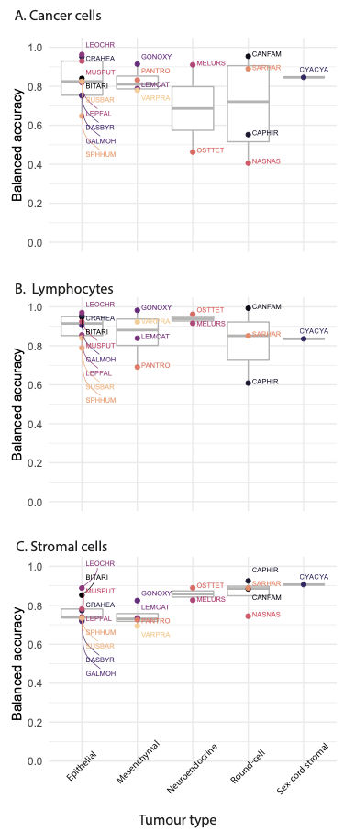
Supplementary Figure 1 Extended AI single-cell prediction comparison across tumour types. Balanced accuracy is computed as the average of sensitivity and specificity for (A) cancer, (B) stromal and (C) lymphocyte cells for all species. Species are grouped according to their tumour type and are labelled with their codes, for more species information, see Table 1.

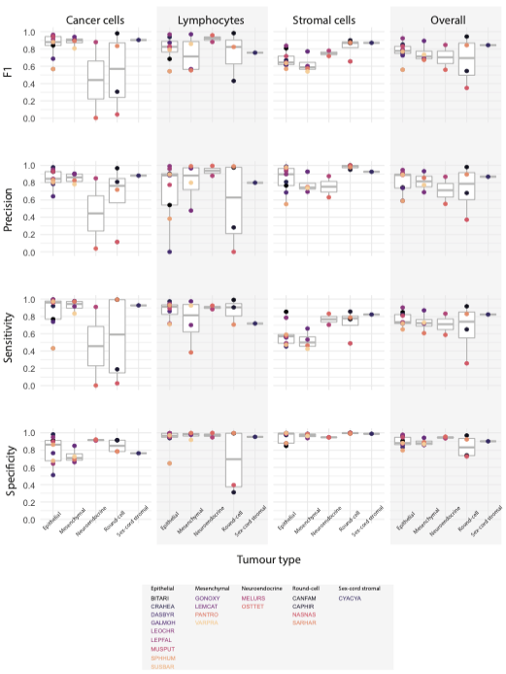
Supplementary Figure 2 Extended AI prediction variability for inter and intra- species tumour microenvironment cells. For each species, four metrics were evaluated including F1, precision, sensitivity and specificity (rows) for the prediction accuracy of cancer, lymphocyte and stromal cells as well as their average shown as ‘overall’ (columns). Species are grouped according to their tumour type and are labelled with their codes, for more species information, see Table 1.

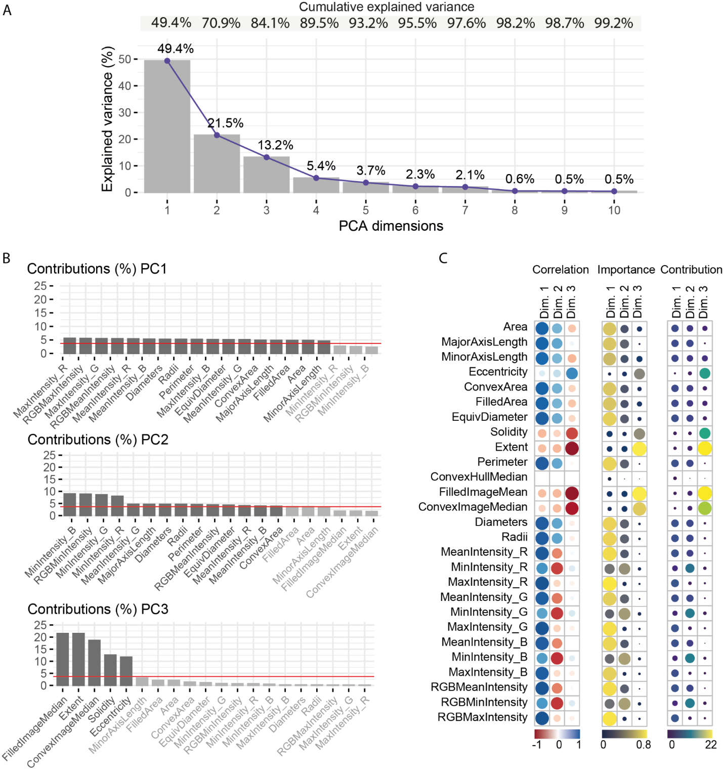
Supplementary Figure 3 Analysis of the morphological space. (A) Dimensions of the principal component analysis (PCA) and their explained variances. (B) The highest 20 contributions to PCA dimensions’ explained variances. Darker bars are features above the mean contribution (red line). (C) From left to right, correlation, importance and contribution of the single-cell morphological features to PCA dimension.

Supplementary Table 1 Summary of sample preparation methods as provided from the Zoological Society of London’s pathological archive.

Case ID | Species code | Pathologists | Method
B01/17 | MUSPUT | IZVG/RVC- DD | Biopsy: removed during surgery and formalin-fixed
B02/18 | GALMOH | IZVG/RVC- DD | Biopsy: removed during surgery and formalin-fixed
B04/17 | LEMCAT | IZVG/RVC- MS | Biopsy: removed during surgery and formalin-fixed
B07-8/04 | PANTRO | ZSL- AP | Biopsy - removed during surgery and formalin-fixed
B09/04 | DASBYR | ZSL- AP | Biopsy - removed during surgery and formalin-fixed
W17M035 | MELURS | IZVG/RVC- MS | Euthanasia: Carcass fresh – PM examination one day after death
W17R187 | OSTTET | IZVG/RVC- DD | Natural death: Carcass fresh - PM on day of death
ZA1360/15 | LEPFAL | IZVG/RVC- MS | Natural death: Carcass slightly autolysed – PM on day of death
ZB017/18 | CYACYA | IZVG/RVC- MS | Euthanasia: Carcass fresh – PM examination one day after death
ZB485/19 | SPHHUM | IZVG/RVC- CS | Euthanasia: No comment on carcass condition - PM carried out 2 days after euthanasia
ZM134/17 | CAPHIR | IZVG/RVC- CS | Carcass fresh – euthanised and PM’d on day of death
ZM138/17 | SUSBAR | IZVG/RVC- MS | Carcass fresh - PM on day of death
ZM203/17 | LEOCHR | IZVG/RVC- MS | Carcass fresh - PM on day of death
ZM633/18 | CRAHEA | IZVG/RVC- DD | Euthanasia: Carcass fresh – PM examination one day after death
ZM748/18 | NASNAS | IZVG/RVC- CS | Euthanasia: Carcass fresh – PM examination one day after death
ZR1145/15 | GONOXY | IZVG/RVC- MS | Euthanasia: Carcass fresh - kept in fridge two days before examination
ZR1148/18 | VARPRA | IZVG/RVC- DD | Euthanasia: Carcass fresh – PM examination one day after death
ZR474/19 | BITARI | IZVG/RVC- CS | Euthanasia: Carcass fresh – PM examination one day after death

Supplementary Table 2 The 27 single-cell features extracted to compute the morphological space.
Feature | Description
Area | Two-dimensional extension of a shape
MajorAxisLength | Longest diameter
MinorAxisLength | Shortest diameter
Eccentricity | Magnitude inversely related to shape curvature
ConvexArea | Area resulting from connecting the external points of the shape
FilledArea | Area of a corresponding image with holes filled in
EquivDiameter | Diameter of a circle with the same area as the region
Solidity | Extent to which the shape fills the convex area
Extent | Ratio of pixels in the region to pixels in the total bounding box
Perimeter | Length of the shape boundary
ConvexHullMean | Smallest convex polygon that can contain the region
FilledImageMean | Average of pixels corresponding to the segmented mask, with all holes filled
ConvexImageMean | Average of pixels corresponding to a segmented mask which specifies the convex hull of the region
Diameters | Cell diameter using major and minor axes
Radii | Cell radius
MeanIntensity_R | Mean pixel intensity in the red channel
MinIntensity_R | Minimum pixel intensity in the red channel
MaxIntensity_R | Maximum pixel intensity in the red channel
MeanIntensity_G | Mean pixel intensity in the green channel
MinIntensity_G | Minimum pixel intensity in the green channel
MaxIntensity_G | Maximum pixel intensity in the green channel
MeanIntensity_B | Mean pixel intensity in the blue channel
MinIntensity_B | Minimum pixel intensity in the blue channel
MaxIntensity_B | Maximum pixel intensity in the blue channel
RGBMeanIntensity | Mean pixel intensity in the composed image
RGBMinIntensity | Minimum pixel intensity in the composed image
RGBMaxIntensity | Maximum pixel intensity in the composed image

Supplementary table 3 Morphological volumes overlap of human cells on non-human cells’ morphological space calculated by the three methods. The highest overlap values for non-human lymphocytes and tumour cells are bold-faced.

Morphological volume of | Covered by the volume of | % Overlap (product) | % Overlap (mean) | % Overlap (geom. mean)
Non-human lymphocytes | Human lymphocytes | 63.47 | 84.55 | 81.25
Non-human lymphocytes | Human tumour cells | 40.41 | 67.6 | 59.84
Non-human tumour cells | Human lymphocytes | 16.56 | 54.82 | 50.24
Non-human tumour cells | Human tumour cells | 67.97 | 86.49 | 86.14

