Supplementary Information
Plastid-localized amino acid metabolism coordinates rice ammonium tolerance and nitrogen use efficiency
Yuanming Xie^{1,2,3#}, Yuanda Lv^{4#}, Letian Jia¹, Lulu Zheng¹, Yonghui Li¹, Ming Zhu¹, Mengjun Tian⁵, Ming Wang⁵, Weicong Qi⁴, Long Luo¹, Hugues De Gernier^{2,3}, Pierre-Mathieu Pelissier^{2,3}, Hans Motte^{2,3}, Shaoyan Lin¹, Le Luo¹, Guohua Xu¹, Tom Beeckman^{2,3$}, Wei Xuan^{1$}

¹State Key Laboratory of Crop Genetics and Germplasm Enhancement and MOA Key Laboratory of Plant Nutrition and Fertilization in Lower-Middle Reaches of the Yangtze River, Nanjing Agricultural University, Nanjing 210095, China
²Department of Plant Biotechnology and Bioinformatics, Ghent University, Technologiepark 71, Ghent B-9052, Belgium
³VIB-UGent Center for Plant Systems Biology, Technologiepark 71, Ghent B-9052, Belgium
⁴Excellence and Innovation Center, Jiangsu Academy of Agricultural Sciences, Nanjing 210014, China
⁵Department of Plant Pathology, Nanjing Agricultural University, Nanjing 210095, China
#Equal contribution to this work
$Corresponding authors: wexua@njau.edu.cn, Tom.Beeckman@psb.vib-ugent.be

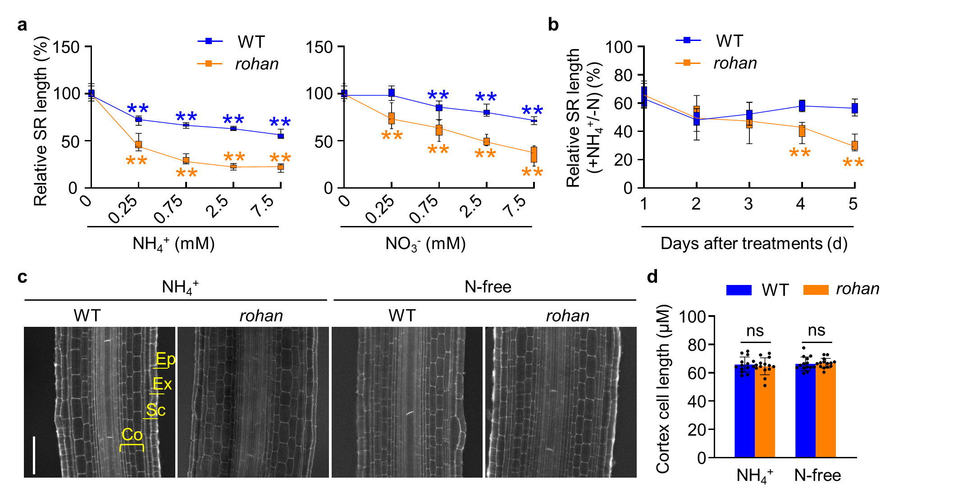
Extended Data Fig. 1 The seminal roots growth of rohan is hypersensitive to external NH₄⁺.
a, Relative seminal roots (SR) of the wild-type (Orzya sativa cv. Wuyungeng7) and rohan mutant seedlings treated with varying concentrations of NH₄⁺ and NO₃⁻ for 6 days. Data represent the means ± s.d. (n ≥ 10 seedlings), and the asterisks indicate significant differences relative to the N-free (student’s t-test, *P<0.05 and **P < 0.01). b, Relative SR length of the wild-type and rohan plants treated N-fee (-N) or with 2.5 mM NH₄⁺ (+N) over one day to five days. Data represent the means ± s.d. (n ≥ 10 seedlings). c and d, Confocal images c and cortex cell length d of the wild-type and rohan root maturation zone under treatments of N-free and NH₄⁺ treatments for 4 days. Ep, epidermis. Ex, exodermis. Sc, Sclerenchyma. Co, cortex. Scale bars, 100 μm. Data represent the means ± s.d. (n ≥ 14 cell files from at least 10 seedlings), and the asterisks indicate significant differences relative to the N-free control (student’s t-test, *P<0.05 and **P < 0.01).

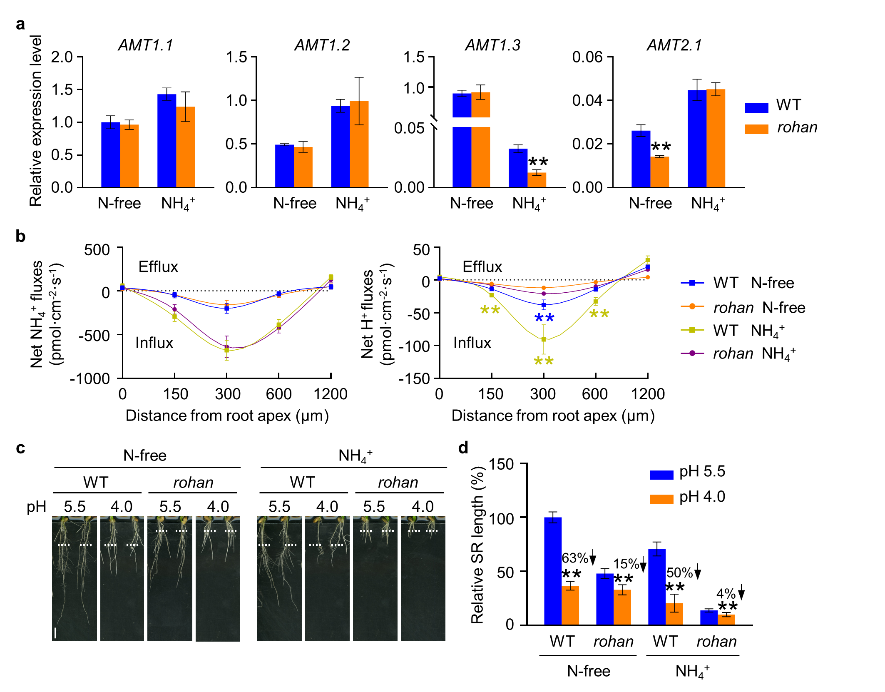
Extended Data Fig. 2 ROHAN-mediated seminal root elongation is independent of NH₄⁺ uptake and low pH.
a, Relative expression level of the ammonium transporters AMT1.1, AMT1.2, AMT1.3 and AMT2.1 in the root tips of the wild-type (Orzya sativa cv. Wuyungeng7) and rohan mutant seedlings treated with or without 2.5 mM NH₄⁺ for 4 days. Data represent the means ± s.e. of three biological replicates (student’s t-test, *P<0.05 and **P < 0.01). b, Quantification of the net NH₄⁺ and proton fluxes in the root tip of the wild-type and rohan seedlings treated with or without 2.5 mM NH₄⁺. Data represent the means ± s.d. of six individuals (student’s t-test, *P<0.05 and **P < 0.01). c and d, Root phenotype c and relative seminal roots (SR) length d of the wild-type and rohan seedlings treated with or without 2.5 mM NH₄⁺, under the conditions of pH 5.5 and pH 4.0. The white dotted line indicates the position of the root tips when the seedlings were transferred to N-free or NH₄⁺ medium with different pHs. Scale bar, 1 cm. Data represent the means ± s.d. (n ≥ 10 seedlings) (student’s t-test, **P < 0.01 and ***P < 0.001).

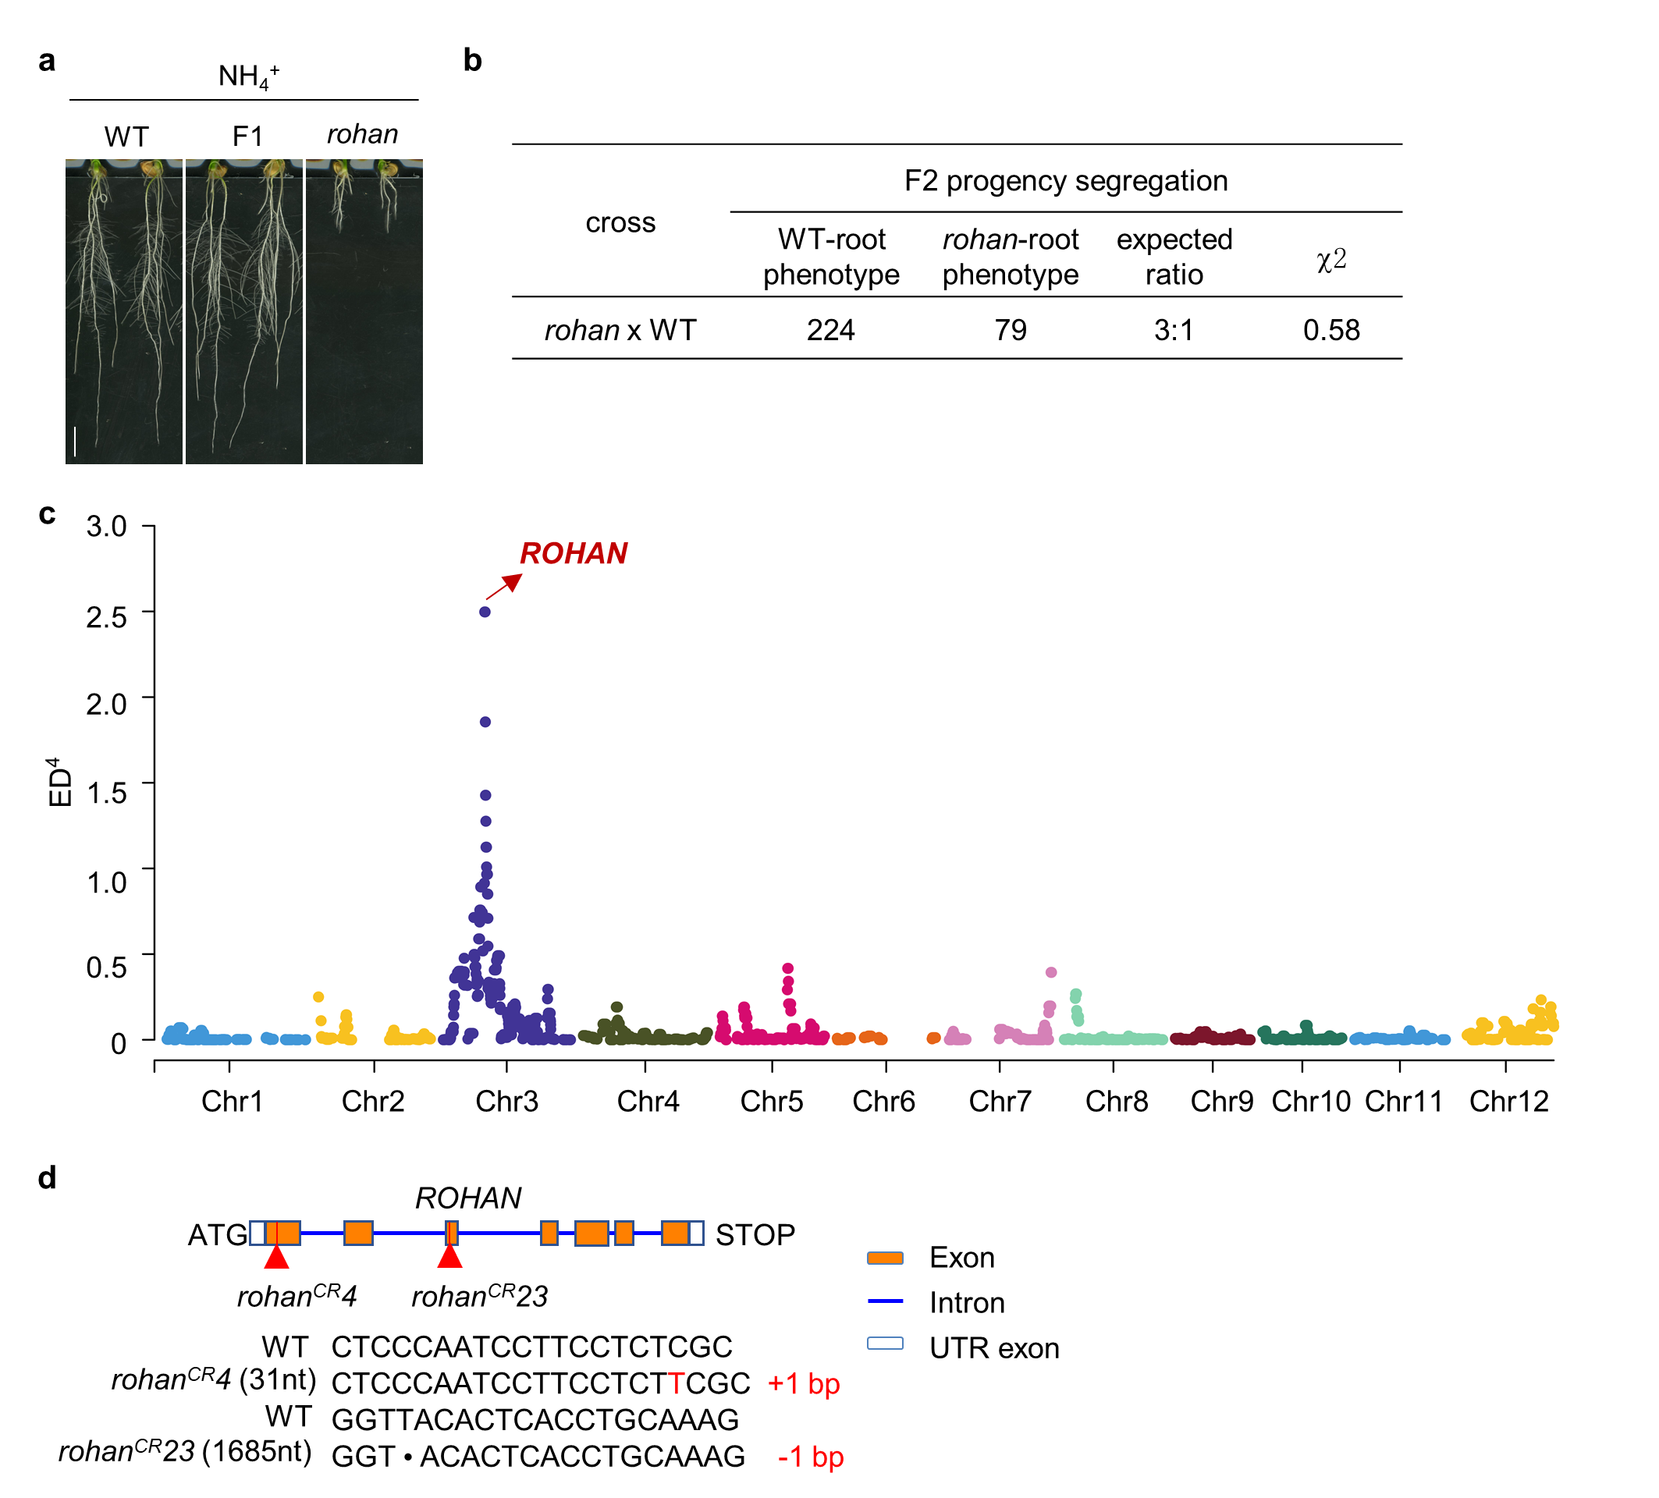
Extended Data Fig. 3 Map-based cloning of ROHAN gene.
a, Root phenotypes of the the wild-type (Orzya sativa cv. Wuyungeng7), the rohan mutant, and the F₁ progeny of the rohan x wild-type backcross treated with 2.5 mM NH₄⁺ for 6 days. Scale bar, 1 cm. b, Segregation statistic of the wild-type and rohan root phenotypes in the backcross F₂ progeny. c, Euclidean distance association analysis of the ROHAN candidate interval in the rice genome. ED⁴ was calculated based on the SNP and InDel frequency. The red arrow indicates the chromosomal location of the ROHAN gene. ED, Euclidean Distance. d, Sketch map of mutation sites in the CRISPR knockout lines of ROHAN. Red triangles indicate the mutation target sites.

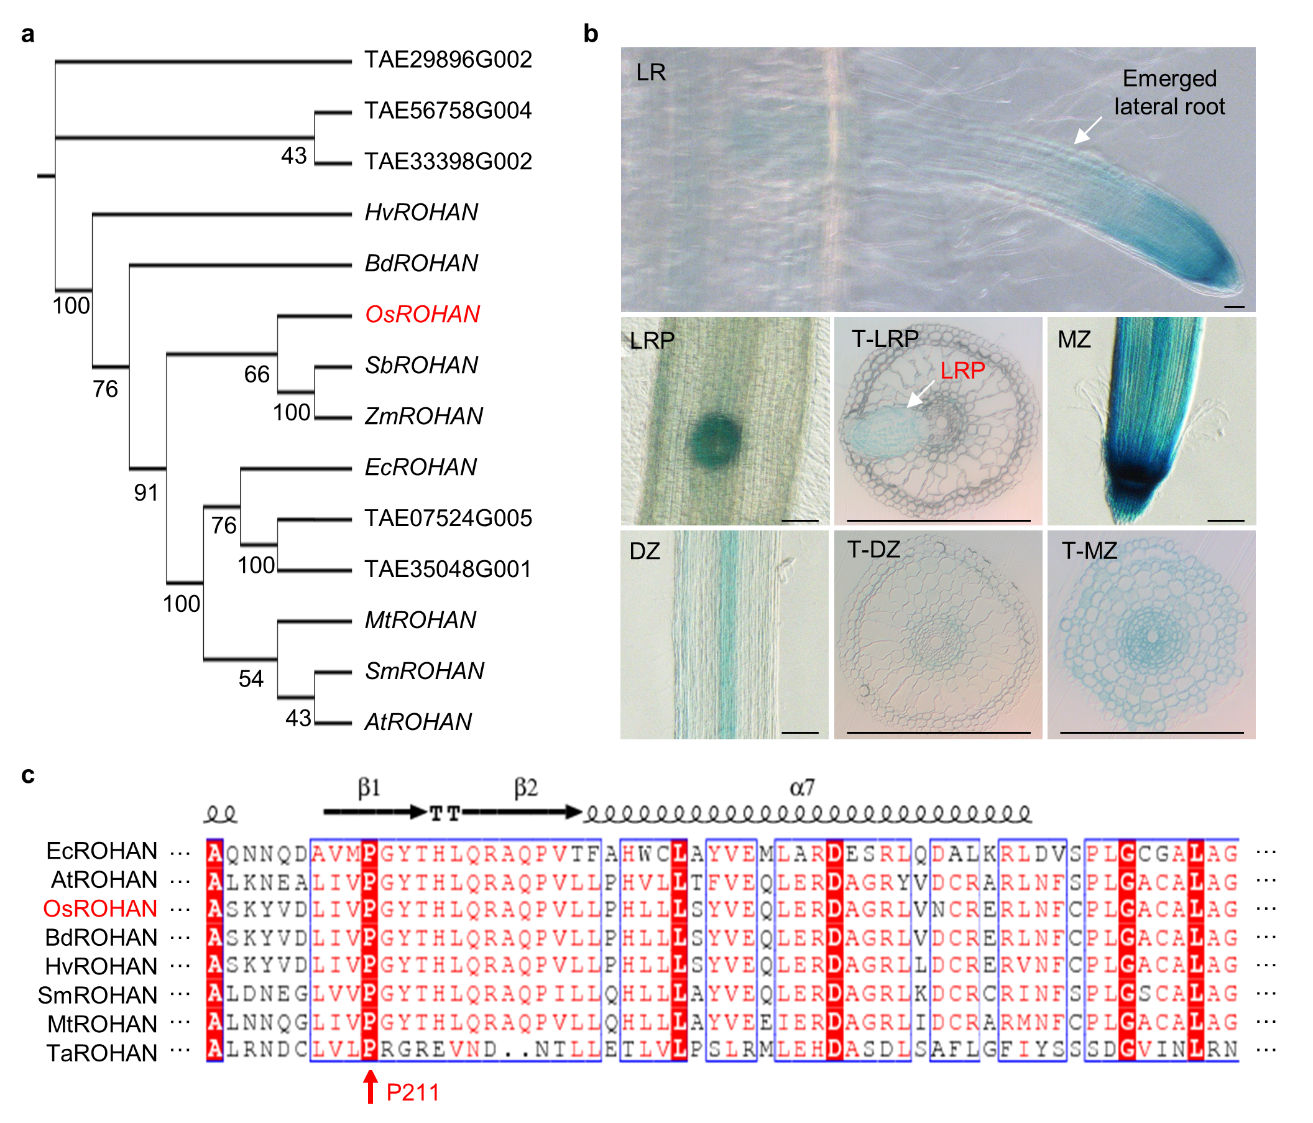
Extended Data Fig. 4 Phylogenetic and protein sequence analysis of ROHAN.
a, Phylogenetic tree of ROHAN established with MEGA 7.0 software by Neighbor-jointing method with 1000 bootstrapping trials. The numbers on the branch indicate bootstrapping values. Escherichia coli (Ec), Triticum aestivum (TAE), Oryza sativa (Os), Medicago truncatula (Mt), Selaginella moellendorffii (Sm), Arabidopsis thaliana (At), Sorghum bicolor (Sb), Zea mays (Zm), Hordeum vulgare (HV), Brachypodium distachyon (Bd). b, Expression pattern of proROHAN:GUS in the root tissues of wild-type (Orzya sativa cv. Wuyungeng7) seedlings. LR, lateral root; LRP, lateral root primordium; DZ, differentiation zone; MZ, meristem zone. Scale bars, 100 μm. T-LRP, transverse section of lateral root primordium. T-DZ, transverse section of root differentiation zone. T-MZ, transverse section of root meristem zone. Scale bars, 100 μm. c, Alignment of ROHAN amino acid sequence in different plant species using ESPript 3 software. Red arrowhead indicates the location of mutation site. Accession numbers for aligned sequences: EcROHAN, WP_109536061.1; AtROHAN, NP_196653.1; OsROHAN, XP_015632553.1; BdROHAN, XP_010228716.1; HvROHAN, BAJ96216.1; SmROHAN, EFJ24721.1; MtROHAN, XP_003602904.2; TaeROHAN, XP_044394196.1.

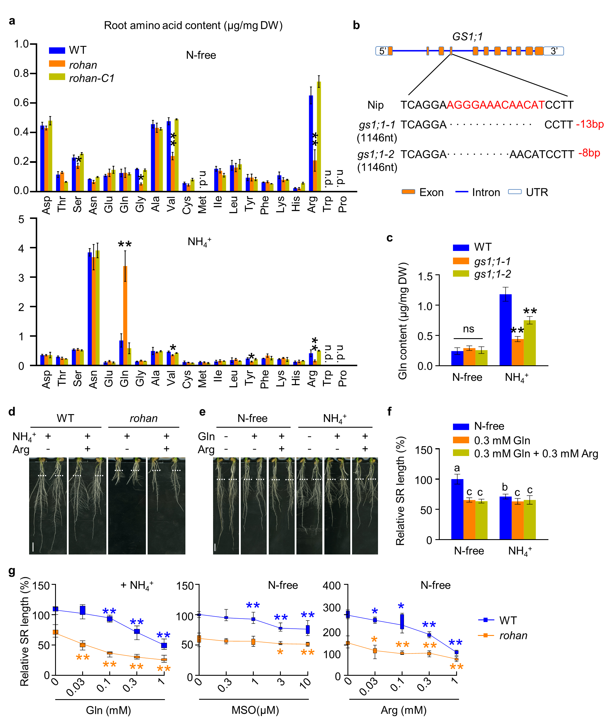
Extended Data Fig. 5 ROHAN acts on the conversion of NH₄⁺/Gln to Arg.
a, Free amino acid content in the roots of the indicated seedlings lines treated with or without 2.5 mM NH₄⁺ for 6 days. The wild-type is Orzya sativa cv. Wuyungeng7 while rohan-C1 is a complementary line of the rohan mutant. Data represent the means ± s.d. (n=4 biological repeats), and the asterisks indicate significant differences relative to the wild-type (student’s t-test, *P<0.05 and **P < 0.01). b, Sketch map of mutation sites in the CRISPR knockout lines of Glutamine Synthestase (GS1;1). c, Quantification of Gln content in the root tips of Nipponbare and two gs1;1 mutant lines treated with or without 2.5 mM NH₄⁺ for 6 days. Data represent the means ± s.d. (n = 4 biological repeats), and the asterisks indicate significant differences relative to Nipponbare (student’s t-test, ***P < 0.001). d, Root phenotype of the wild-type and rohan mutant seedlings treated with or without 0.3 mM Arg in the presence of NH₄⁺ for 6 days (related to Figure 3d). The white dotted line indicates the position of the root tip when the seedlings were transferred to medium supplied with or without Arg. Scale bars, 1 cm. e and f, Root phenotype e and relative seminal roots (SR) length f of the wild-type seedlings grown under indicated treatments for 6 days. The white dotted line indicates the position of the root tip when the seedlings were transferred to medium supplied with indicated chemicals. Scale bars, 1 cm. Data represent the means ± s.d. (n ≥ 10 seedlings), and the letters denote significant differences (P < 0.05, by one-way ANOVA followed by Tukey’s test). g, Relative seminal roots (SR) length of wild-type and rohan seedlings treated with varying concentrations of Gln, MSO, and Arg, under the indicated N condition for 6 days. Data represent the means ± s.d. (n ≥ 10 seedlings), and the asterisks indicate significant differences relative to the chemical-free treatment (student’s t-test, *P<0.05 and **P < 0.01).
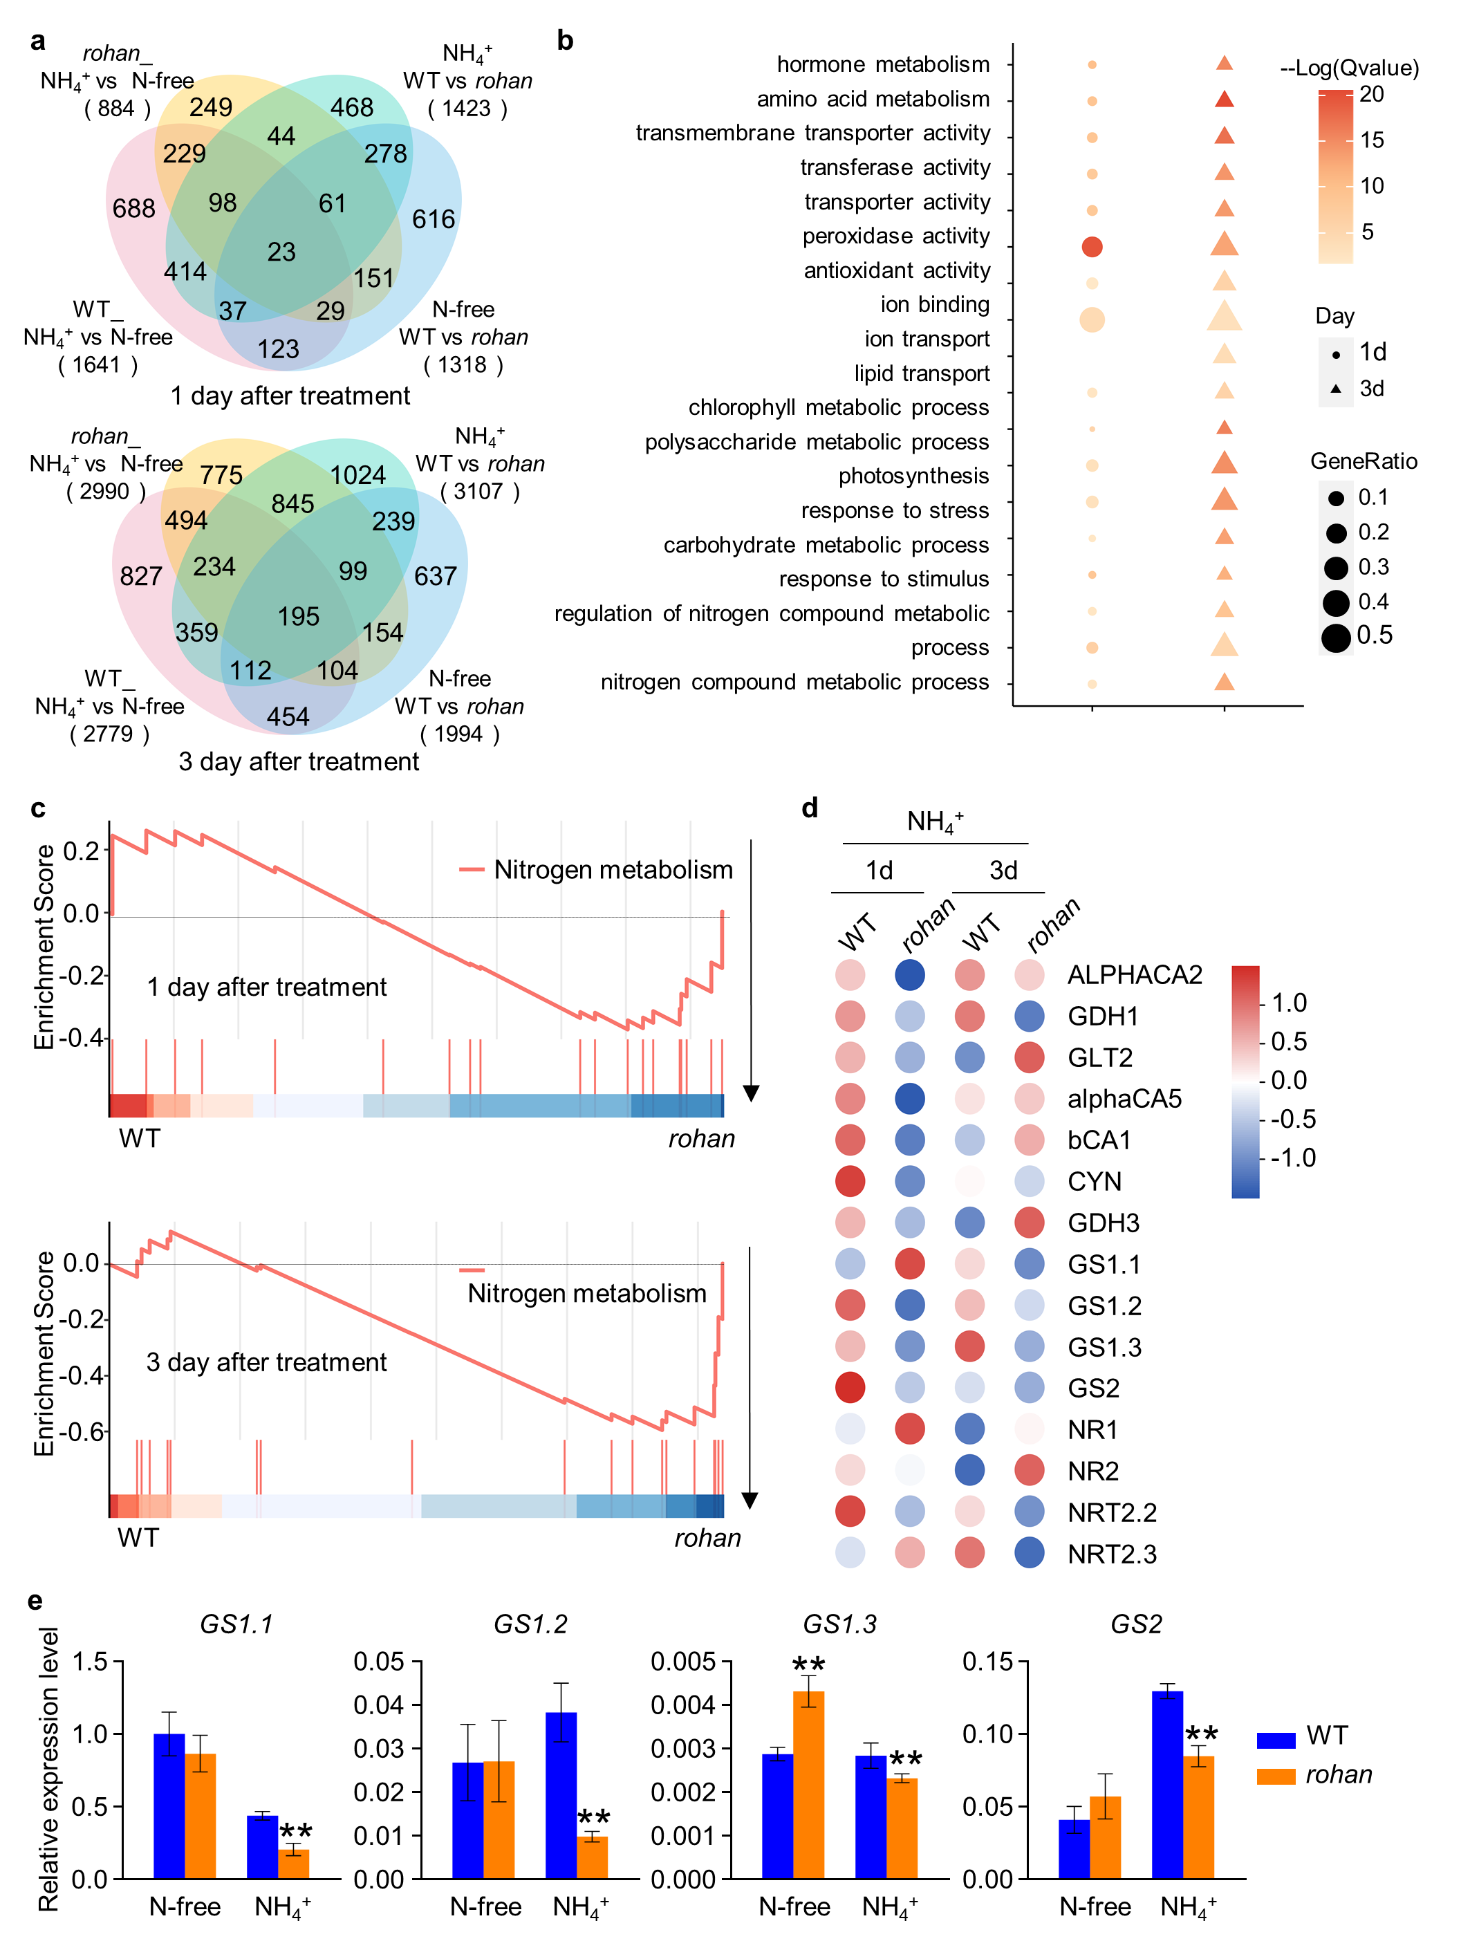
Extended Data Fig. 6 ROHAN regulates the nitrogen metabolism pathway at the transcriptional level.
a, Venn diagram showing the number of differentially expressed genes affected by 2.5 mM NH₄⁺ treatment in the root tips of the wild-type (Orzya sativa cv. Wuyungeng7) and the rohan mutant. b, Gene set enrichment analysis of differentially expressed genes based on GO and KEGG databases between the wild-type and rohan. c, GSEA results of nitrogen metabolism related gene sets in rohan comparing with the wild-type (Orzya sativa cv. Wuyungeng 7) under 1 d and 3 d high NH₄⁺ treatment, Permutation test, two-side. d, Heatmap of Z-score values from expression abundance of genes associated with nitrogen metabolism. Each treatment is a column, while each row is a gene. The colour ranged from red for positive Z-score values to blue for negative values. e, Relative expression level of indicated genes in the root tips of the wild-type and rohan seedlings treated with or without 2.5 mM NH₄⁺ for 3 days. Data represent the means ± s.e. of three biological repeats, and the asterisks indicate significant differences (student’s t-test, **P < 0.01).

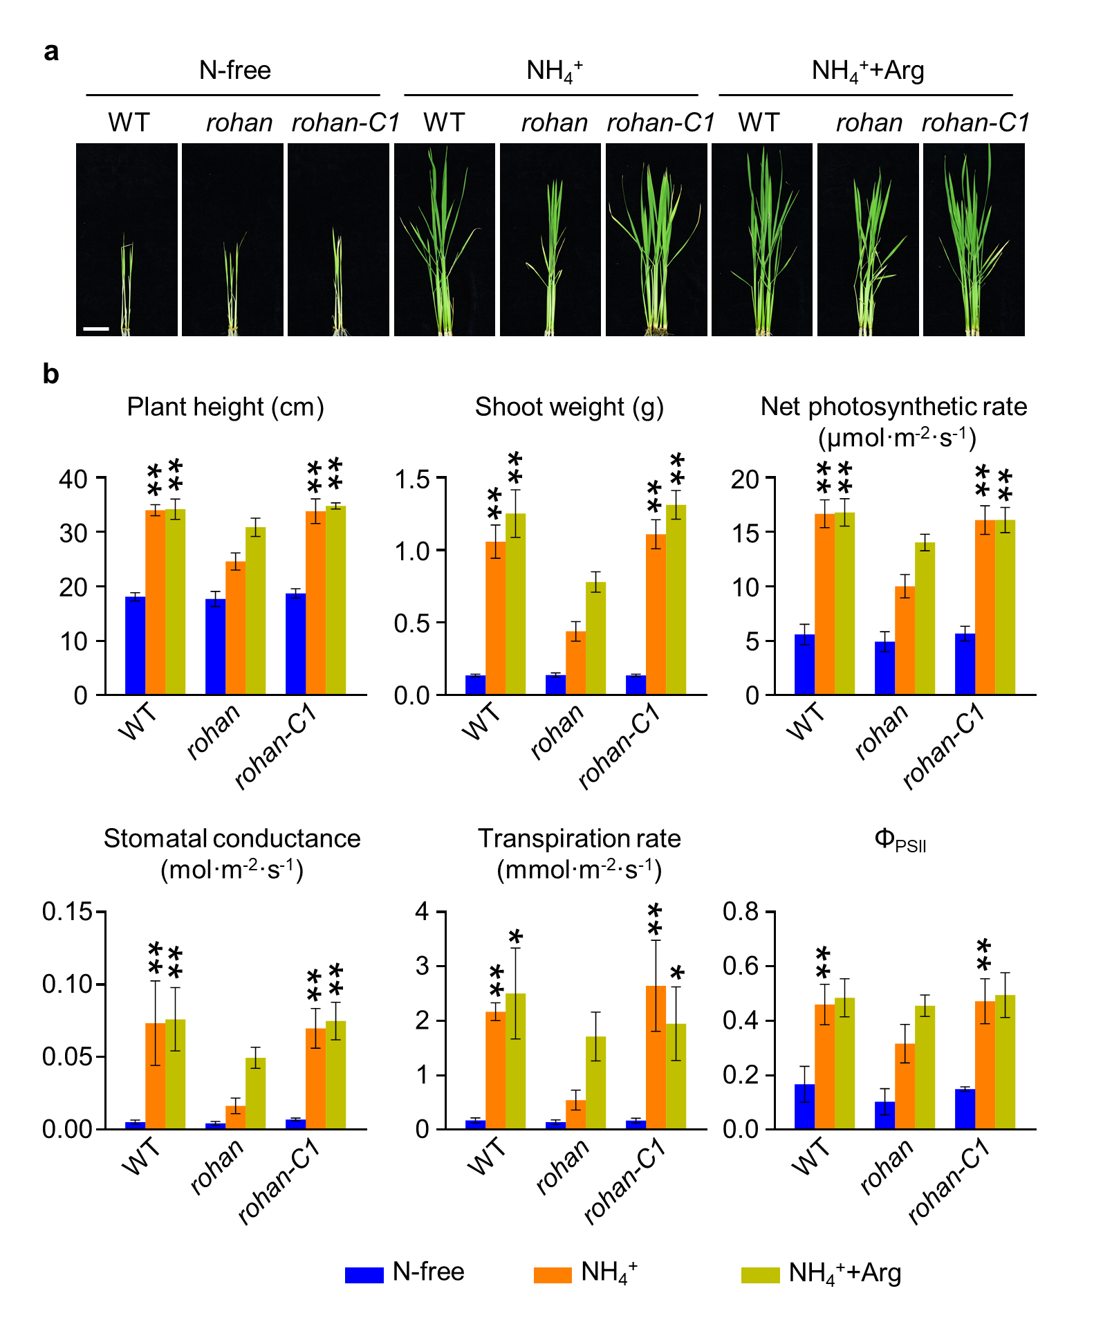
Extended Data Fig. 7 ROHAN regulates photosynthesis and shoot growth.
a, Shoot phenotype of 21-d-old seedlings of the indicated lines grown under various treatments. The wild-type is Orzya sativa cv. Wuyungeng7 while rohan-C1 is a complementary line of the rohan mutant. NH₄⁺ was used at 2.5 mM; Gln was used at 0.3 mM; Arg was used at 0.3 mM. Scale bar, 5 cm. b, Quantification of the plant height, shoot weight, net photosynthetic rate, stomatal conductance, transpiration rate, photochemical efficiency of PSII (Φ_{PSII}) in the leaves of indicated seedlings shown in a. Data represent the means ± s.d. (n ≥ 10 seedlings), and the asterisks indicate significant differences relative to the rohan values (student’s t-test, *P<0.05 and **P < 0.01).

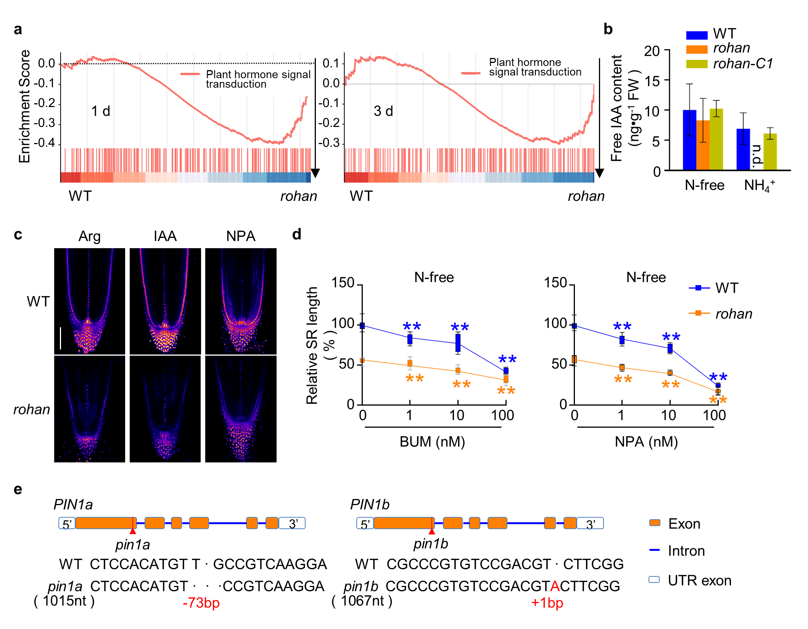
Extended Data Fig. 8 ROHAN response to NH₄⁺ is mediated by auxin metabolism.
a, GSEA results of plant hormone signal transduction related gene sets in rohan comparing with the wild-type (Orzya sativa cv. Wuyungeng7) under 1d and 3d high NH₄⁺ treatment, Permutation test, two-side. b, Quantification of the free IAA content in the roots of wild-type, rohan and rohan-C1(complementary line of the rohan mutant) seedlings treated with or without 2.5 mM NH₄⁺ for 6 days. Data represent the means ± s.d. of 4 biological replicates. c, Expression pattern of DR5rev:3xVENUS-N7 in the root tips of wild-type and rohan mutant seedlings grown under indicated treatment for 48 h (related to Figure 4d). Scale bar, 100 μm. d, Relative SR length of seminal roots (SR) length of wild-type and rohan seedlings treated with NPA or BUM, under N-free condition for 6 days (related to Figure 4g). Data represent the means ± s.d. (n ≥ 10 seedlings), and the asterisks indicate significant differences relative to 0 nM BUM or NPA treatments (student’s t-test, *P<0.05 and **P < 0.01). e, Sketch map of mutation of CRISPR knockout lines of the auxin transporters PIN1a and PIN1b. Red triangles indicate the mutation target sites.

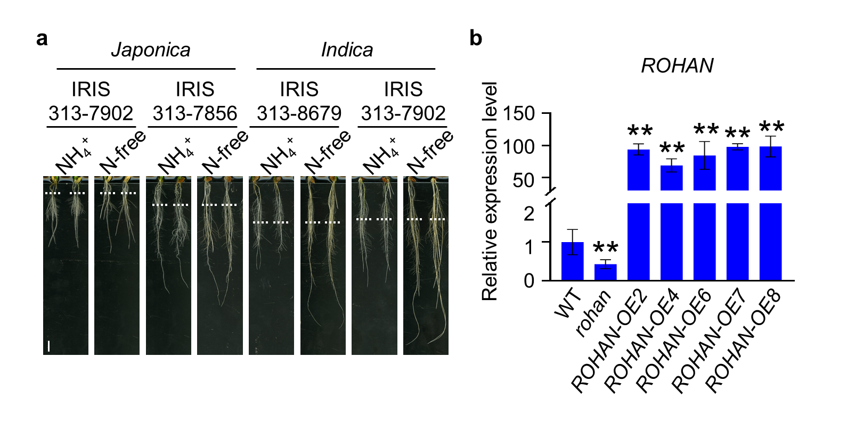
Extended Data Fig. 9 Root phenotype of rice cultivars under high NH₄⁺ treatment and ROHAN expression in its overexpression and mutant lines.
a, Root phenotype of two Japonica and two Indica ssb. cultivars treated with or without 2.5 mM NH₄⁺ for 6 days. The white dotted line indicates the position of the root tip when the seedlings were transferred to media supplied with or without NH₄⁺. Scale bars, 1 cm. b, Relative expression level of ROHAN in roots of the wild-type (Orzya sativa cv. Wuyungeng7), rohan and five transgenic ROHAN overexpression lines. Data represent the means ± s.e. of three biological repeats, and the asterisks indicate significant differences (student’s t-test, **P < 0.01).

Supplementary Table S1. The primer sequences used in this study.
Primers | Sequence (5'-3')
For RT-PCR
Actin-F | TTATGGTTGGGATGGGACA
Actin-R | AGCACGGCTTGAATAGCG
UBQ10-F | TGGTCAGTAATCAGCCAGTTTGG
UBQ10-R | GCACCACAAATACTTGACGAACAG
ROHAN-F | AGCCTGTTTTGCTTCCACAT
ROHAN-R | CAACCGTTCCCTGCAGTT
GS1.1-F | CAAGTCTTTTGGGCGTGATATTGTTGAC
GS1.1-R | CTCAAGAATGTAGCGAG
GS1.2-F | GGTTGGAGGATCGGGCATAG
GS1.2-R | TCACCTTGTGGCGTGTAGCA
GS1.3-F | TAAATCGTACGGGCGCGACATCGTTGAT
GS1.3-R | GACATGATCCCCTGCGGAGACGCCAA
GS2-F | AAAGGCGTTCGGCCGCGACATCGTGGAC
GS2-R | CACTTGGTCAGCAGCGGCGATGCCAAC
AMT1.1-F | ACCAATCCAGAACGAACGAC
AMT1.1-R | AGCCCAGCAAAAGTGAAAGA
AMT1.2-F | GAGATGGGAGGCCATGTCTA
AMT1.2-R | GTCAAATCCCCTGTTCCAAA
AMT1.3-F | CTTCATCGGGAAGCAGTTCT
AMT1.3-R | TGAGGAAGGCGGAGTAGATG
AMT2.1-F | GCTACGTCATCCACCTCTCC
AMT2.1-R | CAGGATGTTGTTCGGTGAGA
For transient transactivation assay and subcellular localization
ROHAN_Pro_attb4F | GGGGACAACTTTGTATAGAAAAGTTGCGCCAGCCTACGACGCCACGAA
ROHAN _Pro_attb1R | GGGGACTGCTTTTTTGTACAAACTTGCAGTATCGTCGCCGAGGGTG
ROHAN _gDNA _attb1F | GGGGACAAGTTTGTACAAAAAAGCAGGCTATATGGCCGCCGCCACCTCCCA
ROHAN _gDNA_s_attb2R | GGGGACCACTTTGTACAAGAAAGCTGGGTCTTATGAACTAATGCCAAGCT
ROHAN_gDNA_nos_attb2R | GGGGACCACTTTGTACAAGAAAGCTGGGTTTGAACTAATGCCAAGCTGAG
ROHAN _gDNA_attb2F | GGGGACAGCTTTCTTGTACAAAGTGGATATGGCCGCCGCCACCTCCCA
ROHAN _gDNA_s_attb3R | GGGGACAACTTTGTATAATAAAGTTGGTTATGAACTAATGCCAAGCTGAGTG
ROHAN^{K470R}-F1 | ATGGCCGCCGCCACCTCCCAAT
ROHAN^{K470R}-R1 | GATCTCAGGTCGTCTAGTCCAAGTTCGGCG
ROHAN^{K470R}-F2 | CGCCGAACTTGGACTAGACGACCTGAGATC
ROHAN^{K470R}-R2 | TGAACTAATGCCAAGCTGAGTGCGCC
ROHAN-spacer1-F | GCCGCTCCCAATCCTTCCTCTCGC
ROHAN-spacer1-R | AAACGCGAGAGGAAGGATTGGGAG
ROHAN-spacer2-F | GTTGCTTTGCAGGTGAGTGTAACC
ROHAN-spacer2-R | AAACGGTTACACTCACCTGCAAAG
GS1;1-spacer-F | GGCATCCAGCACCGGCCAGGCCCC
GS1;1-spacer-R | AAACGGGGCCTGGCCGGTGCTGGA
ARF2-spacer1-F | GTTGCTCGAGGTGGCCCTGCGGC
ARF2-spacer1-R | AAACGCCGCAGGGCCACCTCGAG
ARF2-spacer2-F | GTTGGGCATCGACCTCAACACCG
ARF2-spacer2-R | AAACCGGTGTTGAGGTCGATGCC
PIN1a-spacer-F | GCCGTCGCCCGTGTCCGACGTCTTCGG
PIN1a-spacer-R | AAACCCGAAGACGTCGGACACGGGCGA
PIN1b-spacer-F | GCCGTCGCCCGTGTCCGACGTCTTCGG
PIN1b-spacer-R | AAACCCGAAGACGTCGGACACGGGCGA

