Table 1 Primes sequences used for real time RT-PCR assays.
Gene | Forward primer | Reverse primer
actin | 5'-TGAAAATCAAGGTGGTGGCG-3' | 5'-TCCGGTGAACAATGGAAGGA-3'
FBA | 5'-ATGAACCAAGCACCAAACCC-3' | 5'-TGTACTTTCCGAGCTGAGCA-3'
FBPase | 5'-TCGTCAGCCATTTCTTCCCT-3' | 5'-CACCCACATCAACTCCTCCT-3'
GAPDH | 5'-GACTACTGTGCACGCAACAA-3' | 5'-AGCAGCACCAGTTGAACTTG-3'
TK | 5'-CCCAATGTTCTGATGCTCCG-3' | 5'-CCACCCTTTGCTGTTCCTTC-3'

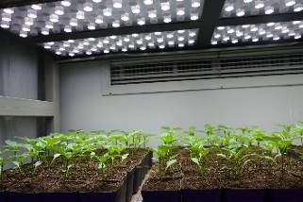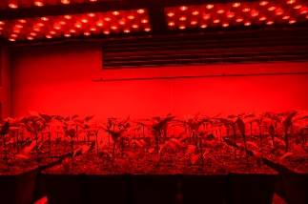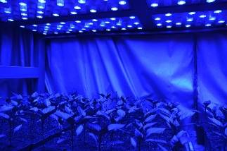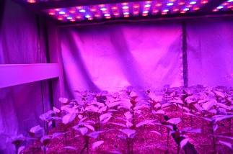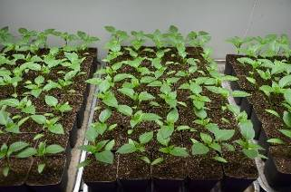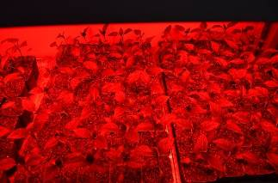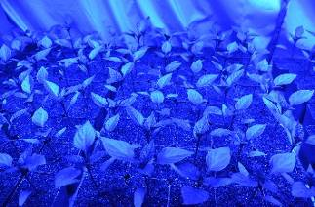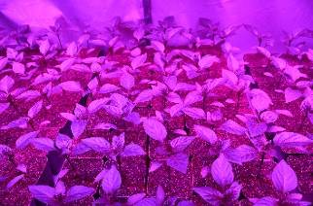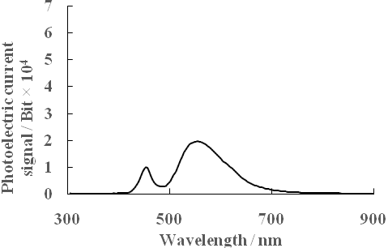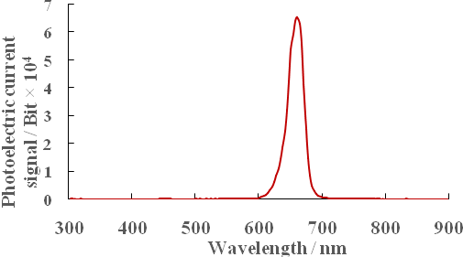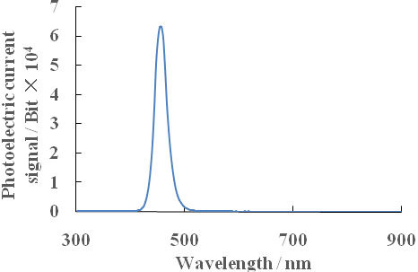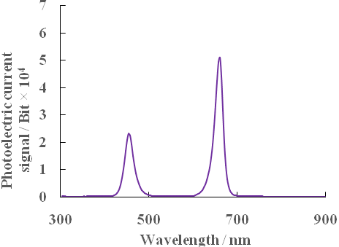
W R B RB
(a)

(b)

Fig. 1. (a) Characteristics of the respective LED irradiance spectra in the different treatments (upper figures); (b) General view and spectral distribution of light quality treatments. W, white light; R, monochromatic R light; B, monochromatic B light; RB, mixed R and B light of 3:1 (lower photographs).

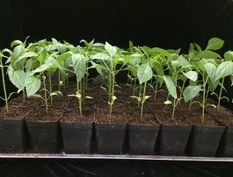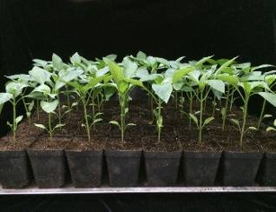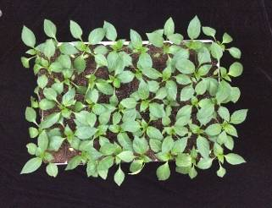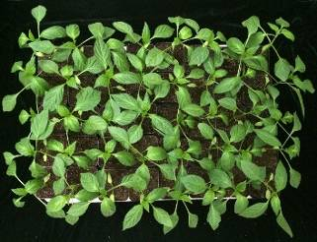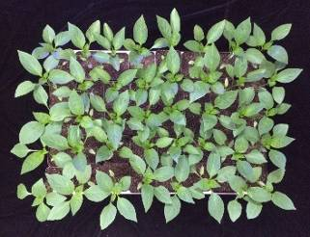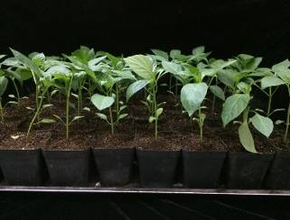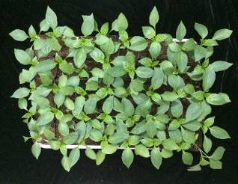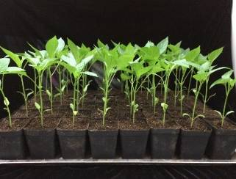
W R B RB

Fig. 2. Side (upper photographs) and top (lower photographs) views of sweet pepper seedlings at 28 DAT under different light treatments. W, white light; R, monochromatic R light; B, monochromatic B light; RB, mixed R and B light of 3:1.

