Supplementary Fig. S2. UPLC-MS analysis results of A. artemisiifolia and A. trifida
1. Standard Curve
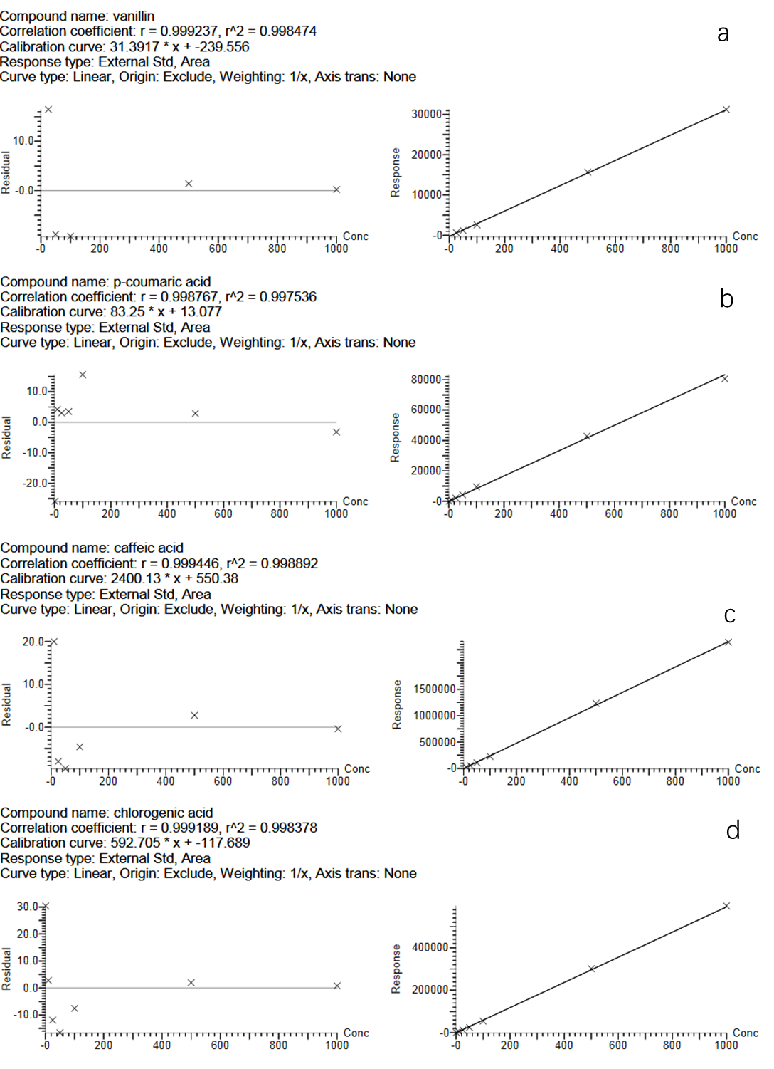
Fig. A.1 Standard curves of four autotoxins prepared by UPLC-MS. Figure a is the standard curve of vanillin standard, Figure b is the standard curve of p-coumaric acid standard, Figure c is the standard curve of caffeic acid standard, Figure d is the standard curve of chlorogenic acid standard. The figure includes the linear range, calibration curves, correlation coefficients and limit of detection of the tested substance.

2. UPLC-MS analysis and detection results of compositions and contents of autotoxins of A. artemisiifolia and A. trifida
Fig. A.2 UPLC-MS chromatograms of four autotoxins in A. artemisiifolia. The figure shows the four autotoxins vanillin (a), p-coumaric acid (b), caffeic acid (c), and chlorogenic acid (d) identified from A. artemisiifolia plants, and the gray area shows the detected autotoxins.
Note: 1. Vanillin (1.86 min);2. P-coumaric acid (1.88 min); 3. Caffeic acid (1.13 min); 4. Chlorogenic acid (0.78 min)

Table A.1 UPLC-MS parameters of four autotoxins in A. artemisiifolia

Sample Text | Name | Trace | RT | Area | Response | Primar… | Conc.
3 | Vanillin | 150.813>135.883 | 1.860 | 701.760 | 701.760 | bb | 30.0
3 | P-coumaric acid | 162.813>119.321 | 1.880 | 871.088 | 871.088 | bb | 10.3
3 | Caffeic acid | 179.096>135.041 | 1.130 | 86057.234 | 86057.234 | bb | 35.6
3 | Chlorogenic acid | 352.949>190.946 | 0.780 | 779922.000 | 779922.000 | db | 1316.1

Fig. A.3 UPLC-MS chromatograms of four autotoxins in A. trifida. The figure shows the four autotoxins vanillin (e), p-coumaric acid (f), caffeic acid (g), and chlorogenic acid (h) identified from A. trifida plants, and the gray area shows the detected autotoxins.
Note: 1. Vanillin (1.86 min);2. P-coumaric acid (1.88 min); 3. Caffeic acid (1.13 min); 4. Chlorogenic acid (0.78 min)

Table A.2 UPLC-MS parameters of four autotoxins in in A. trifida
Sample Text | Name | Trace | RT | Area | Response | Primar… | Conc.
6 | Vanillin | 150.813>135.883 | 1.880 | 671.414 | 671.414 | bb | 29.0
6 | P-coumaric acid | 162.813>119.321 | 1.880 | 2203.958 | 2203.958 | bb | 26.3
6 | Caffeic acid | 179.096>135.041 | 1.130 | 24410.789 | 24410.789 | bb | 9.9
6 | Chlorogenic acid | 352.949>190.946 | 0.780 | 222939.516 | 222939.516 | db | 376.3

