Supplementary Material

Table S1. Distribution of primary instruments in the musician sample.
Primary Instrument(s) | Frequency
Clarinet | 1
Piano | 6
Drums | 1
Guitar/Bass | 4
Violin | 2
Cello | 1
Saxophone | 4
Piano/Flute/Alto Saxophone* | 1
* This category is for one participant who listed multiple primary instruments.

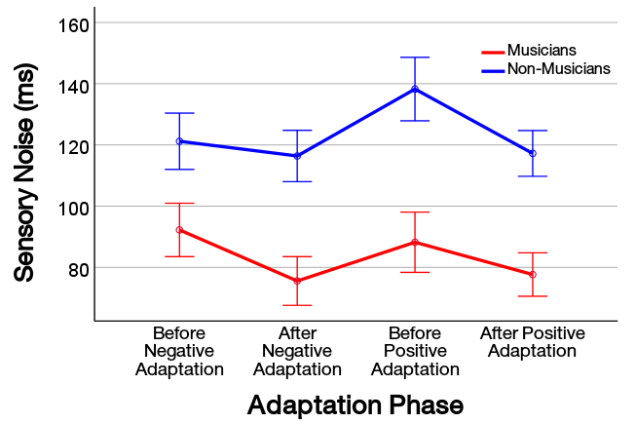
Figure S2. Sensory noise as a function of the adaptation phase in the experiment. Sensory noise was smaller in the post-adaptation phases than in the baseline phases. There was a marginally significant interaction between sensory noise and musical training (see main text), which was seemingly caused by sensory noise being unusually high in the positive adaptation baseline phase for non-musicians. Since the two types of adaptation (negative and positive) were counterbalanced, this was likely a spurious result. Error bars show one standard error of the mean.

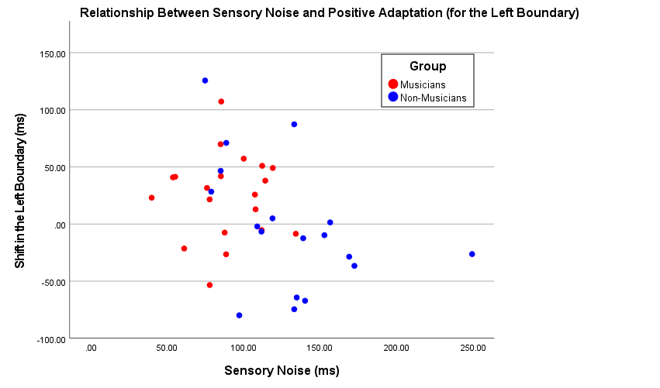

Figure S3. This scatterplot shows the significant relationship (R² = .15, p = .02) between sensory noise and the shift in the left boundary after visual-leading adaptation (i.e., positive cumulative recalibration). As sensory noise decreased, recalibration of the left boundary became stronger. This was the only significant relationship between sensory noise and temporal recalibration (see main text). Red and blue data points represent musicians and non-musicians, respectively.

