Supplementary Information for
Obliquity-paced Antarctic ice-volume fluctuations during the late Oligocene

Swaantje Brzelinski¹*; André Bornemann²; Diederik Liebrand³; Tim E. van Peer^{3,4}; Paul A. Wilson³; Oliver Friedrich¹.

¹Institute of Earth Sciences, Heidelberg University, Heidelberg, Germany; ²Bundesanstalt für Geowissenschaften und Rohstoffe, Hannover, Germany; ³University of Southampton, Waterfront Campus, National Oceanography Centre Southampton, UK; ⁴Now at: Department of Earth Sciences, University College London, London, UK

*swaantje.brzelinski@geow.uni-heidelberg.de

This file includes:

Supplementary text
Figures S1 to S6

S1 Benthic foraminiferal species selection and preservation
Late Oligocene microfossils preserved in sediments from Site U1406 yield an exceptional preservation and benthic foraminifera occur abundantly¹. Both factors are necessary to obtain reliable geochemical data. These prerequisites allow for high-resolution stable oxygen isotope, bottom-water temperature and ice-volume reconstructions. SEM imaging of benthic foraminiferal tests of C. mundulus and O. umbonatus reveal smooth test surfaces with no signs of dissolution or recrystallisation (Fig. 3; main text). Pores channels of O. umbonatus retained their original distinct structure (Fig. 3; main text). Reflected light microscope images of representative specimens of C. mundulus and O. umbonatus from Site U1406 show the exceptionally well and glassy² preservation ruling out diagenetic alteration at the micronscale (Fig. 3; main text). This suggests that geochemical signatures (δ¹⁸O_{BF} and Mg/Ca) in these glassy benthic foraminifera are unaltered².

S2 Benthic foraminiferal stable oxygen isotope composite record
For stable isotope analyses, we primarily used specimens of the shallow infaunal benthic foraminiferal taxon O. umbonatus. Samples with no, or few, specimens of this species were substituted by specimens of the epifaunal species C. mundulus. Both species have been widely used for deep-sea stable isotope analyses^{3,4} because they appear to have consistent and predictable offsets from seawater equilibrium values^{3,5,6}. δ¹⁸O_{BF} analyses on C. mundulus were adjusted to O. umbonatus values by adding 0.37 ‰ based on the average interspecies offset between C. mundulus and O. umbonatus from samples across our study interval (Fig. S1), which is in close agreement with previous studies (0.4 ‰⁶, 0.34 ‰³) that infer similar offsets.

S3 Benthic S3 Evaluation of Oridorsalis umbonatus test contamination for trace-metal analysis.
Mg/Ca analyses were only derived from the shallow infaunal species O. umbonatus, which has multiple advantages than compared to other benthic foraminiferal species: (i) it is an extant species spanning the entire Cenozoic with existing core top calibrations^{7–11}, (ii) it is buffered from the influence of changing bottom-water carbonate ion saturation state^{12,13}, (iii) it has a low sensitivity to temporal variations of Mg/Ca_{sw}¹², and (iv) due to its large chambers it is easier to clean for Mg/Ca analyses procedures compared to e.g., C. mundulus.
Al/Ca, Fe/Ca and Mn/Ca ratios of foraminiferal tests exceeding 0.1 mmol/mol may be indicative for contamination with clay, Fe-oxide or Mn-oxide coatings not removed during the Mg/Ca cleaning process, potentially affecting the initial test Mg/Ca signature¹⁴. To assess the potential influence of such contaminations for Site U1406 O. umbonatus samples across our study interval (25.94–25.78 Ma), we carefully monitored Al, Fe and Mn contents during Mg/Ca analysis. Measured Al concentrations of our data are generally below the detection limit, arguing against the presence of detrital clay. However, Fe/Ca and especially Mn/Ca ratios of O. umbonatus generally exceed the 0.1 mmol/mol threshold value (Fig. S2). Yet, we do not observe a statistically significant correlation between Mg/Ca vs. Fe/Ca (r²=0.17, p<0.0001) and Mg/Ca vs. Mn/Ca (r²=0.05, p<0.005) (Fig. S2), suggesting that Fe- and Mn-oxide coatings or Mn-carbonates (if present at all) did not considerably affect the measured Mg/Ca ratios. In addition, SEM images rule out the presence of microcrystalline overgrowth on the measured O. umbonatus tests (Fig. 3; main text). We thus conclude with reasonable certainty, that early diagenetic overprinting has not severely affected Mg/Ca-based data for the interval ~25.94–25.78 Ma at Site U1406.

S4 Seawater Mg/Ca correction and its influence on paleotemperature reconstructions
The incorporation of most trace elements, including Ca and Mg, into the shells of foraminifera is dependent on their respective concentration in seawater¹⁵. Hence, potential changes in Mg/Ca_{sw} since the Late Oligocene compared to the modern ocean have to be accounted for when applying Mg/Ca-paleothermometry on our Late Oligocene U1406 Mg/Ca measurements. Due to the relatively long residence times of Ca and Mg in seawater (~1 Myr and ~10 Myr, respectively)^{7,12}, Mg/Ca_{sw} can be considered constant over the duration of the study interval (25.94–25.78 Ma) presented in here; its absolute value, however, might be different from today’s ocean waters.
For the Late Oligocene, different Mg/Ca_{sw} ratios reconstructed from the composition of calcium carbonate veins (CCVs) formed in oceanic crust^{16,17} and from fossil coral archives¹⁸ are currently available that range from 1.8 to 3.6 mol/mol. Since the relationship between seawater and shell Mg/Ca is not well constrained for corals¹⁹, doubt has been raised about the use of corals as an archive for Mg/Ca_{sw}. In addition, the Mg/Ca_{sw} data of ref.¹⁸ for the Oligoene period (spanning 33.6 to 23.7 Ma ) is associated with a total Mg/Ca_{sw} range of 2.5 mol/mol. We argue that a Mg/Ca_{sw} shift of 2.5 mol/mol over the course of the Oligocene¹⁸, is unlikely due to the long residence times of Ca and Mg in seawater (~1 Myr and ~10 Myr, respectively)^{7,12} (see detailed discussion in ref.²⁰). This line of reasoning leads us to exclude the Late Oligocene Mg/Ca_{sw} reconstruction of ref.¹⁸.
Following a comparison of available archives used for Mg/Ca_{sw} reconstructions²¹, CCV’s were shown to result in relatively small uncertainties compared to other available Mg/Ca_{sw} reconstructions²¹ and therefore, should provide a more reliable estimate of Mg/Ca_{sw} reconstructions. Yet, several factors that weaken the applicability of the Mg/Ca_{sw} reconstructions from ref.¹⁶ to yield reliable Mg/Ca_{sw} values for the studied interval have been invoked^{17,22}: (i) Considerable uncertainties in the calculation of Mg/Ca_{sw} introduced from temperature extrapolation required for young ocean basement sites, (ii) post-precipitation alteration of CCVs due to sampling CCVs from older crustal ages, and (iii) the scarcity of Mg/Ca_{sw} data within the critical interval of the last 30 Ma years [see ref.²² for detailed discussion]. In the study of ref.¹⁷, these shortcomings have been largely addressed (see ref.¹⁷ for further details). Additional support to the approach of ref.¹⁷ is given by a good agreement of their Mg/Ca_{sw} reconstructions with modelled Mg/Ca_{sw} values of ref.²³ and ref.²⁴. Based on the aforementioned arguments, the Late Oligocene Mg/Ca_{sw} reconstruction of 3.6 mol/mol¹⁷ is being utilized for Mg/Ca-based paleothermometry in this study using the Mg/Ca-based BWT calibration of ref.⁷ (Methods).
Nonetheless, we performed a sensitivity test assuming the whole range of Mg/Ca_{sw} reconstructions for the Late Oligocene. Based on the test results, using a Mg/Ca_{sw} value of 1.8 mol/mol¹⁸ results in unrealistically high BWT reconstructions reaching maximum values of 15 °C (Fig. S3), which seems unrealistically high for the Late Oligocene. The most recent time during which deep-sea temperatures supposedly reached ~15 °C was during the Paleocene Eocene Thermal Maximum²⁵. Using a more positive Mg/Ca_{sw} of 2.3 mol/mol¹⁶ results in slightly more moderate but still relatively high BWTs (~8–12 °C), while the herein used Mg/Ca_{sw} value of 3.6 mol/mol¹⁷ results in the most conservative BWT reconstruction of ~5 to 8 °C (Fig. S3).

S5 Influence of δ¹⁸O_{ice} on our δ¹⁸O_{sw} reconstruction
To constrain the magnitude of ice-volume change related to the observed δ¹⁸O_{sw} amplitude, an assumption regarding the isotopic composition of the Late Oligocene ice-sheet (δ¹⁸O_{ice}) is required. Because major permanent Antarctic glaciation only initiated in the earliest Oligocene around ~33.6 Ma^{26,27}, the first ice to accumulate in the earliest Oligocene would have had a lighter isotopic composition²⁸ than that of the modern East Antarctic (-56.6 ‰) and West Antarctic Ice Sheet (-41 ‰)^{29,30}. State-of-the-art ice-sheet models yield δ¹⁸O_{ice} of -48 ‰, -42 ‰ and -35 ‰ spanning the earliest Oligocene to the early to mid-Miocene^{28,31} (Fig. S4). Modelled δ¹⁸O_{ice} for the fully developed earliest Oligocene ice sheet had a maximum isotopic composition of -35 ‰, yet never became more negative than -42 ‰ as the AIS grew larger²⁸. Following a more recent modelling study, average δ¹⁸O_{ice} for the early to mid-Miocene AIS (based on an approximated mid-Miocene Antarctic bedrock topography) varied between -42 ‰ and -48 ‰³¹. This approach does not account for changing δ¹⁸O_{ice} across glacial/interglacial changes (see discussion in ref. ³²) since we are only estimating ice volumes and an estimation of δ¹⁸O_{ice} for the fully expanded ice sheet(s) across the study interval suffices for our calculations (see discussion in ref. ³³).
Ice-volume estimates can be made by inferring a δ¹⁸O_{sw} baseline of 0 ‰ equating to the modern Antarctic ice-volume of 26.9 ×10⁶ km³ (ref.³⁴) and specific growth rates (×10⁶ km³) of ice per 0.1 ‰ change in δ¹⁸O_{sw}^{35,36}, depending on δ¹⁸O_{ice}. Since the focus of this study is on the Late Oligocene, we suggest a δ¹⁸O_{ice} value of -42 ‰, reconstructed both as the minimum δ¹⁸O_{ice} for the early to mid-Miocene³¹ and the maximum δ¹⁸O_{ice} for the early Oligocene²⁸, is most appropriate to estimate Late Oligocene Antarctic ice-volume fluctuations and used for ice-volume estimates discussed in this study. This, hence, translates the average glacial-interglacial δ¹⁸O_{sw} amplitude change of 0.5 ‰ into 19 × 10⁶ km³ of ice (Fig. S4). However, we also test the sensitivity of the δ¹⁸O_{sw}-based ice-volume estimates to modelled δ¹⁸O_{ice} of -48 ‰ and -35 ‰ (Fig. S4). Accordingly, our glacial-interglacial δ¹⁸O_{sw} amplitude of 0.5 ‰ results in 22.8 × 10⁶ km³ of ice assuming δ¹⁸O_{ice} is -35 ‰. In contrast, using the most negative δ¹⁸O_{ice} of -48 ‰ results in an amplitude change of 16.6 × 10⁶ km³ ice (Fig. S4).

S6 Effect of including the analytical error of the Mg/Ca_{sw} reconstruction into the Monte Carlo Simulation for δ¹⁸O_{sw} reconstruction
As noted in Section 4, we accounted for potential changes in Mg/Ca_{sw} compared to the modern ocean for our BWT calculations. Yet, the broad range of ±1.8 mol/mol for Mg/Ca_{sw} reconstructions available for the Late Oligocene^{16–18} leaves us with a relatively big range, of which the analytical errors are partly as large as the difference between some of the reconstructed Mg/Ca_{sw} values themselves. We note that propagating the uncertainty of the Mg/Ca_{sw} reconstruction into the uncertainty estimate via Monte Carlo Simulation of our δ¹⁸O_{sw} reconstruction may lead to a significant overestimation of uncertainties associated with our δ¹⁸O_{sw} data. While we did not discuss this scenario in the main text, we additionally ran a second Monte Carlo Simulation including the Mg/Ca_{sw} reconstruction with its analytical error¹⁷. Accordingly, input data for the second Monte Carlo Simulation were the Mg/Ca and δ¹⁸O values and Mg/Ca_{sw} reconstruction with their analytical errors, and the BWT^{7,12} and δ¹⁸O_{sw} equation³⁷ with their calibration errors. Similar to the first Monte Carlo Simulation, individual data points were randomly sampled 14,000 times within their proxy uncertainties. The mean propagated uncertainty of the δ¹⁸O_{sw} estimate including the error of the Mg/Ca_{sw} reconstruction, gives a mean propagated uncertainty of ±0.54 ‰.

Fig. S1. Paired isotope analyses of C. mundulus and O. umbonatus for Site U1406 (~25.94–25.78 Ma). Benthic foraminiferal δ¹⁸O_{BF} analyses (in ‰ VPDB) of C. mundulus (blue), O. umbonatus (red), and the composite record (dashed black line; C. mundulus converted to O. umbonatus by adding 0.37 ‰).

Fig. S2. Evaluation of O. umbonatus test contamination for Site U1406 (~25.94–25.78 Ma). Cross correlation plots of Mg/Ca versus (a) Fe/Ca and (b) Mn/Ca show no statistically significant correlation between Mg/Ca vs. Fe/Ca (r² = 0.17, p< 0.0001) and Mg/Ca vs. Mn/Ca (r² = 0.05, p< 0.005), indicating that measured Mg/Ca values are not systematically altered.

Fig. S3. Sensitivity of Mg/Ca-based BWTs towards available Mg/Ca_{sw} reconstructions. Mg/Ca-based BWTs calculated using the calibration of ref.⁷ (Methods) using constant Mg/Casw of 1.8 mol/mol¹⁸ (green), 2.3 mol/mol¹⁶ (purple) and 3.6 mol/mol¹⁷ (blue).

.

Fig. S4. Sensitivity tests for Site U1406 δ¹⁸O_{sw}-based ice-volume estimates using different δ¹⁸O_{ice}. Ice-volume estimates assuming a linear relationship between changing δ¹⁸O_{sw} and δ¹⁸O_{ice}, using different δ¹⁸O_{ice} values of -48 ‰³¹, -42 ‰^{28,31} and -35 ‰²⁸ and a δ¹⁸O_{sw} baseline of 0 ‰ equating to the size of the modern Antarctic ice-volume (26.9 × 10⁶ km³)³⁴. Grey area marks the observed U1406 δ¹⁸O_{sw} range for glacials and interglacials; red dashed line indicates the modern Antarctic ice-volume ³⁴, golden dashed line indicates the mid-Miocene glacial ice-volume³¹.

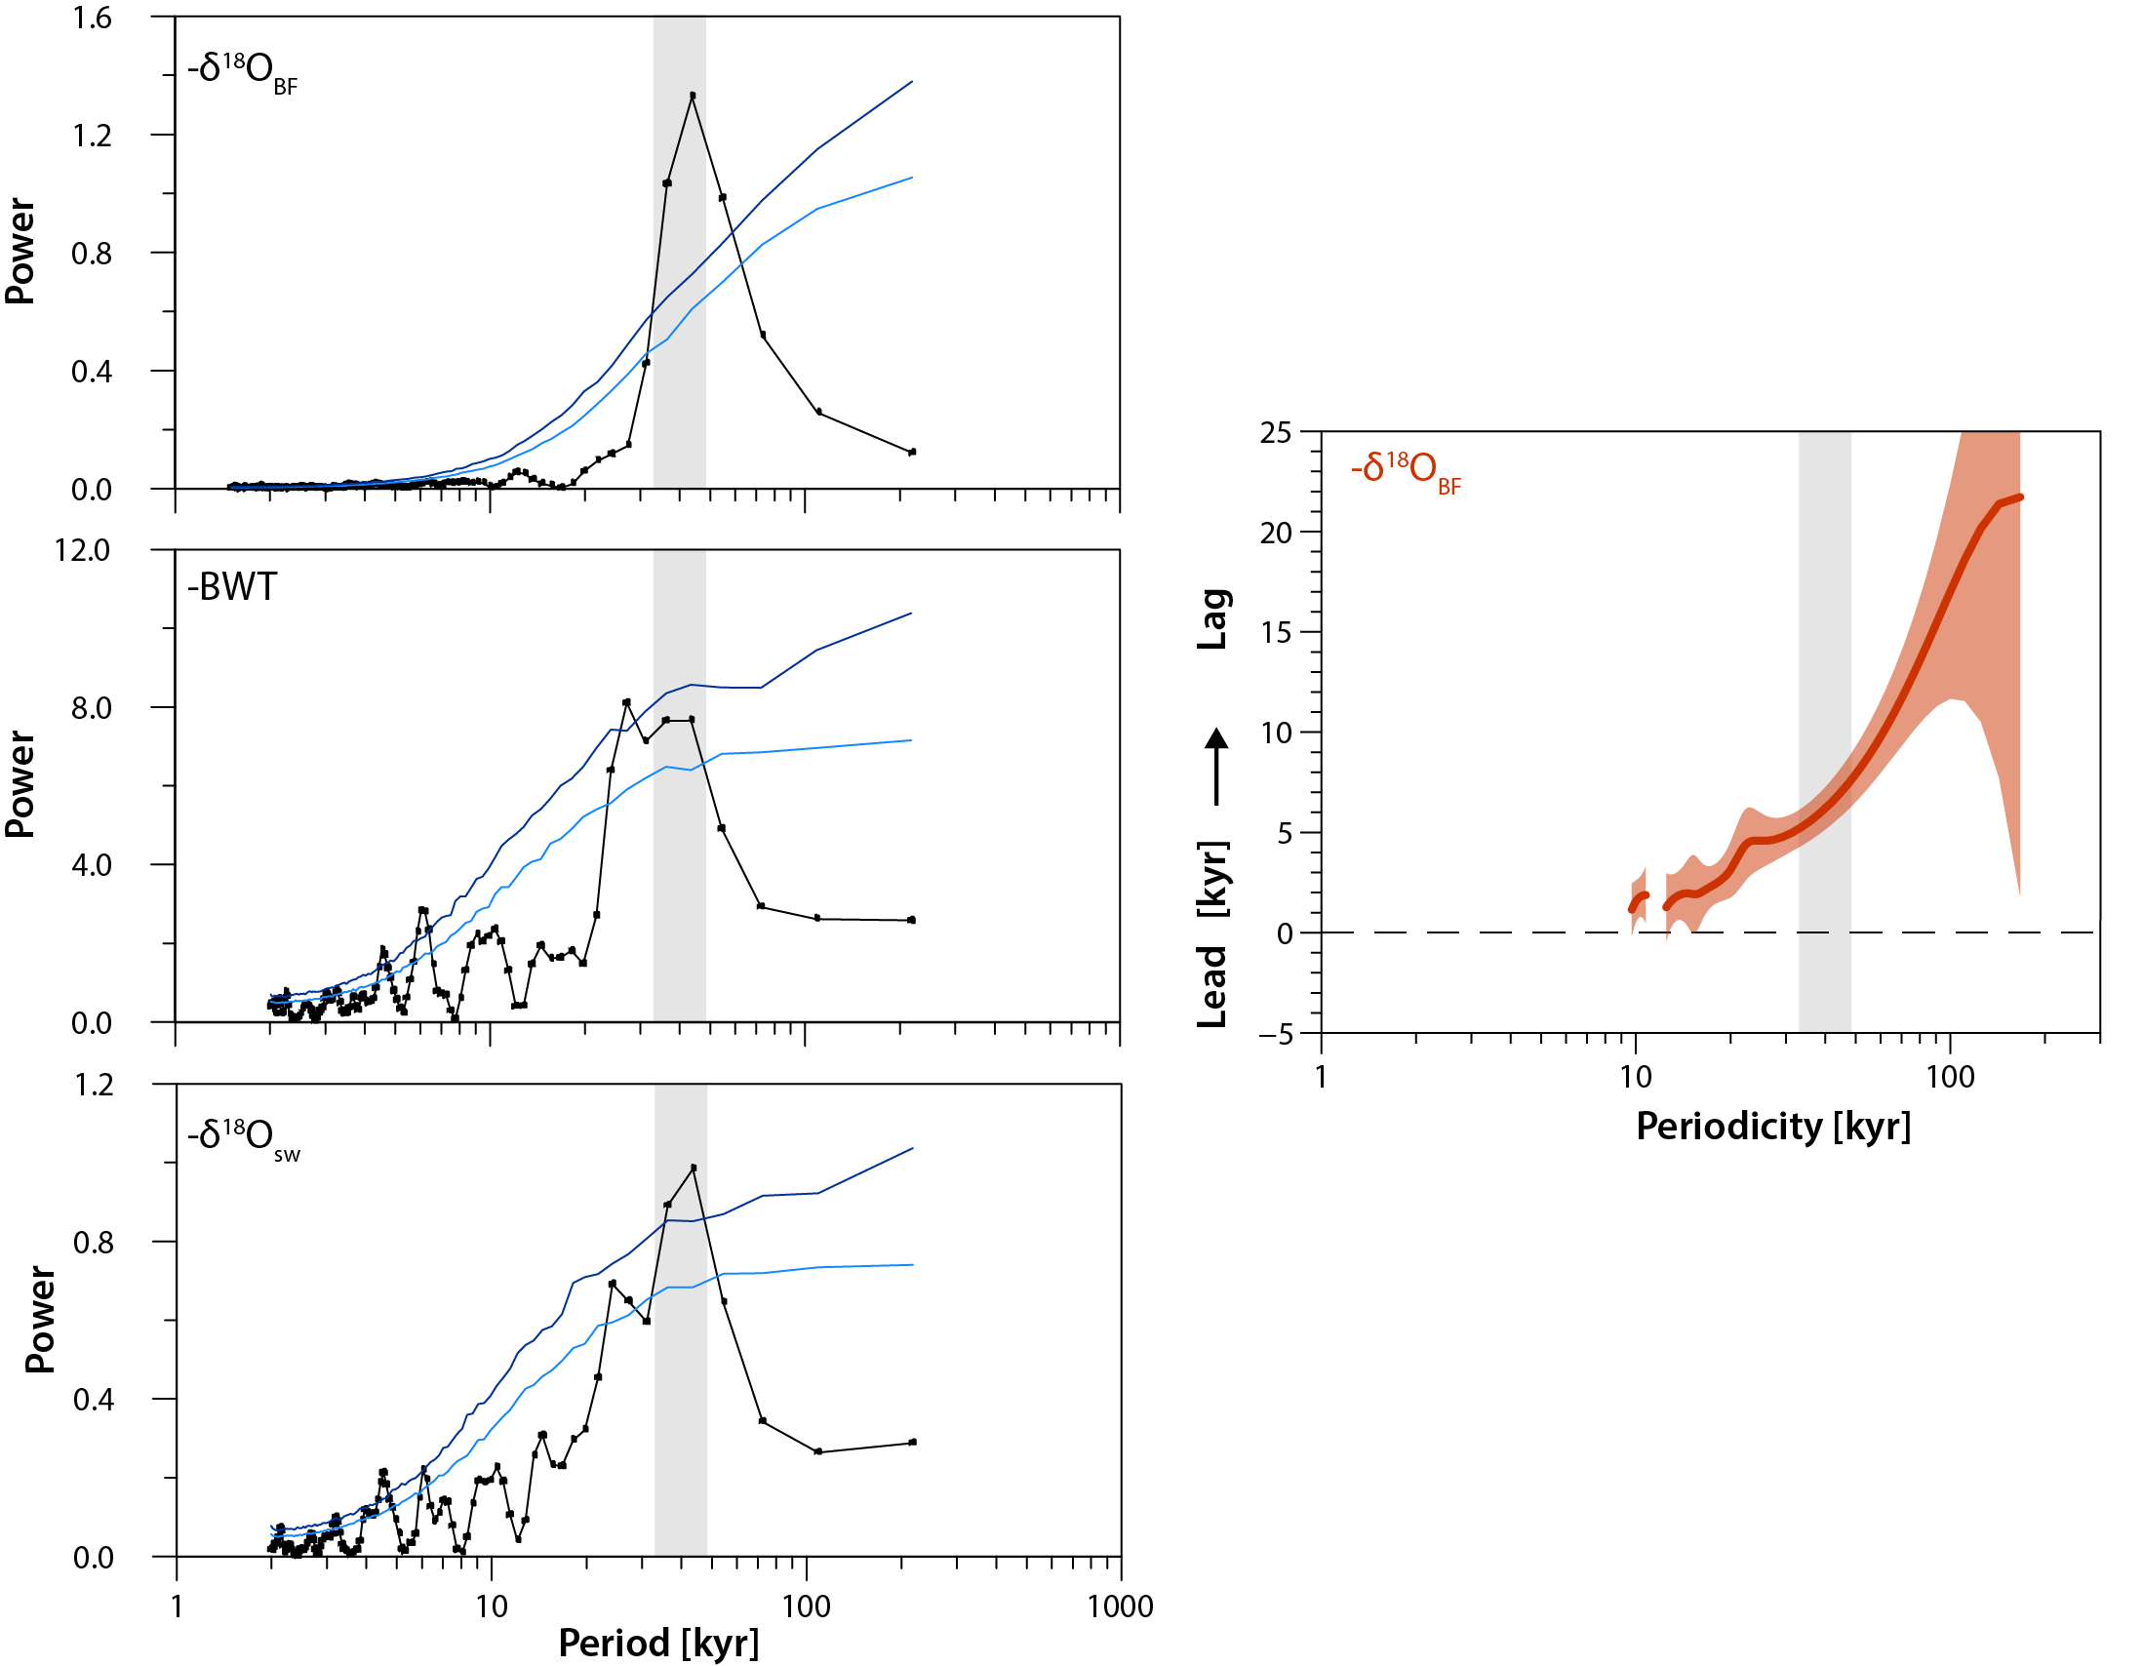
Fig. S5. Spectral analysis of the U1406 δ¹⁸O_{BF}, BWT and δ¹⁸O_{sw} records. Left panel shows REDFIT spectral analysis³⁸ of our δ¹⁸O_{BF}, BWT and δ¹⁸O_{sw} records. Monte Carlo confidence intervals of 80 % (light blue) and 90 % (dark blue). Right panel shows the Blackman-Tukey cross-spectral phase estimate between the δ¹⁸O_{BF} time series (at 95% significance) and the orbital solution for obliquity³⁹ (converted to lag times in kyr). The signal at the obliquity frequency is highlighted with grey bars.

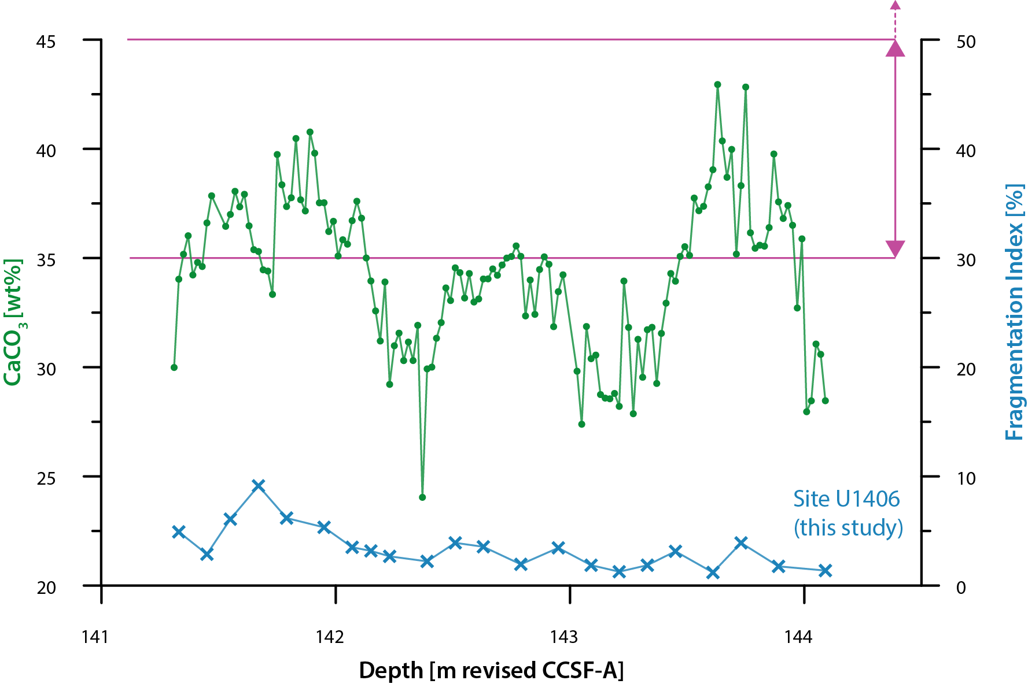

Fig. S6. U1406 CaCO₃ data and fragmentation index. The fragmentation index (FI) is expressed as a percentage of the number of fragments of planktic foraminiferal tests divided by the sum of whole planktic foraminiferal tests and fragments counted in each sample. To demonstrate the low U1406 FI for the Late Oligocene, pink lines display average range of significant shell fragmentation during the Eocene⁴⁰ and Pliocene⁴¹ for comparison (dashed arrow indicates FI up to max. 80%) .

SI References
1. Norris, R. D. et al. Paleogene Newfoundland Sediment Drifts and MDHDS Test. in Proceedings of the Integrated Ocean Drilling Program vol. 342 149 (2014).
2. Sexton, P. F., Wilson, P. A. & Pearson, P. N. Microstructural and geochemical perspectives on planktic foraminiferal preservation: ‘glassy’ versus ‘frosty’. Geochemistry, Geophys. Geosystems 7, Q12P19 (2006).
3. Coxall, H. K. & Wilson, P. A. Early Oligocene glaciation and productivity in the eastern equatorial Pacific: Insights into global carbon cycling. Paleoceanography 26, PA2221 (2011).
4. Coxall, H. K. et al. Export of nutrient rich Northern Component Water preceded early Oligocene Antarctic glaciation /704/106/413 /704/829 /704/106/2738 article. Nat. Geosci. 11, 190–196 (2018).
5. Katz, M. E. et al. Early Cenozoic benthic foraminiferal isotopes: Species reliability and interspecies correction factors. Paleoceanography 18, 1024 (2003).
6. Billups, K., Pälike, H., Channell, J. E. T., Zachos, J. C. & Shackleton, N. J. Astronomic calibration of the late Oligocene through early Miocene geomagnetic polarity time scale. Earth Planet. Sci. Lett. 224, 33–44 (2004).
7. Lear, C. H., Rosenthal, Y. & Slowey, N. Benthic foraminiferal Mg/Ca-paleothermometry: A revised core-top calibration. Geochim. Cosmochim. Acta 66, 3375–3387 (2002).
8. Tisserand, A. A. et al. Refining benthic foraminiferal Mg/Ca-temperature calibrations using core-tops from the western tropical Atlantic: Implication for paleotemperature estimation. Geochemistry, Geophys. Geosystems 14, 929–946 (2013).
9. Rathmann, S., Hess, S., Kuhnert, H. & Mulitza, S. Mg/Ca ratios of the benthic foraminifera Oridorsalis umbonatus obtained by laser ablation from core top sediments: Relationship to bottom water temperature. Geochemistry, Geophys. Geosystems 5, Q12013 (2004).
10. Healey, S. L., Thunell, R. C. & Corliss, B. H. The Mg/Ca-temperature relationship of benthic foraminiferal calcite: New core-top calibrations in the < 4 °C temperature range. Earth Planet. Sci. Lett. 272, 523–530 (2008).
11. Brown, R. E., Anderson, L. D., Thomas, E. & Zachos, J. C. A core-top calibration of B/Ca in the benthic foraminifers Nuttallides umbonifera and Oridorsalis umbonatus: A proxy for Cenozoic bottom water carbonate saturation. Earth Planet. Sci. Lett. 310, 360–368 (2011).
12. Lear, C. H. et al. Neogene ice volume and ocean temperatures: Insights from infaunal foraminiferal Mg/Ca paleothermometry. Paleoceanography 30, 1437–1454 (2015).
13. Rathmann, S. & Kuhnert, H. Carbonate ion effect on Mg/Ca, Sr/Ca and stable isotopes on the benthic foraminifera Oridorsalis umbonatus off Namibia. Mar. Micropaleontol. 66, 120–133 (2008).
14. Barker, S., Greaves, M. & Elderfield, H. A study of cleaning procedures used for foraminiferal Mg/Ca paleothermometry. Geochemistry, Geophys. Geosystems 4, 1–20 (2003).
15. Evans, D. & Müller, W. Deep time foraminifera Mg/Ca paleothermometry: Nonlinear correction for secular change in seawater Mg/Ca. Paleoceanography 27, PA4205 (2012).
16. Coggon, R. M., Teagle, D. A. H., Smith-Duque, C. E., Alt, J. C. & Cooper, M. J. Reconstructing Past Seawater Mg/Ca and Sr/Ca from Mid-Ocean Ridge Flank Calcium Carbonate Veins. Science. 327, 1114–1117 (2010).
17. Rausch, S., Böhm, F., Bach, W., Klügel, A. & Eisenhauer, A. Calcium carbonate veins in ocean crust record a threefold increase of seawater Mg/Ca in the past 30 million years. Earth Planet. Sci. Lett. 362, 215–224 (2013).
18. Gothmann, A. M. et al. Fossil corals as an archive of secular variations in seawater chemistry since the Mesozoic. Geochim. Cosmochim. Acta 160, 188–208 (2015).
19. Evans, D. et al. No substantial long-term bias in the Cenozoic benthic foraminifera oxygen-isotope record. Nat. Commun. 9, 17–19 (2018).
20. Zeebe, R. E. & Tyrrell, T. Comment on “The Effects of Secular Calcium and Magnesium Concentration Changes on the Thermodynamics of Seawater Acid/Base Chemistry: Implications for Eocene and Cretaceous Ocean Carbon Chemistry and Buffering” by Hain et al. (2015). Global Biogeochem. Cycles 32, 895–897 (2018).
21. Evans, D. et al. Eocene greenhouse climate revealed by coupled clumped isotope-Mg/Ca thermometry. Proc. Natl. Acad. Sci. U. S. A. 115, 1174–1179 (2018).
22. Broecker, W. & Yu, J. What do we know about the evolution of Mg to Ca ratios in seawater? Paleoceanography 26, PA3203 (2011).
23. Demicco, R. V., Lowenstein, T. K., Hardie, L. A. & Spencer, R. J. Model of seawater composition for the Phanerozoic. Geology 33, 877–880 (2005).
24. Farkaš, J. et al. Calcium isotope record of Phanerozoic oceans: Implications for chemical evolution of seawater and its causative mechanisms. Geochim. Cosmochim. Acta 71, 5117–5134 (2007).
25. Tripati, A., Backman, J., Elderfield, H. & Ferretti, P. Eocene bipolar glaciation associated with global carbon cycle changes. Nature 436, 341–346 (2005).
26. Lear, C. H., Elderfield, H. & Wilson, P. A. Cenozoic deep-sea temperatures and global ice volumes from Mg/Ca in benthic foraminiferal calcite. Science. 287, 269–272 (2000).
27. Coxall, H. K., Wilson, P. A., Pälike, H., Lear, C. H. & Backman, J. Rapid stepwise onset of Antarctic glaciation and deeper calcite compensation in the Pacific Ocean. Nature 433, 53–57 (2005).
28. DeConto, R. M. et al. Thresholds for Cenozoic bipolar glaciation. Nature 455, 652–656 (2008).
29. Lhomme, N., Clarke, G. K. C. & Ritz, C. Global budget of water isotopes inferred from polar ice sheets. Geophys. Res. Lett. 32, 1–4 (2005).
30. Lhomme, N. Modelling Water Isotopes in Polar Ice Sheets. (University of British Columbia and Université Joseph Fourier, 2004).
31. Gasson, E., DeConto, R. M., Pollard, D. & Levy, R. H. Dynamic Antarctic ice sheet during the early to mid-Miocene. Proc. Natl. Acad. Sci. U. S. A. 113, 3459–3464 (2016).
32. Sima, A., Paul, A., Schulz, M. & Oerlemans, J. Modeling the oxygen-isotopic composition of the North American Ice Sheet and its effect on the isotopic composition of the ocean during the last glacial cycle. Geophys. Res. Lett. 33, L15706 (2006).
33. Bohaty, S. M., Zachos, J. C. & Delaney, M. L. Foraminiferal Mg/Ca evidence for Southern Ocean cooling across the Eocene-Oligocene transition. Earth Planet. Sci. Lett. 317–318, 251–261 (2012).
34. Fretwell, P. et al. Bedmap2: Improved ice bed, surface and thickness datasets for Antarctica. Cryosphere 7, 375–393 (2013).
35. Liebrand, D. et al. Evolution of the early Antarctic ice ages. Proc. Natl. Acad. Sci. U. S. A. 114, 3867–3872 (2017).
36. Bohaty, S. M., Zachos, J. C. & Delaney, M. L. Foraminiferal Mg/Ca evidence for Southern Ocean cooling across the Eocene-Oligocene transition. Earth Planet. Sci. Lett. 317–318, 251–261 (2012).
37. Harreither, W., Nicholls, P., Sygmund, C., Gorton, L. & Ludwig, R. Investigation of the pH-dependent electron transfer mechanism of ascomycetous class II cellobiose dehydrogenases on electrodes. Langmuir 28, 6714–6723 (2012).
38. Schulz, M. & Mudelsee, M. REDFIT: Estimating red-noise spectra directly from unevenly spaced paleoclimatic time series. Comput. Geosci. 28, 421–426 (2002).
39. Laskar, J. et al. A long-term numerical solution for the insolation quantities of the Earth. Astron. Astrophys. 428, 261–285 (2004).
40. Petrizzo, M. R., Leoni, G., Speijer, R. P., De Bernardi, B. & Felletti, F. Dissolution susceptibility of some paleogene planktonic foraminifera from ODP site 1209 (Shatsky rise, Pacific Ocean). J. Foraminifer. Res. 38, 357–371 (2008).
41. Andersson, C. Pliocene calcium carbonate sedimentation patterns of the Ontong Java Plateau: ODP sites 804 and 806. Mar. Geol. 150, 51–71 (1998).

