Supplementary Materials

AI-enabled Automatic Multimodal Fusion of Cone-Beam CT and Intraoral Scans for Intelligent 3D Tooth-Bone Reconstruction and Clinical Applications
Jin Hao^{1,3#}, Jiaxiang Liu^{2,4#}, Hangzheng Lin⁴, Jin Li⁴, Wei Pan⁴, Yang Feng⁵, Ruizhe Chen^{2,4}, Huimin Xiong^{2,4}, Kaiwei Sun⁴, Wanlu Liu⁶, H.Howard Yang⁴, Wanghui Ding², Jianfei Yang⁴, Haoji Hu⁴, Yueling Zhang¹, Zeyu Zhao⁴, Huikai Wu⁴, Youyi Zheng⁷, Bing Fang⁸, Zuozhu Liu^{2,4}*, Zhihe Zhao¹*

1. State Key Laboratory of Oral Diseases & National Clinical Research Center for Oral Diseases & West China Hospital of Stomatology, Sichuan University, Chengdu, China
2. Stomatology Hospital, School of Stomatology, Zhejiang University School of Medicine
3. Harvard School of Dental Medicine, Harvard University, Boston, MA, USA
4. Zhejiang University-University of Illinois at Urbana-Champaign Institute, ZJU-Angelalign R&D Center for Intelligent Healthcare, Zhejiang University, Haining, China
5. Angelalign Technology Inc., Shanghai, China
6. Zhejiang University-University of Edinburgh Institute, Zhejiang University, Haining, China
7. College of Computer Science and Technology, Zhejiang University, Hangzhou, China
8. Ninth People's Hospital Affiliated to Shanghai Jiao Tong University, Shanghai Research Institute of Stomatology, National Clinical Research Center of Stomatology, Shanghai, China

# Equal Contribution.
* Correspondence: zuozhuliu@intl.zju.edu.cn (Z.L.) & zhzhao@scu.edu.cn (Z.Z.)

Part 1: Experimental Setup

Dataset. The dataset included 503 samples with both CBCT and IOS collected from hospitals and clinics in 25 provinces in China during 2018-2021. The 503 samples were associated with ground truth 3D reconstructions with fused IOS tooth crowns and CBCT tooth bones, all annotated by a committee of human experts. The 503 patients were at the age of 19.53±7.57 years old, with 32.5% male and 67.5% female. Besides, we collected an extra 28,559 IOS meshes. The tooth segmentation network was trained with 5-fold cross-validation, each with 50 patients. The jaw segmentation network was trained with 840 slices and tested on 246 slices. The IOS segmentation network was evaluated with 200 IOS scans as the baselines.
We annotated 9,651 CBCT slices of the 503 patients for CBCT tooth segmentation, where we selected 15-25 slices for each patient. Similarly, we annotated 1,066 images for CBCT jaw segmentation. The slices were selected to maximize the difference among slices, e.g., for a CBCT with 400 slices, we might start annotation at slice 100 where tooth apex was first scanned and subsequently selected 15-25 slices to annotate every ten slices, avoiding annotating highly correlated and highly similar slices. By doing so, we could get annotated slices containing different anatomical information, which could help improve our model's robustness and generalization ability. We chose the slices for the jaw annotation following the same procedure.
The annotation process for CBCT slices contains three stages. First, each slice was annotated by some senior undergraduates or master students majoring in stomatology. Second, the annotated slices were revised and corrected by a committee of experts who hold doctoral degrees in stomatology and had at least 5 years of clinical experience. Finally, several senior radiologists with more than 10-year experience would work with the expert to further refine the labels, and their consensus was regarded as the ground truth. The images were annotated with the LabelMe software, while a small portion of them was examined by the Mimic software.
The annotation process for the IOS dataset was as follows. The experts could use the software “Atreat Processor” to annotate each mesh face given an input mesh scan. For each patient, a junior technician with 1-5 years of working experience in dentistry would first annotate the IOS scan with the help of automated solutions such as DC-Net. Afterward, the annotation would be examined by a senior technician with more than 5 years of working experience and a dentist (usually an orthodontist).
The annotations of the fused tooth-bone meshes which would be used to compute the 3D fusion performance, such as ASSD, were also conducted by a committee of human experts. The experts would decide whether the annotation was satisfactory for future oral diagnosis and treatment planning during annotation. If all of them agree that the annotation was satisfactory, we will take that annotation. Otherwise, the annotation needed to be improved until it was good enough for future clinical usage.

Data preprocessing. In the training process, this paper proposed a data augmentation strategy for CBCT data. Firstly, based on the prior and empirical statistics from the annotated masks, we cropped the lower 1/4, and right/top/left 1/10 in the original CBCT image to partially alleviate the class imbalance problem. The CBCT images were resized to random resolution within 2048*2048 with a ratio range of is (0.5, 2.0) and randomly clipped to [512, 512]. Then, the random horizontal flipping probability of 0.5 and random photometric distortion were performed. To better reconstruct the CBCT mesh, we used rescaled versions of the image with scaling factors of [0.5, 1.5, 1.0 ,2.0, 2.5, 3.0, 3.5, 4.0] for multi-scale inference.
As for the IOS scans, we first uniformly sampled 10,000 faces from the original mesh and regarded each face center as a point to form a point cloud with 10,000 points. The features associated with each point included three parts: 1. the position of the face, i.e., the 3D coordinate of the face center denoted as $h_{c}=(x_{c}, y_{c}, z_{c}) ∈R^{3}$; 2. the 3-dimensional normal vector of the face surface $h_{n}∈R^{3}$; 3. the face shape feature $f_{s}∈R^{9}$ . For each face with three vertices as $(x_{i}, y_{i}, z_{i})$for i from 1 to 3, and a face center $(x_{c}, y_{c}, z_{c})$, the face shape feature was defined as $Concat(x_{i}-x_{c}, y_{i}-y_{c}, z_{i}-z_{c})$ for $i$ from 1 to 3. $Concat(⋅)$ is the concatenate operation for vectors, leading to a 9-dimensional shape feature for each face. Consequently, after data preprocessing for each IOS mesh scan, the final output was a point cloud with 10,000 points, each associated with a 15-dimensional feature vector $h=Concat({h_{c},h}_{n},h_{s}) {∈R}^{15}$. This preprocessing procedure could be finished with a modern computer on-the-fly.
We applied data augmentation with four different perturbations to enlarge the IOS dataset. We independently sampled 10,000 points every time for each perturbation. The perturbation was random rotation by -10 to 10 degrees or random translation by -10 to 10 millimeters, along with one x, y, and z axes. The network was trained for 100 epochs. The model was evaluated on a validation set with 100 scans, and the model with the highest validation accuracy was selected for testing. We sampled 40,000 points for each mesh during testing, which would be segmented by DL. For the rest points (i.e., faces), we chose five coordinate-based nearest neighbors from the 40,000 points, and the neighbor with the highest probability would determine the label for that point.
For CBCT jaw data, 840 CBCT images were used for training, and 246 images were tested. In training, random horizontal flip and random scale were applied to augment the input image, random crop and padding were implemented to set the image size (512*512).

The setting of training and test sets. For TSTNet, we employed the AdamW optimizer with an initial learning rate of 6 × 10⁻⁵, a weight decay of 0.01, a scheduler that used linear learning rate decay, and a linear warmup of 1,500 iterations. Models were trained on 4 GPUs with 4 images per GPU for 160K iterations.
As for IOSNet, the number of sampled points for each point cloud was 10,000. We used 4 RTX3090Ti GPUs to train our model. We used a batch size of 8. The network was trained for 200 epochs. We used AdamW as the optimizer with an initial learning rate as 3e-3 and weight decaying as 1e-3.

Part 2. Supplementary Method.

TSTNet Details. The architecture of TSTNet is shown in Supplementary Figure 1. The implementation details of TSTNet were shown in Supplementary Figure 2.
IOSNet Details. The architecture of IOSNet is shown in Supplementary Figure 3. The implementation details of IOSNet are shown in Supplementary Figure 4.
Mesh reconstruction. The CBCT mesh was reconstructed from the CBCT segmentation results. The marching cubes algorithm was used to process CBCT image data to obtain the complete reconstructed mesh of all the CBCT teeth mesh ¹. Afterward, the HLO was applied to smooth the surfaces to reduce the sharp creases on the surface caused by image pixels and marching cube algorithms ². Then, we got a fine CBCT mesh.
Point Curvature-based Segmentation. In our method, the point curvature of a vertex was defined as the average of angles between normal vectors of all its neighbors, which was different from either mean curvature or Gaussian curvature. The point curvature was used to separate the maxillary and mandible and delineate individual teeth in the reconstructed 3D CBCT mesh.
The visualization of colorizing curvature is shown in Figure 5. We observed that the regions of high curvature were distributed in tooth-tooth boundaries or between the mandible and maxillary (as shown in the red part in the red box in ours). The region of high Gaussian curvature was dispersive. The highest gaussian curvature region was located at the tooth root, making it difficult to segment the teeth of the mandible and maxillary (as shown in the red part in the yellow box in gaussian curvature).
We proposed a new segmentation algorithm to separate the half jaws and each tooth using this novel point curvature. The intuition behind the curvature-based segmentation algorithm was that the angle between the normal vectors of adjacent points could capture the curvature of different scales by changing the level of neighbors. The algorithm was like an “erosion-expansion” procedure. We first computed the point curvature for each vertex, and vertices with curvature in the top $M$ percent would be removed from the mesh (erosion). Followed by a simple connected component analysis algorithm, the individual teeth could be separated. We used the 2nd order neighbors and $M$=20% so that the main bodies of the teeth could be roughly separated. The general curvature-based segmentation algorithm is detailed in Algorithm 1.
After the segmentation was applied, we got both the unrefined teeth and the removed segments. After that, we extracted every connected component from the remaining mesh as a single tooth. Small segments (experimentally, less than 2000 vertices) were discarded as noises. Then, we built the k-d tree for each estimated tooth and merged the removed point to its closest tooth. The details of the merge process are shown in Algorithm 2.
To better leverage the precision and efficiency of the k-d tree, we proposed a multi-step approach during the merge process. We used T steps for the merge process. In each step, we merged the 1/T removed points back to teeth. Then we rebuilt all the k-d trees based on the updated tooth points, and so on. The larger T, the better the merge performance. We updated the k-d tree in the extreme case after merging one point. Typically, we chose T = 5 to balance the tradeoff between merging efficiency and performance. We took the minimum and the maximum z-axis coordinates of points as the reference and classified each tooth to the maxilla or mandible by comparing the distance from the tooth centroid to the two references. As a result, the maxilla and mandible were separated and classified for registration in the next step. The segmentation algorithm for maxilla and mandible was detailed in Algorithm 3.
Registration of data with two modalities. The segmented CBCT results from the previous section were provided as mandible and maxilla parts separately, which were registered with the laser mesh data. We denoted the vertex set of the IOS mesh as V_{I}, and the vertex set of the CBCT mesh as V_{C}. The registration method was to find the optimal transformation 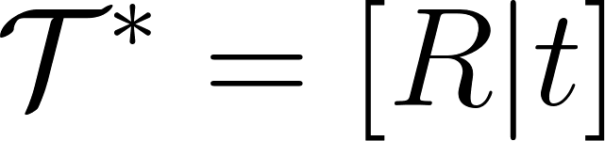 that the transformed point cloud 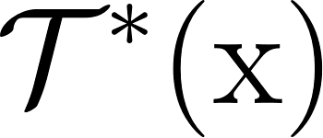 best aligns with the target, in which 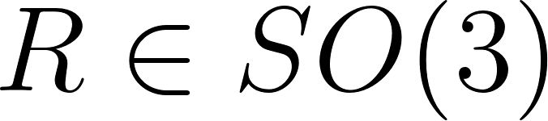 (3D rotation group in geometry) denoted the rotation, 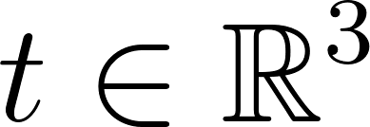 denotes translation. The registration formula could be defined as follows:
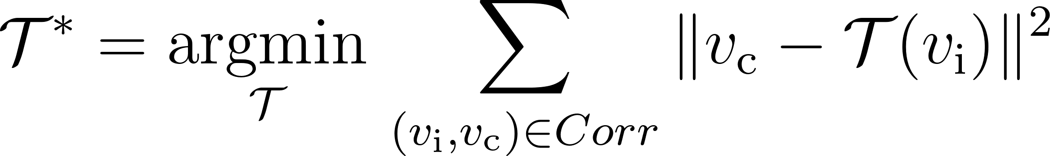
where the matrix was the set of rigid transformations that were modeled with a 4*4 matrix determined by three angles and a translation vector.  was the optimal transformation. Corr was a set of correspondences between V_{I} and V_{C，} where 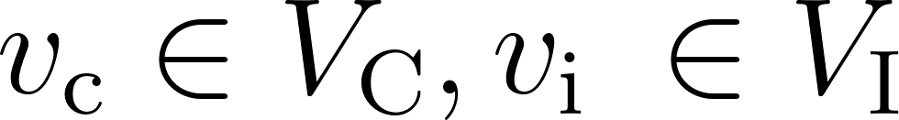.
Since the initial alignment of the two-point sets was of great importance, a rough initial alignment was proposed to globally register the two-point sets, which was further improved by the ICP algorithm. The registration contained three steps:
1) Scale alignment:
The scale of reconstructed CBCT mesh was adjusted by the pixel spacing and slice thickness properties of CBCT data, provided by the equipment.
2) Global rigid transformation:
In rigid global transformation, we first downsampled the CBCT and IOS mesh and used the RANSAC algorithm for transformation. We adopted the global alignment method in Open3D for global coarse level registration, which performed searching and priming in the 33-dimensional FPFH vector space in each RANSAC iteration ³. In RANSAC, we set max iteration the confidence probability of RANSAC to 100,000,000 and 0.7 and set the other RANSAC parameters based on the empirical value provided by reference ⁴.
3) Registration by multi-scale ICP algorithm
Global registration was performed on the down-sampled point cloud, so the result of registration was not optimal for accurate IOS and CBCT registration. Hence, we further performed a multi-scale ICP algorithm to obtain fine-grained registration. The multi-scale ICP algorithm performs point to plane ICP registration at three scales (voxel sizes for the downsample were 0.36, 0.18, 0.12), which was defined as:
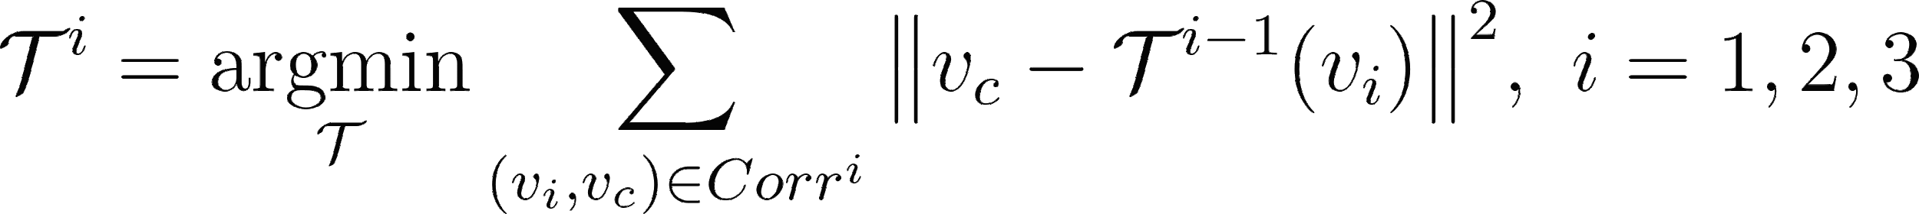
where  was the rigid global transformation obtained at the voxel size of 0.36, and 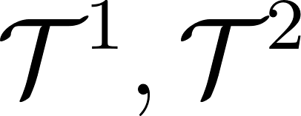 denoted the corresponding iterative multi-scale registration with voxel size 0.18 and 0.12, respectively. Finally, we took the transformed mesh followed by , as the registration output.
Tooth crown replacement algorithm. When the registration IOS data was obtained, the next step was to fuse the CBCT with IOS scans to complete the 3D crown and root data integration. The goal of this step was to replace the points and geometry corresponding to the tooth crown in CBCT with the IOS scan. We proposed a tooth crown replacement algorithm, which consisted of two steps: (1) Half-jaw fusion to get the fused half jaw; (2) Individual tooth fusion to get each fused individual tooth.
The half-jaw fusion algorithm was illustrated in Algorithm 4. We constructed the KD-tree with the IOS data and computed the distance from each point in the CBCT to the KD-tree. To remove the points corresponding to the CBCT crown, we removed points with top d(d=30%) distance in the CBCT point cloud. However, some independent noise (including noise points and clusters) might be introduced in the mesh reconstruction process. Therefore, the outlier and DBSCAN clustering algorithms were adopted to delete those clusters and noise points ⁶. The DBSCAN algorithm was a high-density-based clustering non-parametric algorithm that could delete some abnormal debris clusters with less than k(k=2000) point clouds. Finally, the oral scan was integrated with the remaining points in the CBCT, and Poisson reconstruction (Depth=8) was performed to generate the rough fusion results. Laplacian filtering algorithm (Iter = 6) was applied to obtain the final fusion result.
After getting the fused half jaw, we integrated the tooth roots with the IOS mesh crown to get each tooth. By doing so, we got each tooth with FDI notations. Specifically, we merged the remaining points in the CBCT to its corresponding IOS tooth crown by computing the Euclidean distance and integrating CBCT points to the nearest IOS tooth crown.

Part 3. Supplementary Results.
CBCT image segmentation metrics. To objectively evaluate the results obtained from different CBCT segmentation methods, four representative fusion quality metrics were adopted in this paper ⁷, using the default parameters provided in a corresponding study. The larger values of these metrics, the better the segmentation results. More details regarding these metrics were as follows.
1) IoU
The Intersection over Union (IoU) was defined as the area of intersection between the predicted segmentation map A and the ground truth map B, divided by the area of the union between the two maps, and ranges between 0 and 1:
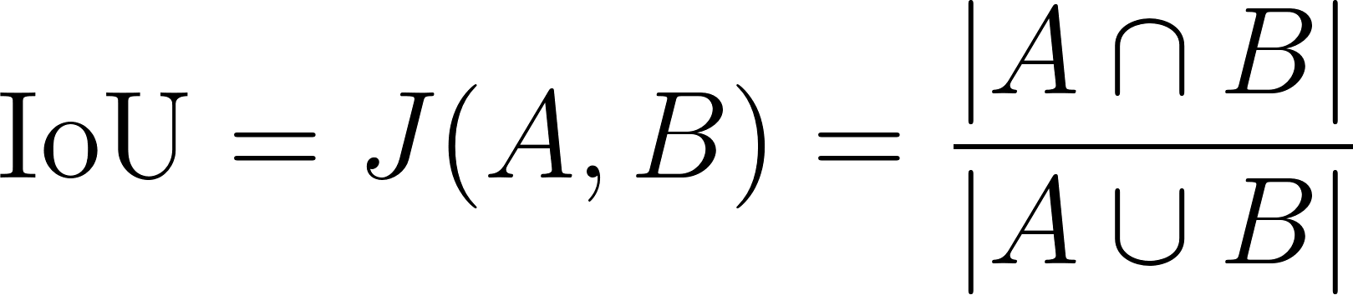
2) Dice
The Dice coefficient, commonly used in medical image analysis, could be defined as twice the overlap area of the predicted and ground-truth maps divided by the total number of pixels:
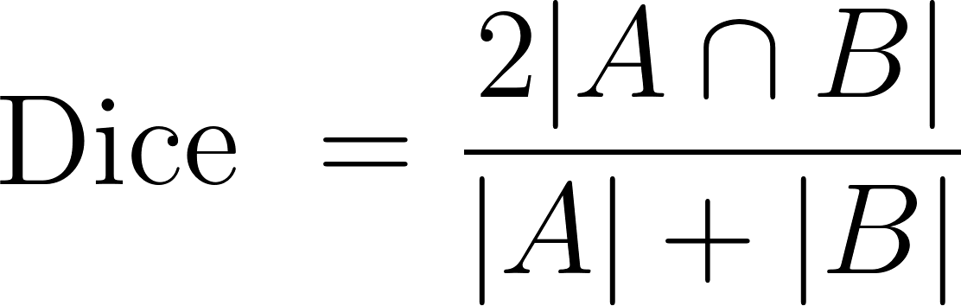
3) Recall / Precision
The Recall / Precision scores could be defined for each class, as well as at the aggregate level, as follows:
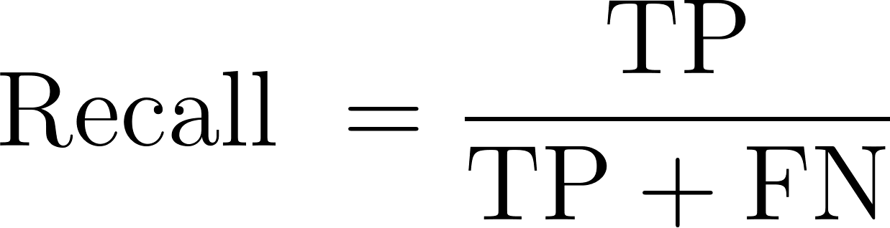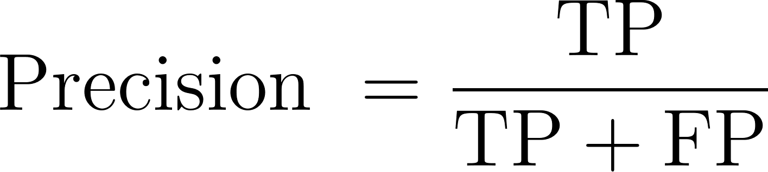
where TP referred to the true positive fraction, FP referred to the false-positive fraction, and FN referred to the false-negative fraction.

IOS mesh segmentation metrics
1) ${ACC}_{a}$
${ACC}_{a}$ means the average-area accuracy. Given a jaw mesh $M=\{m_{i}\}, i=1 to N$ with N faces, the ${ACC}_{a}$ was defined as the ratio of the total area of correctly predicted faces to the whole faces：
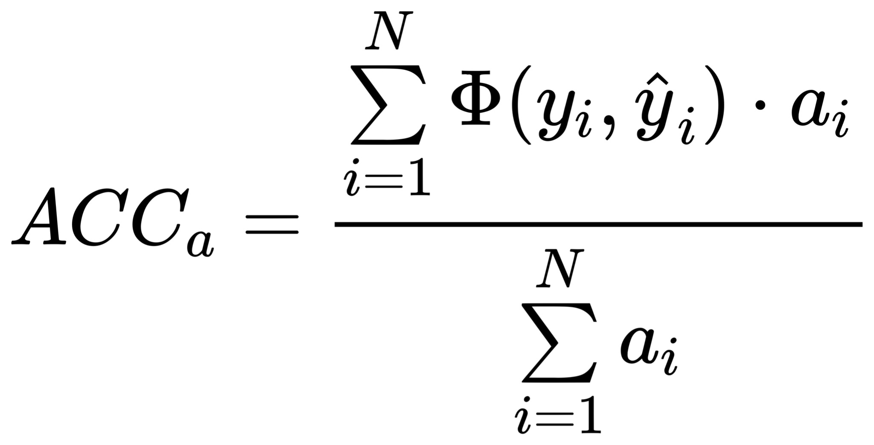
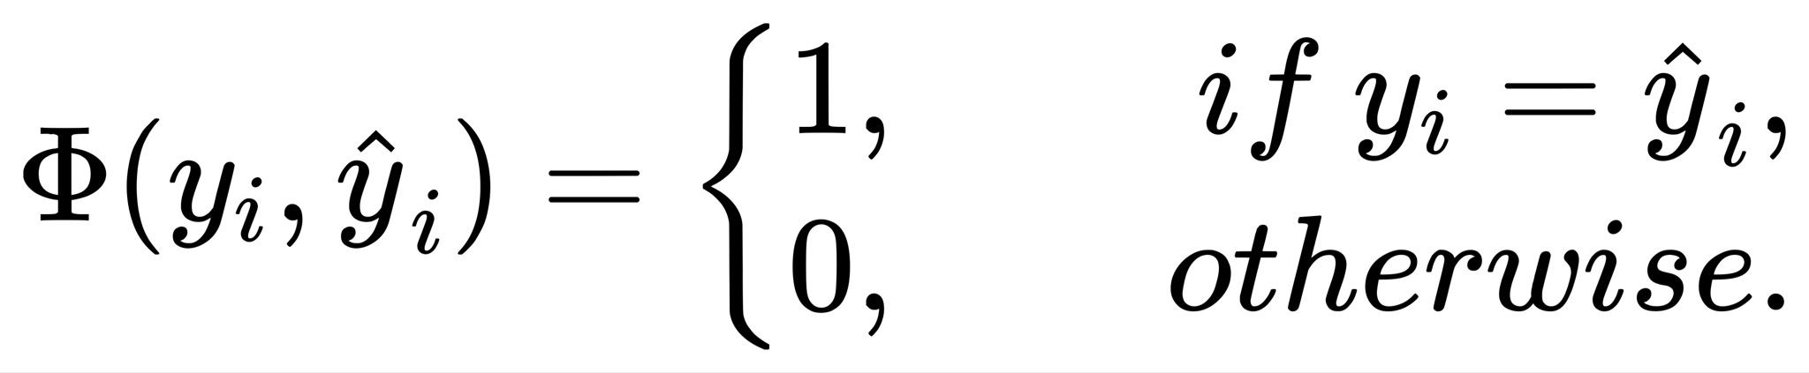
where $a_{i}$ denoted the area for face $m_{i}$, ${\hat{y}}_{i}$ and $y_{i}$ denoted the predicted label and the gold label of face $m_{i}$, respectively, and $Φ(·)$ was the indicator function.
2) ${ACC}_{f}$
${ACC}_{f}$ means the per-face accuracy. Similarly, given a jaw mesh $M=\{m_{i}\}, i=1 to N$ with N faces, the ${ACC}_{f}$ was defined as the ratio of the number of correctly predicted faces to the whole faces:
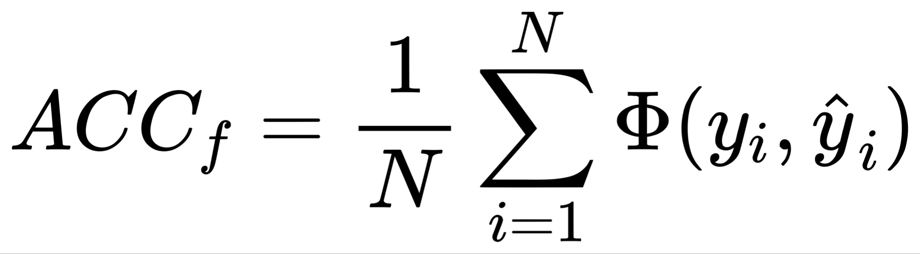
where the meanings of ${\hat{y}}_{i}$ , $y_{i}$ and $Φ(·)$ were the same as above.

Multimodal Fusion metrics. We evaluated the multimodal fusion result by computing the error between the results of DDMA and ground truth. We utilized three distance-based metrics to measure the geometric error, namely, Chamfer distance (CD) ⁸, average absolute distance (ASSD) ⁹, and Hausdorff distance (HD) ⁹. The CD measured the mean distance between two sets of vertices.
The ASSD was defined as follows：
S_{R} and S_{A} were the surfaces of objects of gold standard and algorithm segmentation, respectively, dist (a, S_{R}) was the nearest Euclidean distance from a surface point a to the surface S_{R}, and mean {•} was the arithmetical average operator.
The Hausdorff Distance (HD) between two finite point sets A and B was defined by:
where h(A, B) was called the directed Hausdorff distance and given by
where ||a−b|| was Euclidean distance between a and b.
The Chamfer distance between S₁, S₂ was defined as follow:
For each point, the d_{CD} found the nearest neighbor in the other set and sums the squared distances up. Viewed as a function of point locations in S₁ and S₂, the CD was continuous and piecewise smooth. The range search for each point was independent.

Comparison with Baselines

1) CBCT image segmentation
We introduced state-of-the-art CNNs (Unet, Unet++, FCN, and DeepLabv3) and recently proposed transformer models (Swin transformer) as baselines. The backbone of DeepLabv3 and FCN was ResNet-50 ¹⁰. The Swin Transformer was pre-trained with Imagenet-22k. DeepLabv3, FCN, and standard Swin Transformer were based on the public code at MMSegmentation ¹¹, and the training hyperparameters were in MMSegmentation by default. The training was conducted with 4 Nvidia RTX 3090 GPU and Pytorch 1.8.0 for comparison experiments, and the training procedure lasted for 160K iterations.
We conducted a five-fold cross-validation test, each with a hold-out set of CBCT from 50 patients, to evaluate the segmentation performance of TSTNet. TSTNet achieved an average Dice coefficient and IoU of 93.99% and 88.68%, respectively, significantly outperforming the baselines, as shown in Supplementary Fig. 6. A further individual-level investigation on 43 patients revealed that TSTNet could obtain a 4.62% IoU and 2.73% (Supplementary Table 1). TSTNet can accurately segment the pixels and greatly calibrate the FP and FN pixels (Supplementary Fig. 7). Most methods could achieve a good performance in the jaw dataset, but the results of TSTNet are the closest to the ground truth (Supplementary Fig. 8).
In summary, TSTNet performed better than other state-of-the-art fusion algorithms in most evaluation criteria. Besides, the model complexity and clinical utility of CBCT segmentation were recorded in Supplementary Table 2. The number of parameters was approximately the same as the standard Swin transformer.
2) IOS segmentation
We visualized more randomly chosen segmentation cases (Supplementary Fig. 9). IOSNet could get smoother and more accurate tooth segmentation results than MeshSegNet. In terms of the odd tooth numbers (the 1st row), our IOSNet could identify the incisors accurately. Besides, it could also identify the wisdom/third molar teeth that were hard to detect for MeshSegNet, as illustrated in the 4th-9th rows. In the 2nd row, the IOSNet could separate the neighboring teeth by labeling them as different classes. Smoother teeth-gingiva boundaries were always included in the IOSNet segmentation results.
Additionally, the model complexity and clinical utility of IOS segmentation were recorded in Supplementary Table 3. It indicated that the number of parameters and the inference time of IOSNet was almost the same as the DC-Net. Compared with the baseline, although the IOSNet had more parameters, its inference speed was one order of magnitude faster than the baseline and at least 25 times faster than the human experts, which showed that the IOSNet could achieve highly accurate segmentation at a faster speed. Therefore, our IOSNet had a promising future in clinical dentistry.

3) Multimodal Fusion
We evaluated the multimodal fusion results by computing the error between the results of DDMA and ground truth. We utilized three distance-based metrics to measure the geometric error, namely, Chamfer distance (CD), average absolute distance (ASSD), and Hausdorff distance (HD). AD and HD computed the average and maximum distance between two sets of 10k sampled points from surface meshes. All distances were computed bidirectionally in millimeters (mm). A lower distance meant a better result. The experimental results in 20 cases showed that DDMA achieves a high geometric accuracy (Supplementary Table 8). In addition, the quality of the DDMA result was visualized in Supplementary Fig. 10, which was approximate to the ground truth labeled by professional experts.

Comparison Studies

1) Ablation studies for CBCT segmentation
The performance, designed loss function, and TEC of TSTNet without data augmentation were listed in Supplementary Table 4. Our method led to consistent improvements upon its corresponding modules. We achieved state-of-the-art performance with scores of 93.22% on the IoU metric, respectively, which surpassed results without TEC by 0.35%. This supports our claim that TEC modules can improve segmentation results.
2) Ablation studies for IOS segmentation
We conducted some controlled experiments w.r.t. the proposed loss functions, i.e., the centroid loss and the boundary loss. The results are shown in Supplementary Table 5. With the two losses, the model yielded the highest performance. When the centroid loss was removed from the model, the performance dropped significantly for the mandible and the maxillary. For the mIoU, the performance dropped 2.54% and 1.55% for the mandible and the maxillary, respectively. As for removing the boundary loss, the performance was degraded as well. Given above, adding both the two-loss functions to the network benefits the IOS segmentation.

3) Experiments for Multimodal Fusion
We designed two comparison studies to investigate the performance curvature-based segmentation and registration algorithms. We conducted the comparative studies of the proposed Point Curvature-based Segmentation, as shown in Supplementary Table 6. We achieved the best performance with a 94% success rate. Besides, the visualization of Gaussian curvature and the proposed point curvature on reconstruction mesh was shown in Supplementary Fig. 5. The higher point curvature was mainly distributed at the tooth-tooth boundaries or between the maxillary and mandible contacts, indicating that our point curvature could be employed for curvature-based segmentation.
The results of the registration method for 30 group data are shown in Supplementary Table 7. Our registration method achieved the best performance in registering two modal data.

Supplementary Figure legends
Supplementary Figure 1. The architecture of TSTNet.
Supplementary Figure 2. The details of TSTNet.
Supplementary Figure 3. The architecture of IOSNet.
Supplementary Figure 4. The details of IOSNet.
Supplementary Figure 5. The visualization of colorizing curvature. Red indicates the high curvature areas, and green indicates the low curvature areas.
Supplementary Figure 6. IoU and Dice comparison of 5-fold cross-validation.
Supplementary Figure 7. More visualizations of tooth segmentation results.
Supplementary Figure 8. More visualizations of jaw segmentation results.
Supplementary Figure 9. More visualizations of IOSNet results.
Supplementary Figure 10. More visualizations of DDMA results.

Supplementary Movie Legends
Supplementary Movie 1. Movie related to the patient in Figure 5. Previous treatment planning outcome with IOS.
Supplementary Movie 2. Movie related to the patient in Figure 5. New treatment planning with DDMA framework.
Supplementary Movie 3. Movie related to the patient in Figure 6. Previous treatment planning outcome with IOS.
Supplementary Movie 4. Movie related to the patient in Figure 6. Previous treatment planning outcome with IOS.

References
1 Lorensen, William E., and Harvey E. Cline. "Marching cubes: A high resolution 3D surface construction algorithm." ACM siggraph computer graphics 21.4 (1987): 163-169.
2 Pan, W. et al. HLO: Half-kernel Laplacian operator for surface smoothing. Computer-Aided Design 121, 102807 (2020).
3 Rusu, Radu Bogdan, Nico Blodow, and Michael Beetz. "Fast point feature histograms (FPFH) for 3D registration." 2009 IEEE international conference on robotics and automation. IEEE, (2009).
4 Choi, Sungjoon, Qian-Yi Zhou, and Vladlen Koltun. "Robust reconstruction of indoor scenes." Proceedings of the IEEE Conference on Computer Vision and Pattern Recognition. (2015).
5 Besl, Paul J., and Neil D. McKay. "Method for registration of 3-D shapes." Sensor fusion IV: control paradigms and data structures. Vol. 1611. Spie, (1992).
6 Zhou, Qian-Yi, Jaesik Park, and Vladlen Koltun. "Open3D: A modern library for 3D data processing." arXiv preprint arXiv:1801.09847 (2018).
7 Minaee, Shervin, et al. "Image segmentation using deep learning: A survey." IEEE transactions on pattern analysis and machine intelligence (2021).
8 Fan, Haoqiang, Hao Su, and Leonidas J. Guibas. "A point set generation network for 3d object reconstruction from a single image." Proceedings of the IEEE conference on computer vision and pattern recognition. (2017).
9 Cruz, Rodrigo Santa, et al. "DeepCSR: A 3D deep learning approach for cortical surface reconstruction." Proceedings of the IEEE/CVF Winter Conference on Applications of Computer Vision. (2021).
10 He, Kaiming, et al. "Identity mappings in deep residual networks." European conference on computer vision. Springer, Cham, (2016).
11 Xu, J., Chen, K., Lin, D.: MMSegmenation. https://github.com/openmmlab/mmsegmentation (2020)

