Supplementary Figure 1
Multiple sequence alignment and amino acid conservation of MdCYP proteins.
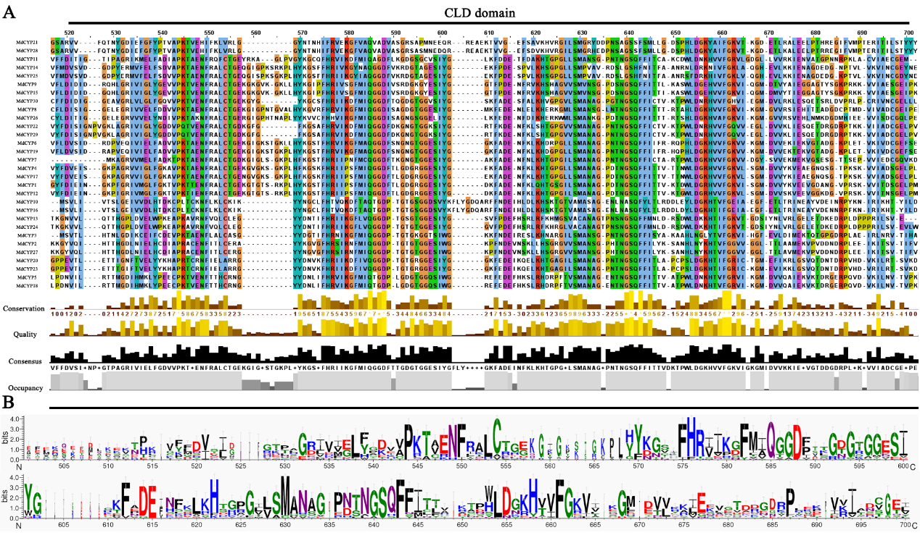

Supplementary Figure 2
Amino acid sequences and conservation of 15 motifs.
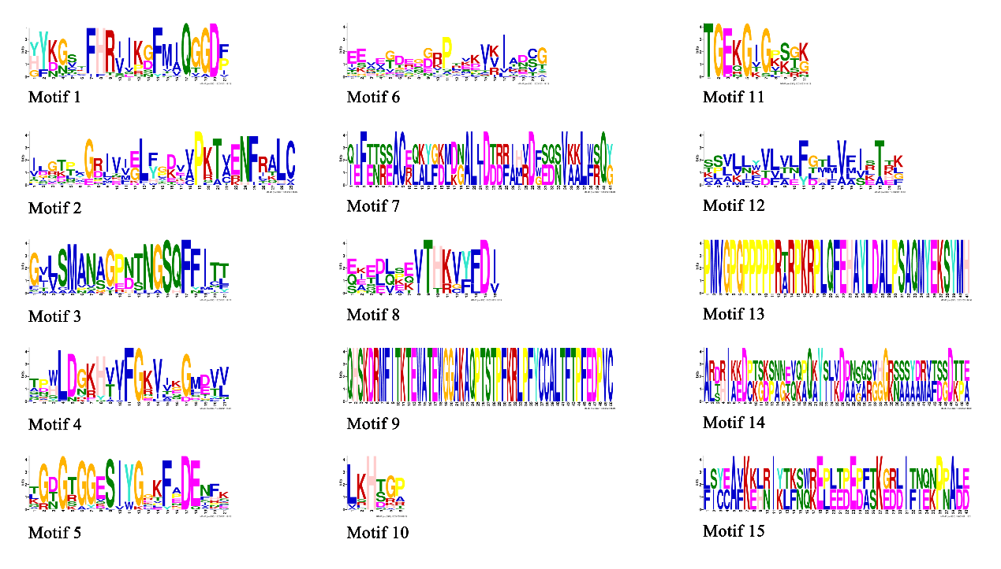

Supplementary Figure 3
Secondary structure statistics of MdCYP proteins.
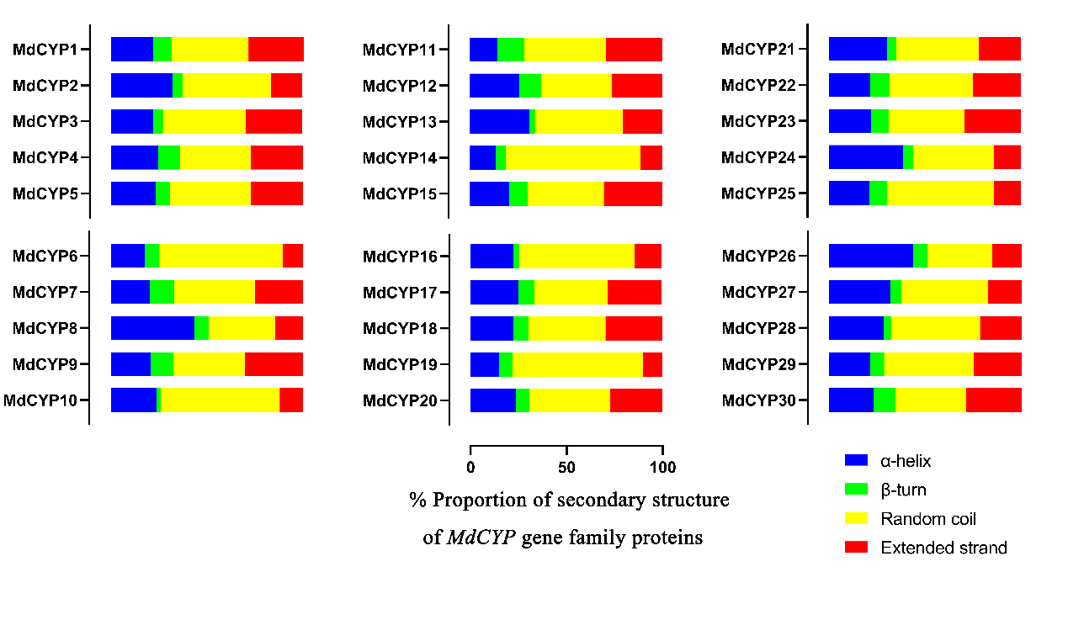
Supplementary Figure 4
Collinearity analysis of MdCYPs in the apple genome-wide context.

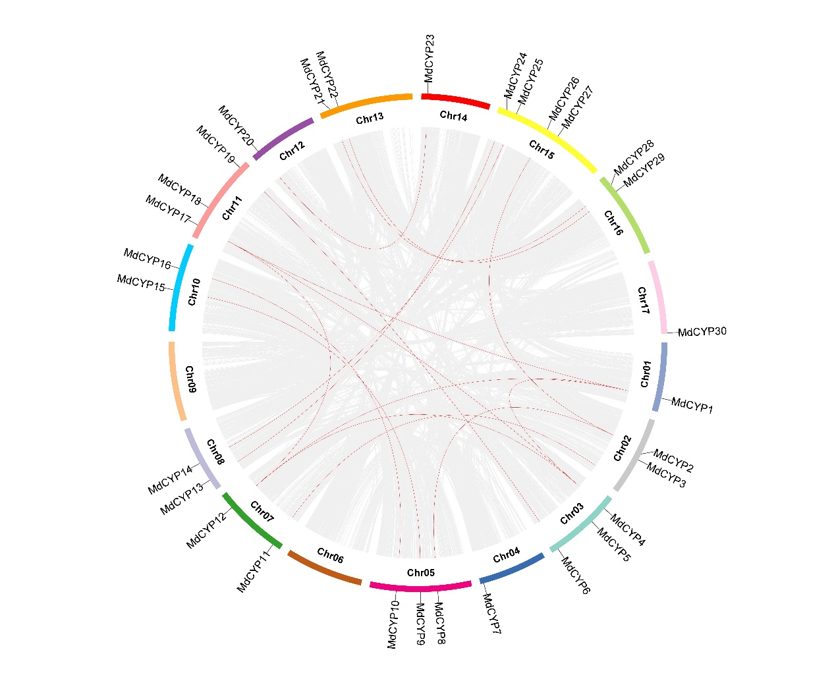
Supplementary Table 1
Segmental duplication genes in colinear gene pairs of MdCYPs.
Gene localization | Gene name | Gene localization | Gene name
Chr1 | MdCYP1 | Chr7 | MdCYP12
Chr3 | MdCYP4 | Chr11 | MdCYP17
Chr3 | MdCYP5 | Chr11 | MdCYP18
Chr3 | MdCYP6 | Chr11 | MdCYP19
Chr5 | MdCYP9 | Chr10 | MdCYP15
Chr5 | MdCYP10 | Chr10 | MdCYP16
Chr8 | MdCYP13 | Chr15 | MdCYP24
Chr8 | MdCYP14 | Chr15 | MdCYP25
Chr13 | MdCYP21 | Chr16 | MdCYP28
Chr13 | MdCYP22 | Chr16 | MdCYP29

Supplementary Table 2
The qRT-PCR primer sequences of MdCYPs.
Gene | Primer
MdCYP1-F | AGGAAAGCGATTTGGAGCAA
MdCYP1-R | GCTCGGAAATTCTCTGTGGT
MdCYP2-F | CATACCGCTAACGTTCCACA
MdCYP2-R | TTCCTGTTGTCTTCACAGCC
MdCYP3-F | GTACACCGTGTTTGGCAAAG
MdCYP3-R | AAGCGGGTTAGCATGTATGG
MdCYP4-F | GTCAATGGCAAATGCTGGTC
MdCYP4-R | CCATTCCAGACAGCACCTTT
MdCYP5-F | CCCACCTTGGTCCAATTGAA
MdCYP5-R | CTCTGTGCGAATCATGACCA
MdCYP6-F | GTCCTGGTGGTTATCGTGTC
MdCYP6-R | TTACAGGAGGTCGGTCAACT
MdCYP7-F | CAAAACCCCGAAAACTGCTG
MdCYP7-R | ATCTCCACCCTGACACATGA
MdCYP8-F | TCACAAACAGCTCTGCTTGT
MdCYP8-R | CATCAACATCGTTAAGCGCC
MdCYP9-F | GGCAAAGGTGTTAAGGGGAA
MdCYP9-R | TCTCATCAGGAAATGTGCCG
MdCYP10-F | GTGCACTTGATCACATTGCC
MdCYP10-R | CACCACCACGCTGTACATTA
MdCYP11-F | ATGTTGTGTTCGGGAGAGTG
MdCYP11-R | ACACAAGCTAGTTTAGGGCG
MdCYP12-F | TCGTATTTGGCAAGGTGCTT
MdCYP12-R | ATTGGAAGTTCGCCACTGTT
MdCYP13-F | CCGGTACACCCAATTCGAAT
MdCYP13-R | ATCCCCAGTTACCTTTCCGA
MdCYP14-F | AGAAAACCGCTGCACTACAA
MdCYP14-R | GAGCACAGGTGACTCATCTG
MdCYP15-F | CGTCCTCGCCATTTTCCTAA
MdCYP15-R | TACCTAAGTGCTGTCCGTCA
MdCYP16-F | GGTGCACTTGATCACATTGC
MdCYP16-R | CACCACGCTGTCCATTATCA
MdCYP17-F | ACTGGTTGGATGGCAAACAT
MdCYP17-R | ATCACGACTTTGCTCTTGGG
MdCYP18-F | CCCACCTTGGTCCAATTGAA
MdCYP18-R | CTCTGTGCGAATCATGACCA
MdCYP19-F | GGGGGTTTGTCAAAAAGCAC
MdCYP19-R | GGAATTACGGAGTGAACGCT
MdCYP20-F | CTGGAGCTGGCATCTTATCG
MdCYP20-R | CTCCATTCCTGTGCAGATCC
MdCYP21-F | CATCGGGAAGGGATTTTCGT
MdCYP21-R | CCTCTGCTTCATGACAGACC
MdCYP22-F | ATATGCACGGTCAAGACACC
MdCYP22-R | CTTTGTAGGGCGATCACCTC
MdCYP23-F | CGAATGCTGGTCCGAATACA
MdCYP23-R | TATCAGTCTGGACACTGCCA
MdCYP24-F | CCGGTACACCCAATTCGAAT
MdCYP24-R | AGTTTCGAGTTCACCCAACC
MdCYP25-F | GTTGTTCCCAAGACTGCAGA
MdCYP25-R | TCGCCACCCTGTGCTATATA
MdCYP26-F | GCTAATAAGGGCCCTGACAC
MdCYP26-R | TGATCACCTTTCCAAACGCA
MdCYP27-F | TACGCCATTTGAAGACCCAG
MdCYP27-R | TGTGGAACGTTAGCGGTATG
MdCYP28-F | ACCGAGCGCATTACAATTCT
MdCYP28-R | GATTTCAATGGCAGCTGCAG
MdCYP29-F | TTCAAGGAGGGGACTTCGAT
MdCYP29-R | GCTAACAACTCCTGGTCCAG
MdCYP30-F | CTCTTTCCACCGCATCATCA
MdCYP30-R | GGACCAACATGCTTCAATGC

Supplementary Table 3
Primer of coding sequence and promoter sequence of MdCYP16.
MdCYP16-F | ATGTCAGTGCTTATAGTGAC
MdCYP16-R | TCGCCTTCTATGTTCTTTTT
pENTR-MdCYP16-F | AAGGAGCCCTTCACCATGTCAGTGCTTATAGTGAC
pENTR-MdCYP16-R | GGCGCGCCCCCTTTCGCCTTCTATGTTCTTTTT
ProMdCYP16-F | ACCATTCATTGCCGAGGATA
ProMdCYP16-R | GGTCTCTCACTGCATTCAAC
ProMdCYP16::GUS-F | CCGGAATTCCCGGGGACCATTCATTGCCGAGGATA
ProMdCYP16::GUS-R | TAGCTTGGCTGCAGGGGTCTCTCACTGCATTCAAC

