 | Forward Primers | Reverse Primers
HOTAIR | CAAACAGAGTCCGTTCAGTGTC | AAAGGCTTTCCTATAACCCAAG
SOX2 | AAGTATCAGGAGTTGTCAAGGCAGAG | GTCCTAGTCTTAAAGAGGCAGCAA
c-Myc | AAGTATCAGGAGTTGTCAAGGCAGAG | GTCCTAGTCTTAAAGAGGCAGCAA
Oct4 | AGGTATTCAGCCAAACGACCATC | TCAGCTTCCTCCACCCACTTCT
Nanog | AGAATGAAATCTAAGAGGTGGCA | CCCTGGTGGTAGGAAGAGTAAA
ALDH1A | TTGATAAAGCCATAACAATCTCCTC | TCCAGACATCTTGAATCCACCA
Cyclin D1 | GTCCCACTCCTACGATACGCTAC | AACCAGCATCTCATAAACAGGTCA
Cyclin D2 | TTCTGGTATCTGGCGTTCTTTG | CAGGCTTGTCTGAGGAATGTTG
p65 | GACTACGACCTGAATGCTGTGCG | CGATTGTCAAAGATGGGATGAGAAAG
p50 | GGATTTCGTTTCCGTTATGTATG | CCTGAGGGTAAGACTTCTTGTTCT
IKKα: | GGCATGAGAAGATTAAGAAGAA | GTAAATGGCTACTAAACCGAAC
IκBα: | ATCCTGAAGGCTACCAACTACAATG | ATCAGCACCCAAGGACACCAAA
IκBα promter1-500 | TGTTTGGCCTGTGGTTGGAGAC | TTCCTCAACTGGCAATTAGGGT
IκBα promter 500-1000 | GTAATAAAGGCTTGAAGGGTCT | GGTTTCTTGTGACATTTGCTCC
IκBα promter 1000-1500 | ATTATCCCTTTCCTGATCCACA | AGACCACTAAATACTGGCTCCT
IκBα promter 1500-2000 | CTCAGCTCACTGCAACCTCCAC | GGCACCTGTAATCCCAGCTACT
IκBα promter 2000-2500 | GGTAAGATGGGAGTGGGGTGAT | TACTAAGGGCATCGTTCCAAAA
IκBα promter 2500-3000 | AATTCTCCTGCCTCAGCCTCCC | GGCGAAACCCCATCTCCACTAA
Supplementary Table 1 Primers used for Real-time PCR

Supplementary Figure 1

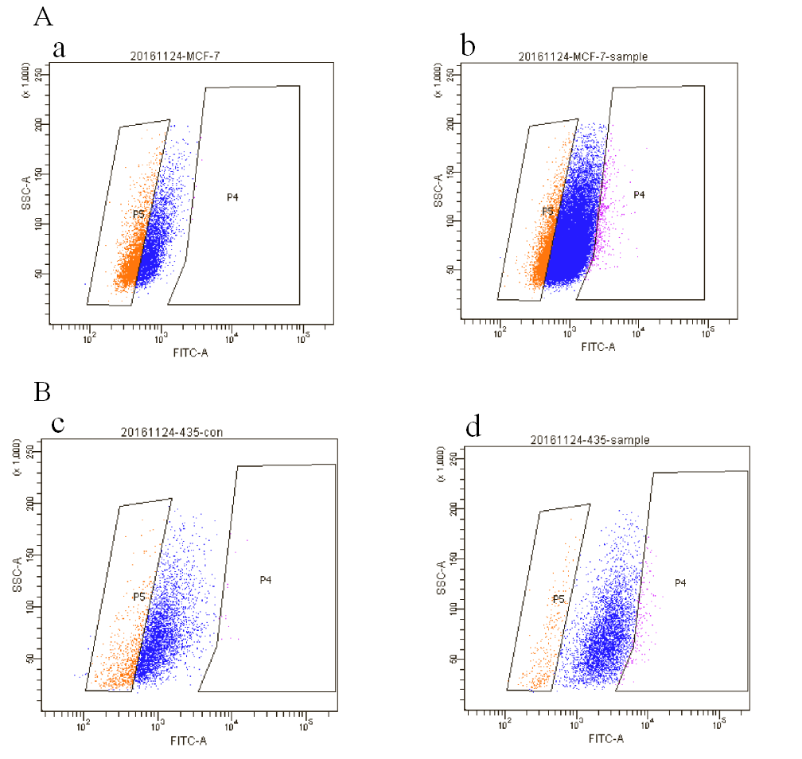
(A) Flow cytometric sorting of ALDH1 positive and negative side population cells in MCF7. a: ALDH1 green fluorescence quenched control sample, b: ALDH1-labeled sample. (B) Flow cytometric sorting of ALDH1 positive and negative side population cells in MDA-MB-435. c: ALDH1 green fluorescence quenched control sample, d: ALDH1-labeled sample.

