Supplementary materials

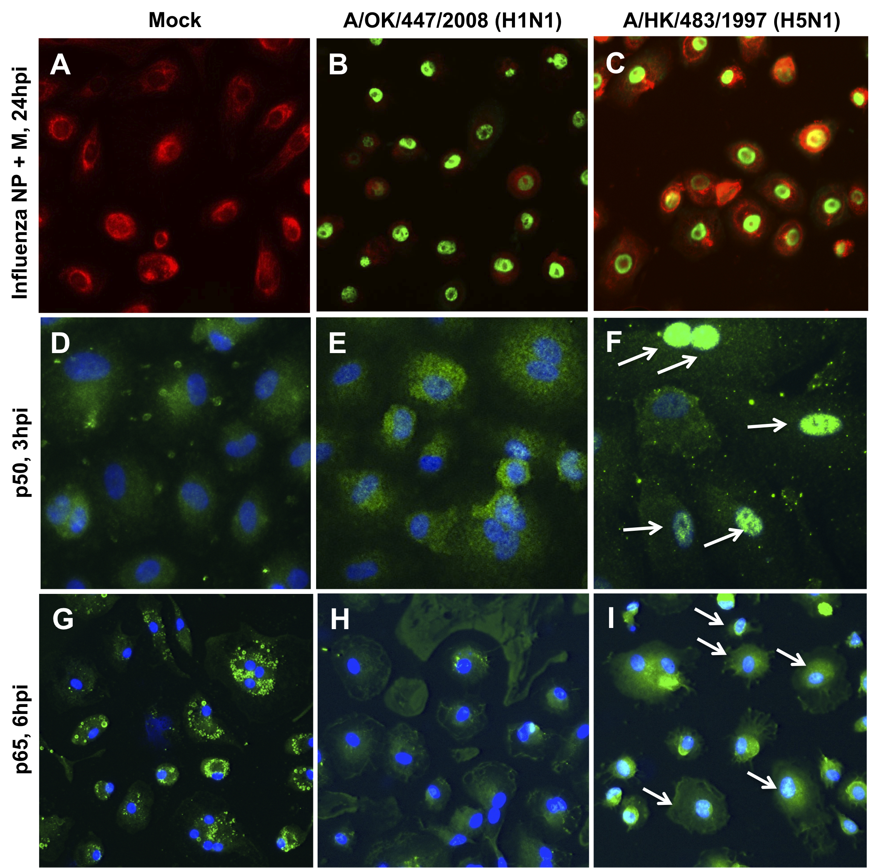
Supp Figure 1. p50 and p65 nuclear translocation in human type I-like pneumocyte upon influenza virus infection. Immunofluorescence staining of type I-like Pϕ with mock, A/OK/447/08 (H1N1) and A/HK/483/97 (H5N1). (A-C) The influenza virus nucleoprotein and matrix protein were stained in green with FITC-conjugated mouse antibody. At 24 hpi the infection rate of H1N1 and H5N1 was similar, as described previously(1). (D-F) p50 and (G-I) p65 proteins were stained in green with FITC-conjugated antibody, while cell nucleus DNA was stained in blue with DAPI. Nuclear translocation of these two proteins were monitored at 10 min, 20 min, 30 min, 1 h, 3 h, 6 h, 16 h and 24 h post infection with TNFα + IL-1β 1600ρg/ml incubation as a positive control. Significant p50 and p60 nuclear translocation were observed at 3 hpi and 6 hpi, respectively in H5N1 infected pneumocytes (indicate by white arrows).

