Supplementary Materials
Fig. S1. Risk of bias graph: review authors' judgements about each risk of bias item presented as percentages across all included studies.
Fig. S2. Risk of bias summary: review authors' judgements about each risk of bias item for each included study.
Fig. S3. Overall Covid-19 death, Gynecologic cancer versus control.
Fig. S4. Overall Covid-19 severity, Gynecologic cancer versus control.
Fig. S5. Overall Covid-19 hospitalization, Gynecologic cancer versus control.
Fig. S6. Overall Covid-19 infection, Gynecologic cancer versus control.
Fig. S7. Covid-19 infection, Gynecologic cancer versus other cancer.
Fig. S8. Severe Covid-19, Gyn-Onco VS Other Cancer.
Fig. S9. Covid-19 hospitalization, Gynecologic cancer versus other cancer.
Fig. S10. Covid-19 infection, Gynecologic cancer versus non cancer.
Fig. S11. Covid-19 severity, Gynecologic cancer versus non cancer.
Fig. S12. Covid-19 infection among cancer treatment.
Fig. S13. Covid-19 death from cancer treatment.
Fig. S14. Covid-19 severity among cancer treatment.
Fig. S15. Covid-19 death Gyn-Onco cancer treatment VS no treatment.
Fig. S16. Covid-19 severity, Gynecologic cancer on cancer treatment versus no treatment.
Fig. S17. Covid-19 death, Among metastasis.
Fig. S18. Covid-19 infection, Gynecologic cancer versus lung cancer.
Fig. S19. Covid-19 infection, Gyn-Onco VS Breast Cancer.
Fig. S20. Severe Covid-19, Gyn-Onco VS Breast Cancer.
Fig. S21. Funnel plot of overall Covid-19 events studies.
Fig. S22. Funnel plot of overall Covid-19 infection studies.
Fig. S23. Funnel plot overall Covid-19 events with subgroup analysis.
Fig. S24. Funnel plot overall Covid-19 infection with subgroup analysis.
Table S1. Sensitivity analysis by exclusion of 12 studies with overlapped study period and study center.

Fig. S1. Risk of bias graph: review authors' judgements about each risk of bias item presented as percentages across all included studies.
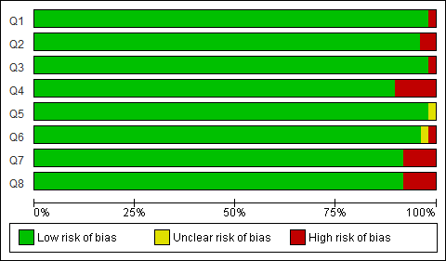

Fig. S2. Risk of bias summary: review authors' judgements about each risk of bias item for each included study.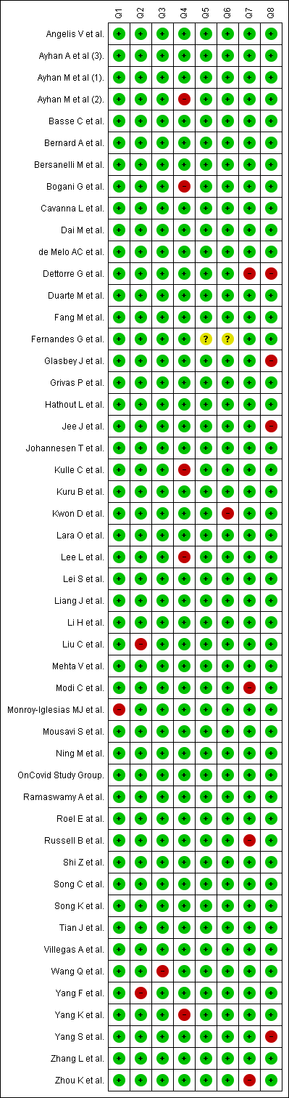
Fig. S3. Overall Covid-19 death, Gynecologic cancer versus control.
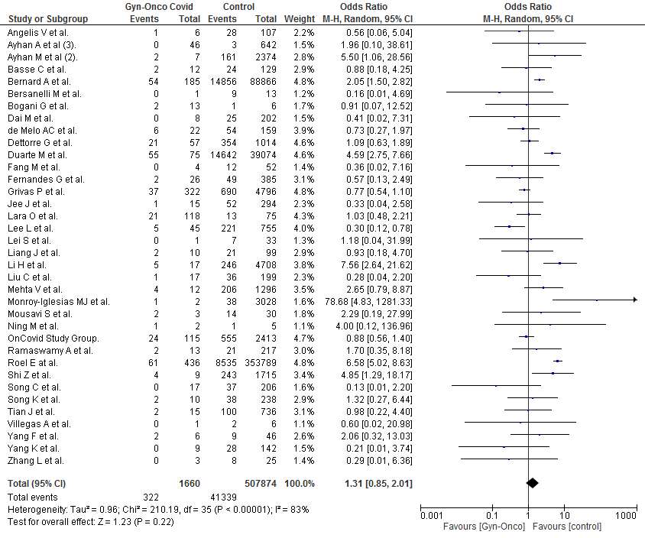
Fig. S4. Overall Covid-19 severity, Gynecologic cancer versus control.
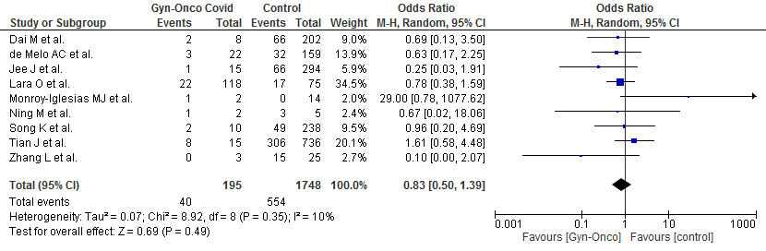

Fig. S5. Overall Covid-19 hospitalization, Gynecologic cancer versus control.
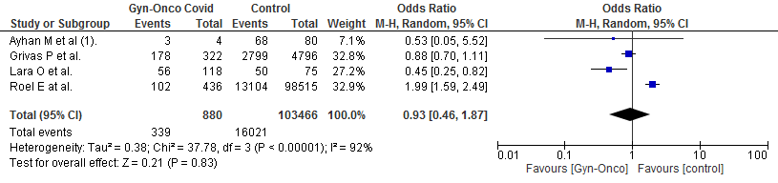
Fig. S6. Overall Covid-19 infection, Gynecologic cancer versus control.
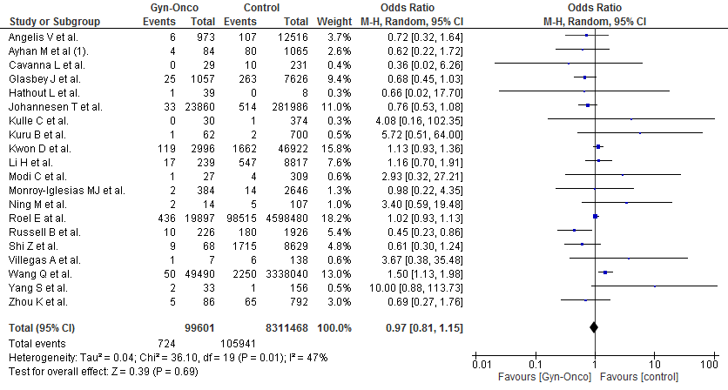
Fig. S7. Covid-19 infection, Gynecologic cancer versus other cancer.
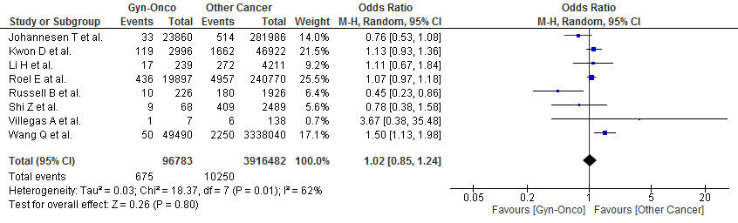

Fig. S8. Severe Covid-19, Gyn-Onco VS Other Cancer.
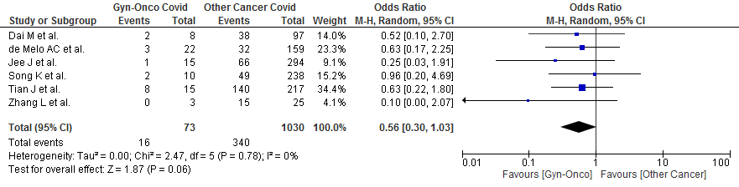
Fig. S9. Covid-19 hospitalization, Gynecologic cancer versus other cancer.
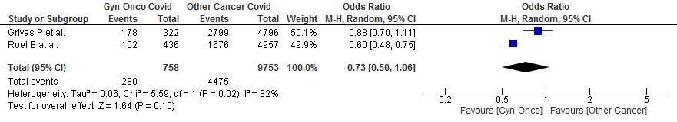
Fig. S10. Covid-19 infection, Gynecologic cancer versus non cancer.
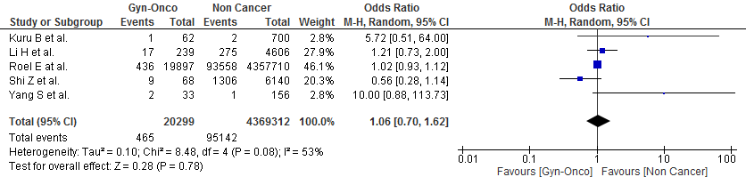
Fig. S11. Covid-19 severity, Gynecologic cancer versus non cancer.
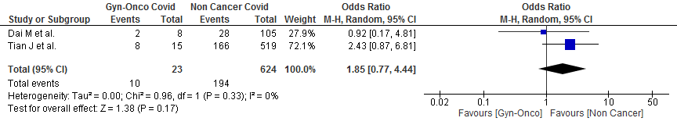

Fig. S12. Covid-19 infection among cancer treatment.
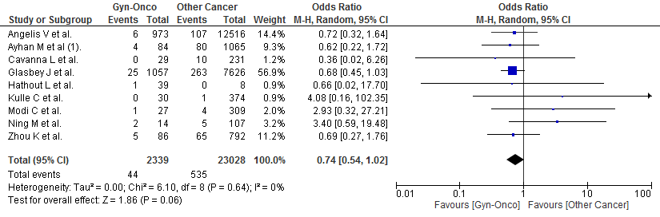
Fig. S13. Covid-19 death from cancer treatment.
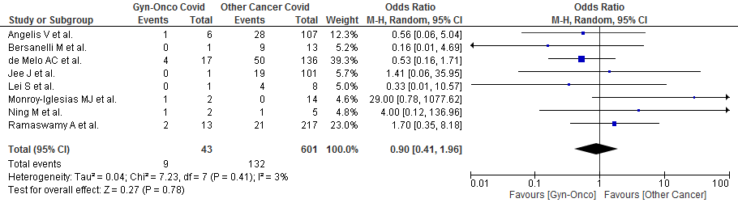

Fig. S14. Covid-19 severity among cancer treatment.
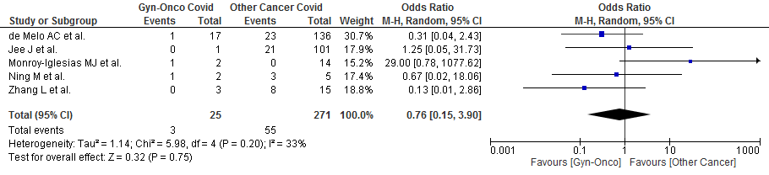

Fig. S15. Covid-19 death Gyn-Onco cancer treatment VS no treatment.
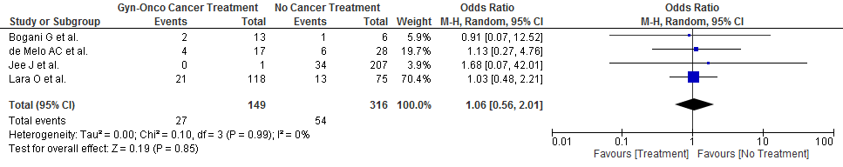
Fig. S16. Covid-19 severity, Gynecologic cancer on cancer treatment versus no treatment.
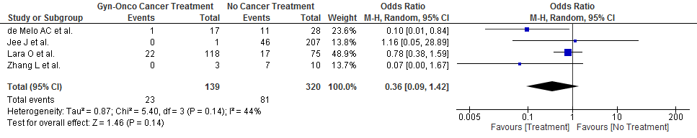
Fig. S17. Covid-19 death, Among metastasis.
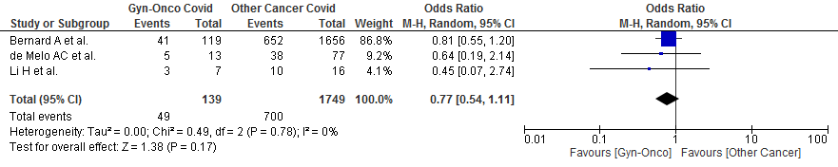
Fig. S18. Covid-19 infection, Gynecologic cancer versus lung cancer.
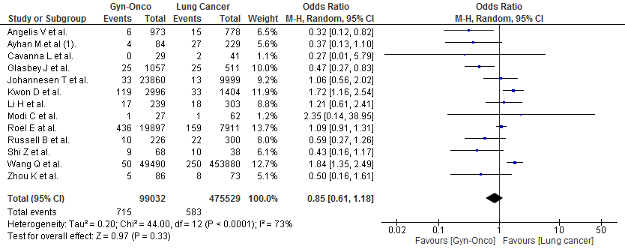

Fig. S19. Covid-19 infection, Gyn-Onco VS Breast Cancer.
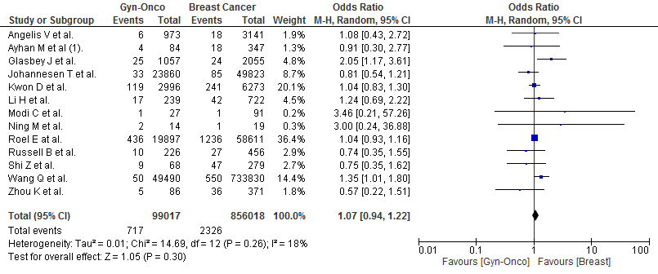
Fig. S20. Severe Covid-19, Gyn-Onco VS Breast Cancer.
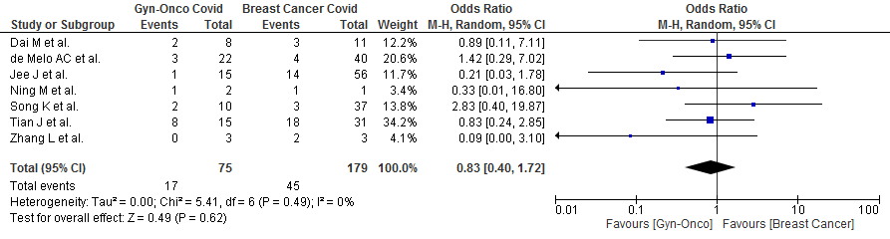

Fig. S21. Funnel plot of overall Covid-19 events studies.
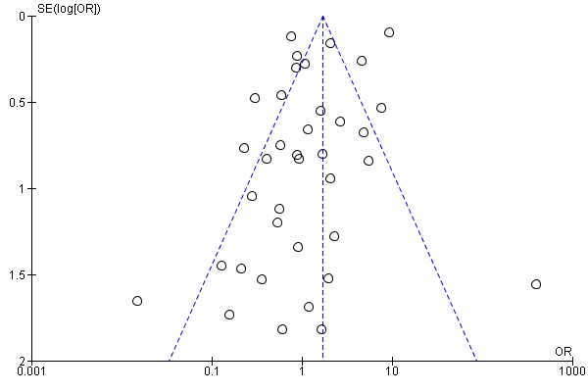

Fig. S22. Funnel plot of overall Covid-19 infection studies.
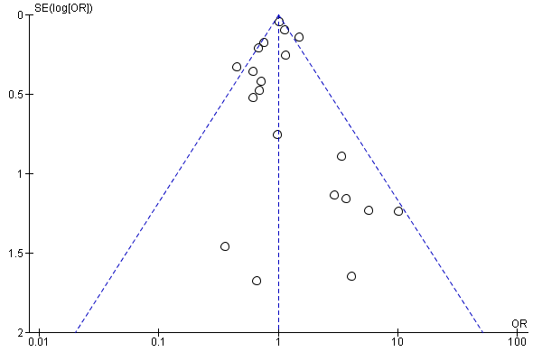

Fig. S23. Funnel plot overall Covid-19 events with subgroup analysis.
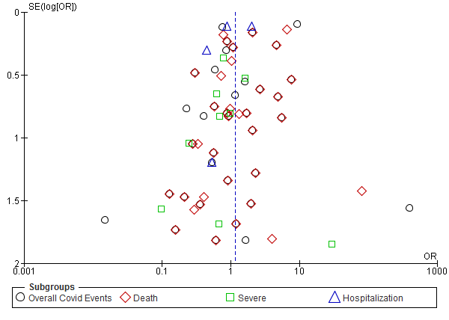

Fig. S24. Funnel plot overall Covid-19 infection with subgroup analysis.
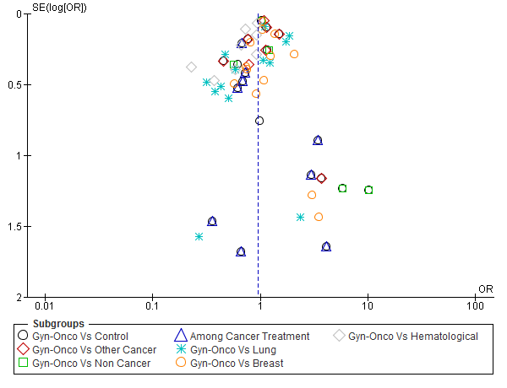
Table S1. Sensitivity analysis by exclusion of 12 studies with overlapped study period and study center.
Outcomes | No. of  studies | OR | (95% CI) | I² | p
Overall Death Longest Study Time | 25 | 1.53 | [0.94, 2.50] | 87% | 0.09
Overall Severe Longest Study Time | 5 | 0.74 | [0.33, 1.65] | 23% | 0.47
Overall Hospitalization Longest Study Time | 4 | 0.93 | [0.46, 1.87] | 92% | 0.83
Overall Infection Longest Study Time | 18 | 0.98 | [0.82, 1.16] | 45% | 0.81
Infection Gyn-Onco Vs Other Cancer Longest Study Time | 7 | 1.04 | [0.85, 1.27] | 66% | 0.69
Infection Gyn-Onco Vs Non Cancer Longest Study Time | 3 | 1.06 | [0.86, 1.31] | 15% | 0.59
Infection Among Cancer Treatment Longest Study Time | 9 | 0.74 | [0.54, 1.02] | 0% | 0.06
Infection Gyn-Onco Vs Lung Longest Study Time | 12 | 0.89 | [0.64, 1.24] | 73% | 0.50
Infection Gyn-Onco Vs Breast Longest Study Time | 12 | 1.08 | [0.95, 1.24] | 21% | 0.24
Infection Gyn-Onco Vs Hematological Longest Study Time | 7 | 0.71 | [0.56, 0.91] | 71% | 0.006
Death Gyn-Onco Vs Other Cancer Longest Study Time | 17 | 0.84 | [0.71, 0.99] | 8% | 0.03
Death Gyn-Onco Vs Non Cancer Longest Study Time | 7 | 3.12 | [2.38, 4.08] | 29% | <0.0001
Death Gyn-Onco Covid Vs Other Cancer Non Covid Longest Study Time | 4 | 12.21 | [8.39, 17.77] | 6% | <0.0001
Death Cancer Treatment VS No Treatment Longest Study Time | 4 | 1.06 | [0.56, 2.01] | 0% | 0.85
Death Among Cancer Treatment Longest Study Time | 8 | 0.90 | [0.41, 1.96] | 3% | 0.78
Death Gyn-Onco Meta VS Local Cancer Longest Study Time | 3 | 1.53 | [1.06, 2.21] | 0% | 0.02
Death Among Metastasis Longest Study Time | 3 | 0.77 | [0.54, 1.11] | 0% | 0.17
Death Gyn-Onco Vs Lung Longest Study Time | 19 | 0.53 | [0.44, 0.63] | 0% | <0.0001
Death Gyn-Onco Vs Breast Longest Study Time | 18 | 1.46 | [1.18, 1.82] | 19% | 0.0006
Death Gyn-Onco Vs Hematological Longest Study Time | 15 | 0.73 | [0.56, 0.95] | 46% | 0.02
Severe Gyn-Onco Vs Other Cancer Longest Study Time | 3 | 0.60 | [0.25, 1.47] | 0% | 0.27
Severe Cancer Treatment VS No Treatment Longest Study Time | 3 | 0.48 | [0.12, 1.92] | 43% | 0.3
Severe Among Cancer Treatment Longest Study Time | 4 | 1.18 | [0.19, 7.49] | 36% | 0.86
Severe Gyn-Onco Vs Lung Longest Study Time | 3 | 0.53 | [0.16, 1.77] | 0% | 0.30
Severe Gyn-Onco Vs Breast Longest Study Time | 4 | 0.95 | [0.29, 3.15] | 21% | 0.93
Severe Gyn-Onco Vs Hematological Longest Study Time | 2 | 0.31 | [0.09, 1.01] | 0% | 0.05
Hospitalization Gyn-Onco Vs Other Cancer Longest Study Time | 2 | 0.73 | [0.50, 1.06] | 82% | 0.1
Hospitalization Gyn-Onco Vs Lung Longest Study Time | 2 | 0.54 | [0.40, 0.73] | 0% | <0.0001
Hospitalization Gyn-Onco Vs Breast Longest Study Time | 2 | 1.52 | [1.18, 1.96] | 0% | 0.001

