Supplementary Information

Atomic-scale identification of the active sites of nanocatalysts
Yao Yang^{1,8}, Jihan Zhou^{1,8}, Zipeng Zhao^{2,8}, Geng Sun^{3,8}, Saman Moniri¹, Colin Ophus⁴, Yongsoo Yang¹, Ziyang Wei⁵, Yakun Yuan¹, Cheng Zhu⁶, Yang Liu², Qiang Sun⁷, Qingying Jia⁷, Hendrik Heinz⁶, Jim Ciston⁴, Peter Ercius⁴, Philippe Sautet^{3,5}, Yu Huang², Jianwei Miao^{1*}
¹Department of Physics & Astronomy and California NanoSystems Institute, University of California, Los Angeles, CA 90095, USA. ²Department of Materials Science and Engineering, University of California, Los Angeles, CA 90095, USA. ³Department of Chemical and Biomolecular Engineering, University of California, Los Angeles, Los Angeles, CA 90095, USA. ⁴National Center for Electron Microscopy, Molecular Foundry, Lawrence Berkeley National Laboratory, Berkeley, CA 94720, USA. ⁵Department of Chemistry and Biochemistry, University of California, Los Angeles, Los Angeles, CA 90095, USA. ⁶Department of Chemical and Biological Engineering, University of Colorado at Boulder, Boulder, CO, USA. ⁷Department of Chemistry and Chemical Biology, Northeastern University, Boston, MA, USA
⁸These authors contributed equally to this work. *e-mail: miao@physics.ucla.edu

Supplementary Figures

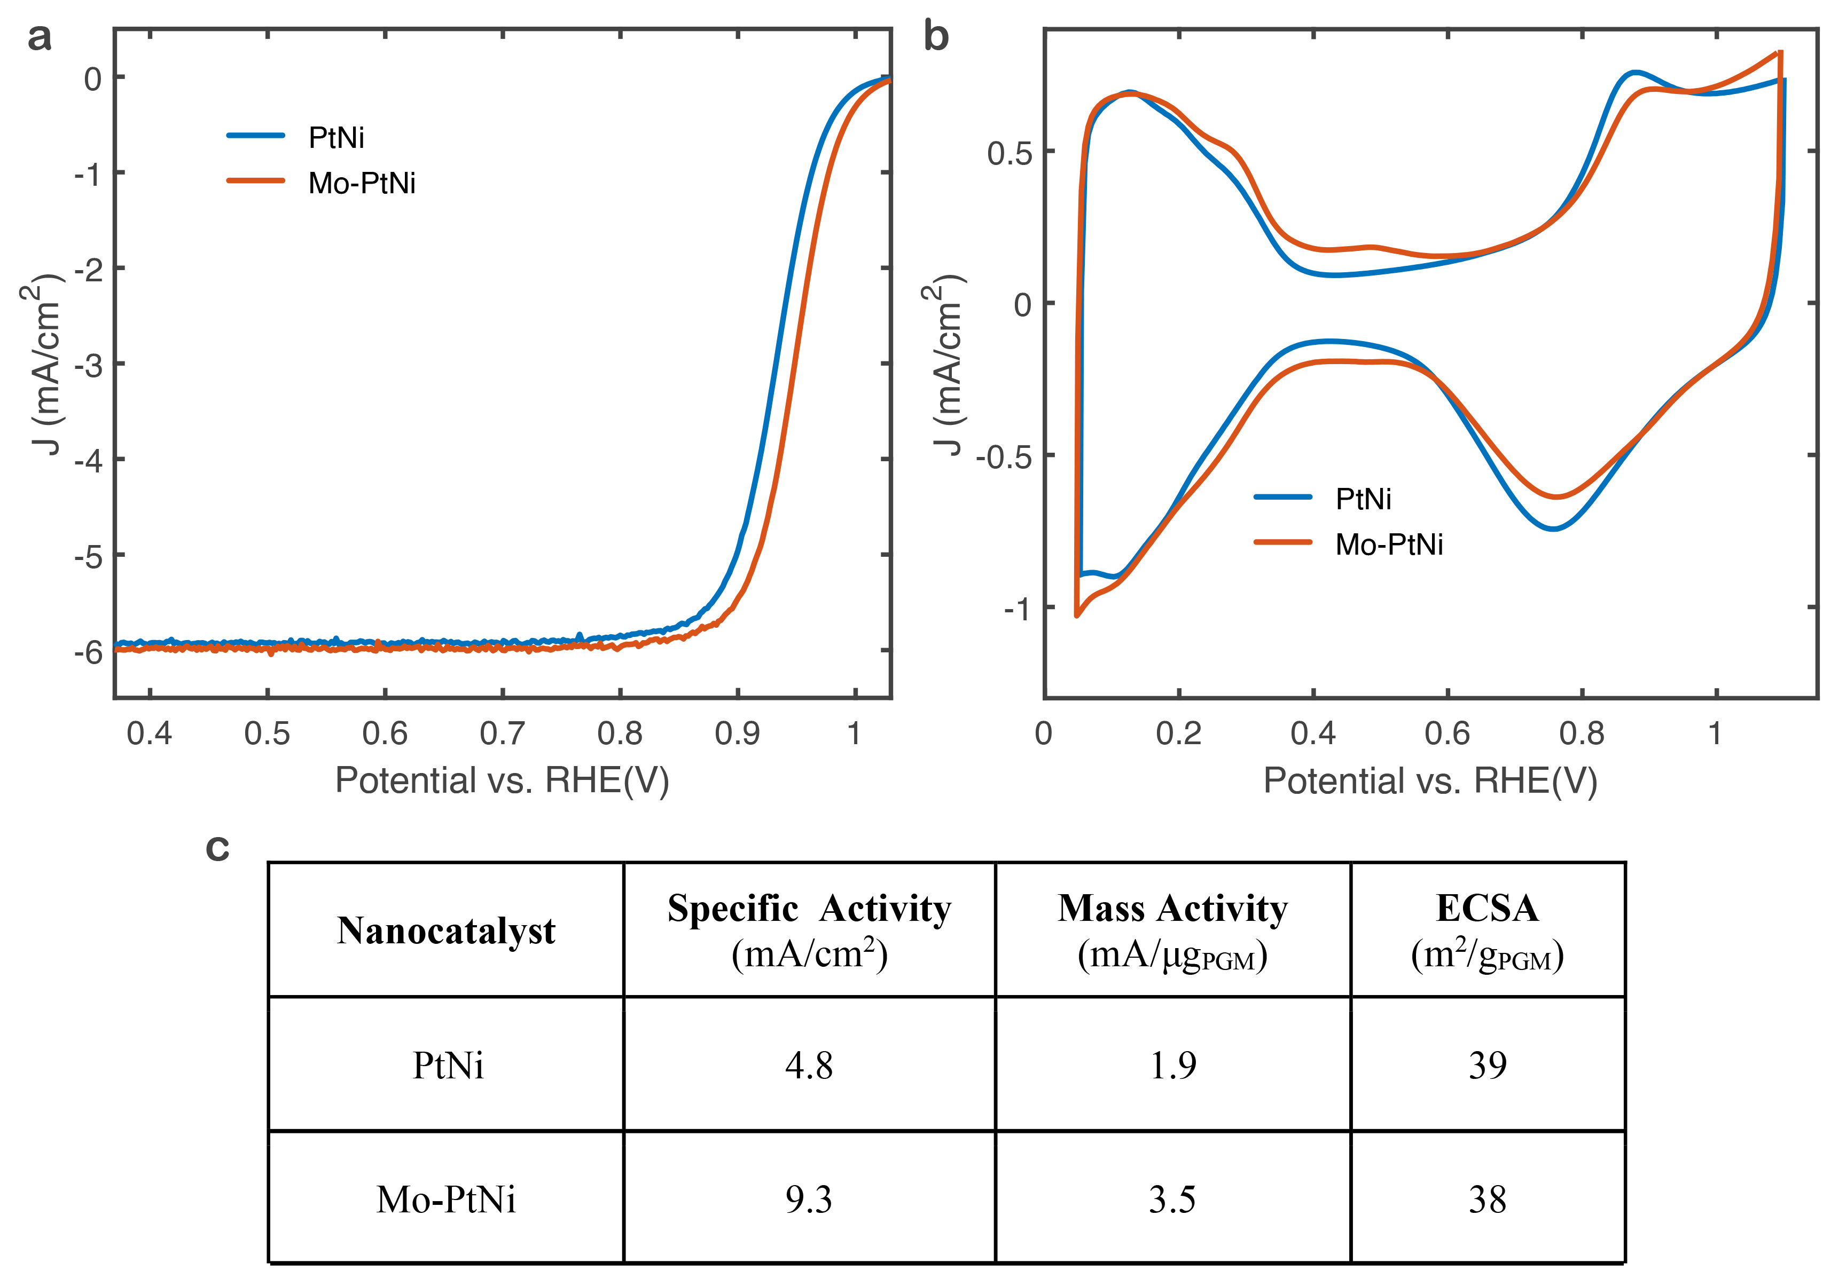

Supplementary Fig. 1 | Electrochemical measurements of the PtNi and Mo-PtNi nanocatalysts. a, ORR polarization curves of the nanocatalysts after 30-cycle cyclic voltammetry (CV) activation. The ORR plots were recorded at room temperature in an O₂-saturated 0.1 M HClO₄ aqueous solution with a sweep rate of 20 mV/s and a rotation rate of 1600 rpm. b, CVs of the nanocatalysts. The CV plots were recorded after ORR test at room temperature in a N₂ saturated 0.1 M HClO₄ electrolyte with sweep rate of 100 mV/s. c, The measured specific activity, mass activity, and electrochemically active surface area (ECSA) of the nanocatalysts.

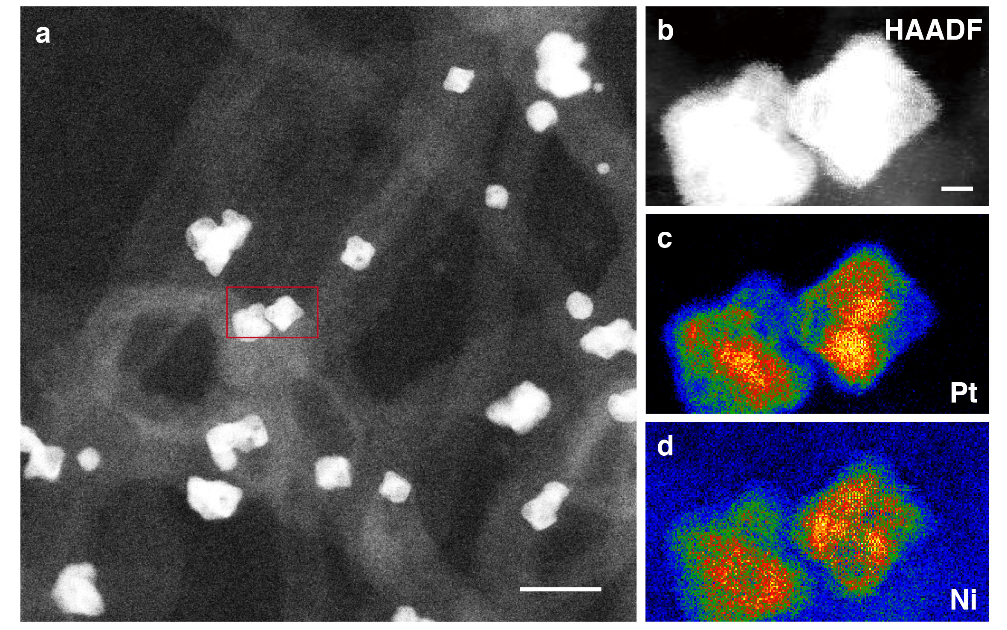
Supplementary Fig. 2 | PtNi nanoparticles embedded in a carbon nanotube matrix. a, ADF-STEM image of nanoparticles. b, A magnified image of two PtNi nanoparticles, corresponding to the rectangular region in (a). c, d, Electron energy loss spectroscopy maps of the distribution of Pt (c) and Ni (d) in the PtNi nanoparticles, showing that individual Ni but not Pt atoms are distributed around the nanoparticles. Scale bars, 20 nm in (a) and 2 nm in (b).

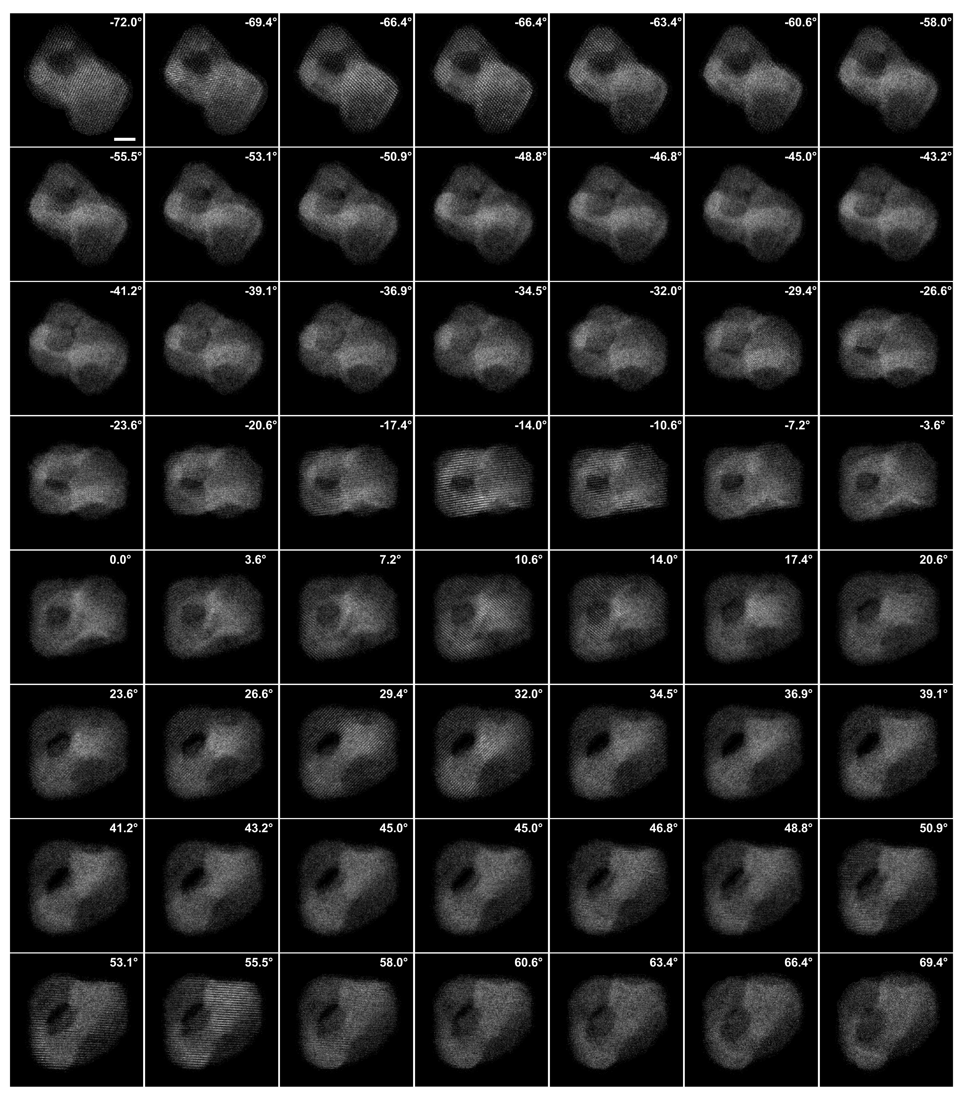
Supplementary Fig. 3 | Experimental tomographic tilt series of a PtNi nanoparticle (particle 1), showing 56 ADF-STEM images with a tilt range from -72.0° to +69.4°. The 3D atomic structure and chemical composition of the nanoparticle are shown in Fig. 1 (1st row). Scale bar, 2 nm.

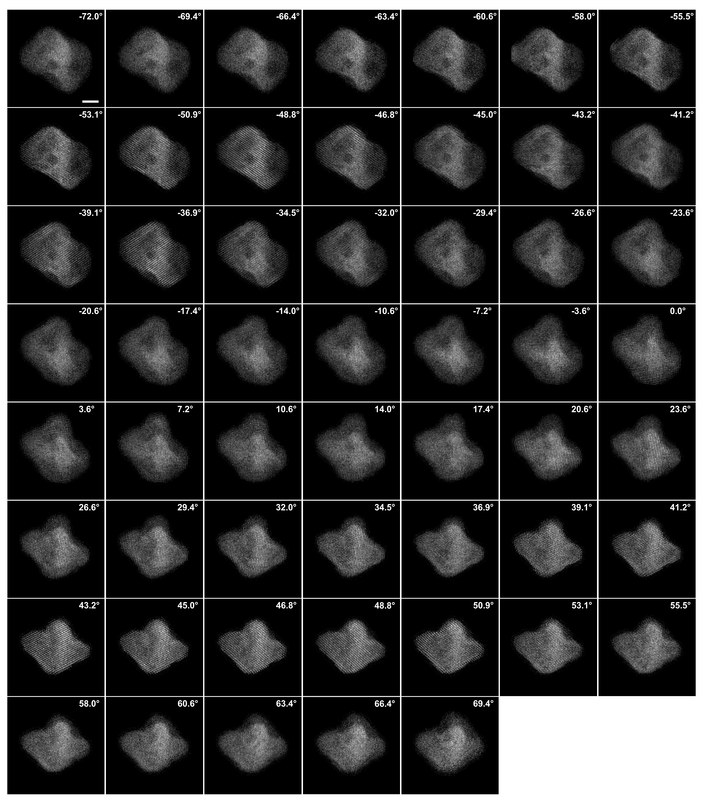
Supplementary Fig. 4 | Experimental tomographic tilt series of a PtNi nanoparticle (Particle #2), showing 54 ADF-STEM images with a tilt range from -72.0° to +69.4°. The 3D atomic structure and chemical composition of the nanoparticle are shown in Fig. 1 (2nd row). Scale bar, 2 nm.

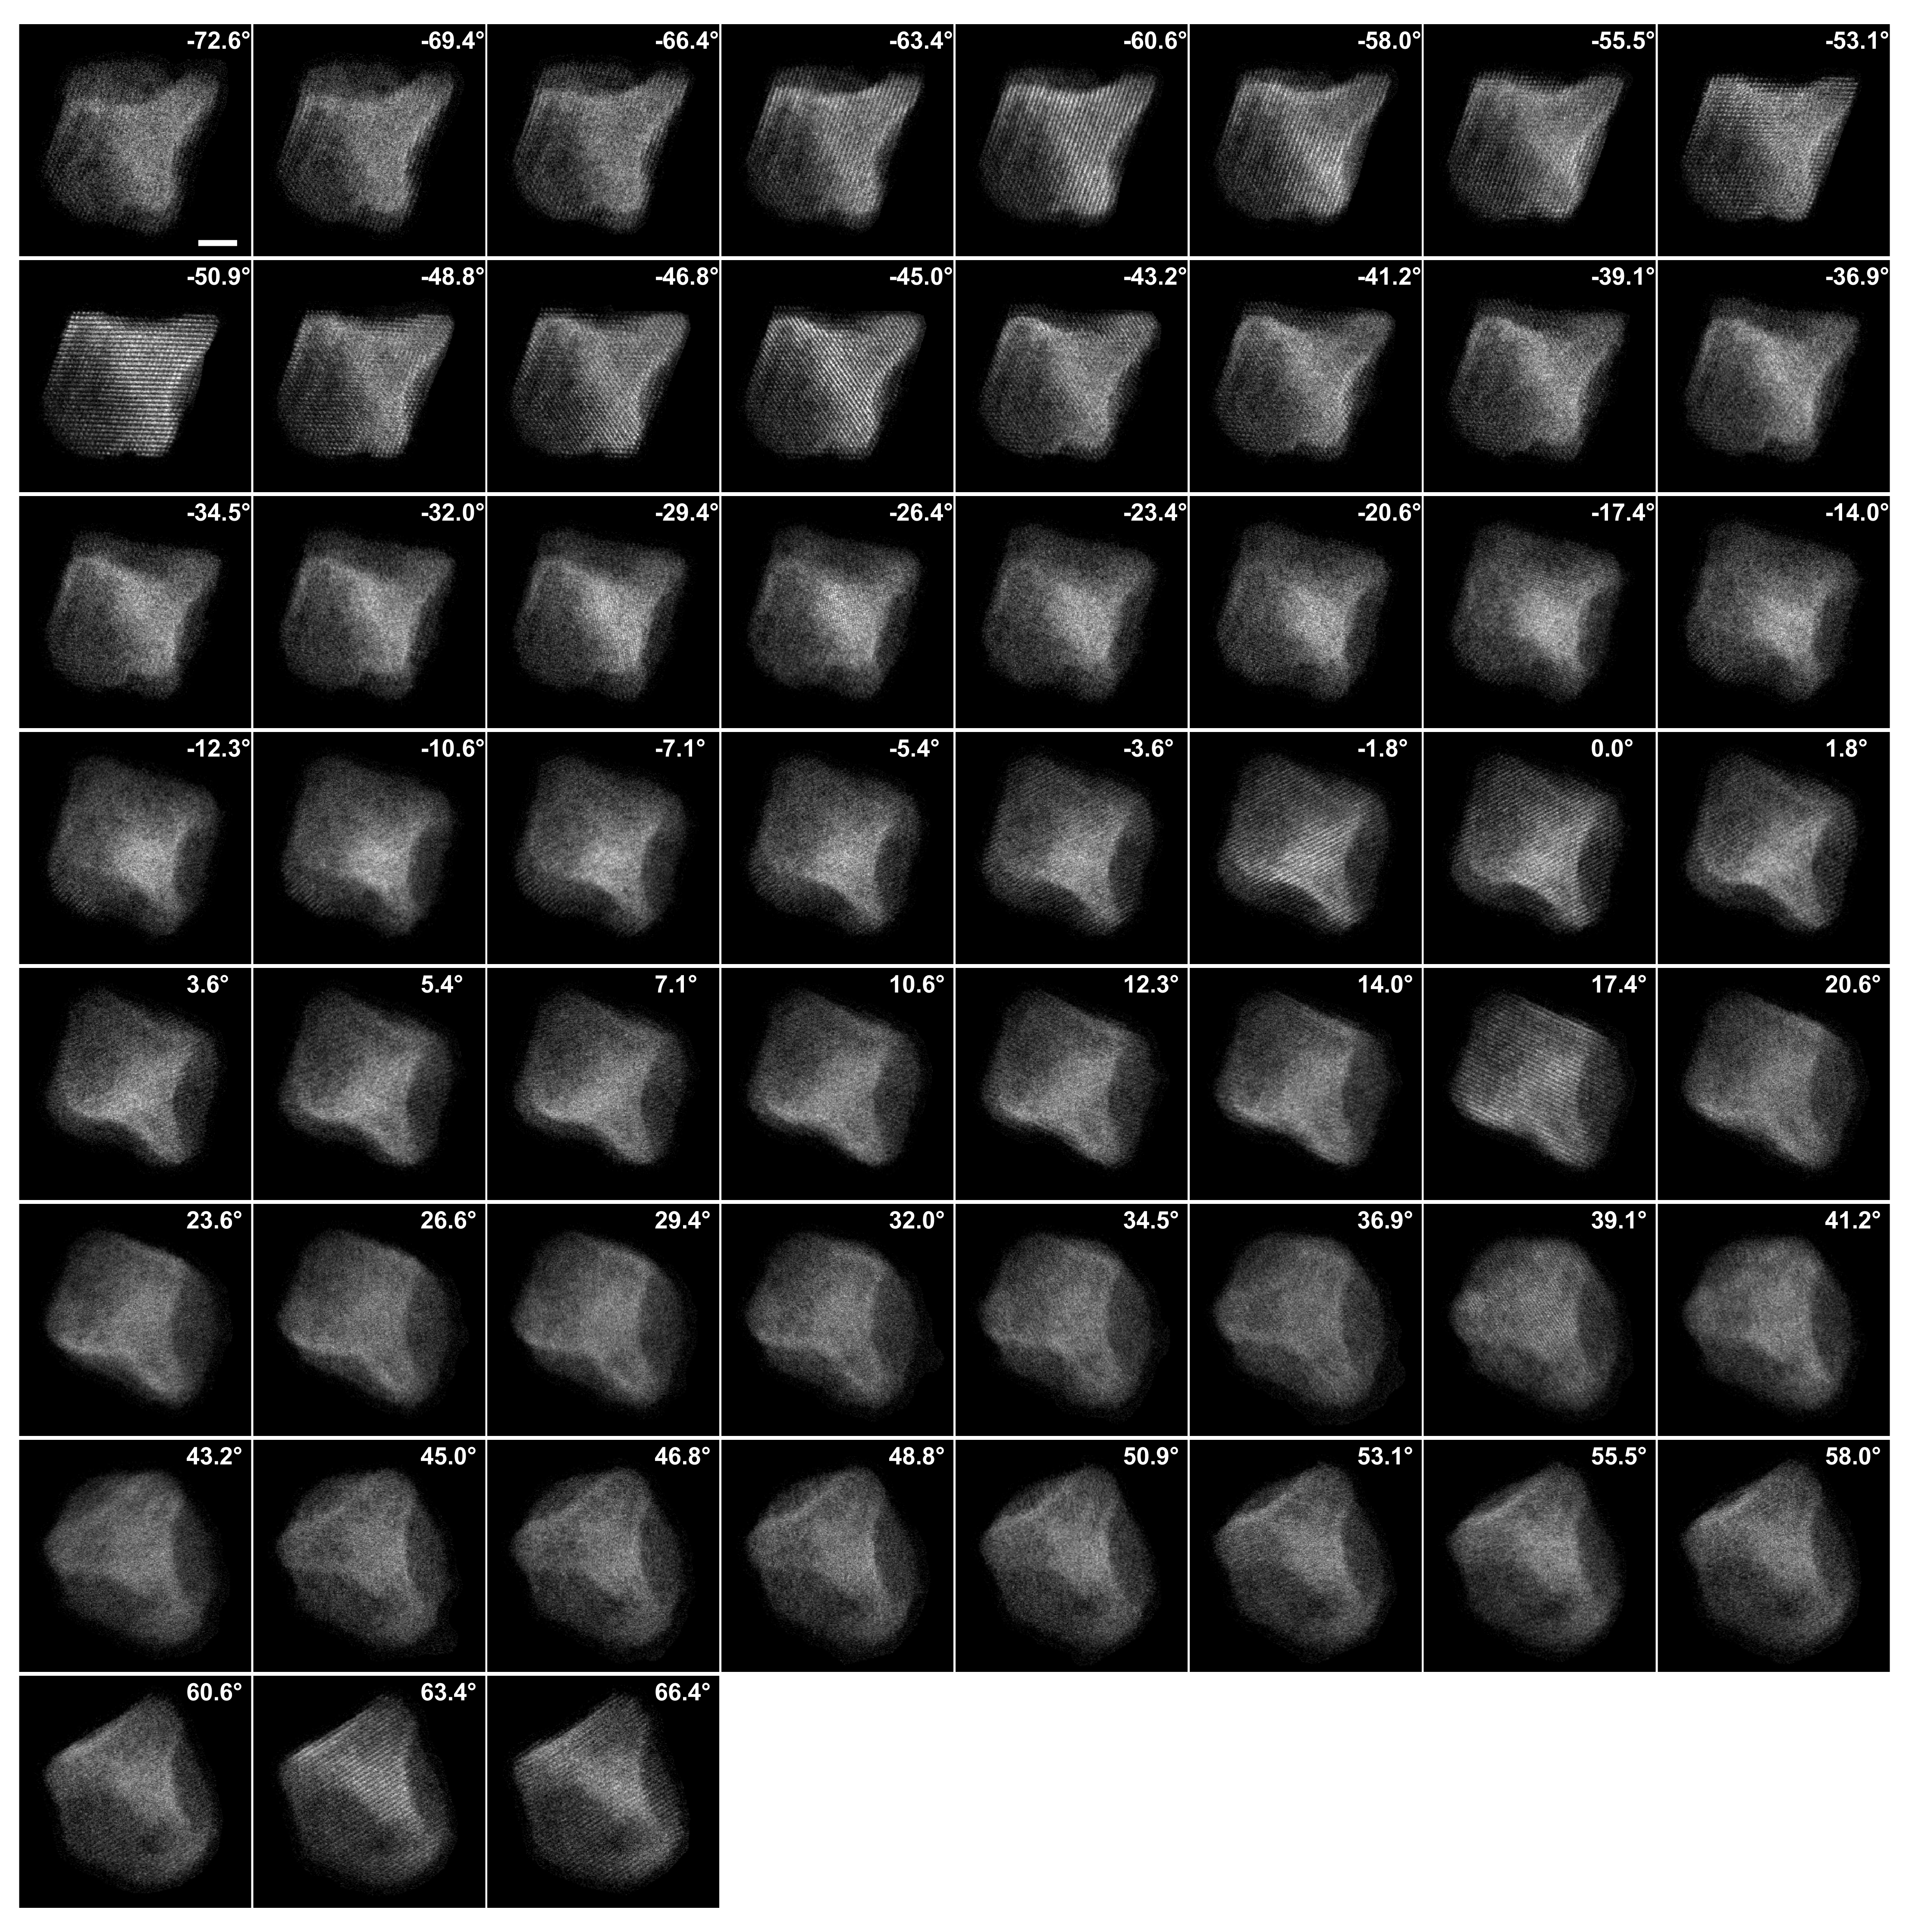
Supplementary Fig. 5 | Experimental tomographic tilt series of a Mo-PtNi nanoparticle (Particle #3), showing 59 ADF-STEM images with a tilt range from -72.6° to +66.4°. The 3D atomic structure and chemical composition of the nanoparticle are shown in Fig. 1 (3rd row). Scale bar, 2 nm.
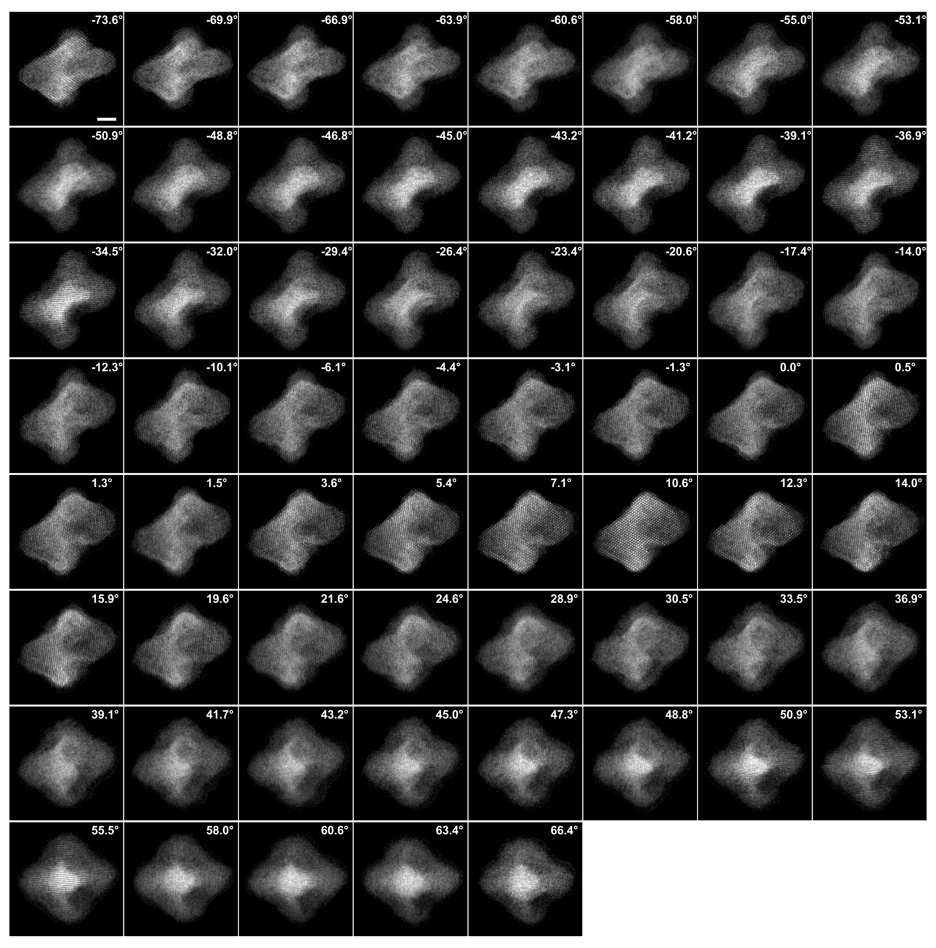
Supplementary Fig. 6 | Experimental tomographic tilt series of a Mo-PtNi nanoparticle (Particle #4), showing 61 ADF-STEM images with a tilt range from -73.6° to +66.4°. The 3D atomic structure and chemical composition of the nanoparticle are shown in Fig. 1 (4th row). Scale bar, 2 nm.

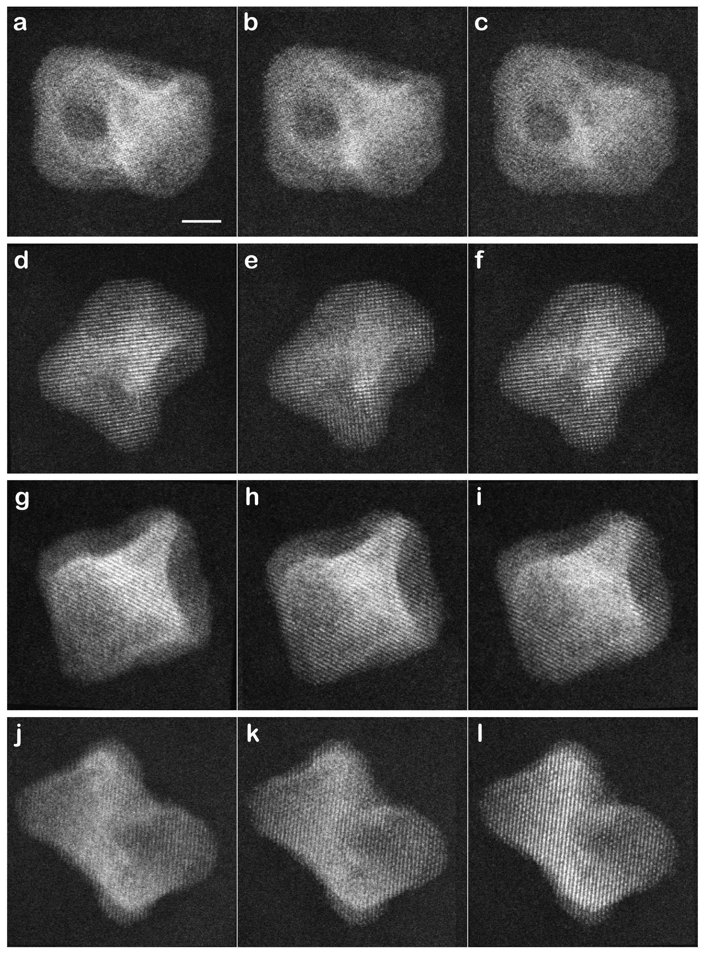
Supplementary Fig. 7 | Consistency check of the PtNi and Mo-PtNi nanocatalysts. ADF-STEM images of taken at 0° before, during and after the experiment for particle 1 (a-c), particle 2 (d-f), particle 3 (g-i), and particle 4 (j-l), indicating the consistency of the sample structure during the data acquisition. Scale bar, 2 nm.
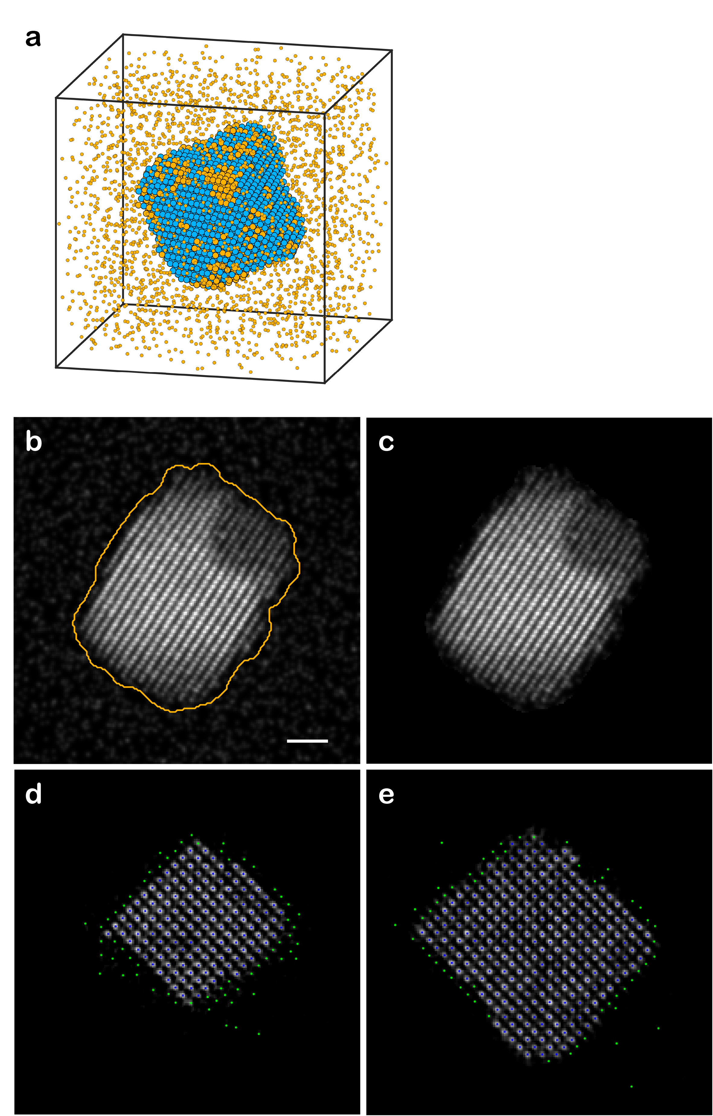
Supplementary Fig. 8 | Numerical simulations on the effect of the surrounding Ni atoms on the 3D reconstruction. a, A PtNi atomic model in an environment with individual Ni atoms, where the Ni atom density was estimated from the EELS map. b, A representative projection image calculated from the atomic model, in which the yellow boundary represents a 2D mask determined by the Otsu threshold. Scale bar, 1 nm. c, The projection image after masking. d, e, Two representative atomic slices of the reconstructed model, where the blue dots represent atoms consistent with the original model and the green dots show a layer of ghost atoms due to the effect of the Ni environment.

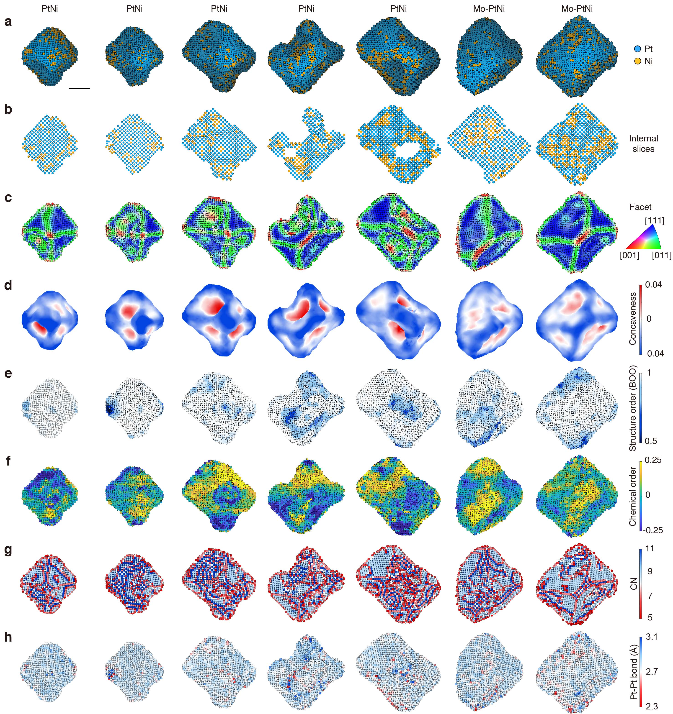
Supplementary Fig. 9 | 3D atomic structure and chemical composition of the other 7 nanocatalysts determined by AET. a-h, The 3D surface morphology and chemical composition (a), elemental segregation in the interior (b), facet (c), surface concaveness (d), structural order/disorder (e), chemical order/disorder (f), CN (g), and surface bonds (h) of the nanocatalysts were quantitatively characterized using the experimental atomic coordinates. For the structural order, BOO = 1 corresponds to a perfect fcc lattice. For the chemical order, positive and negative numbers represent segregation and alloying, respectively. The 7 nanoparticles correspond to particles 1-7 from left to right. Scale bar, 2 nm.

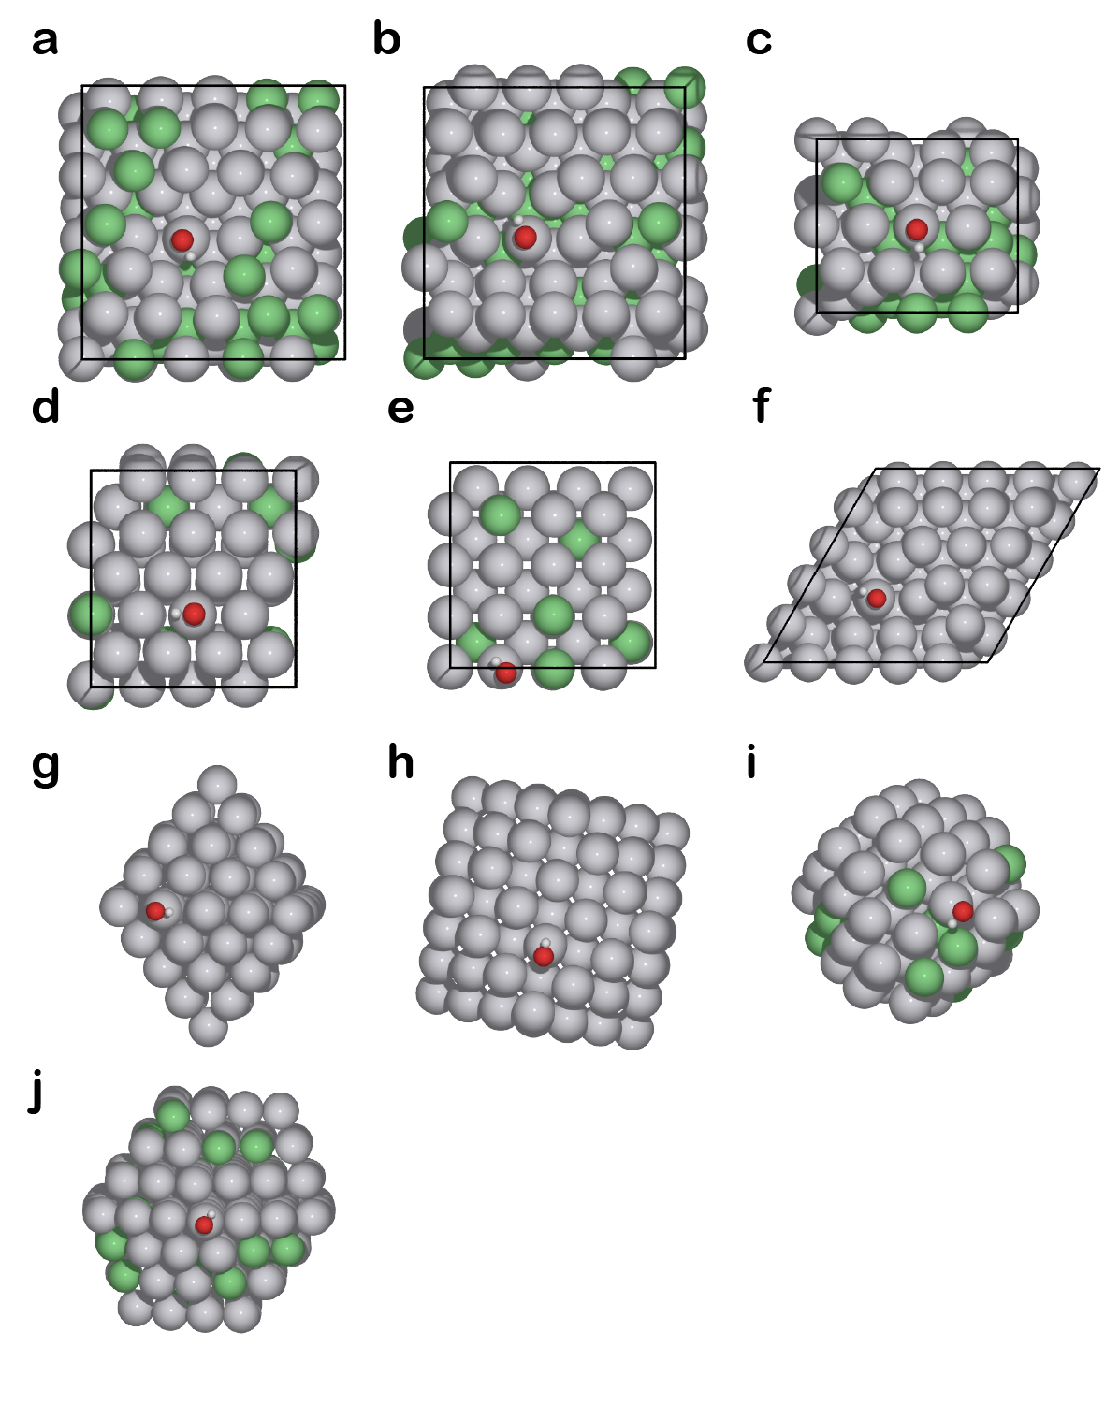
Supplementary Fig. 10 | Database of OH adsorption (red and small white spheres) energies on the surface Pt sites of PtNi model catalysts calculated by DFT. The database include 207 diverse 3D atomic models consisting of nanoclusters and slabs, each surrounding a surface Pt site with a different local environment (Methods). a-f, Six representative slab models. g-j, Four representative nanoclusters.
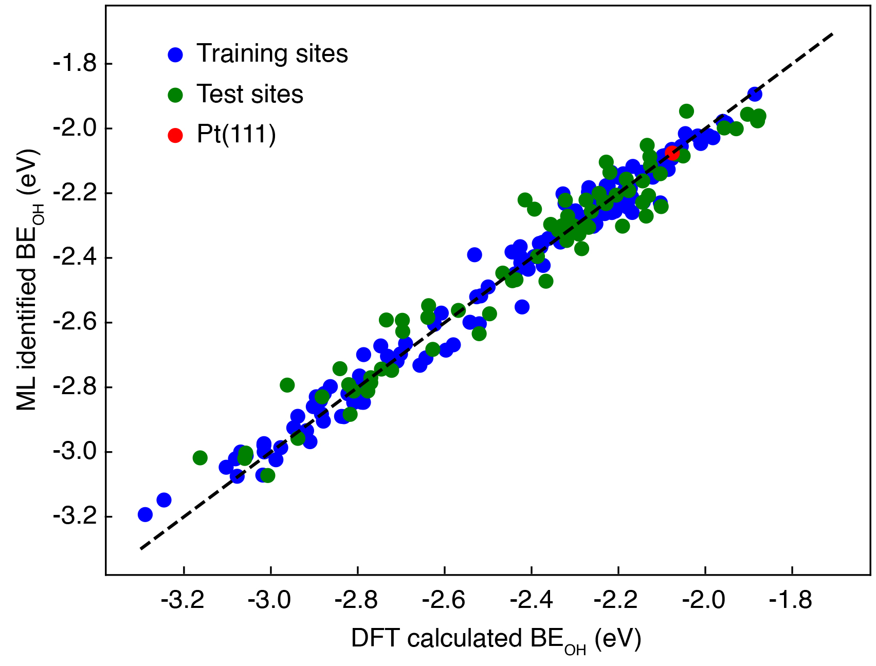
Supplementary Fig. 11 | Quantitative comparison between the DFT calculated and ML identified BE_{OH}, indicating that ML accurately predicted the BE_{OH} with a root mean square error (RMSE) of 0.05 and 0.07 eV per site for the 134 training and 73 test Pt sites.

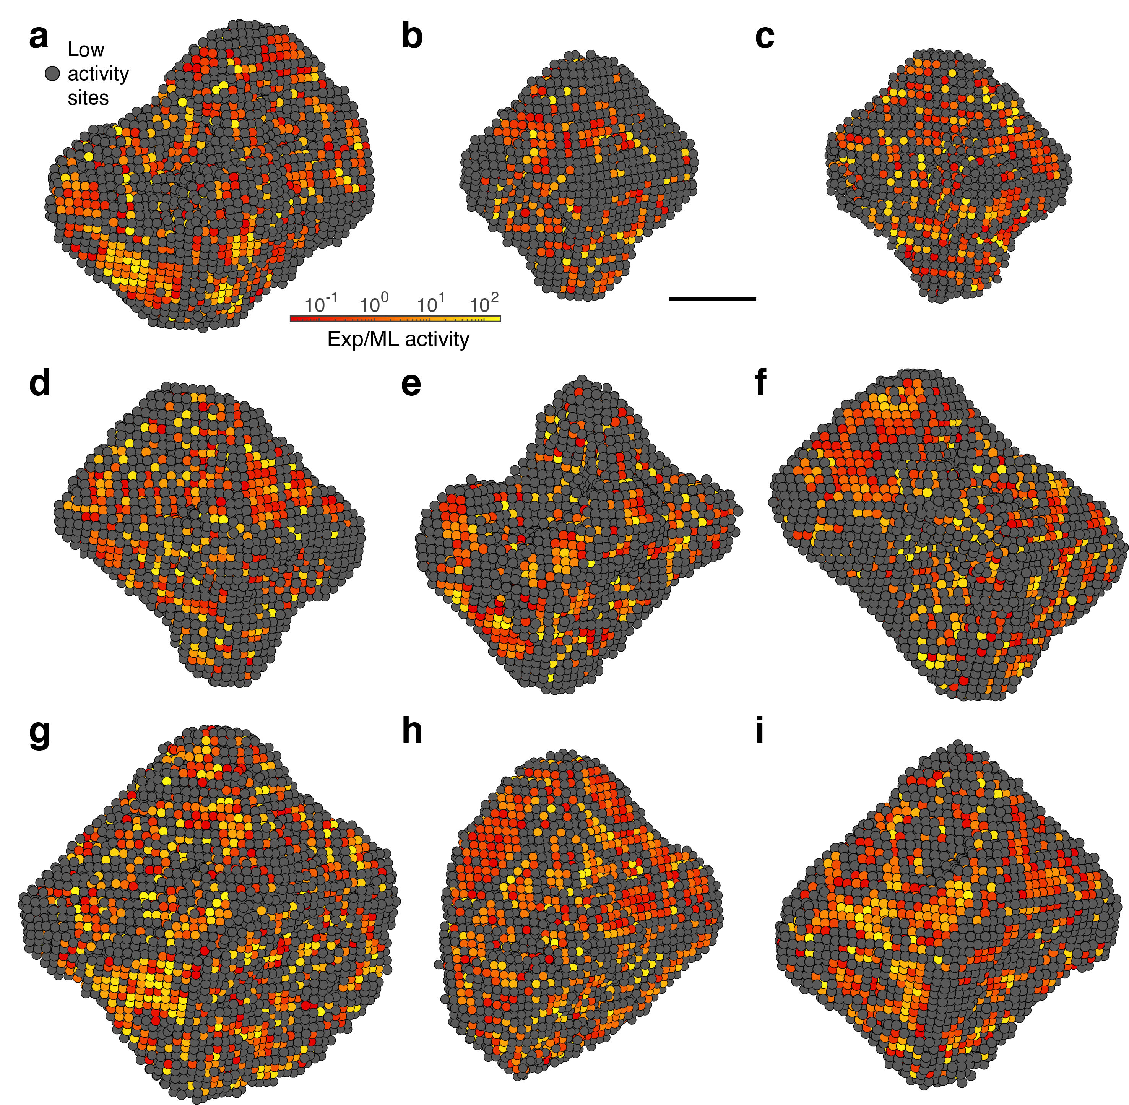
Supplementary Fig. 12 | Identification of the ORR active sites of the PtNi and Mo-PtNi nanocatalysts. a-i, The ML-identified activity maps for the experimental 3D atomic coordinates of the nanocatalyst, corresponding to particles 2, 3, and 5-11, respectively, where low activity sites are defined with the ORR activity smaller than 3% of that of Pt(111). Scale bar, 2 nm.

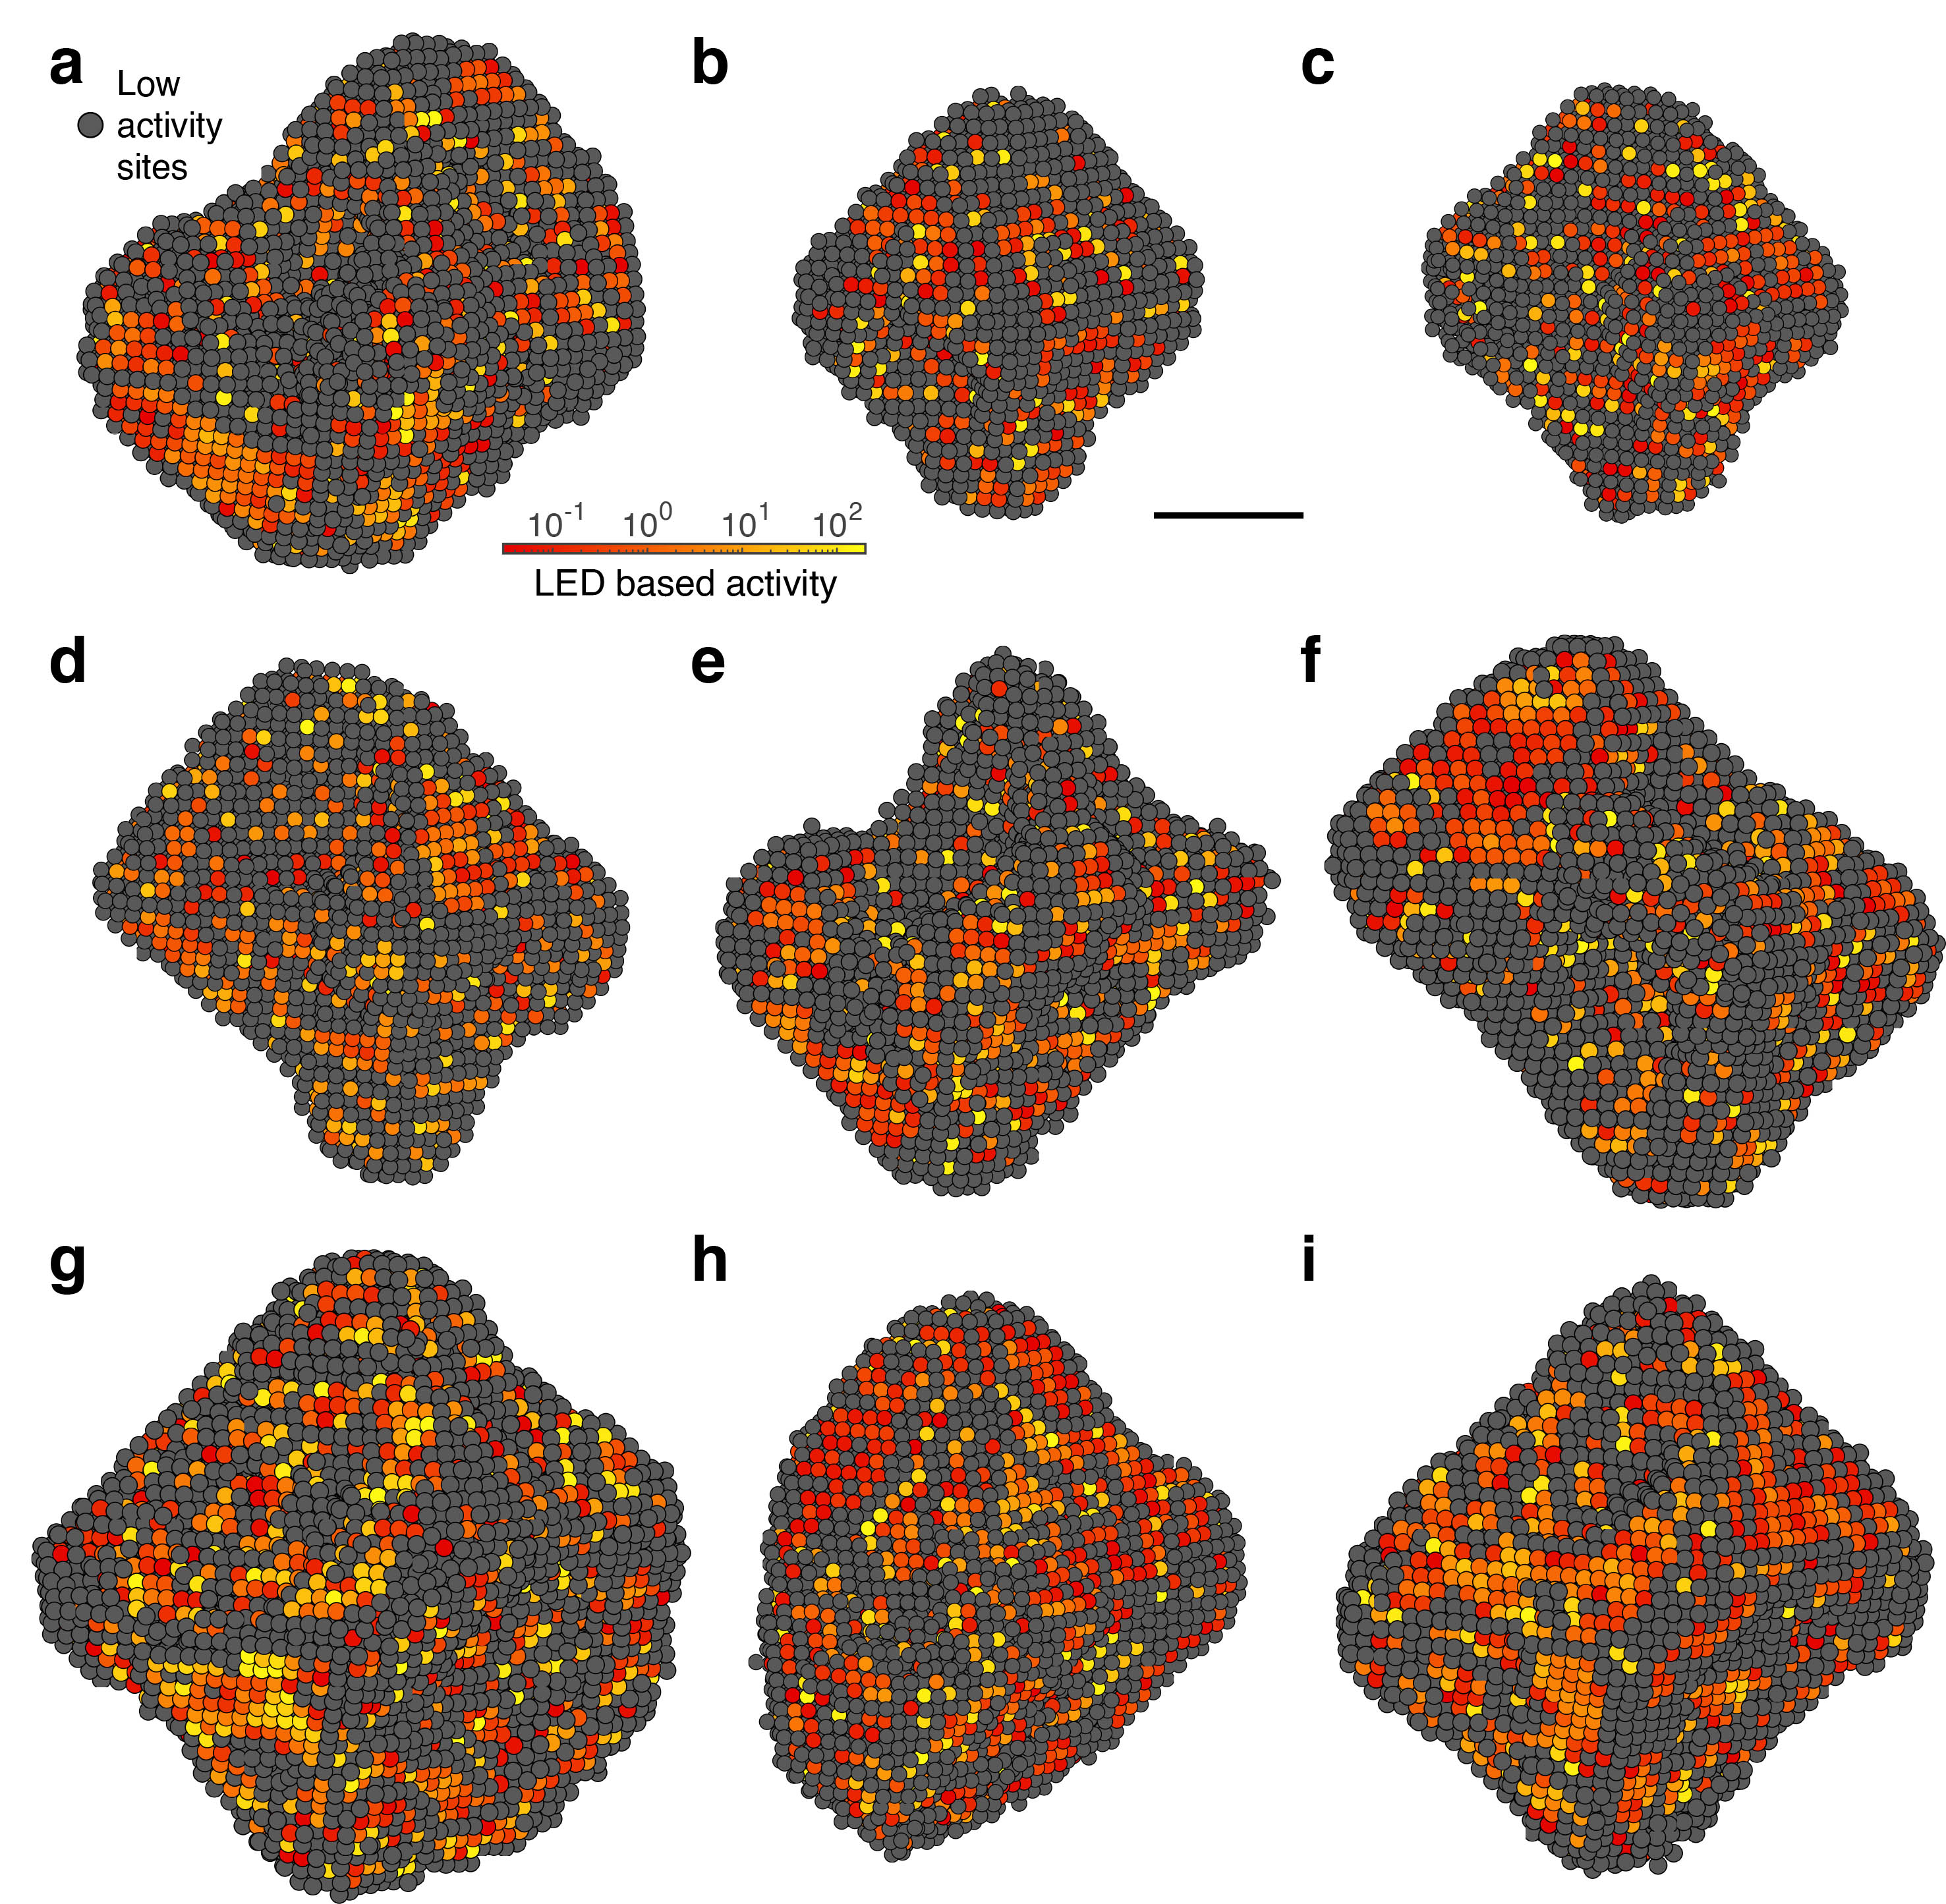
Supplementary Fig. 13 | The LED-based activity maps of the PtNi and Mo-PtNi nanocatalysts. a-i, Corresponding to particles 2, 3, and 5-11, respectively, which are in good agreement with the ML-identified activity maps (Supplementary Data Fig. 8). Scale bar, 2 nm.

Supplementary Tables
Supplementary Table 1. AET data collection, processing, reconstruction, refinement and statistics of PtNi and Mo-PtNi.
 | Particle 1ª | Particle 2 | Particle 3 | Particle 4 | Particle 5 | Particle 6 | Particle 7 | Particle 8 | Particle 9 | Particle 10 | Particle 11
Data collection and processing
Voltage (kV) | 300 | 300 | 300 | 300 | 300 | 300 | 300 | 300 | 300 | 300 | 300
Convergence semi-angle (mrad) | 17.1 | 17.1 | 17.1 | 17.1 | 17.1 | 17.1 | 17.1 | 17.1 | 17.1 | 17.1 | 17.1
Probe size (Å) | 0.7 | 0.7 | 0.7 | 0.7 | 0.7 | 0.7 | 0.7 | 0.7 | 0.7 | 0.7 | 0.7
Detector inner angle (mrad) | 30 | 30 | 30 | 30 | 30 | 30 | 30 | 30 | 30 | 30 | 30
Detector outer angle (mrad) | 195 | 195 | 195 | 195 | 195 | 195 | 195 | 195 | 195 | 195 | 195
Depth of focus (nm) | 14 | 14 | 14 | 14 | 14 | 14 | 14 | 14 | 14 | 14 | 14
Pixel size (Å) | 0.467 | 0.467 | 0.467 | 0.467 | 0.467 | 0.467 | 0.467 | 0.467 | 0.467 | 0.467 | 0.467
# of images | 56 | 54 | 59 | 61 | 57 | 55 | 53 | 56 | 54 | 57 | 57
Tilt range (°) | -72.0° | -74.3° | -72.6° | -73.6° | -74.3° | -72.6° | -72.6° | -74.3° | -74.3° | -72.6° | -72.6°
 | +69.4° | +66.4° | +66.4° | +66.4° | +66.4° | +69.4° | +69.4° | +63.4° | +66.4° | +66.4° | +66.4°
Total electron dose (10⁵ e/Å²) | 7.8 | 7.5 | 8.2 | 8.5 | 7.9 | 7.7 | 7.4 | 7.8 | 7.5 | 7.9 | 7.9
Reconstruction
Algorithm | RESIRE | RESIRE | RESIRE | RESIRE | RESIRE | RESIRE | RESIRE | RESIRE | RESIRE | RESIRE | RESIRE
Oversampling ratio | 4 | 4 | 4 | 4 | 4 | 4 | 4 | 4 | 4 | 4 | 4
Number of iterations | 200 | 200 | 200 | 200 | 200 | 200 | 200 | 200 | 200 | 200 | 200
Refinement
R₁ (%)^{b} | 21.84 | 19.83 | 16.42 | 16.74 | 22.41 | 19.81 | 18.33 | 22.33 | 19.61 | 18.39 | 15.68
R (%)^{c} | 7.50 | 7.73 | 6.03 | 8.16 | 7.31 | 6.77 | 6.39 | 7.55 | 8.07 | 6.12 | 6.34
B’ factors (Å²)
Ni atoms | 27.48 | 11.82 | 10.11 | 16.44 | 10.57 | 11.34 | 7.96 | 10.75 | 12.97 | 7.79 | 7.41
Pt atoms | 35.09 | 29.90 | 39.18 | 42.21 | 15.31 | 26.95 | 25.53 | 23.94 | 20.75 | 28.70 | 26.83
Statistics
# of atoms
Total | 11561 | 9275 | 14172 | 10937 | 4281 | 4383 | 6435 | 6927 | 8082 | 8619 | 10589
Ni | 3239 | 3190 | 5696 | 3588 | 850 | 854 | 1442 | 1795 | 2005 | 2594 | 3937
Pt | 8322 | 6085 | 8476 | 7349 | 3431 | 3529 | 4993 | 5132 | 6077 | 6025 | 6652
ª Particle 1-4 are the four nanoparticles shown in main text figures. Particle 5-9 are PtNi. Particle 10,11 are Mo-PtNi.
^{b} The R₁-factor is defined as equation 5 in ref. 35.
^{c} The R-factor is defined in equation 4 in ref. 28.
Supplementary Table 2. Fitting a large number of experimentally measured structural and chemical properties to a 3-variable equation, $LED=a_{1}x_{1}*x_{2}+a_{2}x_{3}$, by minimizing the root mean square error (RMSE).

$$x_{1}$$ | $$x_{2}$$ | $$x_{3}$$ | $$RMSE$$
$$NN^{Pt}$$ | $$e^{-{\overline{d}}_{Pt}}$$ | $${\overline{CN}}^{Ni}$$ | $$0.104$$
$${\overline{CN}}^{Ni}$$ | $$e^{-{\overline{d}}_{Pt}}$$ | $$NN^{Pt}$$ | $$0.115$$
$$CN$$ | $$e^{-{\overline{d}}_{Pt}}$$ | $$\overline{CN}$$ | $$0.115$$
$$\overline{CN}$$ | $$e^{-{\overline{d}}_{Pt}}$$ | $$CN$$ | $$0.116$$
$$e^{-{\overline{d}}_{Pt}}$$ | $$ε$$ | $$CN$$ | $$0.116$$
$${\overline{d}}_{Pt}$$ | $$e^{-{\overline{d}}_{Pt}}$$ | $$CN$$ | $$0.117$$
$$NN^{Pt}$$ | $$ε$$ | $$CN$$ | $$0.117$$
$$CN$$ | $${\overline{d}}_{Pt}$$ | $$e^{-{\overline{d}}_{Pt}}$$ | $$0.117$$
$$BOO$$ | $$ε$$ | $$CN$$ | $$0.117$$
$$NN^{Pt}$$ | $$e^{-{\overline{d}}_{Pt}}$$ | $$NN^{Ni}$$ | $$0.117$$
$${\overline{CN}}^{Pt}$$ | $$ε$$ | $$CN$$ | $$0.118$$
$$CN$$ | $${\overline{d}}_{Pt}$$ | $$ε$$ | $$0.118$$
$${\overline{d}}_{Pt}$$ | $$ε$$ | $$CN$$ | $$0.118$$
$$\overline{CN}$$ | $$ε$$ | $$CN$$ | $$0.119$$
$$CN$$ | $$e^{-{\overline{d}}_{Pt}}$$ | $${\overline{d}}_{Pt}$$ | $$0.120$$
$$CN$$ | $$e^{-{\overline{d}}_{Pt}}$$ | $$ε$$ | $$0.120$$
$$\overline{CN}$$ | $$e^{-{\overline{d}}_{Pt}}$$ | $$NN^{Pt}$$ | $$0.122$$
$${\overline{CN}}^{Pt}$$ | $$e^{-{\overline{d}}_{Pt}}$$ | $${\overline{CN}}^{Ni}$$ | $$0.123$$
$$CN$$ | $$e^{-{\overline{d}}_{Pt}}$$ | $${\overline{CN}}^{Pt}$$ | $$0.125$$
$$CN$$ | $$e^{-{\overline{d}}_{Pt}}$$ | $$NN^{Pt}$$ | $$0.125$$
$$NN^{Pt}$$ | $$ε$$ | $$\overline{CN}$$ | $$0.125$$
$$e^{-{\overline{d}}_{Pt}}$$ | $$ε$$ | $$\overline{CN}$$ | $$0.125$$
$${\overline{d}}_{Pt}$$ | $$e^{-{\overline{d}}_{Pt}}$$ | $$\overline{CN}$$ | $$0.126$$
$$BOO$$ | $$ε$$ | $$\overline{CN}$$ | $$0.126$$
$${\overline{CN}}^{Pt}$$ | $$ε$$ | $$\overline{CN}$$ | $$0.126$$
$$\overline{CN}$$ | $${\overline{d}}_{Pt}$$ | $$e^{-{\overline{d}}_{Pt}}$$ | $$0.126$$
$${\overline{d}}_{Pt}$$ | $${\overline{CN}}^{Ni}$$ | $$NN^{Pt}$$ | $$0.126$$
$$surface CN$$ | $$ε$$ | $$\overline{CN}$$ | $$0.126$$
$$\overline{CN}$$ | $${\overline{d}}_{Pt}$$ | $$ε$$ | $$0.126$$
$$NN^{Ni}$$ | $$e^{-{\overline{d}}_{Pt}}$$ | $$NN^{Pt}$$ | $$0.126$$
$${\overline{d}}_{Pt}$$ | $$ε$$ | $$\overline{CN}$$ | $$0.126$$
$$CN$$ | $$ε$$ | $$\overline{CN}$$ | $$0.127$$
$$CN$$ | $$\overline{CN}$$ | $$e^{-{\overline{d}}_{Pt}}$$ | $$0.127$$
$$NN^{Ni}$$ | $$ε$$ | $$CN$$ | $$0.127$$
$$CN$$ | $$\overline{CN}$$ | $${\overline{d}}_{Pt}$$ | $$0.128$$
$$CN$$ | $$\overline{CN}$$ | $$ε$$ | $$0.128$$
$${\overline{CN}}^{Ni}$$ | $$ε$$ | $$CN$$ | $$0.128$$
$$\overline{CN}$$ | $$e^{-{\overline{d}}_{Pt}}$$ | $${\overline{CN}}^{Pt}$$ | $$0.128$$
$$CN$$ | $$NN^{Pt}$$ | $${\overline{CN}}^{Ni}$$ | $$0.128$$

