MiR-3168, miR-6125, and miR-4718 as potential predictors of cisplatin-induced nephrotoxicity in patients with head and neck cancer
Running title: MiRNAs predictors of cisplatin-induced nephrotoxicity

Julia C.F. Quintanilha¹, Maria A. Cursino¹, Jessica B. Borges², Nadine G. Torso³, Larissa B. Bastos³, Juliana M. Oliveira³, Thiago S. Cobaxo³, Eder Pincinato¹, Mario H. Hirata^{2,4}, Murilo V. Geraldo⁵, Carmen S.P. Lima¹, Patricia Moriel^{1,3*}

¹School of Medical Science, University of Campinas, Campinas, São Paulo, Brazil.
²Dante Pazzanese Institute of Cardiology, São Paulo, São Paulo, Brazil.
³Faculty of Pharmaceutical Sciences, University of Campinas, Campinas, São Paulo, Brazil.
⁴Faculty of Pharmaceutical Sciences, University of São Paulo, São Paulo, São Paulo, Brazil.
⁵Institute of Biology, University of Campinas, Campinas, São Paulo, Brazil.

*Correspondence: Patricia Moriel, PhD. Faculty of Pharmaceutical Sciences, University of Campinas, 200 Cândido Portinari Street, Campinas 13083-871, SP, Brazil. E-mail: patricia.moriel@fcf.unicamp.br

Supplementary File
Tables and Figures
Table S1. Plasmatic miRNAs with a p-value of <0.05, FR >5.0 or FR <-2.5, without comments or with comment “A” according to the GeneGlobe Data Analysis Center (Qiagen). FR Fold Regulation, *Wald test.
Plasmatic miRNAs
miRNA | FR | p-value* | Comment | miRNA | FR | p-value* | Comment
hsa-miR-3168 | 8.08 | 1.98x10⁻⁸ | - | hsa-miR-17-5p | -3.42 | 2.49x10⁻⁵ | -
hsa-miR-6125 | 5.31 | 6.60x10⁻⁵ | - | hsa-miR-1185-1-3p | -3.03 | 0.0384 | A
hsa-miR-4718 | 5.12 | 4.24x10⁻⁵ | - | hsa-miR-766-3p | -2.77 | 0.0325 | A
hsa-miR-5694 | 4.13 | 0.0002 | A | hsa-miR-151b/151a-5p | -2.63 | 0.0046 | -
hsa-miR-203a-3p | 3.71 | 0.0037 | A | hsa-miR-485-3p | -2.56 | 0.0073 | A
hsa-miR-141-5p | 2.95 | 0.0033 | - | hsa-miR-652-3p | -2.45 | 0.0161 | A
hsa-miR-7977 | 2.70 | 0.0172 | A | hsa-miR-27a-3p | -2.44 | 0.0076 | -
hsa-miR-1303 | 2.57 | 0.0201 | A | hsa-miR-342-3p | -2.30 | 0.0010 | -
hsa-miR-944 | 2.40 | 0.0459 | - | hsa-miR-223-3p | -2.26 | 0.0017 | -
hsa-miR-9-5p | 2.35 | 0.0253 | A | hsa-miR-130a-3p | -2.20 | 0.0240 | -
hsa-miR-625-3p | 2.33 | 0.0175 | - | hsa-miR-127-3p | -2.19 | 0.0237 | -
hsa-miR-4782-5p | 2.21 | 0.0457 | - | hsa-miR-409-3p | -2.17 | 0.0094 | -
hsa-miR-6857-3p | 2.21 | 0.0461 | A | hsa-miR-24-3p | -2.15 | 0.0060 | -
hsa-miR-1224-5p | 2.13 | 0.0388 | A | hsa-miR-103a-3p | -2.14 | 0.0227 | -
hsa-miR-363-5p | 2.12 | 0.0455 | - | hsa-miR-23a-3p | -2.11 | 0.0155 | -
hsa-miR-6728-5p | 2.04 | 0.0381 | - | hsa-miR-423-3p | -2.05 | 0.0100 | -
 |  |  |  | hsa-miR-182-5p | -2.00 | 0.0252 | -

Table S2. MiRNA expression at baseline and D5. SCr serum creatinine, FC fold change.
miRNA | Patients with grade <2 increased SCr Baseline | Patients with grade ≥2 increased SCr Baseline | FC | p-value*
miR-3168 | 10.54 ± 22.08 | 29.09 ± 37.31 | 2.76 | 0.0570
miR-6125 | 1.50 ± 1.24 | 2.27 ± 1.19 | 1.51 | 0.0658
miR-4718 | 1.66 ± 1.75 | 2.86 ± 1.76 | 1.72 | 0.0433
miRNA | Patients with grade <2 increased SCr  D5 | Patients with grade ≥2 increased SCr  D5 | FC | p-value*
miR-3168 | 15.34 ± 37.51 | 5.66 ± 15.93 | 0.37 | 0.3689
miR-6125 | 2.09 ± 3.13 | 0.84 ± 0.89 | 0.40 | 0.3555
miR-4718 | 2.24 ± 3.81 | 1.40 ± 1.17 | 0.62 | 0.7554

Table S3. Spearman correlation for miR-3168, miR-4718 and miR-6125.
miRNA1 | miRNA2 | R | p-value
miR-3168 | miR-6125 | 0.82 | 1.96x10⁻¹¹
miR-3168 | miR-4718 | 0.87 | 3.80 x10⁻¹⁴
miR-6125 | miR-4718 | 0.79 | 2.13x10⁻¹¹

Table S4. Multivariate logistic regression between miRNAs and grade ≥2 increase in serum creatinine, using age and gender as covariates. OR, odds ratio; CI, confidence interval.
 | p-value | OR (95% CI)
miR-3168 | 0.7360 | 1.01 (0.96-1.06)
miR-6125 | 0.9740 | 1.02 (0.31-2.95)
miR-4718 | 0.3900 | 1.46 (0.62-3.66)
Age | 0.5320 | 1.04 (0.92-1.19)
Sex | 0.1400 | 5.27 (0.52-53.10)

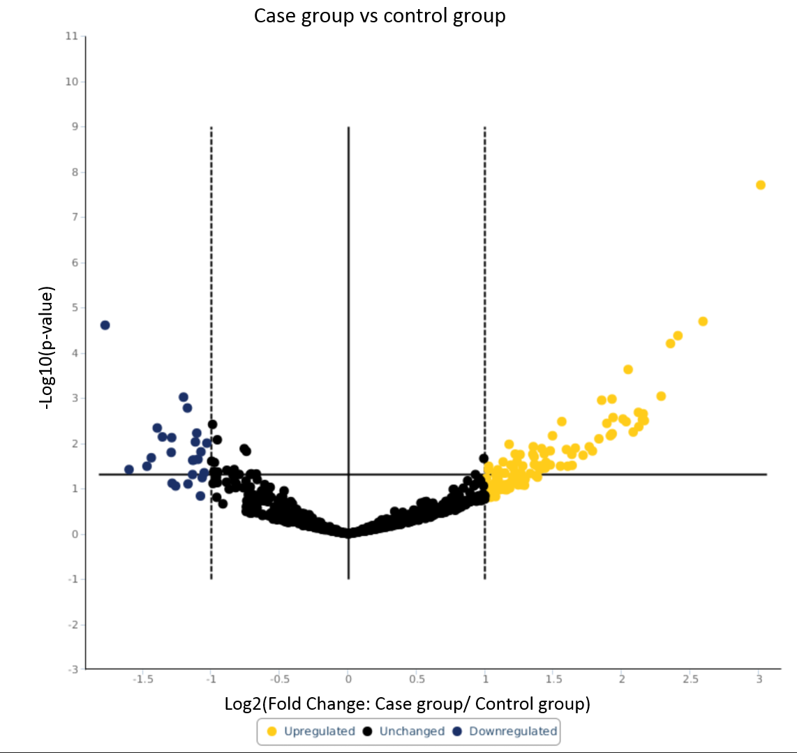

Figure S1. Volcano plot of miRNA sequencing.

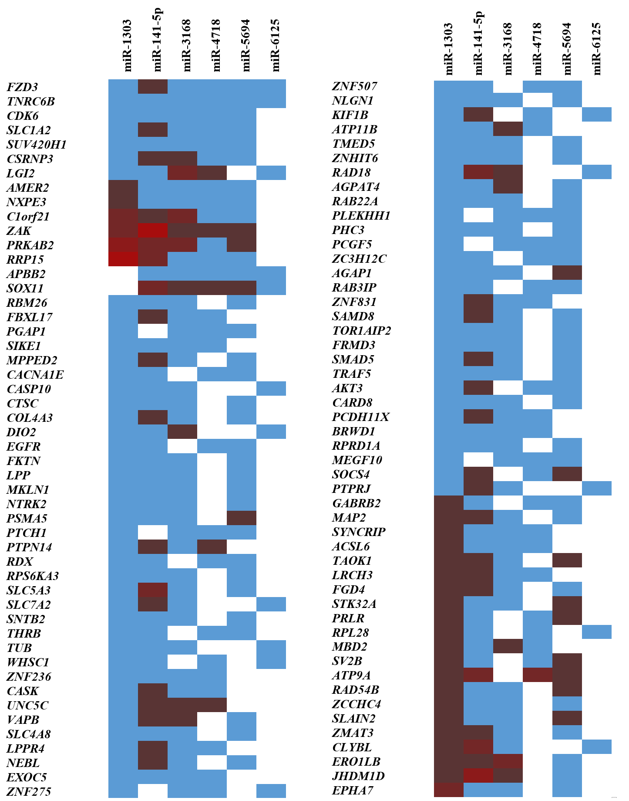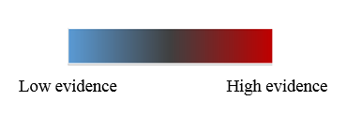
Figure S2. Top 100 target genes predicted by upregulated miRNAs according to miRWalk 2.0. The top genes are the targets predicted by more miRNAs and the color represents the evidence of this prediction.
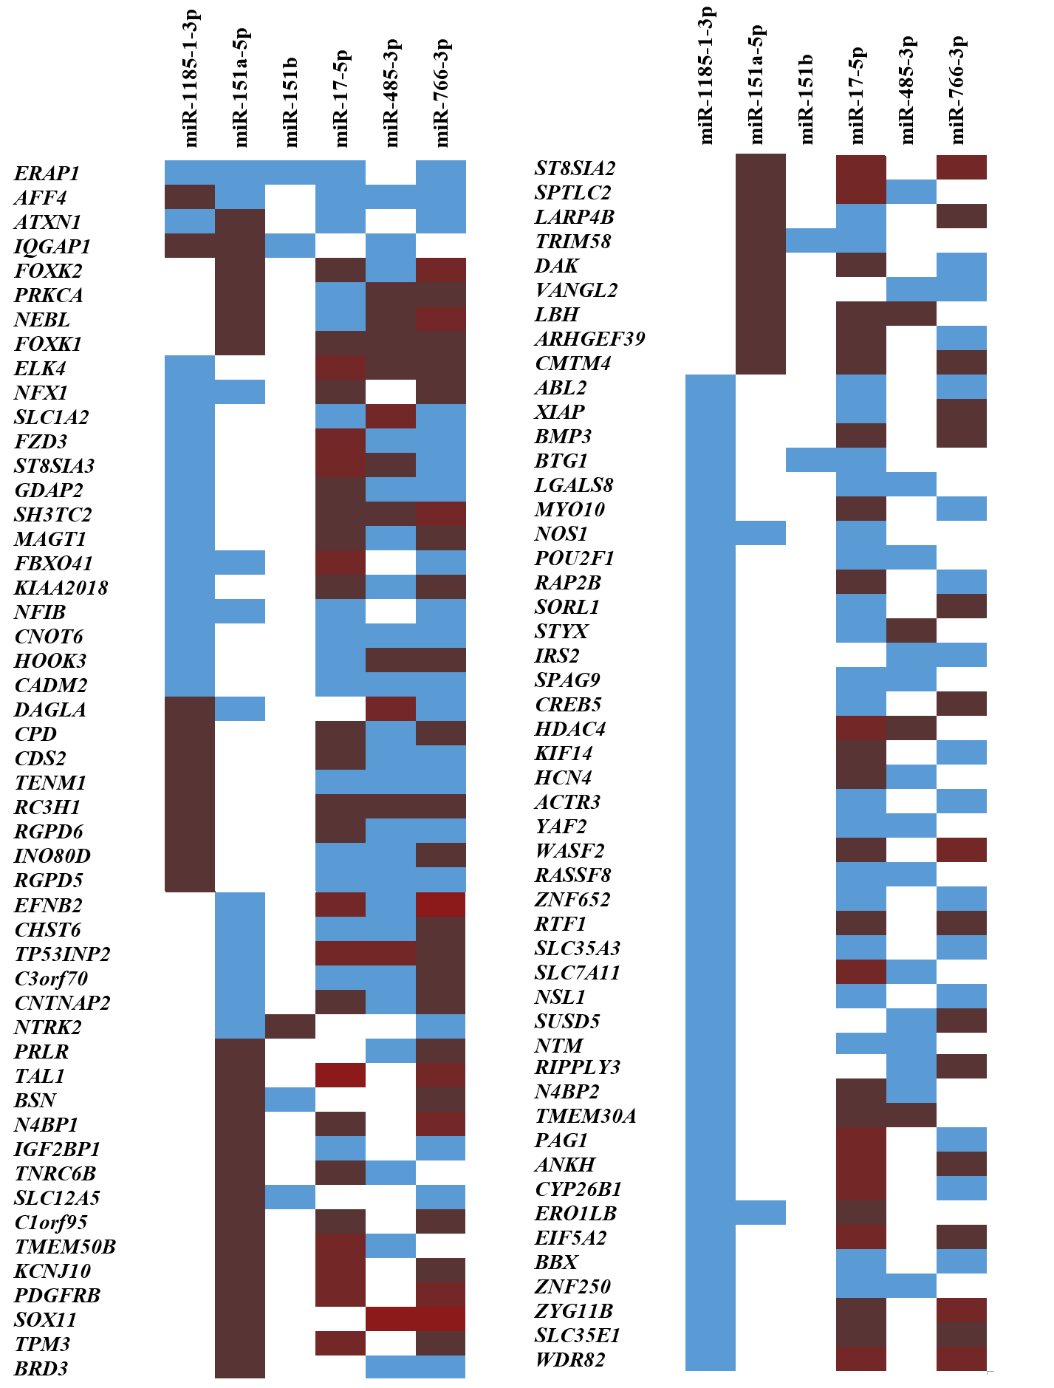
Figure S3. Top 100 target genes predicted by downregulated miRNAs according to miRWalk 2.0. The top genes are the targets predicted by more miRNAs and the color represents the evidence of this prediction.

