Supplementary Information for
Weyl interface states in non-Hermitian synthetic dimension
Wange Song^{1*}, Yuxin Chen¹, Shengjie Wu¹, Chen Chen¹, Chunyu Huang¹, Luqi Yuan^{2*}, Shining Zhu¹, and Tao Li^{1*}
¹National Laboratory of Solid State Microstructures, Key Laboratory of Intelligent Optical Sensing and Manipulations, Jiangsu Key Laboratory of Artificial Functional Materials, College of Engineering and Applied Sciences, Nanjing University, Nanjing, 210093, China.
²State Key Laboratory of Advanced Optical Communication Systems and Networks, School of Physics and Astronomy, Shanghai Jiao Tong University, Shanghai 200240, China.
*Corresponding author: songwange@nju.edu.cn (Wange Song); yuanluqi@sjtu.edu.cn (Luqi Yuan); taoli@nju.edu.cn (Tao Li)

S1. Derivation of the Weyl Hamiltonian.
S2. Interface states induced by mixed phase transition in Hermitian and non-Hermitian synthetic dimensions.
S3. Local density of states (LDOS) of the Weyl systems.
S4. Propagations with random disorders in all synthetic dimensions.

S1. Derivation of the Weyl Hamiltonian.
In this section, we provide a detailed derivation of the Weyl Hamiltonian from the spatially modulated waveguide model with loss elements, as the schematics shown in Fig. 1(a) in the main text. The non-Hermitian Hamiltonian in the tight-binding approximation is
(S1)
where κ₁₍₂₎(n) represents two effective coupling coefficients, and β₁₍₂₎(l,m) is the on-site propagation constants of the waveguides. l, m, and n are three independent numbers within (-1, 1), which are introduced through
(S2)
where w₁and w₂ are the widths of two waveguides in a unit cell, w_{Cr1}and w_{Cr2} are the widths of chromium (Cr) deposited in the two waveguides, d₁ and d₂ are the gaps of waveguides, and f_{i}=(d_{1c}+d_{2c})/2d_{ic}. The lattice constant is Λ= 2w_{c}+d_{1c}+d_{2c}. l, m, and n construct a 4D synthetic dimension when incorporating the 1D Bloch wave vector k along the transverse direction x. Four dimensionless coefficients are defined:
(S3)
where (l_{c}, m_{c}, n_{c}, k_{c})=(0,0,0,0) is the position of the degenerate point.
For a common 1D coupled chain such as a waveguide array, the degenerate point in the momentum space usually appears at the boundary of the Brillion zone¹. However, if there are alternating positive and negative coupling in the waveguide array, the degenerate point could shift to the center of the Brillion zone (k_{c}=0), which makes it easier to realize the eigenmode in the vicinity of the degenerate point². To access a controllable coupling covering the positive and negative regime, we refer to a curved waveguide array, which has well proven to have the capability of coupling tuning by the curve-introduced artificial gauge field³.
We carry out full-wave simulations using COMSOL Multiphysics to obtain β₁₍₂₎(l,m) and κ₁₍₂₎(n). We adopt 220 nm thick curved silicon waveguides on sapphire substrate. The transverse position of the waveguide centers writes z(x)=Asin(2π/Px+φ), where A, P, and φ are the bending amplitude, period, and initial phase. The propagation constant changes with the widths of the waveguides as δl is varied. Figure S1(a) shows the simulated propagation constant β (the fundamental transverse electric (TE) modes at 1550nm wavelength, w_{c}=0.4 μm, A=0.68 μm, and P=10 μm) as a function of δl, which appears as an approximately linear function (fitted by the red line) of δl:
(S4)
where β₀ = 8.84445 μm⁻¹ and b= 6.29321 μm⁻¹ according to the fitted curve.
Figure S1(b) shows the simulated effective coupling coefficient as functions of d with fixed A=0.68 μm and P=10 μm. By increasing the waveguide spacing, the effective coupling coefficient κ_{eff} changes from positive to negative. We choose waveguide spacing of d_{1c}=0.480 μm, and d_{2c}=0.193 μm with corresponding coefficients of -κ₀=-0.01 μm⁻¹, κ₀=0.01 μm⁻¹ respectively. In the vicinity of d_{1c} and d_{2c}, the coupling coefficient changes linearly as a function of δn (fitted by the red line), as shown in Figs. S1(d) and S1(e):
(S5)
where κ₀ =0.01 μm⁻¹, c₁=0.0118 μm⁻¹, and c₂=0.11139 μm⁻¹ according to the fitted curve.
In our model, the loss is introduced through deposition of a thin 2 nm layer of Cr on top of the silicon waveguide, because Cr can bring enough loss modulation while the detuning between the two waveguide sites is kept at a minimum at the wavelength of operation (1550 nm)⁴. To measure the loss of Cr-deposited silicon waveguide, we have fabricated a series of isolated waveguides with varying Cr stripe widths, and extract the loss data and plot as a function of δm (Fig. S1(c), w_{Crc}=0.2 μm), which appears as an approximately linear function (fitted by the red line) of δm:
(S6)
where γ₀=0.02 μm⁻¹. a =0.01991 μm⁻¹ according to the fitted curve. To be noted, the curved waveguides also introduce additional uniform loss to the systems (measured to be ~0.00522 μm⁻¹ in experiments). Nevertheless, this uniform loss only leads to a trivial effect and can be grouped into the σ₀ term.

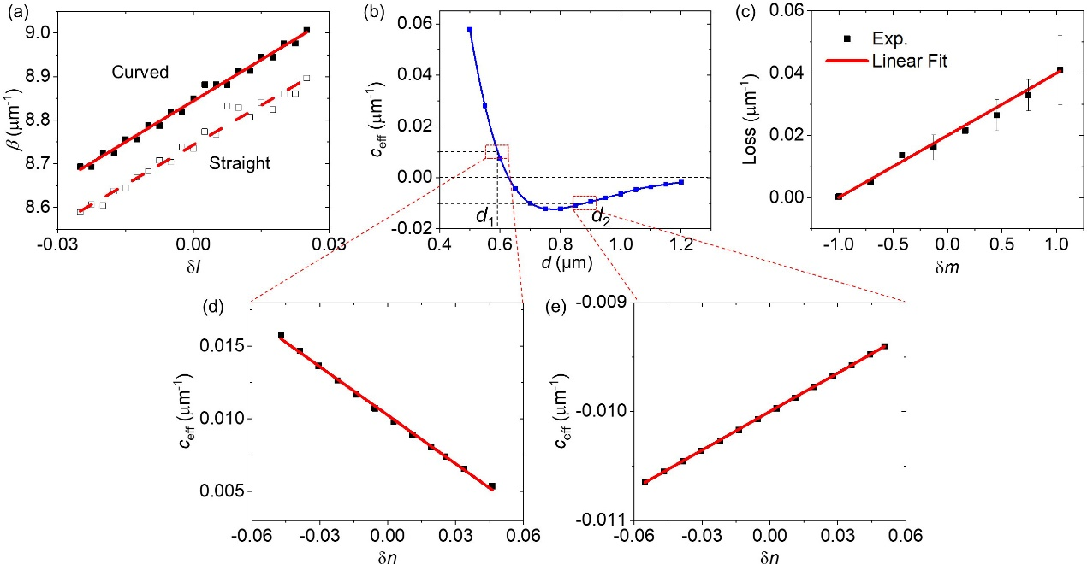
Figure S1 (a) Propagation constant as a function of δl for curved and straight silicon waveguide. (b) Effective coupling coefficient as a function of d. (c),(d) Effective coupling coefficient as a function of δn for d_{1c}=0.480 μm (c) and d_{2c}=0.193 μm (d). Black dots are results from full-wave simulations, and red lines are fitted linear relationships. (e) Loss of Cr-deposited silicon waveguide as a function of δm.

Upon Fourier transformation, Eq. (S1) can be written as
(S7)
Substituting Eqs. (S4)-(S6) into Eq. (S7), one obtains
(S8)
Expanding H with respect to (δl, δm, δn, δk) up to the first order, we finally have
H(k)= cδnσ_{x}+κ₀δkσ_{y}+(bδl+iaδm)σ_{z}+(β₀+iγ₀)σ₀, (S9)
where σ=(σ_{x}, σ_{y}, σ_{z}) are the Pauli matrix, σ₀ is a 2 × 2 identity matrix, and c=c₁+c₂=0.123 μm⁻¹.

S2. Interface states induced by mixed phase transition in Hermitian and non-Hermitian dimensions.

According to Fig. 2(c) in the main text (also shown here as Fig. S2(a)), the symmetric edge mode (upper) is moved from inside to outside of the bulk band as the dimension is gradually transformed from Hermiticy (ϕ=0) to non-Hermiticity (ϕ=π/2). In the range of (0.22π, 0.4π), the interface state merges into the bulk band and becomes the bound states in the continuum (BIC) (see Fig. S2(c), bottom panel). Figure S2(b) shows the imaginary part of the spectrum, where the loss of the BIC (ϕ=π/3) and non-Hermitian interface states (ϕ=π/2) are marked by the black dot and circle, respectively. They all have low loss but the BIC is a little bit higher. This is also well confirmed in the simulation and experimental results (see Fig. 4 in the main text). This type of BIC is generated from the interaction of phase transition in Hermitian and non-Hermitian dimensions (Fig. S2(c), top panel).
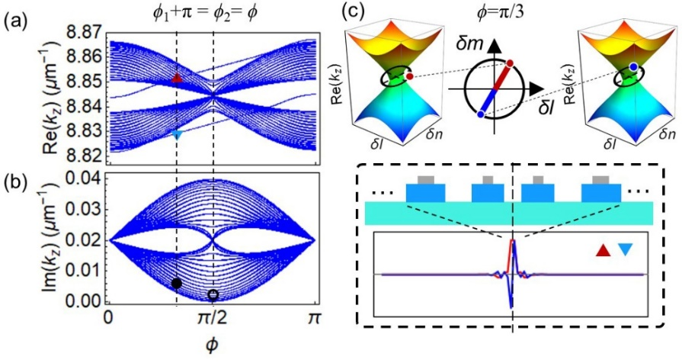
Figure S2 Features of BIC induced by mixed Hermitian and non-Hermitian dimension transitions. Real (a) and imaginary (b) part of the eigenvalue spectra as a function of ϕ, which follow specific paths ϕ₂= ϕ₁+π= ϕ. (c) Top: the band structures of semi arrays at δl-δn dimensions and the loops at the δl-δm dimensions for special cases of ϕ =π/3. The projective loops encircle the EPs in the δl-δn parameter spaces. The dots mark the parameters of waveguide arrays. Bottom: field intensity distributions of the interface states in (a) [indicated by the (inverted) triangle at ϕ=π/3]. The four central waveguides are enlarged and the black dashed line indicates the position of the interface.

S3. Local density of states (LDOS) of the Weyl systems.
To clearly reveal different types of Weyl interface states, we numerically obtain the local density of states (LDOS), which is presented in Fig. S3 and Fig. S4. The LDOS is defined by⁵
(S10)
where β_{j} is the energy of the jth eigenstates, and φ_{i}^{j} is its wave function. D_{i}(β)_{Re(Im)} describes the spatial distribution of the eigenstates of the structure as a function of real (imaginary) energy.
For the structure with Hermitian dimension transition (see Fig. S3(a)), we observe bands of extended states that correspond to the eigenstates of Weyl medium 1 for -40 < i ≤ 0 (see Fig. S3(b)). Similarly, for 0 < i ≤ 40, we recognize the band of extended states of Weyl medium 2. They have almost the same wide of real spectra that confirm the same rotating spaces. However, at the interface, there are spatially localized state with energy inside the gaps (Fig. S3(b), red circle). Its appearance is an explicit signature of the phase transition between two Hermitian Weyl media with real mass inversion (Fig. S3(c)). For the structure with mixed Hermitian and non-Hermitian dimension transition (see Fig. S3(d)), the real spectrum shrinks but the imaginary spectrum expands, indicating the emergence of non-Hermitian dimension (see Figs. S3(e) and S3(f)). In addition, the localized state merges into the bulk bands and becomes the BIC (see Fig. S3(e), red circle). For the non-Hermitian dimension transition case (see Fig. S3(g)), the localized states now are beyond the bulk bands and have low loss (Figs. S3(h) and S3(i), the red circle). We have therefore confirmed the bulk phase transition between two inequivalent non-Hermitian Weyl Media with imaginary mass inversion.
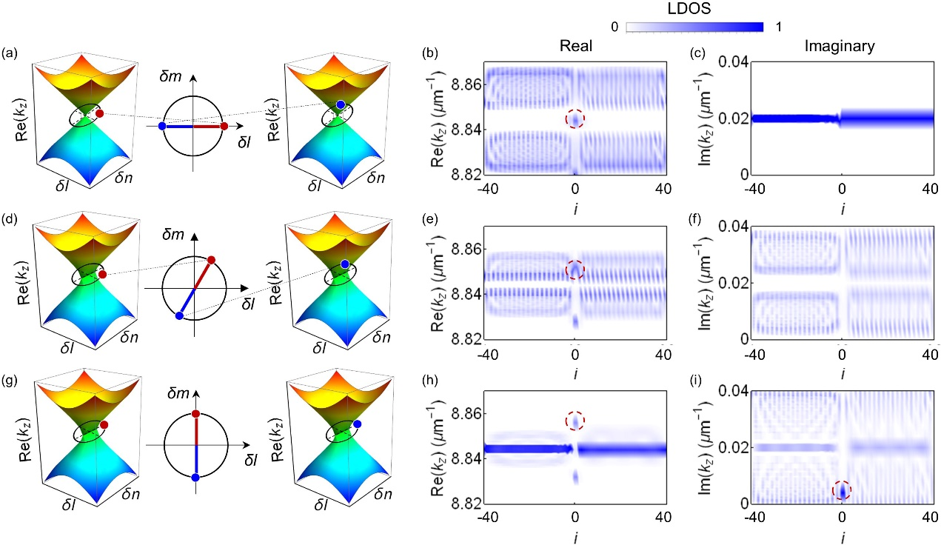
Figure S3 Summary of compound Weyl media with dimension transition in the same parameter space. (a-c) Hermitian dimension transition. (d-f) mixed dimension transition. (g-i) non-Hermitian dimension transition. (a,d,g) Band structures of semi arrays at δl-δn dimensions and the loops at the δl-δm dimensions. The projective loops encircling the WP in the δl-δn parameter spaces for the Hermitian case (a) while encircling EPs for the mixed (d) and non-Hermitian case (g). Numerically obtained LDOS of Weyl structures for the real (b,e,h) and imaginary (c,f,i) spectra.

We then demonstrate the possibility of creating interface states between two Weyl media without Hermitian/non-Hermitian dimension transitions. If the two Weyl media have the same parameter spaces, no interface state could exist (see Figs. S4(a)-S4(c), only bulk states can be observed). However, it becomes possible if the two Weyl media have different parameter spaces, as shown in Figs. S4(d)-S4(i), where the parameter spaces are shifted or deformed in the non-Hermitian dimension. To be noted, the interface state induced by the deformation in non-Hermitian dimension is a zero mode and have the lowest loss (Figs. S4(h) and S4(i), red circle). It can also be interpreted by the creation of interface by different Weyl structures, i.e., the bulk band for -40 < i ≤ 0 (Weyl medium 1) are much wider than it for 0 < i ≤ 40 (Weyl medium 2) (Figs. S4(h)), indicating that medium 1 rotates enclosing the EPs while the medium 2 rotates inside EPs. As a result, the interface state is supported between two Weyl media with different non-Hermitian phases (e.g., the interface constructed by different Weyl exceptional rings).
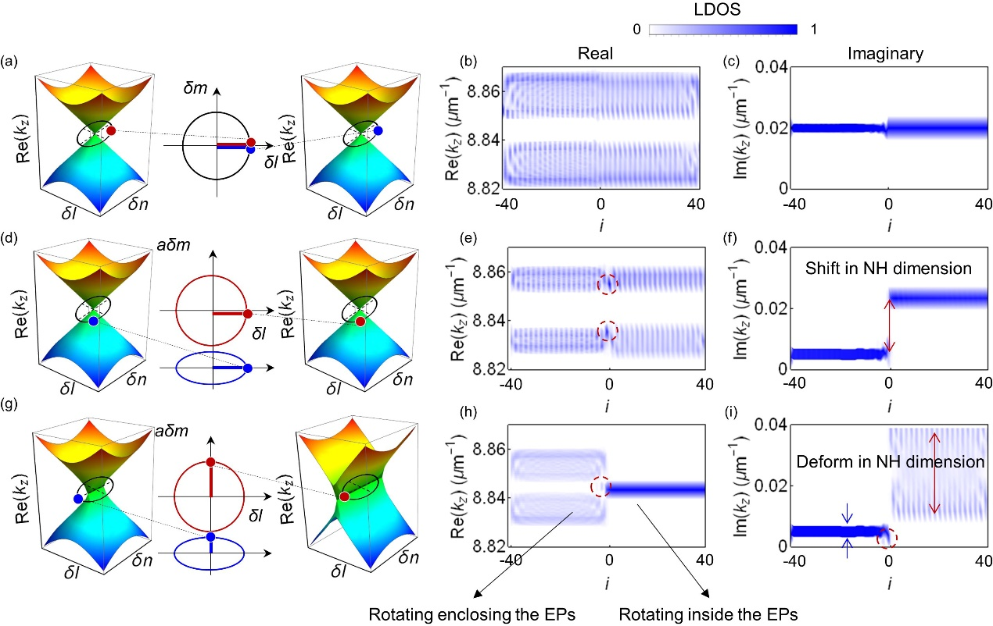
Figure S4 Summary of compound Weyl media without dimension transition. (a-c) with the same parameter space. (d-f) with different parameter spaces that shift along the non-Hermitian dimension. (g-i) with different parameter spaces that deform in the non-Hermitian dimension. (a,d,g) Band structures of semi arrays at δl-δn dimensions and the loops at the δl-δm dimensions. Numerically obtained LDOS of Weyl structures for the real (b,e,h) and imaginary (c,f,i) spectra.

S4. Propagations with random disorders in all synthetic dimensions.
We perform massive numerical calculations to analyze the influence of fabrication errors (±5 nm) on the interface states based on the experimental parameters. The effects of structural disorders are introduced on three parameter spaces l, m, and n, resulting in variations in propagation constants, the coupling coefficients, and the loss parameters:
(S11)
where ξ_{i} is a uniformly distributed random number in the interval [-0.5, 0.5] ,β_{i} and γ_{i} is the ideal propagation constant and loss of the waveguide i , κ_{i} is the ideal coupling coefficient between waveguide i and i +1, Δβ = 0.157 μm⁻¹, Δκ₁ = 0.000246 μm⁻¹, Δκ₂ = 0.00577 μm⁻¹, and Δγ=0.000996 μm⁻¹ are the maximum variation range of the propagation constants, coupling coefficients, and loss respectively, among all samples according to the fabrication accuracy.
Figure S5 shows the intensity distribution at the 200 μm length calculated with Eq. (S1) (by massive check of over 100 samples). For the Hermitian trivial case ϕ₁= ϕ₂= 0 without interface states (Fig. S5(a)), the intensity distribution is still diffused. For the Non-Hermitian case ϕ₁= ϕ₂-π= π/2 (Fig. S5(b)), the mixed Hermitian and non-Hermitian case ϕ₁= ϕ₂-π= π/3 (Fig. S5(c)), and non-Hermitian case ϕ₂=ϕ₁= π/2 with different rotating spaces (Fig. S5(d)), the results are stable and the characteristics of the localization near the interface preserve despite random disorders. Based on the analysis above, the interface states manifest good robustness against fabrication errors in the compound Weyl arrays. We thus expect that the main features in Fig. 4 in the main text are reproducible.
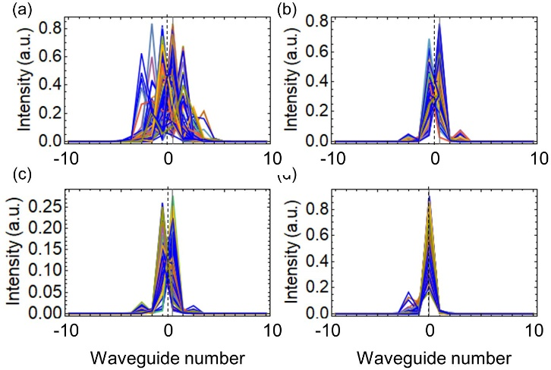
Figure S5 Simulated intensity distribution in the presence of disorder at 200 μm for the four cases considered in the experiments. The results are calculated from over 100 samples. The positions of the interface are indicated by the black dashed line.

References
- Pertsch, T., Zentgraf, T., Peschel, U., Brer, A. & Lederer, F. Anomalous refraction and diffraction in discrete optical systems. Phys. Rev. Lett. 88, 093901 (2002).
- Efremidis, N. K. et al. Wave propagation in waveguide arrays with alternating positive and negative couplings. Phys. Rev. A 81, 053817 (2010).
- Zeuner, J. M. et al. Optical analogues for massless Dirac particles and conical diffraction in one dimension, Phys. Rev. Lett. 109, 023602 (2012).
- Rakić, A. D., Djurišić, A. B., Elazar, J. M. & Majewski, M. L. Optical properties of metallic films for vertical-cavity optoelectronic devices. Appl. Opt. 37, 5271 (1998).
- Verbin, M., Zilberberg, O., Kraus, Y. E., Lahini, Y. & Silberberg, Y. Observation of Topological Phase Transitions in Photonic Quasicrystals. Phys. Rev. Lett. 110, 076403 (2013).

