A B
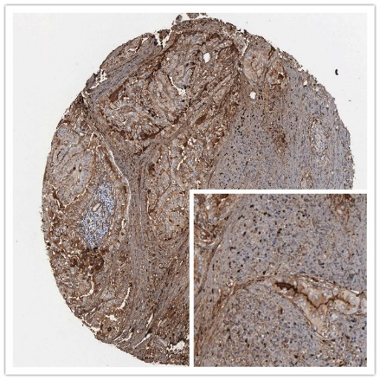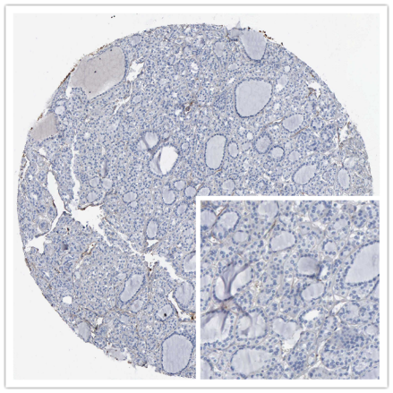
C
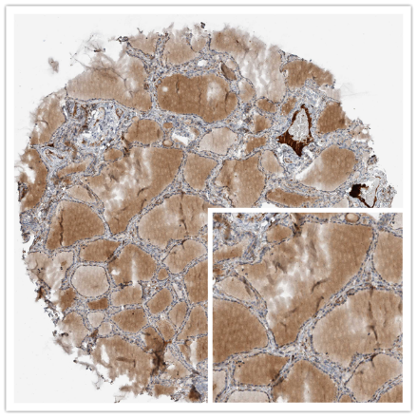
D E
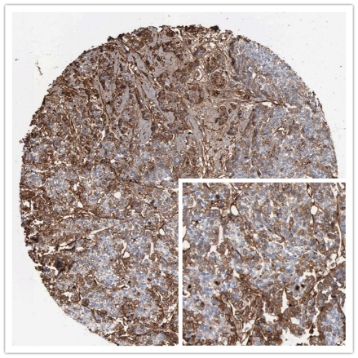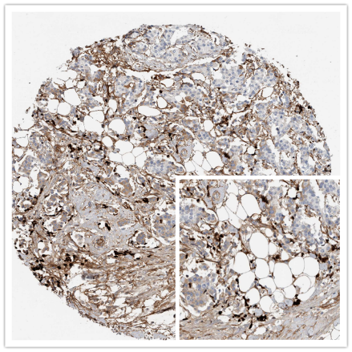
F
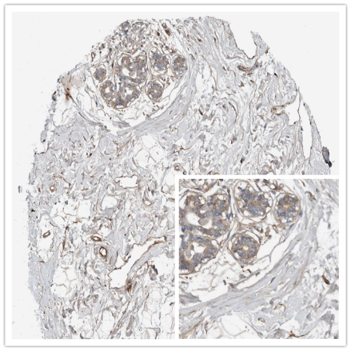
Supplementary FIGURE 1 Representative images of FN1 expression in TC, BC tissues and their normal controls from Human Protein Atlas (HPA, https://www.proteinatlas.org/). (A). High expression of FN1 in THCA tissues. (B). Low expression of FN1 in THCA tissues. (C). Low expression of FN1 in thyroid tissues. (D). High expression of FN1 in BRCA tissues. (E). Low expression of FN1 in BRCA tissues. (F). Low expression of FN1 in breast tissues. Original magnifications ×200.
A
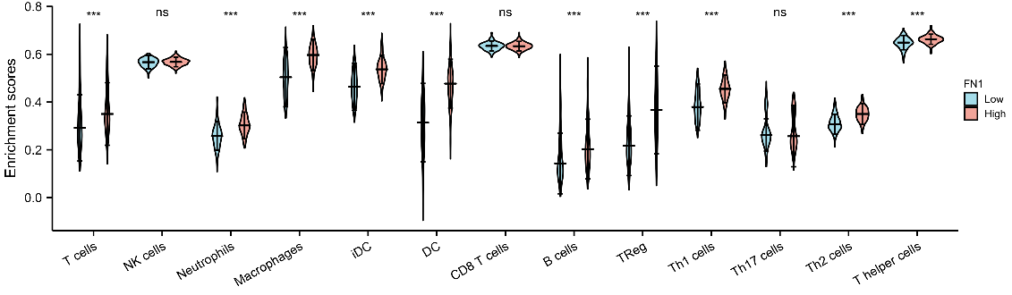
B
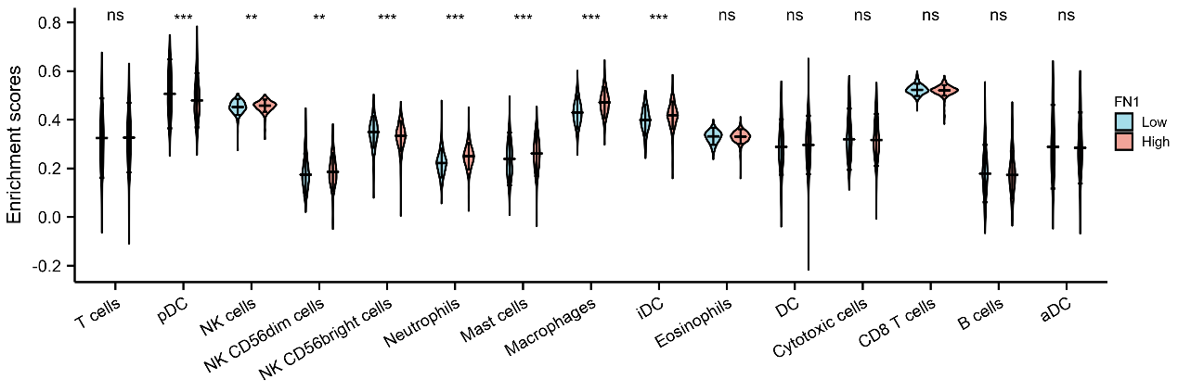
Supplementary FIGURE 2 The proportion of immune cells in THCA and BRCA. (A)
. The proportion of 13 subpopulations of immune cells are main immune cells effected by FN1 expression in THCA. (B). The proportion of 15 subpopulations of immune cells are main immune cells effected by FN1 expression in BRCA.

Supplementary TABLE 1 Association between FN1 expression and clinicopathologic features in patients with THCA in TCGA cohort.
Characteristic | Low expression of FN1 | High expression of FN1 | p
N | 255 | 255
T stage, n (%) |  |  | < 0.001
T1 | 81 (15.9%) | 62 (12.2%)
T2 | 98 (19.3%) | 69 (13.6%)
T3 | 67 (13.2%) | 108 (21.3%)
T4 | 8 (1.6%) | 15 (3%)
N stage, n (%) |  |  | < 0.001
N0 | 146 (31.7%) | 83 (18%)
N1 | 77 (16.7%) | 154 (33.5%)
M stage, n (%) |  |  | 0.308
M0 | 128 (43.4%) | 158 (53.6%)
M1 | 6 (2%) | 3 (1%)
Pathologic stage, n (%) |  |  | < 0.001
Stage I | 149 (29.3%) | 137 (27%)
Stage II | 39 (7.7%) | 13 (2.6%)
Stage III | 46 (9.1%) | 67 (13.2%)
Stage IV | 19 (3.7%) | 38 (7.5%)
Gender, n (%) |  |  | 1.000
Female | 185 (36.3%) | 186 (36.5%)
Male | 70 (13.7%) | 69 (13.5%)
Race, n (%) |  |  | 0.601
Asian | 27 (6.5%) | 24 (5.8%)
Black or African American | 12 (2.9%) | 15 (3.6%)
White | 153 (37%) | 183 (44.2%)
Histological type, n (%) |  |  | < 0.001
Classical | 152 (29.8%) | 212 (41.6%)
Follicular | 94 (18.4%) | 7 (1.4%)
Other | 5 (1%) | 4 (0.8%)
Tall Cell | 4 (0.8%) | 32 (6.3%)
Age, n (%) |  |  | 0.859
<=45 | 119 (23.3%) | 122 (23.9%)
>45 | 136 (26.7%) | 133 (26.1%)
Extrathyroidal extension, n (%) |  |  | < 0.001
No | 199 (40.4%) | 139 (28.3%)
Yes | 43 (8.7%) | 111 (22.6%)
Primary neoplasm focus type, n (%) |  |  | 0.377
Multifocal | 121 (24.2%) | 112 (22.4%)
Unifocal | 127 (25.4%) | 140 (28%)

Supplementary TABLE 2 Association between FN1 expression and clinicopathologic features in patients with BRCA in TCGA cohort.
Characteristic | Low expression of FN1 | High expression of FN1 | p
N | 541 | 542
T stage, n (%) |  |  | 0.003
T1 | 121 (11.2%) | 156 (14.4%)
T2 | 316 (29.3%) | 313 (29%)
T3 | 87 (8.1%) | 52 (4.8%)
T4 | 15 (1.4%) | 20 (1.9%)
N stage, n (%) |  |  | 0.027
N0 | 256 (24.1%) | 258 (24.2%)
N1 | 186 (17.5%) | 172 (16.2%)
N2 | 44 (4.1%) | 72 (6.8%)
N3 | 44 (4.1%) | 32 (3%)
M stage, n (%) |  |  | 0.953
M0 | 435 (47.2%) | 467 (50.7%)
M1 | 9 (1%) | 11 (1.2%)
Pathologic stage, n (%) |  |  | 0.372
Stage I | 81 (7.6%) | 100 (9.4%)
Stage II | 320 (30.2%) | 299 (28.2%)
Stage III | 125 (11.8%) | 117 (11%)
Stage IV | 8 (0.8%) | 10 (0.9%)
Race, n (%) |  |  | 0.025
Asian | 30 (3%) | 30 (3%)
Black or African American | 109 (11%) | 72 (7.2%)
White | 369 (37.1%) | 384 (38.6%)
Age, n (%) |  |  | 0.055
<=60 | 284 (26.2%) | 317 (29.3%)
>60 | 257 (23.7%) | 225 (20.8%)
Histological type, n (%) |  |  | < 0.001
Infiltrating Ductal Carcinoma | 355 (36.3%) | 417 (42.7%)
Infiltrating Lobular Carcinoma | 126 (12.9%) | 79 (8.1%)
PR status, n (%) |  |  | < 0.001
Negative | 193 (18.7%) | 149 (14.4%)
Positive | 321 (31%) | 367 (35.5%)
ER status, n (%) |  |  | 0.031
Negative | 134 (12.9%) | 106 (10.2%)
Positive | 383 (37%) | 410 (39.6%)
HER2 status, n (%) |  |  | 0.007
Negative | 274 (37.7%) | 284 (39.1%)
Positive | 55 (7.6%) | 102 (14%)
PAM50, n (%) |  |  | 0.003
LumA | 274 (25.3%) | 288 (26.6%)
LumB | 96 (8.9%) | 108 (10%)
Her2 | 31 (2.9%) | 51 (4.7%)
Basal | 120 (11.1%) | 75 (6.9%)
Menopause status, n (%) |  |  | 0.336
Pre | 103 (10.6%) | 126 (13%)
Peri | 21 (2.2%) | 19 (2%)
Post | 354 (36.4%) | 349 (35.9%)

Supplementary TABLE 3 FN1 expression (Categorical dependent variable, greater or less than the median expression level) associated with clinical pathological characteristics in patients with THCA in TCGA cohort (logistic regression).
Characteristics | Total(N) | Odds Ratio in FN1 expression | P
Gender (Female vs. Male) | 510 | 1.020 (0.690-1.507) | 0.921
Age (>45 vs. <=45) | 510 | 0.954 (0.674-1.351) | 0.790
T stage (T3&T4 vs. T1&T2) | 508 | 2.241 (1.559-3.237) | <0.001
N stage (N1 vs. N0) | 460 | 3.518 (2.405-5.186) | <0.001
M stage (M1 vs. M0) | 295 | 0.405 (0.084-1.567) | 0.208
Pathologic stage (Stage IV vs. Stage I) | 343 | 2.175 (1.211-4.024) | 0.011
Extrathyroidal extension (Yes vs. No) | 492 | 3.696 (2.460-5.631) | <0.001
Primary neoplasm focus type (Multifocal vs. Unifocal) | 500 | 0.840 (0.590-1.193) | 0.330

Supplementary TABLE 4 FN1 expression (Categorical dependent variable, greater or less than the median expression level) associated with clinical pathological characteristics in patients with BRCA in TCGA cohort (logistic regression).
Characteristics | Total(N) | Odds Ratio in FN1 expression | P
T stage (T2&T3&T4 vs. T1) | 1,080 | 0.714 (0.542-0.940) | 0.016
N stage (N1&N2&N3 vs. N0) | 1,064 | 0.999 (0.786-1.271) | 0.997
M stage (M1 vs. M0) | 922 | 1.138 (0.467-2.850) | 0.775
Pathologic stage (Stage IV&Stage II&Stage III vs. Stage I) | 1,060 | 0.762 (0.551-1.050) | 0.097
Age (>60 vs. <=60) | 1,083 | 0.784 (0.617-0.997) | 0.047
PR status (Positive vs. Negative) | 1,030 | 1.481 (1.141-1.924) | 0.003
ER status (Positive vs. Negative) | 1,033 | 1.353 (1.013-1.811) | 0.041
HER2 status (Positive vs. Negative) | 715 | 1.789 (1.244-2.596) | 0.002
Histological type (Infiltrating Lobular Carcinoma vs. Infiltrating Ductal Carcinoma) | 977 | 0.534 (0.388-0.730) | <0.001
PAM50 (Her2 vs. LumA) | 644 | 1.942 (1.205-3.193) | 0.007
Menopause status (Post vs. Pre&Peri) | 972 | 0.843 (0.636-1.117) | 0.235

Supplementary TABLE 5 Correlation of FN1 expression and clinical prognosis in BRCA with different clinicopathological factors by Kaplan-Meier plotter. Correlation of FN1 expression and OS in THCA, OS, PPS, DMFS in BRCA with different clinicopathological factors by Kaplan-Meier plotter (n = 502, n = 1402, n = 414, n = 1803). OS, overall survival; PPS, post progression survival; DMFS, distant metastasis-free survival.
Clinicopatholo-gical characteristics | OS in BC（n=1402） |  |  | PPS in BC（n=414） |  |  | DMFS in BC (n=1803) |  |  | Clinicopathological characteristics | OS in TC（n=502）
Clinicopatholo-gical characteristics | N | Hazard Ratio | p-value | N | Hazard Ratio | p-value | N | Hazard Ratio | p-value | Clinicopathological characteristics | N | Hazard Ratio | p-value
ER |  |  |  |  |  |  |  |  |  | SEX
+ | 548 | 0.65（0.43-0.98） | 0.039 | 173 | 0.79（0.52-1.2） | 0.27 | 664 | 1.55（1.01-2.37） | 0.044 | MALE | 135 | 0.11（0.02-0.71） | 0.0064
_ | 251 | 1.51（0.94-2.44） | 0.09 | 100 | 1.56（0.9-2.69） | 0.11 | 275 | 2.75（1.78-4.27） | 2.3e-06 | FEMALE | 367 | 2.49（0.64-9.64） | 0.17
PR |  |  |  |  |  |  |  |  |  | STAGE
+ | 83 | 0.34(0.08-1.38) | 0.11 | 13 | - | - | 192 | 2.05（0.89-4.74） | 0.087 | 1 | 281 | 0(0-Inf) | 0.008
_ | 89 | 0.73(0.28-1.87) | 0.51 | 17 | - | - | 154 | 3.13（1.69-5.8） | 0.00014 | 2 | 52 | 0.17(0.01-2.78) | 0.16
HER2 |  |  |  |  |  |  |  |  |  | 3 | 112 | 0.36(0.07-1.85) | 0.2
+ | 129 | 0.68（0.33-1.39） | 0.28 | 33 | 0.35（0.1-1.22） | 0.086 | 126 | 2.82(1.37-5.81) | 0.0034 | 4 | 55 | 2.53（0.39-16.34） | 0.32
_ | 130 | 1.65(0.68-3.99) | 0.26 | 39 | 1.92(0.43-8.45) | 0.39 | 150 | 1.91(0.79-4.6) | 0.14 | RACE
Lymph node status |  |  |  |  |  |  |  |  |  | white | 332 | 1.69（0.57-5.05） | 0.34
+ | 313 | 0.6（0.39-0.91） | 0.015 | 128 | 0.74（0.46-1,18） | 0.21 | 382 | 1.91(1.3-2.82) | 0.00085 | black/african american | 27 | 0（0-Inf） | 0.0096
_ | 594 | 0.82(0.54-1.25) | 0.35 | 165 | 1.26(0.81-1.96) | 0.3 | 988 | 1.16（0.85-1.59） | 0.35 | asian | - | - | -
Intrinsic subtype |  |  |  |  |  |  |  |  |  | Mutation burden
basal | 241 | 0.7(0.42-1.17) | 0.17 | 64 | 0.63(0.33-1.22) | 0.17 | 261 | 1.46(0.89-2.39) | 0.14 | high | 245 | 2.59（0.73-9,23） | 0.13
luminal A | 611 | 0.71（0.49-1,03） | 0.071 | 179 | 1.28（0.86-1.92） | 0.22 | 968 | 1.49（1.11-1.98） | 0.0066 | low | 240 | 0（0-Inf） | 0.1
luminal B | 433 | 1.79（1.19-2.7） | 0.0047 | 134 | 2.5（1.45-4.31） | 0.00069 | 449 | 1.44（1-2.06） | 0.049
HER2+ | 117 | 1.65(0.86-3.15) | 0.13 | 335 | 1.64(0.78-3.47) | 0.19 | 125 | 4.43(2.04-9.63) | 4.1e-05
Grade
1 | 1402 | 0.46（0.16-1.27） | 0.12 | 34 | 2.45（0.55-10.98） | 0.23 | 188 | 1.6（0.71-3.63） | 0.26
2 | 387 | 0.65（0.42-0.99） | 0.045 | 128 | 0.76（0.47-1.23） | 0.26 | 546 | 0.85（0.6-1.2） | 0.35
3 | 503 | 1.51(1.08-2.12) | 0.015 | 165 | 1.82(1.18-2.82) | 0.0062 | 458 | 1.84(1.3-2.6) | 0.00044
Bold values indicate P < 0.05

