A manganese oxide/MOF nano-composite for the adsorption of methylene blue from an aqueous solution
Shokoofeh Geranmayeh,ª*
ª Department of Chemistry, Faculty of Physics and Chemistry, Alzahra University, P.O. Box 1993891176, Tehran, Iran
^{b} Department of Chemistry,

Supporting Information
EDX of the as-synthesized MnO2/IRMOF-3 nano-composite material | Page 2
UV-vis spectrum of methylene blue at 10⁻⁵ M concentration | Page 3
Zeta potential of adsorbent at the solution pH of 6 | Page 4
Calibration curve for the MB solutions at 5.0×10⁻⁶- 4.0×10⁻⁵ M | Page 4
Freundlich isotherm for the adsorption of MB on the MnO₂/IRMOF-3 composite material | Page 5
EDX elemental analysis of the synthesized MnO2/IRMOF-3 composite material | Page 5

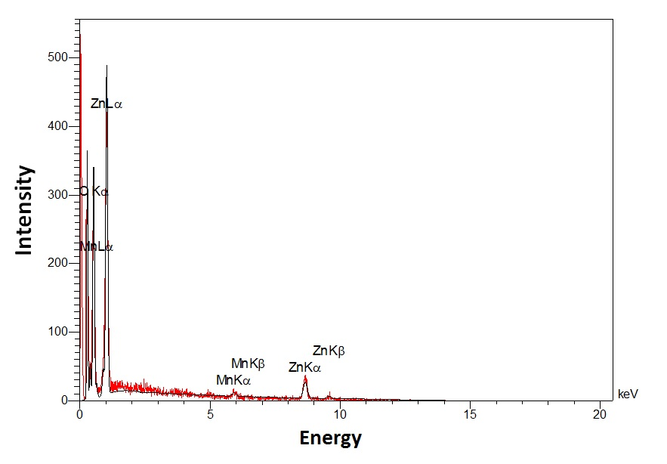

Figure S1. Energy-dispersive X-ray spectroscopy (EDX) of the synthesized MnO2/IRMOF-3 nano-composite material

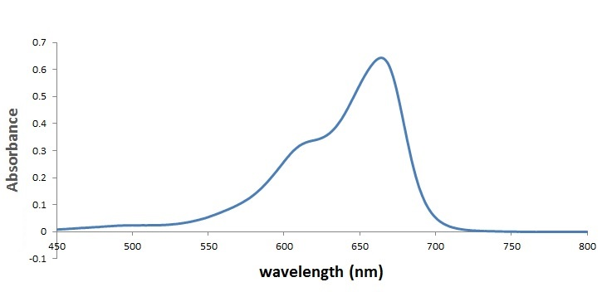

Figure S2. UV-vis spectrum of methylene blue at 10⁻⁵ M concentration

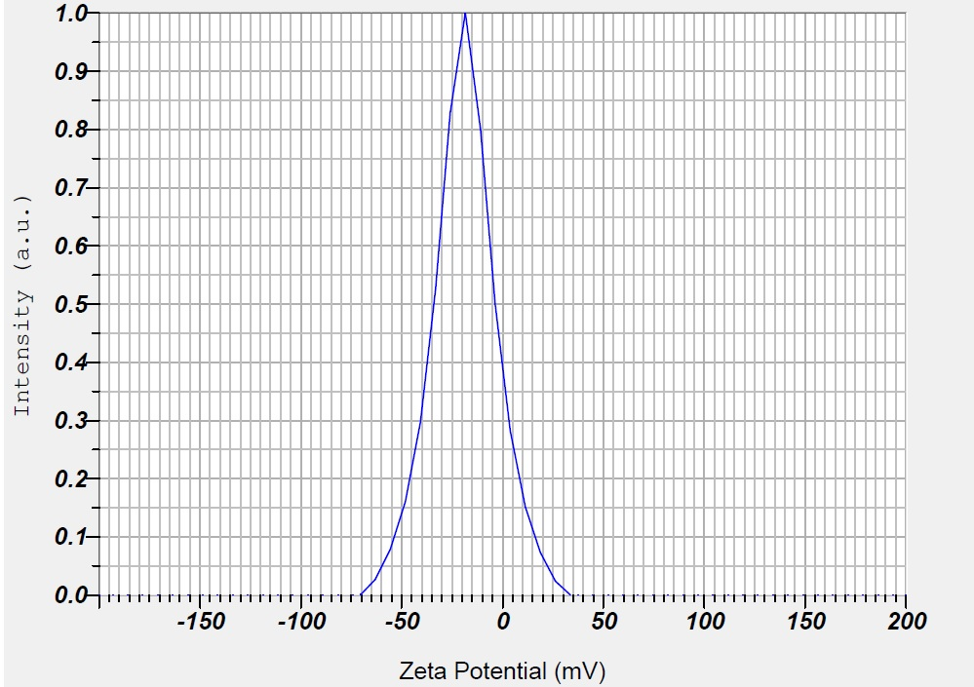
Figure S3. Zeta potential of adsorbent at the solution pH of 6

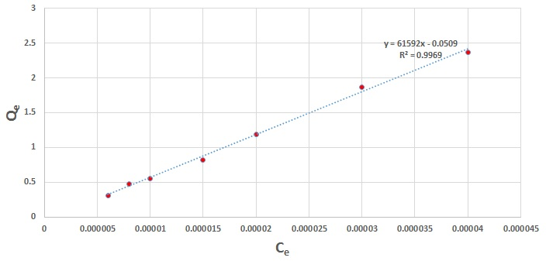
Figure S4. Calibration curve for the MB solutions at 5.0×10⁻⁶- 4.0×10⁻⁵ M.

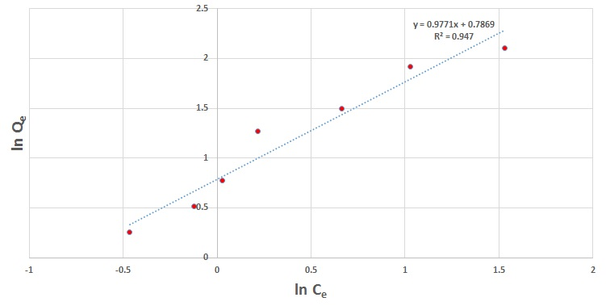
Figure S5. Freundlich isotherm model for the adsorption of MB on the MnO₂/IRMOF-3 composite material

Table S1. EDX elemental analysis of the synthesized MnO₂/IRMOF-3 composite material
Elt | Line | Int | Error | K | Kr | W% | A%
C | Ka | 91.5 | 16.6901 | 0.3906 | 0.1336 | 31.14 | 39.61
N | Ka | 18.3 | 16.6901 | 0.1056 | 0.0361 | 18.08 | 19.72
O | Ka | 126.6 | 16.6901 | 0.2693 | 0.0921 | 39.87 | 38.08
Mn | Ka | 4.9 | 0.3519 | 0.0150 | 0.0051 | 0.64 | 0.18
Zn | Ka | 21.8 | 0.7362 | 0.2195 | 0.0751 | 10.27 | 2.40
 |  |  |  | 1.0000 | 0.3421 | 100.00 | 100.00

