Supplementary Material
Seasonal bacterial niche structures and chemolithoautotrophic ecotypes in a North Atlantic fjord

Eric J. Raes^{1,2}, Jennifer Tolman¹, Dhwani Desai^{1,2}, Jenni-Marie Ratten¹, Jackie Zorz³, Brent M. Robicheau¹, Diana Haider^{1,4}, Julie LaRoche^{1*}

- Dept. of Biology, Dalhousie University, Halifax, NS, Canada
- Flourishing Oceans, Minderoo Foundation, Broadway, 6009, WA, Australia
- Dept. of Pharmacology, Dalhousie University, Halifax, NS, B3H 4R2, Canada
- Dept. of Geoscience, University of Calgary, Calgary, AB, T2N 1N4, Canada
- Faculty of Computer Science, Dalhousie University, Halifax, NS, B3H 4R2, Canada

* Corresponding authors: Julie.LaRoche@dal.ca

Supplementary Figures:
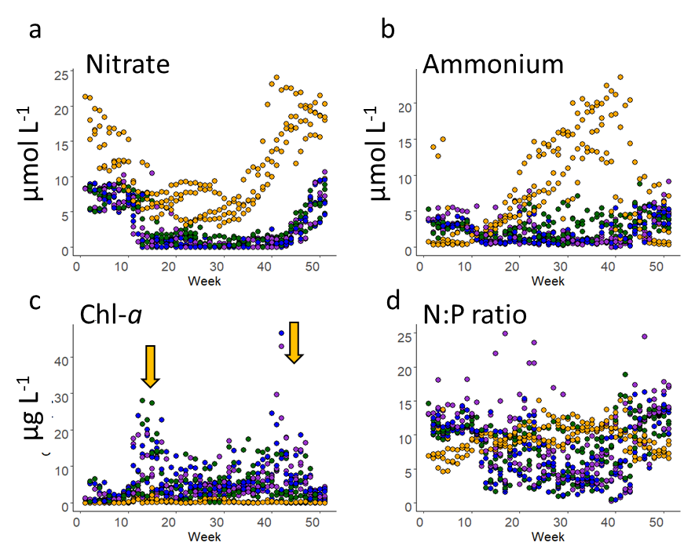
Supplementary Figure 1: Seasonal trend in nitrate (a), ammonium (b), chl-a (c), and N:P ratios (d) in the Bedford Basin from 2014-2017. Sampling depths are colour coded, with purple (1m), blue (5m), green (10m) and orange (60m). Orange arrows (c) denote the spring and autumn blooms.

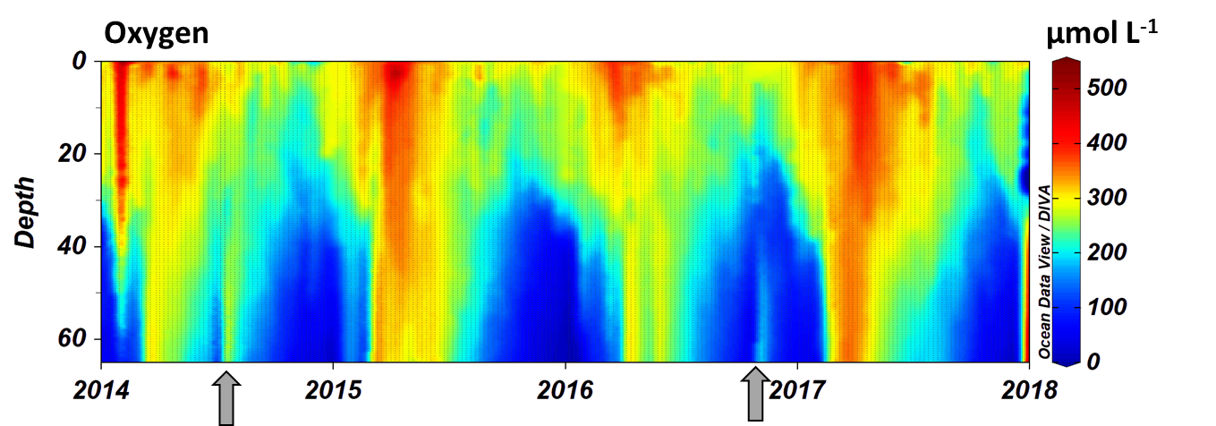
Supplementary Figure 2: Seasonal dissolved oxygen concentrations (in µmol L⁻¹), with suboxic concentrations in the deeper water in the colder winter months. Intrusion events in July 2014 and November 2017 are marked by grey arrows.

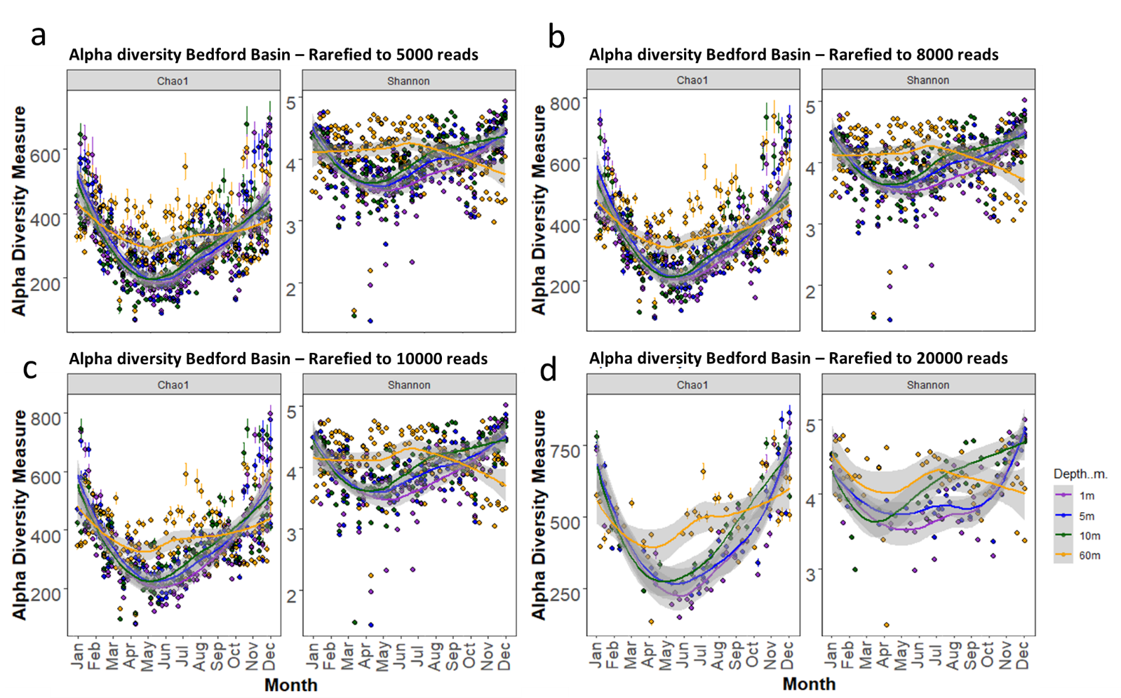
Supplementary Figure 3: Alpha diversity, both Chao1 and Shannon, after different rarefaction depths. a) ASV table rarefied to 5000 reads, b) rarefied to 8000 reads, c) rarefied to 10000 reads and d) rarefied to 20000 reads. The seasonal trends remain regardless of rarefaction depths. Loess regression lines are fitted for each depth.

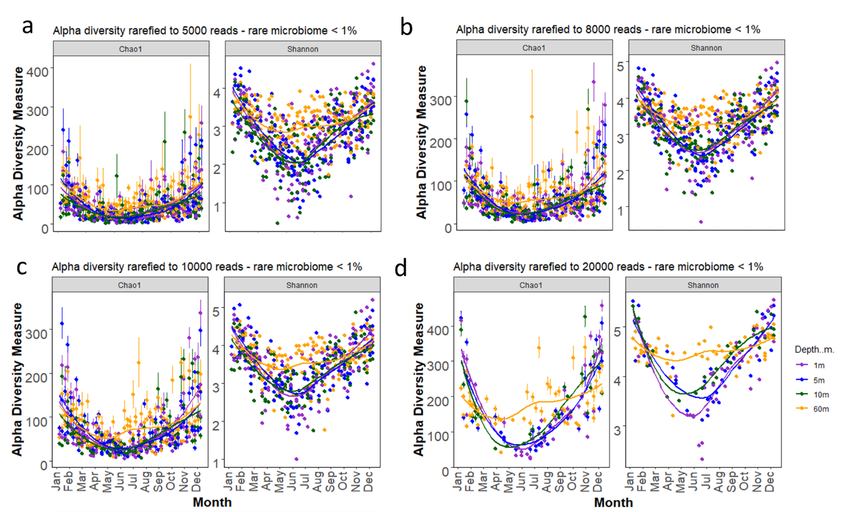
Supplementary Figure 4: Alpha diversity, both Chao1 and Shannon, after different rarefaction depths for the rare microbiome (<1% of the community). a) ASV table rarefied to 5000 reads, b) rarefied to 8000 reads, c) rarefied to 10000 reads and d) rarefied to 20000 reads. The seasonal trends remain regardless of rarefaction depths. Loess regression lines are fitted for each depth.

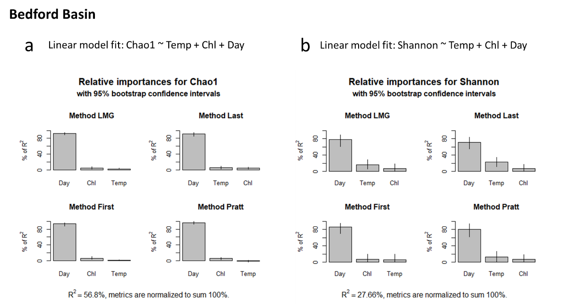
Supplementary Figure 5: Multiple linear regression models (with temperature + chl-a + day length fitted last) for the prokaryotic community in the euphotic zone. Linear regression models were conducted using the Vegan package (v.2.5-6; Oksanen et al., 2007) and the relaimpo package (v. 2.2.5; Groemping and Matthias ²) with the calc.relimp function was used to calculate the relative importance of each parameter to the model.
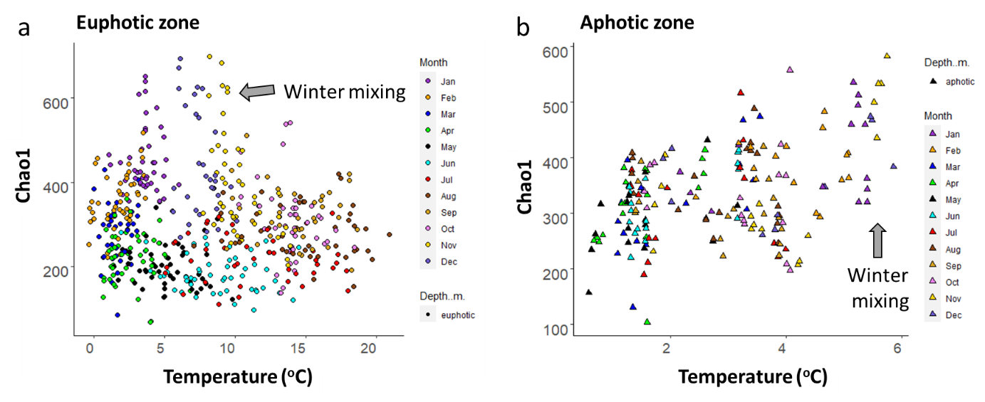
Supplementary Figure 6: Alpha diversity trends in the Bedford Basin from 2014-2017. Species richness (Chao1 diversity) correlated with temperature in the euphotic and aphotic zone (a and b). Grey arrows denote winter mixing and highest diversity in the winter.

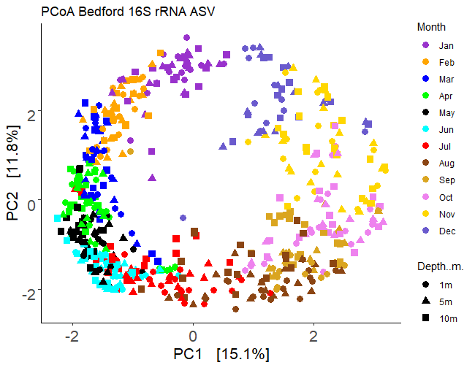
Supplementary Figure 7: Unconstrained PCA with CLR transformed ASVs and Aitchison (Euclidian) distance matrix in the euphotic zone. Symbols denote different depths, and colour different months.

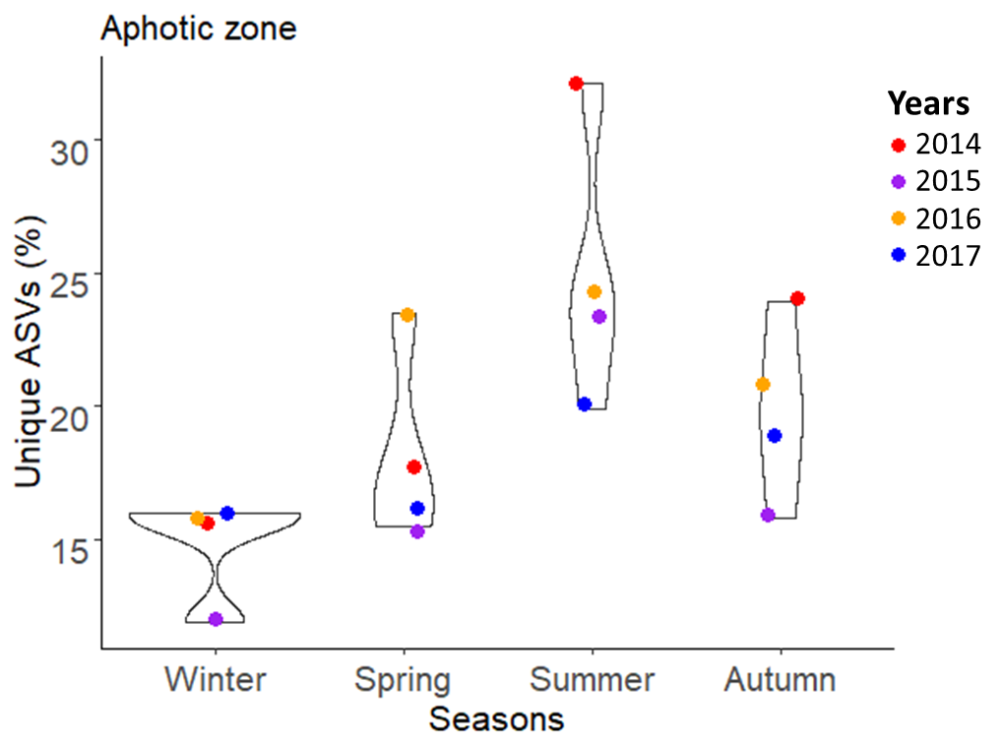
Supplementary Figure 8: Unique ASVs in the aphotic zone (expressed as a percentage). Note the doubling of unique ASVs in the aphotic zone in summer due to stratification of the water column. Unique ASVs were derived using the ggven package v.0.1.8 in R (Yan, L. ggvenn: draw Venn diagram by ‘ggplot2’; https://CRAN.R-project.org/package=ggvenn (2020)).

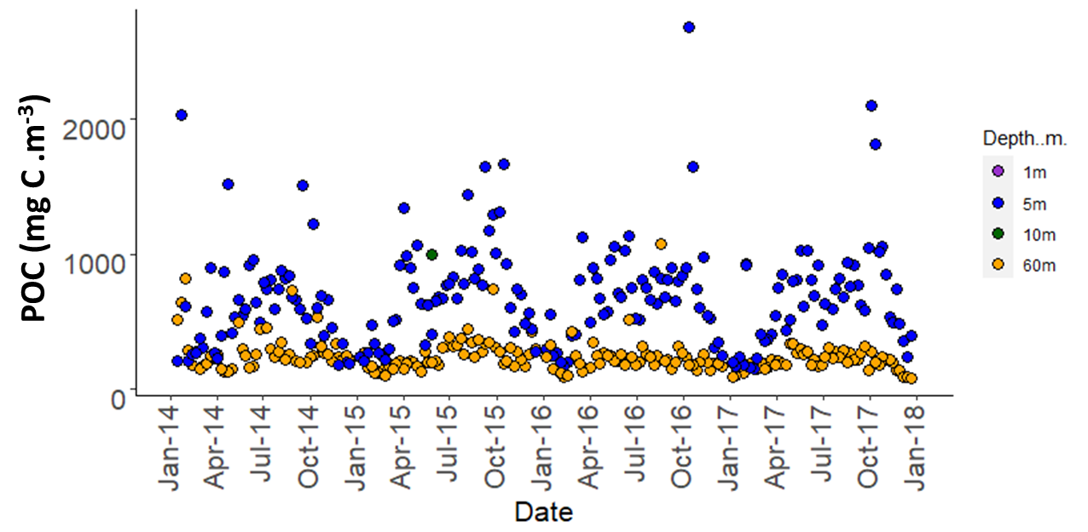
Supplementary Figure 9: Seasonal changes in particulate organic matter (POC). Note not samples were collected at 1m depth.

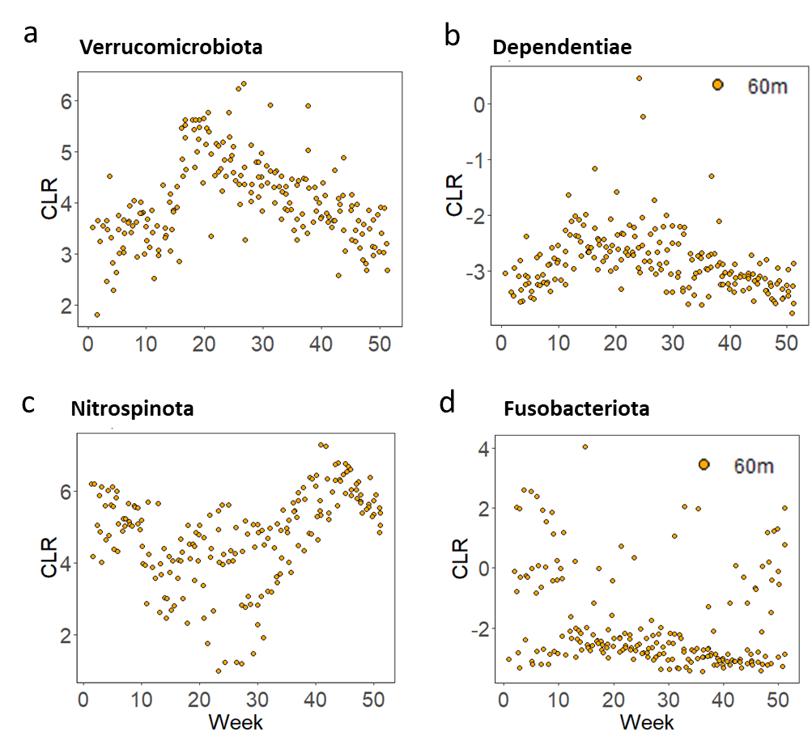
Supplementary Figure 10: Seasonal changes in bacterial Phyla in the aphotic zone (60 m) in Bedford Basin. Significance patterns and temporal niches were assessed with a permutation test (“multipatt” function; see Methods and supplementary Table 8). Due to the compositional nature of the sequence data the changes are visualized with CLR values rather than relative abundances.

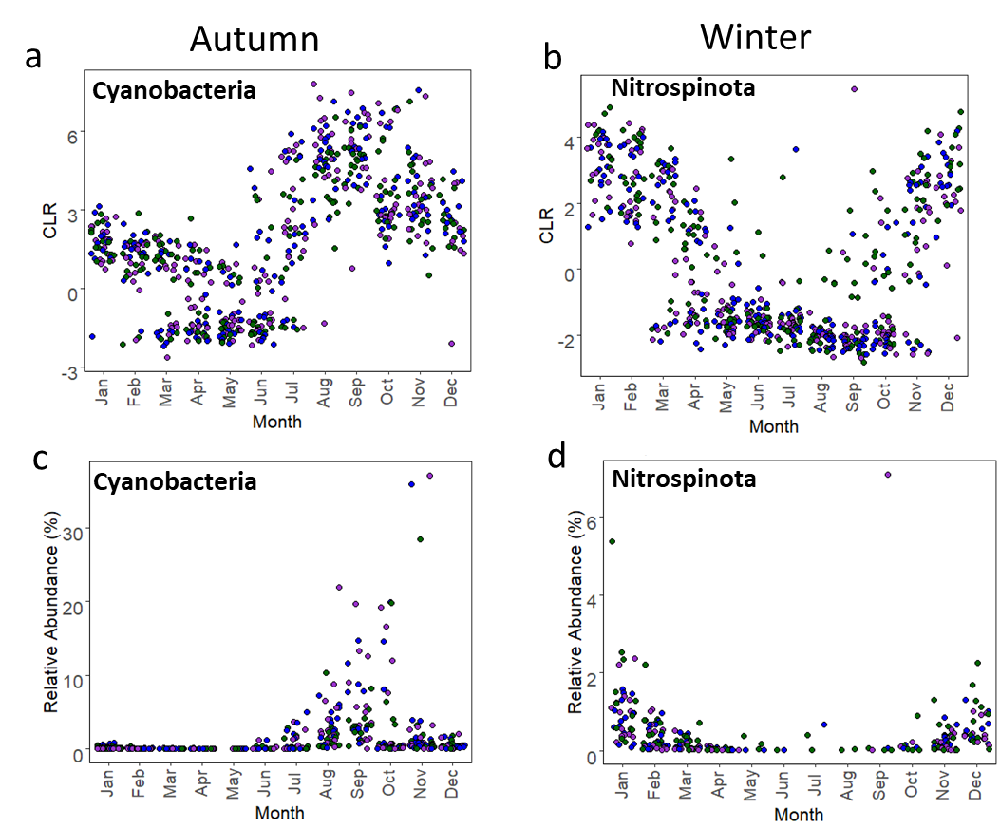
Supplementary Figure 11: Seasonal trends for Cyanobacteria and Nitrospinota shown as CLR transformed data (a and b), and relative abundances (c and d) in the Bedford basin across a 4-year time series data set. Rarefaction depth was 5000 reads.

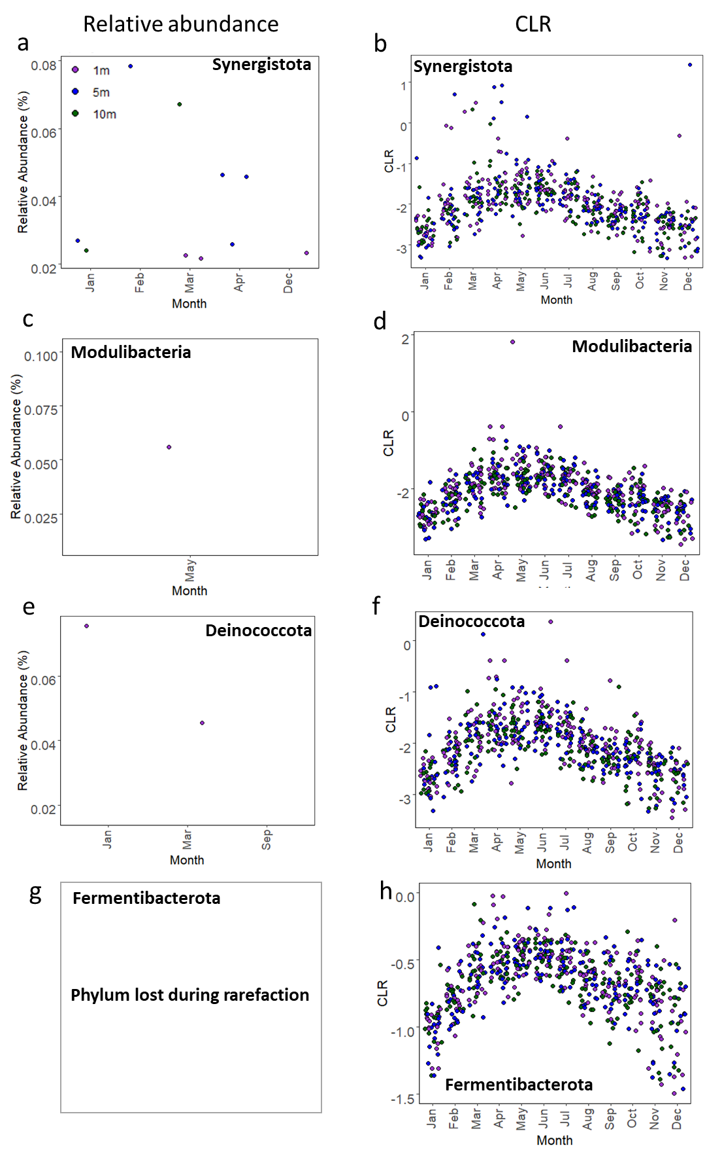
Supplementary Figure 12: Seasonal trends disappear when the ASV table was rarefied to a depth of 5000 reads and expressed as relative abundances. The rare phyla (which contributed < 0.1% of the relative bacterial abundance) did not show any seasonal trends or were either removed during rarefaction. Relative abundances and CLR trends for a-b) Syngergistota, c-d) Modulibacteria, e-f) Deinococcota and g-h) Fermentibacterota.

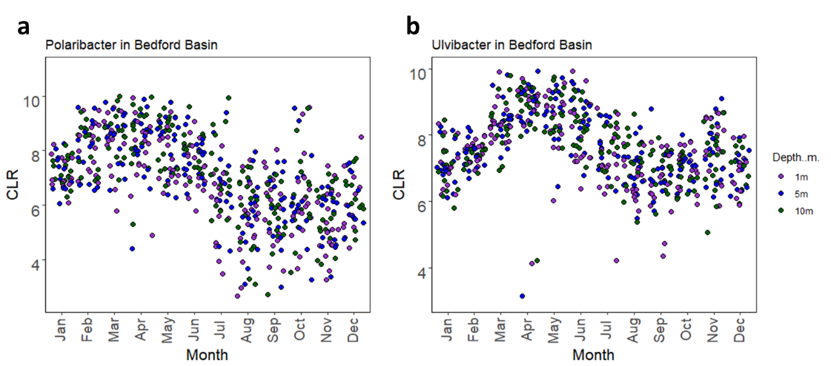
Supplementary Figure 13: Seasonal trends for Pelagibacter and Ulvibacter are associated with the spring bloom in the Bedford basin across a 4-year time series data set. Data were CLR transformed.

Supplementary Tables

Supplementary Table 1: Yearly salinity value (PSU).
Salinity
Year | mean | sd | max | min
2014 | 30.04665 | 0.970396 | 31.2700 | 25.5500
2015 | 30.01835 | 0.917605 | 31.3576 | 26.4968
2016 | 30.18413 | 0.738362 | 31.3098 | 27.5186
2017 | 30.13276 | 0.908307 | 31.5833 | 25.4061
Salinity
group1 | group2 | p | p.signif | method
2016 | 2017 | 0.863 | ns | Wilcoxon
2016 | 2014 | 0.377 | ns | Wilcoxon
2016 | 2015 | 0.215 | ns | Wilcoxon
2017 | 2014 | 0.491 | ns | Wilcoxon
2017 | 2015 | 0.131 | ns | Wilcoxon
2014 | 2015 | 0.645 | ns | Wilcoxon
ns = not significant

Supplementary Table 2: Seasonal alpha diversity comparisons.
Diversity | group1 | group2 | p | p.adj | p.format | p.signif | method
Chao1 | Winter | Spring | 6.64E-39 | 4.00E-38 | < 2e-16 | **** | Wilcoxon
Chao1 | Winter | Summer | 7.47E-34 | 4.50E-33 | < 2e-16 | **** | Wilcoxon
Chao1 | Winter | Autumn | 1.03E-10 | 6.20E-10 | 1.00E-10 | **** | Wilcoxon
Chao1 | Spring | Summer | 0.559572 | 1 | 0.56 | ns | Wilcoxon
Chao1 | Spring | Autumn | 2.84E-18 | 1.70E-17 | < 2e-16 | **** | Wilcoxon
Chao1 | Summer | Autumn | 7.73E-15 | 4.60E-14 | 7.70E-15 | **** | Wilcoxon
Diversity | group1 | group2 | p | p.adj | p.format | p.signif | method
Shannon | Winter | Spring | 1.16E-13 | 7.00E-13 | 1.20E-13 | **** | Wilcoxon
Shannon | Winter | Summer | 4.17E-06 | 2.50E-05 | 4.20E-06 | **** | Wilcoxon
Shannon | Winter | Autumn | 0.010687 | 0.064 | 0.0107 | ns | Wilcoxon
Shannon | Spring | Summer | 5.68E-05 | 0.00034 | 5.70E-05 | **** | Wilcoxon
Shannon | Spring | Autumn | 4.16E-10 | 2.50E-09 | 4.20E-10 | **** | Wilcoxon
Shannon | Summer | Autumn | 0.007546 | 0.045 | 0.0075 | ** | Wilcoxon
ns = not significant

Supplementary Table 3: Correlating environmental parameters (derived from envfit; Vegan package; ¹) with ASV table.
Parameter | PC1 | PC2 | r2 | Pr(>r)
Day Length | -0.45788 | -0.88901 | 0.9083 | 0.001
Temp | 0.78568 | -0.61864 | 0.8313 | 0.001
NO3 | -0.13139 | 0.99133 | 0.7095 | 0.001
PO4 | -0.06238 | 0.99805 | 0.6733 | 0.001
Si | -0.20484 | 0.97879 | 0.6204 | 0.001
DO | -0.99998 | 0.00575 | 0.5119 | 0.001
Chl-a | 0.5048 | -0.86324 | 0.0722 | 0.001
Sal | 0.75152 | -0.65971 | 0.0382 | 0.001
Permutations = 999

Supplementary Table 4: ANOSIM results for depth group comparisons, nested within months and shown for all 4 years. Global tests and pairwise group tests respectively. ASV data were CLR transformed with an Aitchison distance matrix.
 | 2014 | 2015 | 2016 | 2017
Global test (R) | 0.297 | 0.235 | 0.333 | 0.299
Significance | 0.001 | 0.001 | 0.001 | 0.001
Permutations | 999 | 999 | 999 | 999

Year | Depth Group | R-value | Significance | Permutations
2014 | 1m-5m | -0.048 | 0.838 | 999
 | 1m-10m | -0.019 | 0.537 | 999
 | 1m-60m | 0.676 | 0.001 | 999
 | 5m-10m | -0.034 | 0.66 | 999
 | 5m-60m | 0.632 | 0.001 | 999
 | 10m-60m | 0.535 | 0.001 | 999
2015 | 1m-5m | -0.055 | 0.878 | 999
 | 1m-10m | 0.009 | 0.337 | 999
 | 1m-60m | 0.529 | 0.001 | 999
 | 5m-10m | -0.029 | 0.594 | 999
 | 5m-60m | 0.499 | 0.001 | 999
 | 10m-60m | 0.398 | 0.001 | 999
2016 | 1m-5m | -0.023 | 0.553 | 999
 | 1m-10m | 0.008 | 0.376 | 999
 | 1m-60m | 0.708 | 0.001 | 999
 | 5m-10m | -0.018 | 0.526 | 999
 | 5m-60m | 0.692 | 0.001 | 999
 | 10m-60m | 0.6 | 0.001 | 999
2017 | 1m-5m | -0.057 | 0.92 | 999
 | 1m-10m | 0.544 | 0.001 | 999
 | 1m-60m | -0.037 | 0.676 | 999
 | 5m-10m | -0.05 | 0.831 | 999
 | 5m-60m | 0.532 | 0.001 | 999
 | 10m-60m | 0.43 | 0.001 | 999
Significant results are marked in red.

Supplementary Table 5: Global ANOSIM results testing monthly differences in the bacterial communities in the euphotic and aphotic zones. ASV data were CLR transformed with an Aitchison distance matrix.
 | Global test (R)
Years | Euphotic | Aphotic | Significance | Permutations
2014 | 0.734 | 0.731 | 0.001 | 999
2015 | 0.803 | 0.83 | 0.001 | 999
2016 | 0.806 | 0.719 | 0.001 | 999
2017 | 0.842 | 0.77 | 0.001 | 999
average±sd | 0.796±0.045 | 0.762±0.049
sd = standard deviation

Supplementary Table 6: ANOSIM results to test yearly differences in the euphotic and aphotic zones. ASV data were CLR transformed with an Aitchison distance matrix.
 | Euphotic | Aphotic
Global test | 0.091 | 0.276
Significance | 0.001 | 0.001
Permutations | 999 | 999
 | R-value
Groups | Euphotic | Aphotic | Significance | Permutations
2014-2015 | 0.089 | 0.224 | 0.001 | 999
2014-2016 | 0.155 | 0.427 | 0.001 | 999
2014-2017 | 0.11 | 0.231 | 0.001 | 999
2015-2016 | 0.074 | 0.302 | 0.001 | 999
2015-2017 | 0.069 | 0.238 | 0.001 | 999
2016-2017 | 0.059 | 0.256 | 0.001 | 999

Supplementary Table 7: Indicator analysis for samples in the euphotic zone. ASV data were conglomerated at a phylum level and CLR transformed prior to indicator analysis using the ‘Indicspecies’ package ³.
euphotic zone
Season | Month | Phyla | Pearson’s phi coefficient | p-value
Spring | Apr | Synergistota | 0.3 | 0.0001
 |  | Proteobacteria | 0.247 | 0.0001
 |  | Cloacimonadota | 0.221 | 0.0001
 |  | Armatimonadota | 0.213 | 0.0001
 | May | Modulibacteria | 0.299 | 0.0001
 |  | Gemmatimonadota | 0.257 | 0.0001
Summer | Jun | Deinococcota | 0.289 | 0.0001
 |  | Fermentibacterota | 0.287 | 0.0001
 |  | Bacteroidota | 0.245 | 0.0001
 |  | Thermotogota | 0.227 | 0.0001
 |  | Chloroflexi | 0.224 | 0.0001
 |  | Actinobacteriota | 0.211 | 0.0001
 |  | Calditrichota | 0.187 | 0.0004
 |  | Dependentiae | 0.128 | 0.0401
 | Aug | Verrucomicrobiota | 0.235 | 0.0001
Autumn | Sep | Cyanobacteria | 0.401 | 0.0001
 |  | Campylobacterota | 0.239 | 0.0001
 |  | Acidobacteriota | 0.195 | 0.0002
 |  | Fibrobacterota | 0.147 | 0.0069
 | Nov | Bdellovibrionota | 0.212 | 0.0001
Winter | Dec | Planctomycetota | 0.266 | 0.0001
 |  | Myxococcota | 0.237 | 0.0001
 |  | Hydrogenedentes | 0.221 | 0.0001
 | Jan | Nitrospinota | 0.414 | 0.0001
 |  | Fusobacteriota | 0.288 | 0.0001
 |  | Firmicutes | 0.244 | 0.0001
 |  | Desulfobacterota | 0.188 | 0.0004
Note: Missing months did not show any ‘indicator’ phyla.

Supplementary Table 8: Indicator analysis for samples in the aphotic zone. ASV data were conglomerated at a phylum level and CLR transformed prior to indicator analysis using the ‘Indicspecies’ package ³.
aphotic zone
Season | Month | Phyla | Pearson’s phi coefficient | p-value
Spring | Mar | Proteobacteria | 0.258 | 0.0053
 | Apr | Synergistota | 0.349 | 0.0001
 |  | Bacteroidota | 0.34 | 0.0001
 |  | Armatimonadota | 0.319 | 0.0002
 |  | Cloacimonadota | 0.319 | 0.0002
 |  | Thermotogota | 0.319 | 0.0002
 |  | Gemmatimonadota | 0.319 | 0.0002
 |  | Deinococcota | 0.27 | 0.0049
 | May | Verrucomicrobiota | 0.387 | 0.0001
 |  | Fermentibacterota | 0.345 | 0.0011
 |  | Modulibacteria | 0.345 | 0.0011
Summer | Jun | Dependentiae | 0.269 | 0.0083
Autumn | Oct | Planctomycetota | 0.252 | 0.0005
 |  | Cyanobacteria | 0.217 | 0.0105
 |  | Hydrogenedentes | 0.214 | 0.0062
 | Nov | Nitrospinota | 0.303 | 0.0001
Winter | Dec | Desulfobacterota | 0.183 | 0.0186
 | Jan | Fusobacteriota | 0.26 | 0.0079
 |  | Firmicutes | 0.221 | 0.0272
 | Feb | Myxococcota | 0.247 | 0.0039
Note: Missing months did not show any ‘indicator’ phyla.

Supplementary Table 9: Inferred function indicator analysis for samples in the euphotic zone. MetaCyc data CLR transformed prior to indicator analysis using the ‘Indicspecies’ package ³.
Season | Month | Pathways | Pearson’s phi coefficient | p-value
Spring | Mar | Propionate.Degradation | 0.209 | 1.00E-04
 | Apr | Lipid.Biosynthesis | 0.339 | 1.00E-04
 |  | Vitamin.Biosynthesis | 0.252 | 1.00E-04
 |  | Carbohydrates.Degradation | 0.194 | 1.00E-04
 | May | Nitroaromatic.Degradation | 0.294 | 1.00E-04
 |  | Fatty.Acid.and.Lipid.Degradation | 0.281 | 1.00E-04
 |  | Phosphorus.Compounds | 0.238 | 1.00E-04
 |  | Sugar.Nucleotides.Biosynthesis | 0.234 | 1.00E-04
Summer | Jun | Aromatic.compound.degradation | 0.289 | 0.0001
 |  | Purine.Degradation | 0.276 | 0.0001
 |  | Degradation | 0.256 | 0.0001
 |  | Nitrogen.Degradation | 0.149 | 0.002
 |  | Siderophores.Biosynthesis | 0.131 | 0.0047
 | Jul | Aromatic.Compounds.Biosynthesis | 0.34 | 1.00E-04
 |  | Nucleotide.Biosynthesis | 0.314 | 1.00E-04
 |  | Cell.Structure..Cell.Wall.Biosynthesis | 0.312 | 1.00E-04
 |  | Secondary.Metabolite.Biosynthesis | 0.299 | 1.00E-04
 |  | Amino.Acid.Biosynthesis | 0.291 | 1.00E-04
 |  | Sugars.And.Acids.Degradation | 0.281 | 1.00E-04
 |  | Energy.Metabolism | 0.276 | 1.00E-04
 |  | Phospholipid.Biosynthesis | 0.247 | 1.00E-04
 |  | Carbohydrates.Biosynthesis | 0.244 | 1.00E-04
 |  | Sulfur.Metabolism | 0.235 | 1.00E-04
 |  | Fermentation | 0.227 | 1.00E-04
 |  | Alcohol.Degradation | 0.122 | 1.00E-04
 | Aug | Isopentenyl.Diphosphate.Biosynthesis | 0.287 | 1.00E-04
 |  | Cofactor.Biosynthesis | 0.282 | 1.00E-04
 |  | Sugars.And.Polysaccharides.Degradation | 0.249 | 1.00E-04
 |  | Polyamine.Biosynthesis | 0.167 | 7.00E-04
Autumn | Sep | Chlorophyll.Biosynthesis | 0.34 | 1.00E-04
 |  | CO2.Fixation | 0.266 | 1.00E-04
 |  | Glycan.Pathways | 0.23 | 1.00E-04
 |  | Nitrate.Reduction | 0.168 | 3.00E-04
Winter | Nov | Formaldehyde.Assimilation | 0.159 | 1.00E-04
 | Dec | Mevalonate.Pathways | 0.256 | 1.00E-04
 | Jan | Methanogenesis | 0.333 | 1.00E-04
 |  | Denitrification | 0.242 | 1.00E-04
Note: Missing months did not show any ‘indicator’ phyla.

Supplementary Table 10: Inferred function indicator analysis for samples in the aphotic zone. MetaCyc data CLR transformed prior to indicator analysis using the ‘Indicspecies’ package ³.
Season | Month | Pathways | Pearson’s phi coefficient | p-value
Spring | Mar | Propionate.Degradation | 0.154 | 4.00E-04
 | Apr | Lipid.Biosynthesis | 0.283 | 1.00E-04
 |  | Purine.Degradation | 0.197 | 1.00E-04
 |  | Vitamin.Biosynthesis | 0.185 | 1.00E-04
 |  | Polyamine.Biosynthesis | 0.165 | 1.00E-04
 |  | Carbohydrates.Degradation | 0.163 | 3.00E-04
 | May | Nitroaromatic.Degradation | 0.266 | 1.00E-04
 |  | Fatty.Acid.and.Lipid.Degradation | 0.231 | 1.00E-04
 |  | Phosphorus.Compounds | 0.175 | 1.00E-04
Summer | Jun | Aromatic.compound.degradation | 0.212 | 0.0001
 |  | Degradation | 0.151 | 0.0001
 |  | Siderophores.Biosynthesis | 0.111 | 0.0066
 | Jul | Sugars.And.Acids.Degradation | 0.24 | 0.0001
 |  | Aromatic.Compounds.Biosynthesis | 0.238 | 0.0001
 |  | Cell.Structure..Cell.Wall.Biosynthesis | 0.237 | 0.0001
 |  | Nucleotide.Biosynthesis | 0.212 | 0.0001
 |  | Amino.Acid.Biosynthesis | 0.197 | 0.0001
 |  | Secondary.Metabolite.Biosynthesis | 0.193 | 0.0001
 |  | Energy.Metabolism | 0.183 | 0.0001
 |  | Sulfur.Metabolism | 0.148 | 0.0012
 |  | Alcohol.Degradation | 0.117 | 0.0001
 |  | Carbohydrates.Biosynthesis | 0.107 | 0.025
 | Aug | Isopentenyl.Diphosphate.Biosynthesis | 0.231 | 1.00E-04
 |  | Cofactor.Biosynthesis | 0.213 | 1.00E-04
 |  | Phospholipid.Biosynthesis | 0.187 | 1.00E-04
 |  | Sugars.And.Polysaccharides.Degradation | 0.176 | 2.00E-04
 |  | Fermentation | 0.132 | 7.00E-03
Autumn | Sep | Chlorophyll.Biosynthesis | 0.268 | 1.00E-04
 |  | Glycan.Pathways | 0.169 | 2.00E-04
 |  | Nitrate.Reduction | 0.126 | 2.00E-03
 | Oct | CO2.Fixation | 0.171 | 2.00E-04
Winter | Jan | Methanogenesis | 0.231 | 1.00E-04
 |  | Denitrification | 0.217 | 1.00E-04
 |  | Mevalonate.Pathways | 0.196 | 1.00E-04
 | Feb | Formaldehyde.Assimilation | 0.137 | 1.00E-04
Note: Missing months did not show any ‘indicator’ phyla.

References:
1. Oksanen, J. et al. The vegan package. Community Ecol. Packag. 10, 719 (2007).
2. Groemping, U. & Matthias, L. Package ‘relaimpo’. (2021).
3. De Cáceres, M. How to use the indicspecies package (ver. 1.7. 1). R Proj 29, (2013).

