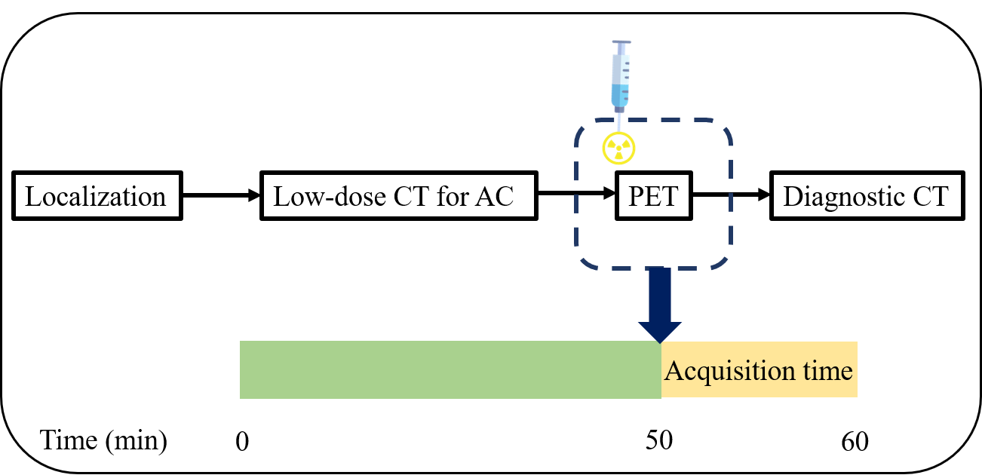
Supplement Fig. 1 Diagram of basic acquisition protocol covering one bed position. AC = attenuation correction CT.

Supplement Fig. 2 Time activity curve showed the biological distribution in liver (ROI1), spleen (ROI2), kidney (ROI3) and pancreas (ROI4) have same trends in the half-activity (a) and the full-activity (b).

Supplement Table 1 Consistency training for 35 standard images interpreting between two physicians.
Score | Inter-reader agreement |  | Intra-reader agreement
 | Reviewer 1 | Reviewer 2 | Reviewer 1 | Reviewer 2
1 | 7 | 6 | 7 | 7
2 | 8 | 8 | 7 | 8
3 | 6 | 7 | 7 | 6
4 | 7 | 7 | 7 | 7
5 | 7 | 7 | 7 | 7
Kappa | 0.96 |  | 0.96 | 0.96
Kappa over 0.85 viewed as excellent agreement.

